FEDF Assignment 2 – CGPA Management System Using ReactJS Routing
Name: M. Venkata Avinash
Roll Number: 2420030458
Section: 6

Overview
This document provides the complete explanation and implementation details of the CGPA Management System developed using ReactJS and React Router DOM.
The application allows users to add and view student CGPA details through a smooth, route-based interface.

Project Summary
The project uses React Router DOM to manage navigation between two main pages:
- AddCGPA Page:
  - Accepts student details such as name, roll number, and CGPA.
  - Stores the entered data using React’s state management.
- ViewCGPA Page:
  - Displays the stored student details for easy viewing.
Routing ensures seamless switching between these two pages without reloading the application.

Commands Executed in Terminal
npx create-react-app student-cgpa
cd student-cgpa
npm install react-router-dom
npm start

Code Implementation
AddCGPA.jsx
import React, { useState } from "react";

const AddCGPA = ({ setStudentData }) => {
const [studentName, setStudentName] = useState("");
const [rollNumber, setRollNumber] = useState("");
const [cgpa, setCgpa] = useState("");

const handleSubmit = (e) => {
e.preventDefault();
if (studentName && rollNumber && cgpa) {
setStudentData({ studentName, rollNumber, cgpa });
alert("Student CGPA Added Successfully!");
} else {
alert("Please fill all fields!");
}
};

return (
<div>
<h2>Add Student CGPA</h2>
<form onSubmit={handleSubmit}>
<div>
<label>Student Name:</label>
<input
type="text"
value={studentName}
onChange={(e) => setStudentName(e.target.value)}
placeholder="Enter name"
required
/>
</div>
<div>
<label>Roll Number:</label>
<input
type="text"
value={rollNumber}
onChange={(e) => setRollNumber(e.target.value)}
placeholder="Enter roll number"
required
/>
</div>
<div>
<label>CGPA:</label>
<input
type="number"
step="0.01"
value={cgpa}
onChange={(e) => setCgpa(e.target.value)}
placeholder="Enter CGPA"
required
/>
</div>
<button type="submit">Add CGPA</button>
</form>
</div>
);
};

export default AddCGPA;

ViewCGPA.jsx
import React from "react";

const ViewCGPA = ({ studentData }) => {
return (
<div>
<h2>View Student CGPA</h2>
{studentData ? (
<div>
<p><strong>Student Name:</strong> {studentData.studentName}</p>
<p><strong>Roll Number:</strong> {studentData.rollNumber}</p>
<p><strong>CGPA:</strong> {studentData.cgpa}</p>
</div>
) : (
<p>No student data available. Please add CGPA first.</p>
)}
</div>
);
};

export default ViewCGPA;

App.jsx
import React, { useState } from "react";
import { BrowserRouter as Router, Route, Routes, Link } from "react-router-dom";
import AddCGPA from "./components/AddCGPA";
import ViewCGPA from "./components/ViewCGPA";

const App = () => {
const [studentData, setStudentData] = useState(null);

return (
<Router>
<div
style={{
display: "flex",
flexDirection: "column",
alignItems: "center",
justifyContent: "center",
height: "100vh",
textAlign: "center",
backgroundColor: "#f9f9f9",
}}
>
<nav style={{ marginBottom: "20px" }}>
<ul style={{ listStyleType: "none", padding: 0, display: "flex", gap: "20px" }}>
<li>
<Link to="/" style={{ textDecoration: "none", color: "#007BFF", fontWeight: "bold" }}>
Add CGPA
</Link>
</li>
<li>
<Link to="/view-cgpa" style={{ textDecoration: "none", color: "#007BFF", fontWeight: "bold" }}>
View CGPA
</Link>
</li>
</ul>
</nav>

<div style={{ width: "100%", maxWidth: "500px" }}>
<Routes>
<Route path="/" element={<AddCGPA setStudentData={setStudentData} />} />
<Route path="/view-cgpa" element={<ViewCGPA studentData={studentData} />} />
</Routes>
</div>
</div>
</Router>
);
};

export default App;

index.js
import React from "react";
import ReactDOM from "react-dom/client";
import App from "./App";

const root = ReactDOM.createRoot(document.getElementById("root"));
root.render(<App />);
Outputs:
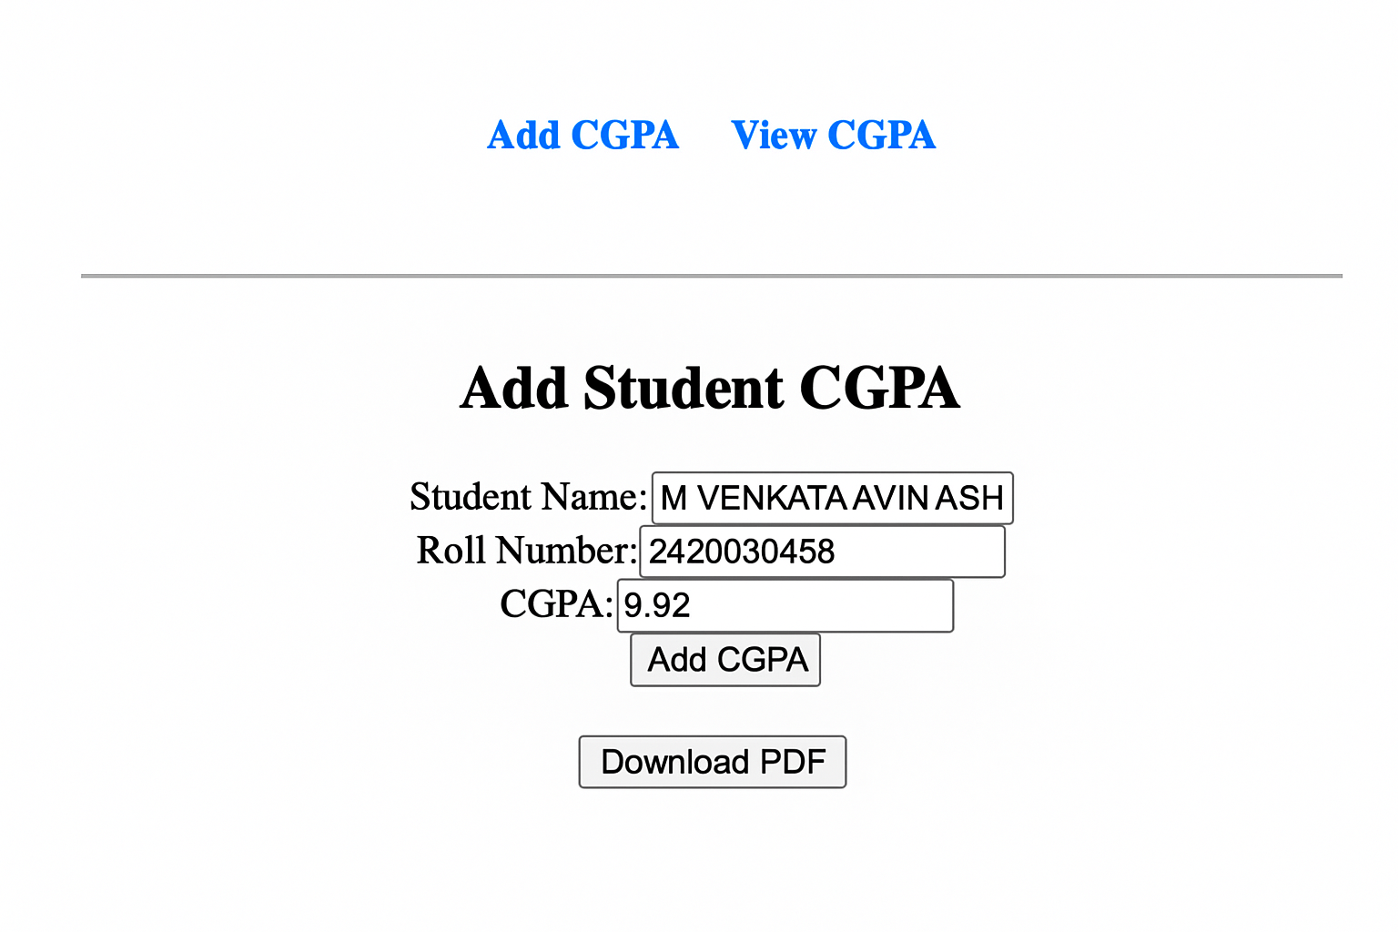

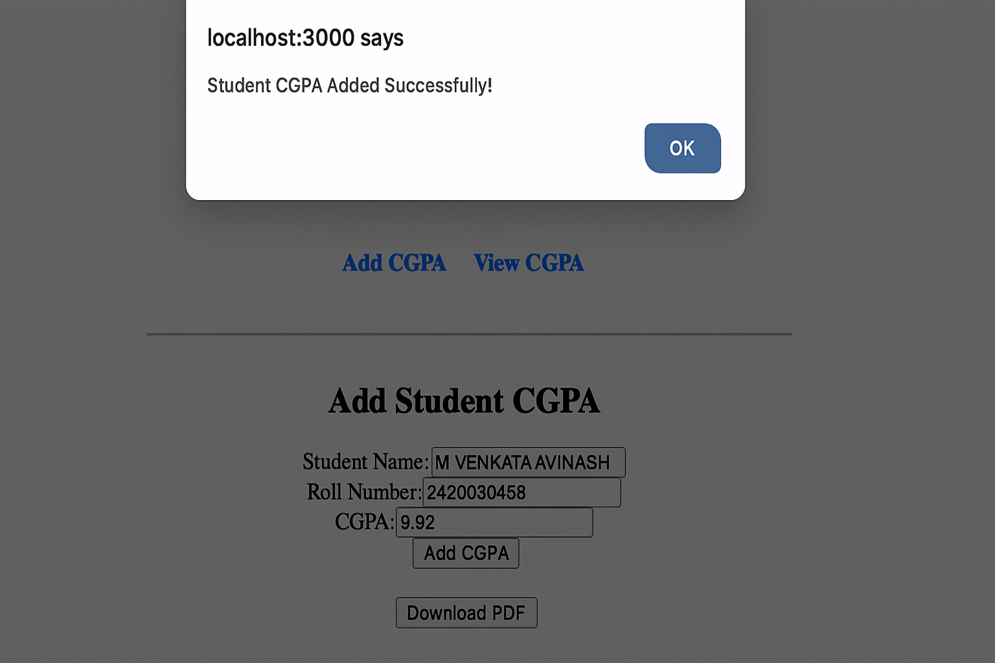

GitHub Repository
🔗 https://github.com/Avinash-2007-M/FEDF-Assignments

