FEDF Assignment 1 – Calculator Using ReactJS
Name: M. Venkata Avinash
Roll Number: 2420030458
Section: 6

Overview
This document presents the detailed explanation, steps, and implementation of a ReactJS-based Calculator application.
The project demonstrates the use of React components, states, and event handling to build an interactive and fully functional calculator interface.

Project Summary
The calculator was developed using Create React App.
Core functionalities such as user input handling, arithmetic operations, and dynamic UI updates were implemented inside the App.js file.
The design emphasizes simplicity, usability, and responsiveness.

Implementation Steps
Below are the terminal commands used to set up and execute the project:
npx create-react-app calculator
cd calculator
npm install
npm start
These commands initialize the React environment, install required dependencies, and launch the development server.

Code Implementation
The calculator logic and layout were implemented in the src/App.js file using React’s functional components and the useState hook for state management.
import React, { useState } from "react";

function App() {
const [input, setInput] = useState("");

const handleClick = (value) => setInput((prev) => prev + value);
const handleClear = () => setInput("");
const handleDelete = () => setInput((prev) => prev.slice(0, -1));

const calculate = () => {
try {
setInput(eval(input).toString());
} catch {
alert("Invalid Expression");
}
};

const buttons = [
"7", "8", "9", "/",
"4", "5", "6", "*",
"1", "2", "3", "-",
"0", ".", "=", "+"
];

return (
<div style={{ textAlign: "center", marginTop: "50px" }}>
<h2>ReactJS Calculator</h2>
<div
style={{
display: "inline-block",
border: "2px solid #333",
padding: "15px",
borderRadius: "10px",
}}
>
<input
type="text"
value={input}
readOnly
style={{
width: "230px",
height: "40px",
marginBottom: "10px",
fontSize: "18px",
textAlign: "right",
}}
/>
<br />
{buttons.map((btn) => (
<button
key={btn}
onClick={() => (btn === "=" ? calculate() : handleClick(btn))}
style={{
width: "50px",
height: "50px",
margin: "5px",
fontSize: "18px",
cursor: "pointer",
}}
>
{btn}
</button>
))}
<br />
<button
onClick={handleClear}
style={{ width: "110px", height: "40px", margin: "5px" }}
>
Clear
</button>
<button
onClick={handleDelete}
style={{ width: "110px", height: "40px", margin: "5px" }}
>
Delete
</button>
</div>
</div>
);
}

export default App;

Outputs:

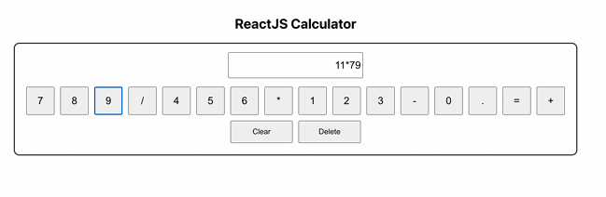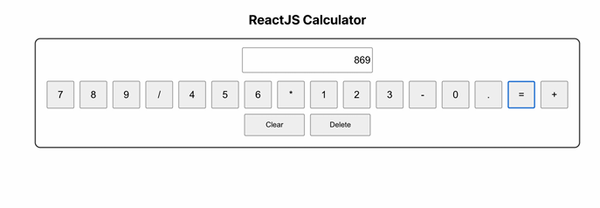

Key Features
- Dynamic UI: Updates instantly with every button press.
- Error Handling: Alerts users when invalid expressions are entered.
- State Management: Efficiently handled using React’s useState hook.
- Minimalist Design: Focused on clarity and functionality.

GitHub Repository
🔗 https://github.com/Avinash-2007-M/FEDF-Assignments

