☕ Spring MVC with XML Configuration: Traditional Web Application

© 2026 Avinash Dhanuka
Master Guide: Traditional Spring MVC with XML Configuration
Crafted with ❤️ for Understanding Spring Evolution

Learning Note: This project demonstrates traditional Spring MVC with XML configuration - understanding this helps appreciate Spring Boot’s auto-configuration magic. Master web.xml, dispatcher-servlet.xml, and manual servlet configuration.
Prerequisites: - Understanding of Spring Boot MVC (day11/SpringMvc) - Basic knowledge of Servlets & Deployment Descriptors - Familiarity with XML configuration - Maven basics

📑 Table of Contents
- What is Traditional Spring MVC?
- Spring Boot vs Traditional Spring
- Project Architecture
- XML Configuration Deep Dive
- Request Mapping Evolution
- Complete Request Flow
- Internal Working
- Query Parameters & Path Variables
- Model Interface Explained
- Deployment Descriptor (web.xml)
- Real-World Comparison
- Common Pitfalls & Solutions
- Interview Questions

1. WHAT IS TRADITIONAL SPRING MVC?

📝 Author: Avinash Dhanuka | GitHub

📌 Definition
Traditional Spring MVC is the pre-Spring Boot way of building web applications using XML configuration files (web.xml, dispatcher-servlet.xml) and manual servlet setup. This approach requires explicit configuration of every component.
Key Differences from Spring Boot: - Manual DispatcherServlet configuration in web.xml - XML-based bean configuration (dispatcher-servlet.xml) - No auto-configuration - Requires external servlet container (Tomcat) - More boilerplate code

🎯 Why Learn This?
Reason | Benefit
Legacy Projects | Many production apps still use XML config
Interview Questions | Understand Spring’s evolution
Appreciate Spring Boot | See what auto-configuration does
Debugging Skills | Know what happens under the hood
Migration Projects | Convert XML to Java config

2. SPRING BOOT VS TRADITIONAL SPRING

📊 Configuration Comparison

🎯 Side-by-Side Comparison
Feature | Spring Boot (Day 11) | Traditional Spring (Day 12)
Configuration | application.properties | web.xml + dispatcher-servlet.xml
DispatcherServlet | Auto-configured | Manual in web.xml
View Resolver | Auto-configured | Manual bean in XML
Component Scan | @SpringBootApplication
Server | Embedded Tomcat | External Tomcat
Packaging | JAR (executable) | WAR (deploy to server)
Startup | java -jar app.jar | Deploy WAR to Tomcat
Dependencies | spring-boot-starter-web | spring-webmvc + JSTL
Lines of Config | ~10 lines | ~50+ lines

📝 Configuration Examples
Spring Boot (Day 11):
# application.properties
server.port=8081
spring.mvc.view.prefix=/WEB-INF/jsp/
spring.mvc.view.suffix=.jsp
Traditional Spring (Day 12):
<!-- web.xml -->
<servlet>
<servlet-name>dispatcher</servlet-name>
<servlet-class>org.springframework.web.servlet.DispatcherServlet</servlet-class>
<load-on-startup>1</load-on-startup>
</servlet>
<!-- dispatcher-servlet.xml -->
<bean class="org.springframework.web.servlet.view.InternalResourceViewResolver">
<property name="prefix" value="/WEB-INF/views/"/>
<property name="suffix" value=".jsp"/>
</bean>

3. PROJECT ARCHITECTURE

📁 Complete Project Structure
MavenApp/
├── src/
│ └── main/
│ ├── java/
│ │ └── com/example/
│ │ ├── controller/
│ │ │ └── UserController.java # @Controller
│ │ ├── service/
│ │ │ ├── UserService.java # Interface
│ │ │ └── UserServiceImpl.java # @Service
│ │ ├── repository/
│ │ │ ├── UserRepository.java # Interface
│ │ │ └── UserRepositoryImpl.java # @Repository
│ │ └── model/
│ │ └── User.java # POJO
│ ├── resources/ # Empty (no properties)
│ └── webapp/
│ ├── WEB-INF/
│ │ ├── web.xml # Deployment Descriptor
│ │ ├── dispatcher-servlet.xml # Spring Config
│ │ └── views/
│ │ ├── home.jsp
│ │ ├── userList.jsp
│ │ ├── userDetail.jsp
│ │ └── addUser.jsp
│ └── index.jsp
├── pom.xml # Maven Dependencies
└── README.md

🎯 Layered Architecture
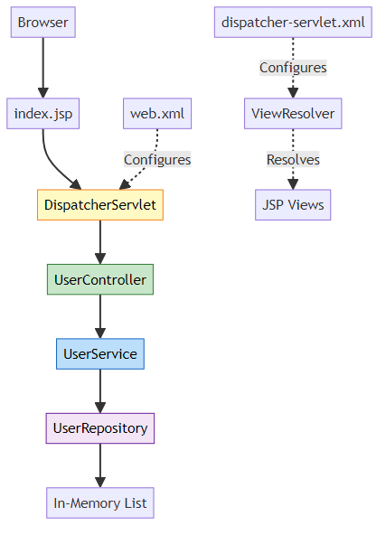

📊 Layer Responsibilities
Layer | Annotation | File | Responsibility
Controller | @Controller | UserController.java | Handle HTTP requests
Service | @Service | UserServiceImpl.java | Business logic
Repository | @Repository | UserRepositoryImpl.java | Data access (in-memory)
Model | POJO | User.java | Data representation
View | JSP | home.jsp, userList.jsp | UI presentation

4. XML CONFIGURATION DEEP DIVE

📝 Author: Avinash Dhanuka | GitHub

📌 web.xml (Deployment Descriptor)
Purpose: Configure servlet container (Tomcat) and register DispatcherServlet
<servlet>
<servlet-name>dispatcher</servlet-name>
<servlet-class>org.springframework.web.servlet.DispatcherServlet</servlet-class>
<init-param>
<param-name>contextConfigLocation</param-name>
<param-value>/WEB-INF/dispatcher-servlet.xml</param-value>
</init-param>
<load-on-startup>1</load-on-startup>
</servlet>
<servlet-mapping>
<servlet-name>dispatcher</servlet-name>
<url-pattern>/</url-pattern>
</servlet-mapping>
Breakdown:
Element | Purpose | Value
servlet-name | Unique identifier | dispatcher
servlet-class | DispatcherServlet class | Spring’s front controller
contextConfigLocation | Spring config file | /WEB-INF/dispatcher-servlet.xml
load-on-startup | Load priority | 1 (load immediately)
url-pattern | URL mapping | / (all requests)

📌 dispatcher-servlet.xml (Spring Configuration)
Purpose: Configure Spring beans, component scanning, and view resolver
<!-- Enable component scanning -->
<context:component-scan base-package="com.example"/>
<!-- Enable annotation-driven MVC -->
<mvc:annotation-driven/>
<!-- View Resolver -->
<bean class="org.springframework.web.servlet.view.InternalResourceViewResolver">
<property name="prefix" value="/WEB-INF/views/"/>
<property name="suffix" value=".jsp"/>
</bean>
Breakdown:
Configuration | Purpose | Equivalent in Spring Boot
component-scan | Scan @Controller, @Service | @SpringBootApplication
annotation-driven | Enable @RequestMapping | Auto-configured
ViewResolver bean | Resolve view names | spring.mvc.view.prefix/suffix

🎯 Why web.xml is Called “Deployment Descriptor”
Answer: It describes how to deploy the application to the servlet container.
What it describes: - Which servlets to load - URL patterns to map - Initialization parameters - Load order - Welcome files - Error pages
Analogy:
web.xml = Instruction manual for Tomcat
"Hey Tomcat, when you start:
1. Load DispatcherServlet
2. Map all URLs (/) to it
3. Use this config file: dispatcher-servlet.xml"

5. REQUEST MAPPING EVOLUTION

📌 @RequestMapping vs @GetMapping
Historical Evolution:
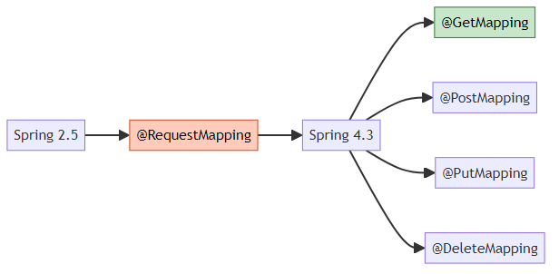

🎯 Old Way (@RequestMapping)
@RequestMapping(value = "/home", method = RequestMethod.GET)
public String home() {
return "home";
}
@RequestMapping(value = "/addUser", method = RequestMethod.POST)
public String addUser(@RequestParam String name) {
// ...
}

🎯 New Way (Specialized Annotations)
@GetMapping("/home")
public String home() {
return "home";
}
@PostMapping("/addUser")
public String addUser(@RequestParam String name) {
// ...
}

📊 Comparison Table
Feature | @RequestMapping | @GetMapping/@PostMapping
Verbosity | More verbose | Concise
HTTP Method | Explicit parameter | Implicit in annotation
Readability | Lower | Higher
Spring Version | 2.5+ | 4.3+
Use Case | Multiple methods | Single method

🎯 Can You Use Both Together?
Answer: NO! You cannot use @GetMapping and @RequestMapping on the same method.
// ❌ WRONG - Compilation error
@GetMapping("/home")
@RequestMapping(value = "/home", method = RequestMethod.GET)
public String home() {
return "home";
}
// ✅ CORRECT - Use one or the other
@GetMapping("/home")
public String home() {
return "home";
}

🎯 Class-Level vs Method-Level
Both can be used at class and method level:
@Controller
@RequestMapping("/api") // Base URL
public class UserController {
@GetMapping("/users") // Full URL: /api/users
public String listUsers() {
return "userList";
}
@PostMapping("/users") // Full URL: /api/users
public String addUser() {
return "redirect:/api/users";
}
}
Is it like a base URL? - Yes! Class-level @RequestMapping acts as a base URL prefix - All method-level mappings are appended to it

6. COMPLETE REQUEST FLOW

📝 Author: Avinash Dhanuka | GitHub

📌 End-to-End Request Processing
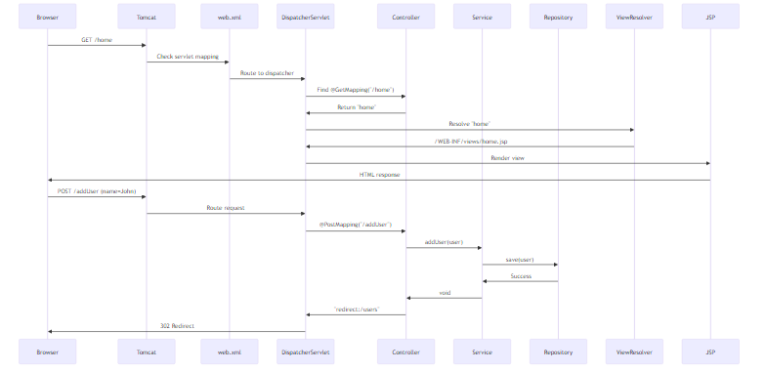

🎯 Step-by-Step Breakdown
Step 1: Application Startup
1. Tomcat starts
2. Reads web.xml
3. Creates DispatcherServlet instance
4. DispatcherServlet reads dispatcher-servlet.xml
5. Component scanning finds @Controller, @Service, @Repository
6. ViewResolver bean created
7. Application ready
Step 2: User Visits /home
Browser → http://localhost:8080/MavenApp/home
↓
Tomcat receives request
↓
web.xml: url-pattern="/" → dispatcher servlet
↓
DispatcherServlet: Find handler for "/home"
↓
UserController.home() called
↓
Returns "home" (view name)
↓
ViewResolver: /WEB-INF/views/ + "home" + .jsp
↓
home.jsp rendered
↓
HTML sent to browser
Step 3: User Adds New User
Browser → POST /addUser (name=John, email=john@test.com)
↓
DispatcherServlet receives POST
↓
@RequestParam binds form data
↓
UserController.addUser() called
↓
UserService.addUser() → UserRepository.save()
↓
User added to in-memory list
↓
Returns "redirect:/users"
↓
Browser redirected to /users
↓
GET /users → userList.jsp displayed

7. INTERNAL WORKING

📌 DispatcherServlet Initialization
What happens when Tomcat starts:
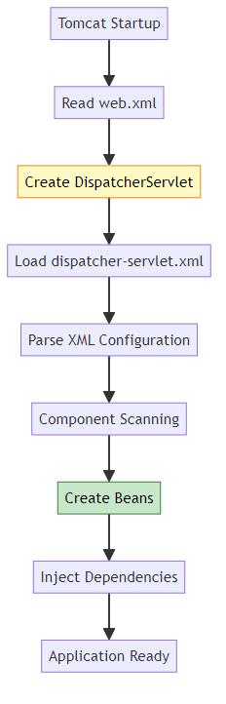
Internal Process:
// 1. Tomcat creates DispatcherServlet
DispatcherServlet servlet = new DispatcherServlet();
// 2. Calls init() method
servlet.init(servletConfig);
// 3. DispatcherServlet loads Spring context
WebApplicationContext context = new XmlWebApplicationContext();
context.setConfigLocation("/WEB-INF/dispatcher-servlet.xml");
context.refresh();
// 4. Component scanning
ClassPathBeanDefinitionScanner scanner = new ClassPathBeanDefinitionScanner(context);
scanner.scan("com.example");
// 5. Bean creation
UserController controller = context.getBean(UserController.class);
UserService service = context.getBean(UserService.class);
UserRepository repository = context.getBean(UserRepository.class);
// 6. Dependency injection
controller.setUserService(service); // @Autowired
service.setUserRepository(repository); // @Autowired

🎯 Why dispatcher-servlet.xml?
Answer: Spring convention - if servlet name is “dispatcher”, it looks for “dispatcher-servlet.xml”
Naming Convention:
Servlet name: dispatcher
Config file: dispatcher-servlet.xml
Servlet name: myapp
Config file: myapp-servlet.xml
Custom Location:
<init-param>
<param-name>contextConfigLocation</param-name>
<param-value>/WEB-INF/spring-config.xml</param-value>
</init-param>

📊 XML vs Java Config vs Spring Boot
Configuration | Traditional | Java Config | Spring Boot
File | dispatcher-servlet.xml | AppConfig.java | application.properties
Component Scan | <context:component-scan> | @ComponentScan | @SpringBootApplication
View Resolver | <bean> XML | @Bean method | Auto-configured
Verbosity | High | Medium | Low

8. QUERY PARAMETERS & PATH VARIABLES

📝 Author: Avinash Dhanuka | GitHub

📌 What are Query Parameters?
Query parameters are key-value pairs appended to URL after ?
Example:
http://localhost:8080/search?name=John&age=25
↑
Query Parameters

🎯 @RequestParam Usage
@GetMapping("/search")
public String search(@RequestParam("name") String name,
@RequestParam("age") int age) {
// URL: /search?name=John&age=25
// name = "John"
// age = 25
}
Optional Parameters:
@GetMapping("/search")
public String search(@RequestParam(value = "name", required = false) String name) {
// name can be null if not provided
}
@GetMapping("/search")
public String search(@RequestParam(defaultValue = "Unknown") String name) {
// name = "Unknown" if not provided
}

📌 Path Variables
Path variables are part of the URL path
@GetMapping("/user/{id}")
public String getUser(@PathVariable("id") Long id, Model model) {
// URL: /user/123
// id = 123
User user = userService.getUserById(id);
model.addAttribute("user", user);
return "userDetail";
}

📊 Query Param vs Path Variable
Feature | Query Parameter | Path Variable
Syntax | ?key=value | /resource/{id}
Annotation | @RequestParam | @PathVariable
Use Case | Filtering, searching | Resource identification
Optional | Yes (required=false) | No (part of URL)
Example | /search?name=John | /user/123
When to use: - Path Variable: Identifying a specific resource (/user/123) - Query Parameter: Filtering or optional data (/users?role=admin&active=true)

🎯 Real-World Example
@GetMapping("/users")
public String listUsers(
@RequestParam(defaultValue = "0") int page,
@RequestParam(defaultValue = "10") int size,
@RequestParam(required = false) String role,
Model model) {
// URL: /users?page=2&size=20&role=admin
List<User> users = userService.getUsers(page, size, role);
model.addAttribute("users", users);
return "userList";
}
@GetMapping("/user/{id}/orders/{orderId}")
public String getOrder(
@PathVariable Long id,
@PathVariable Long orderId,
Model model) {
// URL: /user/123/orders/456
Order order = orderService.getOrder(id, orderId);
model.addAttribute("order", order);
return "orderDetail";
}

9. MODEL INTERFACE EXPLAINED

📌 What is Model?
Model is an interface that carries data from controller to view. It’s a map of key-value pairs.
public interface Model {
Model addAttribute(String name, Object value);
Model addAttribute(Object value);
Map<String, Object> asMap();
}

🎯 Model in Action
@GetMapping("/users")
public String listUsers(Model model) {
List<User> users = userService.getAllUsers();
model.addAttribute("users", users); // Add data to model
return "userList"; // View can access ${users}
}
In JSP:
<c:forEach var="user" items="${users}">
<tr>
<td>${user.id}</td>
<td>${user.name}</td>
</tr>
</c:forEach>

📊 Model vs ModelAndView vs ModelMap
Type | Usage | Return Type
Model | Interface (parameter) | String (view name)
ModelAndView | Contains both | ModelAndView object
ModelMap | Implementation | String (view name)
Example:
// Using Model (most common)
@GetMapping("/users")
public String listUsers(Model model) {
model.addAttribute("users", userService.getAllUsers());
return "userList";
}
// Using ModelAndView
@GetMapping("/users")
public ModelAndView listUsers() {
ModelAndView mav = new ModelAndView("userList");
mav.addObject("users", userService.getAllUsers());
return mav;
}

🎯 What is “Model model ui”?
Answer: It’s a parameter name confusion!
public String listUsers(Model model) {
// "Model" = Interface type
// "model" = Variable name
// "ui" = NOT part of syntax (typo/confusion)
}
Correct Understanding: - Model = Interface from Spring - model = Variable name (can be anything) - Used to pass data to view
You can name it anything:
public String listUsers(Model m) { }
public String listUsers(Model data) { }
public String listUsers(Model viewModel) { }

🎯 How Model Works Internally
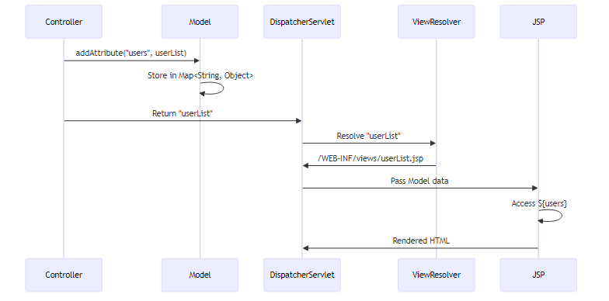
Internal Implementation:
// Spring internally
Map<String, Object> modelMap = new LinkedHashMap<>();
modelMap.put("users", userList);
// JSP can access
request.setAttribute("users", modelMap.get("users"));

10. DEPLOYMENT DESCRIPTOR (web.xml)

📝 Author: Avinash Dhanuka | GitHub

📌 Why is web.xml Called “Deployment Descriptor”?
Answer: It describes how to deploy and configure the web application in the servlet container.
What it describes: 1. Servlet Configuration - Which servlets to load 2. URL Mappings - Which URLs map to which servlets 3. Initialization Parameters - Configuration for servlets 4. Load Order - When to load servlets 5. Welcome Files - Default pages (index.jsp) 6. Error Pages - Custom error handling 7. Security Constraints - Authentication/authorization 8. Session Configuration - Timeout, cookies

🎯 Complete web.xml Breakdown
<?xml version="1.0" encoding="UTF-8"?>
<web-app version="4.0">
<!-- 1. Define Servlet -->
<servlet>
<servlet-name>dispatcher</servlet-name>
<servlet-class>org.springframework.web.servlet.DispatcherServlet</servlet-class>
<!-- 2. Initialization Parameter -->
<init-param>
<param-name>contextConfigLocation</param-name>
<param-value>/WEB-INF/dispatcher-servlet.xml</param-value>
</init-param>
<!-- 3. Load on Startup -->
<load-on-startup>1</load-on-startup>
</servlet>
<!-- 4. Servlet Mapping -->
<servlet-mapping>
<servlet-name>dispatcher</servlet-name>
<url-pattern>/</url-pattern>
</servlet-mapping>
</web-app>
Element Explanation:
Element | Purpose | Value in Project
servlet-name | Unique identifier | dispatcher
servlet-class | Fully qualified class | DispatcherServlet
contextConfigLocation | Spring config file | /WEB-INF/dispatcher-servlet.xml
load-on-startup | Load priority (1=first) | 1
url-pattern | URL to intercept | / (all requests)

🎯 load-on-startup Explained
Values: - Negative or absent: Load on first request (lazy) - 0 or positive: Load at startup (eager) - Lower number = higher priority
<servlet>
<servlet-name>servlet1</servlet-name>
<load-on-startup>1</load-on-startup> <!-- Loads first -->
</servlet>
<servlet>
<servlet-name>servlet2</servlet-name>
<load-on-startup>2</load-on-startup> <!-- Loads second -->
</servlet>
<servlet>
<servlet-name>servlet3</servlet-name>
<!-- No load-on-startup = loads on first request -->
</servlet>

📊 URL Pattern Matching
Pattern | Matches | Example
/ | All requests | /home, /users, /api/data
*.jsp | All JSP files | /page.jsp, /admin/page.jsp
/api/* | All under /api | /api/users, /api/orders
/admin | Exact match | /admin only
Our Project:
<url-pattern>/</url-pattern>
- Matches ALL requests
- DispatcherServlet handles everything
- Static resources also go through it

11. REAL-WORLD COMPARISON

📊 Spring Boot vs Traditional Spring: Production Perspective
Aspect | Traditional Spring (This Project) | Spring Boot (Day 11)
Setup Time | 2-3 hours | 15 minutes
Configuration Files | 2 XML files (50+ lines) | 1 properties file (10 lines)
Server Setup | Install Tomcat separately | Embedded (no setup)
Deployment | Build WAR → Deploy to Tomcat | java -jar app.jar
Debugging | Check XML, web.xml, Tomcat logs | Check application.properties
Learning Curve | Steep (XML, servlets) | Gentle (conventions)
Maintenance | High (XML changes) | Low (properties changes)
Industry Use | Legacy projects (20%) | Modern projects (80%)

🎯 When to Use Traditional Spring
Use Traditional Spring When: - Working on legacy projects - Company policy requires XML config - Need fine-grained control - Deploying to existing Tomcat infrastructure - Learning Spring internals
Use Spring Boot When: - Starting new projects - Need rapid development - Microservices architecture - Cloud deployment - Modern best practices

📝 Migration Path
Traditional Spring → Spring Boot:
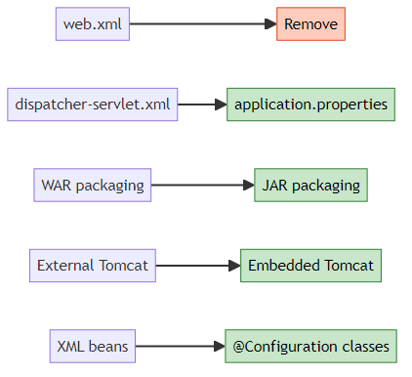
Steps: 1. Remove web.xml 2. Remove dispatcher-servlet.xml 3. Add @SpringBootApplication 4. Create application.properties 5. Change packaging: WAR → JAR 6. Add spring-boot-starter-web dependency

🎯 Real-World Scenario
Company X (Legacy): - 10-year-old application - Traditional Spring with XML - Deployed on Tomcat 8 - 50+ XML configuration files - Maintenance nightmare
Company Y (Modern): - New microservices - Spring Boot - Docker containers - application.yml - Easy to maintain

12. COMMON PITFALLS & SOLUTIONS

📝 Author: Avinash Dhanuka | GitHub

❌ Pitfall 1: Wrong JSP Location
Problem:
src/main/resources/views/home.jsp ❌
Error: 404 - JSP not found
Solution:
src/main/webapp/WEB-INF/views/home.jsp ✅
Why? Servlet containers look in webapp/, not resources/

❌ Pitfall 2: Missing JSTL Dependency
Problem:
<!-- Missing JSTL in pom.xml -->
Error:
<%@ taglib uri="http://java.sun.com/jsp/jstl/core" prefix="c" %>
↑
Not recognized
Solution:
<dependency>
<groupId>jakarta.servlet.jsp.jstl</groupId>
<artifactId>jakarta.servlet.jsp.jstl-api</artifactId>
<version>3.0.0</version>
</dependency>

❌ Pitfall 3: Wrong Servlet Name Convention
Problem:
<!-- web.xml -->
<servlet-name>myapp</servlet-name>
<!-- But config file is: dispatcher-servlet.xml ❌ -->
Error: Config file not found
Solution:
<!-- Option 1: Match names -->
<servlet-name>dispatcher</servlet-name>
<!-- Config: dispatcher-servlet.xml ✅ -->
<!-- Option 2: Explicit path -->
<init-param>
<param-name>contextConfigLocation</param-name>
<param-value>/WEB-INF/myapp-config.xml</param-value>
</init-param>

❌ Pitfall 4: Component Scan Package Mismatch
Problem:
<context:component-scan base-package="com.myapp"/>
But classes are in:
com.example.controller.UserController ❌
Error: No beans found
Solution:
<context:component-scan base-package="com.example"/>

❌ Pitfall 5: Missing @Controller Annotation
Problem:
public class UserController { // Missing @Controller
@GetMapping("/home")
public String home() {
return "home";
}
}
Error: 404 - No handler found
Solution:
@Controller // Required!
public class UserController {
@GetMapping("/home")
public String home() {
return "home";
}
}

❌ Pitfall 6: Packaging as JAR Instead of WAR
Problem:
<packaging>jar</packaging> ❌
Error: Cannot deploy to Tomcat
Solution:
<packaging>war</packaging> ✅
Why? Traditional Spring needs WAR for external Tomcat

13. TOP INTERVIEW QUESTIONS

Q1: Explain the difference between web.xml and dispatcher-servlet.xml
Answer:
Aspect | web.xml | dispatcher-servlet.xml
Purpose | Configure servlet container | Configure Spring beans
Scope | Tomcat/Jetty configuration | Spring MVC configuration
Loaded By | Servlet container | DispatcherServlet
Contains | Servlet mappings, filters | Beans, component scan, view resolver
Required | Yes (traditional) | Yes (unless Java config)
Analogy: - web.xml = Building blueprint (tells Tomcat how to set up) - dispatcher-servlet.xml = Interior design (tells Spring how to configure)
Flow:
Tomcat starts → Reads web.xml → Creates DispatcherServlet →
DispatcherServlet reads dispatcher-servlet.xml → Spring context created

Q2: Why can’t we use @GetMapping and @RequestMapping together?
Answer:
They are mutually exclusive because @GetMapping is a specialized version of @RequestMapping.
Internal Definition:
@RequestMapping(method = RequestMethod.GET)
public @interface GetMapping {
// @GetMapping is just a shortcut
}
Using both creates conflict:
@GetMapping("/home") // Says: GET method only
@RequestMapping(value = "/home", method = RequestMethod.POST) // Says: POST method
public String home() {
// Conflict! Which method to use?
}
Correct Usage:
// Option 1: Use @GetMapping
@GetMapping("/home")
public String home() { }
// Option 2: Use @RequestMapping
@RequestMapping(value = "/home", method = RequestMethod.GET)
public String home() { }
// Option 3: Multiple methods with @RequestMapping
@RequestMapping(value = "/home", method = {RequestMethod.GET, RequestMethod.POST})
public String home() { }

Q3: What happens if you don’t specify load-on-startup in web.xml?
Answer:
Without load-on-startup:
<servlet>
<servlet-name>dispatcher</servlet-name>
<servlet-class>org.springframework.web.servlet.DispatcherServlet</servlet-class>
<!-- No load-on-startup -->
</servlet>
Behavior: - Servlet is NOT created at startup - Created on FIRST request - First request is SLOW (initialization overhead) - Subsequent requests are fast
Timeline:
Tomcat starts → Servlet NOT created
↓
First request arrives → Create servlet → Initialize Spring context → Process request (SLOW)
↓
Second request → Servlet already exists → Process request (FAST)
With load-on-startup=1:
<load-on-startup>1</load-on-startup>
Behavior: - Servlet created at startup - Spring context initialized immediately - ALL requests are fast - Startup time is longer
Best Practice: Always use <load-on-startup>1</load-on-startup> for production

Q4: How does Spring resolve view names without application.properties?
Answer:
In Traditional Spring, view resolution is configured in dispatcher-servlet.xml:
<bean class="org.springframework.web.servlet.view.InternalResourceViewResolver">
<property name="prefix" value="/WEB-INF/views/"/>
<property name="suffix" value=".jsp"/>
</bean>
Internal Process:
// Controller returns
return "home";
// Spring internally
String prefix = "/WEB-INF/views/";
String suffix = ".jsp";
String fullPath = prefix + "home" + suffix;
// Result: /WEB-INF/views/home.jsp
RequestDispatcher dispatcher = request.getRequestDispatcher(fullPath);
dispatcher.forward(request, response);
Comparison:
Configuration | Traditional Spring | Spring Boot
File | dispatcher-servlet.xml | application.properties
Syntax | XML <bean> | Key-value pairs
Prefix | <property name="prefix"> | spring.mvc.view.prefix
Suffix | <property name="suffix"> | spring.mvc.view.suffix

Q5: What is the difference between @RequestParam and @PathVariable?
Answer:
@RequestParam - Query Parameters:
@GetMapping("/search")
public String search(@RequestParam("name") String name) {
// URL: /search?name=John
// name = "John"
}
@PathVariable - URL Path:
@GetMapping("/user/{id}")
public String getUser(@PathVariable("id") Long id) {
// URL: /user/123
// id = 123
}
Key Differences:
Feature | @RequestParam | @PathVariable
Location | After ? in URL | Part of URL path
Syntax | ?key=value | /{variable}
Optional | Yes (required=false) | No (must be present)
Multiple | ?key1=val1&key2=val2 | /path/{var1}/{var2}
Use Case | Filtering, searching | Resource identification
Real-World Example:
// Get user by ID (PathVariable)
@GetMapping("/user/{id}")
public String getUser(@PathVariable Long id) {
// URL: /user/123
}
// Search users (RequestParam)
@GetMapping("/users")
public String searchUsers(
@RequestParam(required = false) String name,
@RequestParam(defaultValue = "0") int page) {
// URL: /users?name=John&page=2
}
// Combined
@GetMapping("/user/{id}/orders")
public String getUserOrders(
@PathVariable Long id,
@RequestParam(defaultValue = "pending") String status) {
// URL: /user/123/orders?status=completed
}

Q6: Why do we need both UserService interface and UserServiceImpl?
Answer:
Benefits of Interface + Implementation:
- Loose Coupling
@Controller
public class UserController {
@Autowired
private UserService userService; // Depends on interface, not implementation
}
- Easy Testing
@Test
public void testController() {
UserService mockService = mock(UserService.class);
UserController controller = new UserController(mockService);
// Easy to mock interface
}
- Multiple Implementations
@Service("dbUserService")
public class DatabaseUserServiceImpl implements UserService { }
@Service("cacheUserService")
public class CachedUserServiceImpl implements UserService { }
// Switch implementations easily
@Autowired
@Qualifier("cacheUserService")
private UserService userService;
- Follows SOLID Principles
- Dependency Inversion: Depend on abstractions, not concretions
- Open/Closed: Open for extension, closed for modification
Without Interface (Tight Coupling):
@Controller
public class UserController {
@Autowired
private UserServiceImpl userService; // Tightly coupled to implementation
// Hard to test, hard to change
}

Q7: What happens internally when you access ${user.name} in JSP?
Answer:
JSP Expression Language (EL) Process:
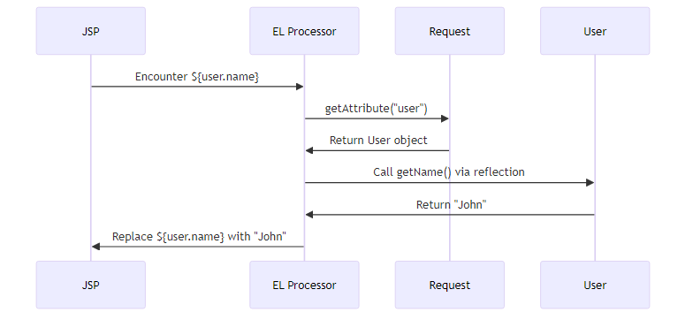
Internal Process:
// 1. Controller adds to model
model.addAttribute("user", userObject);
// 2. Spring adds to request
request.setAttribute("user", userObject);
// 3. JSP processes ${user.name}
Object user = request.getAttribute("user");
Method getter = user.getClass().getMethod("getName");
String name = (String) getter.invoke(user);
// 4. Output to HTML
out.print(name); // Prints "John"
Why it works: - EL uses reflection to call getters - ${user.name} → calls user.getName() - ${user.email} → calls user.getEmail() - Requires getters to be present!
Without Getter:
public class User {
private String name;
// No getName() method
}
${user.name} <!-- Error! No getter found -->

Q8: Explain the complete lifecycle of a request in Traditional Spring MVC
Answer:
Complete Flow:
1. Browser sends request: GET /home
↓
2. Tomcat receives request
↓
3. Tomcat checks web.xml for servlet mapping
↓
4. Finds: url-pattern="/" → dispatcher servlet
↓
5. Tomcat calls DispatcherServlet.doGet()
↓
6. DispatcherServlet asks HandlerMapping: "Who handles /home?"
↓
7. HandlerMapping finds: UserController.home() with @GetMapping("/home")
↓
8. DispatcherServlet calls UserController.home()
↓
9. Controller returns "home" (view name)
↓
10. DispatcherServlet asks ViewResolver: "Where is 'home' view?"
↓
11. ViewResolver: prefix + "home" + suffix = /WEB-INF/views/home.jsp
↓
12. DispatcherServlet forwards to home.jsp
↓
13. JSP engine processes home.jsp
↓
14. Generates HTML
↓
15. HTML sent to browser
Key Components: - Tomcat: Servlet container - web.xml: Servlet configuration - DispatcherServlet: Front controller - HandlerMapping: URL → Controller mapping - Controller: Request handler - ViewResolver: View name → JSP path - JSP: View template

🎓 End of Traditional Spring MVC Guide

Created with dedication by Avinash Dhanuka

Happy Learning! 🚀
“Understand the Past, Master the Present, Build the Future!” - Avinash Dhanuka

📊 Project Statistics
Metric | Value
Configuration Type | XML-based
Packaging | WAR
Server | External Tomcat
View Technology | JSP + JSTL
Data Storage | In-Memory List
Key Annotations | @Controller, @Service, @Repository
XML Files | 2 (web.xml, dispatcher-servlet.xml)
Learning Focus | Traditional Spring MVC

© 2026 Avinash Dhanuka | All Rights Reserved

