☕ Spring Framework: Bean Lifecycle Management - Complete Guide

© 2026 Avinash Dhanuka
Master Guide: Spring Bean Lifecycle Management
Crafted with ❤️ for Understanding Bean Birth to Death

Learning Note: This guide demonstrates Spring Bean Lifecycle management using @PostConstruct and @PreDestroy annotations. Understanding the bean lifecycle is crucial for proper resource management, initialization, and cleanup in Spring applications.
Prerequisites: - Understanding of Spring IoC Container - Knowledge of Dependency Injection - Basic Spring annotations (@Component, @Configuration) - Java OOP fundamentals

📑 Table of Contents
- What is Bean Lifecycle?
- Why Bean Lifecycle Matters
- Complete Bean Lifecycle Phases
- @PostConstruct Annotation
- @PreDestroy Annotation
- Lifecycle Callback Methods
- Internal Working Mechanism
- Lifecycle with Different Scopes
- Project Structure & Implementation
- Execution Flow Analysis
- Real-World Examples
- Best Practices
- Common Pitfalls
- Interview Questions

1. WHAT IS BEAN LIFECYCLE?

📝 Author: Avinash Dhanuka | GitHub

📌 Definition
Bean Lifecycle refers to the complete journey of a Spring bean from its creation (instantiation) to its destruction. Spring IoC container manages this entire lifecycle, providing hooks at various stages for custom initialization and cleanup logic.
Simple Analogy: - Birth: Bean is created (constructor called) - Childhood: Dependencies are injected - Adulthood: Bean is initialized and ready to use (@PostConstruct) - Working Life: Bean serves requests - Retirement: Bean is about to be destroyed (@PreDestroy) - Death: Bean is removed from memory

🎯 Core Concept
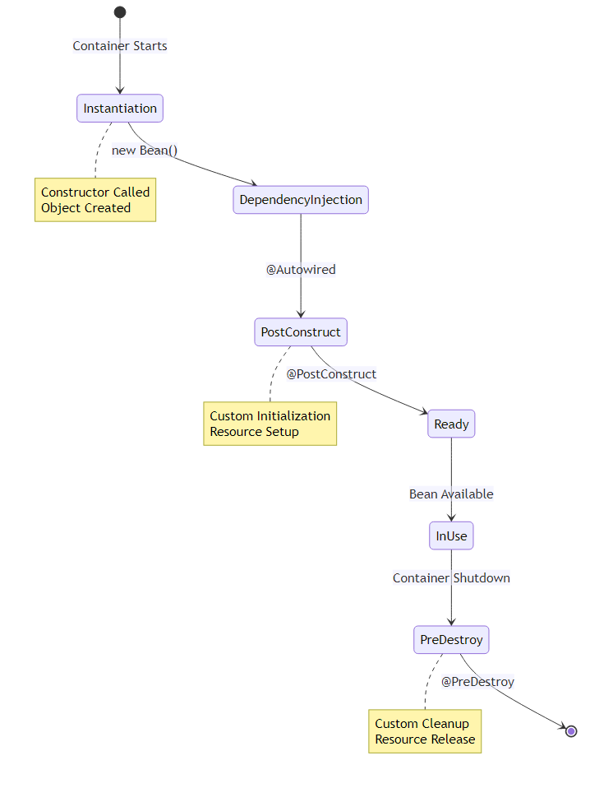

📊 Lifecycle Overview
Reference: dbConnection.java
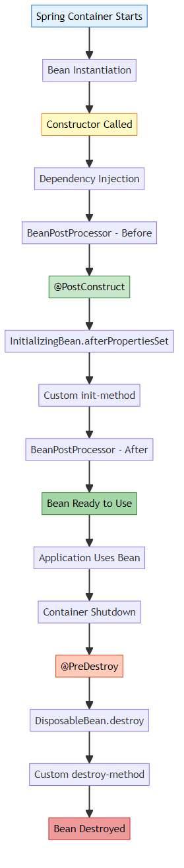

🔍 Our Project Example
Database Connection Bean:
@Component
public class dbConnection {
// 1. Constructor
public dbConnection() {
System.out.println("DB Constructor is called !!");
}
// 2. Initialization
@PostConstruct
public void init() {
System.out.println("Init Method is called !!");
}
// 3. Business Method
public void executeQuery() {
System.out.println("Query is being Executed !!");
}
// 4. Cleanup
@PreDestroy
public void destroy() {
System.out.println("Destroy method called");
}
}
Execution Output:
--- Container Starting ---
DB Constructor is called !!
Init Method is called !!
-- Using Bean --
Operation Successfully : Query is being Executed !!
SELECT * FROM students
--- Container Closing ---
Destroy method called : before Object Destruction

2. WHY BEAN LIFECYCLE MATTERS

🎯 Critical Importance
Understanding and managing bean lifecycle is essential for:

1️⃣ Resource Management
Problem Without Lifecycle Management:
public class DatabaseConnection {
private Connection connection;
public DatabaseConnection() {
// Connection opened but never closed!
connection = DriverManager.getConnection(url);
}
// ❌ Memory leak! Connection never closed
}
Solution With Lifecycle Management:
@Component
public class DatabaseConnection {
private Connection connection;
@PostConstruct
public void init() {
connection = DriverManager.getConnection(url);
}
@PreDestroy
public void cleanup() {
if (connection != null) {
connection.close(); // ✅ Properly closed
}
}
}

2️⃣ Initialization Logic
Use Cases: - Opening database connections - Loading configuration files - Establishing network connections - Initializing caches - Validating dependencies

3️⃣ Cleanup Operations
Use Cases: - Closing database connections - Releasing file handles - Shutting down thread pools - Saving application state - Flushing buffers

📊 Impact Comparison
Without Lifecycle Management | With Lifecycle Management
❌ Resource leaks | ✅ Proper cleanup
❌ Manual initialization | ✅ Automatic initialization
❌ Inconsistent state | ✅ Guaranteed initialization
❌ Memory leaks | ✅ Memory efficient
❌ Connection pool exhaustion | ✅ Connections released
❌ File handle leaks | ✅ Files properly closed

🔥 Real-World Consequences
Without Proper Lifecycle Management:
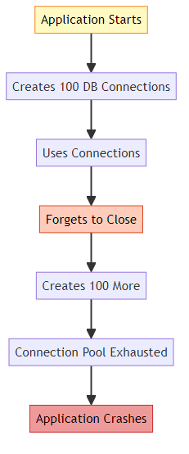
With Proper Lifecycle Management:
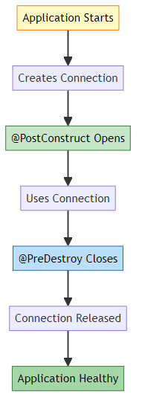

3. COMPLETE BEAN LIFECYCLE PHASES

📌 The 13 Lifecycle Phases
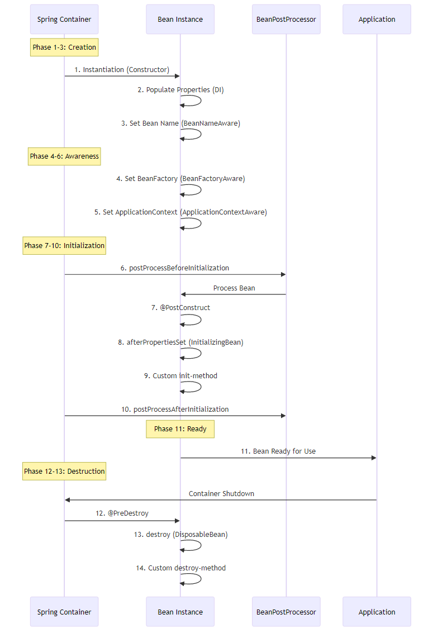

🔍 Phase-by-Phase Breakdown

Phase 1: Instantiation
What Happens: - Spring creates bean instance using constructor - Memory allocated for object - Constructor code executes
Example:
@Component
public class dbConnection {
public dbConnection() {
System.out.println("Constructor called");
// Object created, but NOT ready to use
}
}
Internal Process:
// Spring internally does:
Class<?> clazz = dbConnection.class;
Constructor<?> constructor = clazz.getConstructor();
Object instance = constructor.newInstance();

Phase 2: Dependency Injection
What Happens: - Spring injects all dependencies - @Autowired fields/setters/constructors processed - Properties populated
Example:
@Component
public class UserService {
@Autowired
private UserRepository repository; // Injected here
public UserService() {
// repository is NULL here!
}
}
Why This Matters:
@Component
public class UserService {
@Autowired
private UserRepository repository;
public UserService() {
// ❌ WRONG: repository is null
repository.findAll(); // NullPointerException!
}
@PostConstruct
public void init() {
// ✅ CORRECT: repository is injected
repository.findAll(); // Works!
}
}

Phase 3-5: Aware Interfaces (Optional)
What Happens: - Bean gets access to Spring infrastructure - Rarely used in practice
Available Aware Interfaces:
Interface | Method | Purpose
BeanNameAware | setBeanName(String) | Get bean name
BeanFactoryAware | setBeanFactory(BeanFactory) | Access BeanFactory
ApplicationContextAware | setApplicationContext(ApplicationContext) | Access ApplicationContext
ResourceLoaderAware | setResourceLoader(ResourceLoader) | Load resources
MessageSourceAware | setMessageSource(MessageSource) | i18n support
Example:
@Component
public class MyBean implements ApplicationContextAware {
private ApplicationContext context;
@Override
public void setApplicationContext(ApplicationContext context) {
this.context = context;
System.out.println("ApplicationContext injected");
}
}

Phase 6: BeanPostProcessor - Before Initialization
What Happens: - Custom processing before initialization - Can modify bean or return proxy - Applied to ALL beans
Example:
@Component
public class LoggingBeanPostProcessor implements BeanPostProcessor {
@Override
public Object postProcessBeforeInitialization(Object bean, String name) {
System.out.println("Before init: " + name);
return bean;
}
}

Phase 7: @PostConstruct ✅ (Our Project Uses This)
What Happens: - Custom initialization logic - Called after dependency injection - JSR-250 standard annotation
Reference: dbConnection.java:14-17
Example:
@Component
public class dbConnection {
@PostConstruct
public void init() {
System.out.println("Init Method is called !!");
// Open connections, load config, etc.
}
}
Why Use @PostConstruct: - Dependencies are guaranteed to be injected - Standard Java annotation (JSR-250) - Clean and simple - No Spring coupling

Phase 8: InitializingBean Interface (Alternative)
What Happens: - Spring-specific initialization - Called after @PostConstruct
Example:
@Component
public class MyBean implements InitializingBean {
@Override
public void afterPropertiesSet() throws Exception {
System.out.println("InitializingBean: afterPropertiesSet");
}
}
Comparison:
Method | Pros | Cons
@PostConstruct | Standard, no Spring coupling | Requires annotation support
InitializingBean | Type-safe, IDE support | Spring coupling
init-method (XML) | Works with any class | Only for XML config

Phase 9: Custom init-method (XML/Java Config)
What Happens: - Custom initialization via configuration
XML Example:
<bean id="myBean" class="..." init-method="customInit"/>
Java Config Example:
@Bean(initMethod = "customInit")
public MyBean myBean() {
return new MyBean();
}

Phase 10: BeanPostProcessor - After Initialization
What Happens: - Final processing after initialization - Often used for AOP proxies
Example:
@Component
public class ProxyBeanPostProcessor implements BeanPostProcessor {
@Override
public Object postProcessAfterInitialization(Object bean, String name) {
// Can return proxy here
return bean;
}
}

Phase 11: Bean Ready to Use
What Happens: - Bean is fully initialized - Ready to serve requests - Application can use it
Example:
dbConnection db = context.getBean(dbConnection.class);
db.executeQuery(); // ✅ Safe to use

Phase 12: @PreDestroy ✅ (Our Project Uses This)
What Happens: - Cleanup before destruction - Called when container shuts down - JSR-250 standard annotation
Reference: dbConnection.java:23-26
Example:
@Component
public class dbConnection {
@PreDestroy
public void destroy() {
System.out.println("Destroy method called");
// Close connections, save state, etc.
}
}

Phase 13: DisposableBean Interface (Alternative)
What Happens: - Spring-specific cleanup - Called after @PreDestroy
Example:
@Component
public class MyBean implements DisposableBean {
@Override
public void destroy() throws Exception {
System.out.println("DisposableBean: destroy");
}
}

Phase 14: Custom destroy-method
What Happens: - Custom cleanup via configuration
XML Example:
<bean id="myBean" class="..." destroy-method="customCleanup"/>
Java Config Example:
@Bean(destroyMethod = "customCleanup")
public MyBean myBean() {
return new MyBean();
}

📊 Lifecycle Methods Execution Order
Complete Example:
@Component
public class CompleteLifecycleBean implements InitializingBean, DisposableBean {
// Phase 1
public CompleteLifecycleBean() {
System.out.println("1. Constructor");
}
// Phase 7
@PostConstruct
public void postConstruct() {
System.out.println("2. @PostConstruct");
}
// Phase 8
@Override
public void afterPropertiesSet() {
System.out.println("3. InitializingBean.afterPropertiesSet");
}
// Phase 9 (if configured)
public void customInit() {
System.out.println("4. Custom init-method");
}
// Phase 12
@PreDestroy
public void preDestroy() {
System.out.println("5. @PreDestroy");
}
// Phase 13
@Override
public void destroy() {
System.out.println("6. DisposableBean.destroy");
}
// Phase 14 (if configured)
public void customDestroy() {
System.out.println("7. Custom destroy-method");
}
}
Output:
1. Constructor
2. @PostConstruct
3. InitializingBean.afterPropertiesSet
4. Custom init-method
5. @PreDestroy
6. DisposableBean.destroy
7. Custom destroy-method

4. @POSTCONSTRUCT ANNOTATION

📌 What is @PostConstruct?
@PostConstruct is a JSR-250 annotation that marks a method to be executed after dependency injection is complete. It’s the recommended way to perform initialization logic.
Package: jakarta.annotation.PostConstruct (formerly javax.annotation.PostConstruct)
Reference: dbConnection.java:14-17

🎯 Why @PostConstruct Exists
Problem: Constructor Limitations
@Component
public class UserService {
@Autowired
private UserRepository repository;
public UserService() {
// ❌ PROBLEM: repository is NULL here!
List<User> users = repository.findAll(); // NullPointerException!
}
}
Solution: @PostConstruct
@Component
public class UserService {
@Autowired
private UserRepository repository;
public UserService() {
System.out.println("Constructor: repository is " + repository);
// Output: Constructor: repository is null
}
@PostConstruct
public void init() {
System.out.println("PostConstruct: repository is " + repository);
// Output: PostConstruct: repository is UserRepository@123
// ✅ SAFE: Dependencies are injected
List<User> users = repository.findAll();
}
}

🔍 Internal Working
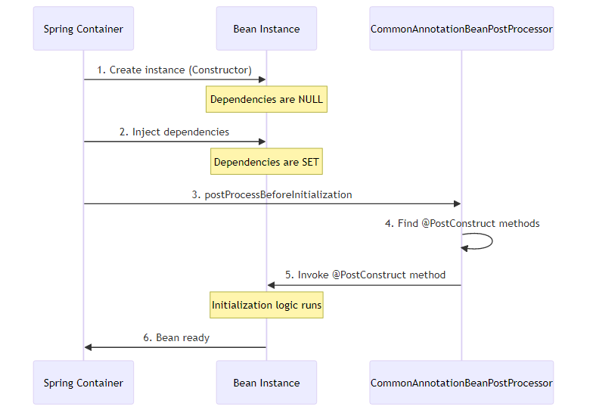
How Spring Finds @PostConstruct:
// Spring internally does:
Method[] methods = bean.getClass().getDeclaredMethods();
for (Method method : methods) {
if (method.isAnnotationPresent(PostConstruct.class)) {
method.setAccessible(true);
method.invoke(bean); // Call the method
}
}

📊 @PostConstruct Rules
Rule | Description | Example
Method Signature | Must be void return type | public void init()
Parameters | Must have no parameters | ❌ init(String param)
Access Modifier | Can be any (public, private, protected) | private void init()
Static | Must NOT be static | ❌ static void init()
Exceptions | Can throw checked exceptions | void init() throws Exception
Multiple Methods | Can have multiple @PostConstruct | ✅ Allowed
Inheritance | Inherited methods are called | Parent → Child order

🎯 Common Use Cases

1️⃣ Database Connection Initialization
Reference: dbConnection.java:14-17
@Component
public class dbConnection {
private Connection connection;
@PostConstruct
public void init() {
System.out.println("Opening database connection...");
connection = DriverManager.getConnection(url, user, password);
}
}

2️⃣ Loading Configuration
@Component
public class ConfigLoader {
private Properties config;
@PostConstruct
public void loadConfig() {
config = new Properties();
config.load(new FileInputStream("app.properties"));
System.out.println("Configuration loaded");
}
}

3️⃣ Cache Initialization
@Component
public class CacheManager {
private Map<String, Object> cache;
@PostConstruct
public void initCache() {
cache = new ConcurrentHashMap<>();
// Pre-load frequently used data
cache.put("config", loadConfig());
System.out.println("Cache initialized");
}
}

4️⃣ Validating Dependencies
@Component
public class PaymentService {
@Autowired
private PaymentGateway gateway;
@Autowired
private EmailService emailService;
@PostConstruct
public void validate() {
if (gateway == null) {
throw new IllegalStateException("PaymentGateway not configured");
}
if (emailService == null) {
throw new IllegalStateException("EmailService not configured");
}
System.out.println("All dependencies validated");
}
}

5️⃣ Starting Background Tasks
@Component
public class ScheduledTaskManager {
private ScheduledExecutorService executor;
@PostConstruct
public void startTasks() {
executor = Executors.newScheduledThreadPool(5);
executor.scheduleAtFixedRate(() -> {
System.out.println("Background task running");
}, 0, 1, TimeUnit.MINUTES);
}
}

⚠️ Common Mistakes

Mistake 1: Using Constructor Instead
@Component
public class UserService {
@Autowired
private UserRepository repository;
// ❌ WRONG: Dependencies not injected yet
public UserService() {
repository.findAll(); // NullPointerException!
}
// ✅ CORRECT: Dependencies are injected
@PostConstruct
public void init() {
repository.findAll(); // Works!
}
}

Mistake 2: Multiple @PostConstruct with Order Dependency
@Component
public class MyBean {
@PostConstruct
public void init1() {
System.out.println("Init 1");
}
@PostConstruct
public void init2() {
System.out.println("Init 2");
}
// ⚠️ WARNING: Order is NOT guaranteed!
// Output could be: Init 1, Init 2 OR Init 2, Init 1
}
Solution:
@Component
public class MyBean {
@PostConstruct
public void init() {
init1();
init2();
}
private void init1() {
System.out.println("Init 1");
}
private void init2() {
System.out.println("Init 2");
}
}

Mistake 3: Returning Value
@Component
public class MyBean {
// ❌ WRONG: @PostConstruct must return void
@PostConstruct
public String init() {
return "initialized";
}
}

Mistake 4: Static Method
@Component
public class MyBean {
// ❌ WRONG: @PostConstruct cannot be static
@PostConstruct
public static void init() {
System.out.println("Init");
}
}

🔥 Advanced: @PostConstruct with Inheritance
public class ParentBean {
@PostConstruct
public void parentInit() {
System.out.println("1. Parent @PostConstruct");
}
}
@Component
public class ChildBean extends ParentBean {
@PostConstruct
public void childInit() {
System.out.println("2. Child @PostConstruct");
}
}
Output:
1. Parent @PostConstruct
2. Child @PostConstruct
Execution Order: 1. Parent class @PostConstruct methods 2. Child class @PostConstruct methods

5. @PREDESTROY ANNOTATION

📌 What is @PreDestroy?
@PreDestroy is a JSR-250 annotation that marks a method to be executed before the bean is destroyed. It’s the recommended way to perform cleanup logic.
Package: jakarta.annotation.PreDestroy (formerly javax.annotation.PreDestroy)
Reference: dbConnection.java:23-26

🎯 Why @PreDestroy Exists
Problem: Resource Leaks
@Component
public class FileProcessor {
private FileWriter writer;
@PostConstruct
public void init() throws IOException {
writer = new FileWriter("output.txt");
}
// ❌ PROBLEM: File never closed!
// Resource leak when application shuts down
}
Solution: @PreDestroy
@Component
public class FileProcessor {
private FileWriter writer;
@PostConstruct
public void init() throws IOException {
writer = new FileWriter("output.txt");
}
@PreDestroy
public void cleanup() throws IOException {
if (writer != null) {
writer.close(); // ✅ Properly closed
System.out.println("File closed");
}
}
}

🔍 Internal Working
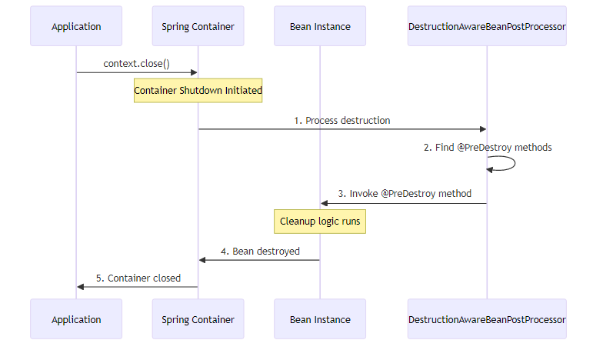
How Spring Finds @PreDestroy:
// Spring internally does:
Method[] methods = bean.getClass().getDeclaredMethods();
for (Method method : methods) {
if (method.isAnnotationPresent(PreDestroy.class)) {
method.setAccessible(true);
method.invoke(bean); // Call the method
}
}

📊 @PreDestroy Rules
Rule | Description | Example
Method Signature | Must be void return type | public void cleanup()
Parameters | Must have no parameters | ❌ cleanup(String param)
Access Modifier | Can be any | private void cleanup()
Static | Must NOT be static | ❌ static void cleanup()
Exceptions | Can throw checked exceptions | void cleanup() throws Exception
Multiple Methods | Can have multiple @PreDestroy | ✅ Allowed
Inheritance | Inherited methods are called | Child → Parent order

🎯 Common Use Cases

1️⃣ Closing Database Connections
Reference: dbConnection.java:23-26
@Component
public class dbConnection {
private Connection connection;
@PostConstruct
public void init() {
connection = DriverManager.getConnection(url);
}
@PreDestroy
public void destroy() {
if (connection != null) {
connection.close();
System.out.println("Database connection closed");
}
}
}

2️⃣ Releasing File Handles
@Component
public class LogWriter {
private BufferedWriter writer;
@PostConstruct
public void init() throws IOException {
writer = new BufferedWriter(new FileWriter("app.log"));
}
@PreDestroy
public void cleanup() throws IOException {
if (writer != null) {
writer.flush();
writer.close();
System.out.println("Log file closed");
}
}
}

3️⃣ Shutting Down Thread Pools
@Component
public class TaskExecutor {
private ExecutorService executor;
@PostConstruct
public void init() {
executor = Executors.newFixedThreadPool(10);
}
@PreDestroy
public void shutdown() {
if (executor != null) {
executor.shutdown();
try {
if (!executor.awaitTermination(60, TimeUnit.SECONDS)) {
executor.shutdownNow();
}
} catch (InterruptedException e) {
executor.shutdownNow();
}
System.out.println("Thread pool shut down");
}
}
}

4️⃣ Saving Application State
@Component
public class StateManager {
private Map<String, Object> state;
@PreDestroy
public void saveState() throws IOException {
ObjectOutputStream oos = new ObjectOutputStream(
new FileOutputStream("state.dat")
);
oos.writeObject(state);
oos.close();
System.out.println("Application state saved");
}
}

5️⃣ Closing Network Connections
@Component
public class WebSocketClient {
private WebSocket socket;
@PostConstruct
public void connect() {
socket = new WebSocket("ws://example.com");
socket.connect();
}
@PreDestroy
public void disconnect() {
if (socket != null && socket.isOpen()) {
socket.close();
System.out.println("WebSocket closed");
}
}
}

⚠️ Critical: @PreDestroy and Prototype Beans
IMPORTANT: @PreDestroy is NOT called for prototype-scoped beans!
@Component
@Scope("prototype")
public class PrototypeBean {
@PostConstruct
public void init() {
System.out.println("Init called"); // ✅ Called
}
@PreDestroy
public void cleanup() {
System.out.println("Cleanup called"); // ❌ NEVER called!
}
}
Why? - Spring creates prototype beans on demand - Spring hands them over to you - Spring doesn’t track them after creation - You are responsible for cleanup
Solution for Prototype Cleanup:
@Component
@Scope("prototype")
public class PrototypeBean implements DisposableBean {
@Override
public void destroy() {
// Manual cleanup
}
}
// Manual cleanup
PrototypeBean bean = context.getBean(PrototypeBean.class);
// Use bean
((DisposableBean) bean).destroy(); // Call manually

🔥 Advanced: @PreDestroy with Inheritance
public class ParentBean {
@PreDestroy
public void parentCleanup() {
System.out.println("2. Parent @PreDestroy");
}
}
@Component
public class ChildBean extends ParentBean {
@PreDestroy
public void childCleanup() {
System.out.println("1. Child @PreDestroy");
}
}
Output:
1. Child @PreDestroy
2. Parent @PreDestroy
Execution Order: 1. Child class @PreDestroy methods 2. Parent class @PreDestroy methods
Note: Opposite order of @PostConstruct!

6. LIFECYCLE CALLBACK METHODS

📌 Three Ways to Define Lifecycle Callbacks
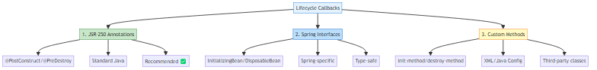

📊 Comparison Table
Method | Pros | Cons | Use When
@PostConstruct/@PreDestroy | Standard, no Spring coupling, clean | Requires annotation support | ✅ Always (recommended)
InitializingBean/DisposableBean | Type-safe, IDE support | Spring coupling | Legacy code
init-method/destroy-method | Works with any class | Only for XML/Java config | Third-party classes

1️⃣ JSR-250 Annotations (Recommended)
Example:
@Component
public class MyBean {
@PostConstruct
public void init() {
System.out.println("Initialization");
}
@PreDestroy
public void cleanup() {
System.out.println("Cleanup");
}
}
Pros: - ✅ Standard Java (JSR-250) - ✅ No Spring coupling - ✅ Clean and simple - ✅ Works with any DI framework
Cons: - ❌ Requires annotation support

2️⃣ Spring Interfaces
Example:
@Component
public class MyBean implements InitializingBean, DisposableBean {
@Override
public void afterPropertiesSet() throws Exception {
System.out.println("InitializingBean: afterPropertiesSet");
}
@Override
public void destroy() throws Exception {
System.out.println("DisposableBean: destroy");
}
}
Pros: - ✅ Type-safe - ✅ IDE support - ✅ Can throw checked exceptions
Cons: - ❌ Spring coupling - ❌ Less flexible

3️⃣ Custom Methods (XML/Java Config)
XML Configuration:
<bean id="myBean"
class="com.example.MyBean"
init-method="customInit"
destroy-method="customCleanup"/>
Java Configuration:
@Configuration
public class AppConfig {
@Bean(initMethod = "customInit", destroyMethod = "customCleanup")
public MyBean myBean() {
return new MyBean();
}
}
Bean Class:
public class MyBean {
public void customInit() {
System.out.println("Custom init");
}
public void customCleanup() {
System.out.println("Custom cleanup");
}
}
Pros: - ✅ Works with third-party classes - ✅ No Spring coupling - ✅ Method name flexibility
Cons: - ❌ Only for XML/Java config - ❌ Not visible in class

🔥 All Three Combined
@Component
public class CompleteLifecycleBean implements InitializingBean, DisposableBean {
// 1. @PostConstruct
@PostConstruct
public void postConstruct() {
System.out.println("1. @PostConstruct");
}
// 2. InitializingBean
@Override
public void afterPropertiesSet() {
System.out.println("2. InitializingBean.afterPropertiesSet");
}
// 3. Custom init-method (if configured)
public void customInit() {
System.out.println("3. Custom init-method");
}
// 4. @PreDestroy
@PreDestroy
public void preDestroy() {
System.out.println("4. @PreDestroy");
}
// 5. DisposableBean
@Override
public void destroy() {
System.out.println("5. DisposableBean.destroy");
}
// 6. Custom destroy-method (if configured)
public void customDestroy() {
System.out.println("6. Custom destroy-method");
}
}
Configuration:
@Bean(initMethod = "customInit", destroyMethod = "customDestroy")
public CompleteLifecycleBean bean() {
return new CompleteLifecycleBean();
}
Output:
1. @PostConstruct
2. InitializingBean.afterPropertiesSet
3. Custom init-method
4. @PreDestroy
5. DisposableBean.destroy
6. Custom destroy-method

7. INTERNAL WORKING MECHANISM

📌 How Spring Manages Bean Lifecycle
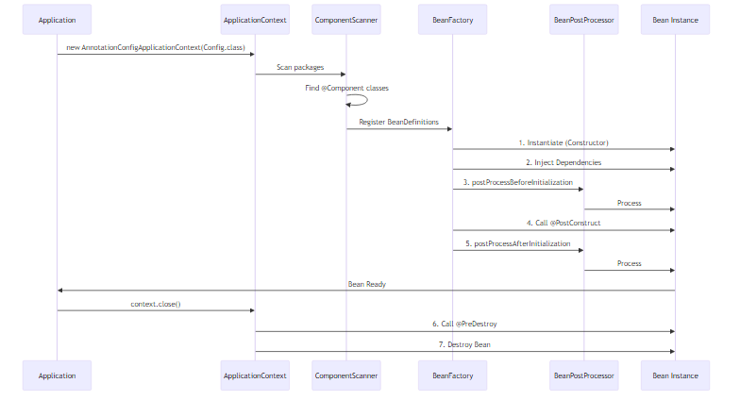

🔍 Step-by-Step Internal Process

Step 1: Component Scanning
What Happens:
// Spring internally does:
ClassPathBeanDefinitionScanner scanner = new ClassPathBeanDefinitionScanner(registry);
scanner.scan("org.example.lifecycle");
// For each .class file:
Class<?> clazz = Class.forName("org.example.lifecycle.dbConnection");
if (clazz.isAnnotationPresent(Component.class)) {
BeanDefinition bd = new GenericBeanDefinition();
bd.setBeanClass(clazz);
registry.registerBeanDefinition("dbConnection", bd);
}
Reference: lifeCycleConfig.java:9

Step 2: Bean Instantiation
What Happens:
// Spring internally does:
Class<?> clazz = dbConnection.class;
Constructor<?> constructor = clazz.getConstructor();
Object instance = constructor.newInstance();
// Output: "DB Constructor is called !!"
Reference: dbConnection.java:10-12

Step 3: Dependency Injection
What Happens:
// Spring internally does:
Field[] fields = instance.getClass().getDeclaredFields();
for (Field field : fields) {
if (field.isAnnotationPresent(Autowired.class)) {
Object dependency = getBean(field.getType());
field.setAccessible(true);
field.set(instance, dependency);
}
}

Step 4: BeanPostProcessor - Before Initialization
What Happens:
// Spring internally does:
for (BeanPostProcessor processor : beanPostProcessors) {
instance = processor.postProcessBeforeInitialization(instance, beanName);
}
CommonAnnotationBeanPostProcessor handles @PostConstruct:
public Object postProcessBeforeInitialization(Object bean, String beanName) {
Method[] methods = bean.getClass().getDeclaredMethods();
for (Method method : methods) {
if (method.isAnnotationPresent(PostConstruct.class)) {
method.setAccessible(true);
method.invoke(bean);
}
}
return bean;
}

Step 5: @PostConstruct Invocation
What Happens:
// Spring finds and calls @PostConstruct method
Method initMethod = dbConnection.class.getDeclaredMethod("init");
initMethod.invoke(instance);
// Output: "Init Method is called !!"
Reference: dbConnection.java:14-17

Step 6: Bean Ready to Use
What Happens:
// Bean is stored in ApplicationContext
singletonObjects.put("dbConnection", instance);
// Application can now use it
dbConnection bean = context.getBean(dbConnection.class);
bean.executeQuery();
Reference: App.java:17-18

Step 7: Container Shutdown
What Happens:
// Application calls close
context.close();
// Spring triggers shutdown hooks
Runtime.getRuntime().addShutdownHook(new Thread(() -> {
destroyBeans();
}));
Reference: App.java:21

Step 8: @PreDestroy Invocation
What Happens:
// Spring finds and calls @PreDestroy method
Method destroyMethod = dbConnection.class.getDeclaredMethod("destroy");
destroyMethod.invoke(instance);
// Output: "Destroy method called : before Object Destruction"
Reference: dbConnection.java:23-26

🔥 Reflection Mechanism
How Spring Uses Reflection:
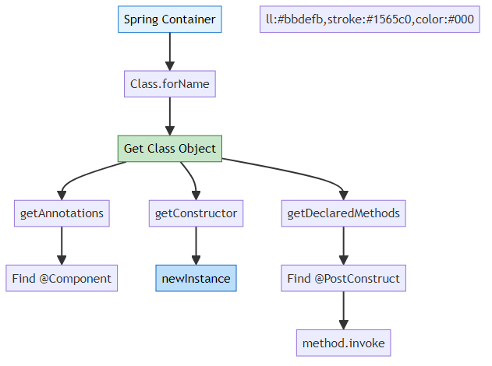
Complete Reflection Example:
// 1. Load class
Class<?> clazz = Class.forName("org.example.lifecycle.dbConnection");
// 2. Check for @Component
if (clazz.isAnnotationPresent(Component.class)) {
// 3. Create instance
Constructor<?> constructor = clazz.getConstructor();
Object instance = constructor.newInstance();
// 4. Find @PostConstruct methods
for (Method method : clazz.getDeclaredMethods()) {
if (method.isAnnotationPresent(PostConstruct.class)) {
method.setAccessible(true);
method.invoke(instance);
}
}
}

8. LIFECYCLE WITH DIFFERENT SCOPES

📌 Bean Scopes Overview
Scope | Lifecycle | @PostConstruct | @PreDestroy | Use Case
Singleton | One per container | ✅ Called | ✅ Called | Default, shared state
Prototype | New per request | ✅ Called | ❌ NOT called | Stateful beans
Request | One per HTTP request | ✅ Called | ✅ Called | Web apps
Session | One per HTTP session | ✅ Called | ✅ Called | User sessions
Application | One per ServletContext | ✅ Called | ✅ Called | Web apps

🎯 Singleton Scope (Default)
Reference: dbConnection.java
@Component // Default scope is singleton
public class dbConnection {
@PostConstruct
public void init() {
System.out.println("Init called");
}
@PreDestroy
public void destroy() {
System.out.println("Destroy called");
}
}
Behavior: - One instance per Spring container - @PostConstruct called once - @PreDestroy called on shutdown - Shared across all requests
Output:
Init called
... application runs ...
Destroy called

🎯 Prototype Scope
@Component
@Scope("prototype")
public class PrototypeBean {
@PostConstruct
public void init() {
System.out.println("Init called");
}
@PreDestroy
public void destroy() {
System.out.println("Destroy called"); // ❌ NEVER called!
}
}
Behavior: - New instance per getBean() call - @PostConstruct called for each instance - @PreDestroy NOT called (Spring doesn’t track) - Client responsible for cleanup
Output:
Bean 1: Init called
Bean 2: Init called
Bean 3: Init called
... application shuts down ...
(No destroy calls!)
Why @PreDestroy Not Called:
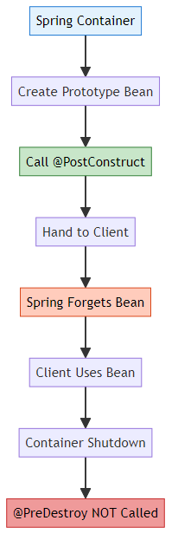

9. PROJECT STRUCTURE & IMPLEMENTATION

📁 Complete Project Structure
BeanLifeCycle/
├── src/
│ └── main/
│ └── java/
│ └── org/
│ └── example/
│ └── lifecycle/
│ ├── App.java # Main application
│ ├── lifeCycleConfig.java # Configuration
│ └── dbConnection.java # Bean with lifecycle
├── pom.xml # Maven dependencies
└── README.md # This file

📄 File-by-File Implementation

1️⃣ pom.xml - Maven Configuration
Purpose: Define project dependencies and build configuration
<?xml version="1.0" encoding="UTF-8"?>
<project xmlns="http://maven.apache.org/POM/4.0.0"
xmlns:xsi="http://www.w3.org/2001/XMLSchema-instance"
xsi:schemaLocation="http://maven.apache.org/POM/4.0.0
http://maven.apache.org/xsd/maven-4.0.0.xsd">
<modelVersion>4.0.0</modelVersion>
<groupId>org.example</groupId>
<artifactId>BeanLifeCycle</artifactId>
<version>1.0-SNAPSHOT</version>
<properties>
<maven.compiler.source>21</maven.compiler.source>
<maven.compiler.target>21</maven.compiler.target>
<project.build.sourceEncoding>UTF-8</project.build.sourceEncoding>
</properties>
<dependencies>
<!-- Spring Context -->
<dependency>
<groupId>org.springframework</groupId>
<artifactId>spring-context</artifactId>
<version>7.0.3</version>
</dependency>
</dependencies>
</project>

2️⃣ lifeCycleConfig.java - Spring Configuration
Reference: lifeCycleConfig.java
package org.example.lifecycle;
import org.springframework.context.annotation.ComponentScan;
import org.springframework.context.annotation.Configuration;
@Configuration
@ComponentScan(basePackages = "org.example.lifecycle")
public class lifeCycleConfig {
// Configuration class for component scanning
}
Explanation: - @Configuration: Marks this as a configuration class - @ComponentScan: Tells Spring to scan for @Component classes - basePackages: Specifies package to scan

3️⃣ dbConnection.java - Bean with Lifecycle
Reference: dbConnection.java
package org.example.lifecycle;
import jakarta.annotation.PostConstruct;
import jakarta.annotation.PreDestroy;
import org.springframework.stereotype.Component;
@Component
public class dbConnection {
public dbConnection() {
System.out.println("DB Constructor is called !!");
}
@PostConstruct
public void init() {
System.out.println("Init Method is called !!");
}
public void executeQuery() {
System.out.println("Query is being Executed !!");
}
@PreDestroy
public void destroy() {
System.out.println("Destroy method called : before Object Destruction");
}
}
Explanation: - @Component: Marks class as Spring-managed bean - Constructor: Called when bean is instantiated - @PostConstruct: Called after dependencies injected - executeQuery(): Business method - @PreDestroy: Called before bean destruction

4️⃣ App.java - Main Application
Reference: App.java
package org.example.lifecycle;
import org.springframework.context.annotation.AnnotationConfigApplicationContext;
public class App {
public static void main(String[] args) {
System.out.println("--- Container Starting ---");
AnnotationConfigApplicationContext context =
new AnnotationConfigApplicationContext(lifeCycleConfig.class);
System.out.println("\n-- Using Bean --");
dbConnection db = context.getBean(dbConnection.class);
System.out.print("Operation Successfully : ");
db.executeQuery();
System.out.println("SELECT * FROM students");
System.out.println("\n--- Container Closing ---");
context.close();
}
}
Explanation: - Creates Spring ApplicationContext - Retrieves bean from container - Uses bean’s business method - Closes container (triggers @PreDestroy)

10. EXECUTION FLOW ANALYSIS

📊 Complete Execution Flow
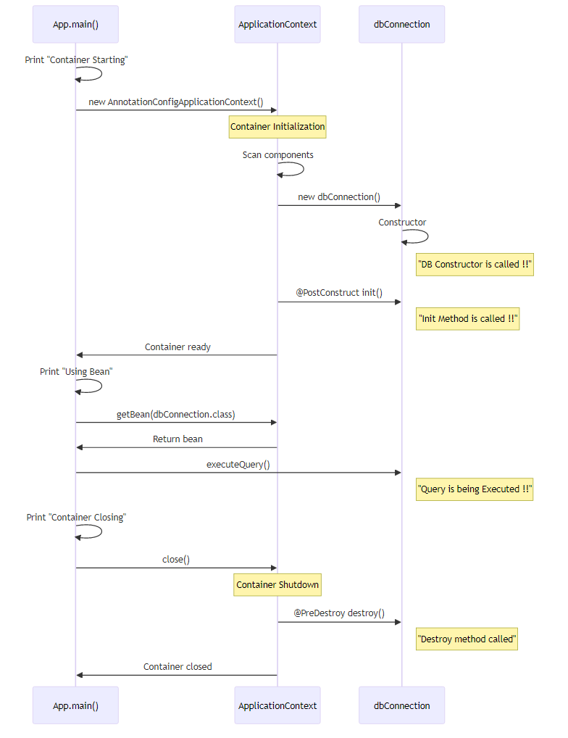

🖥️ Console Output
--- Container Starting ---
DB Constructor is called !!
Init Method is called !!
-- Using Bean --
Operation Successfully : Query is being Executed !!
SELECT * FROM students
--- Container Closing ---
Destroy method called : before Object Destruction

🔍 Step-by-Step Breakdown
Step 1: Container Starting
System.out.println("--- Container Starting ---");
Output: --- Container Starting ---
Step 2: Create ApplicationContext
AnnotationConfigApplicationContext context =
new AnnotationConfigApplicationContext(lifeCycleConfig.class);
- Spring scans org.example.lifecycle package
- Finds dbConnection class with @Component
- Creates BeanDefinition
Step 3: Bean Instantiation
public dbConnection() {
System.out.println("DB Constructor is called !!");
}
Output: DB Constructor is called !!
Step 4: @PostConstruct Initialization
@PostConstruct
public void init() {
System.out.println("Init Method is called !!");
}
Output: Init Method is called !!
Step 5: Bean Ready - Application Uses It
System.out.println("\n-- Using Bean --");
dbConnection db = context.getBean(dbConnection.class);
db.executeQuery();
Output:
-- Using Bean --
Operation Successfully : Query is being Executed !!
SELECT * FROM students
Step 6: Container Shutdown
System.out.println("\n--- Container Closing ---");
context.close();
Output: --- Container Closing ---
Step 7: @PreDestroy Cleanup
@PreDestroy
public void destroy() {
System.out.println("Destroy method called : before Object Destruction");
}
Output: Destroy method called : before Object Destruction

11. REAL-WORLD EXAMPLES

🎯 Example 1: Database Connection Pool
@Component
public class DatabaseConnectionPool {
private HikariDataSource dataSource;
@PostConstruct
public void initializePool() {
HikariConfig config = new HikariConfig();
config.setJdbcUrl("jdbc:mysql://localhost:3306/mydb");
config.setUsername("root");
config.setPassword("password");
config.setMaximumPoolSize(10);
dataSource = new HikariDataSource(config);
System.out.println("Connection pool initialized with 10 connections");
}
public Connection getConnection() throws SQLException {
return dataSource.getConnection();
}
@PreDestroy
public void closePool() {
if (dataSource != null && !dataSource.isClosed()) {
dataSource.close();
System.out.println("Connection pool closed, all connections released");
}
}
}
Benefits: - Pool initialized once at startup - Connections reused efficiently - Proper cleanup on shutdown - No connection leaks

🎯 Example 2: Cache Manager
@Component
public class CacheManager {
private Map<String, Object> cache;
private ScheduledExecutorService scheduler;
@PostConstruct
public void initializeCache() {
cache = new ConcurrentHashMap<>();
// Pre-load frequently accessed data
cache.put("config", loadConfiguration());
cache.put("users", loadActiveUsers());
// Schedule cache refresh every 5 minutes
scheduler = Executors.newScheduledThreadPool(1);
scheduler.scheduleAtFixedRate(
this::refreshCache,
5, 5, TimeUnit.MINUTES
);
System.out.println("Cache initialized and refresh scheduled");
}
private void refreshCache() {
System.out.println("Refreshing cache...");
cache.put("config", loadConfiguration());
}
@PreDestroy
public void cleanup() {
if (scheduler != null) {
scheduler.shutdown();
try {
if (!scheduler.awaitTermination(60, TimeUnit.SECONDS)) {
scheduler.shutdownNow();
}
} catch (InterruptedException e) {
scheduler.shutdownNow();
}
}
cache.clear();
System.out.println("Cache cleared and scheduler stopped");
}
}

🎯 Example 3: File Upload Service
@Component
public class FileUploadService {
private Path uploadDirectory;
private ExecutorService uploadExecutor;
@PostConstruct
public void initialize() throws IOException {
// Create upload directory
uploadDirectory = Paths.get("uploads");
if (!Files.exists(uploadDirectory)) {
Files.createDirectories(uploadDirectory);
}
// Initialize thread pool for async uploads
uploadExecutor = Executors.newFixedThreadPool(5);
System.out.println("Upload service initialized: " + uploadDirectory);
}
public void uploadFile(MultipartFile file) {
uploadExecutor.submit(() -> {
try {
Path targetPath = uploadDirectory.resolve(file.getOriginalFilename());
Files.copy(file.getInputStream(), targetPath);
System.out.println("File uploaded: " + file.getOriginalFilename());
} catch (IOException e) {
e.printStackTrace();
}
});
}
@PreDestroy
public void cleanup() {
if (uploadExecutor != null) {
uploadExecutor.shutdown();
try {
if (!uploadExecutor.awaitTermination(30, TimeUnit.SECONDS)) {
uploadExecutor.shutdownNow();
}
} catch (InterruptedException e) {
uploadExecutor.shutdownNow();
}
}
System.out.println("Upload service shut down, pending uploads completed");
}
}

🎯 Example 4: Email Service with SMTP Connection
@Component
public class EmailService {
private Session mailSession;
private Transport transport;
@Value("${mail.smtp.host}")
private String smtpHost;
@Value("${mail.smtp.port}")
private int smtpPort;
@PostConstruct
public void connectToSMTP() throws MessagingException {
Properties props = new Properties();
props.put("mail.smtp.host", smtpHost);
props.put("mail.smtp.port", smtpPort);
props.put("mail.smtp.auth", "true");
mailSession = Session.getInstance(props);
transport = mailSession.getTransport("smtp");
transport.connect();
System.out.println("Connected to SMTP server: " + smtpHost);
}
public void sendEmail(String to, String subject, String body) throws MessagingException {
MimeMessage message = new MimeMessage(mailSession);
message.setRecipient(Message.RecipientType.TO, new InternetAddress(to));
message.setSubject(subject);
message.setText(body);
transport.sendMessage(message, message.getAllRecipients());
}
@PreDestroy
public void disconnectFromSMTP() throws MessagingException {
if (transport != null && transport.isConnected()) {
transport.close();
System.out.println("Disconnected from SMTP server");
}
}
}

🎯 Example 5: Metrics Collector
@Component
public class MetricsCollector {
private Map<String, AtomicLong> metrics;
private ScheduledExecutorService reporter;
@PostConstruct
public void startCollecting() {
metrics = new ConcurrentHashMap<>();
// Initialize common metrics
metrics.put("requests", new AtomicLong(0));
metrics.put("errors", new AtomicLong(0));
metrics.put("latency", new AtomicLong(0));
// Schedule metrics reporting every minute
reporter = Executors.newScheduledThreadPool(1);
reporter.scheduleAtFixedRate(
this::reportMetrics,
1, 1, TimeUnit.MINUTES
);
System.out.println("Metrics collection started");
}
public void incrementMetric(String name) {
metrics.computeIfAbsent(name, k -> new AtomicLong(0)).incrementAndGet();
}
private void reportMetrics() {
System.out.println("=== Metrics Report ===");
metrics.forEach((name, value) ->
System.out.println(name + ": " + value.get())
);
}
@PreDestroy
public void stopCollecting() {
// Final report before shutdown
reportMetrics();
if (reporter != null) {
reporter.shutdown();
}
System.out.println("Metrics collection stopped");
}
}

12. BEST PRACTICES

✅ DO’s

1. Use @PostConstruct for Initialization
@Component
public class MyService {
@Autowired
private Repository repository;
// ✅ GOOD: Use @PostConstruct
@PostConstruct
public void init() {
// Dependencies are guaranteed to be injected
repository.loadData();
}
}

2. Always Clean Up Resources
@Component
public class ResourceManager {
private Connection connection;
@PostConstruct
public void open() {
connection = openConnection();
}
// ✅ GOOD: Always clean up
@PreDestroy
public void close() {
if (connection != null) {
connection.close();
}
}
}

3. Handle Exceptions Properly
@Component
public class DatabaseService {
@PostConstruct
public void init() {
try {
// Initialization logic
connectToDatabase();
} catch (Exception e) {
// ✅ GOOD: Log and handle
System.err.println("Failed to initialize: " + e.getMessage());
throw new RuntimeException("Initialization failed", e);
}
}
}

4. Keep Lifecycle Methods Simple
@Component
public class MyBean {
// ✅ GOOD: Simple and focused
@PostConstruct
public void init() {
loadConfiguration();
validateDependencies();
initializeCache();
}
private void loadConfiguration() { /* ... */ }
private void validateDependencies() { /* ... */ }
private void initializeCache() { /* ... */ }
}

5. Use Meaningful Method Names
@Component
public class ConnectionPool {
// ✅ GOOD: Clear method names
@PostConstruct
public void initializeConnectionPool() { }
@PreDestroy
public void closeAllConnections() { }
}

❌ DON’Ts

1. Don’t Use Constructor for Dependency-Dependent Logic
@Component
public class UserService {
@Autowired
private UserRepository repository;
// ❌ BAD: Dependencies not injected yet
public UserService() {
repository.findAll(); // NullPointerException!
}
}

2. Don’t Forget Null Checks in @PreDestroy
@Component
public class FileService {
private FileWriter writer;
@PreDestroy
public void cleanup() {
// ❌ BAD: No null check
writer.close(); // NullPointerException if init failed!
// ✅ GOOD: Always check
if (writer != null) {
writer.close();
}
}
}

3. Don’t Rely on @PreDestroy for Prototype Beans
@Component
@Scope("prototype")
public class PrototypeBean {
// ❌ BAD: This will never be called!
@PreDestroy
public void cleanup() {
System.out.println("Never executed");
}
}

4. Don’t Make Lifecycle Methods Static
@Component
public class MyBean {
// ❌ BAD: Cannot be static
@PostConstruct
public static void init() { }
}

5. Don’t Return Values from Lifecycle Methods
@Component
public class MyBean {
// ❌ BAD: Must return void
@PostConstruct
public String init() {
return "initialized";
}
}

🎯 Performance Tips

1. Lazy Initialization for Heavy Resources
@Component
public class HeavyService {
private ExpensiveResource resource;
// Don't initialize in @PostConstruct if not always needed
public ExpensiveResource getResource() {
if (resource == null) {
resource = new ExpensiveResource();
}
return resource;
}
}

2. Async Initialization for Non-Critical Resources
@Component
public class CacheService {
@Autowired
private ApplicationEventPublisher eventPublisher;
@PostConstruct
public void init() {
// Critical initialization
initializeCache();
// Non-critical async initialization
CompletableFuture.runAsync(this::preloadData);
}
}

3. Batch Operations in Lifecycle Methods
@Component
public class DataLoader {
@PostConstruct
public void loadData() {
// ✅ GOOD: Batch load
List<Data> allData = repository.findAll();
cache.putAll(allData);
// ❌ BAD: Individual loads
// for (Data d : allData) {
// cache.put(d.getId(), d);
// }
}
}

13. COMMON PITFALLS

⚠️ Pitfall 1: Using Dependencies in Constructor
Problem:
@Component
public class UserService {
@Autowired
private UserRepository repository;
public UserService() {
// ❌ repository is NULL here!
List<User> users = repository.findAll();
}
}
Solution:
@Component
public class UserService {
@Autowired
private UserRepository repository;
@PostConstruct
public void init() {
// ✅ repository is injected
List<User> users = repository.findAll();
}
}

⚠️ Pitfall 2: Forgetting to Close Resources
Problem:
@Component
public class FileProcessor {
private FileWriter writer;
@PostConstruct
public void init() throws IOException {
writer = new FileWriter("output.txt");
}
// ❌ No @PreDestroy - resource leak!
}
Solution:
@Component
public class FileProcessor {
private FileWriter writer;
@PostConstruct
public void init() throws IOException {
writer = new FileWriter("output.txt");
}
@PreDestroy
public void cleanup() throws IOException {
if (writer != null) {
writer.close();
}
}
}

⚠️ Pitfall 3: Expecting @PreDestroy on Prototype Beans
Problem:
@Component
@Scope("prototype")
public class PrototypeBean {
@PreDestroy
public void cleanup() {
// ❌ This will NEVER be called!
System.out.println("Cleanup");
}
}
Solution:
@Component
@Scope("prototype")
public class PrototypeBean implements DisposableBean {
@Override
public void destroy() {
cleanup();
}
private void cleanup() {
System.out.println("Cleanup");
}
}
// Manual cleanup required
PrototypeBean bean = context.getBean(PrototypeBean.class);
// Use bean
((DisposableBean) bean).destroy(); // Call manually

⚠️ Pitfall 4: Circular Dependencies with @PostConstruct
Problem:
@Component
public class ServiceA {
@Autowired
private ServiceB serviceB;
@PostConstruct
public void init() {
serviceB.doSomething(); // May fail with circular dependency
}
}
@Component
public class ServiceB {
@Autowired
private ServiceA serviceA;
@PostConstruct
public void init() {
serviceA.doSomething(); // Circular dependency!
}
}
Solution:
@Component
public class ServiceA {
@Autowired
@Lazy
private ServiceB serviceB;
@PostConstruct
public void init() {
// Use @Lazy to break circular dependency
}
}

⚠️ Pitfall 5: Long-Running Operations in Lifecycle Methods
Problem:
@Component
public class DataLoader {
@PostConstruct
public void loadData() {
// ❌ Blocks application startup!
for (int i = 0; i < 1000000; i++) {
processData(i);
}
}
}
Solution:
@Component
public class DataLoader {
@PostConstruct
public void init() {
// ✅ Async loading
CompletableFuture.runAsync(this::loadData);
}
private void loadData() {
for (int i = 0; i < 1000000; i++) {
processData(i);
}
}
}

14. TOP INTERVIEW QUESTIONS

📝 Basic Questions
Q1: What is Bean Lifecycle in Spring?
Answer: Bean lifecycle refers to the complete journey of a Spring bean from creation to destruction. It includes instantiation, dependency injection, initialization (@PostConstruct), usage, and cleanup (@PreDestroy). Spring IoC container manages this entire lifecycle.
Q2: What is the difference between @PostConstruct and Constructor?
Answer: - Constructor is called during object instantiation, before dependency injection - @PostConstruct is called after dependency injection is complete - In constructor, @Autowired fields are NULL - In @PostConstruct, all dependencies are guaranteed to be injected
Q3: What are the lifecycle callback methods in Spring?
Answer: 1. @PostConstruct / InitializingBean.afterPropertiesSet() / init-method 2. @PreDestroy / DisposableBean.destroy() / destroy-method
Q4: When is @PreDestroy called?
Answer: @PreDestroy is called when: - ApplicationContext is closed (context.close()) - Application shuts down - Bean is removed from container - NOT called for prototype-scoped beans
Q5: What is the execution order of lifecycle methods?
Answer: 1. Constructor 2. Dependency Injection 3. @PostConstruct 4. InitializingBean.afterPropertiesSet() 5. Custom init-method 6. Bean ready to use 7. @PreDestroy 8. DisposableBean.destroy() 9. Custom destroy-method

📝 Intermediate Questions
Q6: Why is @PreDestroy not called for prototype beans?
Answer: Spring creates prototype beans on demand and hands them to the client. Spring doesn’t track prototype beans after creation, so it cannot call @PreDestroy when the container shuts down. The client is responsible for cleanup.
Q7: Can we have multiple @PostConstruct methods?
Answer: Yes, but the execution order is not guaranteed. It’s better to have a single @PostConstruct method that calls other initialization methods in a specific order.
Q8: What happens if @PostConstruct throws an exception?
Answer: If @PostConstruct throws an exception: - Bean creation fails - Bean is not added to the container - Application startup may fail (for singleton beans) - Exception propagates to the caller
Q9: Difference between @PostConstruct and InitializingBean?
Answer: | @PostConstruct | InitializingBean | |:—————|:—————–| | JSR-250 standard | Spring-specific | | No Spring coupling | Requires Spring interface | | Called first | Called after @PostConstruct | | Recommended | Legacy approach |
Q10: Can lifecycle methods be private?
Answer: Yes, @PostConstruct and @PreDestroy methods can be private, protected, or public. Spring uses reflection to invoke them regardless of access modifier.

📝 Advanced Questions
Q11: How does Spring internally find @PostConstruct methods?
Answer: Spring uses CommonAnnotationBeanPostProcessor which: 1. Scans all methods using reflection 2. Checks for @PostConstruct annotation 3. Invokes the method using method.invoke() 4. Handles this in postProcessBeforeInitialization phase
Q12: What is BeanPostProcessor and how does it relate to lifecycle?
Answer: BeanPostProcessor is an interface that allows custom modification of beans. It has two methods: - postProcessBeforeInitialization: Called before @PostConstruct - postProcessAfterInitialization: Called after initialization Used for AOP proxies, validation, etc.
Q13: How to handle cleanup for prototype beans?
Answer:
// Option 1: Manual cleanup
@Component
@Scope("prototype")
public class PrototypeBean implements DisposableBean {
@Override
public void destroy() {
// Cleanup logic
}
}
// Usage
PrototypeBean bean = context.getBean(PrototypeBean.class);
// Use bean
((DisposableBean) bean).destroy(); // Manual call
// Option 2: Custom scope with destruction callback
// Option 3: Use try-with-resources pattern
Q14: Can we control the order of bean initialization?
Answer: Yes, using: 1. @DependsOn annotation 2. @Order annotation (for collections) 3. Implement Ordered interface 4. Constructor injection (implicit ordering)
Example:
@Component
@DependsOn("databaseService")
public class UserService {
// Initialized after databaseService
}
Q15: What happens to lifecycle methods in bean inheritance?
Answer: - @PostConstruct: Parent methods called first, then child - @PreDestroy: Child methods called first, then parent - Both parent and child methods are executed - Can override parent methods to prevent execution
Q16: How to handle async initialization?
Answer:
@Component
public class AsyncService {
@Autowired
private ApplicationEventPublisher eventPublisher;
@PostConstruct
public void init() {
// Critical sync initialization
initializeCriticalResources();
// Non-critical async initialization
CompletableFuture.runAsync(() -> {
loadHeavyData();
eventPublisher.publishEvent(new InitializationCompleteEvent());
});
}
}
Q17: Difference between destroy-method=“close” and @PreDestroy?
Answer: | destroy-method | @PreDestroy | |:—————|:————| | XML/Java Config | Annotation-based | | Works with any method name | Method must be annotated | | Called last | Called first | | Good for third-party classes | Good for your classes |
Q18: How does Spring handle exceptions in @PreDestroy?
Answer: - Exceptions are logged but not propagated - Container continues shutting down - Other beans’ @PreDestroy methods are still called - Best practice: Catch and log exceptions in @PreDestroy
@PreDestroy
public void cleanup() {
try {
// Cleanup logic
} catch (Exception e) {
System.err.println("Cleanup failed: " + e.getMessage());
// Don't rethrow
}
}
Q19: Can we access ApplicationContext in @PostConstruct?
Answer: Yes, implement ApplicationContextAware:
@Component
public class MyBean implements ApplicationContextAware {
private ApplicationContext context;
@Override
public void setApplicationContext(ApplicationContext context) {
this.context = context;
}
@PostConstruct
public void init() {
// Can use context here
SomeBean bean = context.getBean(SomeBean.class);
}
}
Q20: What is the impact of @Lazy on lifecycle?
Answer: - @Lazy beans are not created at startup - Constructor and @PostConstruct are called on first access - @PreDestroy is still called on shutdown - Useful for heavy beans not always needed
@Component
@Lazy
public class HeavyService {
@PostConstruct
public void init() {
// Called only when first accessed, not at startup
}
}

🎓 Summary
This guide covered Spring Bean Lifecycle management comprehensively:
- Bean lifecycle phases from creation to destruction
- @PostConstruct for initialization after dependency injection
- @PreDestroy for cleanup before bean destruction
- Different callback methods and their execution order
- Lifecycle behavior with different bean scopes
- Real-world examples and best practices
- Common pitfalls and how to avoid them
- Interview questions with detailed answers
Key Takeaways: 1. Always use @PostConstruct for initialization logic that depends on injected dependencies 2. Always implement @PreDestroy to clean up resources 3. Remember @PreDestroy is NOT called for prototype beans 4. Keep lifecycle methods simple and focused 5. Handle exceptions properly in lifecycle methods

🌟 Happy Learning! 🌟

Made with ❤️ by Avinash Dhanuka
If you found this helpful, please ⭐ star the repository!

© 2026 Avinash Dhanuka. All rights reserved.

