☕ Spring Framework: Real-World Case Studies - Complete Guide

© 2026 Avinash Dhanuka
Master Guide: Spring Framework Real-World Applications
Crafted with ❤️ for Practical Spring Mastery

Learning Note: This comprehensive guide demonstrates three real-world Spring applications showcasing advanced Dependency Injection patterns, @Primary/@Qualifier resolution, @Lazy initialization, Bean Scopes, and Lifecycle management. Master production-ready Spring patterns through practical examples.
Prerequisites: - Understanding of Spring IoC Container - Knowledge of Dependency Injection fundamentals - Familiarity with @Component, @Autowired, @Configuration - Bean Lifecycle and Scopes concepts

📑 Table of Contents
- Overview
- Case Studies Summary
- Case Study 1: Bank Loan Approval
- Case Study 2: Food Delivery System
- Case Study 3: Payment Processing
- Core Concepts Deep Dive
- @Primary vs @Qualifier
- @Lazy Initialization
- Bean Scopes
- Bean Lifecycle
- Dependency Injection Patterns
- Internal Working Mechanisms
- Execution Flow Analysis
- Real-World Applications
- Best Practices
- Common Pitfalls
- Interview Questions

1. OVERVIEW

📝 Author: Avinash Dhanuka | GitHub

📌 What Are These Case Studies?
These three production-ready Spring applications demonstrate how advanced Spring concepts work together in real-world scenarios. Each case study solves a specific business problem while showcasing different Spring features.

🎯 Learning Objectives
- ✅ Master @Primary and @Qualifier for dependency resolution
- ✅ Understand @Lazy initialization for performance optimization
- ✅ Apply Singleton and Prototype scopes correctly
- ✅ Implement Bean Lifecycle with @PostConstruct and @PreDestroy
- ✅ Use Constructor and Setter injection appropriately
- ✅ Resolve ambiguity when multiple beans exist
- ✅ Build production-ready Spring applications

📊 Case Studies Architecture

🔍 Why These Case Studies Matter
Real-World Relevance: - Bank Loan Approval → Financial services, validation systems - Food Delivery → E-commerce, notification systems, order processing - Payment Processing → Payment gateways, transaction management
Spring Concepts Demonstrated: - Dependency resolution with multiple implementations - Performance optimization with lazy loading - Resource management with scopes - Lifecycle management for cleanup

2. CASE STUDIES SUMMARY

📦 Projects Overview Table
Case Study | Domain | Key Concepts | Complexity | Lines of Code
BankLoanApproval | Finance | @Qualifier, Prototype, @Lazy, Setter DI | ⭐⭐⭐ | ~150
FoodDelivery | E-Commerce | @Primary, @Qualifier, @Lazy, Lifecycle | ⭐⭐⭐⭐ | ~200
PaymentProcessing | FinTech | @Primary+@Lazy, Prototype, Multiple @Qualifier | ⭐⭐⭐⭐ | ~180

🎯 Concepts Comparison Matrix
Concept | BankLoanApproval | FoodDelivery | PaymentProcessing
@Primary | ✅ CreditScoreValidator | ✅ EmailNotification | ✅ CreditCardPayment
@Qualifier | ✅ incomeValidator | ✅ smsNotification | ✅ upiPayment + creditCardPayment
@Lazy | ✅ AuditService | ✅ SmsNotification | ✅ CreditCardPayment
Singleton | ✅ LoanService | ✅ DeliveryService | ✅ TransactionLogger
Prototype | ✅ IncomeValidator | ❌ | ✅ UpiPayment
@PostConstruct | ✅ AuditService | ✅ DeliveryService | ✅ TransactionLogger
@PreDestroy | ✅ AuditService | ✅ DeliveryService | ✅ TransactionLogger
Constructor DI | ✅ LoanService | ✅ OrderService | ✅ PaymentProcessor
Setter DI | ✅ LoanService | ✅ RestaurantService | ❌

📊 Dependency Resolution Flow
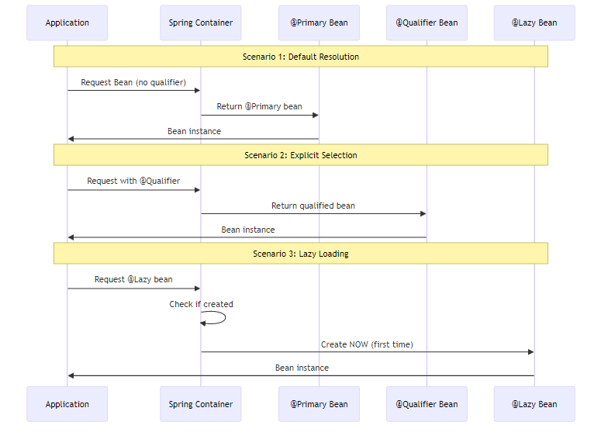

3. CASE STUDY 1: BANK LOAN APPROVAL

📌 Business Problem
A bank needs a loan approval system that can validate loan applications using different validation strategies: - Income-based validation (check applicant’s income) - Credit score validation (check credit history)
The system must be flexible to switch validators and audit all loan requests.

🎯 Spring Concepts Demonstrated
- @Qualifier - Explicitly select IncomeValidator over CreditScoreValidator
- @Primary - CreditScoreValidator as default validator
- Prototype Scope - New IncomeValidator instance per request
- @Lazy - AuditService loaded only when needed
- Setter Injection - AuditService injected via setter
- Constructor Injection - LoanValidator injected via constructor
- @PostConstruct/@PreDestroy - AuditService lifecycle management

📊 Architecture Diagram
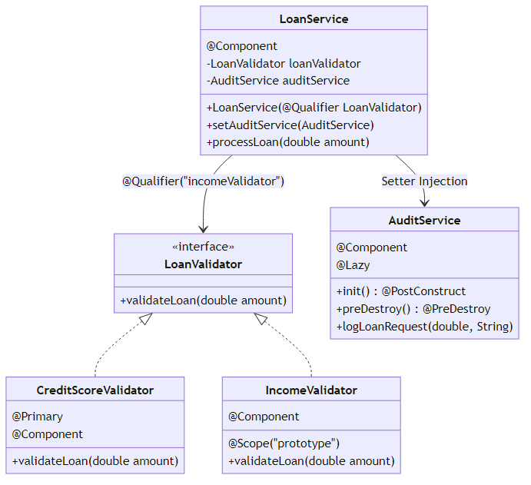

🔍 Component Breakdown

1. LoanValidator Interface
public interface LoanValidator {
void validateLoan(double amount);
}
Purpose: Contract for different validation strategies

2. CreditScoreValidator (@Primary)
@Component
@Primary
public class CreditScoreValidator implements LoanValidator {
@Override
public void validateLoan(double amount) {
System.out.println("CreditScoreValidator: Checking credit score for loan of $" + amount);
}
}
Key Points: - Marked with @Primary → Default validator - Singleton scope (default) - Used when no @Qualifier specified

3. IncomeValidator (Prototype)
@Component
@Scope("prototype")
public class IncomeValidator implements LoanValidator {
@Override
public void validateLoan(double amount) {
System.out.println("IncomeValidator: Checking income for loan of $" + amount);
}
}
Key Points: - Prototype scope → New instance per request - Must use @Qualifier to inject - Useful for stateful validators

4. AuditService (@Lazy)
@Component
@Lazy
public class AuditService {
@PostConstruct
public void init() {
System.out.println("AuditService initialized");
}
@PreDestroy
public void preDestroy() {
System.out.println("AuditService destroyed");
}
public void logLoanRequest(double amount, String validator) {
System.out.println("AUDIT: Loan request for $" + amount + " using " + validator);
}
}
Key Points: - @Lazy → Created only when first used - @PostConstruct → Initialization logic - @PreDestroy → Cleanup logic - Injected via setter (optional dependency)

5. LoanService (Main Service)
@Component
public class LoanService {
private final LoanValidator loanValidator;
private AuditService auditService;
// Constructor Injection with @Qualifier
@Autowired
public LoanService(@Qualifier("incomeValidator") LoanValidator loanValidator) {
this.loanValidator = loanValidator;
System.out.println("LoanService created with " + loanValidator.getClass().getSimpleName());
}
// Setter Injection
@Autowired
public void setAuditService(AuditService auditService) {
this.auditService = auditService;
}
public void processLoan(double amount) {
System.out.println("LoanService: Processing loan application");
auditService.logLoanRequest(amount, loanValidator.getClass().getSimpleName());
loanValidator.validateLoan(amount);
System.out.println("LoanService: Loan approved");
}
}
Key Points: - @Qualifier(“incomeValidator”) → Overrides @Primary - Constructor injection for required dependency - Setter injection for optional dependency - Final field for immutability

📊 Execution Flow
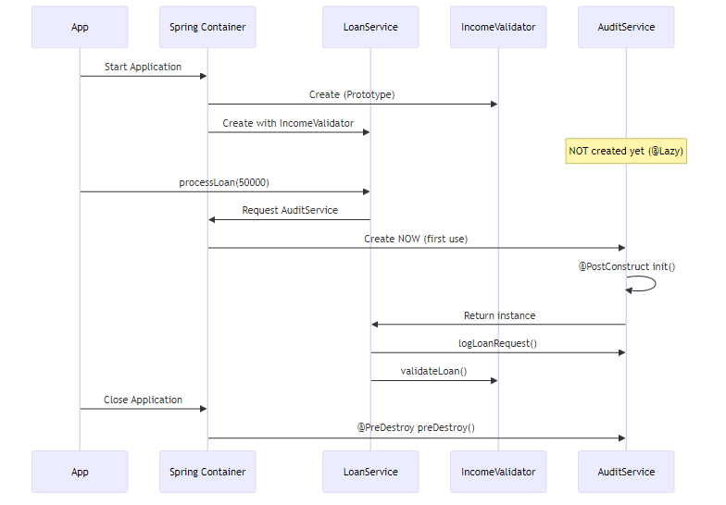

🎯 Why This Design?
@Qualifier Usage: - Bank wants to use IncomeValidator specifically - Overrides the @Primary CreditScoreValidator - Explicit selection for business requirements
Prototype Scope for IncomeValidator: - Each loan application gets fresh validator - Prevents state pollution between requests - Useful if validator maintains state
@Lazy for AuditService: - Audit might not be needed in all scenarios - Saves startup time - Created only when loan processing starts
Setter Injection for AuditService: - Audit is optional feature - Can be null without breaking LoanService - Allows runtime configuration

📈 Output Example
LoanService created with IncomeValidator
--- Using IncomeValidator (via @Qualifier) ---
LoanService: Processing loan application
AuditService initialized
AUDIT: Loan request for $50000.0 using IncomeValidator
IncomeValidator: Checking income for loan of $50000.0
LoanService: Loan approved
--- Using CreditScoreValidator (via @Primary) ---
CreditScoreValidator: Checking credit score for loan of $75000.0
Application closed
AuditService destroyed

4. CASE STUDY 2: FOOD DELIVERY SYSTEM

📌 Business Problem
An online food delivery platform needs a notification system that can send order updates via: - Email (default, most reliable) - SMS (optional, for urgent notifications)
The system must handle order processing, restaurant coordination, and delivery tracking with proper lifecycle management.

🎯 Spring Concepts Demonstrated
- @Primary - EmailNotification as default notification method
- @Qualifier - OrderService explicitly uses SMS
- @Lazy - SmsNotification loaded only when needed
- Singleton Scope - DeliveryService shared across application
- @PostConstruct/@PreDestroy - DeliveryService lifecycle
- Constructor Injection - NotificationService in OrderService
- Setter Injection - DeliveryService in RestaurantService
- Multiple Bean Resolution - Different services use different notifications

📊 Architecture Diagram
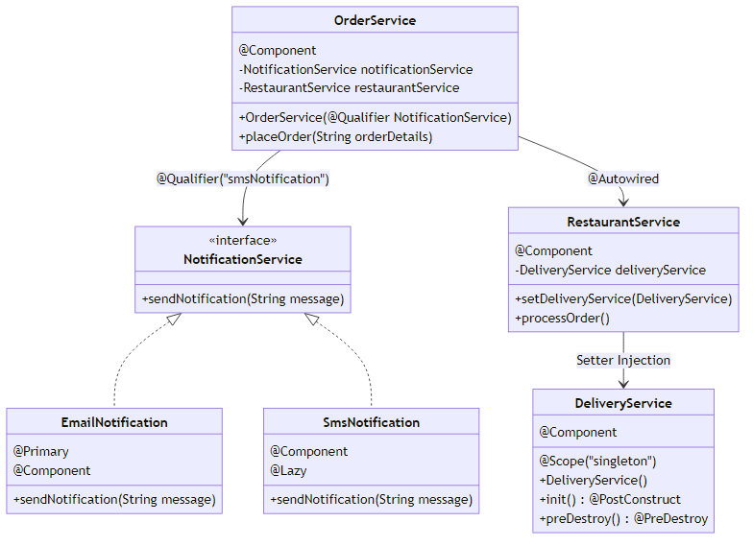

🔍 Component Breakdown

1. NotificationService Interface
public interface NotificationService {
void sendNotification(String message);
}
Purpose: Contract for different notification channels

2. EmailNotification (@Primary)
@Primary
@Component
public class EmailNotification implements NotificationService {
{
System.out.println("Non-Static Block : Email Service is launching !!");
}
@Override
public void sendNotification(String message) {
System.out.println("📧 EMAIL: " + message);
}
}
Key Points: - @Primary → Default notification method - Non-static initialization block - Most reliable notification channel - Used when no @Qualifier specified

3. SmsNotification (@Lazy)
@Component
@Lazy
public class SmsNotification implements NotificationService {
static {
System.out.println("Static Block : SMS Service is launching !!");
}
@Override
public void sendNotification(String message) {
System.out.println("📱 SMS: " + message);
}
}
Key Points: - @Lazy → Created only when requested - Static initialization block - Expensive SMS gateway connection - Used with @Qualifier for explicit selection

4. DeliveryService (Singleton with Lifecycle)
@Component
@Scope("singleton")
public class DeliveryService {
public DeliveryService() {
System.out.println("-- Delivery Service Activated --");
}
@PostConstruct
public void init() {
System.out.println("Init Method: Delivery Service Ready");
}
@PreDestroy
public void preDestroy() {
System.out.println("Delivery Service Closed");
}
}
Key Points: - Singleton scope → One instance for entire application - @PostConstruct → Initialize delivery tracking - @PreDestroy → Cleanup delivery resources - Shared across all orders

5. RestaurantService (Setter Injection)
@Component
public class RestaurantService {
private DeliveryService deliveryService;
@Autowired
public void setDeliveryService(DeliveryService deliveryService) {
this.deliveryService = deliveryService;
System.out.println("-- Setter Injection: DeliveryService injected into RestaurantService --");
}
public void processOrder() {
System.out.println("Restaurant is processing the order...");
}
}
Key Points: - Setter injection for DeliveryService - Optional dependency pattern - Allows runtime configuration

6. OrderService (Constructor Injection with @Qualifier)
@Component
public class OrderService {
private final NotificationService notificationService;
@Autowired
private RestaurantService restaurantService;
public OrderService(@Qualifier("smsNotification") NotificationService notificationService) {
this.notificationService = notificationService;
System.out.println("-- Constructor Injection: NotificationService injected into OrderService --");
}
public void placeOrder(String orderDetails) {
System.out.println("\n=== Placing Order ===");
restaurantService.processOrder();
notificationService.sendNotification("Order placed: " + orderDetails);
System.out.println("=== Order Completed ===\n");
}
}
Key Points: - @Qualifier(“smsNotification”) → Overrides @Primary - Constructor injection for required dependency - Field injection for RestaurantService - Immutable notificationService with final

📊 Execution Flow
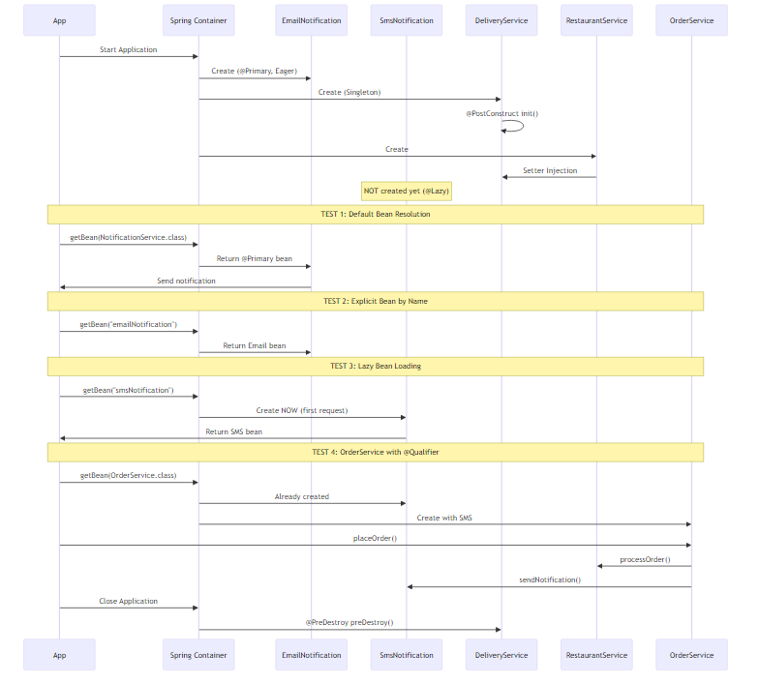

🎯 Why This Design?
@Primary for EmailNotification: - Email is the most reliable notification method - Default choice for most services - Fallback when no specific channel requested
@Qualifier in OrderService: - Orders need immediate SMS notification - Overrides @Primary for urgent updates - Business requirement for real-time alerts
@Lazy for SmsNotification: - SMS gateway connection is expensive - Not all services need SMS - Created only when OrderService is used
Singleton for DeliveryService: - Shared delivery tracking across all orders - Single point of coordination - Resource efficiency
Lifecycle Management: - @PostConstruct → Initialize delivery tracking system - @PreDestroy → Close delivery connections, save state

📈 Output Example
--- Online Food Delivery System ----
Non-Static Block : Email Service is launching !!
-- Delivery Service Activated --
Init Method: Delivery Service Ready
-- Setter Injection: DeliveryService injected into RestaurantService --
TEST 1: Default Bean Resolution (@Primary)
📧 EMAIL: Testing default notification (should be Email)
TEST 2: Explicit Bean Resolution by Name
📧 EMAIL: Explicitly requesting Email notification
TEST 3: @Lazy Bean Resolution
Requesting SMS Notification (Lazy-loaded)...
Static Block : SMS Service is launching !!
📱 SMS: SMS notification loaded lazily
TEST 4: OrderService with @Qualifier Override
OrderService uses @Qualifier("smsNotification") to override @Primary
-- Constructor Injection: NotificationService injected into OrderService --
=== Placing Order ===
Restaurant is processing the order...
📱 SMS: Order placed: Pizza Margherita x2, Coke x1
=== Order Completed ===
Closing Application Context...
Delivery Service Closed
Application Shutdown Complete!

5. CASE STUDY 3: PAYMENT PROCESSING

📌 Business Problem
A payment gateway needs to support multiple payment methods: - Credit Card (default, most common) - UPI (popular in India, fast processing)
The system must log all transactions, support multiple payment methods simultaneously, and manage resources efficiently.

🎯 Spring Concepts Demonstrated
- @Primary + @Lazy - CreditCardPayment as default but lazy-loaded
- Prototype Scope - New UpiPayment instance per transaction
- Multiple @Qualifier - PaymentProcessor uses both payment methods
- @PostConstruct/@PreDestroy - TransactionLogger lifecycle
- Constructor Injection - Multiple dependencies with @Qualifier
- Field Injection - TransactionLogger injected via field
- Combining Annotations - @Primary, @Lazy, @Qualifier together

📊 Architecture Diagram
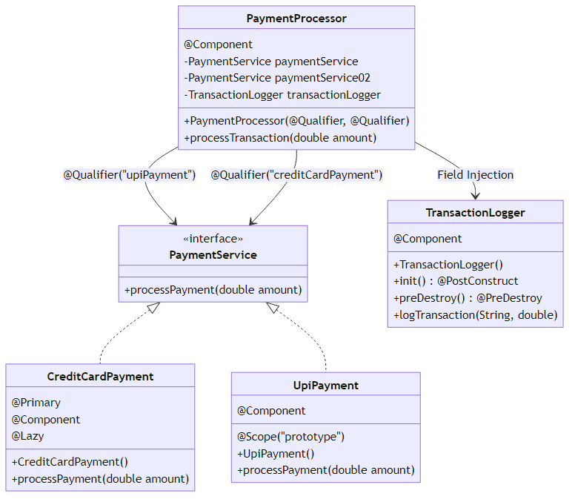

🔍 Component Breakdown

1. PaymentService Interface
public interface PaymentService {
void processPayment(double amount);
}
Purpose: Contract for different payment methods

2. CreditCardPayment (@Primary + @Lazy)
@Primary
@Component
@Lazy
public class CreditCardPayment implements PaymentService {
public CreditCardPayment() {
System.out.println("CreditCardPayment bean created (Lazy)");
}
@Override
public void processPayment(double amount) {
System.out.println("Processing Credit Card payment of $" + amount);
}
}
Key Points: - @Primary → Default payment method - @Lazy → Created only when used - Singleton scope (default) - Expensive credit card gateway initialization

3. UpiPayment (Prototype)
@Component
@Scope("prototype")
public class UpiPayment implements PaymentService {
public UpiPayment() {
System.out.println("UpiPayment bean created (Prototype)");
}
@Override
public void processPayment(double amount) {
System.out.println("Processing UPI payment of " + amount);
}
}
Key Points: - Prototype scope → New instance per request - Fresh instance for each transaction - Prevents transaction state mixing - Must use @Qualifier to inject

4. TransactionLogger (Lifecycle Management)
@Component
public class TransactionLogger {
public TransactionLogger() {
System.out.println("TransactionLogger bean created");
}
@PostConstruct
public void init() {
System.out.println("Logger initialized");
}
@PreDestroy
public void preDestroy() {
System.out.println("Logger destroyed");
}
public void logTransaction(String paymentType, double amount) {
System.out.println("Transaction logged: " + paymentType + " - " + amount);
}
}
Key Points: - Singleton scope → One logger for all transactions - @PostConstruct → Open log file, initialize database connection - @PreDestroy → Flush logs, close connections - Shared resource management

5. PaymentProcessor (Multiple @Qualifier)
@Component
public class PaymentProcessor {
private final PaymentService paymentService;
private final PaymentService paymentService02;
@Autowired
private TransactionLogger transactionLogger;
// Constructor injection with multiple @Qualifier
public PaymentProcessor(
@Qualifier("upiPayment") PaymentService paymentService,
@Qualifier("creditCardPayment") PaymentService paymentService02) {
this.paymentService02 = paymentService02;
this.paymentService = paymentService;
System.out.println("PaymentProcessor bean created");
}
public void processTransaction(double amount) {
System.out.println("\n--- Processing ---");
paymentService.processPayment(amount);
transactionLogger.logTransaction("UPI", amount);
System.out.println("--- Transaction Complete ---\n");
}
}
Key Points: - Two PaymentService dependencies with different @Qualifier - Constructor injection for payment services - Field injection for TransactionLogger - Can switch between payment methods dynamically

📊 Execution Flow
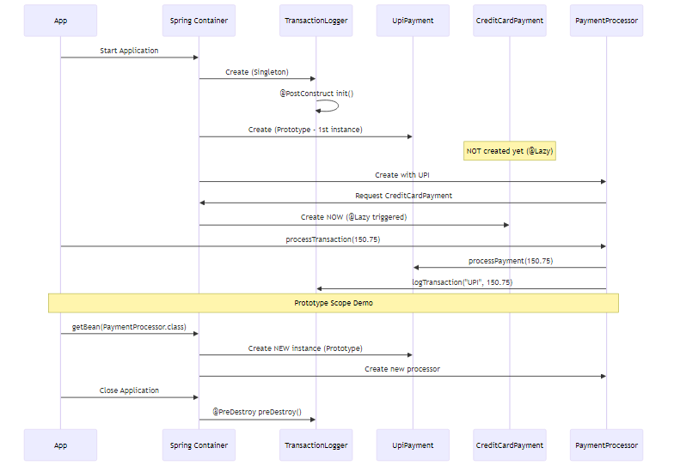

🎯 Why This Design?
@Primary + @Lazy for CreditCardPayment: - Credit card is most common payment method - But expensive gateway initialization - Created only when actually used - Combines default selection with performance optimization
Prototype for UpiPayment: - Each transaction needs fresh payment instance - Prevents transaction state leakage - Stateful payment processing - New instance = clean state
Multiple @Qualifier in PaymentProcessor: - System supports multiple payment methods - Can process different payment types - Flexibility to switch at runtime - Demonstrates complex dependency resolution
Singleton for TransactionLogger: - Centralized logging for all transactions - Shared resource (log file, database) - Lifecycle management for cleanup - Resource efficiency

📈 Output Example
=== Starting Payment Processing System ===
TransactionLogger bean created
Logger initialized
UpiPayment bean created (Prototype)
CreditCardPayment bean created (Lazy)
PaymentProcessor bean created
--- Processing ---
Processing UPI payment of 150.75
Transaction logged: UPI - 150.75
--- Transaction Complete ---
=== Demonstrating Prototype Scope ===
UpiPayment bean created (Prototype)
PaymentProcessor bean created
--- Processing ---
Processing UPI payment of 200.0
Transaction logged: UPI - 200.0
--- Transaction Complete ---
=== Shutting Down ===
Logger destroyed
=== Application Terminated ===

6. CORE CONCEPTS DEEP DIVE

📌 Spring Dependency Injection Fundamentals
What is Dependency Injection?
Dependency Injection is a design pattern where objects receive their dependencies from external sources rather than creating them internally. Spring IoC Container manages this process automatically.
Traditional Approach (Without DI):
public class OrderService {
private NotificationService notificationService;
public OrderService() {
// ❌ Tight coupling - creates dependency internally
this.notificationService = new EmailNotification();
}
}
Problems: - Tight coupling between classes - Hard to test (can’t mock dependencies) - Difficult to change implementation - Violates Single Responsibility Principle
Spring DI Approach:
@Component
public class OrderService {
private final NotificationService notificationService;
// ✅ Loose coupling - dependency injected
@Autowired
public OrderService(NotificationService notificationService) {
this.notificationService = notificationService;
}
}
Benefits: - Loose coupling - Easy to test (inject mocks) - Flexible implementation switching - Follows SOLID principles

🎯 How Spring Resolves Dependencies
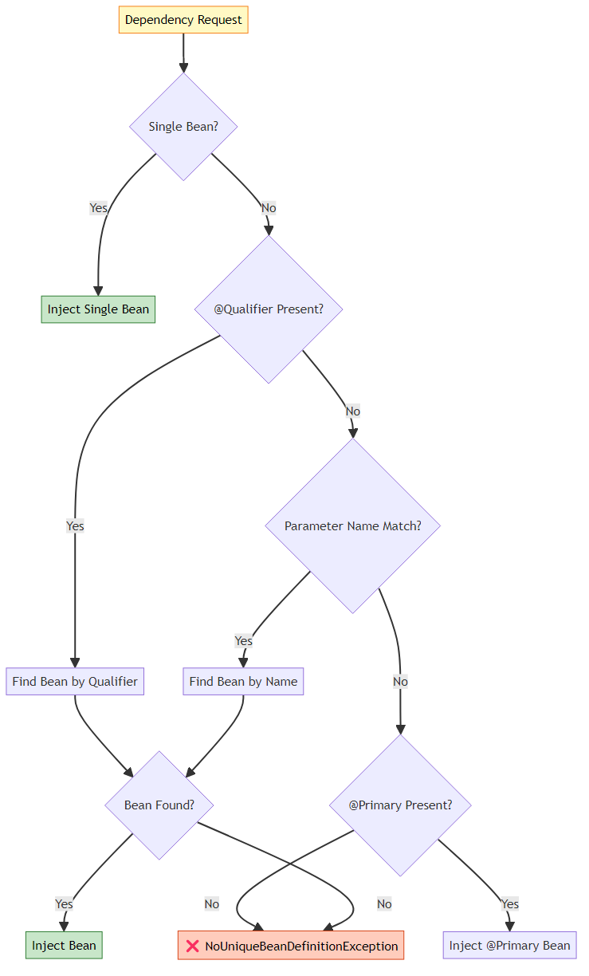

📊 Resolution Priority Table
Priority | Mechanism | Example | Overrides
1 (Highest) | @Qualifier | @Qualifier("smsNotification") | Everything
2 | Parameter Name | NotificationService emailNotification | @Primary, Single
3 | @Primary | @Primary @Component | Single Bean
4 (Lowest) | Single Bean | Only one implementation | Nothing

7. @PRIMARY VS @QUALIFIER

📌 What is @Primary?
@Primary marks a bean as the default choice when multiple beans of the same type exist. It’s a fallback mechanism when no explicit selection is made.
When Spring Uses @Primary: - No @Qualifier specified - Parameter name doesn’t match any bean - Multiple beans of same type exist
Example from FoodDelivery:
@Primary
@Component
public class EmailNotification implements NotificationService {
// This is the DEFAULT notification method
}
@Component
public class SmsNotification implements NotificationService {
// Alternative notification method
}
// Usage
@Component
public class SomeService {
private final NotificationService service;
// Gets EmailNotification (marked with @Primary)
public SomeService(NotificationService service) {
this.service = service;
}
}

📌 What is @Qualifier?
@Qualifier explicitly selects a specific bean by name. It overrides @Primary and provides precise control over dependency resolution.
When to Use @Qualifier: - Need specific implementation - Override @Primary selection - Multiple beans of same type - Explicit business requirement
Example from BankLoanApproval:
@Component
@Primary
public class CreditScoreValidator implements LoanValidator {
// Default validator
}
@Component
public class IncomeValidator implements LoanValidator {
// Alternative validator
}
// Usage
@Component
public class LoanService {
private final LoanValidator validator;
// Gets IncomeValidator (overrides @Primary)
public LoanService(@Qualifier("incomeValidator") LoanValidator validator) {
this.validator = validator;
}
}

🎯 @Primary vs @Qualifier Comparison
Aspect | @Primary | @Qualifier
Purpose | Default selection | Explicit selection
Priority | Lower (fallback) | Higher (overrides)
Usage | On bean definition | On injection point
Count | Only ONE per type | Multiple allowed
Flexibility | Less flexible | More flexible
Use Case | Common default | Specific requirement
Overrides | Single bean only | Everything

📊 Resolution Scenarios
Scenario 1: No @Qualifier, @Primary Exists
@Primary
@Component
class EmailNotification implements NotificationService { }
@Component
class SmsNotification implements NotificationService { }
@Component
class MyService {
// Gets EmailNotification (@Primary)
public MyService(NotificationService service) { }
}
Scenario 2: @Qualifier Overrides @Primary
@Primary
@Component
class EmailNotification implements NotificationService { }
@Component
class SmsNotification implements NotificationService { }
@Component
class MyService {
// Gets SmsNotification (@Qualifier overrides @Primary)
public MyService(@Qualifier("smsNotification") NotificationService service) { }
}
Scenario 3: Parameter Name Matching
@Primary
@Component
class EmailNotification implements NotificationService { }
@Component
class SmsNotification implements NotificationService { }
@Component
class MyService {
// Gets SmsNotification (parameter name matches bean name)
public MyService(NotificationService smsNotification) { }
}
Scenario 4: Multiple @Primary (ERROR)
@Primary
@Component
class EmailNotification implements NotificationService { }
@Primary // ❌ ERROR: Only ONE @Primary allowed per type
@Component
class SmsNotification implements NotificationService { }

🔍 Internal Working
How Spring Processes @Primary:
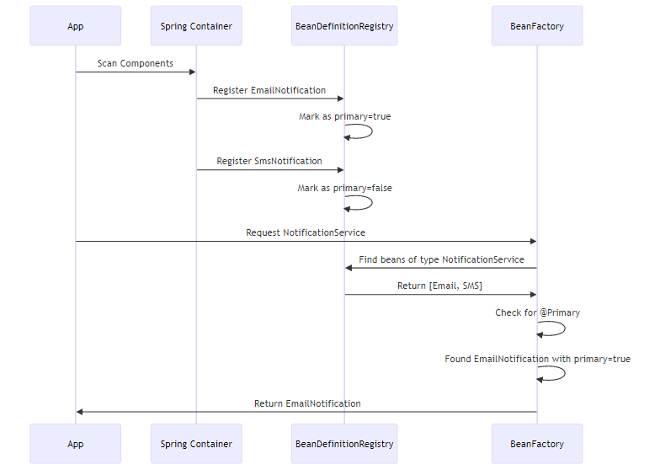
How Spring Processes @Qualifier:
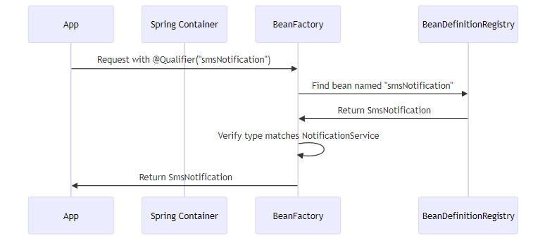

🎯 Best Practices
Use @Primary When: - ✅ One implementation is clearly the default - ✅ Most services should use this implementation - ✅ Fallback behavior is desired - ✅ Simplify configuration for common case
Use @Qualifier When: - ✅ Need specific implementation - ✅ Business logic requires particular bean - ✅ Override default behavior - ✅ Multiple beans needed in same class
Avoid: - ❌ Multiple @Primary for same type - ❌ @Qualifier without clear reason - ❌ Overusing @Qualifier (consider separate interfaces) - ❌ Mixing @Primary with unclear naming

8. @LAZY INITIALIZATION

📌 What is @Lazy?
@Lazy tells Spring to delay bean creation until it’s first requested, rather than creating it at application startup. This is a performance optimization technique.
Default Behavior (Eager):
@Component
public class EmailService {
public EmailService() {
System.out.println("EmailService created at startup");
}
}
// Output at startup: "EmailService created at startup"
With @Lazy:
@Component
@Lazy
public class SmsService {
public SmsService() {
System.out.println("SmsService created on first use");
}
}
// No output at startup
// Output when first used: "SmsService created on first use"

🎯 Why @Lazy Exists
Problem: Slow Application Startup
Imagine an application with 100 beans, each taking 1 second to initialize: - Without @Lazy: 100 seconds startup time - With @Lazy (50% lazy): 50 seconds startup time - User waits less, application feels faster
Real-World Example from Case Studies:
AuditService in BankLoanApproval:
@Component
@Lazy
public class AuditService {
@PostConstruct
public void init() {
// Expensive: Connect to audit database
// Load audit configuration
// Initialize audit logger
System.out.println("AuditService initialized");
}
}
Why Lazy? - Audit might not be needed immediately - Expensive database connection - Not all loan operations require audit - Faster application startup
SmsNotification in FoodDelivery:
@Component
@Lazy
public class SmsNotification implements NotificationService {
static {
// Expensive: Connect to SMS gateway
// Load SMS templates
// Initialize SMS client
System.out.println("SMS Service is launching !!");
}
}
Why Lazy? - SMS gateway connection is expensive - Not all orders need SMS notification - Email is default (@Primary) - SMS used only for urgent orders
CreditCardPayment in PaymentProcessing:
@Primary
@Component
@Lazy
public class CreditCardPayment implements PaymentService {
public CreditCardPayment() {
// Expensive: Connect to payment gateway
// Load encryption keys
// Initialize payment processor
System.out.println("CreditCardPayment bean created (Lazy)");
}
}
Why Lazy? - Payment gateway initialization is expensive - Not all application features need payment - Created only when payment is processed - Combines @Primary (default) with @Lazy (performance)

📊 Eager vs Lazy Comparison
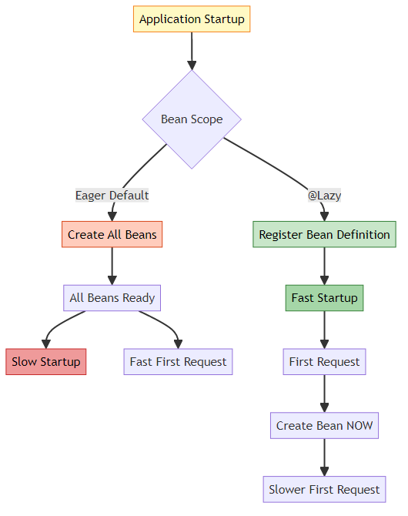
Aspect | Eager (Default) | @Lazy
Creation Time | Application startup | First use
Startup Speed | ❌ Slower | ✅ Faster
First Request | ✅ Fast | ❌ Slower
Memory Usage | ❌ Higher (all beans) | ✅ Lower (only used)
Error Detection | ✅ Immediate | ❌ Delayed
Use Case | Always-used beans | Rarely-used beans

🔍 Internal Working
Lazy Bean Creation Process:
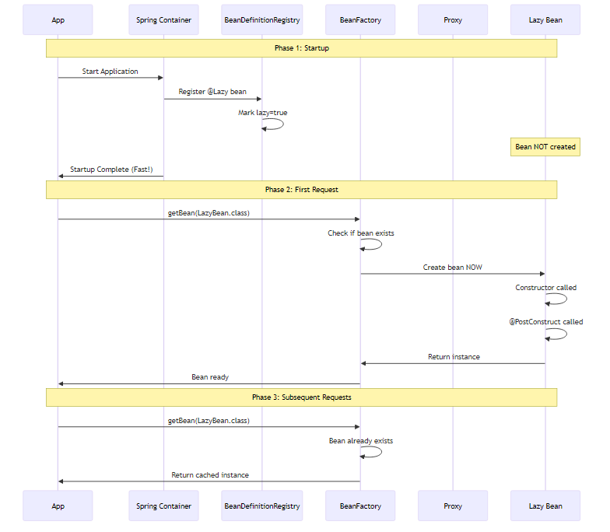
Lazy with Dependency Injection (Proxy Pattern):
When @Lazy bean is injected into another bean, Spring creates a proxy:
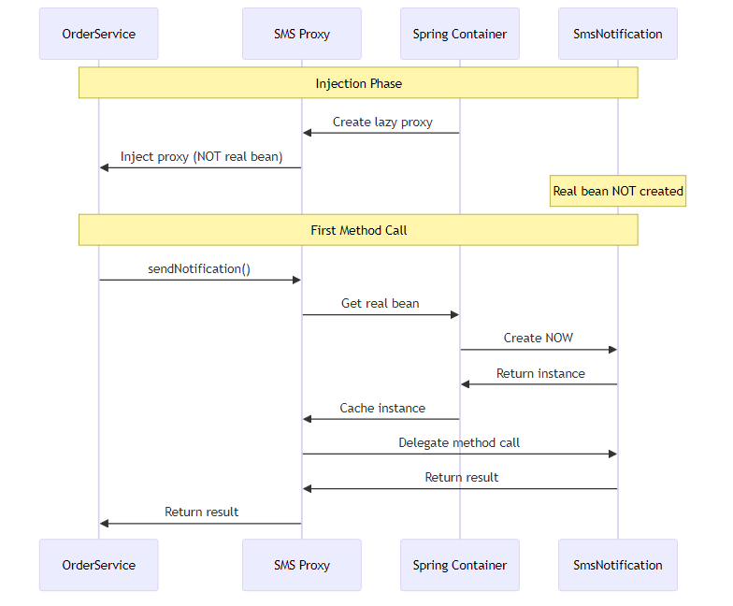

🎯 When to Use @Lazy
Use @Lazy When: - ✅ Bean initialization is expensive (database, network) - ✅ Bean is rarely used - ✅ Want faster application startup - ✅ Optional features that may not be needed - ✅ Breaking circular dependencies
Avoid @Lazy When: - ❌ Bean is always used - ❌ Want fail-fast behavior - ❌ Initialization is quick - ❌ Need predictable performance

📈 Performance Impact
Example: E-Commerce Application
Without @Lazy:
Startup Time: 30 seconds
- EmailService: 2s
- SmsService: 3s
- PaymentGateway: 5s
- ReportGenerator: 8s
- DataExporter: 7s
- Other services: 5s
First Request: 10ms
With @Lazy (50% lazy):
Startup Time: 12 seconds
- EmailService: 2s (eager - always used)
- PaymentGateway: 5s (eager - critical)
- Other services: 5s
First Request: 25ms (creates lazy beans)
- SmsService: 3s (lazy - rarely used)
- ReportGenerator: 8s (lazy - admin only)
- DataExporter: 7s (lazy - admin only)
User Experience: 60% faster startup!

9. BEAN SCOPES

📌 What are Bean Scopes?
Bean Scope defines the lifecycle and visibility of a bean instance. It determines how many instances Spring creates and when they’re created/destroyed.

🎯 Available Scopes
Scope | Instances | Lifecycle | Use Case
Singleton | 1 per container | Container lifetime | Stateless services
Prototype | New per request | Until garbage collected | Stateful objects
Request | 1 per HTTP request | Request lifetime | Web - Request data
Session | 1 per HTTP session | Session lifetime | Web - User session
Application | 1 per ServletContext | Application lifetime | Web - Shared data
WebSocket | 1 per WebSocket | WebSocket lifetime | WebSocket connections
Note: Request, Session, Application, and WebSocket scopes are only available in web applications.

📊 Singleton vs Prototype (Our Case Studies)
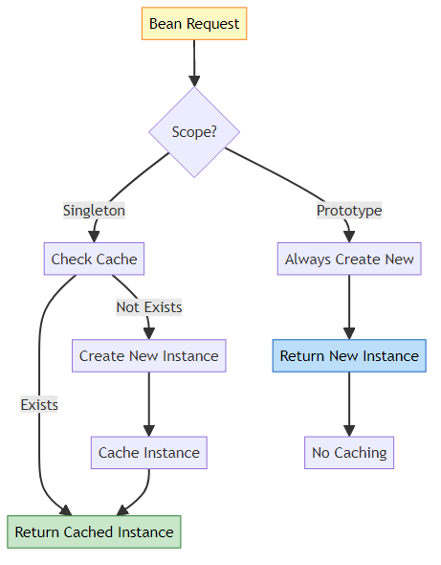

🔍 Singleton Scope (Default)
Definition: Spring creates only ONE instance per container. All requests get the same instance.
Example from FoodDelivery:
@Component
@Scope("singleton") // Default, can be omitted
public class DeliveryService {
public DeliveryService() {
System.out.println("-- Delivery Service Activated --");
}
}
Behavior:
DeliveryService service1 = context.getBean(DeliveryService.class);
DeliveryService service2 = context.getBean(DeliveryService.class);
System.out.println(service1 == service2); // true (same instance)
Output:
-- Delivery Service Activated -- (created once)
true
When to Use Singleton: - ✅ Stateless services - ✅ Shared resources (database connections, caches) - ✅ Thread-safe beans - ✅ Configuration beans - ✅ Most Spring beans
Example: TransactionLogger (PaymentProcessing)
@Component // Singleton by default
public class TransactionLogger {
// Shared logger for all transactions
// One instance serves entire application
}
Why Singleton? - All transactions logged to same file - Shared resource management - Memory efficient - Thread-safe logging

🔍 Prototype Scope
Definition: Spring creates a NEW instance every time the bean is requested.
Example from BankLoanApproval:
@Component
@Scope("prototype")
public class IncomeValidator implements LoanValidator {
@Override
public void validateLoan(double amount) {
System.out.println("IncomeValidator: Checking income for loan of $" + amount);
}
}
Behavior:
IncomeValidator validator1 = context.getBean(IncomeValidator.class);
IncomeValidator validator2 = context.getBean(IncomeValidator.class);
System.out.println(validator1 == validator2); // false (different instances)
Output:
IncomeValidator created (first request)
IncomeValidator created (second request)
false
When to Use Prototype: - ✅ Stateful objects - ✅ Per-request processing - ✅ Mutable beans - ✅ Thread-unsafe beans - ✅ Temporary objects
Example: UpiPayment (PaymentProcessing)
@Component
@Scope("prototype")
public class UpiPayment implements PaymentService {
// New instance per transaction
// Prevents transaction state mixing
}
Why Prototype? - Each transaction needs fresh payment instance - Transaction state isolation - Prevents data leakage between transactions - Clean state for each payment

📊 Singleton vs Prototype Comparison
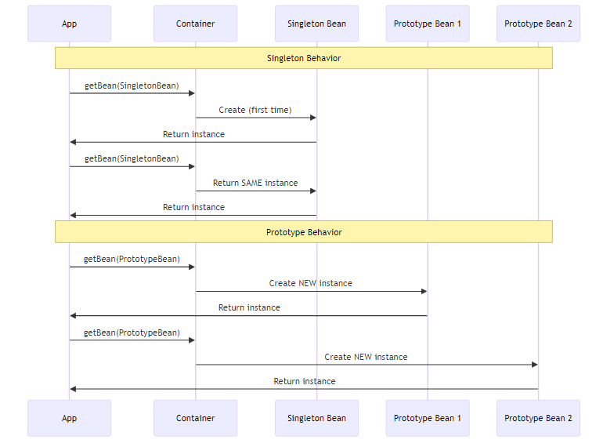
Aspect | Singleton | Prototype
Instances | 1 per container | New per request
Creation | At startup (eager) or first use (lazy) | Every getBean() call
Caching | ✅ Cached | ❌ Not cached
Memory | Low (one instance) | Higher (multiple instances)
Thread Safety | Must be thread-safe | Each thread gets own instance
Lifecycle | Container manages | Container creates, app manages
@PreDestroy | ✅ Called | ❌ NOT called
Use Case | Stateless services | Stateful objects

🎯 Scope Interaction Gotcha
Problem: Singleton with Prototype Dependency
@Component
@Scope("singleton")
public class OrderService {
@Autowired
private PaymentProcessor processor; // Prototype
public void processOrder() {
processor.process(); // ALWAYS SAME INSTANCE!
}
}
Issue: Singleton is created once, so it gets ONE prototype instance and keeps reusing it!
Solution 1: Method Injection
@Component
@Scope("singleton")
public class OrderService {
@Autowired
private ApplicationContext context;
public void processOrder() {
PaymentProcessor processor = context.getBean(PaymentProcessor.class);
processor.process(); // NEW instance each time
}
}
Solution 2: @Lookup
@Component
@Scope("singleton")
public abstract class OrderService {
public void processOrder() {
PaymentProcessor processor = getProcessor();
processor.process(); // NEW instance each time
}
@Lookup
protected abstract PaymentProcessor getProcessor();
}

📈 Performance Implications
Singleton: - ✅ Fast (cached instance) - ✅ Low memory usage - ✅ Efficient for stateless services - ⚠️ Must be thread-safe
Prototype: - ⚠️ Slower (creates new instance) - ⚠️ Higher memory usage - ✅ No thread safety concerns - ✅ Clean state per request

10. BEAN LIFECYCLE

📌 What is Bean Lifecycle?
Bean Lifecycle is the complete journey of a Spring bean from creation to destruction. Spring provides hooks at various stages for custom initialization and cleanup logic.

🎯 Complete Lifecycle Phases
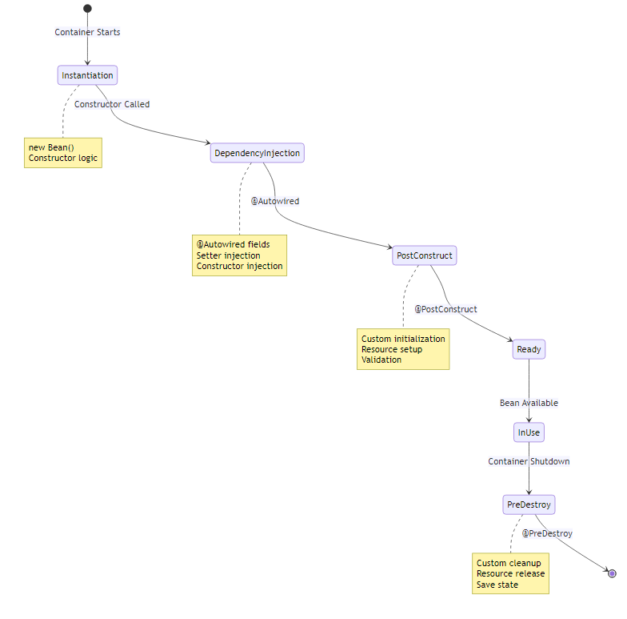

📊 Lifecycle Phases Breakdown
Phase | Description | When | Example
1. Instantiation | Bean object created | Container startup | new DeliveryService()
2. Dependency Injection | Dependencies injected | After instantiation | @Autowired fields set
3. @PostConstruct | Custom initialization | After DI complete | Open connections
4. Bean Ready | Bean available for use | After initialization | Application uses bean
5. @PreDestroy | Custom cleanup | Before destruction | Close connections
6. Destruction | Bean removed | Container shutdown | Memory released

🔍 @PostConstruct Deep Dive
What is @PostConstruct?
@PostConstruct marks a method to be executed AFTER dependency injection is complete. It’s the recommended way to perform initialization logic.
Why @PostConstruct Exists:
Problem: Constructor Limitations
@Component
public class DeliveryService {
@Autowired
private DatabaseConnection connection;
public DeliveryService() {
// ❌ PROBLEM: connection is NULL here!
connection.connect(); // NullPointerException!
}
}
Solution: @PostConstruct
@Component
public class DeliveryService {
@Autowired
private DatabaseConnection connection;
public DeliveryService() {
System.out.println("Constructor: connection is " + connection);
// Output: Constructor: connection is null
}
@PostConstruct
public void init() {
System.out.println("PostConstruct: connection is " + connection);
// Output: PostConstruct: connection is DatabaseConnection@123
// ✅ SAFE: Dependencies are injected
connection.connect();
}
}
Example from FoodDelivery:
@Component
@Scope("singleton")
public class DeliveryService {
public DeliveryService() {
System.out.println("-- Delivery Service Activated --");
}
@PostConstruct
public void init() {
System.out.println("Init Method: Delivery Service Ready");
// Initialize delivery tracking system
// Connect to GPS service
// Load delivery routes
}
}
Example from PaymentProcessing:
@Component
public class TransactionLogger {
public TransactionLogger() {
System.out.println("TransactionLogger bean created");
}
@PostConstruct
public void init() {
System.out.println("Logger initialized");
// Open log file
// Connect to logging database
// Initialize log buffer
}
}
@PostConstruct Rules: - Must be void return type - Must have no parameters - Can be any access modifier (public, private, protected) - Must NOT be static - Can throw checked exceptions - Called AFTER all dependencies injected

🔍 @PreDestroy Deep Dive
What is @PreDestroy?
@PreDestroy marks a method to be executed BEFORE the bean is destroyed. It’s the recommended way to perform cleanup logic.
Why @PreDestroy Exists:
Problem: Resource Leaks
@Component
public class FileProcessor {
private FileWriter writer;
@PostConstruct
public void init() throws IOException {
writer = new FileWriter("output.txt");
}
// ❌ PROBLEM: File never closed!
// Resource leak when application shuts down
}
Solution: @PreDestroy
@Component
public class FileProcessor {
private FileWriter writer;
@PostConstruct
public void init() throws IOException {
writer = new FileWriter("output.txt");
}
@PreDestroy
public void cleanup() throws IOException {
if (writer != null) {
writer.close(); // ✅ Properly closed
System.out.println("File closed");
}
}
}
Example from FoodDelivery:
@Component
@Scope("singleton")
public class DeliveryService {
@PreDestroy
public void preDestroy() {
System.out.println("Delivery Service Closed");
// Close GPS connections
// Save delivery state
// Flush pending deliveries
}
}
Example from PaymentProcessing:
@Component
public class TransactionLogger {
@PreDestroy
public void preDestroy() {
System.out.println("Logger destroyed");
// Flush log buffer
// Close log file
// Disconnect from logging database
}
}
@PreDestroy Rules: - Must be void return type - Must have no parameters - Can be any access modifier - Must NOT be static - Can throw checked exceptions - Called BEFORE bean destruction - NOT called for Prototype beans!

📊 Lifecycle Execution Order
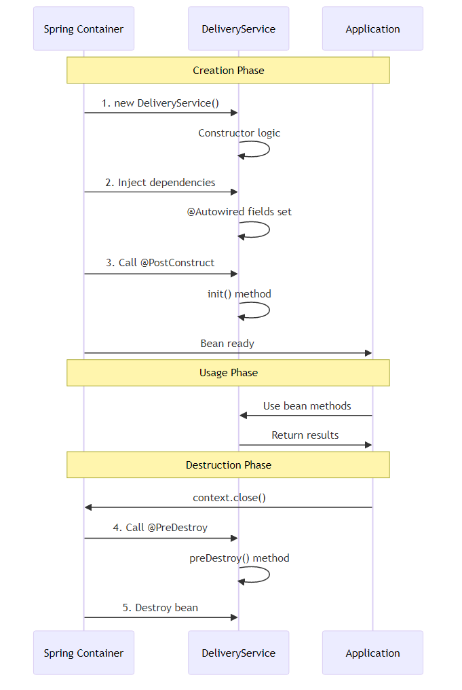
Complete Example:
@Component
public class CompleteLifecycleBean {
@Autowired
private SomeDependency dependency;
// Phase 1: Instantiation
public CompleteLifecycleBean() {
System.out.println("1. Constructor called");
System.out.println(" dependency = " + dependency); // null
}
// Phase 2: Dependency Injection happens here
// Phase 3: Initialization
@PostConstruct
public void init() {
System.out.println("2. @PostConstruct called");
System.out.println(" dependency = " + dependency); // NOT null
// Safe to use dependencies here
}
// Phase 4: Bean Ready - Application uses it
// Phase 5: Cleanup
@PreDestroy
public void cleanup() {
System.out.println("3. @PreDestroy called");
// Cleanup resources
}
}
Output:
1. Constructor called
dependency = null
2. @PostConstruct called
dependency = SomeDependency@123
3. @PreDestroy called

🎯 Lifecycle with Different Scopes
Singleton Scope:
@Component
@Scope("singleton")
public class SingletonBean {
@PostConstruct
public void init() {
System.out.println("Singleton init - called ONCE");
}
@PreDestroy
public void cleanup() {
System.out.println("Singleton cleanup - called ONCE");
}
}
Prototype Scope:
@Component
@Scope("prototype")
public class PrototypeBean {
@PostConstruct
public void init() {
System.out.println("Prototype init - called EVERY TIME");
}
@PreDestroy
public void cleanup() {
System.out.println("Prototype cleanup - NEVER CALLED!");
}
}
Important: @PreDestroy is NOT called for Prototype beans because Spring doesn’t manage their complete lifecycle!

11. DEPENDENCY INJECTION PATTERNS

📌 Types of Dependency Injection
Spring supports three types of dependency injection: 1. Constructor Injection (Recommended ✅) 2. Setter Injection (For optional dependencies) 3. Field Injection (Not recommended ❌)

🎯 Constructor Injection (Recommended)
Definition: Dependencies are provided through the constructor.
Example from BankLoanApproval:
@Component
public class LoanService {
private final LoanValidator loanValidator;
@Autowired // Optional for single constructor
public LoanService(@Qualifier("incomeValidator") LoanValidator loanValidator) {
this.loanValidator = loanValidator;
}
}
Example from FoodDelivery:
@Component
public class OrderService {
private final NotificationService notificationService;
public OrderService(@Qualifier("smsNotification") NotificationService notificationService) {
this.notificationService = notificationService;
}
}
Example from PaymentProcessing:
@Component
public class PaymentProcessor {
private final PaymentService paymentService;
private final PaymentService paymentService02;
public PaymentProcessor(
@Qualifier("upiPayment") PaymentService paymentService,
@Qualifier("creditCardPayment") PaymentService paymentService02) {
this.paymentService = paymentService;
this.paymentService02 = paymentService02;
}
}
Advantages: - ✅ Immutability (final fields) - ✅ Required dependencies enforced - ✅ Easy to test (no reflection needed) - ✅ Null-safe (dependencies guaranteed) - ✅ Clear dependencies in constructor signature

🎯 Setter Injection
Definition: Dependencies are provided through setter methods.
Example from BankLoanApproval:
@Component
public class LoanService {
private AuditService auditService;
@Autowired
public void setAuditService(AuditService auditService) {
this.auditService = auditService;
}
}
Example from FoodDelivery:
@Component
public class RestaurantService {
private DeliveryService deliveryService;
@Autowired
public void setDeliveryService(DeliveryService deliveryService) {
this.deliveryService = deliveryService;
System.out.println("-- Setter Injection: DeliveryService injected --");
}
}
Advantages: - ✅ Optional dependencies - ✅ Allows reconfiguration - ✅ Circular dependency resolution - ✅ Clear setter method names
Disadvantages: - ❌ Mutable (not final) - ❌ Can be null - ❌ Dependencies not obvious
When to Use: - Optional dependencies (AuditService in BankLoanApproval) - Circular dependencies - Reconfigurable beans

🎯 Field Injection (Not Recommended)
Definition: Dependencies are injected directly into fields.
Example from PaymentProcessing:
@Component
public class PaymentProcessor {
@Autowired
private TransactionLogger transactionLogger;
}
Disadvantages: - ❌ Hard to test (requires reflection) - ❌ Breaks encapsulation - ❌ Hidden dependencies - ❌ Cannot make final - ❌ Tight coupling to Spring
When to Use: - Quick prototyping - Legacy code - Avoid in production code

📊 Injection Types Comparison
Aspect | Constructor | Setter | Field
Immutability | ✅ final fields | ❌ mutable | ❌ mutable
Required Dependencies | ✅ enforced | ❌ optional | ❌ optional
Testability | ✅ easy | ✅ easy | ❌ hard
Null Safety | ✅ guaranteed | ❌ can be null | ❌ can be null
Circular Dependencies | ❌ difficult | ✅ possible | ✅ possible
Visibility | ✅ clear | ✅ clear | ❌ hidden
Recommendation | ✅ Use this | ⚠️ Optional only | ❌ Avoid

12. INTERNAL WORKING MECHANISMS

📌 How Spring Container Works
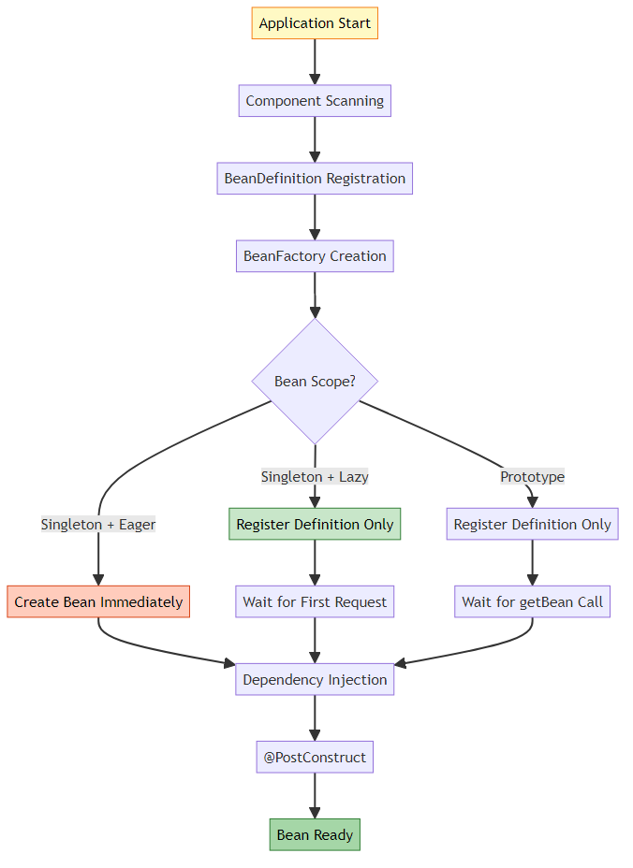

🔍 Component Scanning Process
Step 1: @ComponentScan
@Configuration
@ComponentScan(basePackages = "org.example")
public class AppConfig {
}
What Happens: 1. Spring scans “org.example” package 2. Finds classes with @Component, @Service, @Repository, @Controller 3. Creates BeanDefinition for each 4. Registers in BeanDefinitionRegistry
Step 2: BeanDefinition Creation
// Spring internally creates:
BeanDefinition def = new GenericBeanDefinition();
def.setBeanClassName("org.example.service.LoanService");
def.setScope("singleton");
def.setLazyInit(false);
def.setAutowireMode(AUTOWIRE_BY_TYPE);
Step 3: Bean Instantiation
// Spring internally does:
Class<?> clazz = Class.forName("org.example.service.LoanService");
Constructor<?> constructor = clazz.getConstructor(LoanValidator.class);
Object bean = constructor.newInstance(loanValidator);

🔍 Dependency Resolution Algorithm
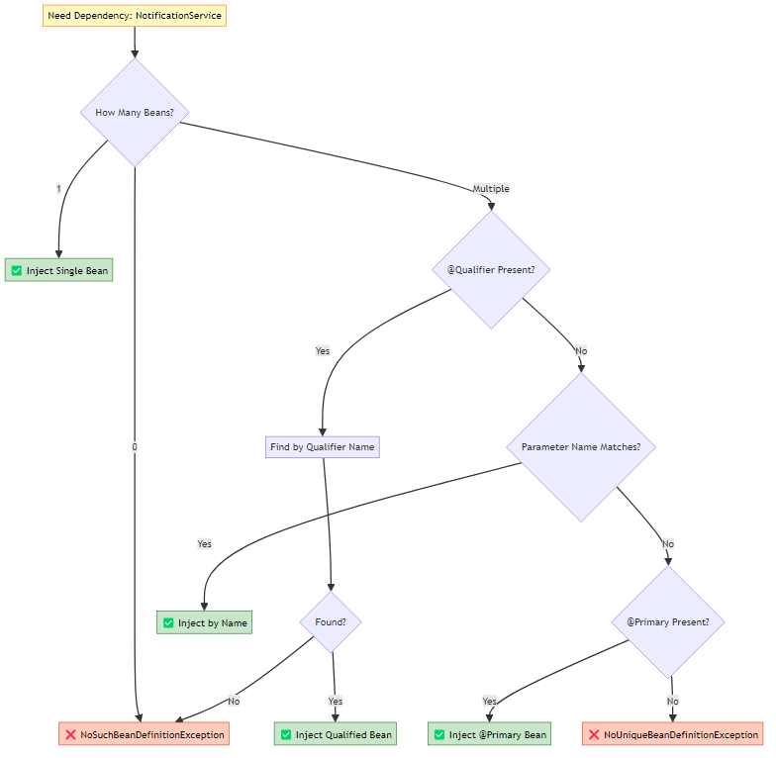

🔍 @Lazy Proxy Creation
How Spring Creates Lazy Proxies:
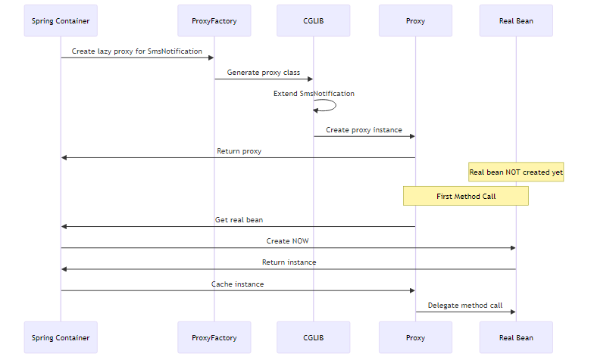
Proxy Class Structure:
// Spring generates something like:
public class SmsNotification$$EnhancerBySpringCGLIB$$12345678 extends SmsNotification {
private SmsNotification target;
private BeanFactory beanFactory;
@Override
public void sendNotification(String message) {
if (target == null) {
// First call - create real bean
target = beanFactory.getBean(SmsNotification.class);
}
// Delegate to real bean
target.sendNotification(message);
}
}

13. EXECUTION FLOW ANALYSIS

📊 BankLoanApproval Execution Flow
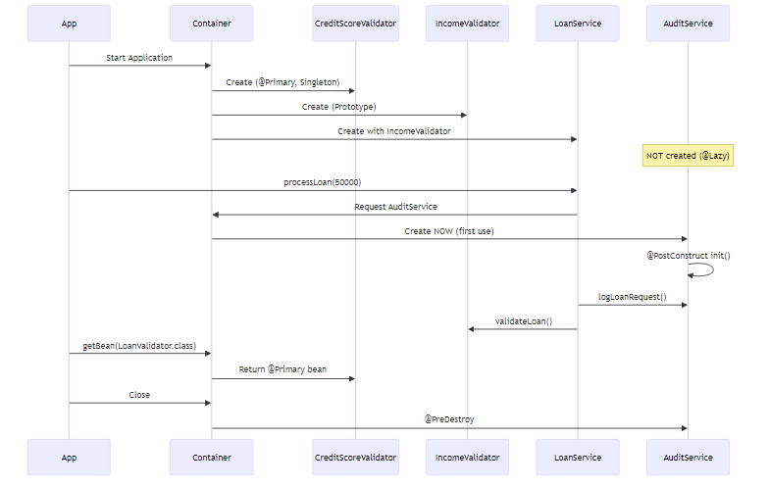

📊 FoodDelivery Execution Flow
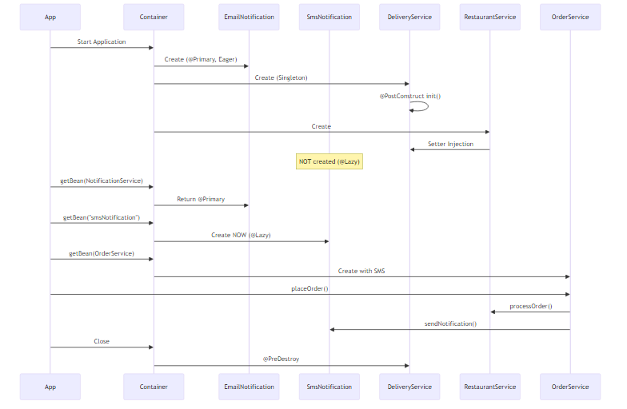

📊 PaymentProcessing Execution Flow
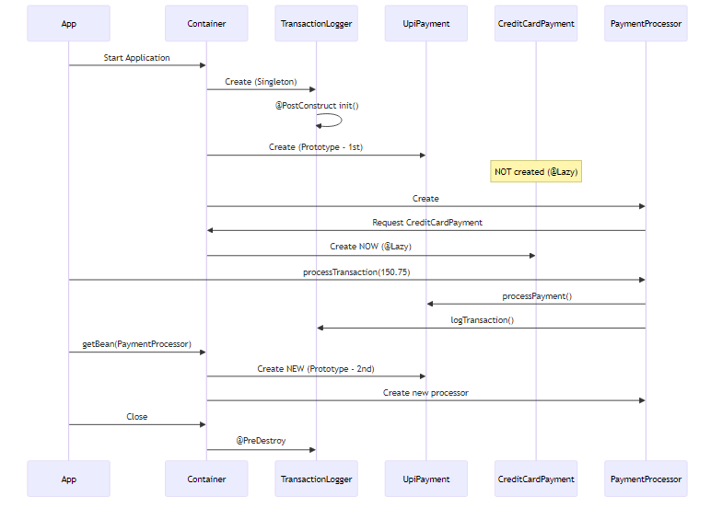

14. REAL-WORLD APPLICATIONS

🌍 E-Commerce Platform
Scenario: Online shopping platform with multiple payment gateways
// Payment Gateway Interface
public interface PaymentGateway {
boolean processPayment(Order order);
}
// Default gateway
@Primary
@Component
public class StripeGateway implements PaymentGateway {
// Most common, default choice
}
// Alternative gateways
@Component
public class PayPalGateway implements PaymentGateway { }
@Component
public class RazorpayGateway implements PaymentGateway { }
// Checkout Service
@Component
public class CheckoutService {
// Uses Stripe by default (@Primary)
public CheckoutService(PaymentGateway gateway) { }
}
// Admin Service
@Component
public class AdminPaymentService {
// Can switch to specific gateway
public AdminPaymentService(
@Qualifier("payPalGateway") PaymentGateway gateway) { }
}
Why This Design: - @Primary for most common gateway (Stripe) - @Qualifier for specific business requirements - Easy to add new gateways - Flexible payment routing

🌍 Notification System
Scenario: Multi-channel notification system
public interface NotificationChannel {
void send(String message);
}
@Primary
@Component
public class EmailChannel implements NotificationChannel {
// Default, most reliable
}
@Component
@Lazy
public class SmsChannel implements NotificationChannel {
// Expensive SMS gateway
}
@Component
@Lazy
public class PushChannel implements NotificationChannel {
// Mobile push notifications
}
@Component
public class NotificationService {
private final NotificationChannel primary;
private final NotificationChannel sms;
public NotificationService(
NotificationChannel primary, // Email
@Qualifier("smsChannel") NotificationChannel sms) {
this.primary = primary;
this.sms = sms;
}
public void sendUrgent(String message) {
sms.send(message); // SMS for urgent
}
public void sendNormal(String message) {
primary.send(message); // Email for normal
}
}
Why This Design: - @Primary for default channel (Email) - @Lazy for expensive channels (SMS, Push) - Multiple channels in same service - Business logic determines channel

🌍 Database Connection Pool
Scenario: Multi-database application
public interface DataSource {
Connection getConnection();
}
@Primary
@Component
public class PrimaryDataSource implements DataSource {
@PostConstruct
public void init() {
// Initialize primary database pool
}
@PreDestroy
public void cleanup() {
// Close all connections
}
}
@Component
@Lazy
public class AnalyticsDataSource implements DataSource {
// Expensive analytics database
// Created only when analytics needed
}
@Component
public class UserRepository {
// Uses primary database
public UserRepository(DataSource dataSource) { }
}
@Component
public class AnalyticsService {
// Uses analytics database
public AnalyticsService(
@Qualifier("analyticsDataSource") DataSource dataSource) { }
}
Why This Design: - @Primary for main database - @Lazy for analytics (expensive, rarely used) - @PostConstruct/@PreDestroy for connection management - Separate data sources for different purposes

15. BEST PRACTICES

✅ Dependency Injection
- Prefer Constructor Injection
- // ✅ GOOD
@Component
public class OrderService {
private final PaymentService paymentService;
public OrderService(PaymentService paymentService) {
this.paymentService = paymentService;
}
}
// ❌ BAD
@Component
public class OrderService {
@Autowired
private PaymentService paymentService;
}
- Use final for Required Dependencies
- // ✅ GOOD - Immutable, null-safe
private final PaymentService paymentService;
// ❌ BAD - Mutable, can be null
private PaymentService paymentService;
- Setter Injection for Optional Dependencies
- // ✅ GOOD - Optional audit service
@Autowired(required = false)
public void setAuditService(AuditService auditService) {
this.auditService = auditService;
}

✅ @Primary and @Qualifier
- Use @Primary for Default Implementation
- // ✅ GOOD - Clear default
@Primary
@Component
public class EmailNotification implements NotificationService { }
- Use @Qualifier for Specific Requirements
- // ✅ GOOD - Explicit selection
public OrderService(@Qualifier("smsNotification") NotificationService service) { }
- Only ONE @Primary per Type
- // ❌ BAD - Multiple @Primary
@Primary @Component
public class EmailNotification implements NotificationService { }
@Primary @Component // ERROR!
public class SmsNotification implements NotificationService { }

✅ @Lazy Initialization
- Use @Lazy for Expensive Beans
- // ✅ GOOD - Expensive initialization
@Component
@Lazy
public class ReportGenerator {
@PostConstruct
public void init() {
// Load heavy templates
// Connect to reporting service
}
}
- Combine @Primary with @Lazy
- // ✅ GOOD - Default but lazy
@Primary
@Component
@Lazy
public class CreditCardPayment implements PaymentService { }
- Don’t Overuse @Lazy
- // ❌ BAD - Always-used service shouldn't be lazy
@Component
@Lazy
public class UserService { } // Used in every request!

✅ Bean Scopes
- Use Singleton for Stateless Services
- // ✅ GOOD - Stateless, thread-safe
@Component // Singleton by default
public class EmailService {
public void send(String message) { }
}
- Use Prototype for Stateful Objects
- // ✅ GOOD - Stateful, per-request
@Component
@Scope("prototype")
public class ShoppingCart {
private List<Item> items = new ArrayList<>();
}
- Be Careful with Singleton-Prototype Interaction
- // ❌ BAD - Singleton holds Prototype
@Component
public class OrderService {
@Autowired
private ShoppingCart cart; // ALWAYS SAME INSTANCE!
}
// ✅ GOOD - Get new instance each time
@Component
public class OrderService {
@Autowired
private ApplicationContext context;
public void processOrder() {
ShoppingCart cart = context.getBean(ShoppingCart.class);
}
}

✅ Lifecycle Management
- Use @PostConstruct for Initialization
- // ✅ GOOD - Dependencies available
@PostConstruct
public void init() {
connection.connect();
}
// ❌ BAD - Dependencies might be null
public MyService() {
connection.connect(); // NullPointerException!
}
- Use @PreDestroy for Cleanup
- // ✅ GOOD - Proper cleanup
@PreDestroy
public void cleanup() {
if (connection != null) {
connection.close();
}
}
- Remember: @PreDestroy NOT Called for Prototype
- @Component
@Scope("prototype")
public class PrototypeBean {
@PreDestroy
public void cleanup() {
// ⚠️ WARNING: This is NEVER called!
}
}

16. COMMON PITFALLS

❌ Pitfall 1: Using Dependencies in Constructor
Problem:
@Component
public class UserService {
@Autowired
private UserRepository repository;
public UserService() {
// ❌ repository is NULL here!
repository.findAll(); // NullPointerException!
}
}
Solution:
@Component
public class UserService {
@Autowired
private UserRepository repository;
@PostConstruct
public void init() {
// ✅ repository is injected
repository.findAll();
}
}

❌ Pitfall 2: Multiple @Primary
Problem:
@Primary
@Component
public class EmailNotification implements NotificationService { }
@Primary // ❌ ERROR: Only ONE @Primary allowed
@Component
public class SmsNotification implements NotificationService { }
Error:
NoUniqueBeanDefinitionException: more than one 'primary' bean found
Solution:
@Primary
@Component
public class EmailNotification implements NotificationService { }
@Component // ✅ No @Primary
public class SmsNotification implements NotificationService { }

❌ Pitfall 3: Forgetting @Qualifier Bean Name
Problem:
@Component
public class SmsNotification implements NotificationService { }
// ❌ Wrong bean name
public OrderService(@Qualifier("smsService") NotificationService service) { }
Error:
NoSuchBeanDefinitionException: No bean named 'smsService' available
Solution:
// ✅ Correct bean name (class name with lowercase first letter)
public OrderService(@Qualifier("smsNotification") NotificationService service) { }

❌ Pitfall 4: Singleton with Prototype Dependency
Problem:
@Component
@Scope("prototype")
public class ShoppingCart { }
@Component // Singleton
public class OrderService {
@Autowired
private ShoppingCart cart; // ❌ ALWAYS SAME INSTANCE!
public void addItem(Item item) {
cart.add(item); // All users share same cart!
}
}
Solution:
@Component
public class OrderService {
@Autowired
private ApplicationContext context;
public void addItem(Item item) {
ShoppingCart cart = context.getBean(ShoppingCart.class);
cart.add(item); // ✅ New cart each time
}
}

❌ Pitfall 5: Expecting @PreDestroy for Prototype
Problem:
@Component
@Scope("prototype")
public class FileProcessor {
private FileWriter writer;
@PostConstruct
public void init() throws IOException {
writer = new FileWriter("output.txt");
}
@PreDestroy
public void cleanup() throws IOException {
writer.close(); // ❌ NEVER CALLED!
}
}
Solution:
@Component
@Scope("prototype")
public class FileProcessor implements DisposableBean {
private FileWriter writer;
@PostConstruct
public void init() throws IOException {
writer = new FileWriter("output.txt");
}
// ✅ Manual cleanup
public void close() throws IOException {
if (writer != null) {
writer.close();
}
}
}
// Usage
FileProcessor processor = context.getBean(FileProcessor.class);
try {
processor.process();
} finally {
processor.close(); // Manual cleanup
}

❌ Pitfall 6: Circular Dependencies
Problem:
@Component
public class A {
@Autowired
private B b; // A needs B
}
@Component
public class B {
@Autowired
private A a; // B needs A → Circular!
}
Error:
BeanCurrentlyInCreationException: Circular dependency
Solution 1: Use @Lazy
@Component
public class A {
private final B b;
public A(@Lazy B b) { // ✅ Proxy injected
this.b = b;
}
}
@Component
public class B {
private final A a;
public B(A a) {
this.a = a;
}
}
Solution 2: Redesign (Better)
// Extract common functionality to separate service
@Component
public class CommonService { }
@Component
public class A {
@Autowired
private CommonService common;
}
@Component
public class B {
@Autowired
private CommonService common;
}

17. TOP INTERVIEW QUESTIONS

🎯 Dependency Injection Questions
Q1: What happens if you have multiple beans of the same type and no @Primary or @Qualifier?
Answer: Spring throws NoUniqueBeanDefinitionException because it cannot determine which bean to inject.
@Component
public class EmailNotification implements NotificationService { }
@Component
public class SmsNotification implements NotificationService { }
@Component
public class MyService {
// ❌ ERROR: NoUniqueBeanDefinitionException
public MyService(NotificationService service) { }
}
Resolution Priority: 1. @Qualifier (highest) 2. Parameter name matching 3. @Primary 4. Single bean (lowest)
Q2: Can you have multiple @Primary annotations for the same type?
Answer: No! Only ONE @Primary is allowed per bean type. If you mark multiple beans with @Primary, Spring throws an exception at startup.
@Primary @Component
public class EmailNotification implements NotificationService { }
@Primary @Component // ❌ ERROR!
public class SmsNotification implements NotificationService { }
// Error: more than one 'primary' bean found
Q3: What’s the difference between @Qualifier and parameter name matching?
Answer:
@Qualifier (Explicit):
public MyService(@Qualifier("smsNotification") NotificationService service) { }
// Explicitly selects "smsNotification" bean
Parameter Name Matching (Implicit):
public MyService(NotificationService smsNotification) { }
// Parameter name "smsNotification" matches bean name
Priority: @Qualifier > Parameter Name > @Primary
Q4: Why is constructor injection preferred over field injection?
Answer:
Constructor Injection Advantages: - ✅ Immutability (final fields) - ✅ Required dependencies enforced - ✅ Easy to test (no reflection) - ✅ Null-safe - ✅ Clear dependencies
Field Injection Disadvantages: - ❌ Cannot use final - ❌ Hard to test (requires reflection) - ❌ Hidden dependencies - ❌ Breaks encapsulation
// ✅ Constructor Injection
@Component
public class OrderService {
private final PaymentService paymentService;
public OrderService(PaymentService paymentService) {
this.paymentService = paymentService;
}
}
// ❌ Field Injection
@Component
public class OrderService {
@Autowired
private PaymentService paymentService;
}

🎯 @Lazy Questions
Q5: What happens when you inject a @Lazy bean into another bean?
Answer: Spring creates a PROXY and injects it instead of the real bean. The real bean is created only when a method is called on the proxy.
@Component
@Lazy
public class SmsService {
public SmsService() {
System.out.println("SmsService created");
}
}
@Component
public class OrderService {
private final SmsService smsService;
public OrderService(SmsService smsService) {
System.out.println("OrderService created");
// smsService is a PROXY here
System.out.println(smsService.getClass().getName());
// Output: SmsService$$EnhancerBySpringCGLIB$$12345678
}
public void sendSms() {
smsService.send(); // NOW real SmsService is created
}
}
Output:
OrderService created
SmsService$$EnhancerBySpringCGLIB$$12345678
(when sendSms() is called)
SmsService created
Q6: Can you combine @Primary with @Lazy?
Answer: Yes! This is a powerful combination for default but expensive beans.
@Primary
@Component
@Lazy
public class CreditCardPayment implements PaymentService {
// Default payment method
// But expensive initialization
// Created only when used
}
Use Case: - Credit card is the default payment method (@Primary) - But payment gateway initialization is expensive - So delay creation until actually needed (@Lazy)
Q7: What’s the performance impact of @Lazy?
Answer:
Startup Time: - Without @Lazy: Slower startup (all beans created) - With @Lazy: Faster startup (beans created on demand)
First Request: - Without @Lazy: Fast (bean already created) - With @Lazy: Slower (bean created now)
Subsequent Requests: - Both: Same performance (bean cached)
Example:
Without @Lazy:
- Startup: 30 seconds
- First request: 10ms
- Subsequent: 10ms
With @Lazy:
- Startup: 5 seconds
- First request: 25ms (creates bean)
- Subsequent: 10ms

🎯 Bean Scope Questions
Q8: What’s the difference between Singleton and Prototype scope?
Answer:
Aspect | Singleton | Prototype
Instances | 1 per container | New per request
Creation | At startup or first use | Every getBean() call
Caching | ✅ Cached | ❌ Not cached
@PreDestroy | ✅ Called | ❌ NOT called
Thread Safety | Must be thread-safe | Each thread gets own
Use Case | Stateless services | Stateful objects
// Singleton
@Component
public class EmailService {
// One instance for entire application
}
// Prototype
@Component
@Scope("prototype")
public class ShoppingCart {
// New instance per request
}
Q9: Why is @PreDestroy not called for Prototype beans?
Answer: Spring doesn’t manage the complete lifecycle of Prototype beans. After creating and returning a Prototype bean, Spring “forgets” about it. The application is responsible for cleanup.
@Component
@Scope("prototype")
public class FileProcessor {
@PreDestroy
public void cleanup() {
// ⚠️ NEVER CALLED!
}
}
Reason: - Prototype beans can have multiple instances - Spring doesn’t track all instances - Application controls when instances are destroyed - @PreDestroy would be ambiguous (when to call?)
Solution: Manual cleanup
FileProcessor processor = context.getBean(FileProcessor.class);
try {
processor.process();
} finally {
processor.close(); // Manual cleanup
}
Q10: What happens when a Singleton bean has a Prototype dependency?
Answer: The Singleton bean gets ONE instance of the Prototype bean and keeps reusing it, defeating the purpose of Prototype scope!
@Component
@Scope("prototype")
public class ShoppingCart { }
@Component // Singleton
public class OrderService {
@Autowired
private ShoppingCart cart; // ❌ ALWAYS SAME INSTANCE!
}
Problem: - OrderService is created once (Singleton) - ShoppingCart is injected once - All users share the same cart!
Solution 1: ApplicationContext
@Component
public class OrderService {
@Autowired
private ApplicationContext context;
public void processOrder() {
ShoppingCart cart = context.getBean(ShoppingCart.class);
// ✅ New cart each time
}
}
Solution 2: @Lookup
@Component
public abstract class OrderService {
public void processOrder() {
ShoppingCart cart = getCart();
// ✅ New cart each time
}
@Lookup
protected abstract ShoppingCart getCart();
}

🎯 Lifecycle Questions
Q11: Why can’t you use dependencies in the constructor?
Answer: Dependencies are injected AFTER the constructor is called. In the constructor, all @Autowired fields are still null.
@Component
public class UserService {
@Autowired
private UserRepository repository;
public UserService() {
System.out.println("Constructor: " + repository);
// Output: Constructor: null
// ❌ NullPointerException!
repository.findAll();
}
@PostConstruct
public void init() {
System.out.println("PostConstruct: " + repository);
// Output: PostConstruct: UserRepository@123
// ✅ Safe to use
repository.findAll();
}
}
Lifecycle Order: 1. Constructor called (dependencies are null) 2. Dependencies injected 3. @PostConstruct called (dependencies available)
Q12: What’s the execution order of lifecycle methods?
Answer:
@Component
public class CompleteLifecycleBean implements InitializingBean, DisposableBean {
// 1. Constructor
public CompleteLifecycleBean() {
System.out.println("1. Constructor");
}
// 2. @PostConstruct
@PostConstruct
public void postConstruct() {
System.out.println("2. @PostConstruct");
}
// 3. InitializingBean.afterPropertiesSet()
@Override
public void afterPropertiesSet() {
System.out.println("3. afterPropertiesSet");
}
// 4. Custom init-method (if configured)
public void customInit() {
System.out.println("4. customInit");
}
// 5. @PreDestroy
@PreDestroy
public void preDestroy() {
System.out.println("5. @PreDestroy");
}
// 6. DisposableBean.destroy()
@Override
public void destroy() {
System.out.println("6. destroy");
}
// 7. Custom destroy-method (if configured)
public void customDestroy() {
System.out.println("7. customDestroy");
}
}
Output:
1. Constructor
2. @PostConstruct
3. afterPropertiesSet
4. customInit
5. @PreDestroy
6. destroy
7. customDestroy
Recommendation: Use @PostConstruct and @PreDestroy (simplest and standard)

🎯 Advanced Questions
Q13: How does Spring resolve circular dependencies?
Answer: Spring uses a three-level cache mechanism and proxy creation to resolve circular dependencies.
Problem:
@Component
public class A {
@Autowired
private B b; // A needs B
}
@Component
public class B {
@Autowired
private A a; // B needs A
}
Spring’s Solution: 1. Create A (partially initialized) 2. Put A in “early reference” cache 3. Start injecting dependencies into A 4. Need B, so create B 5. B needs A, get A from early reference cache 6. Inject A into B (B is complete) 7. Inject B into A (A is complete)
With Constructor Injection (Fails):
@Component
public class A {
public A(B b) { } // ❌ Cannot resolve
}
@Component
public class B {
public B(A a) { } // ❌ Cannot resolve
}
Why it fails: Spring cannot create A without B, and cannot create B without A.
Solution: Use @Lazy
@Component
public class A {
public A(@Lazy B b) { } // ✅ Proxy injected
}
@Component
public class B {
public B(A a) { }
}
Q14: What’s the difference between @Component and @Bean?
Answer:
@Component: - Class-level annotation - Auto-detected by component scanning - Spring creates bean automatically - Used for your own classes
@Component
public class EmailService {
// Spring creates this automatically
}
@Bean: - Method-level annotation - Used in @Configuration classes - Manual bean creation - Used for third-party classes
@Configuration
public class AppConfig {
@Bean
public DataSource dataSource() {
// Manual creation for third-party class
return new HikariDataSource();
}
}
Aspect | @Component | @Bean
Level | Class | Method
Detection | Auto (component scan) | Manual (@Configuration)
Use Case | Your classes | Third-party classes
Control | Less control | Full control
Customization | Limited | Flexible
Q15: Can you inject a List or Map of beans?
Answer: Yes! Spring can inject all beans of a type into a List or Map.
List Injection:
public interface NotificationService {
void send(String message);
}
@Component
public class EmailNotification implements NotificationService { }
@Component
public class SmsNotification implements NotificationService { }
@Component
public class PushNotification implements NotificationService { }
@Component
public class NotificationManager {
private final List<NotificationService> allNotifications;
// Injects ALL NotificationService beans
public NotificationManager(List<NotificationService> allNotifications) {
this.allNotifications = allNotifications;
// List contains: [Email, SMS, Push]
}
public void sendToAll(String message) {
allNotifications.forEach(n -> n.send(message));
}
}
Map Injection:
@Component
public class NotificationManager {
private final Map<String, NotificationService> notificationMap;
// Key = bean name, Value = bean instance
public NotificationManager(Map<String, NotificationService> notificationMap) {
this.notificationMap = notificationMap;
// Map: {
// "emailNotification" -> EmailNotification,
// "smsNotification" -> SmsNotification,
// "pushNotification" -> PushNotification
// }
}
public void send(String channel, String message) {
NotificationService service = notificationMap.get(channel + "Notification");
service.send(message);
}
}
Use Cases: - Strategy pattern (select from multiple implementations) - Plugin architecture - Dynamic service selection - Broadcast to all implementations
Q16: What happens if @PostConstruct throws an exception?
Answer: The bean creation fails, and Spring throws a BeanCreationException. The bean is NOT added to the container.
@Component
public class DatabaseService {
@PostConstruct
public void init() {
throw new RuntimeException("Database connection failed");
}
}
Result: - Application startup fails - Bean is not created - Other beans depending on this bean also fail - Fail-fast behavior (good for catching errors early)
Best Practice:
@Component
public class DatabaseService {
@PostConstruct
public void init() {
try {
connectToDatabase();
} catch (Exception e) {
// Log error
logger.error("Failed to connect to database", e);
// Rethrow to fail fast
throw new BeanCreationException("Database initialization failed", e);
}
}
}

🎓 CONCLUSION

📚 What You’ve Learned
Through these three real-world case studies, you’ve mastered:
✅ Dependency Injection Patterns - Constructor injection for required dependencies - Setter injection for optional dependencies - Field injection (and why to avoid it)
✅ Dependency Resolution - @Primary for default implementations - @Qualifier for explicit selection - Resolution priority and ambiguity handling
✅ Performance Optimization - @Lazy for expensive beans - Lazy proxy mechanism - Startup time vs first-request tradeoff
✅ Bean Scopes - Singleton for stateless services - Prototype for stateful objects - Scope interaction gotchas
✅ Lifecycle Management - @PostConstruct for initialization - @PreDestroy for cleanup - Resource management best practices
✅ Real-World Applications - Bank loan approval system - Food delivery platform - Payment processing gateway

🚀 Next Steps
- Practice: Build your own case studies
- Experiment: Try different combinations of annotations
- Debug: Use Spring’s logging to understand bean creation
- Optimize: Profile your application and apply @Lazy strategically
- Test: Write unit tests for your Spring beans

📧 Contact
Questions or feedback? Reach out!

Avinash Dhanuka
© 2026 Avinash Dhanuka | Crafted with ❤️ for Spring Mastery

Happy Coding! ☕
Master Spring, Build Better Applications

