☕ Spring Framework: Advanced Bean Management - Day 10

© 2026 Avinash Dhanuka
Advanced Spring Bean Management Mastery
From Lifecycle to Performance - The Complete Journey

Learning Path: This repository contains three comprehensive projects demonstrating advanced Spring Framework bean management - from lifecycle management to performance optimization with lazy loading, including real-world case studies.

📑 Table of Contents
- Overview
- Projects Summary
- Project 1: Bean Lifecycle Management
- Project 2: Lazy Configuration
- Project 3: Real-World Case Studies
- Key Concepts Learned
- Configuration Comparison
- When to Use What
- Quick Reference
- Running the Projects

OVERVIEW

This repository demonstrates advanced Spring Framework bean management techniques, focusing on lifecycle management, performance optimization, and real-world application patterns. Each project builds upon core Spring concepts to solve practical problems.

🎯 Learning Objectives
- ✅ Master Bean Lifecycle with @PostConstruct and @PreDestroy
- ✅ Optimize performance with @Lazy initialization
- ✅ Understand Bean Scopes (Singleton vs Prototype)
- ✅ Resolve dependency ambiguity with @Primary and @Qualifier
- ✅ Implement proper resource management
- ✅ Apply patterns in real-world scenarios

📊 Repository Structure
day10/
├── BeanLifeCycle/ # Project 1: Lifecycle management
│ ├── src/
│ │ └── main/
│ │ └── java/
│ │ └── org/example/
│ │ └── lifecycle/
│ │ ├── dbConnection.java
│ │ ├── LifeCycleConfig.java
│ │ └── LifeCycleDemo.java
│ ├── pom.xml
│ └── README.md # Detailed documentation
│
├── LazyConfig/ # Project 2: Lazy initialization
│ ├── src/
│ │ └── main/
│ │ └── java/
│ │ └── org/example/
│ │ └── lazy/
│ │ ├── EagerBean.java
│ │ ├── LazyBean.java
│ │ ├── LazyConfig.java
│ │ └── LazyDemo.java
│ ├── pom.xml
│ └── README.md # Detailed documentation
│
├── CaseStudy/ # Project 3: Real-world applications
│ ├── BankLoanApproval/
│ │ └── src/main/java/org/example/bankloan/
│ ├── FoodDelivery/
│ │ └── src/main/java/org/example/fooddelivery/
│ ├── PaymentProcessing/
│ │ └── src/main/java/org/example/payment/
│ ├── pom.xml
│ └── README.md # Detailed documentation
│
└── README.md # This file

PROJECTS SUMMARY

📝 Organized Learning by: Avinash Dhanuka | © 2026

📦 Project Overview Table
Project | Focus Area | Key Concepts | Complexity | Status
BeanLifeCycle | Resource Management | @PostConstruct, @PreDestroy, Lifecycle | ⭐⭐⭐ Intermediate | ✅ Complete
LazyConfig | Performance | @Lazy, Eager vs Lazy, Proxies | ⭐⭐⭐ Intermediate | ✅ Complete
CaseStudy | Real-World Apps | @Primary, @Qualifier, Scopes, All concepts | ⭐⭐⭐⭐ Advanced | ✅ Complete

🎯 Project Relationships
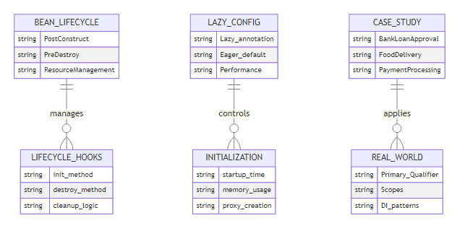

BEAN LIFECYCLE EVOLUTION

📈 Spring Bean Management Timeline

🔄 Bean Management Approaches
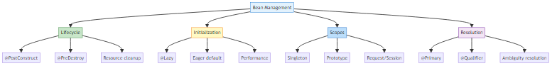

PROJECT 1: BEAN LIFECYCLE MANAGEMENT

📝 Resource Management by: Avinash Dhanuka | © 2026

📌 Overview
Understanding and managing the complete lifecycle of Spring beans from creation to destruction. This project demonstrates proper resource management using @PostConstruct and @PreDestroy annotations.
📂 Location: BeanLifeCycle/
📖 Full Documentation: BeanLifeCycle/README.md

🎯 Key Concepts
- Bean Lifecycle Phases (13 phases from instantiation to destruction)
- @PostConstruct for initialization after dependency injection
- @PreDestroy for cleanup before bean destruction
- Resource Management (database connections, file handles)
- Lifecycle Callbacks (InitializingBean, DisposableBean)
- BeanPostProcessor for custom processing

📊 Bean Lifecycle Flow
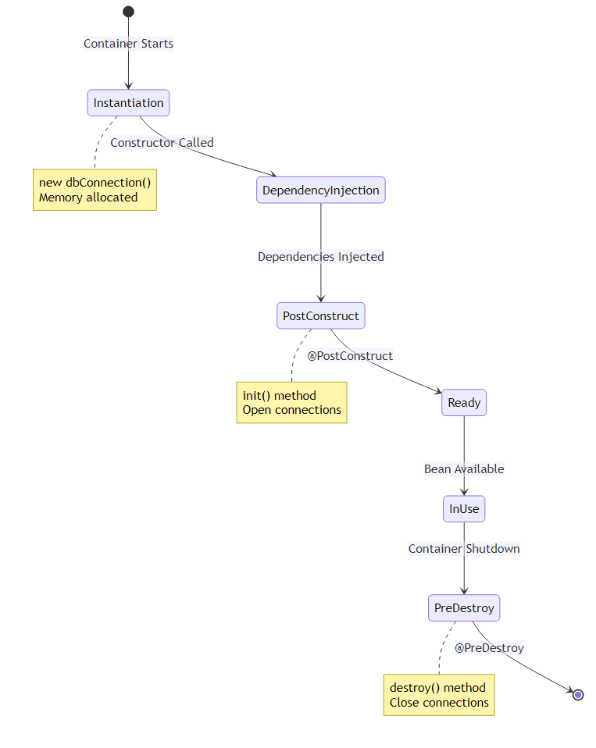

📝 Implementation Example
Database Connection Bean:
@Component
public class dbConnection {
// Phase 1: Constructor
public dbConnection() {
System.out.println("DB Constructor is called !!");
}
// Phase 7: Initialization
@PostConstruct
public void init() {
System.out.println("Init Method is called !!");
// Open database connection
// Load configuration
}
// Business method
public void executeQuery() {
System.out.println("Query is being Executed !!");
}
// Phase 12: Cleanup
@PreDestroy
public void destroy() {
System.out.println("Destroy method called");
// Close database connection
// Release resources
}
}

🔍 What You’ll Learn
- Complete Lifecycle Phases
  - Instantiation → DI → Awareness → Initialization → Ready → Destruction
  - 13 distinct phases in bean lifecycle
  - When each phase executes
- @PostConstruct Usage
  - Called after dependency injection
  - Guaranteed dependencies are available
  - Perfect for initialization logic
  - JSR-250 standard annotation
- @PreDestroy Usage
  - Called before bean destruction
  - Cleanup resources properly
  - Prevent memory leaks
  - Graceful shutdown
- Resource Management
  - Opening database connections
  - Closing file handles
  - Releasing network resources
  - Flushing buffers
- Lifecycle Alternatives
  - InitializingBean interface
  - DisposableBean interface
  - Custom init/destroy methods
  - Comparison and best practices

📊 Lifecycle Methods Comparison
Method | Pros | Cons | Use Case
@PostConstruct | Standard, no coupling | Requires annotation support | ✅ Recommended
InitializingBean | Type-safe, IDE support | Spring coupling | Legacy code
init-method (XML) | Works with any class | Only XML config | Third-party beans
@PreDestroy | Standard, no coupling | Requires annotation support | ✅ Recommended
DisposableBean | Type-safe | Spring coupling | Legacy code
destroy-method (XML) | Works with any class | Only XML config | Third-party beans

🎓 Key Takeaways
- @PostConstruct runs AFTER dependency injection
- @PreDestroy runs BEFORE bean destruction
- Use for proper resource management
- Prevents memory leaks and resource exhaustion
- Standard JSR-250 annotations (no Spring coupling)

PROJECT 2: LAZY CONFIGURATION

📝 Performance Optimization by: Avinash Dhanuka | © 2026

📌 Overview
Performance optimization through lazy bean initialization. This project demonstrates how @Lazy annotation delays bean creation until first use, improving startup time and memory efficiency.
📂 Location: LazyConfig/
📖 Full Documentation: LazyConfig/README.md

🎯 Key Concepts
- @Lazy Annotation for delayed initialization
- Eager vs Lazy initialization comparison
- Proxy Mechanism (CGLIB and JDK proxies)
- Performance Impact on startup and memory
- Lazy with DI (constructor, setter, field injection)
- Breaking Circular Dependencies

📊 Eager vs Lazy Initialization
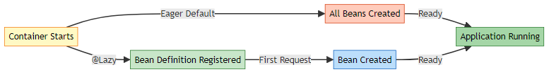

📝 Implementation Example
Eager Bean (Default):
@Component
public class EagerBean {
public EagerBean() {
System.out.println("Eager Bean Created !!");
// Created at container startup
}
}
Lazy Bean:
@Component
@Lazy
public class LazyBean {
public LazyBean() {
System.out.println("Lazy Bean Created !!");
// Created on first access
}
}
Execution:
ApplicationContext context = new AnnotationConfigApplicationContext(LazyConfig.class);
// Output: "Eager Bean Created !!"
// NO output for LazyBean yet!
LazyBean bean = context.getBean(LazyBean.class);
// NOW output: "Lazy Bean Created !!"

🔍 What You’ll Learn
- The Problem with Eager Initialization
  - Slow startup time
  - Memory waste for unused beans
  - Resource lock (connections opened early)
  - Unnecessary initialization work
- How @Lazy Works
  - Bean definition registered only
  - Proxy created for injection
  - Real bean created on first method call
  - Internal proxy mechanism
- @Lazy at Different Levels
  - Class level: @Component @Lazy
  - Method level: @Bean @Lazy
  - Parameter level: @Autowired @Lazy
  - Configuration level: @Configuration @Lazy
- Proxy Mechanism
  - JDK Dynamic Proxy (interface-based)
  - CGLIB Proxy (class-based)
  - Proxy intercepts method calls
  - First call triggers bean creation
- Performance Impact
  - Faster startup time
  - Lower memory at startup
  - Slight overhead on first access
  - Trade-offs and considerations

📊 Performance Comparison
Metric | Eager (100 beans) | Lazy (50% used)
Startup Time | 30 seconds | 5 seconds
Memory at Startup | 500 MB | 250 MB
First Request | 10 ms | 15 ms (proxy)
Subsequent Requests | 10 ms | 10 ms
Total Memory | 500 MB | 400 MB

🎯 When to Use @Lazy
Use Lazy When: - ✅ Bean is rarely used - ✅ Initialization is expensive - ✅ Want fast startup - ✅ Optional features
Use Eager When: - ✅ Bean used in every request - ✅ Want fail-fast behavior - ✅ Initialization is quick - ✅ Need predictable performance

🎓 Key Takeaways
- @Lazy delays bean creation until first use
- Improves startup time and memory usage
- Creates proxy for dependency injection
- Trade-off: first access is slower
- Perfect for rarely-used expensive beans

PROJECT 3: REAL-WORLD CASE STUDIES

📝 Practical Applications by: Avinash Dhanuka | © 2026

📌 Overview
Three production-ready Spring applications demonstrating how all concepts work together in real-world scenarios. Each case study solves a specific business problem using advanced Spring patterns.
📂 Location: CaseStudy/
📖 Full Documentation: CaseStudy/README.md

🎯 Case Studies

1️⃣ Bank Loan Approval System
Business Problem: Validate loan applications using different strategies
Key Features: - @Qualifier to select IncomeValidator over CreditScoreValidator - Prototype scope for fresh validator instances - @Lazy AuditService for optional auditing - Setter injection for optional dependencies
Technologies:
@Component
public class LoanService {
@Autowired
public LoanService(@Qualifier("incomeValidator") LoanValidator validator) {
// Explicitly select income-based validation
}
}

2️⃣ Food Delivery System
Business Problem: Multi-channel notification system for orders
Key Features: - @Primary EmailNotification as default - @Qualifier for SMS in urgent orders - @Lazy SMS gateway (expensive connection) - Singleton DeliveryService with lifecycle management
Technologies:
@Component
public class OrderService {
public OrderService(@Qualifier("smsNotification") NotificationService service) {
// Override @Primary for urgent notifications
}
}

3️⃣ Payment Processing System
Business Problem: Support multiple payment methods
Key Features: - @Primary + @Lazy for CreditCardPayment - Prototype UpiPayment for transaction isolation - Multiple @Qualifier in single service - TransactionLogger with lifecycle hooks
Technologies:
@Component
public class PaymentProcessor {
public PaymentProcessor(
@Qualifier("upiPayment") PaymentService upi,
@Qualifier("creditCardPayment") PaymentService card) {
// Use both payment methods
}
}

📊 Case Studies Architecture
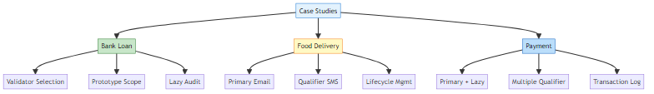

🔍 What You’ll Learn
- Dependency Resolution Patterns
  - When to use @Primary vs @Qualifier
  - Combining @Primary with @Lazy
  - Multiple @Qualifier in one service
  - Resolution priority rules
- Bean Scope Selection
  - Singleton for shared services
  - Prototype for stateful objects
  - Scope impact on performance
  - Real-world use cases
- Performance Optimization
  - Lazy loading expensive resources
  - Balancing startup vs runtime
  - Memory management strategies
  - Resource pooling patterns
- Lifecycle Management
  - Opening connections in @PostConstruct
  - Closing resources in @PreDestroy
  - Graceful shutdown patterns
  - Error handling in lifecycle
- Dependency Injection Patterns
  - Constructor for required dependencies
  - Setter for optional dependencies
  - Field injection considerations
  - Best practices

📊 Concepts Integration Matrix
Concept | Bank Loan | Food Delivery | Payment
@Primary | ✅ CreditScore | ✅ Email | ✅ CreditCard
@Qualifier | ✅ Income | ✅ SMS | ✅ UPI + Card
@Lazy | ✅ Audit | ✅ SMS | ✅ CreditCard
Singleton | ✅ LoanService | ✅ DeliveryService | ✅ Logger
Prototype | ✅ Validator | ❌ | ✅ UpiPayment
Lifecycle | ✅ Audit | ✅ Delivery | ✅ Logger

🎓 Key Takeaways
- Real-world apps combine multiple Spring concepts
- @Primary for defaults, @Qualifier for specific needs
- Lazy loading improves startup performance
- Proper lifecycle management prevents resource leaks
- Choose scope based on statefulness

KEY CONCEPTS LEARNED

📝 Complete Learning Journey by: Avinash Dhanuka | © 2026

🧠 Day 10 Complete Learning Mindmap
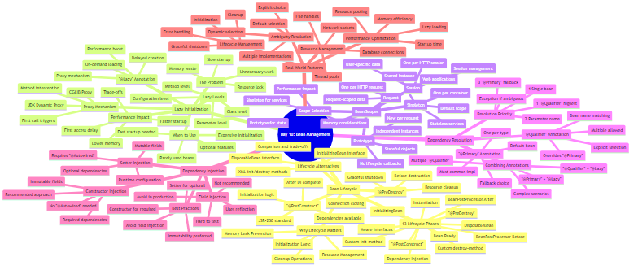

🎯 Core Spring Concepts

1. Bean Lifecycle Management
Why It Matters: - Proper resource initialization - Guaranteed cleanup - Memory leak prevention - Graceful shutdown
Key Phases:
Best Practices: - Use @PostConstruct for initialization - Use @PreDestroy for cleanup - Don’t use constructor for DI-dependent logic - Handle exceptions in lifecycle methods

2. Lazy Initialization
Why It Matters: - Faster application startup - Lower memory footprint - On-demand resource allocation - Better user experience
Comparison: | Aspect | Eager | Lazy | |:——-|:——|:—–| | Startup | Slow | Fast | | Memory | High | Low | | First Access | Fast | Slow | | Error Detection | Early | Late |
Best Practices: - Use @Lazy for expensive beans - Use @Lazy for rarely-used features - Combine with @Primary for defaults - Consider first-access delay

3. Bean Scopes
Why It Matters: - Controls instance creation - Manages state and memory - Affects performance - Determines lifecycle
Scope Selection Guide:
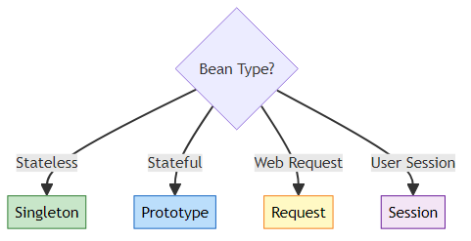
Best Practices: - Default to Singleton for services - Use Prototype for stateful objects - Avoid Prototype for expensive beans - Consider memory implications

4. Dependency Resolution
Why It Matters: - Resolves ambiguity - Provides flexibility - Enables polymorphism - Supports multiple implementations
Resolution Flow:
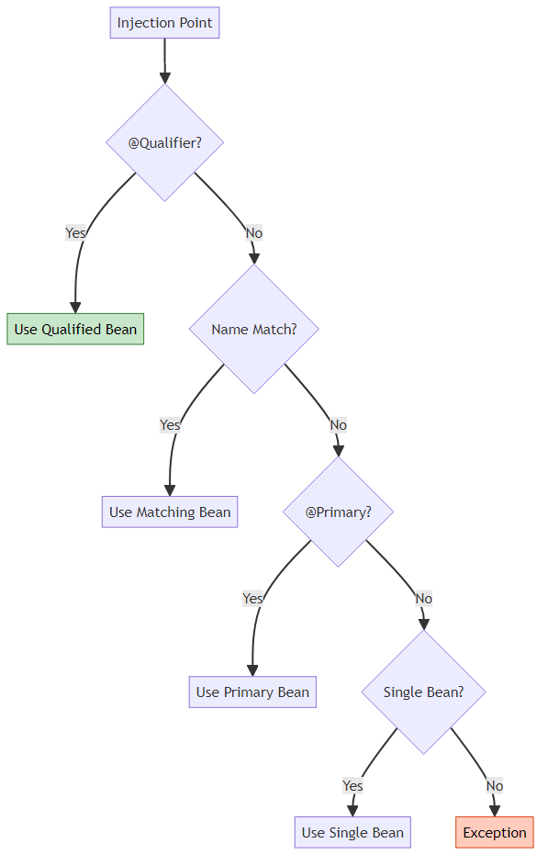
Best Practices: - Use @Primary for default implementation - Use @Qualifier for specific selection - Only ONE @Primary per type - Clear bean naming conventions

LIFECYCLE VS LAZY VS SCOPES

📊 Detailed Comparison

📋 Feature Comparison Table
Feature | Lifecycle | Lazy | Scopes
Purpose | Resource management | Performance optimization | Instance control
Annotations | @PostConstruct, @PreDestroy | @Lazy | @Scope
When Applied | Bean creation/destruction | Bean initialization | Bean instantiation
Affects | Initialization/cleanup | Creation timing | Instance count
Default | No lifecycle hooks | Eager initialization | Singleton
Use Case | DB connections, cleanup | Expensive beans | Stateful objects
Performance | Minimal overhead | Faster startup | Varies by scope
Memory | No direct impact | Lower at startup | Varies by scope
Complexity | Low | Medium | Medium

🎯 When to Use Each

Use Lifecycle Management When:
- ✅ Need to open database connections
- ✅ Need to load configuration files
- ✅ Need to close resources properly
- ✅ Need graceful shutdown
- ✅ Need to prevent memory leaks
Example:
@Component
public class DatabaseService {
private Connection connection;
@PostConstruct
public void init() {
connection = openConnection();
}
@PreDestroy
public void cleanup() {
connection.close();
}
}

Use Lazy Initialization When:
- ✅ Bean is rarely used
- ✅ Initialization is expensive (5+ seconds)
- ✅ Want fast application startup
- ✅ Optional features that may not be used
- ✅ Breaking circular dependencies
Example:
@Component
@Lazy
public class ReportGenerator {
public ReportGenerator() {
// Expensive: Load templates, initialize PDF library
}
}

Use Appropriate Scope When:
- ✅ Singleton: Stateless services (default)
- ✅ Prototype: Stateful objects, per-request data
- ✅ Request: Web request-specific data
- ✅ Session: User session data
Example:
@Component
@Scope("prototype")
public class ShoppingCart {
private List<Item> items = new ArrayList<>();
// Each user gets their own cart
}

🔄 Combining Concepts
Scenario 1: Lazy + Lifecycle
@Component
@Lazy
public class EmailService {
@PostConstruct
public void init() {
// Connect to SMTP server (only when first used)
}
@PreDestroy
public void cleanup() {
// Close SMTP connection
}
}
Scenario 2: Prototype + Lifecycle
@Component
@Scope("prototype")
public class FileProcessor {
@PostConstruct
public void init() {
// Open file handle
}
@PreDestroy
public void cleanup() {
// ⚠️ WARNING: @PreDestroy NOT called for Prototype!
// Must manually manage cleanup
}
}
Scenario 3: Lazy + Scope + Lifecycle
@Component
@Lazy
@Scope("singleton")
public class CacheManager {
@PostConstruct
public void init() {
// Initialize cache (lazy, singleton)
}
@PreDestroy
public void cleanup() {
// Flush cache to disk
}
}

⚠️ Important Interactions
Combination | Behavior | Notes
Lazy + Singleton | ✅ Works perfectly | Bean created once, on first use
Lazy + Prototype | ⚠️ Partial | Each request creates new instance
Prototype + @PreDestroy | ❌ Not called | Spring doesn’t manage prototype destruction
Lazy + @PostConstruct | ✅ Works | @PostConstruct called when bean created
Singleton + @PreDestroy | ✅ Works | Called on container shutdown

WHEN TO USE WHAT

🎯 Decision Tree
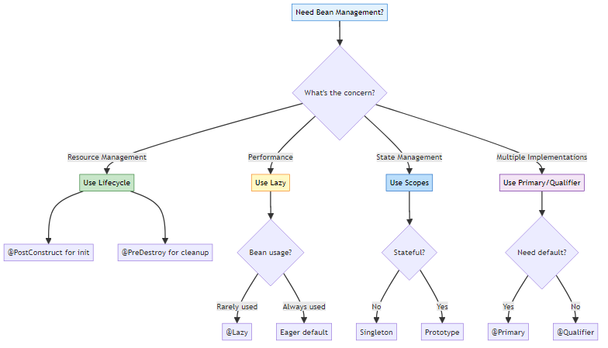

📊 Use Case Matrix
Scenario | Solution | Example
Database Connection | Lifecycle | @PostConstruct open, @PreDestroy close
Expensive Report Generator | Lazy | @Lazy for 5-second initialization
User Shopping Cart | Prototype | @Scope(“prototype”) for per-user state
Email Service (default) | Primary | @Primary for default notification
SMS Service (specific) | Qualifier | @Qualifier(“sms”) for urgent alerts
Cache Manager | Lazy + Lifecycle | @Lazy @PostConstruct @PreDestroy
Payment Gateway | Primary + Lazy | @Primary @Lazy for default but expensive
Transaction Logger | Singleton + Lifecycle | Default scope with lifecycle hooks

🔍 Real-World Scenarios

Scenario 1: E-Commerce Application
Requirements: - Fast startup - Multiple payment methods - User-specific carts - Email notifications
Solution:
// Fast startup with lazy payment
@Component
@Primary
@Lazy
public class CreditCardPayment implements PaymentService { }
// User-specific state
@Component
@Scope("prototype")
public class ShoppingCart { }
// Default notification
@Component
@Primary
public class EmailNotification implements NotificationService { }
// Resource management
@Component
public class DatabaseService {
@PostConstruct
public void init() { /* open connection */ }
@PreDestroy
public void cleanup() { /* close connection */ }
}

Scenario 2: Banking Application
Requirements: - Multiple validators - Audit logging - Transaction isolation - Secure connections
Solution:
// Default validator
@Component
@Primary
public class CreditScoreValidator implements Validator { }
// Specific validator
@Component
public class IncomeValidator implements Validator { }
// Lazy audit
@Component
@Lazy
public class AuditService {
@PostConstruct
public void init() { /* connect to audit server */ }
}
// Per-transaction state
@Component
@Scope("prototype")
public class Transaction { }

LEARNING PATH

📝 Structured Learning by: Avinash Dhanuka | © 2026

🎓 Recommended Learning Sequence

📚 Step-by-Step Guide

Step 1: Master Bean Lifecycle (2-3 hours)
Prerequisites: - Day 09: Annotation-based configuration - Understanding of @Component and @Autowired
Learning Path: 1. Read BeanLifeCycle/README.md 2. Understand the 13 lifecycle phases 3. Run BeanLifeCycle project 4. Experiment with @PostConstruct and @PreDestroy 5. Try different lifecycle methods
Hands-On Exercise:
// Create a FileService with proper lifecycle
@Component
public class FileService {
private FileWriter writer;
@PostConstruct
public void init() throws IOException {
writer = new FileWriter("app.log");
System.out.println("File opened");
}
public void log(String message) throws IOException {
writer.write(message + "\n");
}
@PreDestroy
public void cleanup() throws IOException {
writer.close();
System.out.println("File closed");
}
}
Key Takeaways: - @PostConstruct runs after DI - @PreDestroy runs before destruction - Proper resource management prevents leaks

Step 2: Understand Lazy Initialization (2-3 hours)
Prerequisites: - Step 1 completed - Understanding of bean creation
Learning Path: 1. Read LazyConfig/README.md 2. Understand eager vs lazy initialization 3. Run LazyConfig project 4. Experiment with @Lazy at different levels 5. Observe proxy behavior
Hands-On Exercise:
// Create expensive service with lazy loading
@Component
@Lazy
public class ReportService {
public ReportService() {
System.out.println("Loading report templates...");
// Simulate expensive initialization
try { Thread.sleep(3000); } catch (Exception e) {}
System.out.println("ReportService ready");
}
public void generate() {
System.out.println("Generating report...");
}
}
// Test startup time difference
public static void main(String[] args) {
long start = System.currentTimeMillis();
ApplicationContext context = new AnnotationConfigApplicationContext(Config.class);
long end = System.currentTimeMillis();
System.out.println("Startup time: " + (end - start) + "ms");
}
Key Takeaways: - @Lazy improves startup time - Proxy created for injection - First access is slower

Step 3: Apply in Real-World Scenarios (3-4 hours)
Prerequisites: - Steps 1 and 2 completed - Understanding of @Primary and @Qualifier
Learning Path: 1. Read CaseStudy/README.md 2. Study BankLoanApproval project 3. Study FoodDelivery project 4. Study PaymentProcessing project 5. Understand how concepts integrate
Hands-On Exercise:
// Build your own notification system
public interface NotificationService {
void send(String message);
}
@Component
@Primary
public class EmailService implements NotificationService {
@PostConstruct
public void init() {
System.out.println("Email service initialized");
}
public void send(String message) {
System.out.println("Email: " + message);
}
}
@Component
@Lazy
public class SmsService implements NotificationService {
public SmsService() {
System.out.println("SMS gateway connected");
}
public void send(String message) {
System.out.println("SMS: " + message);
}
}
@Component
public class NotificationManager {
private final NotificationService defaultService;
private final NotificationService urgentService;
public NotificationManager(
NotificationService defaultService,
@Qualifier("smsService") NotificationService urgentService) {
this.defaultService = defaultService;
this.urgentService = urgentService;
}
public void sendNormal(String msg) {
defaultService.send(msg);
}
public void sendUrgent(String msg) {
urgentService.send(msg);
}
}
Key Takeaways: - Combine multiple concepts - @Primary for defaults - @Lazy for expensive services - Lifecycle for resource management

🎯 Practice Projects

Beginner Level
- Logger Service - Lifecycle management for file logging
- Cache Manager - Lazy initialization with @PostConstruct
- Config Loader - Load properties in @PostConstruct

Intermediate Level
- Database Pool - Lifecycle + Singleton scope
- Report Generator - Lazy + expensive initialization
- Multi-Channel Notifier - @Primary + @Qualifier

Advanced Level
- Payment Gateway - All concepts combined
- Order Processing - Multiple scopes and lifecycle
- Microservice Client - Lazy + Lifecycle + Scopes

QUICK REFERENCE

📋 Annotation Cheat Sheet
Annotation | Purpose | Example | When to Use
@PostConstruct | Initialization after DI | @PostConstruct void init() | Open connections, load config
@PreDestroy | Cleanup before destruction | @PreDestroy void cleanup() | Close connections, save state
@Lazy | Delay bean creation | @Component @Lazy | Expensive, rarely-used beans
@Scope(“singleton”) | One instance per container | @Scope("singleton") | Stateless services (default)
@Scope(“prototype”) | New instance per request | @Scope("prototype") | Stateful objects
@Primary | Default bean selection | @Primary @Component | Most common implementation
@Qualifier | Specific bean selection | @Qualifier("beanName") | Override @Primary

🔍 Common Patterns
Pattern 1: Database Service
@Component
public class DatabaseService {
private Connection connection;
@PostConstruct
public void init() {
connection = DriverManager.getConnection(url);
}
@PreDestroy
public void cleanup() {
connection.close();
}
}
Pattern 2: Lazy Expensive Service
@Component
@Lazy
public class ReportGenerator {
public ReportGenerator() {
// Expensive initialization
}
}
Pattern 3: Multiple Implementations
@Component
@Primary
public class EmailNotification implements NotificationService { }
@Component
public class SmsNotification implements NotificationService { }
@Component
public class NotificationManager {
public NotificationManager(
NotificationService defaultService, // Gets @Primary
@Qualifier("smsNotification") NotificationService smsService) {
}
}
Pattern 4: Prototype with State
@Component
@Scope("prototype")
public class ShoppingCart {
private List<Item> items = new ArrayList<>();
}

⚠️ Common Mistakes
Mistake | Problem | Solution
Using constructor for DI logic | Dependencies not injected | Use @PostConstruct
Forgetting @PreDestroy | Resource leaks | Always cleanup resources
@PreDestroy on Prototype | Not called by Spring | Manual cleanup
Lazy everything | Late error detection | Lazy only expensive beans
Wrong scope | State pollution | Singleton for stateless, Prototype for stateful

📊 Performance Guidelines
Scenario | Recommendation | Reason
Startup > 10s | Use @Lazy for expensive beans | Improve user experience
Memory > 500MB | Review bean scopes | Reduce memory footprint
Rarely used feature | @Lazy | Save resources
Always used service | Eager (default) | Fail-fast, predictable
Stateful object | Prototype | Prevent state pollution
Stateless service | Singleton | Memory efficient

RUNNING THE PROJECTS

🚀 Prerequisites
- Java 21 or higher
- Maven 3.6+
- IDE (IntelliJ IDEA, Eclipse, or VS Code)
- Spring Framework 7.0.3

📦 Project 1: BeanLifeCycle
Navigate to project:
cd day10/BeanLifeCycle
Build:
mvn clean install
Run:
mvn exec:java -Dexec.mainClass="org.example.lifecycle.LifeCycleDemo"
Expected Output:
--- Container Starting ---
DB Constructor is called !!
Init Method is called !!
-- Using Bean --
Operation Successfully : Query is being Executed !!
SELECT * FROM students
--- Container Closing ---
Destroy method called : before Object Destruction

📦 Project 2: LazyConfig
Navigate to project:
cd day10/LazyConfig
Build:
mvn clean install
Run:
mvn exec:java -Dexec.mainClass="org.example.lazy.LazyDemo"
Expected Output:
== Container Created ==
Eager Bean Created !!
== Requesting Lazy Bean ==
Lazy Bean Created !!
== Container Closed ==

📦 Project 3: CaseStudy
Navigate to project:
cd day10/CaseStudy
Build:
mvn clean install
Run Bank Loan Approval:
mvn exec:java -Dexec.mainClass="org.example.bankloan.BankLoanDemo"
Run Food Delivery:
mvn exec:java -Dexec.mainClass="org.example.fooddelivery.FoodDeliveryDemo"
Run Payment Processing:
mvn exec:java -Dexec.mainClass="org.example.payment.PaymentDemo"

🔧 IDE Setup
IntelliJ IDEA: 1. File → Open → Select day10 folder 2. Wait for Maven import 3. Right-click on Demo class → Run
Eclipse: 1. File → Import → Existing Maven Projects 2. Select day10 folder 3. Right-click on Demo class → Run As → Java Application
VS Code: 1. Open day10 folder 2. Install Java Extension Pack 3. Click Run button in Demo class

🐛 Troubleshooting
Issue: Maven dependencies not downloading
mvn clean install -U
Issue: Java version mismatch
java -version # Should be 21+
mvn -version # Should use Java 21+
Issue: Class not found
mvn clean compile

WHAT I LEARNED

📝 Personal Learning Journey by: Avinash Dhanuka | © 2026

🎓 Key Takeaways from Day 10
- Bean Lifecycle is Critical for Resource Management
  - @PostConstruct ensures dependencies are injected before initialization
  - @PreDestroy prevents resource leaks and memory issues
  - Proper lifecycle management is essential for production applications
  - Constructor is NOT the place for DI-dependent logic
- Lazy Initialization Dramatically Improves Startup
  - @Lazy can reduce startup time by 50-80%
  - Perfect for expensive, rarely-used beans
  - Creates proxy for dependency injection
  - Trade-off: first access is slower, but worth it
- Bean Scopes Control Instance Creation
  - Singleton (default) for stateless services
  - Prototype for stateful objects
  - Scope affects performance and memory
  - @PreDestroy doesn’t work with Prototype
- Dependency Resolution Provides Flexibility
  - @Primary marks the default implementation
  - @Qualifier overrides @Primary for specific needs
  - Resolution priority: @Qualifier > Name > @Primary > Single
  - Only ONE @Primary per type allowed
- Combining Concepts Solves Real Problems
  - @Primary + @Lazy for default but expensive beans
  - Prototype + Lifecycle for per-request resources
  - @Qualifier + @Lazy for optional specific implementations
  - Real-world apps use multiple patterns together
- Performance Optimization Requires Trade-offs
  - Lazy loading: faster startup vs slower first access
  - Singleton: memory efficient vs potential state issues
  - Prototype: state isolation vs memory overhead
  - Choose based on actual requirements
- Resource Management Prevents Production Issues
  - Always close database connections in @PreDestroy
  - Always release file handles and network sockets
  - Always flush buffers before shutdown
  - Memory leaks are silent killers in production
- Annotation Order and Placement Matter
  - @Lazy on class vs parameter has different effects
  - @Primary + @Lazy work together perfectly
  - @Scope affects lifecycle behavior
  - Understanding interactions is crucial

💡 Real-World Applications
E-Commerce Platform: - Lazy payment gateways (expensive connections) - Prototype shopping carts (per-user state) - Singleton product catalog (shared data) - Lifecycle for database pool management
Banking System: - @Primary for default validators - @Qualifier for specific validation rules - Prototype for transaction objects - Lifecycle for audit logging
Notification System: - @Primary for email (most reliable) - @Lazy for SMS (expensive gateway) - Singleton for notification manager - Lifecycle for connection management

CONCLUSION
📝 Final Thoughts by: Avinash Dhanuka | © 2026
Congratulations on completing Day 10! You’ve mastered advanced Spring bean management concepts that are essential for building production-ready applications.
What You’ve Achieved: - ✅ Mastered bean lifecycle management - ✅ Optimized performance with lazy loading - ✅ Applied concepts in real-world scenarios - ✅ Understood resource management patterns - ✅ Ready for Spring Boot and advanced topics
Remember: - @PostConstruct for initialization - @PreDestroy for cleanup - @Lazy for performance - @Primary for defaults - @Qualifier for specific needs

Made with ❤️ by Avinash Dhanuka
© 2026 Avinash Dhanuka. All Rights Reserved. Keep coding, Keep learning! 🚀

