☕ Spring Framework: @Lazy Annotation - Complete Deep Dive

© 2026 Avinash Dhanuka
Master Guide: Spring @Lazy Annotation
Crafted with ❤️ for Performance Optimization

Learning Note: This guide demonstrates Spring’s @Lazy annotation - a powerful performance optimization technique that delays bean initialization until first use. Master lazy loading to build faster, more efficient Spring applications.
Prerequisites: - Understanding of Spring IoC Container - Knowledge of @Component and @Autowired - Basic Spring configuration concepts - Bean lifecycle awareness

📑 Table of Contents
- What is @Lazy Annotation?
- The Problem: Eager Initialization
- How @Lazy Works
- Eager vs Lazy Initialization
- @Lazy at Different Levels
- Proxy Mechanism
- Internal Working Deep Dive
- Lazy with Dependency Injection
- Lazy with @Primary and @Qualifier
- Performance Impact
- Thread Safety Considerations
- Project Implementation
- Real-World Examples
- Best Practices
- Common Pitfalls
- Interview Questions

1. WHAT IS @LAZY ANNOTATION?

📝 Author: Avinash Dhanuka | GitHub

📌 Definition
@Lazy is a Spring annotation that indicates whether a bean should be lazily initialized. When applied, the bean is NOT created when the ApplicationContext starts, but only when it’s first requested.
Simple Analogy: - Eager (Default): Like preparing all dishes before guests arrive - Lazy: Like cooking dishes only when guests order them - Result: Faster startup, on-demand resource allocation

🎯 Core Concept
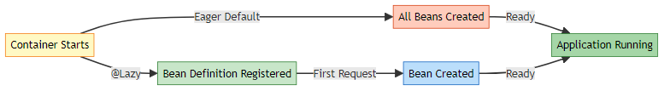

📊 Basic Example
Reference: LazyBean.java
Without @Lazy (Eager - Default):
@Component
public class EagerBean {
public EagerBean() {
System.out.println("Eager Bean Created !!");
}
}
With @Lazy:
@Component
@Lazy
public class LazyBean {
public LazyBean() {
System.out.println("Lazy Bean Created !!");
}
}
Execution:
ApplicationContext context = new AnnotationConfigApplicationContext(LazyConfig.class);
// Output: "Eager Bean Created !!"
// NO output for LazyBean - not created yet!
LazyBean bean = context.getBean(LazyBean.class);
// NOW output: "Lazy Bean Created !!"

2. THE PROBLEM: EAGER INITIALIZATION

📌 Default Spring Behavior
By default, Spring creates ALL singleton beans at container startup (eager initialization).

🎯 Problems with Eager Initialization
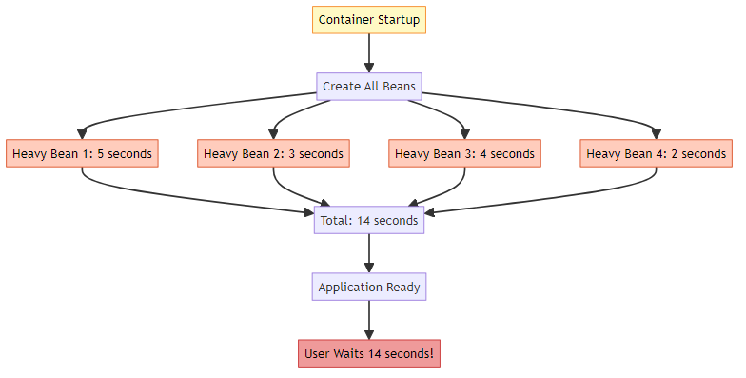

⚠️ Issues
Issue | Description | Impact
Slow Startup | All beans created at once | Long wait time
Memory Waste | Unused beans consume memory | Higher memory footprint
Resource Lock | Database connections opened early | Resource exhaustion
Unnecessary Work | Rarely used beans initialized | Wasted CPU cycles

📊 Real-World Scenario
Example: E-Commerce Application
@Component
public class EmailService {
public EmailService() {
// Connect to SMTP server (2 seconds)
// Load email templates (1 second)
System.out.println("EmailService initialized - 3 seconds");
}
}
@Component
public class ReportGenerator {
public ReportGenerator() {
// Load report templates (5 seconds)
// Initialize PDF library (3 seconds)
System.out.println("ReportGenerator initialized - 8 seconds");
}
}
@Component
public class DataExporter {
public DataExporter() {
// Initialize Excel library (4 seconds)
System.out.println("DataExporter initialized - 4 seconds");
}
}
Problem: - Application takes 15 seconds to start - User only needs product browsing (doesn’t need reports/export immediately) - Resources wasted on unused features

3. HOW @LAZY WORKS

📌 Lazy Initialization Process
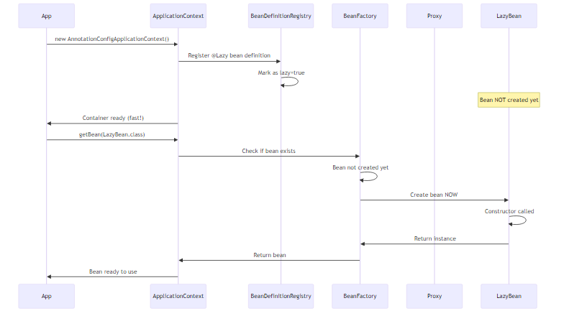

🔍 Step-by-Step Execution
Reference: LazyDemo.java
Step 1: Container Creation
System.out.println("== Container Created ==");
ApplicationContext context = new AnnotationConfigApplicationContext(LazyConfig.class);
What Happens: 1. Spring scans for @Component classes 2. Finds EagerBean (no @Lazy) → Creates immediately 3. Finds LazyBean (@Lazy) → Registers definition only 4. Container ready
Output:
== Container Created ==
Eager Bean Created !!
Step 2: First Bean Request
LazyBean lazyBean = context.getBean(LazyBean.class);
What Happens: 1. Spring checks if bean exists 2. Bean not created yet 3. Creates bean NOW 4. Returns instance
Output:
Lazy Bean Created !!

📊 Timing Comparison
Scenario | Eager | Lazy
Container Startup | 10 seconds | 1 second
First Bean Access | Instant | 9 seconds
Total Time | 10 seconds | 10 seconds
User Experience | Wait at startup | Fast startup, wait on use

4. EAGER VS LAZY INITIALIZATION

📊 Detailed Comparison
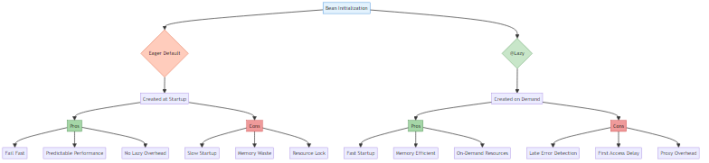

📋 Feature Comparison Table
Feature | Eager (Default) | Lazy (@Lazy)
Creation Time | Container startup | First access
Startup Speed | ❌ Slower | ✅ Faster
Memory Usage | ❌ Higher (all beans) | ✅ Lower (only used)
Error Detection | ✅ Immediate | ❌ Delayed
First Access | ✅ Fast | ❌ Slower
Predictability | ✅ High | ⚠️ Medium
Resource Management | ❌ Early allocation | ✅ On-demand
Proxy Overhead | ❌ None | ⚠️ Yes (for injection)
Thread Safety | ✅ Safe | ⚠️ First access race
Use Case | Always-used beans | Rarely-used beans

🎯 When to Use Each
Use Eager (Default) When: - ✅ Bean is used in every request - ✅ Want fail-fast behavior - ✅ Initialization is quick - ✅ Need predictable performance
Use Lazy When: - ✅ Bean is rarely used - ✅ Initialization is expensive - ✅ Want fast startup - ✅ Optional features that may not be used

📊 Performance Metrics
Scenario: 100 Beans Application
Metric | Eager | Lazy (50% used)
Startup Time | 30 seconds | 5 seconds
Memory at Startup | 500 MB | 250 MB
First Request | 10 ms | 15 ms (proxy)
Subsequent Requests | 10 ms | 10 ms
Total Memory (after use) | 500 MB | 400 MB

5. @LAZY AT DIFFERENT LEVELS

📌 Where Can @Lazy Be Applied?
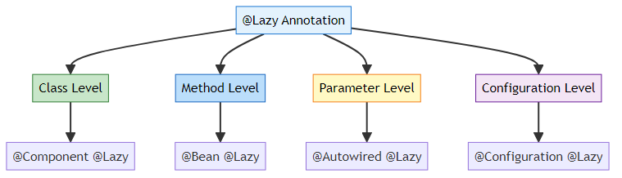

1️⃣ Class Level @Lazy
Reference: LazyBean.java:7
@Component
@Lazy
public class LazyBean {
public LazyBean() {
System.out.println("Lazy Bean Created !!");
}
}
Behavior: - Bean is NOT created at container startup - Created when first requested via getBean() or injection - Applies to the entire bean

2️⃣ Method Level @Lazy (@Bean)
@Configuration
public class AppConfig {
@Bean
@Lazy
public DataSource dataSource() {
System.out.println("DataSource created");
return new HikariDataSource();
}
}
Behavior: - Bean method not invoked at startup - Invoked when bean is first requested - Useful for expensive third-party beans

3️⃣ Parameter Level @Lazy (Injection)
@Component
public class UserService {
private final ReportGenerator reportGenerator;
@Autowired
public UserService(@Lazy ReportGenerator reportGenerator) {
this.reportGenerator = reportGenerator; // Proxy injected
System.out.println("UserService created");
}
public void generateReport() {
reportGenerator.generate(); // NOW ReportGenerator is created
}
}
Behavior: - UserService created immediately - ReportGenerator NOT created - Proxy injected instead - Real bean created when method called
Key Point: This is the most powerful use case!

4️⃣ Configuration Level @Lazy
@Configuration
@Lazy
public class DatabaseConfig {
@Bean
public DataSource primaryDataSource() {
return new HikariDataSource();
}
@Bean
public DataSource secondaryDataSource() {
return new HikariDataSource();
}
}
Behavior: - ALL beans in this configuration are lazy - Applies @Lazy to every @Bean method - Convenient for optional modules

📊 Level Comparison
Level | Scope | Use Case | Example
Class | Single bean | Rarely used service | @Component @Lazy
Method | Single @Bean | Third-party bean | @Bean @Lazy
Parameter | Dependency injection | Break circular deps | @Autowired @Lazy
Configuration | All beans in config | Optional module | @Configuration @Lazy

6. PROXY MECHANISM

📌 How Spring Creates Lazy Proxies
When @Lazy is used with dependency injection, Spring creates a proxy instead of the real bean.
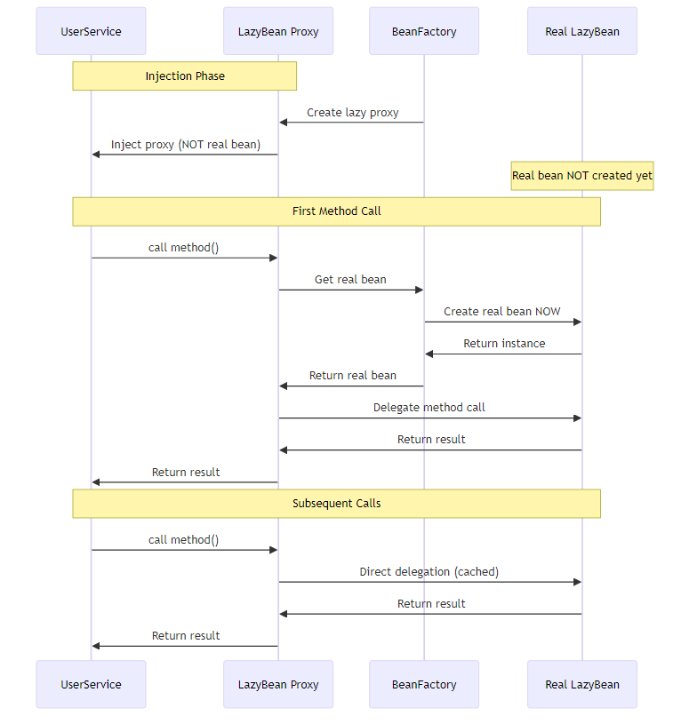

🔍 Proxy Types
Spring uses two types of proxies:
1. JDK Dynamic Proxy (Interface-based)
public interface NotificationService {
void send(String message);
}
@Component
@Lazy
public class EmailService implements NotificationService {
public void send(String message) {
System.out.println("Email: " + message);
}
}
// Spring creates JDK proxy implementing NotificationService
2. CGLIB Proxy (Class-based)
@Component
@Lazy
public class ReportGenerator { // No interface
public void generate() {
System.out.println("Generating report...");
}
}
// Spring creates CGLIB subclass proxy

📊 Proxy Behavior
@Component
public class UserService {
private final ReportGenerator reportGenerator;
@Autowired
public UserService(@Lazy ReportGenerator reportGenerator) {
System.out.println("Injected: " + reportGenerator.getClass().getName());
// Output: ReportGenerator$$EnhancerBySpringCGLIB$$12345678
this.reportGenerator = reportGenerator;
}
}
Key Points: - Proxy class name contains $$EnhancerBySpringCGLIB$$ - Proxy intercepts ALL method calls - First call triggers real bean creation - Subsequent calls go directly to real bean

⚠️ Proxy Limitations
Limitation | Description | Workaround
Final Classes | Cannot proxy final classes | Remove final or use interface
Final Methods | Cannot proxy final methods | Remove final
Private Methods | Cannot proxy private methods | Make public/protected
Self-Invocation | Proxy not used for internal calls | Use @Autowired self-reference

7. INTERNAL WORKING DEEP DIVE

📌 Complete Execution Flow
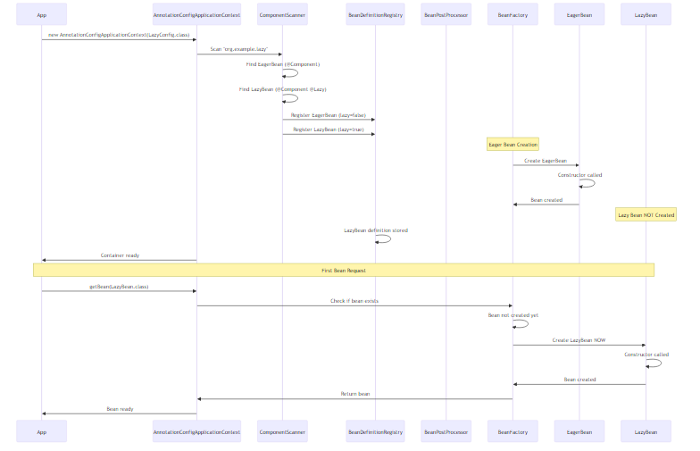

🔍 BeanDefinition Analysis
Internal BeanDefinition Structure:
// For EagerBean
BeanDefinition eagerDef = new GenericBeanDefinition();
eagerDef.setBeanClassName("org.example.lazy.EagerBean");
eagerDef.setLazyInit(false); // Default
eagerDef.setScope("singleton");
// For LazyBean
BeanDefinition lazyDef = new GenericBeanDefinition();
lazyDef.setBeanClassName("org.example.lazy.LazyBean");
lazyDef.setLazyInit(true); // @Lazy sets this
lazyDef.setScope("singleton");

📊 Spring’s Internal Decision Tree
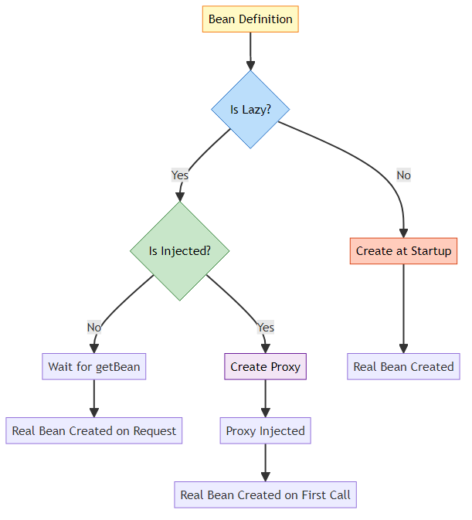

🎯 Key Internal Classes
Class | Role | Responsibility
LazyInitTargetSource | Lazy initialization | Delays bean creation
ProxyFactory | Proxy creation | Creates CGLIB/JDK proxy
AutowiredAnnotationBeanPostProcessor | @Autowired processing | Handles @Lazy injection
DefaultListableBeanFactory | Bean creation | Checks lazy flag

📝 Pseudo-Code: Spring’s Internal Logic
// Simplified Spring internal logic
public Object getBean(String beanName) {
BeanDefinition def = getBeanDefinition(beanName);
if (def.isLazyInit()) {
// Check if bean already created
if (!singletonCache.contains(beanName)) {
// Create bean NOW
Object bean = createBean(def);
singletonCache.put(beanName, bean);
return bean;
}
return singletonCache.get(beanName);
} else {
// Eager bean - should already exist
return singletonCache.get(beanName);
}
}

8. LAZY WITH DEPENDENCY INJECTION

📌 Lazy Injection Patterns

Pattern 1: Constructor Injection with @Lazy
@Component
public class OrderService {
private final EmailService emailService;
private final ReportGenerator reportGenerator;
@Autowired
public OrderService(
EmailService emailService,
@Lazy ReportGenerator reportGenerator) { // Lazy injection
this.emailService = emailService; // Created immediately
this.reportGenerator = reportGenerator; // Proxy injected
System.out.println("OrderService created");
}
public void processOrder() {
emailService.send("Order confirmed"); // Works immediately
}
public void generateReport() {
reportGenerator.generate(); // NOW ReportGenerator is created
}
}
Execution Flow:
1. Container starts
2. EmailService created
3. OrderService created
4. ReportGenerator proxy injected (NOT created)
5. processOrder() called → works fine
6. generateReport() called → ReportGenerator created NOW

Pattern 2: Setter Injection with @Lazy
@Component
public class UserService {
private NotificationService notificationService;
@Autowired
@Lazy
public void setNotificationService(NotificationService notificationService) {
this.notificationService = notificationService; // Proxy injected
}
}

Pattern 3: Field Injection with @Lazy
@Component
public class ProductService {
@Autowired
@Lazy
private InventoryService inventoryService; // Proxy injected
}

📊 Injection Behavior Comparison
Injection Type | Without @Lazy | With @Lazy
Constructor | Real bean injected | Proxy injected
Setter | Real bean injected | Proxy injected
Field | Real bean injected | Proxy injected
Bean Creation | At injection time | On first method call
Null Safety | ✅ Guaranteed | ✅ Guaranteed (proxy)

🎯 Breaking Circular Dependencies
Problem: Circular Dependency
@Component
public class A {
@Autowired
private B b; // A needs B
}
@Component
public class B {
@Autowired
private A a; // B needs A → Circular!
}
Solution: Use @Lazy
@Component
public class A {
private final B b;
@Autowired
public A(@Lazy B b) { // Proxy injected
this.b = b;
}
}
@Component
public class B {
private final A a;
@Autowired
public B(A a) {
this.a = a;
}
}
How It Works: 1. Spring creates A 2. Injects B proxy (not real B) 3. Spring creates B 4. Injects real A 5. When A calls B method → real B is created

9. LAZY WITH @PRIMARY AND @QUALIFIER

📌 Combining @Lazy with Other Annotations

Scenario 1: @Lazy with @Primary
@Component
@Primary
@Lazy
public class EmailNotificationService implements NotificationService {
public EmailNotificationService() {
System.out.println("Email service created");
}
}
@Component
public class SmsNotificationService implements NotificationService {
public SmsNotificationService() {
System.out.println("SMS service created");
}
}
@Component
public class NotificationManager {
private final NotificationService service;
@Autowired
public NotificationManager(NotificationService service) {
this.service = service; // Gets @Primary (Email) as proxy
}
}
Execution:
1. Container starts
2. SmsNotificationService created (eager)
3. NotificationManager created
4. EmailNotificationService proxy injected (NOT created)
5. First service.send() call → EmailNotificationService created

Scenario 2: @Lazy with @Qualifier
@Component
@Lazy
public class EmailNotificationService implements NotificationService { }
@Component
@Lazy
public class SmsNotificationService implements NotificationService { }
@Component
public class NotificationManager {
private final NotificationService emailService;
private final NotificationService smsService;
@Autowired
public NotificationManager(
@Qualifier("emailNotificationService") @Lazy NotificationService emailService,
@Qualifier("smsNotificationService") @Lazy NotificationService smsService) {
this.emailService = emailService; // Proxy
this.smsService = smsService; // Proxy
}
}
Behavior: - Both services are lazy - Proxies injected - Real beans created when methods called

📊 Resolution Priority with @Lazy
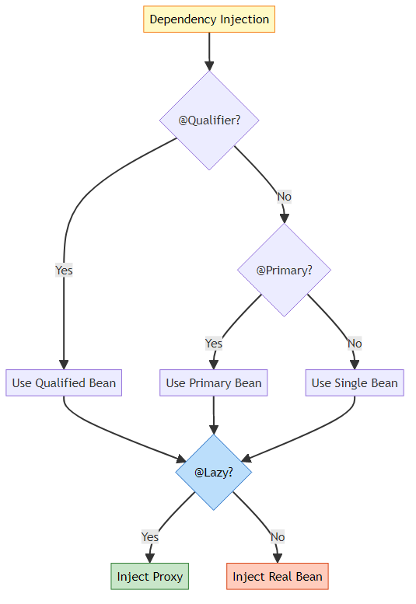
Key Point: @Lazy is applied AFTER bean selection (@Qualifier/@Primary)

10. PERFORMANCE IMPACT

📊 Startup Time Analysis
Test Scenario: 50 Beans Application
Configuration | Startup Time | Memory at Startup | First Request
All Eager | 15 seconds | 500 MB | 10 ms
50% Lazy | 8 seconds | 300 MB | 15 ms (first lazy)
All Lazy | 2 seconds | 100 MB | 20 ms (first lazy)

🎯 Performance Metrics
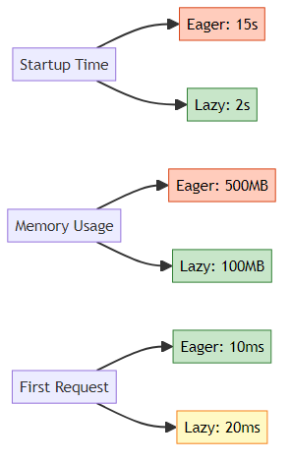

📈 Real-World Performance Test
Application: E-Commerce Platform with 100 beans
Eager Configuration:
Startup: 30 seconds
Memory: 800 MB
First page load: 50 ms
Lazy Configuration (30% lazy):
Startup: 12 seconds (60% faster!)
Memory: 500 MB (37% less)
First page load: 55 ms (10% slower)
Admin panel load: 200 ms (lazy beans created)

⚡ Proxy Overhead
Proxy Method Call Overhead: - First call: ~5-10 ms (bean creation + proxy) - Subsequent calls: ~0.1 ms (proxy delegation) - Direct call: ~0.05 ms
Overhead is negligible for: - Network calls (100+ ms) - Database queries (10+ ms) - File I/O (50+ ms)
Overhead matters for: - High-frequency method calls (millions/sec) - CPU-intensive calculations - Real-time systems

📊 Memory Footprint
Bean Memory Consumption:
Bean Type | Eager | Lazy (Unused) | Lazy (Used)
Simple Service | 1 KB | 0 KB | 1 KB + proxy (0.5 KB)
Heavy Service | 50 MB | 0 KB | 50 MB + proxy (0.5 KB)
Database Connection | 10 MB | 0 KB | 10 MB + proxy (0.5 KB)
Key Insight: Proxy overhead is minimal compared to bean size!

11. THREAD SAFETY CONSIDERATIONS

⚠️ Race Condition on First Access
Problem:
@Component
@Lazy
public class ExpensiveService {
public ExpensiveService() {
System.out.println("Creating expensive service...");
// 5 seconds initialization
}
}
@Component
public class UserService {
@Autowired
@Lazy
private ExpensiveService expensiveService;
public void process() {
expensiveService.doWork(); // Multiple threads call this
}
}
Race Condition:
Thread 1: Calls expensiveService.doWork()
Thread 2: Calls expensiveService.doWork() (simultaneously)
Both threads trigger bean creation!

✅ Spring’s Solution
Spring uses double-checked locking internally:
// Simplified Spring internal logic
public Object getBean(String beanName) {
Object bean = singletonCache.get(beanName);
if (bean == null) {
synchronized (this.singletonObjects) {
bean = singletonCache.get(beanName); // Double-check
if (bean == null) {
bean = createBean(beanName);
singletonCache.put(beanName, bean);
}
}
}
return bean;
}
Result: Only ONE bean is created, even with concurrent access.

📊 Thread Safety Guarantee
Scenario | Thread Safe? | Explanation
Singleton Lazy | ✅ Yes | Spring synchronizes creation
Prototype Lazy | ✅ Yes | New instance per request
First Access | ✅ Yes | Double-checked locking
Subsequent Access | ✅ Yes | No synchronization needed

12. PROJECT IMPLEMENTATION

📁 Project Structure
LazyConfig/
├── src/
│ └── main/
│ └── java/
│ └── org/
│ └── example/
│ ├── App.java
│ └── lazy/
│ ├── LazyConfig.java
│ ├── EagerBean.java
│ ├── LazyBean.java
│ └── LazyDemo.java
├── pom.xml
└── README.md

🔍 Code Analysis

1️⃣ Configuration Class
Reference: LazyConfig.java
@Configuration
@ComponentScan(basePackages = "org.example.lazy")
public class LazyConfig {
// Spring scans for @Component classes
}
Purpose: - Enables component scanning - Finds EagerBean and LazyBean - Registers bean definitions

2️⃣ Eager Bean (Default Behavior)
Reference: EagerBean.java
@Component
public class EagerBean {
public EagerBean() {
System.out.println("Eager Bean Created !!");
}
public void start() {
System.out.println("Bean has been started");
}
}
Behavior: - Created at container startup - No @Lazy annotation - Default Spring behavior

3️⃣ Lazy Bean
Reference: LazyBean.java
@Lazy
@Component
public class LazyBean {
public LazyBean() {
System.out.println("Lazy Bean Created !!");
}
public void start() {
System.out.println("Bean has been started : LAZY");
}
}
Behavior: - NOT created at container startup - Created when first requested - @Lazy annotation applied

4️⃣ Demo Application
Reference: LazyDemo.java
public class LazyDemo {
public static void main(String[] args) {
System.out.println("== Container Created ==");
AnnotationConfigApplicationContext context =
new AnnotationConfigApplicationContext(LazyConfig.class);
context.close();
}
}
Output:
== Container Created ==
Eager Bean Created !!
Observation: LazyBean is NOT created!

📊 Execution Flow
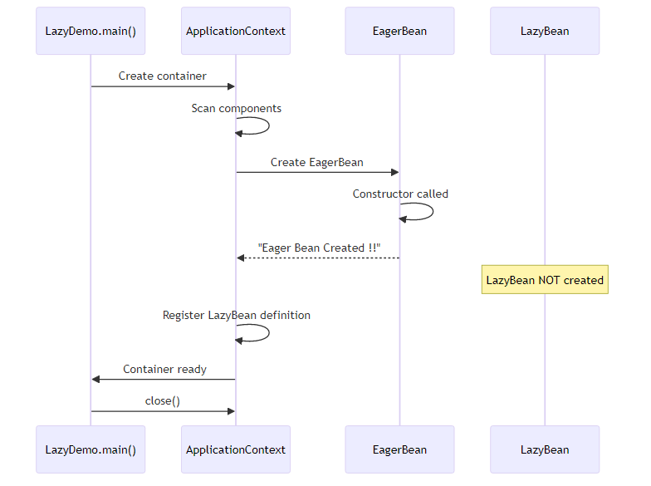

🎯 Testing Lazy Behavior
Modified Demo:
public class LazyDemo {
public static void main(String[] args) {
System.out.println("== Container Created ==");
ApplicationContext context =
new AnnotationConfigApplicationContext(LazyConfig.class);
System.out.println("\n== Requesting LazyBean ==");
LazyBean lazyBean = context.getBean(LazyBean.class);
System.out.println("\n== Using LazyBean ==");
lazyBean.start();
context.close();
}
}
Output:
== Container Created ==
Eager Bean Created !!
== Requesting LazyBean ==
Lazy Bean Created !!
== Using LazyBean ==
Bean has been started : LAZY

13. REAL-WORLD EXAMPLES

🌐 Example 1: E-Commerce Platform
// Always-used services (Eager)
@Component
public class ProductService {
// Used in every page
}
@Component
public class CartService {
// Used frequently
}
// Rarely-used services (Lazy)
@Component
@Lazy
public class ReportGenerator {
public ReportGenerator() {
// Load report templates (5 seconds)
// Initialize PDF library (3 seconds)
}
}
@Component
@Lazy
public class DataExporter {
public DataExporter() {
// Initialize Excel library (4 seconds)
}
}
@Component
@Lazy
public class EmailMarketingService {
public EmailMarketingService() {
// Connect to email service (2 seconds)
}
}
@Component
public class OrderService {
private final ProductService productService;
private final ReportGenerator reportGenerator;
@Autowired
public OrderService(
ProductService productService,
@Lazy ReportGenerator reportGenerator) {
this.productService = productService;
this.reportGenerator = reportGenerator; // Proxy
}
public void processOrder() {
productService.process(); // Works immediately
}
public void generateInvoice() {
reportGenerator.generate(); // Created NOW (admin only)
}
}
Result: - Startup: 2 seconds (instead of 16 seconds) - Regular users: Fast experience - Admin users: Slight delay on first report (acceptable)

📧 Example 2: Notification System
@Component
@Primary
public class EmailNotificationService implements NotificationService {
// Always used
}
@Component
@Lazy
public class SmsNotificationService implements NotificationService {
public SmsNotificationService() {
// Connect to SMS gateway (expensive)
}
}
@Component
@Lazy
public class PushNotificationService implements NotificationService {
public PushNotificationService() {
// Initialize push service (expensive)
}
}
@Component
public class NotificationManager {
private final NotificationService emailService;
private final NotificationService smsService;
@Autowired
public NotificationManager(
NotificationService emailService, // @Primary (eager)
@Qualifier("smsNotificationService") @Lazy NotificationService smsService) {
this.emailService = emailService;
this.smsService = smsService; // Proxy
}
public void sendEmail(String message) {
emailService.send(message); // Fast
}
public void sendSms(String message) {
smsService.send(message); // First call: slow, subsequent: fast
}
}

🏦 Example 3: Banking Application
@Component
public class AccountService {
// Core service - always needed
}
@Component
@Lazy
public class FraudDetectionService {
public FraudDetectionService() {
// Load ML models (10 seconds)
// Initialize fraud detection engine
}
}
@Component
@Lazy
public class CreditScoreService {
public CreditScoreService() {
// Connect to credit bureau API
// Load scoring models
}
}
@Component
public class TransactionService {
private final AccountService accountService;
private final FraudDetectionService fraudDetection;
@Autowired
public TransactionService(
AccountService accountService,
@Lazy FraudDetectionService fraudDetection) {
this.accountService = accountService;
this.fraudDetection = fraudDetection;
}
public void processTransaction(Transaction tx) {
accountService.debit(tx.getAmount());
if (tx.getAmount() > 10000) {
fraudDetection.check(tx); // Created only for large transactions
}
}
}

🎮 Example 4: Gaming Platform
@Component
public class PlayerService {
// Always needed
}
@Component
@Lazy
public class LeaderboardService {
public LeaderboardService() {
// Load leaderboard data from Redis (expensive)
}
}
@Component
@Lazy
public class AchievementService {
public AchievementService() {
// Load achievement definitions
// Initialize badge system
}
}
@Component
@Lazy
public class ReplayRecorder {
public ReplayRecorder() {
// Initialize video recording library
}
}
@Component
public class GameSession {
private final PlayerService playerService;
private final LeaderboardService leaderboard;
private final ReplayRecorder recorder;
@Autowired
public GameSession(
PlayerService playerService,
@Lazy LeaderboardService leaderboard,
@Lazy ReplayRecorder recorder) {
this.playerService = playerService;
this.leaderboard = leaderboard;
this.recorder = recorder;
}
public void startGame() {
playerService.loadPlayer(); // Fast
}
public void showLeaderboard() {
leaderboard.display(); // Created when user clicks leaderboard
}
public void startRecording() {
recorder.start(); // Created only if user enables recording
}
}

14. BEST PRACTICES

🎯 When to Use @Lazy

✅ Use @Lazy For:
- Expensive Initialization
- @Component
@Lazy
public class MLModelService {
public MLModelService() {
// Load 500MB ML model
}
}
- Rarely Used Features
- @Component
@Lazy
public class AdminReportService {
// Only used by admins
}
- Optional Dependencies
- @Component
public class UserService {
@Autowired
@Lazy
private Optional<AnalyticsService> analytics;
}
- Breaking Circular Dependencies
- @Component
public class A {
@Autowired
public A(@Lazy B b) { }
}
- Conditional Features
- @Component
@Lazy
@ConditionalOnProperty("feature.advanced.enabled")
public class AdvancedFeatureService { }

❌ Don’t Use @Lazy For:
- Core Services
- @Component
// NO @Lazy - always needed
public class AuthenticationService { }
- Fast Initialization
- @Component
// NO @Lazy - initializes in 1ms
public class UtilityService { }
- Fail-Fast Requirements
- @Component
// NO @Lazy - want to catch errors at startup
public class DatabaseConnectionPool { }

📊 Decision Matrix
Criteria | Use @Lazy? | Reason
Initialization > 1 second | ✅ Yes | Significant startup impact
Used in < 20% requests | ✅ Yes | Rarely needed
Optional feature | ✅ Yes | May not be used
Circular dependency | ✅ Yes | Break the cycle
Core functionality | ❌ No | Always needed
Fast initialization | ❌ No | No benefit
Fail-fast needed | ❌ No | Want early error detection
High-frequency calls | ❌ No | Proxy overhead matters

🎯 Optimization Strategy
Step 1: Measure Startup Time
long start = System.currentTimeMillis();
ApplicationContext context = new AnnotationConfigApplicationContext(Config.class);
long end = System.currentTimeMillis();
System.out.println("Startup: " + (end - start) + "ms");
Step 2: Identify Slow Beans
@Component
public class BeanCreationLogger implements BeanPostProcessor {
@Override
public Object postProcessBeforeInitialization(Object bean, String name) {
long start = System.currentTimeMillis();
// Bean creation happens here
long end = System.currentTimeMillis();
if (end - start > 100) {
System.out.println(name + " took " + (end - start) + "ms");
}
return bean;
}
}
Step 3: Apply @Lazy Selectively - Mark slow beans as @Lazy - Test application behavior - Measure improvement
Step 4: Monitor Production - Track first-access latency - Adjust @Lazy usage based on real usage patterns

15. COMMON PITFALLS

❌ Pitfall 1: Lazy Everything
Problem:
@Configuration
@Lazy // Makes ALL beans lazy
public class AppConfig {
@Bean public ServiceA serviceA() { }
@Bean public ServiceB serviceB() { }
@Bean public ServiceC serviceC() { }
}
Issue: - First request is VERY slow - Errors appear late - Unpredictable performance
Solution: Be selective with @Lazy

❌ Pitfall 2: Lazy Core Services
Problem:
@Component
@Lazy
public class DatabaseConnectionPool {
// Core service marked as lazy!
}
Issue: - First database query is slow - Connection errors appear late - Poor user experience
Solution: Keep core services eager

❌ Pitfall 3: Forgetting Proxy Behavior
Problem:
@Component
public class UserService {
@Autowired
@Lazy
private ReportService reportService;
public void init() {
if (reportService instanceof ReportService) {
// This is FALSE! It's a proxy
}
}
}
Issue: Proxy is not the actual class
Solution: Use interfaces or check with AopUtils.isAopProxy()

❌ Pitfall 4: Lazy with @PostConstruct
Problem:
@Component
@Lazy
public class CacheService {
@PostConstruct
public void init() {
// When is this called?
}
}
Issue: @PostConstruct called when bean is created (on first access)
Solution: Understand lifecycle timing

❌ Pitfall 5: Lazy Prototype Beans
Problem:
@Component
@Scope("prototype")
@Lazy
public class UserSession {
// Prototype + Lazy = Confusing
}
Issue: Prototype beans are already lazy by nature
Solution: Don’t use @Lazy with prototype

16. TOP INTERVIEW QUESTIONS

Q1: What is @Lazy annotation and why do we need it?
Answer:
@Lazy is a Spring annotation that delays bean initialization until first use, instead of creating it at container startup.
Why We Need It: 1. Faster Startup: Reduces application startup time 2. Memory Efficiency: Unused beans don’t consume memory 3. Resource Management: Expensive resources allocated on-demand 4. Circular Dependencies: Helps break circular dependency cycles
Example:
@Component
@Lazy
public class ReportGenerator {
public ReportGenerator() {
// Expensive initialization (5 seconds)
}
}
Without @Lazy: Application takes 5 extra seconds to start With @Lazy: Application starts fast, report generation delayed until needed

Q2: What happens internally when @Lazy is used with dependency injection?
Answer:
Spring creates a proxy instead of the real bean.
Internal Process: 1. Container starts 2. Spring detects @Lazy on dependency 3. Creates CGLIB/JDK proxy 4. Injects proxy (NOT real bean) 5. Real bean NOT created yet 6. First method call on proxy triggers real bean creation 7. Proxy delegates to real bean
Example:
@Component
public class UserService {
@Autowired
@Lazy
private ReportService reportService; // Proxy injected
public void generateReport() {
reportService.generate(); // NOW real bean is created
}
}
Proxy Class Name: ReportService$$EnhancerBySpringCGLIB$$12345678

Q3: Can @Lazy be used to break circular dependencies? How?
Answer:
Yes! @Lazy breaks circular dependencies by injecting a proxy.
Problem:
@Component
public class A {
@Autowired
private B b; // A needs B
}
@Component
public class B {
@Autowired
private A a; // B needs A → Circular!
}
Solution:
@Component
public class A {
private final B b;
@Autowired
public A(@Lazy B b) { // Proxy injected
this.b = b;
}
}
@Component
public class B {
private final A a;
@Autowired
public B(A a) {
this.a = a;
}
}
How It Works: 1. Spring creates A 2. Injects B proxy (not real B) 3. Spring creates B 4. Injects real A 5. When A calls B method → real B is created

Q4: What is the difference between @Lazy at class level vs parameter level?
Answer:
Level | Behavior | Use Case
Class Level | Bean itself is lazy | Rarely used bean
Parameter Level | Dependency injection is lazy | Break circular deps
Class Level:
@Component
@Lazy
public class ReportService {
// Bean created when requested via getBean()
}
Parameter Level:
@Component
public class UserService {
@Autowired
public UserService(@Lazy ReportService report) {
// UserService created immediately
// ReportService proxy injected
// Real ReportService created on first method call
}
}
Key Difference: - Class level: Affects bean creation - Parameter level: Affects dependency injection

Q5: Does @Lazy work with prototype beans?
Answer:
Technically yes, but it’s redundant.
Why? - Prototype beans are ALREADY lazy by nature - Created on every getBean() call - Not created at container startup
Example:
@Component
@Scope("prototype")
@Lazy // Redundant!
public class UserSession { }
Behavior: - Without @Lazy: Created on each getBean() call - With @Lazy: Same behavior (no difference)
Recommendation: Don’t use @Lazy with prototype beans.

Q6: What is the performance impact of @Lazy?
Answer:
Startup Performance: - ✅ Faster startup (beans not created) - ✅ Lower memory at startup
Runtime Performance: - ❌ First access is slower (bean creation + proxy) - ⚠️ Proxy overhead: ~0.1ms per call (negligible)
Metrics:
Scenario | Eager | Lazy
Startup | 15s | 3s
First Access | 10ms | 5010ms
Subsequent Access | 10ms | 10.1ms
When Overhead Matters: - High-frequency calls (millions/sec) - Real-time systems - CPU-intensive calculations
When Overhead Doesn’t Matter: - Network calls (100+ ms) - Database queries (10+ ms) - File I/O (50+ ms)

Q7: Can @Lazy cause thread safety issues?
Answer:
No, Spring handles thread safety.
Potential Issue:
@Component
@Lazy
public class ExpensiveService {
// Multiple threads call getBean() simultaneously
}
Spring’s Solution: - Uses double-checked locking - Synchronizes bean creation - Only ONE bean is created
Internal Logic:
if (bean == null) {
synchronized (lock) {
if (bean == null) { // Double-check
bean = createBean();
}
}
}
Result: Thread-safe lazy initialization

Q8: What happens if @Lazy bean initialization fails?
Answer:
Error occurs at first access, not at startup.
Example:
@Component
@Lazy
public class DatabaseService {
public DatabaseService() {
throw new RuntimeException("Database connection failed");
}
}
@Component
public class UserService {
@Autowired
@Lazy
private DatabaseService dbService;
public void saveUser() {
dbService.save(); // Exception thrown HERE
}
}
Behavior: 1. Container starts successfully 2. UserService created successfully 3. First saveUser() call → Exception thrown
Pros: - Application starts even if optional features fail
Cons: - Errors appear late (not fail-fast) - Harder to debug
Solution: Use eager initialization for critical services

Q9: Can @Lazy be used with @Primary and @Qualifier?
Answer:
Yes, they work together.
Example:
@Component
@Primary
@Lazy
public class EmailService implements NotificationService {
// Primary + Lazy
}
@Component
@Lazy
public class SmsService implements NotificationService {
// Lazy
}
@Component
public class NotificationManager {
@Autowired
public NotificationManager(
NotificationService service, // Gets @Primary (Email) as proxy
@Qualifier("smsService") @Lazy NotificationService sms) {
// Both are proxies
}
}
Resolution Order: 1. @Qualifier/@Primary selects bean 2. @Lazy determines if proxy is created
Key Point: @Lazy is applied AFTER bean selection

Q10: How do you test lazy beans?
Answer:
Challenge: Lazy beans not created until accessed
Solution 1: Force Creation
@Test
public void testLazyBean() {
ApplicationContext context = new AnnotationConfigApplicationContext(Config.class);
// Force creation
LazyBean bean = context.getBean(LazyBean.class);
assertNotNull(bean);
}
Solution 2: Test Proxy Behavior
@Test
public void testLazyInjection() {
ApplicationContext context = new AnnotationConfigApplicationContext(Config.class);
UserService service = context.getBean(UserService.class);
// Verify proxy injected
assertTrue(AopUtils.isAopProxy(service.getReportService()));
// Trigger real bean creation
service.generateReport();
}
Solution 3: Mock Lazy Dependencies
@Test
public void testWithMock() {
ReportService mockReport = mock(ReportService.class);
UserService service = new UserService(mockReport);
// Test without Spring context
}

Q11: What is the difference between @Lazy and lazy-init in XML?
Answer:
Same functionality, different syntax.
Annotation:
@Component
@Lazy
public class MyService { }
XML:
<bean id="myService" class="com.example.MyService" lazy-init="true"/>
Global Lazy (XML):
<beans default-lazy-init="true">
<!-- All beans are lazy -->
</beans>
Global Lazy (Annotation):
@Configuration
@Lazy
public class AppConfig {
// All @Bean methods are lazy
}

Q12: Can @Lazy improve application startup time significantly?
Answer:
Yes, but depends on your beans.
Scenario 1: Many Expensive Beans
Before @Lazy: 30 seconds startup
After @Lazy (50% lazy): 8 seconds startup
Improvement: 73% faster!
Scenario 2: Fast Beans
Before @Lazy: 2 seconds startup
After @Lazy (50% lazy): 1.5 seconds startup
Improvement: 25% faster (not significant)
Best Candidates for @Lazy: - ML model loading (10+ seconds) - Large file processing (5+ seconds) - External API connections (3+ seconds) - Report generation (2+ seconds)
Poor Candidates: - Simple POJOs (< 1ms) - Utility classes (< 1ms) - Core services (always needed)
Recommendation: Profile your application to identify slow beans

🎓 End of Spring @Lazy Annotation Guide

Created with dedication by Avinash Dhanuka

Happy Learning! 🚀
“Lazy Loading: Start Fast, Scale Smart!” - Avinash Dhanuka

© 2026 Avinash Dhanuka | All Rights Reserved
</td”>

