☕ Spring Framework: Annotation-Based Configuration - Complete Guide

© 2026 Avinash Dhanuka
Master Guide: Spring Annotation-Based Configuration
Crafted with ❤️ for Modern Spring Development

Learning Note: This guide demonstrates Spring’s modern Annotation-Based Configuration approach, which is the preferred way of configuring Spring applications today. Understanding annotations helps you build cleaner, more maintainable, and type-safe Spring applications.
Prerequisites: - Understanding of Dependency Injection concepts - Basic knowledge of Java annotations - Java OOP fundamentals - Maven basics

📑 Table of Contents
- What is Annotation-Based Configuration?
- Spring Core Architecture
- ApplicationContext Deep Dive
- AnnotationConfigApplicationContext
- Core Spring Annotations
- Dependency Injection Annotations
- Bean Scopes & Lifecycle
- Component Scanning
- Advanced Annotations
- Internal Working Mechanism
- Project Structure & Implementation
- Real-World Examples
- Best Practices
- Interview Questions

1. WHAT IS ANNOTATION-BASED CONFIGURATION?

📝 Author: Avinash Dhanuka | GitHub

📌 Definition
Annotation-Based Configuration is Spring’s modern approach where bean definitions and configurations are declared using Java annotations directly in the code, eliminating the need for XML files.
Simple Analogy: - XML Configuration: Like writing instructions on a separate manual - Annotation Configuration: Like writing sticky notes directly on the objects - Result: Faster development, better IDE support, type-safe configuration

🎯 Core Concept

📊 Example: Our Project
Reference: AppConfig.java
Annotation Configuration:
@Configuration
@ComponentScan(basePackages = "org.example.services")
public class AppConfig {
// Spring automatically finds @Component classes
}
Java Code:
// Create Spring container
ApplicationContext context = new AnnotationConfigApplicationContext(AppConfig.class);
// Get bean
MessageService service = context.getBean(MessageService.class);
// Use the bean
service.sendMessage();
What Happens: 1. ✅ Spring scans “org.example.services” package 2. ✅ Finds classes with @Component annotation 3. ✅ Creates beans automatically 4. ✅ Injects dependencies via @Autowired or constructor 5. ✅ Beans are ready to use

2. SPRING CORE ARCHITECTURE

📌 Spring Framework Hierarchy
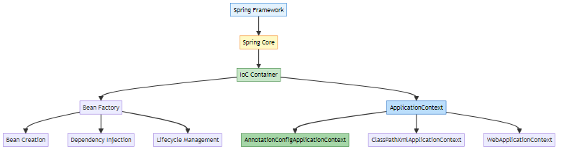

🎯 Configuration Evolution
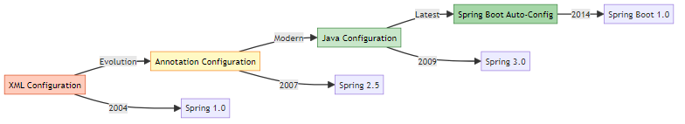

3. APPLICATIONCONTEXT DEEP DIVE

📌 What is ApplicationContext?
ApplicationContext is Spring’s advanced IoC container that manages the complete lifecycle of beans.
Think of it as: - A smart factory that creates objects - A warehouse that stores objects - A manager that handles dependencies - A coordinator that manages lifecycle

🔍 ApplicationContext Hierarchy
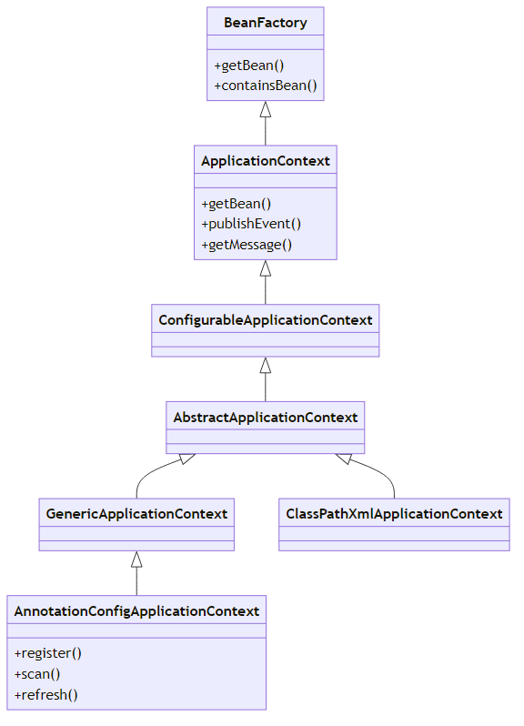

📊 ApplicationContext Features
Feature | BeanFactory | ApplicationContext
Bean Instantiation | Lazy | Eager
Event Publication | ❌ No | ✅ Yes
Internationalization | ❌ No | ✅ Yes
AOP Integration | ❌ Limited | ✅ Full
Bean Post Processors | Manual | Automatic
Environment Abstraction | ❌ No | ✅ Yes
Resource Loading | ❌ No | ✅ Yes
Annotation Support | ❌ No | ✅ Yes

4. ANNOTATIONCONFIGAPPLICATIONCONTEXT

📌 What is AnnotationConfigApplicationContext?
AnnotationConfigApplicationContext is a standalone application context that accepts annotated classes as input.
Reference: App.java:16
ApplicationContext context = new AnnotationConfigApplicationContext(AppConfig.class);

🎯 Why Use .class?
Question: Why AppConfig.class and not just AppConfig?
Answer:
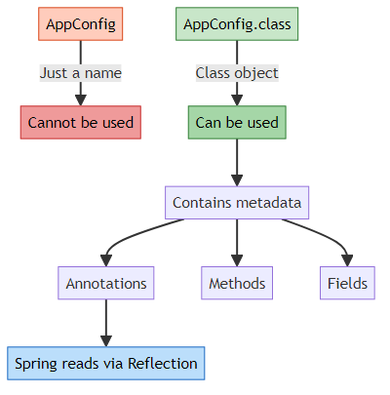
Technical Explanation:
- AppConfig = Class name (just text)
- AppConfig.class = Class object (java.lang.Class instance)
- Spring needs Class object to use Java Reflection API
- Reflection allows Spring to:
  - Read annotations
  - Inspect methods
  - Create instances
  - Inject dependencies
Example:
// ❌ WRONG - Cannot pass class name as string
ApplicationContext context = new AnnotationConfigApplicationContext("AppConfig");
// ✅ CORRECT - Pass Class object
ApplicationContext context = new AnnotationConfigApplicationContext(AppConfig.class);
// What Spring does internally:
Class<?> configClass = AppConfig.class;
Configuration annotation = configClass.getAnnotation(Configuration.class);
ComponentScan scanAnnotation = configClass.getAnnotation(ComponentScan.class);
// ... reads all annotations and creates beans

🔍 Internal Working
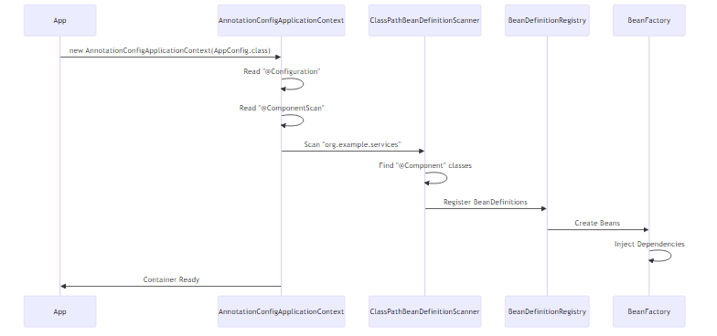

📊 Creation Methods
Method 1: Constructor with Config Class ✅ (Our Project)
ApplicationContext context = new AnnotationConfigApplicationContext(AppConfig.class);
Method 2: Constructor with Multiple Classes
ApplicationContext context = new AnnotationConfigApplicationContext(
AppConfig.class,
DatabaseConfig.class,
SecurityConfig.class
);
Method 3: Constructor with Package Scanning
ApplicationContext context = new AnnotationConfigApplicationContext();
context.scan("org.example.services");
context.refresh();
Method 4: Programmatic Registration
AnnotationConfigApplicationContext context = new AnnotationConfigApplicationContext();
context.register(AppConfig.class);
context.register(EmailService.class);
context.refresh();

5. CORE SPRING ANNOTATIONS

📌 Annotation Categories
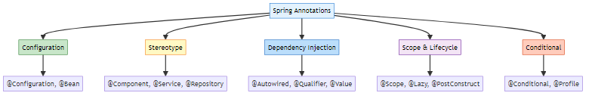

1️⃣ @Configuration
Purpose: Indicates that a class declares one or more @Bean methods and may be processed by Spring container.
Reference: AppConfig.java:8
@Configuration
public class AppConfig {
// Configuration class
}
Internal Working:
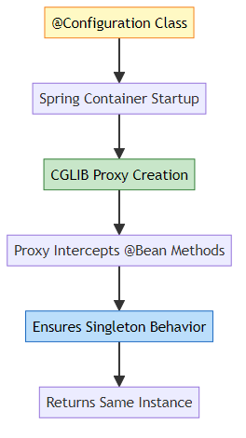
What Spring Does: 1. Detects @Configuration during component scanning 2. Creates CGLIB proxy of the class 3. Intercepts @Bean method calls to ensure singleton 4. Registers bean definitions in container
Example:
@Configuration
public class AppConfig {
@Bean
public EmailService emailService() {
return new EmailService();
}
@Bean
public MessageService messageService() {
// Calling emailService() returns SAME instance (singleton)
return new MessageService(emailService());
}
}
Why CGLIB Proxy?
// Without proxy:
EmailService e1 = emailService(); // New instance
EmailService e2 = emailService(); // New instance (WRONG!)
// With CGLIB proxy:
EmailService e1 = emailService(); // New instance
EmailService e2 = emailService(); // Same instance (CORRECT!)

2️⃣ @ComponentScan
Purpose: Tells Spring where to look for @Component annotated classes.
Reference: AppConfig.java:10
@ComponentScan(basePackages = "org.example.services")
Internal Working:
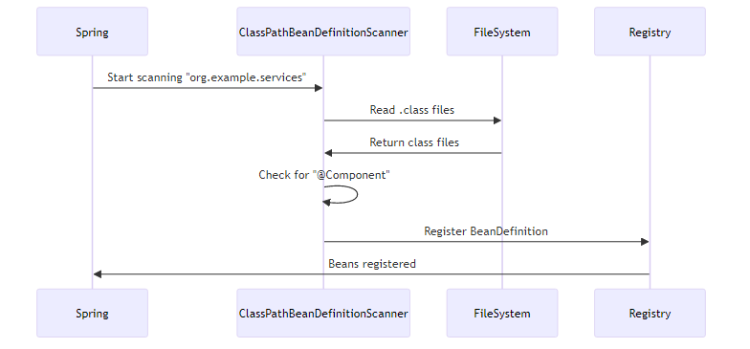
Scanning Process: 1. Reads basePackages attribute 2. Scans classpath for .class files 3. Checks each class for stereotype annotations 4. Creates BeanDefinition for each component 5. Registers in BeanDefinitionRegistry
Advanced Options:
@ComponentScan(
basePackages = "org.example",
includeFilters = @Filter(type = FilterType.ANNOTATION, classes = Service.class),
excludeFilters = @Filter(type = FilterType.REGEX, pattern = ".*Test.*")
)

3️⃣ @Component
Purpose: Marks a class as a Spring-managed component (bean).
Reference: EmailService.java:7
@Component
public class EmailService {
public void send() {
System.out.println("Email sent!");
}
}
Internal Working:
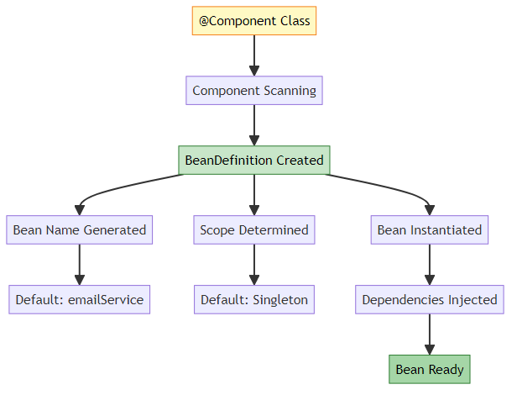
Bean Naming:
@Component // Bean name: "emailService" (lowercase first letter)
public class EmailService { }
@Component("myEmail") // Bean name: "myEmail" (custom)
public class EmailService { }
What Spring Does: 1. Scans for @Component during startup 2. Creates BeanDefinition with metadata 3. Generates bean name (default: class name with lowercase first letter) 4. Instantiates the class 5. Injects dependencies 6. Stores in ApplicationContext

4️⃣ @Service
Purpose: Specialization of @Component for service layer classes.
@Service
public class UserService {
// Business logic
}
Internal Working: - Functionally identical to @Component - Semantic difference - indicates service layer - Future enhancements - Spring may add service-specific features - Better readability - clear architectural role
When to Use: - Business logic classes - Service layer components - Transaction management - Complex operations

5️⃣ @Repository
Purpose: Specialization of @Component for data access layer classes.
@Repository
public class UserRepository {
// Database operations
}
Internal Working: - Extends @Component functionality - Exception Translation - converts database exceptions to Spring’s DataAccessException - Persistence layer marker - AOP pointcut for transaction management
Special Feature:
@Repository
public class UserRepository {
public User findById(int id) {
// SQLException thrown
}
}
// Spring automatically converts SQLException to DataAccessException

6️⃣ @Controller
Purpose: Specialization of @Component for presentation layer (MVC controllers).
@Controller
public class UserController {
@RequestMapping("/users")
public String getUsers() {
return "users";
}
}
Internal Working: - Web layer marker - Request mapping support - View resolution integration - Model binding capabilities

📊 Stereotype Annotations Comparison
Annotation | Layer | Special Feature | Use Case
@Component | Generic | None | Generic beans
@Service | Business | None (semantic) | Business logic
@Repository | Data Access | Exception translation | Database operations
@Controller | Presentation | Request mapping | Web controllers
@RestController | Presentation | @ResponseBody | REST APIs
Hierarchy:
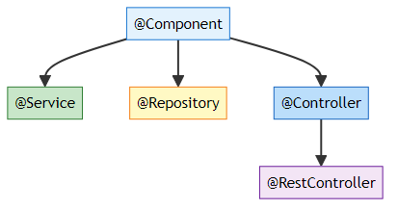

7️⃣ @Bean
Purpose: Declares a method that returns a bean to be managed by Spring.
@Configuration
public class AppConfig {
@Bean
public EmailService emailService() {
return new EmailService();
}
@Bean(name = "myEmail")
public EmailService customNamedBean() {
return new EmailService();
}
@Bean(initMethod = "init", destroyMethod = "cleanup")
public DataSource dataSource() {
return new DataSource();
}
}
Internal Working:
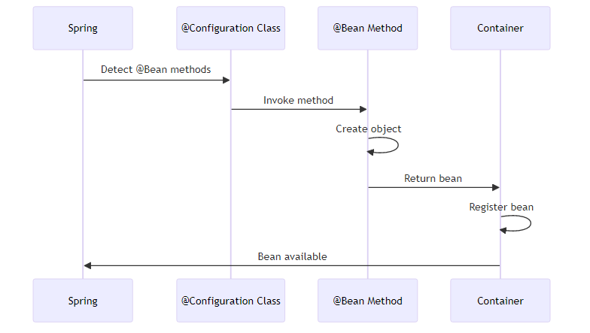
When to Use: - Third-party classes (cannot add @Component) - Complex initialization logic - Conditional bean creation - Multiple instances of same type
Example:
@Configuration
public class DatabaseConfig {
@Bean
public DataSource dataSource() {
HikariDataSource ds = new HikariDataSource();
ds.setJdbcUrl("jdbc:mysql://localhost:3306/mydb");
ds.setUsername("root");
ds.setPassword("password");
return ds; // Cannot add @Component to HikariDataSource
}
}

6. DEPENDENCY INJECTION ANNOTATIONS

📌 Dependency Injection Types
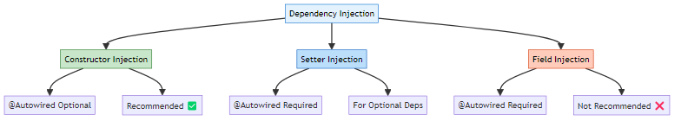

1️⃣ @Autowired
Purpose: Marks a constructor, field, setter method, or config method as to be autowired by Spring’s dependency injection.
Reference: SetterInjectionService.java:15

Constructor Injection ✅ (Recommended)
Reference: MessageService.java:16-20
@Component
public class MessageService {
private final EmailService emailService;
private final SmsService smsService;
// @Autowired is OPTIONAL for single constructor (Spring 4.3+)
public MessageService(EmailService emailService, SmsService smsService) {
this.emailService = emailService;
this.smsService = smsService;
}
}
Internal Working:
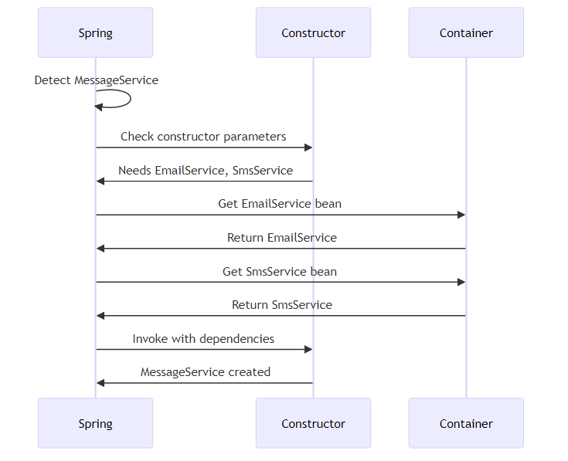
Why No @Autowired Needed? - Spring 4.3+ automatically autowires single constructor - Implicit autowiring for cleaner code - Multiple constructors require @Autowired on one
Example:
@Component
public class UserService {
private final UserRepository repository;
// No @Autowired needed - single constructor
public UserService(UserRepository repository) {
this.repository = repository;
}
}
@Component
public class OrderService {
private final OrderRepository repository;
// Default constructor
public OrderService() {
this.repository = null;
}
// @Autowired required - multiple constructors
@Autowired
public OrderService(OrderRepository repository) {
this.repository = repository;
}
}
Pros: - ✅ Immutable (final fields) - ✅ Required dependencies guaranteed - ✅ Easy to test (pass mocks in constructor) - ✅ Null-safe - ✅ No reflection needed for testing

Setter Injection
Reference: SetterInjectionService.java:14-18
@Component
public class SetterInjectionService {
private EmailService emailService;
@Autowired // Required for setter injection
public void setEmailService(EmailService emailService) {
this.emailService = emailService;
System.out.println("Setter Injection - EmailService injected");
}
}
Internal Working:
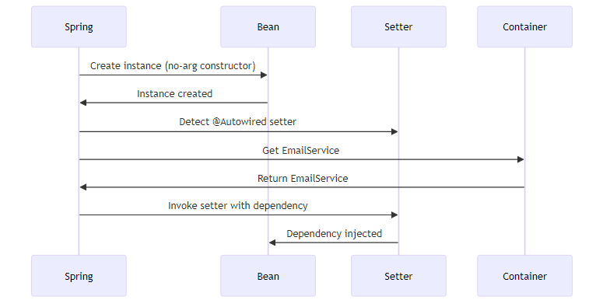
When Spring Calls Setter: 1. After bean instantiation 2. Before initialization callbacks (@PostConstruct) 3. During dependency injection phase
Pros: - ✅ Optional dependencies (can be null) - ✅ Can change at runtime - ✅ Circular dependencies easier to resolve
Cons: - ❌ Mutable (not final) - ❌ Can be null (NullPointerException risk) - ❌ Requires @Autowired annotation

Field Injection ❌ (Not Recommended)
Reference: FieldInjectionService.java:9-10
@Component
public class FieldInjectionService {
@Autowired
private EmailService emailService;
public void sendMessage() {
emailService.send();
}
}
Internal Working:
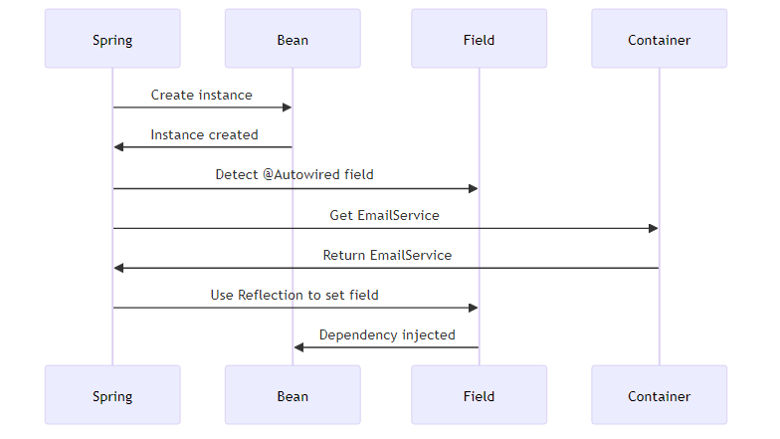
Why Not Recommended? - ❌ Breaks encapsulation (private field accessed via reflection) - ❌ Hard to test (cannot inject mocks easily) - ❌ Cannot be final (immutability lost) - ❌ Hidden dependencies (not visible in constructor) - ❌ Reflection overhead (slower)
Testing Difficulty:
// Hard to test
@Test
public void testFieldInjection() {
FieldInjectionService service = new FieldInjectionService();
// How to inject mock? Need reflection!
EmailService mock = Mockito.mock(EmailService.class);
// Must use reflection to set private field
ReflectionTestUtils.setField(service, "emailService", mock);
}
// Easy to test with constructor injection
@Test
public void testConstructorInjection() {
EmailService mock = Mockito.mock(EmailService.class);
MessageService service = new MessageService(mock, null);
// Clean and simple!
}

📊 Injection Types Comparison
Aspect | Constructor | Setter | Field
Immutability | ✅ Yes (final) | ❌ No | ❌ No
Null Safety | ✅ Yes | ❌ No | ❌ No
Testability | ✅ Excellent | ✅ Good | ❌ Poor
@Autowired | Optional (single) | Required | Required
Circular Deps | ❌ Difficult | ✅ Easy | ✅ Easy
Encapsulation | ✅ Maintained | ✅ Maintained | ❌ Broken
IDE Support | ✅ Excellent | ✅ Good | ⚠️ Limited
Recommendation | ✅ Use This | ⚠️ Optional deps | ❌ Avoid

2️⃣ @Qualifier
Purpose: Specifies which bean to inject when multiple candidates exist.
@Component("emailNotifier")
public class EmailNotifier implements Notifier { }
@Component("smsNotifier")
public class SmsNotifier implements Notifier { }
@Component
public class NotificationService {
private final Notifier notifier;
@Autowired
public NotificationService(@Qualifier("emailNotifier") Notifier notifier) {
this.notifier = notifier;
}
}
Internal Working:
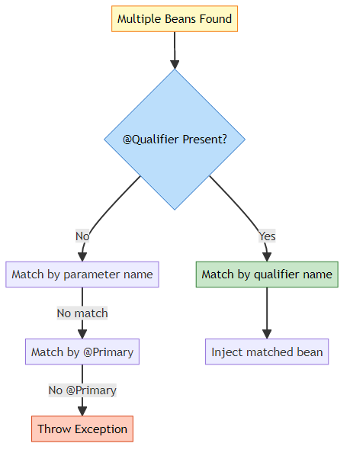
Resolution Order: 1. @Qualifier name match 2. Parameter name match 3. @Primary bean 4. Exception if ambiguous

3️⃣ @Primary
Purpose: Indicates that a bean should be given preference when multiple candidates are qualified.
@Component
@Primary // This will be injected by default
public class EmailNotifier implements Notifier { }
@Component
public class SmsNotifier implements Notifier { }
@Component
public class NotificationService {
private final Notifier notifier;
// EmailNotifier injected (marked as @Primary)
public NotificationService(Notifier notifier) {
this.notifier = notifier;
}
}
When to Use: - Default implementation - Most commonly used bean - Fallback option

4️⃣ @Value
Purpose: Injects values from properties files or expressions.
@Component
public class DatabaseConfig {
@Value("${db.url}")
private String url;
@Value("${db.username}")
private String username;
@Value("${db.password}")
private String password;
@Value("#{systemProperties['user.home']}")
private String userHome;
@Value("#{10 * 2}")
private int calculatedValue;
}
application.properties:
db.url=jdbc:mysql://localhost:3306/mydb
db.username=root
db.password=secret
SpEL (Spring Expression Language):
@Value("#{T(java.lang.Math).random() * 100}")
private double randomNumber;
@Value("#{someBean.someProperty}")
private String propertyFromBean;
@Value("#{someBean.someMethod()}")
private String methodResult;

5️⃣ @Required (Deprecated)
Purpose: Marks a setter method as required (deprecated in Spring 5.1).
@Component
public class UserService {
private UserRepository repository;
@Required // Deprecated - use constructor injection instead
public void setRepository(UserRepository repository) {
this.repository = repository;
}
}
Modern Alternative:
@Component
public class UserService {
private final UserRepository repository;
// Constructor injection ensures required dependency
public UserService(UserRepository repository) {
this.repository = repository;
}
}

6️⃣ @Lazy
Purpose: Indicates that a bean should be lazily initialized.
@Component
@Lazy // Created only when first requested
public class HeavyService {
public HeavyService() {
System.out.println("HeavyService created");
// Expensive initialization
}
}
@Component
public class UserService {
private final HeavyService heavyService;
@Autowired
public UserService(@Lazy HeavyService heavyService) {
this.heavyService = heavyService; // Proxy injected
System.out.println("UserService created");
}
public void useHeavyService() {
heavyService.doSomething(); // NOW HeavyService is created
}
}
Internal Working:
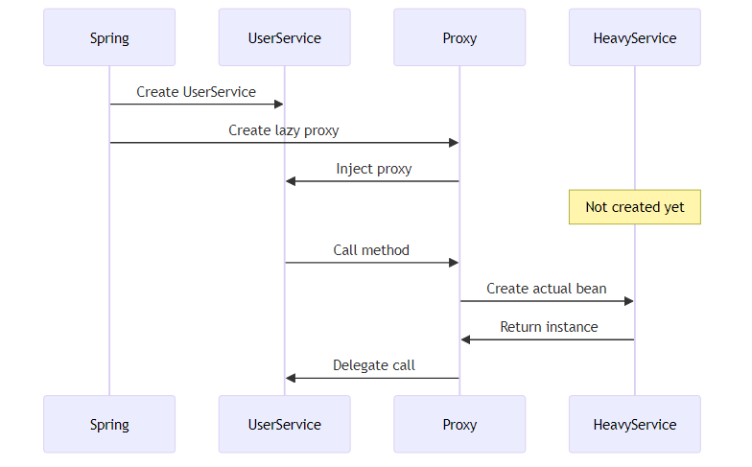
When to Use: - Expensive initialization - Rarely used beans - Circular dependency resolution - Conditional usage

7️⃣ @DependsOn
Purpose: Specifies that a bean depends on other beans being initialized first.
@Component
@DependsOn("databaseInitializer")
public class UserService {
// Will be created AFTER databaseInitializer
}
@Component("databaseInitializer")
public class DatabaseInitializer {
@PostConstruct
public void init() {
System.out.println("Database initialized");
}
}
Multiple Dependencies:
@Component
@DependsOn({"cacheManager", "databaseInitializer", "securityConfig"})
public class ApplicationService {
// Created after all dependencies
}

8️⃣ @Inject (JSR-330)
Purpose: Standard Java dependency injection annotation (alternative to @Autowired).
import javax.inject.Inject;
import javax.inject.Named;
@Named // Equivalent to @Component
public class UserService {
private final UserRepository repository;
@Inject // Equivalent to @Autowired
public UserService(UserRepository repository) {
this.repository = repository;
}
}
@Autowired vs @Inject:
Feature | @Autowired | @Inject
Source | Spring | JSR-330 (Java standard)
Required | Has required attribute | No required attribute
Portability | Spring only | Works with any JSR-330 container
Qualifier | @Qualifier | @Named

7. BEAN SCOPES & LIFECYCLE

📌 Bean Scopes
Reference: BeanScopeDemo.java
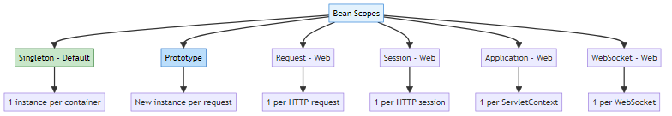

1️⃣ @Scope - Singleton (Default)
Reference: SingletonBean.java
@Component // Default scope is singleton
public class SingletonBean {
public SingletonBean() {
System.out.println("SingletonBean created");
}
}
Explicit Declaration:
@Component
@Scope("singleton") // or @Scope(ConfigurableBeanFactory.SCOPE_SINGLETON)
public class SingletonBean { }
Internal Working:
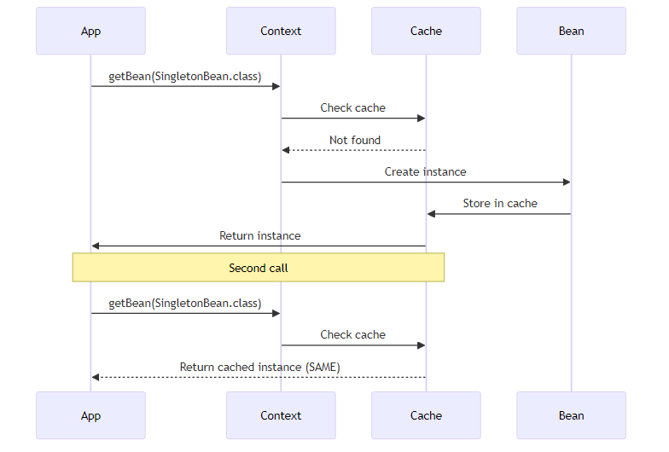
Behavior:
ApplicationContext context = new AnnotationConfigApplicationContext(BeanScopeConfig.class);
SingletonBean s1 = context.getBean(SingletonBean.class);
SingletonBean s2 = context.getBean(SingletonBean.class);
System.out.println(s1 == s2); // true - SAME instance
Output:
SingletonBean created
Same Instance? true
Characteristics: - ✅ Created at container startup (eager) - ✅ One instance per container - ✅ Shared across application - ✅ Thread-safe if stateless - ✅ Memory efficient

2️⃣ @Scope - Prototype
Reference: PrototypeBean.java
@Component
@Scope("prototype") // or @Scope(ConfigurableBeanFactory.SCOPE_PROTOTYPE)
public class PrototypeBean {
public PrototypeBean() {
System.out.println("PrototypeBean created");
}
}
Internal Working:
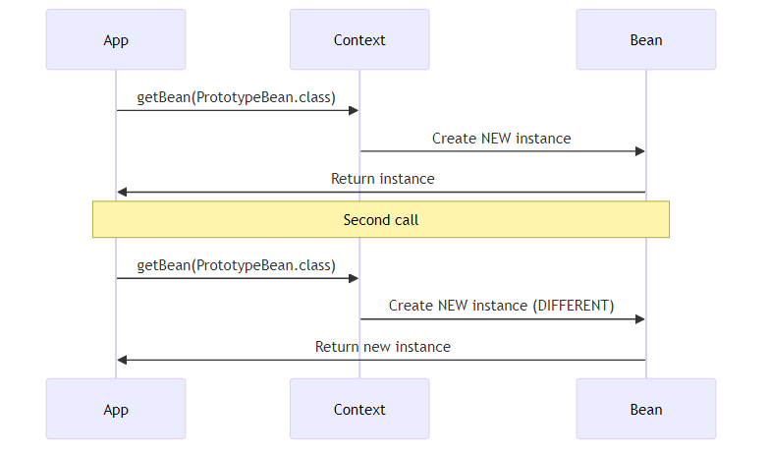
Behavior:
ApplicationContext context = new AnnotationConfigApplicationContext(BeanScopeConfig.class);
PrototypeBean p1 = context.getBean(PrototypeBean.class);
PrototypeBean p2 = context.getBean(PrototypeBean.class);
System.out.println(p1 == p2); // false - DIFFERENT instances
Output:
PrototypeBean created
PrototypeBean created
Same Instance? false
Characteristics: - ✅ Created on demand (lazy) - ✅ New instance per request - ✅ Not cached - ❌ Spring doesn’t manage destruction - ⚠️ Higher memory usage

3️⃣ Web Scopes
Request Scope:
@Component
@Scope(value = WebApplicationContext.SCOPE_REQUEST, proxyMode = ScopedProxyMode.TARGET_CLASS)
public class LoginForm {
// New instance per HTTP request
}
Session Scope:
@Component
@Scope(value = WebApplicationContext.SCOPE_SESSION, proxyMode = ScopedProxyMode.TARGET_CLASS)
public class UserPreferences {
// New instance per HTTP session
}
Application Scope:
@Component
@Scope(value = WebApplicationContext.SCOPE_APPLICATION, proxyMode = ScopedProxyMode.TARGET_CLASS)
public class AppConfig {
// One instance per ServletContext
}
Why proxyMode? - Singleton beans cannot directly inject prototype/request/session beans - Proxy allows lazy resolution of actual bean

📊 Scope Comparison
Scope | Instances | Lifecycle | Use Case | Web Only
Singleton | 1 per container | Container lifetime | Stateless services | ❌ No
Prototype | New per request | Until GC | Stateful objects | ❌ No
Request | 1 per HTTP request | Request lifetime | Form data | ✅ Yes
Session | 1 per HTTP session | Session lifetime | User data | ✅ Yes
Application | 1 per ServletContext | App lifetime | App config | ✅ Yes
WebSocket | 1 per WebSocket | WebSocket lifetime | Chat sessions | ✅ Yes

🔄 Bean Lifecycle Annotations
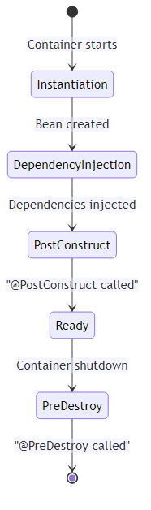

1️⃣ @PostConstruct
Purpose: Method executed after dependency injection is complete.
import javax.annotation.PostConstruct;
@Component
public class DatabaseService {
@Autowired
private DataSource dataSource;
@PostConstruct
public void init() {
System.out.println("Initializing database connection...");
// Open connections, load cache, etc.
}
}
Execution Order: 1. Constructor called 2. Dependencies injected 3. @PostConstruct method called 4. Bean ready to use
Use Cases: - Initialize resources - Load configuration - Validate dependencies - Start background tasks

2️⃣ @PreDestroy
Purpose: Method executed before bean is destroyed.
import javax.annotation.PreDestroy;
@Component
public class DatabaseService {
@PreDestroy
public void cleanup() {
System.out.println("Closing database connections...");
// Close connections, save state, etc.
}
}
When Called: - Container shutdown - Application stop - Context close
Use Cases: - Close connections - Release resources - Save state - Stop background tasks
⚠️ Important: @PreDestroy is NOT called for prototype beans!

3️⃣ Complete Lifecycle Example
@Component
@Scope("singleton")
public class LifecycleBean {
@Autowired
private EmailService emailService;
// 1. Constructor
public LifecycleBean() {
System.out.println("1. Constructor called");
}
// 2. Setter injection (if any)
@Autowired
public void setSomeService(SomeService service) {
System.out.println("2. Setter injection");
}
// 3. Post-construct
@PostConstruct
public void init() {
System.out.println("3. @PostConstruct - Bean initialized");
}
// 4. Bean in use
public void doSomething() {
System.out.println("4. Bean in use");
}
// 5. Pre-destroy
@PreDestroy
public void cleanup() {
System.out.println("5. @PreDestroy - Bean being destroyed");
}
}
Output:
1. Constructor called
2. Setter injection
3. @PostConstruct - Bean initialized
4. Bean in use
5. @PreDestroy - Bean being destroyed

4️⃣ InitializingBean & DisposableBean (Alternative)
Interface-based approach:
import org.springframework.beans.factory.InitializingBean;
import org.springframework.beans.factory.DisposableBean;
@Component
public class DatabaseService implements InitializingBean, DisposableBean {
@Override
public void afterPropertiesSet() throws Exception {
System.out.println("InitializingBean: afterPropertiesSet");
}
@Override
public void destroy() throws Exception {
System.out.println("DisposableBean: destroy");
}
}
Comparison:
Method | Pros | Cons
@PostConstruct/@PreDestroy | Standard (JSR-250), no Spring coupling | Requires annotation support
InitializingBean/DisposableBean | Type-safe, IDE support | Spring coupling
@Bean(initMethod/destroyMethod) | Works with third-party classes | Only for @Bean methods

5️⃣ @Bean Lifecycle Methods
@Configuration
public class AppConfig {
@Bean(initMethod = "init", destroyMethod = "cleanup")
public DataSource dataSource() {
return new HikariDataSource();
}
}
public class HikariDataSource {
public void init() {
System.out.println("DataSource initialized");
}
public void cleanup() {
System.out.println("DataSource closed");
}
}

8. COMPONENT SCANNING

📌 How Component Scanning Works
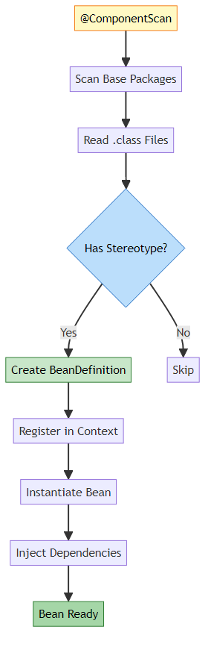

🔍 @ComponentScan Attributes
Basic Usage:
@Configuration
@ComponentScan(basePackages = "org.example.services")
public class AppConfig { }
Multiple Packages:
@ComponentScan(basePackages = {"org.example.services", "org.example.repositories"})
Type-Safe Package Scanning:
@ComponentScan(basePackageClasses = {EmailService.class, UserRepository.class})
// Scans packages containing these classes
Include Filters:
@ComponentScan(
basePackages = "org.example",
includeFilters = @Filter(
type = FilterType.ANNOTATION,
classes = Service.class
)
)
Exclude Filters:
@ComponentScan(
basePackages = "org.example",
excludeFilters = @Filter(
type = FilterType.REGEX,
pattern = ".*Test.*"
)
)
Filter Types:
FilterType | Description | Example
ANNOTATION | By annotation | @Service.class
ASSIGNABLE_TYPE | By class type | UserService.class
ASPECTJ | AspectJ pattern | org.example..*Service+
REGEX | Regular expression | .*Service
CUSTOM | Custom filter | Implement TypeFilter

📊 Component Scanning Strategies
Strategy 1: Single Package
@ComponentScan("org.example") // Scans org.example and sub-packages
Strategy 2: Multiple Packages
@ComponentScan({"org.example.services", "org.example.repositories"})
Strategy 3: Exclude Test Classes
@ComponentScan(
basePackages = "org.example",
excludeFilters = @Filter(
type = FilterType.REGEX,
pattern = ".*Test.*"
)
)
Strategy 4: Include Only Specific Annotations
@ComponentScan(
basePackages = "org.example",
useDefaultFilters = false, // Disable default filters
includeFilters = @Filter(
type = FilterType.ANNOTATION,
classes = {Service.class, Repository.class}
)
)

9. ADVANCED ANNOTATIONS

1️⃣ @Profile
Purpose: Conditionally register beans based on active profiles.
@Configuration
@Profile("development")
public class DevConfig {
@Bean
public DataSource dataSource() {
return new H2DataSource(); // In-memory database
}
}
@Configuration
@Profile("production")
public class ProdConfig {
@Bean
public DataSource dataSource() {
return new MySQLDataSource(); // Production database
}
}
Activating Profiles:
// Programmatically
System.setProperty("spring.profiles.active", "development");
// Via JVM argument
-Dspring.profiles.active=development
// Via environment variable
export SPRING_PROFILES_ACTIVE=development
Multiple Profiles:
@Profile({"development", "test"}) // Active in dev OR test
NOT Profile:
@Profile("!production") // Active when NOT production

2️⃣ @Conditional
Purpose: Conditionally register beans based on custom conditions.
@Configuration
public class AppConfig {
@Bean
@Conditional(WindowsCondition.class)
public FileSystem windowsFileSystem() {
return new WindowsFileSystem();
}
@Bean
@Conditional(LinuxCondition.class)
public FileSystem linuxFileSystem() {
return new LinuxFileSystem();
}
}
public class WindowsCondition implements Condition {
@Override
public boolean matches(ConditionContext context, AnnotatedTypeMetadata metadata) {
return System.getProperty("os.name").toLowerCase().contains("windows");
}
}
Built-in Conditional Annotations:
Annotation | Condition
@ConditionalOnClass | Class present in classpath
@ConditionalOnMissingClass | Class not in classpath
@ConditionalOnBean | Bean exists
@ConditionalOnMissingBean | Bean doesn’t exist
@ConditionalOnProperty | Property has value
@ConditionalOnResource | Resource exists
@ConditionalOnWebApplication | Web application
Example:
@Bean
@ConditionalOnProperty(name = "feature.email.enabled", havingValue = "true")
public EmailService emailService() {
return new EmailService();
}

3️⃣ @PropertySource
Purpose: Load properties from external files.
@Configuration
@PropertySource("classpath:application.properties")
public class AppConfig {
@Value("${app.name}")
private String appName;
@Value("${app.version}")
private String appVersion;
}
Multiple Property Sources:
@PropertySources({
@PropertySource("classpath:application.properties"),
@PropertySource("classpath:database.properties")
})
With Placeholders:
@PropertySource("classpath:config-${env}.properties")

4️⃣ @Import
Purpose: Import additional configuration classes.
@Configuration
@Import({DatabaseConfig.class, SecurityConfig.class})
public class AppConfig {
// Main configuration
}
Import Selector:
@Configuration
@Import(MyImportSelector.class)
public class AppConfig { }
public class MyImportSelector implements ImportSelector {
@Override
public String[] selectImports(AnnotationMetadata metadata) {
return new String[]{
"org.example.DatabaseConfig",
"org.example.SecurityConfig"
};
}
}

5️⃣ @Order
Purpose: Define bean initialization order.
@Component
@Order(1) // Initialized first
public class FirstService { }
@Component
@Order(2) // Initialized second
public class SecondService { }
@Component
@Order(3) // Initialized third
public class ThirdService { }
Lower values have higher priority.

6️⃣ @EventListener
Purpose: Listen to application events.
@Component
public class ApplicationEventListener {
@EventListener
public void handleContextRefresh(ContextRefreshedEvent event) {
System.out.println("Context refreshed!");
}
@EventListener
public void handleContextClosed(ContextClosedEvent event) {
System.out.println("Context closed!");
}
@EventListener
public void handleCustomEvent(CustomEvent event) {
System.out.println("Custom event: " + event.getMessage());
}
}
Publishing Events:
@Component
public class EventPublisher {
@Autowired
private ApplicationEventPublisher publisher;
public void publishEvent() {
publisher.publishEvent(new CustomEvent("Hello!"));
}
}

7️⃣ @Async
Purpose: Execute methods asynchronously.
@Configuration
@EnableAsync
public class AppConfig { }
@Service
public class EmailService {
@Async
public void sendEmail(String to, String message) {
// Runs in separate thread
System.out.println("Sending email to: " + to);
}
@Async
public CompletableFuture<String> sendEmailAsync(String to) {
// Returns immediately
return CompletableFuture.completedFuture("Email sent");
}
}

8️⃣ @Scheduled
Purpose: Schedule method execution.
@Configuration
@EnableScheduling
public class AppConfig { }
@Component
public class ScheduledTasks {
@Scheduled(fixedRate = 5000) // Every 5 seconds
public void reportStatus() {
System.out.println("Status: OK");
}
@Scheduled(cron = "0 0 * * * *") // Every hour
public void hourlyTask() {
System.out.println("Hourly task executed");
}
@Scheduled(fixedDelay = 10000, initialDelay = 5000)
public void delayedTask() {
System.out.println("Delayed task");
}
}

9️⃣ @Cacheable
Purpose: Cache method results.
@Configuration
@EnableCaching
public class AppConfig { }
@Service
public class UserService {
@Cacheable("users")
public User findById(int id) {
// Expensive database query
return userRepository.findById(id);
}
@CacheEvict(value = "users", key = "#id")
public void deleteUser(int id) {
userRepository.delete(id);
}
@CachePut(value = "users", key = "#user.id")
public User updateUser(User user) {
return userRepository.save(user);
}
}

🔟 @Transactional
Purpose: Manage database transactions.
@Configuration
@EnableTransactionManagement
public class AppConfig { }
@Service
public class UserService {
@Transactional
public void createUser(User user) {
userRepository.save(user);
// If exception occurs, transaction rolls back
}
@Transactional(readOnly = true)
public User findById(int id) {
return userRepository.findById(id);
}
@Transactional(
propagation = Propagation.REQUIRES_NEW,
isolation = Isolation.SERIALIZABLE,
timeout = 30,
rollbackFor = Exception.class
)
public void complexTransaction() {
// Complex transaction logic
}
}

10. INTERNAL WORKING MECHANISM

📌 Complete Execution Flow
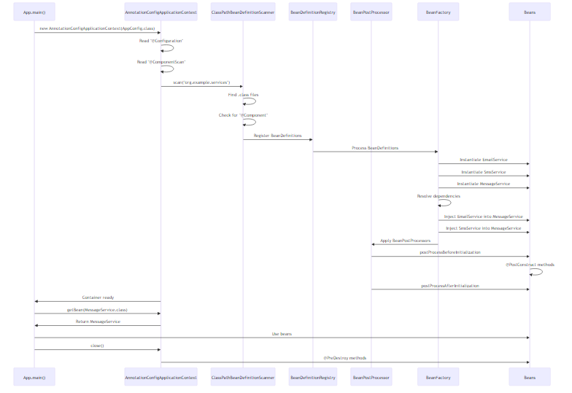

🔍 Step-by-Step Breakdown

Step 1: Container Creation
ApplicationContext context = new AnnotationConfigApplicationContext(AppConfig.class);
What Happens: 1. Create AnnotationConfigApplicationContext instance 2. Register AppConfig.class as configuration 3. Read @Configuration annotation 4. Read @ComponentScan annotation 5. Trigger refresh() method

Step 2: Component Scanning
@ComponentScan(basePackages = "org.example.services")
What Happens: 1. ClassPathBeanDefinitionScanner created 2. Scans “org.example.services” package 3. Reads all .class files in package 4. Checks for stereotype annotations (@Component, @Service, etc.) 5. Creates BeanDefinition for each component 6. Registers BeanDefinitions in registry
Internal Process:
org.example.services/
├── EmailService.class → @Component found → Register
├── SmsService.class → @Component found → Register
├── MessageService.class → @Component found → Register
├── AppConfig.class → @Configuration found → Register
└── SomeOtherClass.class → No annotation → Skip

Step 3: Bean Definition Processing
BeanDefinition Contains: - Bean class name - Bean scope (singleton/prototype) - Constructor arguments - Property values - Initialization method - Destruction method - Dependencies
Example BeanDefinition:
BeanDefinition for MessageService:
- Class: org.example.services.MessageService
- Scope: singleton
- Constructor args: [EmailService, SmsService]
- Lazy: false
- Primary: false

Step 4: Dependency Resolution
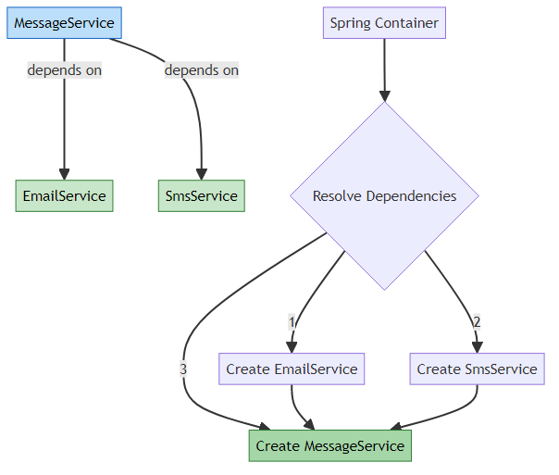
Resolution Order: 1. Analyze dependencies of each bean 2. Build dependency graph 3. Topological sort (dependencies first) 4. Create beans in order
For MessageService:
MessageService needs:
- EmailService (no dependencies) → Create first
- SmsService (no dependencies) → Create first
Creation order:
1. EmailService
2. SmsService
3. MessageService (inject EmailService, SmsService)

Step 5: Bean Instantiation
For Constructor Injection:
@Component
public class MessageService {
private final EmailService emailService;
private final SmsService smsService;
public MessageService(EmailService emailService, SmsService smsService) {
this.emailService = emailService;
this.smsService = smsService;
}
}
What Spring Does: 1. Find constructor (single constructor = auto-detected) 2. Resolve parameters (EmailService, SmsService) 3. Get beans from container 4. Invoke constructor with parameters 5. Store instance in container
Equivalent Code:
EmailService emailService = container.getBean(EmailService.class);
SmsService smsService = container.getBean(SmsService.class);
MessageService messageService = new MessageService(emailService, smsService);
container.registerBean("messageService", messageService);

Step 6: BeanPostProcessor Execution
BeanPostProcessor Interface:
public interface BeanPostProcessor {
Object postProcessBeforeInitialization(Object bean, String beanName);
Object postProcessAfterInitialization(Object bean, String beanName);
}
What It Does: - Before initialization: Modify bean before @PostConstruct - After initialization: Wrap bean in proxy (AOP, transactions)
Example:
@Component
public class LoggingBeanPostProcessor implements BeanPostProcessor {
@Override
public Object postProcessBeforeInitialization(Object bean, String beanName) {
System.out.println("Before init: " + beanName);
return bean;
}
@Override
public Object postProcessAfterInitialization(Object bean, String beanName) {
System.out.println("After init: " + beanName);
return bean; // Or return proxy
}
}

Step 7: Bean Ready to Use
MessageService messageService = context.getBean(MessageService.class);
messageService.sendMessage();
What Happens: 1. Lookup bean in container by type 2. Return cached instance (singleton) 3. Use bean in application

Step 8: Container Shutdown
((AnnotationConfigApplicationContext) context).close();
What Happens: 1. Publish ContextClosedEvent 2. Call @PreDestroy methods 3. Call DisposableBean.destroy() 4. Call custom destroy-method 5. Release resources 6. Clear bean cache

🎯 Reflection & Proxy Mechanisms
How Spring Uses Reflection:
// Spring internally does something like this:
Class<?> clazz = Class.forName("org.example.services.EmailService");
Constructor<?> constructor = clazz.getConstructor();
Object instance = constructor.newInstance();
// For @Autowired fields:
Field field = clazz.getDeclaredField("emailService");
field.setAccessible(true);
field.set(instance, emailServiceBean);
// For @PostConstruct:
Method method = clazz.getMethod("init");
method.invoke(instance);
CGLIB Proxy for @Configuration:
@Configuration
public class AppConfig {
@Bean
public EmailService emailService() {
return new EmailService();
}
@Bean
public MessageService messageService() {
return new MessageService(emailService()); // Proxy intercepts this
}
}
// Without proxy:
EmailService e1 = emailService(); // New instance
EmailService e2 = emailService(); // New instance (WRONG!)
// With CGLIB proxy:
EmailService e1 = emailService(); // New instance
EmailService e2 = emailService(); // Same instance from cache (CORRECT!)

📊 Performance Considerations
Container Startup Time:
Beans | Startup Time | Memory
10 | ~100ms | ~10MB
100 | ~500ms | ~50MB
1000 | ~2s | ~200MB
10000 | ~20s | ~1GB
Optimization Tips: - Use @Lazy for rarely used beans - Avoid circular dependencies - Use @ComponentScan wisely (don’t scan entire classpath) - Use @Conditional to skip unnecessary beans - Consider lazy initialization for large applications

11. PROJECT STRUCTURE & IMPLEMENTATION

📁 Project Structure
AnnotationBased/
├── src/
│ ├── main/
│ │ └── java/
│ │ └── org/
│ │ └── example/
│ │ ├── App.java # Main application
│ │ ├── services/
│ │ │ ├── AppConfig.java # Configuration class
│ │ │ ├── EmailService.java # Email service
│ │ │ ├── SmsService.java # SMS service
│ │ │ ├── MessageService.java # Message service
│ │ │ ├── ConstructorInjectionService.java
│ │ │ ├── SetterInjectionService.java
│ │ │ ├── FieldInjectionService.java
│ │ │ └── NotificationService.java
│ │ └── bean_scope/
│ │ ├── BeanScopeConfig.java # Scope configuration
│ │ ├── BeanScopeDemo.java # Scope demonstration
│ │ ├── SingletonBean.java # Singleton example
│ │ └── PrototypeBean.java # Prototype example
│ └── test/
│ └── java/
│ └── org/
│ └── example/
│ └── AppTest.java
├── pom.xml # Maven configuration
└── README.md

🔍 Key Components
1. Configuration Class:
@Configuration
@ComponentScan(basePackages = "org.example.services")
public class AppConfig { }
2. Service Classes: - EmailService - Sends emails - SmsService - Sends SMS - MessageService - Uses both services - NotificationService - Demonstrates multiple methods
3. Injection Examples: - ConstructorInjectionService - Constructor injection - SetterInjectionService - Setter injection - FieldInjectionService - Field injection
4. Scope Examples: - SingletonBean - Singleton scope - PrototypeBean - Prototype scope

12. REAL-WORLD EXAMPLES

🌐 Example 1: E-Commerce Application
// Configuration
@Configuration
@ComponentScan("com.ecommerce")
@EnableTransactionManagement
public class ECommerceConfig { }
// Repository Layer
@Repository
public class ProductRepository {
public Product findById(int id) {
// Database query
}
}
// Service Layer
@Service
@Transactional
public class OrderService {
private final ProductRepository productRepository;
private final PaymentService paymentService;
private final EmailService emailService;
@Autowired
public OrderService(ProductRepository productRepository,
PaymentService paymentService,
EmailService emailService) {
this.productRepository = productRepository;
this.paymentService = paymentService;
this.emailService = emailService;
}
public Order createOrder(OrderRequest request) {
Product product = productRepository.findById(request.getProductId());
Payment payment = paymentService.processPayment(request.getPayment());
Order order = new Order(product, payment);
emailService.sendOrderConfirmation(order);
return order;
}
}
// Controller Layer
@RestController
@RequestMapping("/api/orders")
public class OrderController {
private final OrderService orderService;
@Autowired
public OrderController(OrderService orderService) {
this.orderService = orderService;
}
@PostMapping
public ResponseEntity<Order> createOrder(@RequestBody OrderRequest request) {
Order order = orderService.createOrder(request);
return ResponseEntity.ok(order);
}
}

🏦 Example 2: Banking Application
// Configuration with Profiles
@Configuration
@ComponentScan("com.bank")
public class BankConfig { }
@Configuration
@Profile("development")
public class DevDatabaseConfig {
@Bean
public DataSource dataSource() {
return new H2DataSource(); // In-memory
}
}
@Configuration
@Profile("production")
public class ProdDatabaseConfig {
@Bean
public DataSource dataSource() {
return new OracleDataSource(); // Production DB
}
}
// Service with Caching
@Service
public class AccountService {
private final AccountRepository accountRepository;
@Autowired
public AccountService(AccountRepository accountRepository) {
this.accountRepository = accountRepository;
}
@Cacheable("accounts")
public Account getAccount(String accountNumber) {
return accountRepository.findByAccountNumber(accountNumber);
}
@Transactional
public void transfer(String from, String to, BigDecimal amount) {
Account fromAccount = getAccount(from);
Account toAccount = getAccount(to);
fromAccount.debit(amount);
toAccount.credit(amount);
accountRepository.save(fromAccount);
accountRepository.save(toAccount);
}
}

📧 Example 3: Email Marketing System
// Configuration
@Configuration
@ComponentScan("com.marketing")
@EnableAsync
@EnableScheduling
public class MarketingConfig { }
// Email Service with Async
@Service
public class EmailMarketingService {
private final EmailSender emailSender;
private final TemplateEngine templateEngine;
@Autowired
public EmailMarketingService(EmailSender emailSender,
TemplateEngine templateEngine) {
this.emailSender = emailSender;
this.templateEngine = templateEngine;
}
@Async
public CompletableFuture<Void> sendCampaign(Campaign campaign) {
List<User> users = campaign.getUsers();
String template = templateEngine.render(campaign.getTemplate());
users.forEach(user -> {
String personalizedEmail = template.replace("{{name}}", user.getName());
emailSender.send(user.getEmail(), personalizedEmail);
});
return CompletableFuture.completedFuture(null);
}
}
// Scheduled Tasks
@Component
public class CampaignScheduler {
private final EmailMarketingService marketingService;
@Autowired
public CampaignScheduler(EmailMarketingService marketingService) {
this.marketingService = marketingService;
}
@Scheduled(cron = "0 0 9 * * MON") // Every Monday at 9 AM
public void sendWeeklyNewsletter() {
Campaign campaign = new Campaign("Weekly Newsletter");
marketingService.sendCampaign(campaign);
}
}

🎮 Example 4: Gaming Platform
// Configuration
@Configuration
@ComponentScan("com.gaming")
public class GamingConfig { }
// Player Service with Scope
@Service
public class PlayerService {
private final PlayerRepository playerRepository;
private final LeaderboardService leaderboardService;
@Autowired
public PlayerService(PlayerRepository playerRepository,
LeaderboardService leaderboardService) {
this.playerRepository = playerRepository;
this.leaderboardService = leaderboardService;
}
@Transactional
public void updateScore(int playerId, int score) {
Player player = playerRepository.findById(playerId);
player.addScore(score);
playerRepository.save(player);
leaderboardService.updateLeaderboard(player);
}
}
// Game Session (Prototype Scope)
@Component
@Scope("prototype")
public class GameSession {
private final String sessionId;
private final List<Player> players;
public GameSession() {
this.sessionId = UUID.randomUUID().toString();
this.players = new ArrayList<>();
System.out.println("New game session created: " + sessionId);
}
public void addPlayer(Player player) {
players.add(player);
}
}
// Game Service
@Service
public class GameService {
private final ApplicationContext context;
@Autowired
public GameService(ApplicationContext context) {
this.context = context;
}
public GameSession createNewGame() {
// Get new prototype instance
return context.getBean(GameSession.class);
}
}

🏥 Example 5: Hospital Management System
// Configuration
@Configuration
@ComponentScan("com.hospital")
@EnableTransactionManagement
public class HospitalConfig { }
// Appointment Service
@Service
public class AppointmentService {
private final PatientRepository patientRepository;
private final DoctorRepository doctorRepository;
private final NotificationService notificationService;
@Autowired
public AppointmentService(PatientRepository patientRepository,
DoctorRepository doctorRepository,
NotificationService notificationService) {
this.patientRepository = patientRepository;
this.doctorRepository = doctorRepository;
this.notificationService = notificationService;
}
@Transactional
public Appointment bookAppointment(AppointmentRequest request) {
Patient patient = patientRepository.findById(request.getPatientId());
Doctor doctor = doctorRepository.findById(request.getDoctorId());
Appointment appointment = new Appointment(patient, doctor, request.getDateTime());
// Send notifications
notificationService.notifyPatient(patient, appointment);
notificationService.notifyDoctor(doctor, appointment);
return appointment;
}
}
// Event Listener
@Component
public class AppointmentEventListener {
@EventListener
public void handleAppointmentCreated(AppointmentCreatedEvent event) {
System.out.println("Appointment created: " + event.getAppointment());
// Send SMS, update calendar, etc.
}
@EventListener
public void handleAppointmentCancelled(AppointmentCancelledEvent event) {
System.out.println("Appointment cancelled: " + event.getAppointment());
// Refund, notify, etc.
}
}

13. BEST PRACTICES

🎯 Dependency Injection Best Practices

1. Always Use Constructor Injection for Required Dependencies
✅ Good:
@Component
public class UserService {
private final UserRepository repository;
public UserService(UserRepository repository) {
this.repository = repository;
}
}
❌ Bad:
@Component
public class UserService {
@Autowired
private UserRepository repository; // Field injection
}
Why? - Immutability (final fields) - Testability (easy to mock) - Null safety - Clear dependencies

2. Use @Qualifier for Multiple Implementations
✅ Good:
@Component("emailNotifier")
public class EmailNotifier implements Notifier { }
@Component("smsNotifier")
public class SmsNotifier implements Notifier { }
@Service
public class NotificationService {
private final Notifier notifier;
public NotificationService(@Qualifier("emailNotifier") Notifier notifier) {
this.notifier = notifier;
}
}

3. Avoid Circular Dependencies
❌ Bad:
@Component
public class A {
@Autowired
private B b; // A depends on B
}
@Component
public class B {
@Autowired
private A a; // B depends on A (Circular!)
}
✅ Good:
@Component
public class CommonService { }
@Component
public class A {
@Autowired
private CommonService service;
}
@Component
public class B {
@Autowired
private CommonService service;
}

4. Use Appropriate Scopes
✅ Good:
@Service // Singleton by default - stateless
public class UserService { }
@Component
@Scope("prototype") // Prototype - stateful
public class ShoppingCart { }

5. Keep Configuration Classes Organized
✅ Good:
@Configuration
@ComponentScan("com.example")
public class AppConfig { }
@Configuration
public class DatabaseConfig { }
@Configuration
public class SecurityConfig { }

📊 Performance Best Practices

1. Use @Lazy for Heavy Beans
@Component
@Lazy
public class HeavyService {
// Expensive initialization
}

2. Optimize Component Scanning
// ❌ Bad - Scans entire classpath
@ComponentScan("com")
// ✅ Good - Specific packages
@ComponentScan({"com.example.services", "com.example.repositories"})

3. Use @Conditional Wisely
@Bean
@ConditionalOnProperty(name = "feature.enabled", havingValue = "true")
public FeatureService featureService() {
return new FeatureService();
}

🔒 Security Best Practices

1. Don’t Hardcode Sensitive Data
❌ Bad:
@Value("mySecretPassword123")
private String password;
✅ Good:
@Value("${db.password}")
private String password;

2. Use Profiles for Environment-Specific Config
@Configuration
@Profile("production")
public class ProdConfig {
@Bean
public DataSource dataSource() {
// Production database
}
}

📝 Code Organization Best Practices

1. Follow Package Structure
com.example/
├── config/ # Configuration classes
├── controller/ # REST controllers
├── service/ # Business logic
├── repository/ # Data access
├── model/ # Domain models
└── util/ # Utilities

2. Use Meaningful Bean Names
@Component("userAuthenticationService")
public class UserAuthenticationService { }

3. Document Complex Configurations
/**
* Database configuration for production environment.
* Uses connection pooling with HikariCP.
* Max pool size: 20 connections
*/
@Configuration
@Profile("production")
public class DatabaseConfig { }

14. TOP INTERVIEW QUESTIONS

Q1: What is the difference between @Component, @Service, @Repository, and @Controller?
Answer:
All are specializations of @Component for different layers:
Annotation | Layer | Special Feature
@Component | Generic | None
@Service | Business | None (semantic)
@Repository | Data Access | Exception translation
@Controller | Presentation | Request mapping
Example:
@Component // Generic bean
public class UtilityClass { }
@Service // Business logic
public class UserService { }
@Repository // Data access - converts SQLException to DataAccessException
public class UserRepository { }
@Controller // Web controller
public class UserController { }
Key Point: @Repository has special exception translation feature that converts database exceptions to Spring’s DataAccessException hierarchy.

Q2: Why is constructor injection preferred over field injection?
Answer:
Constructor Injection Advantages: 1. Immutability - Can use final fields 2. Testability - Easy to inject mocks 3. Null Safety - Dependencies guaranteed at construction 4. No Reflection - Direct instantiation 5. Clear Dependencies - Visible in constructor signature
Example:
// ✅ Constructor Injection
@Component
public class UserService {
private final UserRepository repository;
public UserService(UserRepository repository) {
this.repository = repository;
}
}
// Testing is easy
@Test
public void test() {
UserRepository mock = Mockito.mock(UserRepository.class);
UserService service = new UserService(mock); // Simple!
}
// ❌ Field Injection
@Component
public class UserService {
@Autowired
private UserRepository repository;
}
// Testing requires reflection
@Test
public void test() {
UserService service = new UserService();
UserRepository mock = Mockito.mock(UserRepository.class);
ReflectionTestUtils.setField(service, "repository", mock); // Complex!
}

Q3: What happens if Spring finds multiple beans of the same type?
Answer:
Spring throws NoUniqueBeanDefinitionException.
Solutions:
1. Use @Primary:
@Component
@Primary // This will be injected by default
public class EmailNotifier implements Notifier { }
@Component
public class SmsNotifier implements Notifier { }
2. Use @Qualifier:
@Component
public class NotificationService {
private final Notifier notifier;
public NotificationService(@Qualifier("emailNotifier") Notifier notifier) {
this.notifier = notifier;
}
}
3. Use parameter name matching:
@Component
public class NotificationService {
private final Notifier notifier;
// Spring matches parameter name "emailNotifier" with bean name
public NotificationService(Notifier emailNotifier) {
this.notifier = emailNotifier;
}
}
Resolution Order: 1. @Qualifier match 2. Parameter name match 3. @Primary bean 4. Exception if still ambiguous

Q4: Explain the difference between @Configuration and @Component
Answer:
Aspect | @Configuration | @Component
Purpose | Configuration class | Regular bean
@Bean methods | ✅ Supported | ❌ Not supported
CGLIB Proxy | ✅ Yes | ❌ No
Singleton enforcement | ✅ Yes | ❌ No
Key Difference - CGLIB Proxy:
@Configuration
public class AppConfig {
@Bean
public EmailService emailService() {
return new EmailService();
}
@Bean
public MessageService messageService() {
// Calling emailService() returns SAME instance (proxied)
return new MessageService(emailService());
}
}
@Component
public class AppConfig {
@Bean
public EmailService emailService() {
return new EmailService();
}
@Bean
public MessageService messageService() {
// Calling emailService() returns NEW instance (not proxied)
return new MessageService(emailService());
}
}
Why CGLIB Proxy? - Ensures singleton behavior for @Bean methods - Intercepts method calls to return cached instances - Without proxy, each call creates new instance

Q5: What is the purpose of @ComponentScan and how does it work internally?
Answer:
Purpose: Tells Spring where to look for @Component annotated classes.
Internal Working: 1. ClassPathBeanDefinitionScanner created 2. Scans specified packages 3. Reads .class files 4. Checks for stereotype annotations 5. Creates BeanDefinition for each component 6. Registers in BeanDefinitionRegistry
Example:
@Configuration
@ComponentScan(basePackages = "com.example.services")
public class AppConfig { }
Advanced Options:
@ComponentScan(
basePackages = "com.example",
includeFilters = @Filter(type = FilterType.ANNOTATION, classes = Service.class),
excludeFilters = @Filter(type = FilterType.REGEX, pattern = ".*Test.*"),
useDefaultFilters = false
)
Performance Tip: Scan specific packages, not entire classpath!

Q6: Explain the bean lifecycle in Spring with annotations
Answer:
Lifecycle Phases:
Example:
@Component
public class LifecycleBean {
@Autowired
private EmailService emailService;
// 1. Constructor
public LifecycleBean() {
System.out.println("1. Constructor");
}
// 2. Dependency injection happens here
// 3. Post-construct
@PostConstruct
public void init() {
System.out.println("3. @PostConstruct");
}
// 4. Bean ready to use
// 5. Pre-destroy
@PreDestroy
public void cleanup() {
System.out.println("5. @PreDestroy");
}
}

Q7: What is the difference between singleton and prototype scope?
Answer:
Aspect | Singleton | Prototype
Instances | 1 per container | New per request
Creation | At startup | On demand
Caching | ✅ Yes | ❌ No
@PreDestroy | ✅ Called | ❌ NOT called
Thread Safety | Must be stateless | Can be stateful
Example:
@Component // Singleton by default
public class SingletonBean {
public SingletonBean() {
System.out.println("Singleton created");
}
}
@Component
@Scope("prototype")
public class PrototypeBean {
public PrototypeBean() {
System.out.println("Prototype created");
}
}
// Usage
SingletonBean s1 = context.getBean(SingletonBean.class);
SingletonBean s2 = context.getBean(SingletonBean.class);
System.out.println(s1 == s2); // true
PrototypeBean p1 = context.getBean(PrototypeBean.class);
PrototypeBean p2 = context.getBean(PrototypeBean.class);
System.out.println(p1 == p2); // false
Output:
Singleton created
true
Prototype created
Prototype created
false

Q8: How does @Autowired work internally?
Answer:
Internal Process:
- AutowiredAnnotationBeanPostProcessor detects @Autowired
- Finds injection points (constructor, field, setter)
- Resolves dependencies by type
- Injects using reflection (for fields/setters) or constructor
For Constructor:
@Component
public class UserService {
private final UserRepository repository;
@Autowired // Optional for single constructor
public UserService(UserRepository repository) {
this.repository = repository;
}
}
// Spring does:
UserRepository repo = context.getBean(UserRepository.class);
UserService service = new UserService(repo);
For Field:
@Component
public class UserService {
@Autowired
private UserRepository repository;
}
// Spring does:
UserService service = new UserService();
Field field = UserService.class.getDeclaredField("repository");
field.setAccessible(true);
UserRepository repo = context.getBean(UserRepository.class);
field.set(service, repo);
Resolution Strategy: 1. By type - Find bean of matching type 2. By qualifier - If @Qualifier present 3. By name - Match parameter/field name 4. By @Primary - If multiple candidates

Q9: What is the purpose of @Lazy annotation?
Answer:
Purpose: Delays bean initialization until first use.
Without @Lazy:
@Component
public class HeavyService {
public HeavyService() {
System.out.println("HeavyService created at startup");
// Expensive initialization (5 seconds)
}
}
// Created immediately when container starts
With @Lazy:
@Component
@Lazy
public class HeavyService {
public HeavyService() {
System.out.println("HeavyService created on first use");
}
}
// Created only when first requested
Lazy Injection:
@Component
public class UserService {
private final HeavyService heavyService;
@Autowired
public UserService(@Lazy HeavyService heavyService) {
this.heavyService = heavyService; // Proxy injected
System.out.println("UserService created");
}
public void useHeavy() {
heavyService.doSomething(); // NOW HeavyService is created
}
}
When to Use: - Expensive initialization - Rarely used beans - Circular dependency resolution - Faster application startup

Q10: Explain circular dependency and how to resolve it
Answer:
Circular Dependency: When two beans depend on each other.
Problem:
@Component
public class A {
@Autowired
private B b; // A needs B
}
@Component
public class B {
@Autowired
private A a; // B needs A (Circular!)
}
Spring’s Behavior: - Constructor injection: Throws BeanCurrentlyInCreationException - Setter/Field injection: Works (Spring uses early bean reference)
Solutions:
1. Redesign (Best):
@Component
public class CommonService { }
@Component
public class A {
@Autowired
private CommonService service;
}
@Component
public class B {
@Autowired
private CommonService service;
}
2. Use @Lazy:
@Component
public class A {
private final B b;
@Autowired
public A(@Lazy B b) { // Inject proxy
this.b = b;
}
}
@Component
public class B {
private final A a;
@Autowired
public B(A a) {
this.a = a;
}
}
3. Use Setter Injection:
@Component
public class A {
private B b;
@Autowired
public void setB(B b) {
this.b = b;
}
}
@Component
public class B {
private A a;
@Autowired
public void setA(A a) {
this.a = a;
}
}

Q11: What is the difference between @Autowired and @Inject?
Answer:
Feature | @Autowired | @Inject
Source | Spring | JSR-330 (Java standard)
Required | Has required attribute | No required attribute
Portability | Spring only | Any JSR-330 container
Qualifier | @Qualifier | @Named
Example:
// @Autowired (Spring)
@Component
public class UserService {
@Autowired(required = false)
private EmailService emailService;
}
// @Inject (JSR-330)
import javax.inject.Inject;
import javax.inject.Named;
@Named
public class UserService {
@Inject
private EmailService emailService;
}
Recommendation: Use @Inject for portability, @Autowired for Spring-specific features.

Q12: How does Spring resolve ambiguity when multiple beans of same type exist?
Answer:
Resolution Order:
- @Qualifier match
- Parameter name match
- @Primary bean
- Exception if still ambiguous
Example:
@Component("emailNotifier")
public class EmailNotifier implements Notifier { }
@Component("smsNotifier")
@Primary
public class SmsNotifier implements Notifier { }
@Component
public class NotificationService {
private final Notifier notifier;
// 1. @Qualifier - Highest priority
public NotificationService(@Qualifier("emailNotifier") Notifier notifier) {
this.notifier = notifier; // EmailNotifier injected
}
// 2. Parameter name matching
public NotificationService(Notifier emailNotifier) {
this.notifier = emailNotifier; // EmailNotifier injected
}
// 3. @Primary
public NotificationService(Notifier notifier) {
this.notifier = notifier; // SmsNotifier injected (@Primary)
}
// 4. Exception
// If no @Qualifier, no name match, no @Primary
// → NoUniqueBeanDefinitionException
}

Q13: What is the purpose of @PostConstruct and @PreDestroy?
Answer:
@PostConstruct: Executed after dependency injection is complete.
@PreDestroy: Executed before bean is destroyed.
Example:
@Component
public class DatabaseService {
@Autowired
private DataSource dataSource;
private Connection connection;
@PostConstruct
public void init() {
System.out.println("Opening database connection...");
connection = dataSource.getConnection();
}
@PreDestroy
public void cleanup() {
System.out.println("Closing database connection...");
if (connection != null) {
connection.close();
}
}
}
Execution Order:
1. Constructor called
2. Dependencies injected (@Autowired)
3. @PostConstruct called
4. Bean ready to use
5. Container shutdown
6. @PreDestroy called
⚠️ Important: @PreDestroy is NOT called for prototype beans!

Q14: Explain the concept of BeanPostProcessor
Answer:
BeanPostProcessor allows custom modification of beans before and after initialization.
Interface:
public interface BeanPostProcessor {
Object postProcessBeforeInitialization(Object bean, String beanName);
Object postProcessAfterInitialization(Object bean, String beanName);
}
Example:
@Component
public class LoggingBeanPostProcessor implements BeanPostProcessor {
@Override
public Object postProcessBeforeInitialization(Object bean, String beanName) {
System.out.println("Before init: " + beanName);
return bean;
}
@Override
public Object postProcessAfterInitialization(Object bean, String beanName) {
System.out.println("After init: " + beanName);
// Can return proxy here (AOP, transactions)
return bean;
}
}
Use Cases: - AOP proxies - Wrap beans in proxies - Transaction management - Add transactional behavior - Logging - Add logging to beans - Validation - Validate bean configuration - Custom initialization - Custom setup logic
Execution Flow:
Bean created
↓
postProcessBeforeInitialization
↓
@PostConstruct
↓
InitializingBean.afterPropertiesSet
↓
postProcessAfterInitialization
↓
Bean ready

Q15: What is the difference between @Component and @Bean?
Answer:
Aspect | @Component | @Bean
Level | Class level | Method level
Auto-detection | ✅ Yes (component scanning) | ❌ No
Configuration | On the class itself | In @Configuration class
Use Case | Your own classes | Third-party classes
Customization | Limited | Full control
@Component:
@Component
public class EmailService {
// Spring auto-detects and creates bean
}
@Bean:
@Configuration
public class AppConfig {
@Bean
public DataSource dataSource() {
HikariDataSource ds = new HikariDataSource();
ds.setJdbcUrl("jdbc:mysql://localhost:3306/mydb");
ds.setUsername("root");
ds.setPassword("password");
return ds; // Cannot add @Component to HikariDataSource
}
}
When to Use: - @Component: Your own classes that you control - @Bean: Third-party classes, complex initialization, conditional creation

🎓 End of Spring Annotation-Based Configuration Guide

Created with dedication by Avinash Dhanuka

Happy Learning! 🚀
“Annotate Once, Configure Everywhere!” - Avinash Dhanuka

