☕ Spring Framework: Complete Configuration Guide - Day 09

© 2026 Avinash Dhanuka
Complete Spring Configuration Mastery
From XML to Annotations - The Complete Journey

Learning Path: This repository contains three comprehensive projects demonstrating Spring Framework configuration approaches - from traditional XML to modern Annotation-based configuration, including advanced dependency injection patterns.

📑 Table of Contents
- Overview
- Projects Summary
- Configuration Evolution
- Project 1: XML-Based Configuration
- Project 2: Annotation-Based Configuration
- Project 3: @Primary & @Qualifier
- Key Concepts Learned
- Configuration Comparison
- When to Use What
- Learning Path
- Quick Reference
- Running the Projects

OVERVIEW

This repository demonstrates the complete evolution of Spring Framework configuration approaches, from traditional XML-based configuration to modern annotation-based configuration. Each project builds upon the previous one, introducing new concepts and best practices.

🎯 Learning Objectives
- ✅ Understand Spring IoC Container and Dependency Injection
- ✅ Master XML-based configuration (legacy approach)
- ✅ Master Annotation-based configuration (modern approach)
- ✅ Learn dependency resolution with @Primary and @Qualifier
- ✅ Understand bean scopes and lifecycle
- ✅ Apply best practices for Spring configuration

📊 Repository Structure
day09/
├── XML_BasedConfiguration/ # Project 1: Traditional XML approach
│ ├── src/
│ │ └── main/
│ │ ├── java/
│ │ │ └── org/example/
│ │ │ ├── services/
│ │ │ │ ├── EmailService.java
│ │ │ │ ├── MessageService.java
│ │ │ │ └── NotificationService.java
│ │ │ └── App.java
│ │ └── resources/
│ │ └── bean.xml # XML configuration file
│ ├── pom.xml
│ └── README.md # Detailed documentation
│
├── AnnotationBased/ # Project 2: Modern annotation approach
│ ├── src/
│ │ └── main/
│ │ ├── java/
│ │ │ └── org/example/
│ │ │ ├── services/
│ │ │ │ ├── AppConfig.java
│ │ │ │ ├── EmailService.java
│ │ │ │ ├── MessageService.java
│ │ │ │ └── SetterInjectionService.java
│ │ │ ├── bean_scope/
│ │ │ │ ├── BeanScopeConfig.java
│ │ │ │ ├── SingletonBean.java
│ │ │ │ └── PrototypeBean.java
│ │ │ └── App.java
│ │ └── resources/
│ ├── pom.xml
│ ├── EXPLAIN.md
│ └── README.md # Detailed documentation
│
├── PrimaryQualifier/ # Project 3: Advanced DI patterns
│ ├── src/
│ │ └── main/
│ │ └── java/
│ │ └── org/example/
│ │ └── primary_qualifier/
│ │ ├── NotificationService.java
│ │ ├── EmailNotificationService.java
│ │ ├── SmsNotificationService.java
│ │ ├── PushNotificationService.java
│ │ ├── NotificationManager.java
│ │ ├── PrimaryQualifierConfig.java
│ │ └── PrimaryQualifierDemo.java
│ ├── pom.xml
│ ├── PRIMARY_QUALIFIER_EXPLAIN.md
│ └── README.md # Detailed documentation
│
├── favicon.png # Project logo
└── README.md # This file

PROJECTS SUMMARY

📝 Organized Learning by: Avinash Dhanuka | © 2026

📦 Project Overview Table
Project | Configuration Type | Key Concepts | Complexity | Status
XML_BasedConfiguration | XML | Bean definition, DI, Scopes | ⭐⭐ Basic | ✅ Complete
AnnotationBased | Annotations | @Component, @Autowired, @Configuration | ⭐⭐⭐ Intermediate | ✅ Complete
PrimaryQualifier | Annotations | @Primary, @Qualifier, Ambiguity resolution | ⭐⭐⭐⭐ Advanced | ✅ Complete

🎯 Configuration Relationships
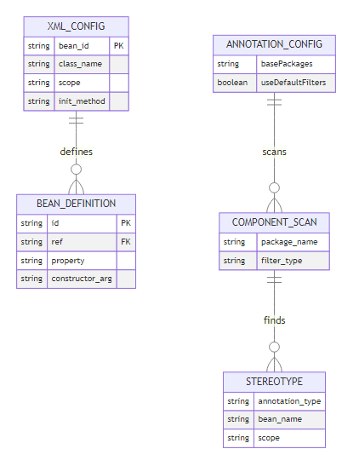

CONFIGURATION EVOLUTION

📈 Spring Configuration Timeline

🔄 Configuration Approaches
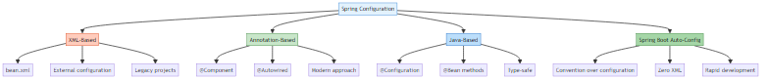

PROJECT 1: XML-BASED CONFIGURATION

📝 Traditional Approach by: Avinash Dhanuka | © 2026

📌 Overview
Traditional Spring configuration using XML files. This approach was the standard before Spring 2.5 and is still used in legacy applications.
📂 Location: XML_BasedConfiguration/
📖 Full Documentation: XML_BasedConfiguration/README.md

🎯 Key Concepts
- Bean Definition in XML
- Constructor Injection
- Setter Injection
- Bean Scopes (Singleton, Prototype)
- Lifecycle Callbacks
- ApplicationContext

📊 XML Configuration Structure
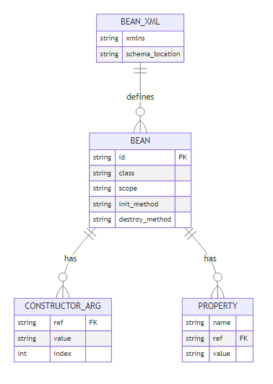

📝 Configuration Example
File: XML_BasedConfiguration/src/main/resources/bean.xml
<beans>
<!-- Bean Definition -->
<bean id="emailService" class="org.example.services.EmailService"/>
<!-- Constructor Injection -->
<bean id="messageService" class="org.example.services.MessageService">
<constructor-arg ref="emailService"/>
</bean>
<!-- Setter Injection -->
<bean id="notificationService" class="org.example.services.NotificationService">
<property name="emailService" ref="emailService"/>
</bean>
<!-- Bean Scopes -->
<bean id="singletonBean" class="..." scope="singleton"/>
<bean id="prototypeBean" class="..." scope="prototype"/>
</beans>

🔍 What You’ll Learn
- XML Bean Configuration
  - How to define beans in XML
  - Bean naming and referencing
  - External configuration management
- Dependency Injection
  - Constructor-based injection
  - Setter-based injection
  - When to use each approach
- Bean Scopes
  - Singleton scope (default)
  - Prototype scope
  - Scope behavior and lifecycle
- ApplicationContext
  - ClassPathXmlApplicationContext
  - Loading XML configuration
  - Bean retrieval and usage

📊 Pros & Cons
Pros ✅ | Cons ❌
Clear separation of config and code | Verbose and repetitive
Easy to modify without recompilation | No compile-time checking
Good for external configuration | Difficult to refactor
Works with any Java class | IDE support limited

🎓 Key Takeaways
- XML configuration provides external configuration
- Suitable for legacy applications
- Good for third-party library integration
- Not recommended for new projects

PROJECT 2: ANNOTATION-BASED CONFIGURATION

📝 Modern Approach by: Avinash Dhanuka | © 2026

📌 Overview
Modern Spring configuration using Java annotations. This is the recommended approach for new Spring applications.
📂 Location: AnnotationBased/
📖 Full Documentation: AnnotationBased/README.md
📄 Simple Explanation: AnnotationBased/EXPLAIN.md

🎯 Key Concepts
- @Configuration & @ComponentScan
- Stereotype Annotations (@Component, @Service, @Repository)
- @Autowired (Constructor, Setter, Field injection)
- @Bean Methods
- Bean Lifecycle (@PostConstruct, @PreDestroy)
- Advanced Annotations (@Lazy, @DependsOn, @Profile)

📊 Annotation Configuration Structure
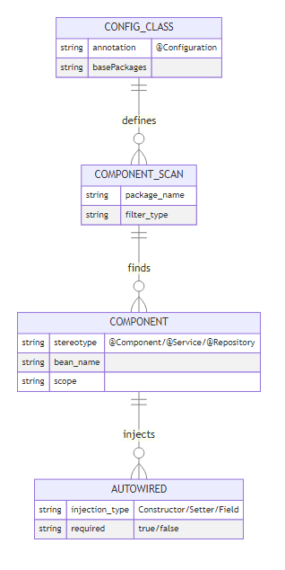

📝 Configuration Example
File: AnnotationBased/src/main/java/org/example/services/AppConfig.java
@Configuration
@ComponentScan(basePackages = "org.example.services")
public class AppConfig {
// Spring automatically finds @Component classes
}
Service Class:
@Component
public class EmailService {
public void send(String message) {
System.out.println("Email: " + message);
}
}
@Component
public class MessageService {
private final EmailService emailService;
// Constructor injection (no @Autowired needed for single constructor)
public MessageService(EmailService emailService) {
this.emailService = emailService;
}
}

🔍 What You’ll Learn
- Configuration Annotations
  - @Configuration for config classes
  - @ComponentScan for package scanning
  - AnnotationConfigApplicationContext
- Stereotype Annotations
  - @Component (generic)
  - @Service (business layer)
  - @Repository (data layer)
  - @Controller (presentation layer)
- Dependency Injection
  - Constructor injection (recommended)
  - Setter injection
  - Field injection (not recommended)
  - @Autowired behavior
- Bean Lifecycle
  - @PostConstruct for initialization
  - @PreDestroy for cleanup
  - InitializingBean & DisposableBean interfaces
- Advanced Features
  - @Lazy for lazy initialization
  - @DependsOn for bean ordering
  - @Profile for environment-specific beans
  - @Conditional for conditional bean creation

📊 Pros & Cons
Pros ✅ | Cons ❌
Type-safe configuration | Configuration in code
Compile-time checking | Requires recompilation
Better IDE support | Learning curve for annotations
Less verbose | Tight coupling to Spring
Refactoring-friendly | Harder to externalize

🎓 Key Takeaways
- Annotation-based config is modern and recommended
- Constructor injection is the best practice
- Use @Component for auto-detection
- @Configuration classes for complex setup
- Provides type safety and IDE support

PROJECT 3: @PRIMARY & @QUALIFIER

📝 Advanced DI Patterns by: Avinash Dhanuka | © 2026

📌 Overview
Advanced dependency injection patterns for resolving ambiguity when multiple beans of the same type exist.
📂 Location: PrimaryQualifier/
📖 Full Documentation: PrimaryQualifier/README.md
📄 Simple Explanation: PrimaryQualifier/PRIMARY_QUALIFIER_EXPLAIN.md

🎯 Key Concepts
- The Ambiguity Problem
- @Primary for default bean selection
- @Qualifier for specific bean selection
- Bean Naming Convention
- Resolution Priority
- Dynamic Bean Selection

📊 Primary & Qualifier Structure
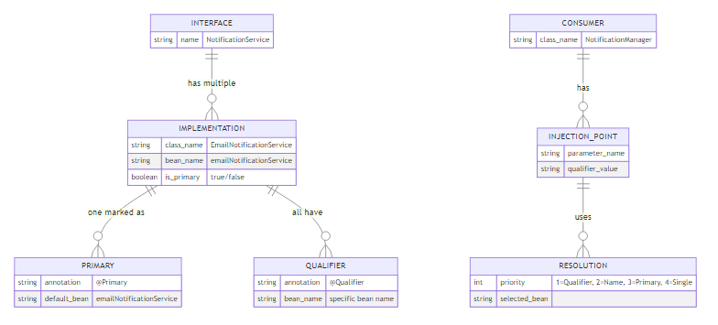

📝 Configuration Example
Interface:
public interface NotificationService {
void sendMsg(String message);
}
Implementations:
@Component
@Primary // Default choice
public class EmailNotificationService implements NotificationService {
public void sendMsg(String message) {
System.out.println("Email: " + message);
}
}
@Component
public class SmsNotificationService implements NotificationService {
public void sendMsg(String message) {
System.out.println("SMS: " + message);
}
}
@Component
public class PushNotificationService implements NotificationService {
public void sendMsg(String message) {
System.out.println("Push: " + message);
}
}
Usage:
@Component
public class NotificationManager {
private final NotificationService primaryService;
private final NotificationService emailService;
private final NotificationService smsService;
public NotificationManager(
NotificationService primaryService, // Gets @Primary (Email)
@Qualifier("emailNotificationService") NotificationService emailService,
@Qualifier("smsNotificationService") NotificationService smsService) {
this.primaryService = primaryService;
this.emailService = emailService;
this.smsService = smsService;
}
}

🔍 What You’ll Learn
- The Problem
  - NoUniqueBeanDefinitionException
  - Multiple bean candidates
  - Ambiguity resolution
- @Primary Annotation
  - Marking default bean
  - When to use @Primary
  - Only ONE @Primary per type
- @Qualifier Annotation
  - Selecting specific beans
  - Bean naming convention
  - Using with constructor injection
- Resolution Priority
  - @Qualifier (highest)
  - Parameter name matching
  - @Primary (fallback)
  - Single bean (last resort)
- Advanced Scenarios
  - Combining @Primary and @Qualifier
  - @Lazy with @Primary/@Qualifier
  - Dynamic bean selection
  - Map/List injection

📊 Resolution Priority
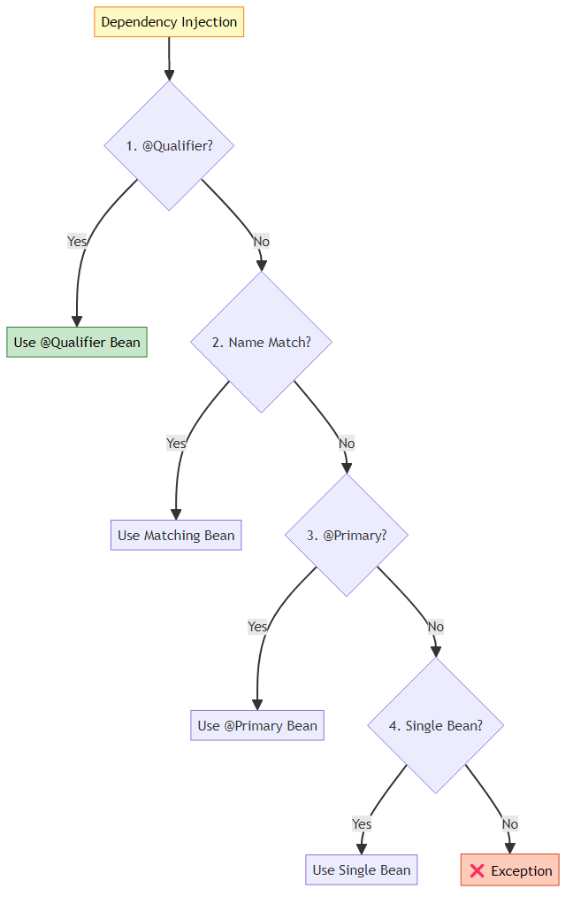

🎓 Key Takeaways
- Use @Primary for default implementation
- Use @Qualifier for specific selection
- @Qualifier overrides @Primary
- Only ONE @Primary per type allowed
- Bean names are class name with lowercase first letter

KEY CONCEPTS LEARNED

📝 Complete Learning Journey by: Avinash Dhanuka | © 2026

🧠 Day 09 Complete Learning Mindmap
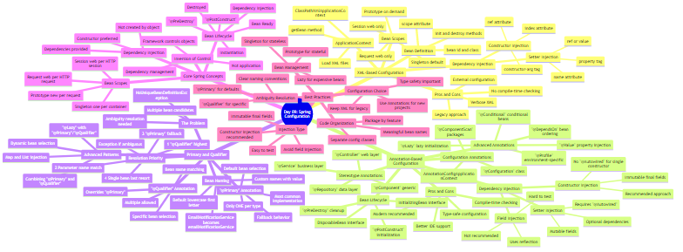

🎯 Core Spring Concepts

1. Inversion of Control (IoC)
Definition: Framework controls object creation and lifecycle, not the application.
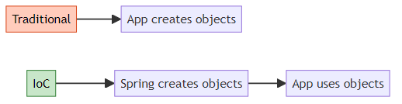

2. Dependency Injection (DI)
Definition: Dependencies are provided to objects rather than objects creating them.
Types: - Constructor Injection ✅ (Recommended) - Setter Injection ⚠️ (Optional dependencies) - Field Injection ❌ (Not recommended)

3. Bean Scopes
Scope | Instances | Lifecycle | Use Case
Singleton | 1 per container | Container lifetime | Stateless services
Prototype | New per request | Until GC | Stateful objects
Request | 1 per HTTP request | Request lifetime | Web - Form data
Session | 1 per HTTP session | Session lifetime | Web - User data

4. Bean Lifecycle

WHAT I LEARNED

📝 Personal Learning Journey by: Avinash Dhanuka | © 2026

🎓 Key Takeaways from Day 09
- Configuration Evolution Matters
  - XML was the original approach (Spring 1.0 - 2004)
  - Annotations introduced in Spring 2.5 (2007)
  - Modern applications prefer annotation-based
  - Each approach has its place and purpose
- Dependency Injection Best Practices
  - Constructor injection is the gold standard
  - Provides immutability with final fields
  - Makes testing easier (no reflection needed)
  - Setter injection for optional dependencies only
  - Avoid field injection (hard to test, breaks encapsulation)
- Bean Scopes Impact Performance
  - Singleton (default) - one instance per container
  - Prototype - new instance per request
  - Choose based on statefulness
  - Singleton for stateless services
  - Prototype for stateful objects
- Ambiguity Resolution is Critical
  - Multiple beans of same type cause NoUniqueBeanDefinitionException
  - @Primary marks the default choice
  - @Qualifier selects specific beans
  - Resolution priority: @Qualifier > Name Match > @Primary > Single Bean
- Lifecycle Management is Powerful
  - @PostConstruct for initialization after DI
  - @PreDestroy for cleanup before destruction
  - Proper resource management prevents leaks
  - Use for database connections, file handles, etc.
- Type Safety is a Game Changer
  - Annotation-based config provides compile-time checking
  - IDE support for refactoring
  - Catch errors before runtime
  - XML has no type safety
- Bean Naming Conventions
  - Default: class name with lowercase first letter
  - EmailService → emailService
  - Custom names with @Component(“customName”)
  - Important for @Qualifier usage
- Configuration Flexibility
  - @Profile for environment-specific beans
  - @Conditional for conditional bean creation
  - @Lazy for performance optimization
  - @DependsOn for bean ordering

💡 Real-World Applications
E-Commerce Platform: - Use @Primary for default payment gateway (Stripe) - Use @Qualifier for specific gateways (PayPal, Razorpay) - Singleton for services, Prototype for shopping carts
Notification System: - @Primary for email notifications (most common) - @Qualifier for SMS, Push notifications - Dynamic selection based on user preferences
Multi-Database Application: - @Primary for main database - @Qualifier for read replicas, analytics DB - @Profile for dev/test/prod environments

🚀 Skills Acquired
✅ XML Configuration Mastery - Bean definition and wiring - Constructor and setter injection - Scope management - Lifecycle callbacks
✅ Annotation Configuration Expertise - @Configuration and @ComponentScan - Stereotype annotations usage - @Autowired best practices - Bean lifecycle management
✅ Advanced DI Patterns - @Primary for defaults - @Qualifier for specifics - Resolution priority understanding - Dynamic bean selection
✅ Spring IoC Container Understanding - ApplicationContext vs BeanFactory - Bean creation and lifecycle - Dependency resolution - Scope management

CONFIGURATION COMPARISON

📊 XML vs Annotation Configuration
Aspect | XML Configuration | Annotation Configuration
Configuration Location | External XML file | In Java code
Type Safety | ❌ No | ✅ Yes
Compile-time Checking | ❌ No | ✅ Yes
IDE Support | ⚠️ Limited | ✅ Excellent
Refactoring | ❌ Difficult | ✅ Easy
Verbosity | ❌ High | ✅ Low
Learning Curve | ⚠️ Moderate | ⚠️ Moderate
Flexibility | ✅ High | ⚠️ Moderate
Externalization | ✅ Easy | ❌ Difficult
Recompilation | ✅ Not needed | ❌ Required
Best For | Legacy apps | New projects
Recommendation | ⚠️ Legacy only | ✅ Recommended

🔄 Same Feature, Different Approach

Bean Definition
XML:
<bean id="emailService" class="org.example.EmailService"/>
Annotation:
@Component
public class EmailService { }

Constructor Injection
XML:
<bean id="messageService" class="org.example.MessageService">
<constructor-arg ref="emailService"/>
</bean>
Annotation:
@Component
public class MessageService {
public MessageService(EmailService emailService) {
// Automatically injected
}
}

Bean Scope
XML:
<bean id="prototypeBean" class="..." scope="prototype"/>
Annotation:
@Component
@Scope("prototype")
public class PrototypeBean { }

WHEN TO USE WHAT

🎯 Decision Matrix
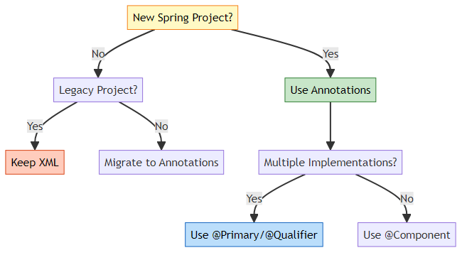

📋 Use Case Guidelines

Use XML Configuration When:
- ✅ Working with legacy applications
- ✅ Need external configuration without recompilation
- ✅ Integrating third-party libraries without source code
- ✅ Team prefers separation of config and code

Use Annotation Configuration When:
- ✅ Starting a new project
- ✅ Want type safety and compile-time checking
- ✅ Need better IDE support and refactoring
- ✅ Prefer less verbose configuration
- ✅ Following modern Spring practices

Use @Primary When:
- ✅ Have a default/preferred implementation
- ✅ One implementation used 80% of the time
- ✅ Want fallback behavior

Use @Qualifier When:
- ✅ Need specific implementation
- ✅ Using multiple implementations in same class
- ✅ Want to override @Primary choice
- ✅ Need explicit control

LEARNING PATH

🎓 Recommended Study Order
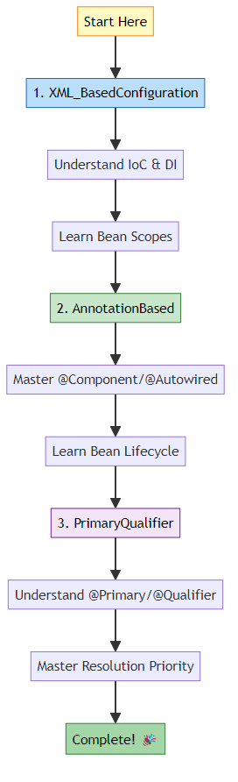

📚 Step-by-Step Guide

Step 1: XML-Based Configuration (2-3 hours)
- Read XML_BasedConfiguration/README.md
- Understand bean definition in XML
- Practice constructor and setter injection
- Experiment with bean scopes
- Run the project and observe behavior
Key Files to Study: - XML_BasedConfiguration/src/main/resources/bean.xml - XML_BasedConfiguration/src/main/java/org/example/App.java

Step 2: Annotation-Based Configuration (4-5 hours)
- Read AnnotationBased/README.md
- Understand @Configuration and @ComponentScan
- Learn stereotype annotations
- Master @Autowired and dependency injection
- Study bean lifecycle annotations
- Explore advanced annotations
Key Files to Study: - AnnotationBased/src/main/java/org/example/services/AppConfig.java - AnnotationBased/src/main/java/org/example/services/MessageService.java - AnnotationBased/src/main/java/org/example/bean_scope/BeanScopeDemo.java

Step 3: @Primary & @Qualifier (2-3 hours)
- Read PrimaryQualifier/PRIMARY_QUALIFIER_EXPLAIN.md (Simple)
- Read PrimaryQualifier/README.md (Detailed)
- Understand the ambiguity problem
- Learn @Primary for default selection
- Master @Qualifier for specific selection
- Study resolution priority
Key Files to Study: - PrimaryQualifier/src/main/java/org/example/primary_qualifier/NotificationManager.java - PrimaryQualifier/src/main/java/org/example/primary_qualifier/EmailNotificationService.java

QUICK REFERENCE

📖 Essential Annotations
Annotation | Purpose | Example
@Configuration | Mark configuration class | @Configuration public class AppConfig
@ComponentScan | Scan for components | @ComponentScan("org.example")
@Component | Generic component | @Component public class MyService
@Service | Business layer | @Service public class UserService
@Repository | Data layer | @Repository public class UserRepo
@Controller | Presentation layer | @Controller public class UserController
@Autowired | Inject dependency | @Autowired private UserService service
@Qualifier | Specify bean | @Qualifier("emailService")
@Primary | Default bean | @Primary @Component
@Scope | Bean scope | @Scope("prototype")
@Lazy | Lazy initialization | @Lazy @Component
@PostConstruct | After DI | @PostConstruct public void init()
@PreDestroy | Before destroy | @PreDestroy public void cleanup()
@Bean | Bean method | @Bean public DataSource ds()
@Value | Inject value | @Value("${app.name}")

🔧 Common Patterns

Pattern 1: Simple Service
@Service
public class UserService {
private final UserRepository repository;
public UserService(UserRepository repository) {
this.repository = repository;
}
}

Pattern 2: Multiple Implementations
@Component
@Primary
public class EmailNotifier implements Notifier { }
@Component
public class SmsNotifier implements Notifier { }
@Service
public class NotificationService {
public NotificationService(
Notifier defaultNotifier, // Gets @Primary
@Qualifier("smsNotifier") Notifier smsNotifier) {
}
}

Pattern 3: Lifecycle Management
@Component
public class DatabaseService {
@PostConstruct
public void init() {
// Initialize connection
}
@PreDestroy
public void cleanup() {
// Close connection
}
}

RUNNING THE PROJECTS

🚀 Prerequisites
- Java 21 or higher
- Maven 3.6+
- IDE (IntelliJ IDEA, Eclipse, or VS Code)

📦 Running Each Project

Project 1: XML_BasedConfiguration
cd XML_BasedConfiguration
mvn clean compile
mvn exec:java -Dexec.mainClass="org.example.App"
Expected Output:
=== Spring Container Created ===
Constructor Injection - MessageService created
Setter Injection - NotificationService created
Message sent via Email
Notification sent via Email
=== Spring Container Closed ===

Project 2: AnnotationBased
cd AnnotationBased
mvn clean compile
mvn exec:java -Dexec.mainClass="org.example.App"
Expected Output:
=== Spring Container Created ===
EmailService created
MessageService created with EmailService
Message: Hello from Annotation-Based Configuration!
=== Spring Container Closed ===

Project 3: PrimaryQualifier
cd PrimaryQualifier
mvn clean compile
mvn exec:java -Dexec.mainClass="org.example.primary_qualifier.PrimaryQualifierDemo"
Expected Output:
=== Spring Container Created ===
NotificationManager created with all notification services
--- Using @Primary (Default Service) ---
Email: Welcome to Spring!
--- Using @Qualifier (All Services) ---
Email: Important Update!
SMS: Important Update!
Push Notification: Important Update!
=== Spring Container Closed ===

🔧 Using IDE
- Import Project: File → Open → Select project folder
- Maven Sync: Right-click on pom.xml → Maven → Reload Project
- Run: Right-click on main class → Run

📚 ADDITIONAL RESOURCES

📖 Documentation References
- Spring Framework Documentation: https://docs.spring.io/spring-framework/docs/current/reference/html/
- Spring IoC Container: https://docs.spring.io/spring-framework/docs/current/reference/html/core.html#beans
- Dependency Injection: https://docs.spring.io/spring-framework/docs/current/reference/html/core.html#beans-dependencies

🎯 Project-Specific Documentation
Project | Simple Guide | Detailed Guide | Key Files
XML_BasedConfiguration | - | README.md | bean.xml, App.java
AnnotationBased | EXPLAIN.md | README.md | AppConfig.java, MessageService.java
PrimaryQualifier | PRIMARY_QUALIFIER_EXPLAIN.md | README.md | NotificationManager.java, EmailNotificationService.java

📖 Quick Navigation
Want to understand XML configuration? → Start with XML_BasedConfiguration/README.md
Want to learn modern annotations? → Start with AnnotationBased/EXPLAIN.md (simple) → Then read AnnotationBased/README.md (detailed)
Want to master @Primary and @Qualifier? → Start with PrimaryQualifier/PRIMARY_QUALIFIER_EXPLAIN.md (simple) → Then read PrimaryQualifier/README.md (detailed)

🎯 KEY TAKEAWAYS

✅ What We Learned
- Spring IoC Container
  - Manages object lifecycle
  - Handles dependency injection
  - Provides configuration flexibility
- Configuration Approaches
  - XML: External, flexible, legacy
  - Annotations: Modern, type-safe, recommended
- Dependency Injection
  - Constructor injection (best practice)
  - Setter injection (optional dependencies)
  - Field injection (avoid)
- Bean Management
  - Scopes: Singleton, Prototype
  - Lifecycle: @PostConstruct, @PreDestroy
  - Naming conventions
- Ambiguity Resolution
  - @Primary for defaults
  - @Qualifier for specific selection
  - Resolution priority order

🎓 Best Practices Summary
Practice | Recommendation | Reason
Configuration | Use Annotations | Modern, type-safe
Injection Type | Constructor | Immutable, testable
Bean Scope | Singleton (default) | Memory efficient
Multiple Beans | @Primary + @Qualifier | Clear intent
Lifecycle | @PostConstruct/@PreDestroy | Standard, clean
Field Injection | Avoid | Hard to test

🤝 CONTRIBUTING
Found an issue or want to improve the documentation? Feel free to reach out!

🎓 End of Spring Configuration Guide

Created with dedication by Avinash Dhanuka

Happy Learning! 🚀
“Master the fundamentals, embrace the modern!” - Avinash Dhanuka

📊 Project Statistics
Metric | Value
Total Projects | 3
Configuration Types | 2 (XML, Annotations)
Key Annotations Covered | 15+
Code Examples | 50+
Mermaid Diagrams | 10+
Documentation Pages | 3 comprehensive READMEs

© 2026 Avinash Dhanuka | All Rights Reserved

