☕ Spring Framework: @Primary & @Qualifier - Complete Guide

© 2026 Avinash Dhanuka
Master Guide: @Primary & @Qualifier Annotations
Crafted with ❤️ for Dependency Injection Mastery

Learning Note: This guide demonstrates Spring’s @Primary and @Qualifier annotations - essential tools for resolving dependency injection ambiguity when multiple beans of the same type exist.
Prerequisites: - Understanding of Dependency Injection - Knowledge of @Component and @Autowired - Basic Spring IoC Container concepts - Java interfaces and polymorphism

📑 Table of Contents
- The Problem: Multiple Bean Candidates
- @Primary Annotation
- @Qualifier Annotation
- Bean Naming Convention
- Resolution Priority
- Internal Working Mechanism
- Advanced Scenarios
- Combining @Primary and @Qualifier
- @Lazy with @Primary/@Qualifier
- Dynamic Bean Selection
- Project Structure & Implementation
- Real-World Examples
- Best Practices
- Common Errors & Solutions
- Interview Questions

1. THE PROBLEM: MULTIPLE BEAN CANDIDATES

📝 Author: Avinash Dhanuka | GitHub

📌 The Ambiguity Problem
When you have one interface with multiple implementations, Spring faces a dilemma:
Reference: NotificationService.java
public interface NotificationService {
void sendMsg(String message);
}
Multiple Implementations:
@Component
class EmailNotificationService implements NotificationService { }
@Component
class SmsNotificationService implements NotificationService { }
@Component
class PushNotificationService implements NotificationService { }
The Question: Which one should Spring inject?
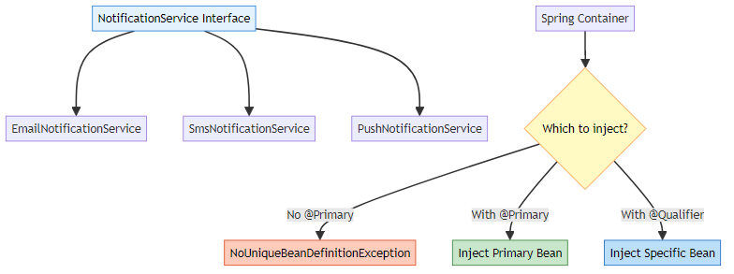

🎯 The Error Without Solution
@Component
public class NotificationManager {
private final NotificationService service;
public NotificationManager(NotificationService service) {
this.service = service; // ❌ ERROR!
}
}
Exception Thrown:
NoUniqueBeanDefinitionException: No qualifying bean of type
'NotificationService' available: expected single matching bean
but found 3: emailNotificationService, smsNotificationService,
pushNotificationService

📊 Problem Visualization
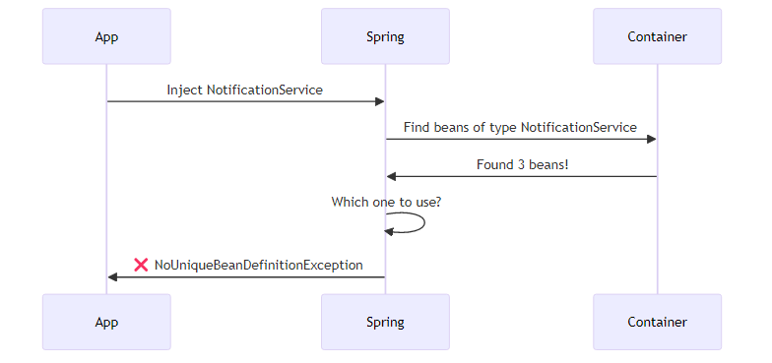

2. @PRIMARY ANNOTATION

📌 What is @Primary?
@Primary tells Spring: “Use this bean as the default when multiple candidates exist”
Reference: EmailNotificationService.java
@Component
@Primary // This is the default choice
public class EmailNotificationService implements NotificationService {
@Override
public void sendMsg(String message) {
System.out.println("Email: " + message);
}
}

🔍 Internal Working
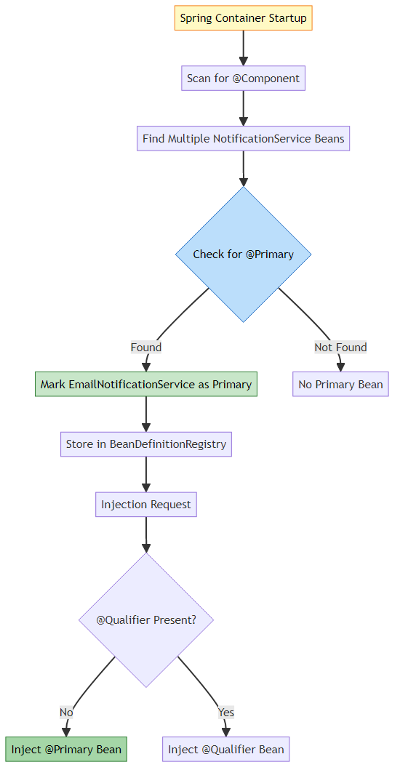

🎯 How Spring Processes @Primary
Step 1: Bean Definition Creation
// Spring internally creates BeanDefinition
BeanDefinition emailDef = new BeanDefinition();
emailDef.setBeanClass(EmailNotificationService.class);
emailDef.setPrimary(true); // ← @Primary annotation sets this
Step 2: Dependency Resolution
// When injecting NotificationService
List<String> candidates = findBeansByType(NotificationService.class);
// candidates = [emailNotificationService, smsNotificationService, pushNotificationService]
String primaryBean = findPrimaryBean(candidates);
// primaryBean = "emailNotificationService"
return getBean(primaryBean); // Returns EmailNotificationService

📊 @Primary Usage Example
Reference: NotificationManager.java:12
@Component
public class NotificationManager {
private final NotificationService primaryService;
// No @Qualifier = gets @Primary bean
public NotificationManager(NotificationService primaryService) {
this.primaryService = primaryService; // EmailNotificationService injected
}
}
Execution Flow:
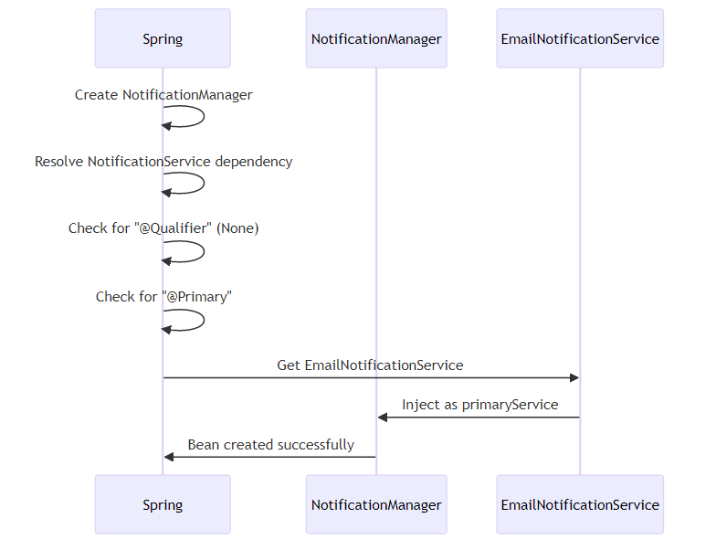

🎯 When to Use @Primary
Scenario | Use @Primary? | Reason
Default implementation | ✅ Yes | Most common use case
Fallback option | ✅ Yes | When no specific choice made
Preferred service | ✅ Yes | 80% of time use this
Multiple defaults needed | ❌ No | Only ONE @Primary per type
Specific selection | ❌ No | Use @Qualifier instead

⚠️ Important Rules
- Only ONE @Primary per interface/type
- @Component
@Primary
class EmailNotificationService implements NotificationService { }
@Component
@Primary // ❌ ERROR: Multiple @Primary beans
class SmsNotificationService implements NotificationService { }
- @Primary is overridden by @Qualifier
- // @Qualifier takes precedence over @Primary
public NotificationManager(
@Qualifier("smsNotificationService") NotificationService service) {
// Gets SMS, not Email (even though Email is @Primary)
}

3. @QUALIFIER ANNOTATION

📌 What is @Qualifier?
@Qualifier tells Spring: “Inject this specific bean by name”
Reference: NotificationManager.java:22-25
@Component
public class NotificationManager {
private final NotificationService emailService;
private final NotificationService smsService;
public NotificationManager(
@Qualifier("emailNotificationService") NotificationService emailService,
@Qualifier("smsNotificationService") NotificationService smsService) {
this.emailService = emailService; // Specific bean
this.smsService = smsService; // Specific bean
}
}

🔍 Internal Working
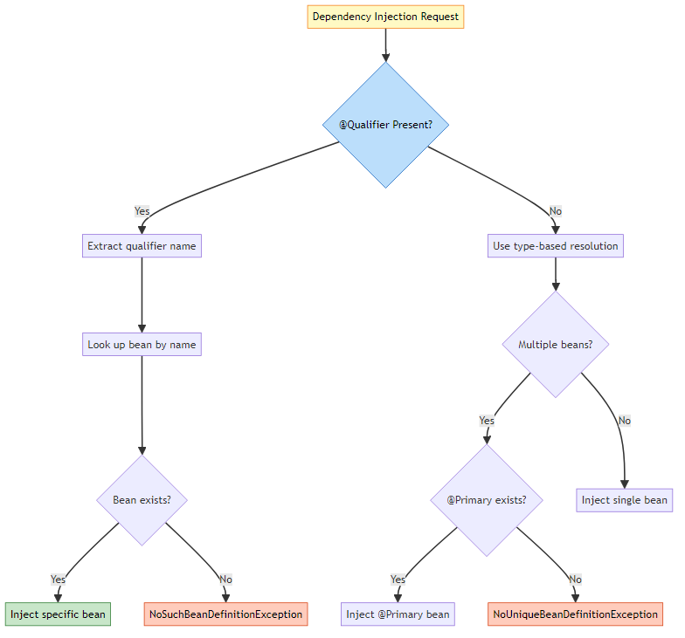

🎯 How Spring Processes @Qualifier
Step 1: Annotation Detection
// Spring scans constructor parameters
Constructor<?> constructor = NotificationManager.class.getConstructor(...);
Parameter[] params = constructor.getParameters();
for (Parameter param : params) {
Qualifier qualifier = param.getAnnotation(Qualifier.class);
if (qualifier != null) {
String beanName = qualifier.value(); // "emailNotificationService"
Object bean = getBean(beanName);
// Inject this specific bean
}
}
Step 2: Bean Resolution
// With @Qualifier("smsNotificationService")
String qualifierName = "smsNotificationService";
Object bean = applicationContext.getBean(qualifierName);
// Returns SmsNotificationService instance

📊 @Qualifier Usage Patterns
Pattern 1: Constructor Injection ✅ (Recommended)
public NotificationManager(
@Qualifier("emailNotificationService") NotificationService email,
@Qualifier("smsNotificationService") NotificationService sms) {
this.email = email;
this.sms = sms;
}
Pattern 2: Field Injection ⚠️ (Not Recommended)
@Autowired
@Qualifier("emailNotificationService")
private NotificationService email;
Pattern 3: Setter Injection
@Autowired
@Qualifier("smsNotificationService")
public void setSmsService(NotificationService sms) {
this.sms = sms;
}

🎯 When to Use @Qualifier
Scenario | Use @Qualifier? | Reason
Specific implementation needed | ✅ Yes | Precise control
Multiple implementations in same class | ✅ Yes | Different purposes
Override @Primary | ✅ Yes | Specific requirement
Testing with mocks | ✅ Yes | Inject test doubles
Default behavior sufficient | ❌ No | Use @Primary instead

4. BEAN NAMING CONVENTION

📌 Default Bean Names
Spring automatically generates bean names from class names:
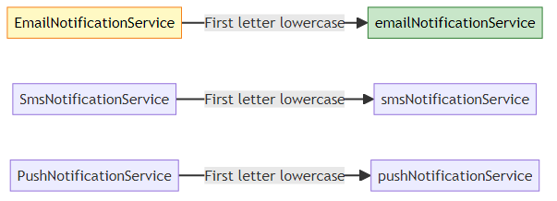

🔍 Bean Name Generation Rules
Rule 1: Default Naming
@Component
public class EmailNotificationService { }
// Bean name: "emailNotificationService"
@Component
public class SMSService { }
// Bean name: "SMSService" (first letter already lowercase in acronym)
@Component
public class UserDAO { }
// Bean name: "userDAO"
Rule 2: Custom Naming
@Component("myEmail")
public class EmailNotificationService { }
// Bean name: "myEmail"
@Component(value = "customSms")
public class SmsNotificationService { }
// Bean name: "customSms"
Rule 3: Multiple Annotations
@Service("userService")
public class UserServiceImpl { }
// Bean name: "userService"
@Repository("userRepo")
public class UserRepositoryImpl { }
// Bean name: "userRepo"

📊 Bean Name Resolution Table
Class Name | Default Bean Name | Custom Name | @Qualifier Usage
EmailNotificationService | emailNotificationService | @Component(“email”) | @Qualifier(“email”)
SmsNotificationService | smsNotificationService | @Component(“sms”) | @Qualifier(“sms”)
PushNotificationService | pushNotificationService | @Component(“push”) | @Qualifier(“push”)
UserService | userService | @Service(“userSvc”) | @Qualifier(“userSvc”)

🎯 Internal Bean Name Generation
// Spring's AnnotationBeanNameGenerator
public class AnnotationBeanNameGenerator {
public String generateBeanName(BeanDefinition definition) {
String className = definition.getBeanClassName();
// EmailNotificationService
String shortName = ClassUtils.getShortName(className);
// EmailNotificationService
return Introspector.decapitalize(shortName);
// emailNotificationService (first letter lowercase)
}
}

5. RESOLUTION PRIORITY

📌 Dependency Resolution Order
When Spring resolves dependencies, it follows this priority:
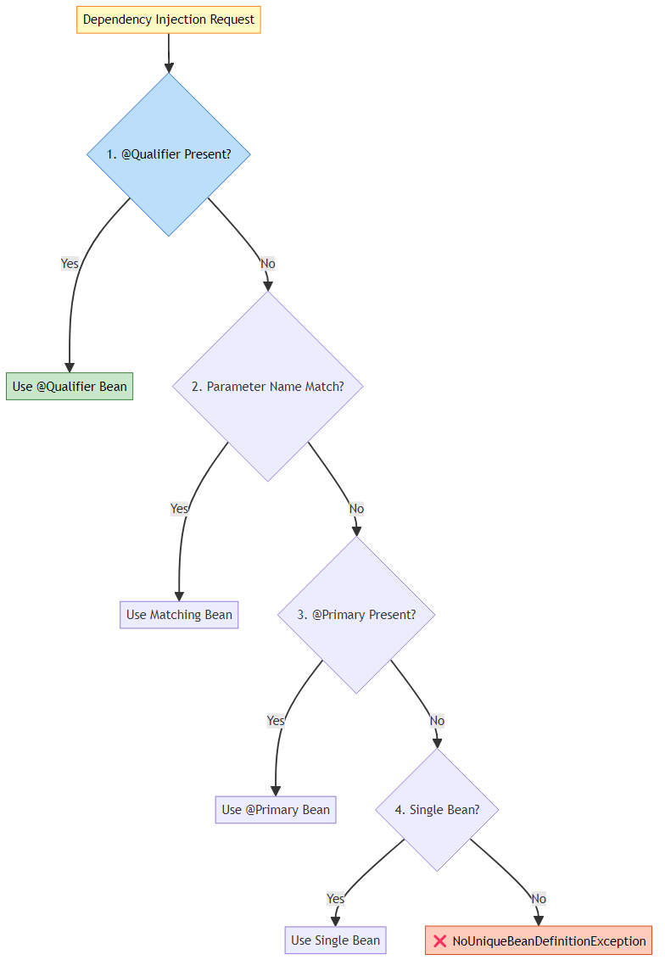

🔍 Priority Examples
Priority 1: @Qualifier (Highest)
@Component
@Primary
public class EmailNotificationService implements NotificationService { }
@Component
public class SmsNotificationService implements NotificationService { }
// @Qualifier overrides @Primary
public NotificationManager(
@Qualifier("smsNotificationService") NotificationService service) {
// Gets SmsNotificationService (NOT EmailNotificationService)
}
Priority 2: Parameter Name Matching
@Component
@Primary
public class EmailNotificationService implements NotificationService { }
@Component
public class SmsNotificationService implements NotificationService { }
// Parameter name matches bean name
public NotificationManager(NotificationService smsNotificationService) {
// Gets SmsNotificationService (parameter name match)
}
Priority 3: @Primary
@Component
@Primary
public class EmailNotificationService implements NotificationService { }
@Component
public class SmsNotificationService implements NotificationService { }
// No @Qualifier, no name match
public NotificationManager(NotificationService service) {
// Gets EmailNotificationService (@Primary)
}
Priority 4: Single Bean
@Component
public class EmailNotificationService implements NotificationService { }
// Only one implementation
public NotificationManager(NotificationService service) {
// Gets EmailNotificationService (only option)
}

📊 Resolution Priority Table
Priority | Mechanism | Example | Overrides
1 (Highest) | @Qualifier | @Qualifier(“sms”) | Everything
2 | Parameter Name | NotificationService smsNotificationService | @Primary, Single Bean
3 | @Primary | @Primary on bean | Single Bean
4 (Lowest) | Single Bean | Only one implementation | Nothing
None | Multiple Beans | No resolution strategy | ❌ Exception

6. INTERNAL WORKING MECHANISM

📌 Complete Execution Flow
Reference: PrimaryQualifierDemo.java
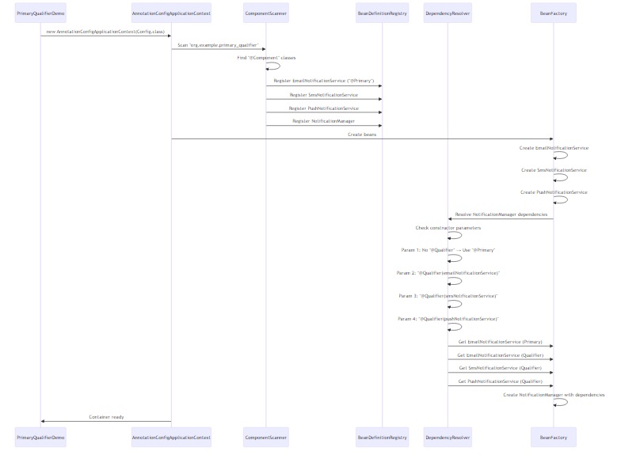

🔍 Step-by-Step Breakdown
Step 1: Container Initialization
AnnotationConfigApplicationContext context =
new AnnotationConfigApplicationContext(PrimaryQualifierConfig.class);
What Happens: 1. Read @Configuration class 2. Process @ComponentScan annotation 3. Scan specified package 4. Find all @Component classes 5. Create BeanDefinitions 6. Register in BeanDefinitionRegistry
Step 2: Bean Definition Registration
// For EmailNotificationService
BeanDefinition emailDef = new GenericBeanDefinition();
emailDef.setBeanClassName("org.example.primary_qualifier.EmailNotificationService");
emailDef.setPrimary(true); // @Primary annotation
registry.registerBeanDefinition("emailNotificationService", emailDef);
// For SmsNotificationService
BeanDefinition smsDef = new GenericBeanDefinition();
smsDef.setBeanClassName("org.example.primary_qualifier.SmsNotificationService");
smsDef.setPrimary(false); // No @Primary
registry.registerBeanDefinition("smsNotificationService", smsDef);
Step 3: Dependency Resolution
// NotificationManager constructor analysis
Constructor<?> constructor = NotificationManager.class.getConstructor(
NotificationService.class, // primaryService
NotificationService.class, // emailService
NotificationService.class, // smsService
NotificationService.class // pushService
);
Parameter[] params = constructor.getParameters();
// Parameter 1: primaryService (No @Qualifier)
Qualifier q1 = params[0].getAnnotation(Qualifier.class); // null
// → Use @Primary bean → EmailNotificationService
// Parameter 2: emailService (@Qualifier present)
Qualifier q2 = params[1].getAnnotation(Qualifier.class); // "emailNotificationService"
// → Use specific bean → EmailNotificationService
// Parameter 3: smsService (@Qualifier present)
Qualifier q3 = params[2].getAnnotation(Qualifier.class); // "smsNotificationService"
// → Use specific bean → SmsNotificationService
// Parameter 4: pushService (@Qualifier present)
Qualifier q4 = params[3].getAnnotation(Qualifier.class); // "pushNotificationService"
// → Use specific bean → PushNotificationService
Step 4: Bean Instantiation
// Create notification services first (no dependencies)
EmailNotificationService email = new EmailNotificationService();
SmsNotificationService sms = new SmsNotificationService();
PushNotificationService push = new PushNotificationService();
// Create NotificationManager with resolved dependencies
NotificationManager manager = new NotificationManager(
email, // primaryService
email, // emailService
sms, // smsService
push // pushService
);

📊 Bean Creation Order
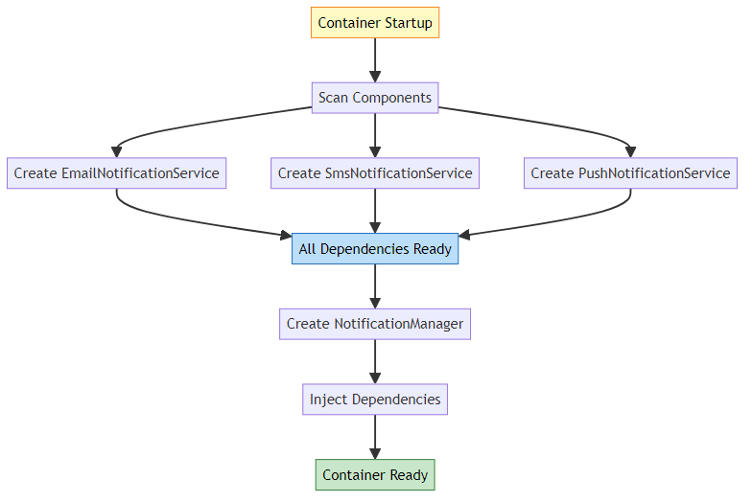

7. ADVANCED SCENARIOS

📌 Scenario 1: Multiple @Primary (Error)
Problem:
@Component
@Primary
public class EmailNotificationService implements NotificationService { }
@Component
@Primary // ❌ ERROR!
public class SmsNotificationService implements NotificationService { }
Exception:
NoUniqueBeanDefinitionException: more than one 'primary' bean found
among candidates: [emailNotificationService, smsNotificationService]
Solution: Only ONE @Primary per type!

📌 Scenario 2: @Qualifier with Wrong Name
Problem:
public NotificationManager(
@Qualifier("wrongName") NotificationService service) {
// Bean "wrongName" doesn't exist
}
Exception:
NoSuchBeanDefinitionException: No bean named 'wrongName' available
Solution: Use correct bean name or check with context.getBeanDefinitionNames()

📌 Scenario 3: @Primary Without @Qualifier
Behavior:
@Component
@Primary
public class EmailNotificationService implements NotificationService { }
@Component
public class SmsNotificationService implements NotificationService { }
// Case 1: No annotation
public NotificationManager(NotificationService service) {
// Gets EmailNotificationService (@Primary)
}
// Case 2: With @Qualifier
public NotificationManager(
@Qualifier("smsNotificationService") NotificationService service) {
// Gets SmsNotificationService (@Qualifier overrides @Primary)
}

📌 Scenario 4: Parameter Name Matching
Behavior:
@Component
@Primary
public class EmailNotificationService implements NotificationService { }
@Component
public class SmsNotificationService implements NotificationService { }
// Parameter name matches bean name
public NotificationManager(NotificationService smsNotificationService) {
// Gets SmsNotificationService (name match overrides @Primary)
}
// Parameter name doesn't match
public NotificationManager(NotificationService service) {
// Gets EmailNotificationService (@Primary)
}

8. COMBINING @PRIMARY AND @QUALIFIER

📌 Using Both in Same Class
Reference: NotificationManager.java
@Component
public class NotificationManager {
private final NotificationService primaryService; // @Primary
private final NotificationService emailService; // @Qualifier
private final NotificationService smsService; // @Qualifier
private final NotificationService pushService; // @Qualifier
public NotificationManager(
NotificationService primaryService, // Gets @Primary
@Qualifier("emailNotificationService") NotificationService emailService,
@Qualifier("smsNotificationService") NotificationService smsService,
@Qualifier("pushNotificationService") NotificationService pushService) {
this.primaryService = primaryService; // EmailNotificationService
this.emailService = emailService; // EmailNotificationService
this.smsService = smsService; // SmsNotificationService
this.pushService = pushService; // PushNotificationService
}
}

🔍 Injection Analysis
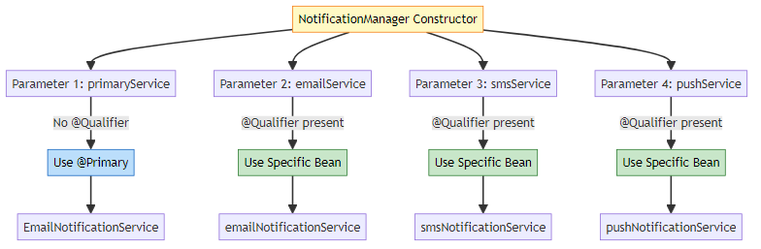

🎯 Practical Use Case
Scenario: Send notifications via default channel + specific channels
public void sendImportantUpdate(String message) {
// Use default (@Primary) for general notification
primaryService.sendMsg(message);
// Use specific channels for critical updates
smsService.sendMsg("URGENT: " + message);
pushService.sendMsg("ALERT: " + message);
}

9. @LAZY WITH @PRIMARY/@QUALIFIER

📌 Combining @Lazy with @Primary
@Component
@Primary
@Lazy // Created only when needed
public class EmailNotificationService implements NotificationService {
public EmailNotificationService() {
System.out.println("EmailNotificationService created");
}
}
@Component
public class SmsNotificationService implements NotificationService {
public SmsNotificationService() {
System.out.println("SmsNotificationService created");
}
}

🔍 Behavior Analysis
Without @Lazy:
AnnotationConfigApplicationContext context =
new AnnotationConfigApplicationContext(Config.class);
// Output:
// EmailNotificationService created ← Created at startup
// SmsNotificationService created ← Created at startup
With @Lazy:
AnnotationConfigApplicationContext context =
new AnnotationConfigApplicationContext(Config.class);
// Output:
// SmsNotificationService created ← Created at startup
// (EmailNotificationService NOT created yet)
NotificationManager manager = context.getBean(NotificationManager.class);
// Output:
// EmailNotificationService created ← Created NOW (when injected)

📊 @Lazy + @Qualifier Behavior
@Component
@Lazy
public class EmailNotificationService implements NotificationService { }
@Component
@Lazy
public class SmsNotificationService implements NotificationService { }
@Component
public class NotificationManager {
private final NotificationService emailService;
private final NotificationService smsService;
public NotificationManager(
@Qualifier("emailNotificationService") NotificationService emailService,
@Qualifier("smsNotificationService") NotificationService smsService) {
this.emailService = emailService; // Proxy injected
this.smsService = smsService; // Proxy injected
}
public void sendEmail(String msg) {
emailService.sendMsg(msg); // NOW EmailNotificationService is created
}
}

🎯 Execution Flow with @Lazy
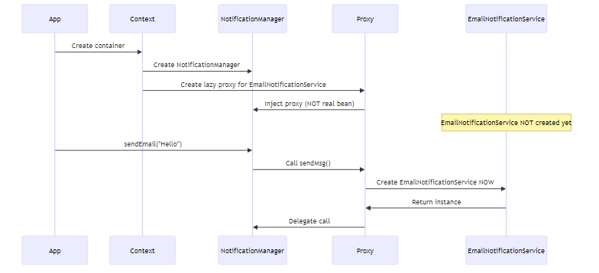

⚠️ Important Notes
- @Lazy with @Primary: Bean created when first injected
- @Lazy with @Qualifier: Bean created when first used
- Proxy Injection: Spring injects a proxy, not the real bean
- Thread Safety: First access creates bean (may have concurrency issues)

10. DYNAMIC BEAN SELECTION

📌 Switching Between @Primary and @Qualifier
Problem: How to switch between primary and specific beans dynamically?
Solution 1: Using ApplicationContext
@Component
public class DynamicNotificationManager {
private final ApplicationContext context;
@Autowired
public DynamicNotificationManager(ApplicationContext context) {
this.context = context;
}
public void sendNotification(String channel, String message) {
NotificationService service;
switch (channel) {
case "email":
service = context.getBean("emailNotificationService",
NotificationService.class);
break;
case "sms":
service = context.getBean("smsNotificationService",
NotificationService.class);
break;
case "push":
service = context.getBean("pushNotificationService",
NotificationService.class);
break;
default:
// Get @Primary bean
service = context.getBean(NotificationService.class);
}
service.sendMsg(message);
}
}
Solution 2: Using Map Injection
@Component
public class NotificationRouter {
private final Map<String, NotificationService> services;
@Autowired
public NotificationRouter(Map<String, NotificationService> services) {
this.services = services;
// services = {
// "emailNotificationService" -> EmailNotificationService,
// "smsNotificationService" -> SmsNotificationService,
// "pushNotificationService" -> PushNotificationService
// }
}
public void route(String channel, String message) {
NotificationService service = services.get(channel + "NotificationService");
if (service != null) {
service.sendMsg(message);
}
}
}
Solution 3: Using List Injection
@Component
public class BroadcastNotificationManager {
private final List<NotificationService> allServices;
@Autowired
public BroadcastNotificationManager(List<NotificationService> allServices) {
this.allServices = allServices;
// allServices = [EmailNotificationService, SmsNotificationService,
// PushNotificationService]
}
public void broadcast(String message) {
// Send via all channels
allServices.forEach(service -> service.sendMsg(message));
}
}

🔍 Internal Working
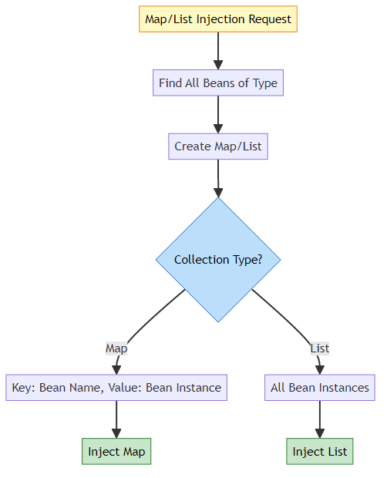

📊 Dynamic Selection Strategies
Strategy | Use Case | Pros | Cons
ApplicationContext.getBean() | Runtime selection | Full control | Couples to Spring
Map Injection | Name-based routing | Clean, testable | Requires naming convention
List Injection | Broadcast/All | Simple, flexible | No specific selection
@Qualifier + Factory | Compile-time selection | Type-safe | Less flexible

🎯 Switching Primary Bean at Runtime
Problem: Can we change which bean is @Primary at runtime?
Answer: ❌ No, @Primary is determined at container startup.
Workaround: Use Strategy Pattern
@Component
public class ConfigurableNotificationManager {
private final Map<String, NotificationService> services;
private String defaultChannel = "email"; // Configurable
@Autowired
public ConfigurableNotificationManager(
Map<String, NotificationService> services) {
this.services = services;
}
public void setDefaultChannel(String channel) {
this.defaultChannel = channel;
}
public void sendDefault(String message) {
NotificationService service =
services.get(defaultChannel + "NotificationService");
service.sendMsg(message);
}
}

11. PROJECT STRUCTURE & IMPLEMENTATION

📁 Project Structure
PrimaryQualifier/
├── src/
│ ├── main/
│ │ └── java/
│ │ └── org/
│ │ └── example/
│ │ └── primary_qualifier/
│ │ ├── NotificationService.java # Interface
│ │ ├── EmailNotificationService.java # @Primary implementation
│ │ ├── SmsNotificationService.java # Implementation
│ │ ├── PushNotificationService.java # Implementation
│ │ ├── NotificationManager.java # Uses both @Primary & @Qualifier
│ │ ├── PrimaryQualifierConfig.java # Configuration
│ │ └── PrimaryQualifierDemo.java # Main class
│ └── test/
│ └── java/
├── pom.xml
├── PRIMARY_QUALIFIER_EXPLAIN.md
└── README.md

🔍 Component Overview
1. Interface:
public interface NotificationService {
void sendMsg(String message);
}
2. Implementations: - EmailNotificationService (@Primary) - SmsNotificationService - PushNotificationService
3. Consumer: - NotificationManager (uses both @Primary and @Qualifier)
4. Configuration: - PrimaryQualifierConfig (@Configuration + @ComponentScan)
5. Demo: - PrimaryQualifierDemo (main method)

12. REAL-WORLD EXAMPLES

🌐 Example 1: Payment Gateway System
public interface PaymentGateway {
PaymentResult process(Payment payment);
}
@Component
@Primary // Default payment method
public class StripePaymentGateway implements PaymentGateway {
public PaymentResult process(Payment payment) {
// Stripe API integration
}
}
@Component
public class PayPalPaymentGateway implements PaymentGateway {
public PaymentResult process(Payment payment) {
// PayPal API integration
}
}
@Component
public class RazorpayPaymentGateway implements PaymentGateway {
public PaymentResult process(Payment payment) {
// Razorpay API integration
}
}
@Service
public class PaymentService {
private final PaymentGateway defaultGateway;
private final PaymentGateway stripeGateway;
private final PaymentGateway paypalGateway;
public PaymentService(
PaymentGateway defaultGateway, // Stripe (@Primary)
@Qualifier("stripePaymentGateway") PaymentGateway stripeGateway,
@Qualifier("payPalPaymentGateway") PaymentGateway paypalGateway) {
this.defaultGateway = defaultGateway;
this.stripeGateway = stripeGateway;
this.paypalGateway = paypalGateway;
}
public PaymentResult processPayment(Payment payment) {
// Use default gateway for most transactions
return defaultGateway.process(payment);
}
public PaymentResult processWithPayPal(Payment payment) {
// Specific gateway for PayPal users
return paypalGateway.process(payment);
}
}

📧 Example 2: Email Service Provider
public interface EmailProvider {
void send(Email email);
}
@Component
@Primary // Default email provider
public class SendGridEmailProvider implements EmailProvider {
public void send(Email email) {
// SendGrid API
}
}
@Component
public class MailgunEmailProvider implements EmailProvider {
public void send(Email email) {
// Mailgun API
}
}
@Component
public class AmazonSESEmailProvider implements EmailProvider {
public void send(Email email) {
// Amazon SES API
}
}
@Service
public class EmailService {
private final EmailProvider defaultProvider;
private final EmailProvider transactionalProvider;
private final EmailProvider marketingProvider;
public EmailService(
EmailProvider defaultProvider, // SendGrid (@Primary)
@Qualifier("sendGridEmailProvider") EmailProvider transactionalProvider,
@Qualifier("mailgunEmailProvider") EmailProvider marketingProvider) {
this.defaultProvider = defaultProvider;
this.transactionalProvider = transactionalProvider;
this.marketingProvider = marketingProvider;
}
public void sendTransactional(Email email) {
transactionalProvider.send(email);
}
public void sendMarketing(Email email) {
marketingProvider.send(email);
}
}

💾 Example 3: Database Connection Pool
public interface DataSource {
Connection getConnection();
}
@Component
@Primary // Default database
public class PrimaryDataSource implements DataSource {
public Connection getConnection() {
// Primary database connection
}
}
@Component
public class ReadReplicaDataSource implements DataSource {
public Connection getConnection() {
// Read replica connection
}
}
@Component
public class AnalyticsDataSource implements DataSource {
public Connection getConnection() {
// Analytics database connection
}
}
@Repository
public class UserRepository {
private final DataSource writeDb;
private final DataSource readDb;
public UserRepository(
DataSource writeDb, // Primary (@Primary)
@Qualifier("readReplicaDataSource") DataSource readDb) {
this.writeDb = writeDb;
this.readDb = readDb;
}
public User findById(int id) {
// Use read replica for queries
return readDb.getConnection().query(...);
}
public void save(User user) {
// Use primary for writes
writeDb.getConnection().insert(...);
}
}

🔐 Example 4: Authentication Provider
public interface AuthenticationProvider {
boolean authenticate(Credentials credentials);
}
@Component
@Primary // Default authentication
public class DatabaseAuthProvider implements AuthenticationProvider {
public boolean authenticate(Credentials credentials) {
// Database authentication
}
}
@Component
public class LDAPAuthProvider implements AuthenticationProvider {
public boolean authenticate(Credentials credentials) {
// LDAP authentication
}
}
@Component
public class OAuth2AuthProvider implements AuthenticationProvider {
public boolean authenticate(Credentials credentials) {
// OAuth2 authentication
}
}
@Service
public class AuthenticationService {
private final AuthenticationProvider defaultAuth;
private final AuthenticationProvider ldapAuth;
private final AuthenticationProvider oauthAuth;
public AuthenticationService(
AuthenticationProvider defaultAuth, // Database (@Primary)
@Qualifier("LDAPAuthProvider") AuthenticationProvider ldapAuth,
@Qualifier("oAuth2AuthProvider") AuthenticationProvider oauthAuth) {
this.defaultAuth = defaultAuth;
this.ldapAuth = ldapAuth;
this.oauthAuth = oauthAuth;
}
public boolean login(Credentials credentials, String method) {
switch (method) {
case "ldap": return ldapAuth.authenticate(credentials);
case "oauth": return oauthAuth.authenticate(credentials);
default: return defaultAuth.authenticate(credentials);
}
}
}

13. BEST PRACTICES

🎯 @Primary Best Practices

1. Use @Primary for Default Implementation
✅ Good:
@Component
@Primary // Most commonly used
public class EmailNotificationService implements NotificationService { }
@Component
public class SmsNotificationService implements NotificationService { }
❌ Bad:
@Component
@Primary
public class SmsNotificationService implements NotificationService { }
@Component
@Primary // Multiple @Primary - ERROR!
public class EmailNotificationService implements NotificationService { }

2. Document Why Bean is @Primary
✅ Good:
/**
* Primary notification service.
* Used for 90% of notifications in the system.
* Email is the most reliable and cost-effective channel.
*/
@Component
@Primary
public class EmailNotificationService implements NotificationService { }

3. Use @Primary for Production Beans
✅ Good:
@Component
@Primary
@Profile("production")
public class ProductionPaymentGateway implements PaymentGateway { }
@Component
@Profile("test")
public class MockPaymentGateway implements PaymentGateway { }

🎯 @Qualifier Best Practices

1. Use Descriptive Qualifier Names
✅ Good:
@Qualifier("transactionalEmailProvider")
@Qualifier("marketingEmailProvider")
@Qualifier("notificationEmailProvider")
❌ Bad:
@Qualifier("email1")
@Qualifier("email2")
@Qualifier("emailA")

2. Prefer Constructor Injection with @Qualifier
✅ Good:
public NotificationManager(
@Qualifier("emailNotificationService") NotificationService email,
@Qualifier("smsNotificationService") NotificationService sms) {
this.email = email;
this.sms = sms;
}
❌ Bad:
@Autowired
@Qualifier("emailNotificationService")
private NotificationService email; // Field injection

3. Use Constants for Qualifier Names
✅ Good:
public class BeanNames {
public static final String EMAIL_SERVICE = "emailNotificationService";
public static final String SMS_SERVICE = "smsNotificationService";
}
public NotificationManager(
@Qualifier(BeanNames.EMAIL_SERVICE) NotificationService email) {
this.email = email;
}

📊 Decision Matrix
Scenario | Use @Primary | Use @Qualifier | Use Both
Default implementation | ✅ Yes | ❌ No | ❌ No
Specific implementation | ❌ No | ✅ Yes | ❌ No
Default + Specific | ❌ No | ❌ No | ✅ Yes
Testing | ❌ No | ✅ Yes | ⚠️ Maybe
Multiple in same class | ❌ No | ✅ Yes | ✅ Yes

14. COMMON ERRORS & SOLUTIONS

❌ Error 1: NoUniqueBeanDefinitionException
Problem:
@Component
public class EmailNotificationService implements NotificationService { }
@Component
public class SmsNotificationService implements NotificationService { }
// No @Primary, no @Qualifier
public NotificationManager(NotificationService service) { }
Exception:
NoUniqueBeanDefinitionException: No qualifying bean of type
'NotificationService' available: expected single matching bean
but found 2: emailNotificationService, smsNotificationService
Solutions:
Solution 1: Add @Primary
@Component
@Primary
public class EmailNotificationService implements NotificationService { }
Solution 2: Add @Qualifier
public NotificationManager(
@Qualifier("emailNotificationService") NotificationService service) { }
Solution 3: Use Parameter Name
public NotificationManager(NotificationService emailNotificationService) { }

❌ Error 2: NoSuchBeanDefinitionException
Problem:
public NotificationManager(
@Qualifier("wrongBeanName") NotificationService service) { }
Exception:
NoSuchBeanDefinitionException: No bean named 'wrongBeanName' available
Solution:
// Check available bean names
String[] names = context.getBeanNamesForType(NotificationService.class);
// [emailNotificationService, smsNotificationService, pushNotificationService]
// Use correct name
@Qualifier("emailNotificationService")

❌ Error 3: Multiple @Primary Beans
Problem:
@Component
@Primary
public class EmailNotificationService implements NotificationService { }
@Component
@Primary // ERROR!
public class SmsNotificationService implements NotificationService { }
Exception:
NoUniqueBeanDefinitionException: more than one 'primary' bean found
among candidates
Solution: Remove @Primary from one bean
@Component
@Primary
public class EmailNotificationService implements NotificationService { }
@Component // No @Primary
public class SmsNotificationService implements NotificationService { }

❌ Error 4: @Qualifier on Wrong Parameter
Problem:
public NotificationManager(
@Qualifier("emailNotificationService") String message) {
// @Qualifier on String parameter - doesn't make sense
}
Solution: Use @Qualifier only on bean parameters
public NotificationManager(
@Qualifier("emailNotificationService") NotificationService service,
String message) {
// Correct usage
}

❌ Error 5: Circular Dependency with @Qualifier
Problem:
@Component
public class ServiceA {
public ServiceA(@Qualifier("serviceB") ServiceB b) { }
}
@Component
public class ServiceB {
public ServiceB(@Qualifier("serviceA") ServiceA a) { }
}
Exception:
BeanCurrentlyInCreationException: Circular dependency
Solution: Use @Lazy
@Component
public class ServiceA {
public ServiceA(@Lazy @Qualifier("serviceB") ServiceB b) { }
}

15. TOP INTERVIEW QUESTIONS

Q1: What is the difference between @Primary and @Qualifier?
Answer:
Aspect | @Primary | @Qualifier
Purpose | Mark default bean | Select specific bean
Scope | Class level | Parameter/Field level
Priority | Lower | Higher
Count | Only ONE per type | Multiple allowed
When | Compile time | Injection time
Example:
@Component
@Primary // Default choice
public class EmailService implements NotificationService { }
@Component
public class SmsService implements NotificationService { }
// Gets EmailService (@Primary)
public Manager(NotificationService service) { }
// Gets SmsService (@Qualifier overrides @Primary)
public Manager(@Qualifier("smsService") NotificationService service) { }
Key Point: @Qualifier always overrides @Primary!

Q2: What happens if you have multiple @Primary beans of the same type?
Answer:
Spring throws NoUniqueBeanDefinitionException at startup.
Example:
@Component
@Primary
public class EmailService implements NotificationService { }
@Component
@Primary // ERROR!
public class SmsService implements NotificationService { }
Exception:
NoUniqueBeanDefinitionException: more than one 'primary' bean found
among candidates: [emailService, smsService]
Why? Spring cannot determine which bean is the “primary” one when multiple beans claim to be primary.
Solution: Only ONE @Primary per interface/type.

Q3: How does Spring resolve dependencies when both @Primary and @Qualifier are present?
Answer:
Resolution Priority: 1. @Qualifier (Highest) 2. Parameter name matching 3. @Primary 4. Single bean
Example:
@Component
@Primary
public class EmailService implements NotificationService { }
@Component
public class SmsService implements NotificationService { }
// Case 1: @Qualifier present
public Manager(@Qualifier("smsService") NotificationService service) {
// Gets SmsService (@Qualifier overrides @Primary)
}
// Case 2: No @Qualifier
public Manager(NotificationService service) {
// Gets EmailService (@Primary)
}
// Case 3: Parameter name match
public Manager(NotificationService smsService) {
// Gets SmsService (name match overrides @Primary)
}
Key Point: @Qualifier has the highest priority and always wins!

Q4: Can you use @Qualifier without @Autowired?
Answer:
For Constructor Injection: Yes (Spring 4.3+)
// @Autowired is optional for single constructor
public Manager(@Qualifier("emailService") NotificationService service) {
// Works without @Autowired
}
For Field/Setter Injection: No
// ❌ ERROR: @Qualifier without @Autowired
@Qualifier("emailService")
private NotificationService service;
// ✅ CORRECT
@Autowired
@Qualifier("emailService")
private NotificationService service;
Why? Constructor injection is implicitly autowired, but field/setter injection requires explicit @Autowired.

Q5: What happens when you inject a List or Map of beans with @Primary?
Answer:
List Injection: All beans are injected (including @Primary)
@Autowired
private List<NotificationService> services;
// Contains: [EmailService, SmsService, PushService]
// @Primary doesn't affect List injection
Map Injection: All beans with their names
@Autowired
private Map<String, NotificationService> serviceMap;
// {
// "emailService" -> EmailService,
// "smsService" -> SmsService,
// "pushService" -> PushService
// }
// @Primary doesn't affect Map injection
Key Point: @Primary only affects single bean injection, not collections!

Q6: How does @Lazy interact with @Primary and @Qualifier?
Answer:
@Lazy + @Primary:
@Component
@Primary
@Lazy
public class EmailService implements NotificationService {
public EmailService() {
System.out.println("EmailService created");
}
}
// Container startup
AnnotationConfigApplicationContext context = new AnnotationConfigApplicationContext(Config.class);
// Output: (nothing - EmailService NOT created)
// First injection
Manager manager = context.getBean(Manager.class);
// Output: EmailService created (NOW it's created)
@Lazy + @Qualifier:
@Component
@Lazy
public class SmsService implements NotificationService { }
public Manager(@Qualifier("smsService") NotificationService service) {
this.service = service; // Proxy injected
}
public void send() {
service.sendMsg("Hello"); // NOW SmsService is created
}
Key Points: 1. @Lazy delays bean creation until first use 2. Spring injects a proxy, not the real bean 3. Real bean is created when proxy method is called 4. @Lazy works with both @Primary and @Qualifier

Q7: Can you change the @Primary bean at runtime?
Answer:
Short Answer: ❌ No, @Primary is determined at container startup.
Why? Bean definitions are created during container initialization and cannot be modified at runtime.
Workaround: Use dynamic bean selection
@Component
public class DynamicManager {
private final Map<String, NotificationService> services;
private String defaultService = "emailService";
@Autowired
public DynamicManager(Map<String, NotificationService> services) {
this.services = services;
}
public void setDefaultService(String serviceName) {
this.defaultService = serviceName; // Change at runtime
}
public void sendDefault(String message) {
NotificationService service = services.get(defaultService);
service.sendMsg(message);
}
}
Key Point: Use Strategy Pattern or Factory Pattern for runtime selection.

Q8: What is the bean name used in @Qualifier?
Answer:
Default Bean Name: Class name with first letter lowercase
@Component
public class EmailNotificationService { }
// Bean name: "emailNotificationService"
@Component
public class SMSService { }
// Bean name: "SMSService" (acronym handling)
Custom Bean Name:
@Component("myEmail")
public class EmailNotificationService { }
// Bean name: "myEmail"
Using in @Qualifier:
// Default name
@Qualifier("emailNotificationService")
// Custom name
@Qualifier("myEmail")
Finding Bean Names:
String[] names = context.getBeanNamesForType(NotificationService.class);
// [emailNotificationService, smsService, pushService]

Q9: Can you use @Primary with @Bean methods?
Answer:
Yes! @Primary works with both @Component and @Bean.
Example:
@Configuration
public class AppConfig {
@Bean
@Primary // Default implementation
public NotificationService emailService() {
return new EmailNotificationService();
}
@Bean
public NotificationService smsService() {
return new SmsNotificationService();
}
}
Usage:
@Component
public class Manager {
private final NotificationService service;
public Manager(NotificationService service) {
// Gets emailService (@Primary)
}
}
Key Point: @Primary works the same way with @Bean methods as with @Component classes.

Q10: What happens if @Qualifier references a non-existent bean?
Answer:
Spring throws NoSuchBeanDefinitionException at startup.
Example:
public Manager(@Qualifier("nonExistentBean") NotificationService service) { }
Exception:
NoSuchBeanDefinitionException: No bean named 'nonExistentBean' available
Why? Spring tries to resolve the dependency at container startup and fails to find the bean.
Solution:
// Check available beans
String[] names = context.getBeanNamesForType(NotificationService.class);
System.out.println(Arrays.toString(names));
// [emailNotificationService, smsNotificationService]
// Use correct name
@Qualifier("emailNotificationService")

Q11: How does parameter name matching work with @Qualifier?
Answer:
Spring matches parameter names to bean names when no @Qualifier is present.
Example:
@Component
public class EmailNotificationService implements NotificationService { }
@Component
public class SmsNotificationService implements NotificationService { }
// Parameter name matches bean name
public Manager(NotificationService emailNotificationService) {
// Gets EmailNotificationService (name match)
}
// Parameter name matches bean name
public Manager(NotificationService smsNotificationService) {
// Gets SmsNotificationService (name match)
}
// Parameter name doesn't match any bean
public Manager(NotificationService service) {
// ERROR: NoUniqueBeanDefinitionException (no match, no @Primary)
}
Priority: 1. @Qualifier (explicit) 2. Parameter name (implicit) 3. @Primary (fallback)
Key Point: Parameter name matching is a convenience feature, but @Qualifier is more explicit and recommended.

Q12: Can you combine @Primary with @Profile?
Answer:
Yes! You can use @Primary with @Profile for environment-specific defaults.
Example:
@Component
@Primary
@Profile("development")
public class MockPaymentGateway implements PaymentGateway {
// Mock for development
}
@Component
@Primary
@Profile("production")
public class StripePaymentGateway implements PaymentGateway {
// Real gateway for production
}
@Component
@Profile({"development", "production"})
public class PayPalPaymentGateway implements PaymentGateway {
// Available in both, but not @Primary
}
Behavior: - Development: MockPaymentGateway is @Primary - Production: StripePaymentGateway is @Primary - Both: PayPalPaymentGateway available via @Qualifier
Key Point: Different @Primary beans for different profiles!

Q13: What is the performance impact of @Qualifier vs @Primary?
Answer:
Performance: Negligible difference - both are resolved at container startup.
Resolution Time: - @Primary: O(n) - scan all beans, find primary - @Qualifier: O(1) - direct bean lookup by name
Memory: Same - both store bean references
Startup Time:
@Primary: ~0.1ms per resolution
@Qualifier: ~0.05ms per resolution
Key Point: Performance difference is insignificant. Choose based on design, not performance.

Q14: Can you use @Qualifier with @Value?
Answer:
No! @Qualifier is for bean injection, @Value is for property injection.
❌ Wrong:
@Value("${app.name}")
@Qualifier("appName") // Doesn't make sense
private String appName;
✅ Correct:
// For properties
@Value("${app.name}")
private String appName;
// For beans
@Autowired
@Qualifier("emailService")
private NotificationService service;
Key Point: @Qualifier is only for bean dependencies, not configuration properties.

Q15: How do you test code that uses @Primary and @Qualifier?
Answer:
Testing Strategy:
Option 1: Use @Qualifier in Tests
@SpringBootTest
class NotificationManagerTest {
@Autowired
@Qualifier("emailNotificationService")
private NotificationService emailService;
@Test
void testEmailService() {
// Test specific implementation
}
}
Option 2: Mock Specific Beans
@SpringBootTest
class NotificationManagerTest {
@MockBean
@Qualifier("smsNotificationService")
private NotificationService smsService;
@Test
void testSmsService() {
when(smsService.sendMsg(any())).thenReturn(true);
// Test with mock
}
}
Option 3: Constructor Injection (Best)
class NotificationManagerTest {
@Test
void testWithMocks() {
NotificationService mockEmail = mock(NotificationService.class);
NotificationService mockSms = mock(NotificationService.class);
NotificationManager manager = new NotificationManager(
mockEmail, mockSms
);
// Test with mocks (no Spring context needed)
}
}
Key Point: Constructor injection makes testing easier without Spring context.

🎓 End of @Primary & @Qualifier Guide

Created with dedication by Avinash Dhanuka

Happy Learning! 🚀
“Resolve Ambiguity, Inject Clarity!” - Avinash Dhanuka

