☕ Spring Framework: XML-Based Configuration Deep Dive

© 2026 Avinash Dhanuka
Master Guide: Spring XML-Based Configuration
Crafted with ❤️ for Understanding Spring IoC Container

Learning Note: This guide demonstrates Spring’s XML-Based Configuration approach, which was the traditional way of configuring Spring applications before annotations became popular. Understanding XML configuration helps you appreciate modern annotation-based approaches and maintain legacy Spring applications.
Prerequisites: - Understanding of Dependency Injection concepts - Basic knowledge of XML syntax - Java OOP fundamentals - Maven basics

📑 Table of Contents
- What is XML-Based Configuration?
- Spring Core Architecture
- Spring IoC Containers
- Configuration Types in Spring
- Dependency Injection Types
- Bean Scopes
- Bean Lifecycle
- Scope Combinations Deep Dive
- Project Structure & Implementation
- Internal Working Mechanism
- Real-World Examples
- Best Practices
- Interview Questions

1. WHAT IS XML-BASED CONFIGURATION?

📝 Author: Avinash Dhanuka | GitHub

📌 Definition
XML-Based Configuration is Spring’s traditional approach where bean definitions, dependencies, and configurations are declared in XML files. The Spring IoC container reads these XML files and creates/manages beans accordingly.
Simple Analogy: - XML Configuration: Like a recipe book that tells Spring how to cook (create) your beans - Spring Container: The chef who reads the recipe and prepares the dishes (beans) - Your Application: The restaurant that serves the prepared dishes to customers

🎯 Core Concept

📊 Example: Our Project
Reference: bean.xml
XML Configuration:
<?xml version="1.0" encoding="UTF-8"?>
<beans xmlns="http://www.springframework.org/schema/beans"
xmlns:xsi="http://www.w3.org/2001/XMLSchema-instance"
xsi:schemaLocation="
http://www.springframework.org/schema/beans
https://www.springframework.org/schema/beans/spring-beans.xsd">
<!-- Define MessageService bean with setter injection -->
<bean id="msgSrv" class="org.example.services.MessageService">
<property ref="emlSrv" name="EmailService"/>
</bean>
<!-- Define EmailService bean with prototype scope -->
<bean id="emlSrv"
scope="prototype"
init-method="init"
destroy-method="destroy"
class="org.example.services.EmailService"/>
</beans>
Java Code:
// Load XML configuration
ApplicationContext context = new ClassPathXmlApplicationContext("bean.xml");
// Get bean from container
MessageService messageService = context.getBean(MessageService.class);
// Use the bean
messageService.sendMessage();
What Happens: 1. ✅ Spring reads bean.xml 2. ✅ Creates EmailService bean (prototype scope) 3. ✅ Creates MessageService bean 4. ✅ Injects EmailService into MessageService via setter 5. ✅ Calls init() method on EmailService 6. ✅ Beans are ready to use

2. SPRING CORE ARCHITECTURE

📌 Spring Framework Hierarchy
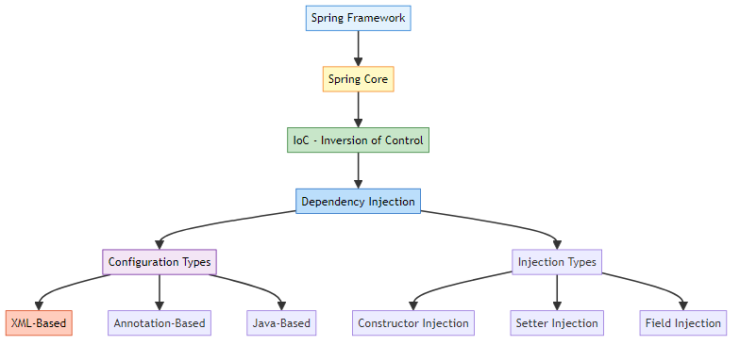

🎯 IoC (Inversion of Control)
Definition: A design principle where the control of object creation and lifecycle management is transferred from the application to a framework (Spring Container).
Traditional Approach (No IoC):
public class MessageService {
private EmailService emailService = new EmailService(); // We control creation
}
IoC Approach (Spring):
<!-- Spring controls creation -->
<bean id="msgSrv" class="org.example.services.MessageService">
<property ref="emlSrv" name="EmailService"/>
</bean>
<bean id="emlSrv" class="org.example.services.EmailService"/>
Control Inverted: - Before: Application creates objects - After: Spring Container creates objects - Benefit: Loose coupling, easier testing, centralized management

3. SPRING IOC CONTAINERS

📌 Container Hierarchy
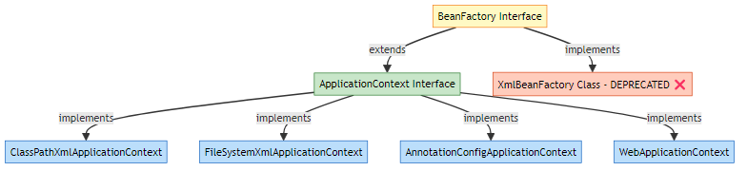

1️⃣ BeanFactory (Basic Container)
Definition: The root interface for accessing Spring bean container. Provides basic functionality for managing beans.
Features: - Lazy initialization (beans created on demand) - Basic dependency injection - Lightweight
Example:
// BeanFactory - Basic container (rarely used directly)
BeanFactory factory = new XmlBeanFactory(new ClassPathResource("bean.xml"));
MessageService service = (MessageService) factory.getBean("msgSrv");
⚠️ Note: XmlBeanFactory is deprecated since Spring 3.1. Use ApplicationContext instead.

2️⃣ ApplicationContext (Advanced Container)
Definition: Advanced Spring container that extends BeanFactory with additional enterprise features.
Features: - ✅ Eager initialization (beans created at startup) - ✅ Event publication - ✅ Internationalization (i18n) - ✅ AOP integration - ✅ Application layer-specific contexts (Web)

Types of ApplicationContext
a) ClassPathXmlApplicationContext ✅ (Used in our project)
Reference: App.java:17
// Loads XML from classpath (src/main/resources)
ApplicationContext context = new ClassPathXmlApplicationContext("bean.xml");
Use Case: - XML file is in src/main/resources or classpath - Most common approach - Works in any environment
Example:
Project Structure:
src/
main/
resources/
bean.xml ← ClassPathXmlApplicationContext looks here

b) FileSystemXmlApplicationContext
// Loads XML from file system path
ApplicationContext context = new FileSystemXmlApplicationContext(
"C:/projects/spring/config/bean.xml"
);
Use Case: - XML file is outside the project - Absolute or relative file path - External configuration
Example:
File System:
C:/
projects/
spring/
config/
bean.xml ← FileSystemXmlApplicationContext looks here

c) AnnotationConfigApplicationContext
// Loads Java-based configuration
ApplicationContext context = new AnnotationConfigApplicationContext(AppConfig.class);
Use Case: - Java-based configuration (no XML) - Modern Spring applications - Type-safe configuration
Example:
@Configuration
public class AppConfig {
@Bean
public MessageService messageService() {
return new MessageService(emailService());
}
@Bean
public EmailService emailService() {
return new EmailService();
}
}

d) WebApplicationContext
// Used in Spring MVC web applications
WebApplicationContext context =
WebApplicationContextUtils.getWebApplicationContext(servletContext);
Use Case: - Spring MVC applications - Web-aware features - Servlet context integration

📊 BeanFactory vs ApplicationContext
Feature | BeanFactory | ApplicationContext
Initialization | Lazy (on-demand) | Eager (at startup)
Memory | Lightweight | Heavier
Event Publication | ❌ No | ✅ Yes
Internationalization | ❌ No | ✅ Yes
AOP | ❌ Limited | ✅ Full support
Bean Post Processors | Manual registration | Automatic
Use Case | Resource-constrained | Enterprise applications
Recommendation | ❌ Rarely used | ✅ Recommended
Visual Comparison:
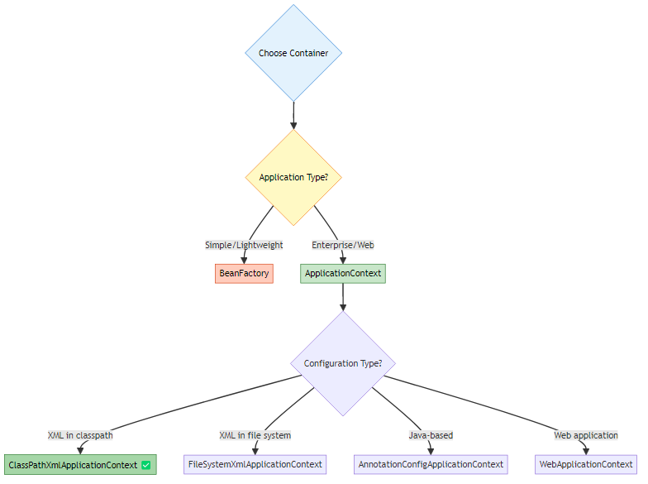

4. CONFIGURATION TYPES IN SPRING

📌 Three Ways to Configure Spring
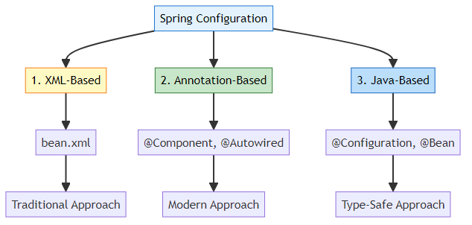

1️⃣ XML-Based Configuration ✅ (Our Project)
Definition: Bean definitions in XML files.
Reference: bean.xml
Example:
<beans xmlns="http://www.springframework.org/schema/beans"
xmlns:xsi="http://www.w3.org/2001/XMLSchema-instance"
xsi:schemaLocation="
http://www.springframework.org/schema/beans
https://www.springframework.org/schema/beans/spring-beans.xsd">
<!-- Bean definition -->
<bean id="msgSrv" class="org.example.services.MessageService">
<property ref="emlSrv" name="EmailService"/>
</bean>
<bean id="emlSrv" class="org.example.services.EmailService"/>
</beans>
Pros: - ✅ Clear separation of configuration and code - ✅ Easy to modify without recompiling - ✅ Good for legacy applications - ✅ Centralized configuration
Cons: - ❌ Verbose (lots of XML) - ❌ No compile-time checking - ❌ Harder to refactor - ❌ Runtime errors if misconfigured

2️⃣ Annotation-Based Configuration
Definition: Bean definitions using annotations in Java classes.
Example:
@Component
public class EmailService {
public void sendMail() {
System.out.println("Sending email...");
}
}
@Component
public class MessageService {
@Autowired
private EmailService emailService;
public void sendMessage() {
emailService.sendMail();
}
}
Configuration:
<!-- Enable component scanning -->
<context:component-scan base-package="org.example.services"/>
Pros: - ✅ Less verbose than XML - ✅ Configuration close to code - ✅ Faster development - ✅ Modern approach
Cons: - ❌ Configuration scattered across classes - ❌ Requires recompilation for changes - ❌ Harder to see overall configuration

3️⃣ Java-Based Configuration
Definition: Bean definitions using Java classes with @Configuration.
Example:
@Configuration
public class AppConfig {
@Bean
public EmailService emailService() {
return new EmailService();
}
@Bean
public MessageService messageService() {
MessageService service = new MessageService();
service.setEmailService(emailService());
return service;
}
}
Usage:
ApplicationContext context =
new AnnotationConfigApplicationContext(AppConfig.class);
MessageService service = context.getBean(MessageService.class);
Pros: - ✅ Type-safe (compile-time checking) - ✅ Refactoring-friendly - ✅ Full Java power (conditionals, loops) - ✅ No XML needed
Cons: - ❌ Configuration mixed with code - ❌ Requires recompilation

📊 Configuration Comparison
Aspect | XML-Based | Annotation-Based | Java-Based
Syntax | XML | Annotations | Java
Verbosity | High | Low | Medium
Type Safety | ❌ No | ⚠️ Partial | ✅ Yes
Refactoring | Hard | Easy | Easy
Centralized | ✅ Yes | ❌ No | ✅ Yes
Compile Check | ❌ No | ⚠️ Partial | ✅ Yes
Learning Curve | Easy | Medium | Medium
Use Case | Legacy apps | Modern apps | Enterprise apps

5. DEPENDENCY INJECTION TYPES

📌 Three Types of Dependency Injection
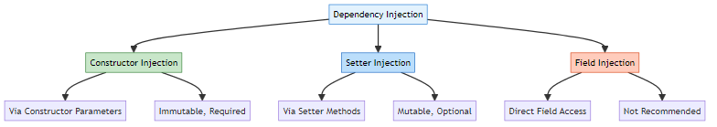

1️⃣ Constructor Injection
Definition: Dependencies injected through constructor parameters.
XML Configuration:
<!-- Constructor injection -->
<bean id="msgSrv" class="org.example.services.MessageService">
<constructor-arg ref="emlSrv"/>
</bean>
<bean id="emlSrv" class="org.example.services.EmailService"/>
Java Code:
public class MessageService {
private final EmailService emailService; // Can be final
public MessageService(EmailService emailService) {
System.out.println("Constructor called");
this.emailService = emailService;
}
}
Pros: - ✅ Immutable (final fields) - ✅ Required dependencies guaranteed - ✅ Null-safe - ✅ Easy to test - ✅ Recommended by Spring
Cons: - ❌ Verbose for many dependencies - ❌ Cannot change at runtime
When to Use: - ✅ Required dependencies - ✅ Immutable objects - ✅ Production code

2️⃣ Setter Injection ✅ (Used in our project)
Definition: Dependencies injected through setter methods.
Reference: bean.xml:29-31 | MessageService.java:17-20
XML Configuration:
<!-- Setter injection -->
<bean id="msgSrv" class="org.example.services.MessageService">
<property ref="emlSrv" name="EmailService"/>
</bean>
<bean id="emlSrv" class="org.example.services.EmailService"/>
Java Code:
public class MessageService {
private EmailService emailService; // Not final
public void setEmailService(EmailService emailService) {
System.out.println("-- Setter called --");
this.emailService = emailService;
}
}
Pros: - ✅ Optional dependencies - ✅ Can change at runtime - ✅ Flexible - ✅ Good for optional features
Cons: - ❌ Can be null (NullPointerException risk) - ❌ Mutable - ❌ Object can be in invalid state
When to Use: - ✅ Optional dependencies - ✅ Dependencies that might change - ✅ Circular dependencies (rare)

3️⃣ Field Injection
Definition: Dependencies injected directly into fields (annotation-based only).
Example:
@Component
public class MessageService {
@Autowired
private EmailService emailService; // Direct injection
}
XML Equivalent: Not possible (XML doesn’t support field injection)
Pros: - ✅ Less boilerplate - ✅ Quick for prototypes
Cons: - ❌ Breaks encapsulation - ❌ Hard to test - ❌ Cannot be final - ❌ Not recommended
When to Use: - ⚠️ Only for quick prototypes - ❌ Not for production

📊 Injection Type Comparison
Aspect | Constructor | Setter | Field
Immutability | ✅ Yes (final) | ❌ No | ❌ No
Null Safety | ✅ Yes | ❌ No | ❌ No
Optional Deps | ❌ No | ✅ Yes | ✅ Yes
Testability | ✅ Excellent | ✅ Good | ❌ Poor
XML Support | ✅ Yes | ✅ Yes | ❌ No
Recommendation | ✅ Best | ⚠️ Optional | ❌ Avoid

6. BEAN SCOPES

📌 What is Bean Scope?
Definition: Bean scope defines the lifecycle and visibility of a bean in the Spring container.
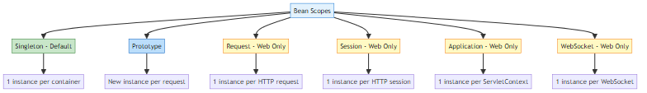

1️⃣ Singleton Scope (Default) ✅
Definition: Only ONE instance of the bean is created per Spring container.
Reference: bean.xml:29
XML Configuration:
<!-- Singleton (default - no need to specify) -->
<bean id="msgSrv" class="org.example.services.MessageService">
<property ref="emlSrv" name="EmailService"/>
</bean>
<!-- Explicit singleton -->
<bean id="msgSrv" scope="singleton" class="org.example.services.MessageService">
<property ref="emlSrv" name="EmailService"/>
</bean>
Behavior:
MessageService service1 = context.getBean(MessageService.class);
MessageService service2 = context.getBean(MessageService.class);
MessageService service3 = context.getBean(MessageService.class);
System.out.println(service1); // org.example.services.MessageService@1a2b3c
System.out.println(service2); // org.example.services.MessageService@1a2b3c (SAME)
System.out.println(service3); // org.example.services.MessageService@1a2b3c (SAME)
System.out.println(service1 == service2); // true
System.out.println(service2 == service3); // true
Characteristics: - ✅ Created at container startup (eager initialization) - ✅ Shared across entire application - ✅ Thread-safe if stateless - ✅ Memory efficient
Use Cases: - Stateless services - DAOs (Data Access Objects) - Controllers - Utility classes
Real-World Example:
// Database connection pool - shared across application
@Bean
@Scope("singleton")
public DataSource dataSource() {
return new HikariDataSource(); // One pool for all
}

2️⃣ Prototype Scope ✅ (Used in our project)
Definition: NEW instance created every time the bean is requested.
Reference: bean.xml:31
XML Configuration:
<!-- Prototype scope -->
<bean id="emlSrv" scope="prototype" class="org.example.services.EmailService"/>
Behavior:
EmailService email1 = context.getBean(EmailService.class);
EmailService email2 = context.getBean(EmailService.class);
EmailService email3 = context.getBean(EmailService.class);
System.out.println(email1); // org.example.services.EmailService@1a2b3c
System.out.println(email2); // org.example.services.EmailService@4d5e6f (DIFFERENT)
System.out.println(email3); // org.example.services.EmailService@7g8h9i (DIFFERENT)
System.out.println(email1 == email2); // false
System.out.println(email2 == email3); // false
Characteristics: - ✅ Created on demand (lazy initialization) - ✅ New instance per request - ✅ Not shared - ❌ Spring doesn’t manage destruction
Use Cases: - Stateful objects - Objects with mutable state - Short-lived objects - Objects that need isolation
Real-World Example:
// Shopping cart - each user needs their own
@Bean
@Scope("prototype")
public ShoppingCart shoppingCart() {
return new ShoppingCart(); // New cart per user
}

3️⃣ Request Scope (Web Applications Only)
Definition: One instance per HTTP request.
XML Configuration:
<bean id="loginAction" scope="request" class="com.example.LoginAction"/>
Use Case:
// Login form data - unique per HTTP request
@Bean
@Scope("request")
public LoginForm loginForm() {
return new LoginForm();
}
Lifecycle: - Created when HTTP request starts - Destroyed when HTTP request completes

4️⃣ Session Scope (Web Applications Only)
Definition: One instance per HTTP session.
XML Configuration:
<bean id="userPreferences" scope="session" class="com.example.UserPreferences"/>
Use Case:
// User preferences - persist across requests in same session
@Bean
@Scope("session")
public UserPreferences userPreferences() {
return new UserPreferences();
}
Lifecycle: - Created when HTTP session starts - Destroyed when HTTP session expires

5️⃣ Application Scope (Web Applications Only)
Definition: One instance per ServletContext (entire web application).
XML Configuration:
<bean id="appConfig" scope="application" class="com.example.AppConfig"/>
Use Case:
// Application-wide configuration
@Bean
@Scope("application")
public AppConfig appConfig() {
return new AppConfig();
}

6️⃣ WebSocket Scope (Web Applications Only)
Definition: One instance per WebSocket session.
XML Configuration:
<bean id="chatSession" scope="websocket" class="com.example.ChatSession"/>
Use Case:
// WebSocket chat session
@Bean
@Scope("websocket")
public ChatSession chatSession() {
return new ChatSession();
}

📊 Bean Scope Comparison
Scope | Instances | Lifecycle | Use Case | Web Only
Singleton | 1 per container | Container lifetime | Stateless services | ❌ No
Prototype | New per request | Until garbage collected | Stateful objects | ❌ No
Request | 1 per HTTP request | Request lifetime | Form data | ✅ Yes
Session | 1 per HTTP session | Session lifetime | User data | ✅ Yes
Application | 1 per ServletContext | Application lifetime | App config | ✅ Yes
WebSocket | 1 per WebSocket | WebSocket lifetime | Chat sessions | ✅ Yes

7. BEAN LIFECYCLE

📌 Bean Lifecycle Phases
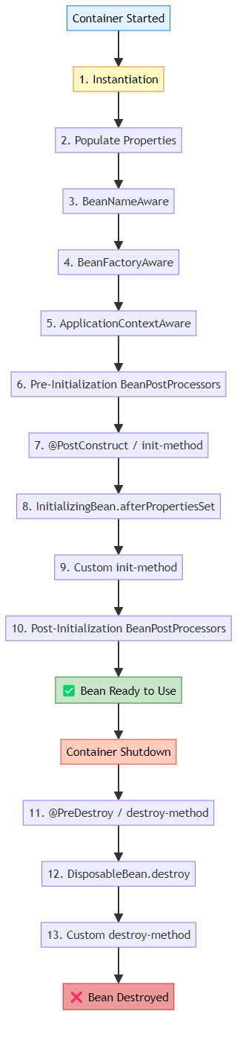

🔄 Lifecycle Phases Explained

Phase 1: Instantiation
public EmailService() {
System.out.println("Email constructor called");
}
- Bean object is created
- Constructor is called
- Memory allocated

Phase 2: Populate Properties (Dependency Injection)
<bean id="msgSrv" class="org.example.services.MessageService">
<property ref="emlSrv" name="EmailService"/> <!-- Injected here -->
</bean>
- Dependencies are injected
- Setter methods called (for setter injection)
- Fields populated

Phase 3-6: Aware Interfaces (Optional)
public class EmailService implements BeanNameAware, ApplicationContextAware {
@Override
public void setBeanName(String name) {
System.out.println("Bean name: " + name);
}
@Override
public void setApplicationContext(ApplicationContext context) {
System.out.println("ApplicationContext set");
}
}
- Bean gets access to Spring infrastructure
- Rarely used in practice

Phase 7: Initialization (init-method) ✅ (Used in our project)
Reference: bean.xml:31 | EmailService.java:19-21
XML Configuration:
<bean id="emlSrv"
scope="prototype"
init-method="init" <!-- Custom initialization -->
class="org.example.services.EmailService"/>
Java Code:
public class EmailService {
public void init() {
System.out.println("Init Method Called");
// Initialize resources, connections, etc.
}
}
When Called: - After dependencies are injected - Before bean is ready to use - For singleton: at container startup - For prototype: when bean is requested
Use Cases: - Open database connections - Load configuration - Initialize caches - Validate dependencies

Phase 8: Bean Ready to Use
EmailService emailService = context.getBean(EmailService.class);
emailService.sendMail(); // Bean is fully initialized and ready

Phase 9: Destruction (destroy-method) ✅ (Used in our project)
Reference: bean.xml:31 | EmailService.java:22-24
XML Configuration:
<bean id="emlSrv"
scope="prototype"
init-method="init"
destroy-method="destroy" <!-- Custom destruction -->
class="org.example.services.EmailService"/>
Java Code:
public class EmailService {
public void destroy() {
System.out.println("Destroy Method Called");
// Clean up resources, close connections, etc.
}
}
When Called: - When container is closed - For singleton: automatically called - For prototype: NOT called (Spring doesn’t manage destruction)
Use Cases: - Close database connections - Release file handles - Clean up caches - Save state

🎯 Lifecycle Methods in XML
Three Ways to Define Lifecycle Methods:
1. XML init-method and destroy-method (Our approach):
<bean id="emlSrv"
init-method="init"
destroy-method="destroy"
class="org.example.services.EmailService"/>
2. Implement InitializingBean and DisposableBean:
public class EmailService implements InitializingBean, DisposableBean {
@Override
public void afterPropertiesSet() throws Exception {
System.out.println("InitializingBean: afterPropertiesSet");
}
@Override
public void destroy() throws Exception {
System.out.println("DisposableBean: destroy");
}
}
3. JSR-250 Annotations (requires annotation support):
public class EmailService {
@PostConstruct
public void init() {
System.out.println("@PostConstruct: init");
}
@PreDestroy
public void cleanup() {
System.out.println("@PreDestroy: cleanup");
}
}

⚠️ Important: Scope and Lifecycle
Singleton Scope:
<bean id="emlSrv" scope="singleton" init-method="init" destroy-method="destroy"
class="org.example.services.EmailService"/>
Behavior:
ApplicationContext context = new ClassPathXmlApplicationContext("bean.xml");
// Output: Email constructor called
// Output: Init Method Called
context.close();
// Output: Destroy Method Called ✅ Automatically called

Prototype Scope: ✅ (Our project)
<bean id="emlSrv" scope="prototype" init-method="init" destroy-method="destroy"
class="org.example.services.EmailService"/>
Behavior:
ApplicationContext context = new ClassPathXmlApplicationContext("bean.xml");
// No output yet (lazy initialization)
EmailService email = context.getBean(EmailService.class);
// Output: Email constructor called
// Output: Init Method Called
context.close();
// NO OUTPUT ❌ Destroy NOT called for prototype beans
Why? - Spring creates prototype beans on demand - Spring hands over the bean to you - You are responsible for cleanup - Spring doesn’t track prototype beans after creation
Solution for Prototype Cleanup:
// Manual cleanup
EmailService email = context.getBean(EmailService.class);
// Use the bean
email.destroy(); // Call manually

📊 Lifecycle Comparison
Aspect | Singleton | Prototype
Creation | At startup | On demand
init-method | ✅ Called | ✅ Called
destroy-method | ✅ Called automatically | ❌ NOT called
Cleanup | Automatic | Manual
Spring Management | Full lifecycle | Creation only

8. SCOPE COMBINATIONS DEEP DIVE
📝 Understanding Scope Interactions by: Avinash Dhanuka

📌 Four Possible Combinations
When we have two beans (MessageService and EmailService), there are 4 possible scope combinations:
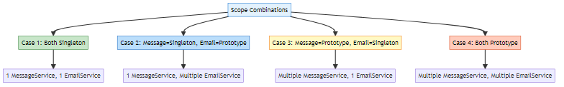

🔍 Case 1: Both Singleton
XML Configuration:
<bean id="msgSrv" scope="singleton" class="org.example.services.MessageService">
<property ref="emlSrv" name="EmailService"/>
</bean>
<bean id="emlSrv" scope="singleton" class="org.example.services.EmailService"/>

Setter Injection Flow
Step-by-Step Execution:
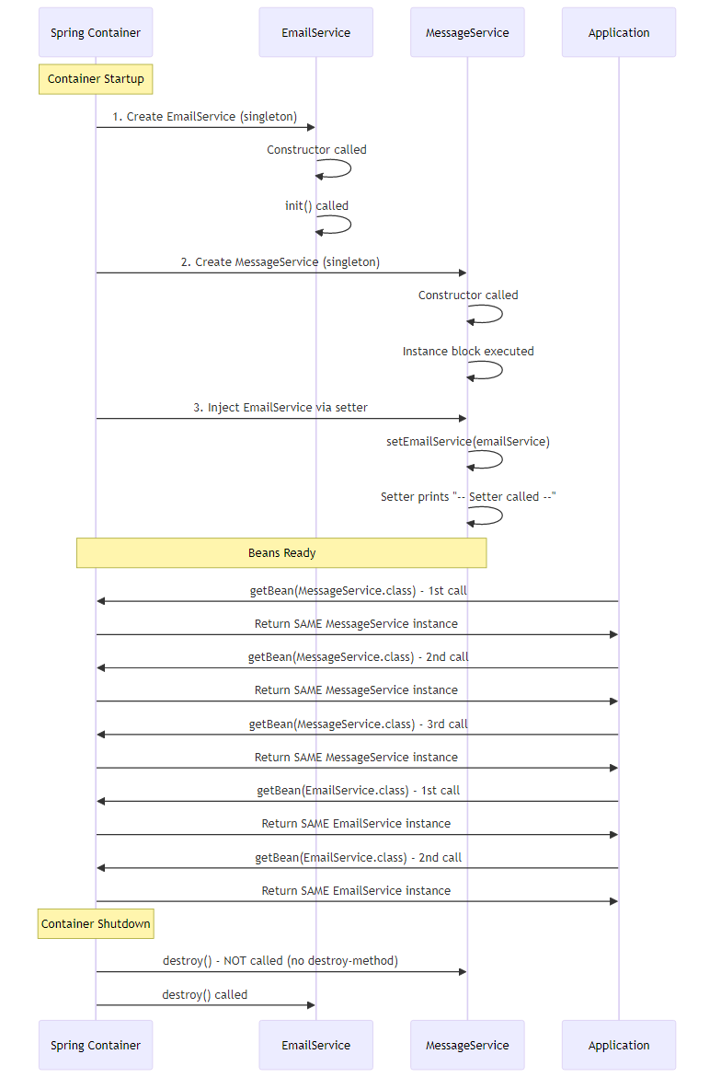
Output:
Email constructor called
Init Method Called
-- Starting Message Service --
-- Setter called --
Message is Sent !!
Send Through Mail !!
-- Exiting Mail Service --
-- Exiting Message Service --
--- Checking for Bean Scope ---
-- PROTOTYPE --
org.example.services.MessageService@1a2b3c4d
org.example.services.MessageService@1a2b3c4d ← SAME
org.example.services.MessageService@1a2b3c4d ← SAME
-- PROTOTYPE --
org.example.services.EmailService@5e6f7g8h
org.example.services.EmailService@5e6f7g8h ← SAME
org.example.services.EmailService@5e6f7g8h ← SAME
Destroy Method Called
Key Points: - ✅ EmailService created once at startup - ✅ MessageService created once at startup - ✅ Setter called once during initialization - ✅ All getBean() calls return same instances - ✅ destroy() called on container close

Constructor Injection Flow
XML Configuration:
<bean id="msgSrv" scope="singleton" class="org.example.services.MessageService">
<constructor-arg ref="emlSrv"/>
</bean>
<bean id="emlSrv" scope="singleton" class="org.example.services.EmailService"/>
Java Code:
public class MessageService {
private final EmailService emailService;
public MessageService(EmailService emailService) {
System.out.println("-- Constructor called --");
this.emailService = emailService;
}
}
Output:
Email constructor called
Init Method Called
-- Constructor called --
Message is Sent !!
Send Through Mail !!
-- Exiting Mail Service --
--- Checking for Bean Scope ---
org.example.services.MessageService@1a2b3c4d
org.example.services.MessageService@1a2b3c4d ← SAME
org.example.services.MessageService@1a2b3c4d ← SAME
org.example.services.EmailService@5e6f7g8h
org.example.services.EmailService@5e6f7g8h ← SAME
org.example.services.EmailService@5e6f7g8h ← SAME
Destroy Method Called
Difference from Setter: - Constructor called instead of setter - Dependency injected during object creation - More concise output

🔍 Case 2: MessageService=Singleton, EmailService=Prototype ✅ (Our Project)
Reference: bean.xml:29-31
XML Configuration:
<bean id="msgSrv" scope="singleton" class="org.example.services.MessageService">
<property ref="emlSrv" name="EmailService"/>
</bean>
<bean id="emlSrv" scope="prototype" init-method="init" destroy-method="destroy"
class="org.example.services.EmailService"/>

Setter Injection Flow
Step-by-Step Execution:
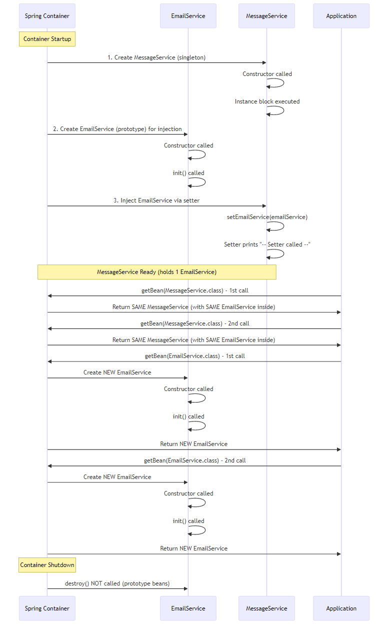
Output:
-- Starting Message Service --
Email constructor called
Init Method Called
-- Setter called --
Message is Sent !!
Send Through Mail !!
-- Exiting Mail Service --
-- Exiting Message Service --
--- Checking for Bean Scope ---
-- PROTOTYPE --
org.example.services.MessageService@1a2b3c4d
org.example.services.MessageService@1a2b3c4d ← SAME MessageService
org.example.services.MessageService@1a2b3c4d ← SAME MessageService
-- PROTOTYPE --
Email constructor called
Init Method Called
org.example.services.EmailService@5e6f7g8h
Email constructor called
Init Method Called
org.example.services.EmailService@9i0j1k2l ← DIFFERENT EmailService
Email constructor called
Init Method Called
org.example.services.EmailService@3m4n5o6p ← DIFFERENT EmailService
(No destroy output - prototype beans not destroyed)
Key Points: - ✅ MessageService created once (singleton) - ✅ First EmailService created for injection into MessageService - ✅ MessageService always uses the SAME EmailService instance - ✅ Each getBean(EmailService.class) creates NEW EmailService - ❌ destroy() NOT called (prototype beans)
Important Observation:
MessageService msg = context.getBean(MessageService.class);
msg.sendMessage(); // Uses EmailService@5e6f7g8h (injected at startup)
EmailService email1 = context.getBean(EmailService.class); // Creates EmailService@9i0j1k2l
EmailService email2 = context.getBean(EmailService.class); // Creates EmailService@3m4n5o6p
// MessageService still uses EmailService@5e6f7g8h (cannot change)
Problem: MessageService is “stuck” with the first EmailService instance. Even though EmailService is prototype, MessageService always uses the same one.
Solution: Use method injection or lookup method (advanced topic).

Constructor Injection Flow
XML Configuration:
<bean id="msgSrv" scope="singleton" class="org.example.services.MessageService">
<constructor-arg ref="emlSrv"/>
</bean>
<bean id="emlSrv" scope="prototype" init-method="init" destroy-method="destroy"
class="org.example.services.EmailService"/>
Output:
Email constructor called
Init Method Called
-- Constructor called --
Message is Sent !!
Send Through Mail !!
-- Exiting Mail Service --
--- Checking for Bean Scope ---
org.example.services.MessageService@1a2b3c4d
org.example.services.MessageService@1a2b3c4d ← SAME
org.example.services.MessageService@1a2b3c4d ← SAME
Email constructor called
Init Method Called
org.example.services.EmailService@5e6f7g8h
Email constructor called
Init Method Called
org.example.services.EmailService@9i0j1k2l ← DIFFERENT
Email constructor called
Init Method Called
org.example.services.EmailService@3m4n5o6p ← DIFFERENT
(No destroy output)
Same behavior as setter injection.

🔍 Case 3: MessageService=Prototype, EmailService=Singleton
XML Configuration:
<bean id="msgSrv" scope="prototype" class="org.example.services.MessageService">
<property ref="emlSrv" name="EmailService"/>
</bean>
<bean id="emlSrv" scope="singleton" init-method="init" destroy-method="destroy"
class="org.example.services.EmailService"/>

Setter Injection Flow
Step-by-Step Execution:
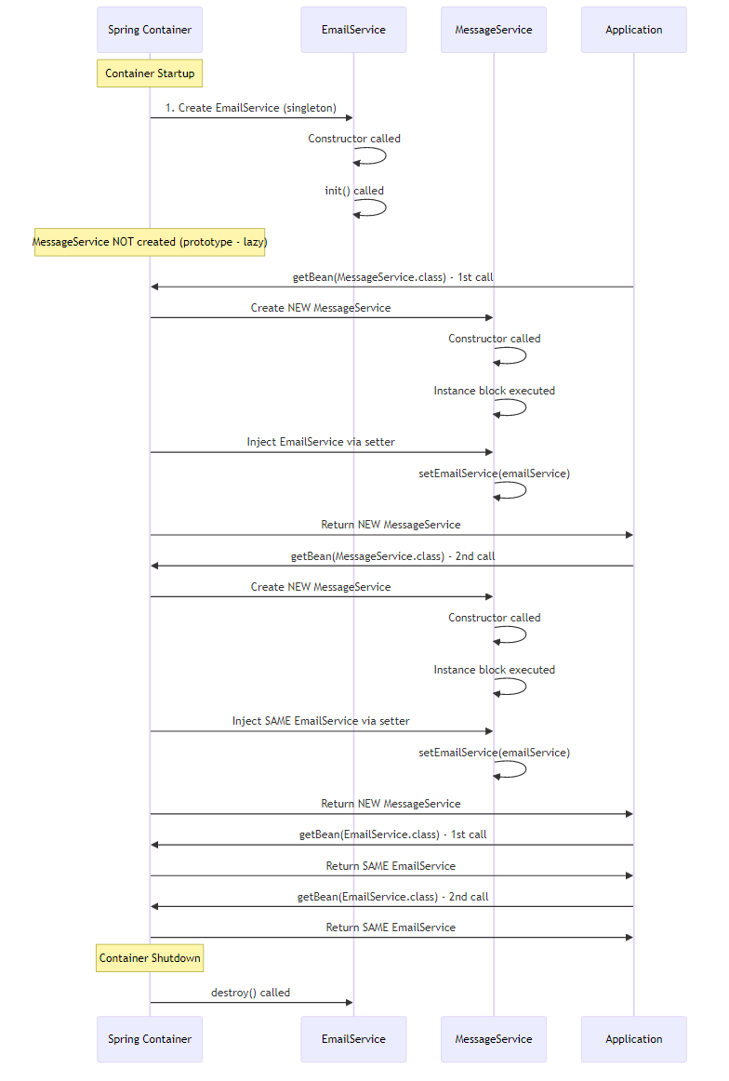
Output:
Email constructor called
Init Method Called
-- Starting Message Service --
-- Setter called --
Message is Sent !!
Send Through Mail !!
-- Exiting Mail Service --
-- Exiting Message Service --
--- Checking for Bean Scope ---
-- PROTOTYPE --
-- Starting Message Service --
-- Setter called --
org.example.services.MessageService@1a2b3c4d
-- Starting Message Service --
-- Setter called --
org.example.services.MessageService@5e6f7g8h ← DIFFERENT MessageService
-- Starting Message Service --
-- Setter called --
org.example.services.MessageService@9i0j1k2l ← DIFFERENT MessageService
-- PROTOTYPE --
org.example.services.EmailService@3m4n5o6p
org.example.services.EmailService@3m4n5o6p ← SAME EmailService
org.example.services.EmailService@3m4n5o6p ← SAME EmailService
Destroy Method Called
Key Points: - ✅ EmailService created once at startup (singleton) - ✅ MessageService created on each getBean() call (prototype) - ✅ Each MessageService gets the SAME EmailService injected - ✅ Setter called for each new MessageService - ✅ destroy() called on EmailService (singleton)
Observation:
MessageService msg1 = context.getBean(MessageService.class); // New MessageService
MessageService msg2 = context.getBean(MessageService.class); // New MessageService
MessageService msg3 = context.getBean(MessageService.class); // New MessageService
// All three MessageService instances share the SAME EmailService
Use Case: Multiple message processors sharing a single email sender.

Constructor Injection Flow
XML Configuration:
<bean id="msgSrv" scope="prototype" class="org.example.services.MessageService">
<constructor-arg ref="emlSrv"/>
</bean>
<bean id="emlSrv" scope="singleton" init-method="init" destroy-method="destroy"
class="org.example.services.EmailService"/>
Output:
Email constructor called
Init Method Called
-- Constructor called --
Message is Sent !!
Send Through Mail !!
-- Exiting Mail Service --
--- Checking for Bean Scope ---
-- Constructor called --
org.example.services.MessageService@1a2b3c4d
-- Constructor called --
org.example.services.MessageService@5e6f7g8h ← DIFFERENT
-- Constructor called --
org.example.services.MessageService@9i0j1k2l ← DIFFERENT
org.example.services.EmailService@3m4n5o6p
org.example.services.EmailService@3m4n5o6p ← SAME
org.example.services.EmailService@3m4n5o6p ← SAME
Destroy Method Called
Same behavior, but constructor called instead of setter.

🔍 Case 4: Both Prototype
XML Configuration:
<bean id="msgSrv" scope="prototype" class="org.example.services.MessageService">
<property ref="emlSrv" name="EmailService"/>
</bean>
<bean id="emlSrv" scope="prototype" init-method="init" destroy-method="destroy"
class="org.example.services.EmailService"/>

Setter Injection Flow
Step-by-Step Execution:
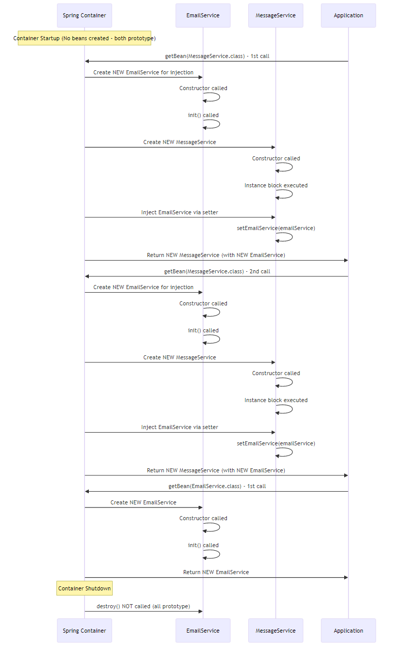
Output:
-- Starting Message Service --
Email constructor called
Init Method Called
-- Setter called --
Message is Sent !!
Send Through Mail !!
-- Exiting Mail Service --
-- Exiting Message Service --
--- Checking for Bean Scope ---
-- PROTOTYPE --
-- Starting Message Service --
Email constructor called
Init Method Called
-- Setter called --
org.example.services.MessageService@1a2b3c4d
-- Starting Message Service --
Email constructor called
Init Method Called
-- Setter called --
org.example.services.MessageService@5e6f7g8h ← DIFFERENT MessageService
-- Starting Message Service --
Email constructor called
Init Method Called
-- Setter called --
org.example.services.MessageService@9i0j1k2l ← DIFFERENT MessageService
-- PROTOTYPE --
Email constructor called
Init Method Called
org.example.services.EmailService@3m4n5o6p
Email constructor called
Init Method Called
org.example.services.EmailService@7q8r9s0t ← DIFFERENT EmailService
Email constructor called
Init Method Called
org.example.services.EmailService@1u2v3w4x ← DIFFERENT EmailService
(No destroy output - all prototype)
Key Points: - ✅ No beans created at startup (both prototype) - ✅ Each getBean(MessageService) creates NEW MessageService - ✅ Each MessageService gets NEW EmailService injected - ✅ Each getBean(EmailService) creates NEW EmailService - ❌ destroy() NOT called (all prototype)
Observation:
MessageService msg1 = context.getBean(MessageService.class);
// Creates: MessageService@1a2b3c4d with EmailService@aaa
MessageService msg2 = context.getBean(MessageService.class);
// Creates: MessageService@5e6f7g8h with EmailService@bbb
EmailService email1 = context.getBean(EmailService.class);
// Creates: EmailService@3m4n5o6p (independent)
// Total EmailService instances created: 5
// (2 for MessageService injection + 3 direct getBean calls)
Use Case: Completely isolated instances, no sharing.

Constructor Injection Flow
XML Configuration:
<bean id="msgSrv" scope="prototype" class="org.example.services.MessageService">
<constructor-arg ref="emlSrv"/>
</bean>
<bean id="emlSrv" scope="prototype" init-method="init" destroy-method="destroy"
class="org.example.services.EmailService"/>
Output:
Email constructor called
Init Method Called
-- Constructor called --
Message is Sent !!
Send Through Mail !!
-- Exiting Mail Service --
--- Checking for Bean Scope ---
Email constructor called
Init Method Called
-- Constructor called --
org.example.services.MessageService@1a2b3c4d
Email constructor called
Init Method Called
-- Constructor called --
org.example.services.MessageService@5e6f7g8h ← DIFFERENT
Email constructor called
Init Method Called
-- Constructor called --
org.example.services.MessageService@9i0j1k2l ← DIFFERENT
Email constructor called
Init Method Called
org.example.services.EmailService@3m4n5o6p
Email constructor called
Init Method Called
org.example.services.EmailService@7q8r9s0t ← DIFFERENT
Email constructor called
Init Method Called
org.example.services.EmailService@1u2v3w4x ← DIFFERENT
(No destroy output)
Same behavior, constructor called instead of setter.

📊 Scope Combinations Summary
Case | MessageService | EmailService | MessageService Instances | EmailService Instances | destroy() Called
1 | Singleton | Singleton | 1 | 1 | ✅ Yes (both)
2 | Singleton | Prototype | 1 | 1 (in MessageService) + N (direct calls) | ❌ No
3 | Prototype | Singleton | N | 1 (shared) | ✅ Yes (EmailService)
4 | Prototype | Prototype | N | N (each MessageService gets new) + M (direct calls) | ❌ No
Visual Summary:
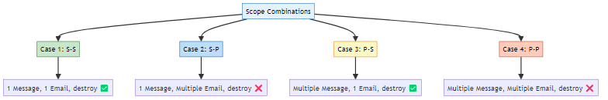

9. PROJECT STRUCTURE & IMPLEMENTATION

📁 Project Structure
XML_BasedConfiguration/
├── src/
│ ├── main/
│ │ ├── java/
│ │ │ └── org/
│ │ │ └── example/
│ │ │ ├── App.java # Main class
│ │ │ └── services/
│ │ │ ├── MessageService.java # Dependent bean
│ │ │ └── EmailService.java # Dependency bean
│ │ └── resources/
│ │ └── bean.xml # Spring configuration
│ └── test/
│ └── java/
│ └── org/
│ └── example/
│ └── AppTest.java
├── pom.xml # Maven configuration
└── README.md

🔍 Code Implementation

1️⃣ EmailService (Dependency)
Reference: EmailService.java
package org.example.services;
public class EmailService {
public EmailService() {
System.out.println("Email constructor called");
}
public void init() {
System.out.println("Init Method Called");
}
public void destroy() {
System.out.println("Destroy Method Called");
}
public void sendMail() {
System.out.println("Send Through Mail !!");
System.out.println("-- Exiting Mail Service --");
}
}
Key Points: - Simple POJO (Plain Old Java Object) - No Spring annotations - Lifecycle methods: init() and destroy() - Business method: sendMail()

2️⃣ MessageService (Dependent Bean)
Reference: MessageService.java
package org.example.services;
public class MessageService {
private EmailService emailService;
{
System.out.println("-- Starting Message Service --");
}
// Setter injection
public void setEmailService(EmailService emailService) {
System.out.println("-- Setter called --");
this.emailService = emailService;
}
public void sendMessage() {
System.out.println("Message is Sent !!");
emailService.sendMail();
System.out.println("-- Exiting Message Service --");
}
}
Key Points: - Depends on EmailService - Instance initialization block for logging - Setter method for dependency injection - Business method delegates to EmailService

3️⃣ Spring XML Configuration
Reference: bean.xml
<?xml version="1.0" encoding="UTF-8"?>
<beans xmlns="http://www.springframework.org/schema/beans"
xmlns:xsi="http://www.w3.org/2001/XMLSchema-instance"
xsi:schemaLocation="
http://www.springframework.org/schema/beans
https://www.springframework.org/schema/beans/spring-beans.xsd">
<!-- MessageService bean with setter injection -->
<bean id="msgSrv" class="org.example.services.MessageService">
<property ref="emlSrv" name="EmailService"/>
</bean>
<!-- EmailService bean with prototype scope and lifecycle methods -->
<bean id="emlSrv"
scope="prototype"
init-method="init"
destroy-method="destroy"
class="org.example.services.EmailService"/>
</beans>
XML Elements Explained:
<beans>: Root element - Defines Spring bean container - Contains all bean definitions
<bean>: Bean definition - id: Unique identifier for the bean - class: Fully qualified class name - scope: Bean scope (singleton/prototype) - init-method: Method to call after initialization - destroy-method: Method to call before destruction
<property>: Setter injection - name: Property name (setter method without “set”) - ref: Reference to another bean

4️⃣ Main Application
Reference: App.java
package org.example;
import org.example.services.EmailService;
import org.example.services.MessageService;
import org.springframework.context.ApplicationContext;
import org.springframework.context.support.ClassPathXmlApplicationContext;
public class App {
public static void main(String[] args) {
// Load Spring configuration
ApplicationContext context =
new ClassPathXmlApplicationContext("bean.xml");
// Get MessageService bean
MessageService messageService = context.getBean(MessageService.class);
messageService.sendMessage();
// Test bean scopes
System.out.println("\n--- Checking for Bean Scope ---");
System.out.println("-- PROTOTYPE --");
MessageService messageService02 = context.getBean(MessageService.class);
MessageService messageService03 = context.getBean(MessageService.class);
System.out.println(messageService);
System.out.println(messageService02);
System.out.println(messageService03);
System.out.println("\n-- PROTOTYPE --");
EmailService emailService = context.getBean(EmailService.class);
EmailService emailService02 = context.getBean(EmailService.class);
EmailService emailService03 = context.getBean(EmailService.class);
System.out.println(emailService);
System.out.println(emailService02);
System.out.println(emailService03);
// Close container
((ClassPathXmlApplicationContext)context).close();
}
}
Execution Flow: 1. Load XML configuration 2. Spring creates beans based on configuration 3. Get MessageService bean 4. Call business method 5. Test bean scopes 6. Close container (triggers destroy methods)

5️⃣ Maven Configuration
Reference: pom.xml
<dependencies>
<!-- Spring Context -->
<dependency>
<groupId>org.springframework</groupId>
<artifactId>spring-context</artifactId>
<version>7.0.3</version>
</dependency>
</dependencies>
Key Dependency: - spring-context: Core Spring IoC container

10. INTERNAL WORKING MECHANISM

📌 How Spring Container Works
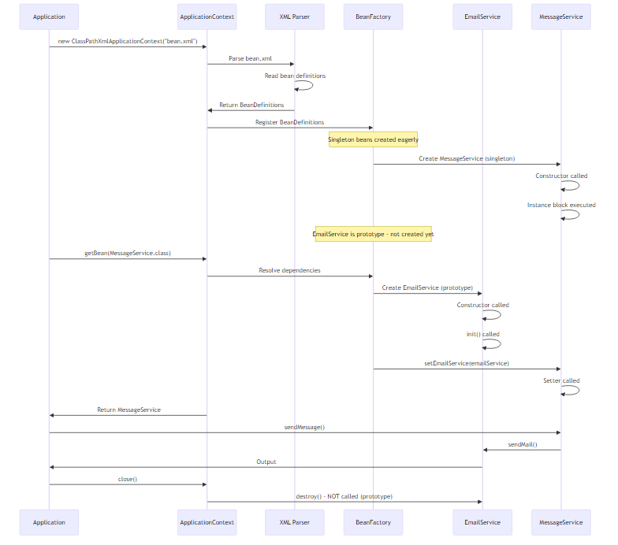

🔍 Step-by-Step Internal Process

Step 1: Container Initialization
ApplicationContext context = new ClassPathXmlApplicationContext("bean.xml");
What Happens: 1. Locate XML file: Spring looks for bean.xml in classpath 2. Parse XML: DOM/SAX parser reads XML structure 3. Create BeanDefinitions: Each <bean> becomes a BeanDefinition object 4. Register BeanDefinitions: Stored in BeanFactory registry
Memory State:
BeanFactory Registry:
msgSrv -> BeanDefinition {
class: MessageService
scope: singleton
properties: [EmailService -> ref(emlSrv)]
}
emlSrv -> BeanDefinition {
class: EmailService
scope: prototype
init-method: init
destroy-method: destroy
}

Step 2: Singleton Bean Creation
For Singleton Beans (Eager Initialization):
// Spring automatically creates singleton beans
Process: 1. Instantiate: Call constructor 2. Populate Properties: Inject dependencies 3. Initialize: Call init-method 4. Store: Cache in singleton registry
For MessageService:
1. new MessageService() // Constructor
2. Instance block executed
3. Dependencies not yet injected (EmailService is prototype)
4. Stored in singleton cache

Step 3: Dependency Resolution
MessageService messageService = context.getBean(MessageService.class);
Process: 1. Check Cache: Is MessageService already created? Yes (singleton) 2. Resolve Dependencies: Does it need EmailService? Yes 3. Create Dependency: EmailService is prototype, create new instance 4. Inject Dependency: Call setEmailService() 5. Return Bean: MessageService is ready
Detailed Flow:
getBean(MessageService.class)
├─> Check singleton cache
│ └─> Found: MessageService@1a2b3c4d
├─> Check dependencies
│ └─> Needs: EmailService
├─> Create EmailService (prototype)
│ ├─> new EmailService()
│ └─> init() called
├─> Inject via setter
│ └─> messageService.setEmailService(emailService)
└─> Return MessageService@1a2b3c4d

Step 4: Prototype Bean Creation
EmailService email1 = context.getBean(EmailService.class);
EmailService email2 = context.getBean(EmailService.class);
Process: 1. No Cache Check: Prototype beans are never cached 2. Create New Instance: Every time 3. Initialize: Call init-method 4. Return: New instance 5. No Tracking: Spring doesn’t track prototype beans
Flow:
getBean(EmailService.class) - Call 1
├─> Prototype scope detected
├─> Create new instance
│ ├─> new EmailService()
│ └─> init() called
└─> Return EmailService@5e6f7g8h
getBean(EmailService.class) - Call 2
├─> Prototype scope detected
├─> Create new instance
│ ├─> new EmailService()
│ └─> init() called
└─> Return EmailService@9i0j1k2l (DIFFERENT)

Step 5: Container Shutdown
((ClassPathXmlApplicationContext)context).close();
Process: 1. Publish Shutdown Event: Notify listeners 2. Destroy Singleton Beans: Call destroy-method 3. Skip Prototype Beans: Not tracked, not destroyed 4. Release Resources: Close container
Flow:
context.close()
├─> Publish ContextClosedEvent
├─> Get all singleton beans
├─> For each singleton:
│ ├─> Call @PreDestroy methods
│ ├─> Call DisposableBean.destroy()
│ └─> Call custom destroy-method
├─> Prototype beans: IGNORED
└─> Close container
Why Prototype Beans Not Destroyed: - Spring creates them on demand - Spring hands them over to you - You are responsible for cleanup - Spring doesn’t track them after creation

🧠 Memory Management
Singleton Beans:
Heap:
Spring Container {
Singleton Cache {
msgSrv -> MessageService@1a2b3c4d {
emailService -> EmailService@5e6f7g8h
}
}
}
Prototype Beans:
Heap:
EmailService@9i0j1k2l (created by getBean call 1)
EmailService@3m4n5o6p (created by getBean call 2)
EmailService@7q8r9s0t (created by getBean call 3)
(No references in Spring container)

🎯 Bean Creation Order
Dependency Graph:
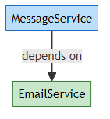
Creation Order: 1. EmailService (dependency) - Created first when needed 2. MessageService (dependent) - Created after dependency
Why This Order: - Spring resolves dependencies recursively - Dependencies must exist before dependent beans - Circular dependencies cause errors

11. REAL-WORLD EXAMPLES

🌐 Example 1: E-Commerce Application
Scenario: Online shopping platform with order processing.
XML Configuration:
<?xml version="1.0" encoding="UTF-8"?>
<beans xmlns="http://www.springframework.org/schema/beans"
xmlns:xsi="http://www.w3.org/2001/XMLSchema-instance"
xsi:schemaLocation="
http://www.springframework.org/schema/beans
https://www.springframework.org/schema/beans/spring-beans.xsd">
<!-- Database Connection Pool (Singleton) -->
<bean id="dataSource" class="com.example.HikariDataSource"
init-method="initialize"
destroy-method="close">
<property name="url" value="jdbc:mysql://localhost:3306/ecommerce"/>
<property name="username" value="root"/>
<property name="password" value="password"/>
</bean>
<!-- Product Repository (Singleton) -->
<bean id="productRepository" class="com.example.ProductRepository">
<property name="dataSource" ref="dataSource"/>
</bean>
<!-- Order Service (Singleton) -->
<bean id="orderService" class="com.example.OrderService">
<property name="productRepository" ref="productRepository"/>
<property name="paymentGateway" ref="paymentGateway"/>
</bean>
<!-- Payment Gateway (Singleton) -->
<bean id="paymentGateway" class="com.example.PaymentGateway">
<property name="apiKey" value="sk_test_123456"/>
</bean>
<!-- Shopping Cart (Prototype - one per user) -->
<bean id="shoppingCart" scope="prototype" class="com.example.ShoppingCart"/>
<!-- Order (Prototype - one per order) -->
<bean id="order" scope="prototype" class="com.example.Order">
<property name="orderService" ref="orderService"/>
</bean>
</beans>
Why These Scopes: - DataSource (Singleton): One connection pool for entire application - Repositories (Singleton): Stateless, can be shared - Services (Singleton): Stateless business logic - ShoppingCart (Prototype): Each user needs their own cart - Order (Prototype): Each order is unique

🏦 Example 2: Banking Application
Scenario: Bank system with account management.
XML Configuration:
<beans>
<!-- Database Connection (Singleton) -->
<bean id="dbConnection" class="com.bank.DatabaseConnection"
scope="singleton"
init-method="connect"
destroy-method="disconnect">
<property name="url" value="jdbc:oracle:thin:@localhost:1521:BANK"/>
</bean>
<!-- Account Repository (Singleton) -->
<bean id="accountRepository" class="com.bank.AccountRepository">
<constructor-arg ref="dbConnection"/>
</bean>
<!-- Transaction Manager (Singleton) -->
<bean id="transactionManager" class="com.bank.TransactionManager">
<property name="accountRepository" ref="accountRepository"/>
</bean>
<!-- Account Service (Singleton) -->
<bean id="accountService" class="com.bank.AccountService">
<constructor-arg ref="accountRepository"/>
<constructor-arg ref="transactionManager"/>
</bean>
<!-- Transaction (Prototype - one per transaction) -->
<bean id="transaction" scope="prototype" class="com.bank.Transaction">
<property name="transactionManager" ref="transactionManager"/>
</bean>
<!-- Account Statement (Prototype - generated per request) -->
<bean id="accountStatement" scope="prototype"
class="com.bank.AccountStatement">
<property name="accountService" ref="accountService"/>
</bean>
</beans>
Usage:
// Get singleton services
AccountService accountService = context.getBean(AccountService.class);
// Create new transaction (prototype)
Transaction transaction1 = context.getBean(Transaction.class);
transaction1.setAmount(1000.00);
transaction1.setType("DEPOSIT");
Transaction transaction2 = context.getBean(Transaction.class);
transaction2.setAmount(500.00);
transaction2.setType("WITHDRAWAL");
// Each transaction is independent

📧 Example 3: Email Marketing System
Scenario: Bulk email sender with templates.
XML Configuration:
<beans>
<!-- SMTP Configuration (Singleton) -->
<bean id="smtpConfig" class="com.email.SMTPConfig">
<property name="host" value="smtp.gmail.com"/>
<property name="port" value="587"/>
<property name="username" value="marketing@company.com"/>
<property name="password" value="secret"/>
</bean>
<!-- Email Sender (Singleton) -->
<bean id="emailSender" class="com.email.EmailSender"
init-method="connect"
destroy-method="disconnect">
<constructor-arg ref="smtpConfig"/>
</bean>
<!-- Template Engine (Singleton) -->
<bean id="templateEngine" class="com.email.TemplateEngine">
<property name="templatePath" value="/templates/"/>
</bean>
<!-- Campaign Service (Singleton) -->
<bean id="campaignService" class="com.email.CampaignService">
<property name="emailSender" ref="emailSender"/>
<property name="templateEngine" ref="templateEngine"/>
</bean>
<!-- Email Message (Prototype - one per email) -->
<bean id="emailMessage" scope="prototype" class="com.email.EmailMessage">
<property name="templateEngine" ref="templateEngine"/>
</bean>
<!-- Campaign (Prototype - one per campaign) -->
<bean id="campaign" scope="prototype" class="com.email.Campaign">
<property name="campaignService" ref="campaignService"/>
</bean>
</beans>
Usage:
CampaignService campaignService = context.getBean(CampaignService.class);
// Create campaign (prototype)
Campaign campaign = context.getBean(Campaign.class);
campaign.setName("Black Friday Sale");
// Create emails (prototype)
for (User user : users) {
EmailMessage email = context.getBean(EmailMessage.class);
email.setRecipient(user.getEmail());
email.setTemplate("black-friday.html");
email.setData(user);
campaign.addEmail(email);
}
campaignService.send(campaign);

🎮 Example 4: Gaming Platform
Scenario: Multiplayer game server.
XML Configuration:
<beans>
<!-- Game Server (Singleton) -->
<bean id="gameServer" class="com.game.GameServer"
init-method="start"
destroy-method="stop">
<property name="port" value="8080"/>
<property name="maxPlayers" value="1000"/>
</bean>
<!-- Player Repository (Singleton) -->
<bean id="playerRepository" class="com.game.PlayerRepository">
<constructor-arg ref="dataSource"/>
</bean>
<!-- Leaderboard (Singleton) -->
<bean id="leaderboard" class="com.game.Leaderboard">
<property name="playerRepository" ref="playerRepository"/>
</bean>
<!-- Player Session (Prototype - one per player) -->
<bean id="playerSession" scope="prototype" class="com.game.PlayerSession">
<property name="gameServer" ref="gameServer"/>
</bean>
<!-- Game Match (Prototype - one per match) -->
<bean id="gameMatch" scope="prototype" class="com.game.GameMatch">
<property name="leaderboard" ref="leaderboard"/>
</bean>
<!-- Player Inventory (Prototype - one per player) -->
<bean id="playerInventory" scope="prototype" class="com.game.PlayerInventory"/>
</beans>

🏥 Example 5: Hospital Management System
Scenario: Patient management and appointment scheduling.
XML Configuration:
<beans>
<!-- Database (Singleton) -->
<bean id="hospitalDB" class="com.hospital.HospitalDatabase"
init-method="initialize"
destroy-method="cleanup">
<property name="url" value="jdbc:postgresql://localhost:5432/hospital"/>
</bean>
<!-- Patient Repository (Singleton) -->
<bean id="patientRepository" class="com.hospital.PatientRepository">
<constructor-arg ref="hospitalDB"/>
</bean>
<!-- Doctor Repository (Singleton) -->
<bean id="doctorRepository" class="com.hospital.DoctorRepository">
<constructor-arg ref="hospitalDB"/>
</bean>
<!-- Appointment Service (Singleton) -->
<bean id="appointmentService" class="com.hospital.AppointmentService">
<property name="patientRepository" ref="patientRepository"/>
<property name="doctorRepository" ref="doctorRepository"/>
</bean>
<!-- Patient Record (Prototype - one per patient visit) -->
<bean id="patientRecord" scope="prototype" class="com.hospital.PatientRecord">
<property name="patientRepository" ref="patientRepository"/>
</bean>
<!-- Prescription (Prototype - one per prescription) -->
<bean id="prescription" scope="prototype" class="com.hospital.Prescription">
<property name="patientRecord" ref="patientRecord"/>
</bean>
<!-- Appointment (Prototype - one per appointment) -->
<bean id="appointment" scope="prototype" class="com.hospital.Appointment">
<property name="appointmentService" ref="appointmentService"/>
</bean>
</beans>

📊 Scope Selection Guidelines
Component Type | Recommended Scope | Reason
Database Connections | Singleton | Expensive to create, shared resource
Repositories/DAOs | Singleton | Stateless, thread-safe
Services | Singleton | Stateless business logic
Controllers | Singleton | Stateless request handlers
Utilities | Singleton | Stateless helper classes
User Sessions | Prototype | User-specific state
Shopping Carts | Prototype | User-specific data
Transactions | Prototype | Unique per operation
Reports | Prototype | Generated per request
Form Data | Prototype | Request-specific

12. BEST PRACTICES

🎯 XML Configuration Best Practices

1. Use Meaningful Bean IDs
✅ Good:
<bean id="userService" class="com.example.UserService"/>
<bean id="emailNotificationService" class="com.example.EmailNotificationService"/>
❌ Bad:
<bean id="us" class="com.example.UserService"/>
<bean id="bean1" class="com.example.EmailNotificationService"/>

2. Organize Beans Logically
✅ Good:
<beans>
<!-- Data Access Layer -->
<bean id="dataSource" class="..."/>
<bean id="userRepository" class="..."/>
<bean id="orderRepository" class="..."/>
<!-- Service Layer -->
<bean id="userService" class="..."/>
<bean id="orderService" class="..."/>
<!-- Presentation Layer -->
<bean id="userController" class="..."/>
</beans>

3. Use Constructor Injection for Required Dependencies
✅ Good:
<bean id="orderService" class="com.example.OrderService">
<constructor-arg ref="orderRepository"/>
<constructor-arg ref="paymentGateway"/>
</bean>
❌ Bad (for required dependencies):
<bean id="orderService" class="com.example.OrderService">
<property name="orderRepository" ref="orderRepository"/>
<property name="paymentGateway" ref="paymentGateway"/>
</bean>

4. Externalize Configuration
✅ Good:
<!-- Load properties file -->
<context:property-placeholder location="classpath:application.properties"/>
<bean id="dataSource" class="com.example.DataSource">
<property name="url" value="${db.url}"/>
<property name="username" value="${db.username}"/>
<property name="password" value="${db.password}"/>
</bean>
application.properties:
db.url=jdbc:mysql://localhost:3306/mydb
db.username=root
db.password=secret

5. Use Appropriate Scopes
✅ Good:
<!-- Stateless service - singleton -->
<bean id="userService" scope="singleton" class="com.example.UserService"/>
<!-- User-specific data - prototype -->
<bean id="shoppingCart" scope="prototype" class="com.example.ShoppingCart"/>
❌ Bad:
<!-- Stateful data as singleton - WRONG! -->
<bean id="shoppingCart" scope="singleton" class="com.example.ShoppingCart"/>

6. Always Define Lifecycle Methods
✅ Good:
<bean id="dataSource"
class="com.example.DataSource"
init-method="connect"
destroy-method="disconnect"/>
Why: - Proper resource initialization - Clean resource cleanup - Prevents resource leaks

7. Split Large Configuration Files
✅ Good:
<!-- applicationContext.xml -->
<beans>
<import resource="data-access-config.xml"/>
<import resource="service-config.xml"/>
<import resource="web-config.xml"/>
</beans>
Benefits: - Better organization - Easier maintenance - Team collaboration

8. Use Profiles for Environment-Specific Configuration
✅ Good:
<beans profile="development">
<bean id="dataSource" class="com.example.H2DataSource"/>
</beans>
<beans profile="production">
<bean id="dataSource" class="com.example.MySQLDataSource"/>
</beans>
Activation:
System.setProperty("spring.profiles.active", "development");

9. Document Complex Configurations
✅ Good:
<beans>
<!--
User Service Configuration
Dependencies: UserRepository, EmailService
Scope: Singleton (stateless)
Note: Requires database connection
-->
<bean id="userService" class="com.example.UserService">
<constructor-arg ref="userRepository"/>
<property name="emailService" ref="emailService"/>
</bean>
</beans>

10. Avoid Circular Dependencies
❌ Bad:
<bean id="beanA" class="com.example.BeanA">
<property name="beanB" ref="beanB"/>
</bean>
<bean id="beanB" class="com.example.BeanB">
<property name="beanA" ref="beanA"/> <!-- Circular! -->
</bean>
✅ Good:
<!-- Extract common functionality to a third bean -->
<bean id="commonService" class="com.example.CommonService"/>
<bean id="beanA" class="com.example.BeanA">
<property name="commonService" ref="commonService"/>
</bean>
<bean id="beanB" class="com.example.BeanB">
<property name="commonService" ref="commonService"/>
</bean>

🔒 Security Best Practices

1. Don’t Hardcode Sensitive Data
❌ Bad:
<bean id="dataSource" class="com.example.DataSource">
<property name="password" value="mySecretPassword123"/>
</bean>
✅ Good:
<bean id="dataSource" class="com.example.DataSource">
<property name="password" value="${db.password}"/>
</bean>
Use environment variables or encrypted properties.

2. Validate Bean Properties
✅ Good:
public class DataSource {
private String url;
public void setUrl(String url) {
if (url == null || url.isEmpty()) {
throw new IllegalArgumentException("URL cannot be null or empty");
}
this.url = url;
}
public void init() {
// Validate all required properties
if (url == null) {
throw new IllegalStateException("DataSource not properly configured");
}
}
}

🚀 Performance Best Practices

1. Use Lazy Initialization for Heavy Beans
✅ Good:
<bean id="heavyService"
class="com.example.HeavyService"
lazy-init="true"/>
When to Use: - Expensive initialization - Rarely used beans - Optional features

2. Prefer Singleton for Stateless Beans
✅ Good:
<!-- Stateless service - singleton (default) -->
<bean id="calculatorService" class="com.example.CalculatorService"/>
Benefits: - Memory efficient - Better performance - Thread-safe if stateless

3. Use Prototype Only When Necessary
⚠️ Caution:
<!-- Only use prototype for stateful beans -->
<bean id="userSession" scope="prototype" class="com.example.UserSession"/>
Why: - Prototype beans are more expensive - Created on every request - Not cached

📝 Maintenance Best Practices

1. Keep XML Files Small
Guideline: Max 200-300 lines per file
Solution: Split into multiple files
<import resource="data-config.xml"/>
<import resource="service-config.xml"/>

2. Use Consistent Naming Conventions
✅ Good:
<bean id="userService" class="com.example.service.UserService"/>
<bean id="userRepository" class="com.example.repository.UserRepository"/>
<bean id="userController" class="com.example.controller.UserController"/>
Pattern: {entity}{layer}

3. Version Control Your Configuration
✅ Good:
<!--
Version: 2.0
Last Modified: 2026-02-23
Author: Avinash Dhanuka
Changes: Added email notification service
-->
<beans>
...
</beans>

🎓 Migration Best Practices

When to Use XML Configuration
✅ Use XML When: - Maintaining legacy applications - Need external configuration - Non-Java configuration required - Team prefers XML
❌ Avoid XML When: - Starting new projects (use annotations) - Need type safety - Want refactoring support - Modern Spring Boot application

📊 Best Practices Summary
Practice | Benefit | Priority
Meaningful bean IDs | Readability | High
Constructor injection | Immutability | High
Externalize config | Security | High
Appropriate scopes | Performance | High
Lifecycle methods | Resource management | High
Split large files | Maintainability | Medium
Use profiles | Flexibility | Medium
Document complex beans | Understanding | Medium
Avoid circular deps | Stability | High
Lazy initialization | Performance | Low

13. TOP INTERVIEW QUESTIONS

📝 Interview Preparation by: Avinash Dhanuka

Q1: What is XML-based configuration in Spring?
Answer:
XML-based configuration is Spring’s traditional approach where bean definitions and their dependencies are declared in XML files. The Spring IoC container reads these XML files and creates/manages beans accordingly.
Example:
<bean id="userService" class="com.example.UserService">
<property name="userRepository" ref="userRepository"/>
</bean>
Key Points: - Externalized configuration - No code changes needed for configuration updates - Clear separation of concerns - Good for legacy applications

Q2: What is the difference between BeanFactory and ApplicationContext?
Answer:
Feature | BeanFactory | ApplicationContext
Initialization | Lazy | Eager
Event Publication | ❌ No | ✅ Yes
Internationalization | ❌ No | ✅ Yes
AOP | ❌ Limited | ✅ Full
Bean Post Processors | Manual | Automatic
Use Case | Resource-constrained | Enterprise apps
Example:
// BeanFactory (basic)
BeanFactory factory = new XmlBeanFactory(new ClassPathResource("bean.xml"));
// ApplicationContext (advanced) - RECOMMENDED
ApplicationContext context = new ClassPathXmlApplicationContext("bean.xml");
Recommendation: Always use ApplicationContext in production.

Q3: Explain bean scopes in Spring
Answer:
Bean scope defines the lifecycle and visibility of a bean.
Main Scopes:
1. Singleton (Default): - One instance per container - Shared across application - Created at startup
<bean id="userService" scope="singleton" class="com.example.UserService"/>
2. Prototype: - New instance per request - Not shared - Created on demand
<bean id="shoppingCart" scope="prototype" class="com.example.ShoppingCart"/>
Web Scopes: - Request: One per HTTP request - Session: One per HTTP session - Application: One per ServletContext - WebSocket: One per WebSocket
When to Use: - Singleton: Stateless services, repositories - Prototype: Stateful objects, user-specific data

Q4: What is the bean lifecycle in Spring?
Answer:
Lifecycle Phases:
Example:
<bean id="dataSource"
class="com.example.DataSource"
init-method="connect"
destroy-method="disconnect"/>
public class DataSource {
public void connect() {
System.out.println("Connecting to database...");
}
public void disconnect() {
System.out.println("Disconnecting from database...");
}
}
Important: destroy-method is NOT called for prototype beans.

Q5: What happens when a singleton bean depends on a prototype bean?
Answer:
Problem: Singleton bean gets only ONE instance of the prototype bean (at initialization).
Example:
<bean id="messageService" scope="singleton" class="com.example.MessageService">
<property name="emailService" ref="emailService"/>
</bean>
<bean id="emailService" scope="prototype" class="com.example.EmailService"/>
What Happens:
MessageService msg = context.getBean(MessageService.class);
// MessageService gets EmailService@123 (created once)
msg.sendMessage(); // Uses EmailService@123
msg.sendMessage(); // Uses EmailService@123 (SAME instance)
Solutions:
1. Method Injection (Lookup Method):
<bean id="messageService" class="com.example.MessageService">
<lookup-method name="getEmailService" bean="emailService"/>
</bean>
2. ApplicationContextAware:
public class MessageService implements ApplicationContextAware {
private ApplicationContext context;
public void setApplicationContext(ApplicationContext context) {
this.context = context;
}
public void sendMessage() {
EmailService email = context.getBean(EmailService.class); // New instance
email.sendMail();
}
}
3. ObjectFactory:
public class MessageService {
@Autowired
private ObjectFactory<EmailService> emailServiceFactory;
public void sendMessage() {
EmailService email = emailServiceFactory.getObject(); // New instance
email.sendMail();
}
}

Q6: How do you inject dependencies in XML configuration?
Answer:
Three Ways:
1. Constructor Injection:
<bean id="userService" class="com.example.UserService">
<constructor-arg ref="userRepository"/>
<constructor-arg value="admin"/>
</bean>
public class UserService {
private UserRepository userRepository;
private String role;
public UserService(UserRepository userRepository, String role) {
this.userRepository = userRepository;
this.role = role;
}
}
2. Setter Injection:
<bean id="userService" class="com.example.UserService">
<property name="userRepository" ref="userRepository"/>
<property name="role" value="admin"/>
</bean>
public class UserService {
private UserRepository userRepository;
private String role;
public void setUserRepository(UserRepository userRepository) {
this.userRepository = userRepository;
}
public void setRole(String role) {
this.role = role;
}
}
3. Field Injection (Not possible in pure XML): - Requires annotations (@Autowired)
Recommendation: Use constructor injection for required dependencies.

Q7: What is the difference between ref and value in XML?
Answer:
ref: Reference to another bean
<bean id="userService" class="com.example.UserService">
<property name="userRepository" ref="userRepository"/> <!-- Bean reference -->
</bean>
<bean id="userRepository" class="com.example.UserRepository"/>
value: Literal value (String, int, boolean, etc.)
<bean id="dataSource" class="com.example.DataSource">
<property name="url" value="jdbc:mysql://localhost:3306/mydb"/>
<property name="port" value="3306"/>
<property name="autoCommit" value="true"/>
</bean>
Summary: - ref: For bean dependencies - value: For primitive values and strings

Q8: How do you handle circular dependencies in Spring?
Answer:
Circular Dependency: When two beans depend on each other.
Example:
<bean id="beanA" class="com.example.BeanA">
<property name="beanB" ref="beanB"/>
</bean>
<bean id="beanB" class="com.example.BeanB">
<property name="beanA" ref="beanA"/> <!-- Circular! -->
</bean>
Problem: Spring cannot determine which bean to create first.
Solutions:
1. Redesign (Best Solution):
<!-- Extract common functionality -->
<bean id="commonService" class="com.example.CommonService"/>
<bean id="beanA" class="com.example.BeanA">
<property name="commonService" ref="commonService"/>
</bean>
<bean id="beanB" class="com.example.BeanB">
<property name="commonService" ref="commonService"/>
</bean>
2. Use Setter Injection (Not Constructor):
<!-- Setter injection allows circular dependencies -->
<bean id="beanA" class="com.example.BeanA">
<property name="beanB" ref="beanB"/>
</bean>
<bean id="beanB" class="com.example.BeanB">
<property name="beanA" ref="beanA"/>
</bean>
Why Setter Works: - Spring creates both beans first - Then injects dependencies via setters
3. Use @Lazy:
@Component
public class BeanA {
@Autowired
@Lazy
private BeanB beanB;
}

Q9: What is lazy initialization in Spring?
Answer:
Lazy Initialization: Bean is created only when first requested, not at container startup.
Default (Eager):
<bean id="heavyService" class="com.example.HeavyService"/>
<!-- Created at container startup -->
Lazy:
<bean id="heavyService" class="com.example.HeavyService" lazy-init="true"/>
<!-- Created when first requested -->
Global Lazy:
<beans default-lazy-init="true">
<!-- All beans are lazy -->
<bean id="service1" class="com.example.Service1"/>
<bean id="service2" class="com.example.Service2"/>
</beans>
Pros: - Faster application startup - Saves memory for unused beans
Cons: - Slower first request - Errors appear later (not at startup)
When to Use: - Heavy initialization - Rarely used beans - Optional features

Q10: How do you externalize configuration in Spring XML?
Answer:
Using Property Placeholder:
1. Create properties file:
# application.properties
db.url=jdbc:mysql://localhost:3306/mydb
db.username=root
db.password=secret
db.maxConnections=100
2. Load in XML:
<beans>
<!-- Load properties file -->
<context:property-placeholder location="classpath:application.properties"/>
<!-- Use properties -->
<bean id="dataSource" class="com.example.DataSource">
<property name="url" value="${db.url}"/>
<property name="username" value="${db.username}"/>
<property name="password" value="${db.password}"/>
<property name="maxConnections" value="${db.maxConnections}"/>
</bean>
</beans>
Benefits: - Externalized configuration - Environment-specific values - Security (passwords not in XML) - Easy to change without recompiling
Multiple Files:
<context:property-placeholder
location="classpath:application.properties,classpath:database.properties"/>

Q11: What is the difference between ClassPathXmlApplicationContext and FileSystemXmlApplicationContext?
Answer:
ClassPathXmlApplicationContext: - Loads XML from classpath - Looks in src/main/resources - Relative to classpath root
ApplicationContext context =
new ClassPathXmlApplicationContext("bean.xml");
// Looks for: src/main/resources/bean.xml
FileSystemXmlApplicationContext: - Loads XML from file system - Absolute or relative file path - Relative to current working directory
ApplicationContext context =
new FileSystemXmlApplicationContext("C:/config/bean.xml");
// Looks for: C:/config/bean.xml
Comparison:
Aspect | ClassPathXml | FileSystemXml
Location | Classpath | File system
Path | Relative to classpath | Absolute or relative
Packaging | Inside JAR/WAR | External file
Use Case | Application config | External config
Portability | ✅ High | ⚠️ Lower
Recommendation: Use ClassPathXmlApplicationContext for most cases.

Q12: How do you inject collections in Spring XML?
Answer:
List:
<bean id="userService" class="com.example.UserService">
<property name="roles">
<list>
<value>ADMIN</value>
<value>USER</value>
<value>GUEST</value>
</list>
</property>
</bean>
Set:
<bean id="userService" class="com.example.UserService">
<property name="permissions">
<set>
<value>READ</value>
<value>WRITE</value>
<value>DELETE</value>
</set>
</property>
</bean>
Map:
<bean id="config" class="com.example.Config">
<property name="settings">
<map>
<entry key="timeout" value="30"/>
<entry key="retries" value="3"/>
<entry key="debug" value="true"/>
</map>
</property>
</bean>
Properties:
<bean id="config" class="com.example.Config">
<property name="properties">
<props>
<prop key="url">http://example.com</prop>
<prop key="port">8080</prop>
</props>
</property>
</bean>
Bean References in Collections:
<bean id="orderService" class="com.example.OrderService">
<property name="paymentGateways">
<list>
<ref bean="paypal"/>
<ref bean="stripe"/>
<ref bean="razorpay"/>
</list>
</property>
</bean>

Q13: What are the advantages and disadvantages of XML configuration?
Answer:
Advantages:
- ✅ Externalized Configuration: No code changes needed
- ✅ Clear Separation: Configuration separate from code
- ✅ Centralized: All beans in one place
- ✅ No Recompilation: Change XML without recompiling
- ✅ Legacy Support: Good for maintaining old applications
- ✅ Non-Java Config: Can be edited by non-developers
Disadvantages:
- ❌ Verbose: Lots of XML boilerplate
- ❌ No Type Safety: Errors at runtime, not compile-time
- ❌ Hard to Refactor: IDEs don’t refactor XML well
- ❌ No IDE Support: Limited autocomplete and validation
- ❌ Maintenance: Large XML files are hard to manage
- ❌ Modern Alternative: Annotations are preferred now
When to Use XML: - Legacy applications - External configuration required - Team prefers XML - Non-Java configuration
When to Avoid XML: - New projects (use annotations) - Need type safety - Want refactoring support - Modern Spring Boot apps

Q14: How does Spring resolve bean dependencies?
Answer:
Dependency Resolution Process:
1. Parse Configuration:
<bean id="orderService" class="com.example.OrderService">
<property name="orderRepository" ref="orderRepository"/>
</bean>
<bean id="orderRepository" class="com.example.OrderRepository">
<property name="dataSource" ref="dataSource"/>
</bean>
<bean id="dataSource" class="com.example.DataSource"/>
2. Build Dependency Graph:
OrderService
└─> OrderRepository
└─> DataSource
3. Create Beans in Order:
1. Create DataSource (no dependencies)
2. Create OrderRepository (inject DataSource)
3. Create OrderService (inject OrderRepository)
4. Handle Circular Dependencies: - Use setter injection - Create beans first, inject later
Algorithm: 1. Identify all bean definitions 2. Build dependency graph 3. Topological sort (dependencies first) 4. Create beans in order 5. Inject dependencies 6. Call init methods

Q15: What is the difference between singleton and prototype scope in terms of lifecycle?
Answer:
Singleton Lifecycle:
Prototype Lifecycle:
Key Differences:
Aspect | Singleton | Prototype
Creation | At startup | On demand
init-method | ✅ Called | ✅ Called
destroy-method | ✅ Called | ❌ NOT called
Cleanup | Automatic | Manual
Tracking | Tracked by Spring | Not tracked
Example:
<bean id="singleton" scope="singleton"
init-method="init" destroy-method="destroy"
class="com.example.SingletonBean"/>
<bean id="prototype" scope="prototype"
init-method="init" destroy-method="destroy"
class="com.example.PrototypeBean"/>
Output:
// Container startup
SingletonBean: init() called
// Container shutdown
SingletonBean: destroy() called
// Prototype beans
PrototypeBean: init() called (when getBean is called)
PrototypeBean: destroy() NOT called (even on container shutdown)
Why Prototype destroy() Not Called: - Spring creates prototype beans on demand - Spring hands them over to you - You are responsible for cleanup - Spring doesn’t track them after creation

🎓 End of Spring XML Configuration Guide

Created with dedication by Avinash Dhanuka

Happy Learning! 🚀
“Configure Once, Run Anywhere!” - Avinash Dhanuka

