Spring Framework: Document Processing Engine - Deep Dive

© 2026 Avinash Dhanuka
Master Guide: Spring Dependency Injection & Bean Lifecycle
Crafted with â¤ï¸ for Enterprise Architecture Mastery

Learning Note: This guide demonstrates Spring Framework’s core concepts through a real-world Document Processing Engine. Master dependency injection patterns, bean scopes, lifecycle management, and annotation-based configuration.
Prerequisites: - Understanding of Java OOP concepts - Basic knowledge of Spring IoC Container - Familiarity with annotations - Maven basics

Table of Contents
- What is Document Processing Engine?
- Architecture Overview
- Dependency Injection Patterns
- Bean Scopes Deep Dive
- @Primary vs @Qualifier
- Lazy Initialization
- Bean Lifecycle Management
- Complete Execution Flow
- Internal Working
- Real-World Production Patterns
- Common Pitfalls & Solutions
- Interview Questions

1. WHAT IS DOCUMENT PROCESSING ENGINE?

ðŸ“ Author: Avinash Dhanuka | GitHub

ðŸ“Œ Definition
Document Processing Engine is an enterprise-grade application demonstrating Spring Framework’s core features through a practical document processing system that handles PDF, Word, and XML documents.
Key Features: - Multiple document processors (PDF, Word, XML) - Audit logging system - Storage management - Flexible dependency injection - Bean lifecycle management

Why This Case Study?
Concept | Demonstration
Dependency Injection | 3 types: Constructor, Setter, Field
Bean Scopes | Singleton vs Prototype
@Primary | Default bean selection
@Qualifier | Explicit bean selection
@Lazy | Delayed initialization
Lifecycle Callbacks | @PostConstruct, @PreDestroy

2. ARCHITECTURE OVERVIEW

Component Architecture
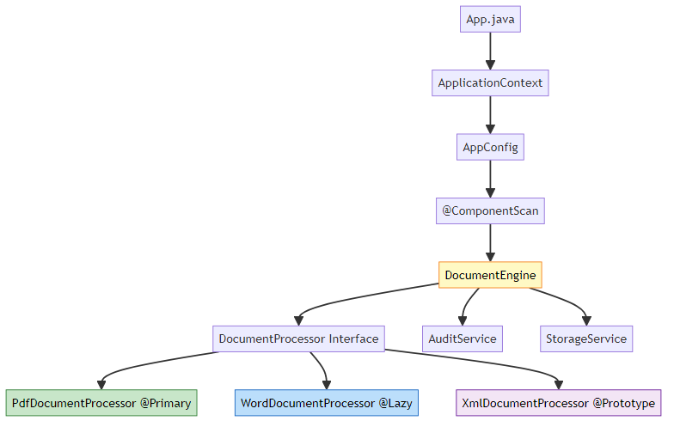

Class Diagram
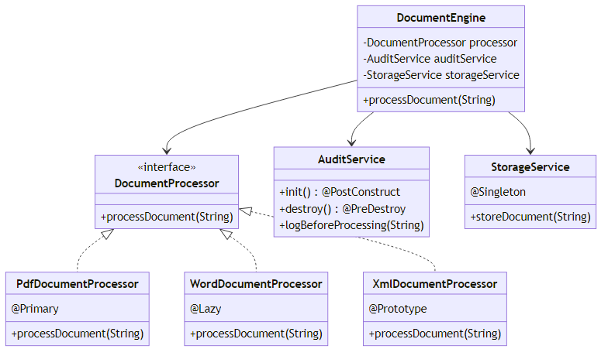

3. DEPENDENCY INJECTION PATTERNS

ðŸ“Œ Three Types of Dependency Injection
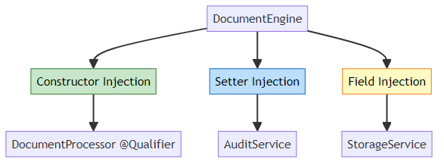

1. Constructor Injection (Recommended)
@Component
public class DocumentEngine {
private final DocumentProcessor documentProcessor;
@Autowired
public DocumentEngine(@Qualifier("xmlDocumentProcessor") DocumentProcessor documentProcessor) {
this.documentProcessor = documentProcessor;
System.out.println("[Constructor Injection] Injected: " + documentProcessor.getClass().getSimpleName());
}
}
Advantages: - Immutable dependencies (final fields) - Required dependencies enforced - Easy to test (no reflection needed) - Null-safe
When to Use: - Required dependencies - Immutable objects - Unit testing scenarios

2. Setter Injection
@Component
public class DocumentEngine {
private AuditService auditService;
@Autowired
public void setAuditService(AuditService auditService) {
this.auditService = auditService;
System.out.println("[Setter Injection] Injected: " + auditService.getClass().getSimpleName());
}
}
Advantages: - Optional dependencies - Allows reconfiguration - Circular dependency resolution
When to Use: - Optional dependencies - Reconfigurable beans - Breaking circular dependencies

3. Field Injection
@Component
public class DocumentEngine {
@Autowired
private StorageService storageService;
}
Advantages: - Simplest syntax - Less boilerplate code
Disadvantages: - Cannot use final fields - Harder to test (requires reflection) - Hidden dependencies
When to Use: - Rapid prototyping - Simple applications - Not recommended for production

ðŸ“Š Injection Pattern Comparison
Feature | Constructor | Setter | Field
Immutability | âœ… Yes (final) | âŒ No | âŒ No
Required Dependencies | âœ… Enforced | âŒ Optional | âŒ Optional
Testability | âœ… Easy | âš ï¸ Medium | âŒ Hard
Circular Dependencies | âŒ Fails | âœ… Resolves | âœ… Resolves
Null Safety | âœ… Guaranteed | âš ï¸ Possible | âš ï¸ Possible
Code Clarity | âœ… Explicit | âœ… Explicit | âŒ Hidden
Spring Recommendation | âœ… Preferred | âš ï¸ Acceptable | âŒ Discouraged

4. BEAN SCOPES DEEP DIVE

ðŸ“Œ Singleton vs Prototype
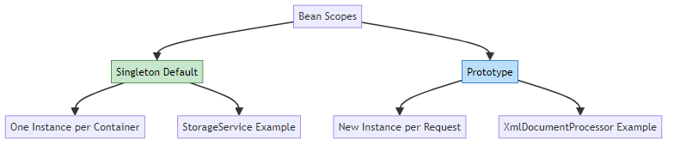

Singleton Scope (Default)
@Component
@Scope("singleton") // Default, can be omitted
public class StorageService {
public StorageService() {
System.out.println("Creating instance of: " + this.getClass().getSimpleName());
}
}
Behavior:
Container starts â†’ StorageService created ONCE
Request 1 â†’ Same instance
Request 2 â†’ Same instance
Request 3 â†’ Same instance
Characteristics: - One instance per Spring container - Created at container startup (unless @Lazy) - Thread-safe if stateless - Memory efficient
Use Cases: - Stateless services - Shared resources (connection pools) - Utility classes - Configuration beans

Prototype Scope
@Component
@Scope("prototype")
public class XmlDocumentProcessor implements DocumentProcessor {
public XmlDocumentProcessor() {
System.out.println("Creating instance of: " + this.getClass().getSimpleName());
}
}
Behavior:
Container starts â†’ No instance created
Request 1 â†’ New instance created
Request 2 â†’ New instance created
Request 3 â†’ New instance created
Characteristics: - New instance per getBean() call - Not created at startup - Spring doesn’t manage destruction - Higher memory usage
Use Cases: - Stateful objects - Per-request processing - Thread-specific instances - Temporary objects

ðŸ“Š Scope Comparison
Feature | Singleton | Prototype
Instances | One per container | Many
Creation Time | Startup (unless @Lazy) | On demand
Memory | Low | Higher
Thread Safety | Must be stateless | Each thread gets own
Destruction | Spring manages | Developer manages
@PreDestroy | âœ… Called | âŒ Not called
Performance | âœ… Fast | âš ï¸ Slower

Scope Demonstration
// Singleton behavior
StorageService storage1 = context.getBean(StorageService.class);
StorageService storage2 = context.getBean(StorageService.class);
System.out.println(storage1 == storage2); // true (same instance)
// Prototype behavior
XmlDocumentProcessor xml1 = context.getBean(XmlDocumentProcessor.class);
XmlDocumentProcessor xml2 = context.getBean(XmlDocumentProcessor.class);
System.out.println(xml1 == xml2); // false (different instances)

5. @PRIMARY VS @QUALIFIER

ðŸ“Œ The Problem: Multiple Implementations
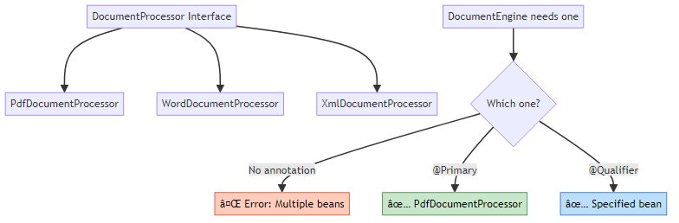

@Primary: Default Selection
@Component
@Primary // This is the default choice
public class PdfDocumentProcessor implements DocumentProcessor {
@Override
public void processDocument(String documentName) {
System.out.println("Processing PDF: " + documentName);
}
}
Usage:
// Without @Qualifier, gets @Primary bean
DocumentProcessor processor = context.getBean(DocumentProcessor.class);
// Returns: PdfDocumentProcessor
When to Use @Primary: - One implementation is used 80% of the time - Default behavior for most cases - Reduces @Qualifier usage

@Qualifier: Explicit Selection
@Component
public class DocumentEngine {
private final DocumentProcessor documentProcessor;
@Autowired
public DocumentEngine(@Qualifier("xmlDocumentProcessor") DocumentProcessor documentProcessor) {
this.documentProcessor = documentProcessor;
// Explicitly gets XmlDocumentProcessor, ignoring @Primary
}
}
Bean Naming:
@Component // Bean name: "pdfDocumentProcessor" (camelCase)
public class PdfDocumentProcessor { }
@Component("customName") // Bean name: "customName"
public class WordDocumentProcessor { }
When to Use @Qualifier: - Need specific implementation - Override @Primary behavior - Multiple injection points need different beans

ðŸ“Š @Primary vs @Qualifier Decision Tree
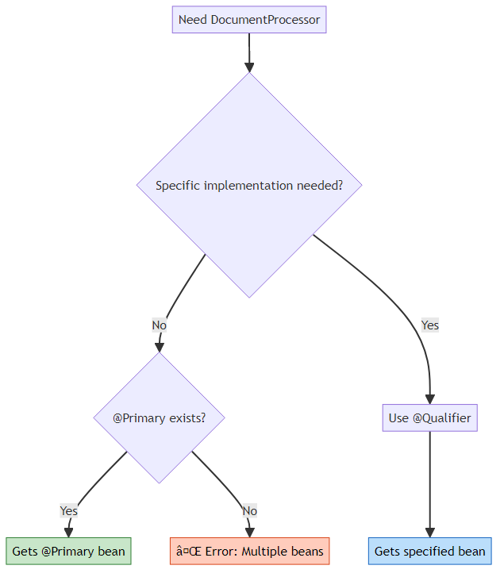

Real-World Example
// Scenario: Payment Processing System
@Component
@Primary
public class CreditCardPayment implements PaymentProcessor {
// Default payment method (80% of transactions)
}
@Component
public class PayPalPayment implements PaymentProcessor {
// Alternative payment method
}
@Component
public class CryptoPayment implements PaymentProcessor {
// Rare payment method
}
// Usage
@Service
public class OrderService {
private final PaymentProcessor defaultPayment;
private final PaymentProcessor cryptoPayment;
@Autowired
public OrderService(
PaymentProcessor defaultPayment, // Gets @Primary (CreditCard)
@Qualifier("cryptoPayment") PaymentProcessor cryptoPayment) {
this.defaultPayment = defaultPayment;
this.cryptoPayment = cryptoPayment;
}
}

6. LAZY INITIALIZATION

ðŸ“Œ Eager vs Lazy Loading
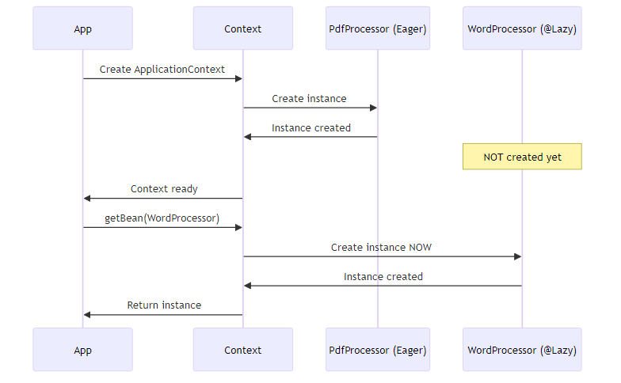

@Lazy Implementation
@Component
@Lazy // Not created at startup
public class WordDocumentProcessor implements DocumentProcessor {
public WordDocumentProcessor() {
System.out.println("Creating instance of: " + this.getClass().getSimpleName());
}
}
Execution Timeline:
Time 0: Container starts
âœ… PdfDocumentProcessor created
âœ… XmlDocumentProcessor definition registered
âœ… AuditService created
âœ… StorageService created
âŒ WordDocumentProcessor NOT created
Time 5: First getBean(WordDocumentProcessor.class)
âœ… WordDocumentProcessor created NOW

ðŸ“Š Lazy vs Eager Comparison
Feature | Eager (Default) | Lazy (@Lazy)
Creation Time | Startup | First access
Startup Speed | âŒ Slower | âœ… Faster
First Access | âœ… Fast | âŒ Slower
Error Detection | âœ… Immediate | âŒ Delayed
Memory at Startup | âŒ Higher | âœ… Lower
Use Case | Always-used beans | Rarely-used beans

When to Use @Lazy
âœ… Use @Lazy When: - Bean is rarely used - Expensive initialization (database connections, file loading) - Optional features - Conditional beans
âŒ Don’t Use @Lazy When: - Bean is always needed - Fast initialization - Want fail-fast behavior - Critical startup validation

7. BEAN LIFECYCLE MANAGEMENT

ðŸ“Œ Complete Bean Lifecycle
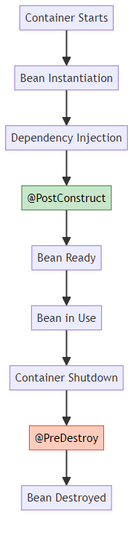

@PostConstruct: Initialization
@Component
public class AuditService {
public AuditService() {
System.out.println("Creating instance of: " + this.getClass().getSimpleName());
}
@PostConstruct
public void init() {
System.out.println("[PostConstruct] Initializing audit configuration");
// Initialize resources
// Load configuration
// Connect to audit database
}
}
Execution Order:
1. Constructor called
2. Dependencies injected
3. @PostConstruct called â† Initialization logic here
4. Bean ready for use
Use Cases: - Initialize resources (connections, caches) - Load configuration - Validate dependencies - Start background threads

@PreDestroy: Cleanup
@Component
public class AuditService {
@PreDestroy
public void destroy() {
System.out.println("[PreDestroy] Releasing audit resources");
// Close connections
// Flush buffers
// Release resources
}
}
Execution Order:
1. Container shutdown initiated
2. @PreDestroy called â† Cleanup logic here
3. Bean destroyed
Use Cases: - Close database connections - Flush buffers - Release file handles - Stop background threads

ðŸ“Š Lifecycle Callbacks Comparison
Callback | Purpose | When Called | Scope Support
Constructor | Create instance | Bean instantiation | All
@PostConstruct | Initialize | After DI complete | Singleton, Prototype
@PreDestroy | Cleanup | Before destruction | Singleton only
Important: @PreDestroy is NOT called for prototype beans!

8. COMPLETE EXECUTION FLOW

ðŸ“Œ Application Execution Sequence
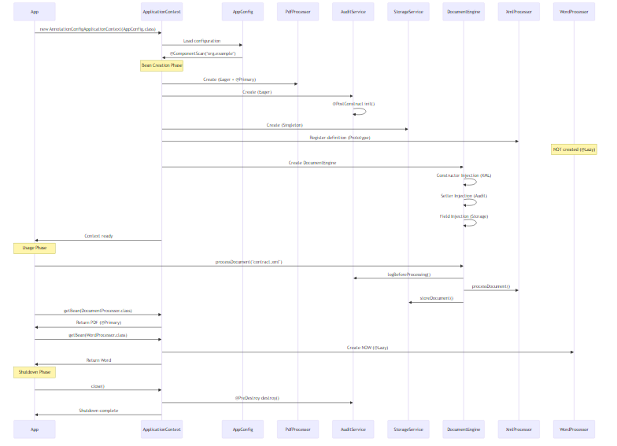

Console Output Analysis
--- Enterprise Document Processing Engine ---
Creating instance of: PdfDocumentProcessor
Creating instance of: AuditService
[PostConstruct] Initializing audit configuration for AuditService
Creating instance of: StorageService
Creating instance of: XmlDocumentProcessor
Creating instance of: DocumentEngine
[Constructor Injection] Injected DocumentProcessor: XmlDocumentProcessor
[Setter Injection] Injected AuditService: AuditService
-- @qualifier with XmlDocumentProcessor --
DocumentEngine is using: XmlDocumentProcessor
-- Document Processing Started --
[AUDIT LOG] Starting to process document: contract.xml
Processing XML document: contract.xml using XmlDocumentProcessor
[STORAGE] Storing document: contract.xml using StorageService
-- Document Processing Completed --
-- @primary (PdfDocumentProcessor) --
Default processor (without qualifier) is: PdfDocumentProcessor
Processing PDF document: report.pdf using PdfDocumentProcessor
-- @Lazy (WordDocumentProcessor) --
Creating instance of: WordDocumentProcessor
Processing Word document: document.docx using WordDocumentProcessor
-- Closing Application Context --
[PreDestroy] Releasing audit resources for AuditService
-- Application Completed --
Key Observations: 1. PdfDocumentProcessor created first (eager + @Primary) 2. AuditService @PostConstruct called after creation 3. XmlDocumentProcessor created for DocumentEngine (prototype) 4. WordDocumentProcessor created only when requested (@Lazy) 5. @PreDestroy called during shutdown

9. INTERNAL WORKING

ðŸ“Œ Spring Container Internals
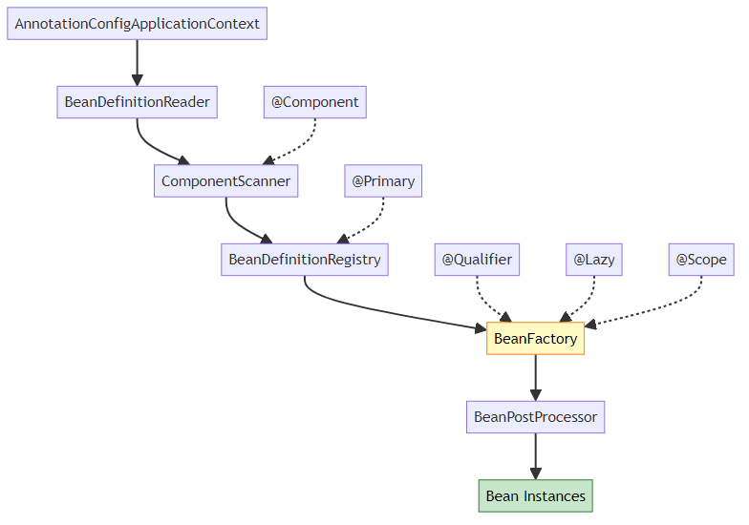

Bean Creation Process
Step 1: Component Scanning
@ComponentScan(basePackages = "org.example")
// Spring scans all classes in org.example package
// Finds classes with @Component, @Service, @Repository, @Controller
Step 2: Bean Definition Registration
// Spring internally creates BeanDefinition for each component
BeanDefinition pdfDef = new GenericBeanDefinition();
pdfDef.setBeanClassName("org.example.entity.PdfDocumentProcessor");
pdfDef.setPrimary(true); // @Primary annotation
pdfDef.setLazyInit(false); // Eager by default
BeanDefinition wordDef = new GenericBeanDefinition();
wordDef.setBeanClassName("org.example.entity.WordDocumentProcessor");
wordDef.setLazyInit(true); // @Lazy annotation
BeanDefinition xmlDef = new GenericBeanDefinition();
xmlDef.setBeanClassName("org.example.entity.XmlDocumentProcessor");
xmlDef.setScope("prototype"); // @Scope annotation
Step 3: Dependency Resolution
// Spring analyzes DocumentEngine dependencies
@Autowired
public DocumentEngine(@Qualifier("xmlDocumentProcessor") DocumentProcessor processor) {
// Spring looks for bean named "xmlDocumentProcessor"
// Ignores @Primary because @Qualifier is explicit
}
Step 4: Bean Instantiation
// Spring uses reflection to create instances
Class<?> clazz = Class.forName("org.example.entity.PdfDocumentProcessor");
Constructor<?> constructor = clazz.getConstructor();
Object instance = constructor.newInstance();
Step 5: Dependency Injection
// Constructor injection
Constructor<?> constructor = DocumentEngine.class.getConstructor(DocumentProcessor.class);
Object engine = constructor.newInstance(xmlProcessor);
// Setter injection
Method setter = DocumentEngine.class.getMethod("setAuditService", AuditService.class);
setter.invoke(engine, auditService);
// Field injection
Field field = DocumentEngine.class.getDeclaredField("storageService");
field.setAccessible(true);
field.set(engine, storageService);
Step 6: Lifecycle Callbacks
// @PostConstruct
Method postConstruct = AuditService.class.getMethod("init");
postConstruct.invoke(auditServiceInstance);
// @PreDestroy (on shutdown)
Method preDestroy = AuditService.class.getMethod("destroy");
preDestroy.invoke(auditServiceInstance);

10. REAL-WORLD PRODUCTION PATTERNS

Pattern 1: Strategy Pattern with DI
// Payment Processing System
public interface PaymentStrategy {
void processPayment(double amount);
}
@Component
@Primary
public class CreditCardPayment implements PaymentStrategy {
@Override
public void processPayment(double amount) {
System.out.println("Processing credit card payment: $" + amount);
}
}
@Component
public class PayPalPayment implements PaymentStrategy {
@Override
public void processPayment(double amount) {
System.out.println("Processing PayPal payment: $" + amount);
}
}
@Service
public class PaymentService {
private final Map<String, PaymentStrategy> strategies;
@Autowired
public PaymentService(List<PaymentStrategy> strategyList) {
// Spring injects ALL implementations
this.strategies = strategyList.stream()
.collect(Collectors.toMap(
s -> s.getClass().getSimpleName(),
s -> s
));
}
public void pay(String method, double amount) {
PaymentStrategy strategy = strategies.get(method + "Payment");
strategy.processPayment(amount);
}
}

Pattern 2: Factory Pattern with @Qualifier
@Component
public class DocumentProcessorFactory {
private final Map<String, DocumentProcessor> processors;
@Autowired
public DocumentProcessorFactory(
@Qualifier("pdfDocumentProcessor") DocumentProcessor pdfProcessor,
@Qualifier("wordDocumentProcessor") DocumentProcessor wordProcessor,
@Qualifier("xmlDocumentProcessor") DocumentProcessor xmlProcessor) {
processors = Map.of(
"pdf", pdfProcessor,
"docx", wordProcessor,
"xml", xmlProcessor
);
}
public DocumentProcessor getProcessor(String fileExtension) {
return processors.getOrDefault(fileExtension, processors.get("pdf"));
}
}

Pattern 3: Resource Pool with Prototype
@Component
@Scope("prototype")
public class DatabaseConnection {
private final String connectionId;
public DatabaseConnection() {
this.connectionId = UUID.randomUUID().toString();
System.out.println("Created connection: " + connectionId);
}
public void execute(String query) {
System.out.println("Executing on " + connectionId + ": " + query);
}
}
@Component
public class ConnectionPool {
@Autowired
private ApplicationContext context;
private final Queue<DatabaseConnection> pool = new ConcurrentLinkedQueue<>();
public DatabaseConnection getConnection() {
if (pool.isEmpty()) {
return context.getBean(DatabaseConnection.class); // New instance
}
return pool.poll();
}
public void releaseConnection(DatabaseConnection conn) {
pool.offer(conn);
}
}

Pattern 4: Conditional Beans
@Component
@Profile("dev")
public class DevDocumentProcessor implements DocumentProcessor {
@Override
public void processDocument(String documentName) {
System.out.println("[DEV] Processing: " + documentName);
}
}
@Component
@Profile("prod")
public class ProdDocumentProcessor implements DocumentProcessor {
@Override
public void processDocument(String documentName) {
System.out.println("[PROD] Processing: " + documentName);
// Add production logging, monitoring, etc.
}
}

11. COMMON PITFALLS & SOLUTIONS

❌ Pitfall 1: Field Injection in Final Fields
Problem:
@Component
public class DocumentEngine {
@Autowired
private final DocumentProcessor processor; // Compilation error!
}
Solution:
@Component
public class DocumentEngine {
private final DocumentProcessor processor;
@Autowired // Constructor injection for final fields
public DocumentEngine(DocumentProcessor processor) {
this.processor = processor;
}
}

❌ Pitfall 2: Multiple Beans Without @Primary or @Qualifier
Problem:
@Component
public class PdfDocumentProcessor implements DocumentProcessor { }
@Component
public class WordDocumentProcessor implements DocumentProcessor { }
@Component
public class DocumentEngine {
@Autowired
private DocumentProcessor processor; // Error: Multiple beans found!
}
Solution:
// Option 1: Use @Primary
@Component
@Primary
public class PdfDocumentProcessor implements DocumentProcessor { }
// Option 2: Use @Qualifier
@Component
public class DocumentEngine {
@Autowired
@Qualifier("wordDocumentProcessor")
private DocumentProcessor processor;
}

❌ Pitfall 3: Circular Dependency
Problem:
@Component
public class ServiceA {
@Autowired
private ServiceB serviceB; // Circular!
}
@Component
public class ServiceB {
@Autowired
private ServiceA serviceA; // Circular!
}
Solution:
@Component
public class ServiceA {
@Autowired
@Lazy // Break circular dependency
private ServiceB serviceB;
}

❌ Pitfall 4: Prototype Bean in Singleton
Problem:
@Component
@Scope("singleton")
public class DocumentEngine {
@Autowired
private DocumentProcessor processor; // Prototype bean injected once!
}
@Component
@Scope("prototype")
public class DocumentProcessor { }
Solution:
@Component
public class DocumentEngine {
@Autowired
private ApplicationContext context;
public void process() {
DocumentProcessor processor = context.getBean(DocumentProcessor.class);
// New instance every time
}
}

❌ Pitfall 5: @PostConstruct with Uninitialized Dependencies
Problem:
@Component
public class AuditService {
@Autowired
private DatabaseService dbService;
@PostConstruct
public void init() {
dbService.connect(); // May fail if dbService not fully initialized
}
}
Solution:
@Component
public class AuditService {
private final DatabaseService dbService;
@Autowired
public AuditService(DatabaseService dbService) {
this.dbService = dbService; // Guaranteed initialized
}
@PostConstruct
public void init() {
dbService.connect(); // Safe now
}
}

12. TOP INTERVIEW QUESTIONS

Q1: What happens if you inject a Prototype bean into a Singleton bean?
Answer:
Scenario:
@Component
@Scope("singleton")
public class DocumentEngine {
@Autowired
private DocumentProcessor processor; // Prototype bean
}
@Component
@Scope("prototype")
public class DocumentProcessor { }
Problem: The prototype bean is injected ONLY ONCE when the singleton is created. You get the same instance every time, defeating the purpose of prototype scope.
Why?
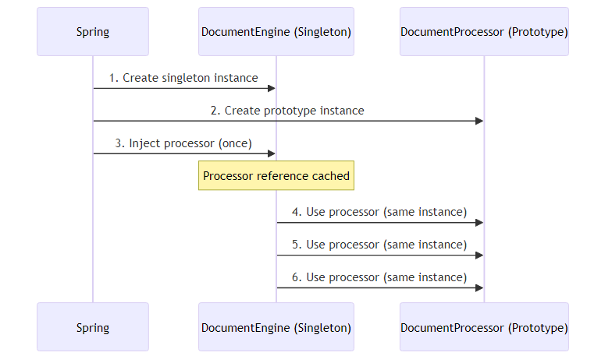
Solutions:
Option 1: ApplicationContext Lookup
@Component
public class DocumentEngine {
@Autowired
private ApplicationContext context;
public void process() {
DocumentProcessor processor = context.getBean(DocumentProcessor.class);
processor.process(); // New instance every time
}
}
Option 2: ObjectFactory
@Component
public class DocumentEngine {
@Autowired
private ObjectFactory<DocumentProcessor> processorFactory;
public void process() {
DocumentProcessor processor = processorFactory.getObject();
processor.process(); // New instance every time
}
}
Option 3: @Lookup (Method Injection)
@Component
public abstract class DocumentEngine {
@Lookup
protected abstract DocumentProcessor getProcessor();
public void process() {
DocumentProcessor processor = getProcessor();
processor.process(); // New instance every time
}
}

Q2: Explain the order of bean initialization when using @PostConstruct
Answer:
Complete Lifecycle:
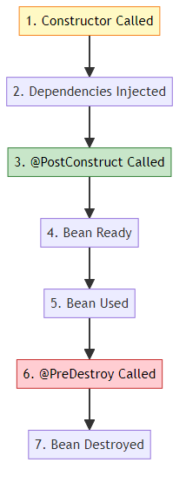
Example:
@Component
public class AuditService {
@Autowired
private StorageService storageService;
public AuditService() {
System.out.println("1. Constructor called");
// storageService is NULL here!
}
@PostConstruct
public void init() {
System.out.println("2. @PostConstruct called");
// storageService is AVAILABLE here!
storageService.initialize();
}
@PreDestroy
public void cleanup() {
System.out.println("3. @PreDestroy called");
storageService.cleanup();
}
}
Output:
1. Constructor called
2. @PostConstruct called
3. @PreDestroy called
Key Points: - Constructor runs BEFORE dependency injection - @PostConstruct runs AFTER all dependencies injected - @PreDestroy runs BEFORE bean destruction - Use @PostConstruct for initialization logic that needs dependencies

Q3: What’s the difference between @Autowired and @Inject?
Answer:
Comparison:
Feature | @Autowired (Spring) | @Inject (JSR-330)
Standard | Spring-specific | Java standard
Required | @Autowired(required=false) | No equivalent
Qualifier | @Qualifier | @Named
Provider | No | Provider
Portability | Spring only | Any DI framework
Example:
Spring @Autowired:
@Component
public class OrderService {
@Autowired
@Qualifier("creditCardPayment")
private PaymentService paymentService;
@Autowired(required = false)
private Optional<EmailService> emailService;
}
JSR-330 @Inject:
@Component
public class OrderService {
@Inject
@Named("creditCardPayment")
private PaymentService paymentService;
@Inject
private Provider<EmailService> emailProvider;
}
When to use: - @Autowired: Most common (Spring projects) - @Inject: Need portability across DI frameworks
Both do the same thing, but @Inject is a Java standard.

Q4: How does Spring resolve circular dependencies?
Answer:
Scenario:
@Component
public class ServiceA {
@Autowired
private ServiceB serviceB;
}
@Component
public class ServiceB {
@Autowired
private ServiceA serviceA; // Circular!
}
Spring’s Resolution Process:
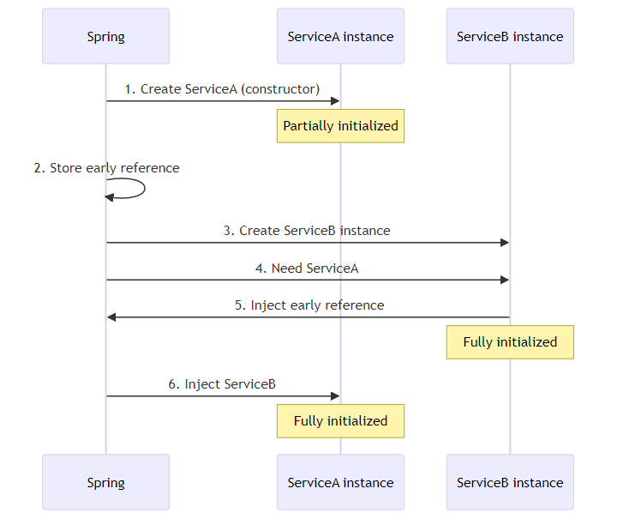
Step-by-Step:
1. Spring creates ServiceA instance (constructor called)
2. ServiceA tries to inject ServiceB
3. Spring creates ServiceB instance
4. ServiceB needs ServiceA
5. Spring injects early reference of ServiceA (not fully initialized)
6. ServiceB fully initialized
7. Spring injects ServiceB into ServiceA
8. ServiceA fully initialized
9. Both beans ready
Why Constructor Injection Fails:
@Component
public class ServiceA {
private final ServiceB serviceB;
@Autowired
public ServiceA(ServiceB serviceB) { // Circular dependency error!
this.serviceB = serviceB;
}
}
Solution:
// Option 1: Use @Lazy
@Component
public class ServiceA {
private final ServiceB serviceB;
@Autowired
public ServiceA(@Lazy ServiceB serviceB) {
this.serviceB = serviceB; // Proxy injected
}
}
// Option 2: Redesign (best)
// Extract common logic to ServiceC

Q5: Explain bean naming conventions in Spring
Answer:
Default Naming:
Spring uses class name as bean name (camelCase)
Examples:
@Component
public class UserService { }
// Bean name: "userService"
@Component
public class XMLParser { }
// Bean name: "XMLParser" (preserves capitals)
@Component("myService")
public class UserService { }
// Bean name: "myService"
@Component
@Qualifier("customName")
public class UserService { }
// Bean name: "userService"
// Qualifier: "customName"
Accessing Beans:
// By type
UserService service = context.getBean(UserService.class);
// By name
UserService service = (UserService) context.getBean("userService");
// By name and type
UserService service = context.getBean("userService", UserService.class);
// Get all beans of type
Map<String, DocumentProcessor> processors =
context.getBeansOfType(DocumentProcessor.class);
// Returns: {"pdfDocumentProcessor": PdfDocumentProcessor,
// "wordDocumentProcessor": WordDocumentProcessor}
Multiple Beans:
@Component("pdfProcessor")
public class PdfDocumentProcessor implements DocumentProcessor { }
@Component("wordProcessor")
public class WordDocumentProcessor implements DocumentProcessor { }
// Get specific bean
DocumentProcessor pdf = context.getBean("pdfProcessor", DocumentProcessor.class);
DocumentProcessor word = context.getBean("wordProcessor", DocumentProcessor.class);

Q6: What happens if @PostConstruct method throws an exception?
Answer:
Scenario:
@Component
public class AuditService {
@PostConstruct
public void init() {
throw new RuntimeException("Initialization failed!");
}
}
Result: - Bean creation FAILS - Application context fails to start - Spring throws BeanCreationException - Application DOES NOT START
Example Output:
Error creating bean with name 'auditService':
Invocation of init method failed;
nested exception is java.lang.RuntimeException: Initialization failed!
Best Practice:
@Component
public class AuditService {
@PostConstruct
public void init() {
try {
// Risky initialization
connectToDatabase();
} catch (Exception e) {
// Log error but don't fail application
logger.error("Failed to initialize audit service", e);
// Or rethrow if critical
throw new BeanCreationException("Critical initialization failed", e);
}
}
}
Lifecycle Impact:
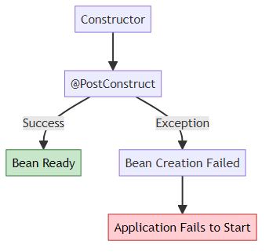

Q7: Why use Constructor Injection over Field Injection?
Answer:
Field Injection (Not Recommended):
@Component
public class DocumentEngine {
@Autowired
private DocumentProcessor processor; // Hard to test
@Autowired
private StorageService storage;
}
Constructor Injection (Recommended):
@Component
public class DocumentEngine {
private final DocumentProcessor processor;
private final StorageService storage;
@Autowired
public DocumentEngine(DocumentProcessor processor, StorageService storage) {
this.processor = processor;
this.storage = storage;
}
}
Advantages:
Aspect | Field Injection | Constructor Injection
Immutability | No (mutable) | Yes (final fields)
Testing | Hard (need Spring) | Easy (plain Java)
Null Safety | Can be null | Never null
Circular Dependency | Hidden | Detected early
Required Dependencies | Unclear | Explicit
Testing Comparison:
Field Injection (Hard):
@Test
public void testDocumentEngine() {
DocumentEngine engine = new DocumentEngine();
// processor is NULL! Need reflection or Spring context
}
Constructor Injection (Easy):
@Test
public void testDocumentEngine() {
DocumentProcessor mockProcessor = mock(DocumentProcessor.class);
StorageService mockStorage = mock(StorageService.class);
DocumentEngine engine = new DocumentEngine(mockProcessor, mockStorage);
// Easy to test without Spring!
}
Circular Dependency Detection:
// Field injection: Fails at runtime
@Component
public class ServiceA {
@Autowired
private ServiceB serviceB; // Runtime error
}
// Constructor injection: Fails at startup
@Component
public class ServiceA {
@Autowired
public ServiceA(ServiceB serviceB) { // Immediate error
this.serviceB = serviceB;
}
}

Q8: Explain @Primary vs @Qualifier with multiple beans
Answer:
Scenario:
@Component
public class PdfDocumentProcessor implements DocumentProcessor { }
@Component
public class WordDocumentProcessor implements DocumentProcessor { }
@Component
public class XmlDocumentProcessor implements DocumentProcessor { }
Problem:
@Component
public class DocumentEngine {
@Autowired
private DocumentProcessor processor; // Error: 3 beans found!
}
Solution 1: @Primary (Default Choice)
@Component
@Primary // This will be injected by default
public class PdfDocumentProcessor implements DocumentProcessor { }
@Component
public class DocumentEngine {
@Autowired
private DocumentProcessor processor; // PdfDocumentProcessor injected
}
Solution 2: @Qualifier (Specific Choice)
@Component
public class DocumentEngine {
@Autowired
@Qualifier("xmlDocumentProcessor") // Specific bean
private DocumentProcessor processor;
}
Combination:
@Component
@Primary
public class PdfDocumentProcessor implements DocumentProcessor { }
@Component
public class Engine1 {
@Autowired
private DocumentProcessor processor; // PdfDocumentProcessor (@Primary)
}
@Component
public class Engine2 {
@Autowired
@Qualifier("wordDocumentProcessor")
private DocumentProcessor processor; // WordDocumentProcessor (@Qualifier wins)
}
Priority:
@Qualifier > @Primary > Bean Name
Decision Tree:
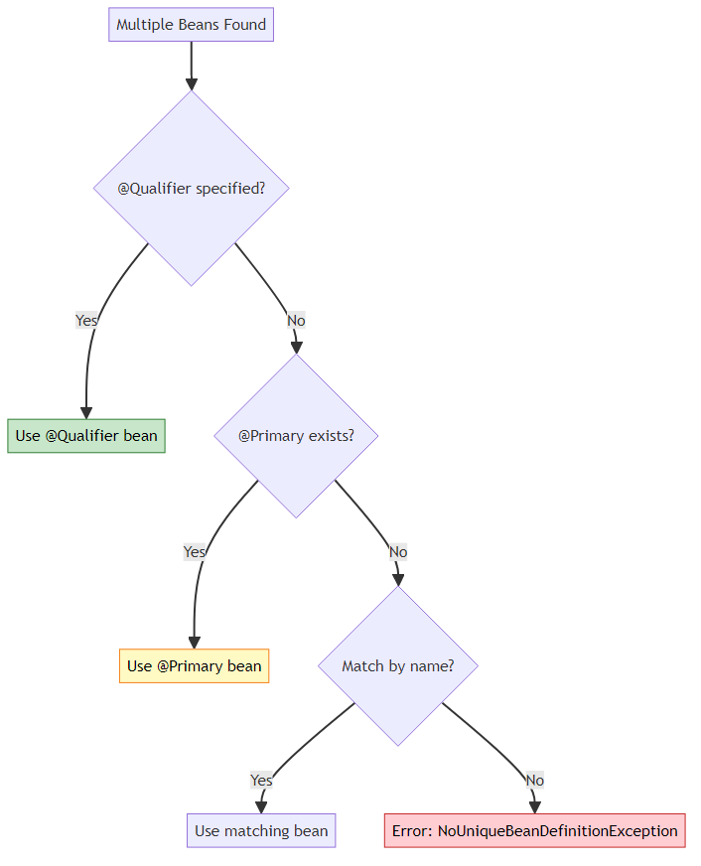

🎓 End of Document Processing Engine Guide

Created with dedication by Avinash Dhanuka

Happy Learning! 🚀
“Master Dependency Injection, Build Scalable Systems!” - Avinash Dhanuka

© 2026 Avinash Dhanuka | All Rights Reserved

