☕ Spring MVC: Complete Architecture Deep Dive

© 2026 Avinash Dhanuka
Master Guide: Spring MVC Architecture
Crafted with ❤️ for Full-Stack Mastery

Learning Note: This guide demonstrates Spring MVC architecture with JPA integration - the industry-standard pattern for building scalable web applications. Master the complete request-response lifecycle, data persistence, and layered architecture.
Prerequisites: - Understanding of Spring Core & IoC - Basic knowledge of HTTP & REST - Familiarity with Servlets & JSP - Database fundamentals (SQL)

📑 Table of Contents
- What is Spring MVC?
- MVC Architecture Pattern
- Project Structure Analysis
- Complete Request Flow
- Layer-by-Layer Deep Dive
- JPA vs Hibernate vs JDBC
- JpaRepository Hierarchy
- Internal Working: DispatcherServlet
- Model & ModelAttribute
- JSP vs HTML: View Resolution
- application.properties Deep Dive
- Maven & Dependency Management
- Real-World Production Patterns
- Common Pitfalls & Solutions
- Interview Questions

1. WHAT IS SPRING MVC?

📝 Author: Avinash Dhanuka | GitHub

📌 Definition
Spring MVC is a web framework built on the Servlet API that follows the Model-View-Controller design pattern. It provides a clean separation of concerns for building web applications.
Key Components: - Model: Data & Business Logic - View: UI Presentation (JSP, Thymeleaf, etc.) - Controller: Request Handler & Flow Control

🎯 Why Spring MVC?
Feature | Benefit
Separation of Concerns | Clean architecture, easy maintenance
Flexible View Resolution | JSP, Thymeleaf, JSON, XML
Annotation-Based | Less XML, more productivity
RESTful Support | Built-in REST capabilities
Integration | Seamless with Spring ecosystem

2. MVC ARCHITECTURE PATTERN

📌 Traditional MVC Flow
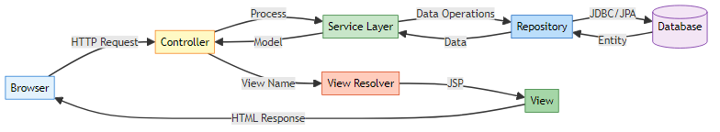

🎯 Layered Architecture
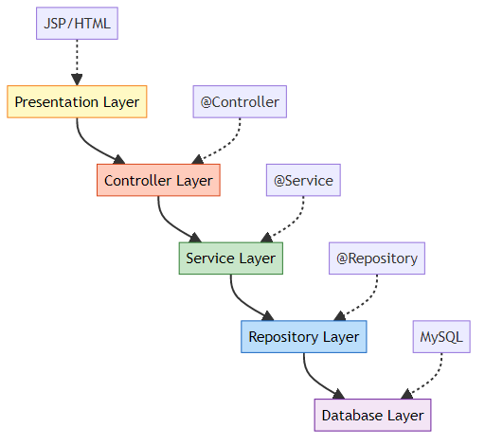

📊 Layer Responsibilities
Layer | Annotation | Responsibility | Example
Controller | @Controller | Handle HTTP requests | StudentController
Service | @Service | Business logic | StudentService
Repository | @Repository | Data access | StudentDao
Model | @Entity | Data representation | Student

3. PROJECT STRUCTURE ANALYSIS

📁 Complete Project Structure
SpringMvc/
├── src/
│ ├── main/
│ │ ├── java/
│ │ │ └── com/example/SpringMvc/
│ │ │ ├── SpringMvcApplication.java # Entry Point
│ │ │ ├── Controller/
│ │ │ │ └── StudentController.java # Request Handler
│ │ │ ├── Service/
│ │ │ │ └── StudentService.java # Business Logic
│ │ │ ├── Repository/
│ │ │ │ └── StudentDao.java # Data Access
│ │ │ └── Model/
│ │ │ └── Student.java # Entity
│ │ ├── resources/
│ │ │ └── application.properties # Configuration
│ │ └── webapp/
│ │ └── WEB-INF/
│ │ └── jsp/
│ │ ├── register.jsp # Form View
│ │ └── success.jsp # Success View
│ └── test/
├── pom.xml # Maven Dependencies
└── README.md

🔍 File Purpose Breakdown
1. SpringMvcApplication.java
@SpringBootApplication // = @Configuration + @EnableAutoConfiguration + @ComponentScan
public class SpringMvcApplication {
public static void main(String[] args) {
SpringApplication.run(SpringMvcApplication.class, args);
}
}
- Entry point of application
- Bootstraps Spring Boot
- Auto-configures components
2. StudentController.java
@Controller // Marks as Spring MVC controller
public class StudentController {
@Autowired
private StudentService studentService;
@GetMapping("/register") // Handles GET requests
public String showForm() {
return "register"; // Returns view name
}
@PostMapping("/register") // Handles POST requests
public String registerStudent(@ModelAttribute Student student, Model model) {
studentService.saveStudent(student);
model.addAttribute("name", student.getName());
return "success";
}
}
3. StudentService.java
@Service // Business logic layer
public class StudentService {
@Autowired
private StudentDao studentDao;
public void saveStudent(Student student) {
studentDao.save(student); // Delegates to repository
}
}
4. StudentDao.java
@Repository // Data access layer
public interface StudentDao extends JpaRepository<Student, Long> {
// No code needed! Spring Data JPA provides implementation
}
5. Student.java
@Entity // JPA entity
@Table(name = "StudentTable")
public class Student {
@Id
@GeneratedValue(strategy = GenerationType.IDENTITY)
private Long id;
private String name;
@Email(message = "Invalid !!")
private String email;
}

4. COMPLETE REQUEST FLOW

📌 End-to-End Request Processing
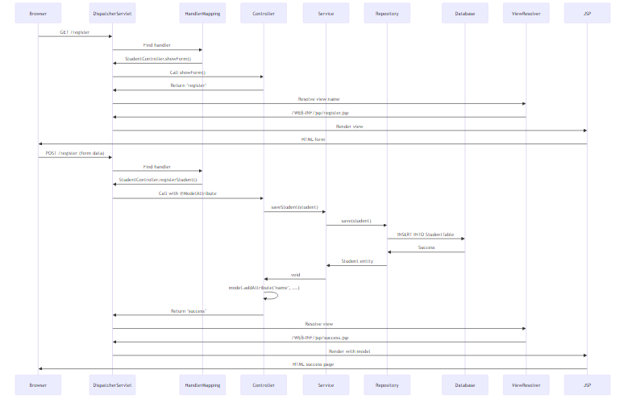

🎯 Step-by-Step Breakdown
Step 1: User Opens Form
Browser → GET http://localhost:8081/register
↓
DispatcherServlet receives request
↓
HandlerMapping finds @GetMapping("/register")
↓
StudentController.showForm() called
↓
Returns "register" (view name)
↓
ViewResolver: prefix + "register" + suffix
↓
/WEB-INF/jsp/register.jsp rendered
↓
HTML form sent to browser
Step 2: User Submits Form
Browser → POST http://localhost:8081/register
name=John&email=john@example.com
↓
DispatcherServlet receives POST
↓
@ModelAttribute binds form data to Student object
↓
StudentController.registerStudent(student, model) called
↓
studentService.saveStudent(student)
↓
studentDao.save(student) [JPA Repository]
↓
Hibernate generates: INSERT INTO StudentTable (name, email) VALUES (?, ?)
↓
MySQL executes query
↓
model.addAttribute("name", student.getName())
↓
Returns "success"
↓
/WEB-INF/jsp/success.jsp rendered with ${name}
↓
HTML response to browser

5. LAYER-BY-LAYER DEEP DIVE

🎯 Controller Layer (@Controller)
Purpose: Handle HTTP requests and responses
@Controller // Spring MVC controller
public class StudentController {
@Autowired // Dependency injection
private StudentService studentService;
@GetMapping("/register") // Maps GET requests
public String showForm() {
return "register"; // Logical view name
}
@PostMapping("/register") // Maps POST requests
public String registerStudent(
@ModelAttribute Student student, // Binds form data
Model model) { // Carries data to view
studentService.saveStudent(student);
model.addAttribute("name", student.getName());
return "success";
}
}
Key Annotations:
Annotation | Purpose | Example
@Controller | Marks as MVC controller | Class level
@GetMapping | Handle GET requests | Method level
@PostMapping | Handle POST requests | Method level
@ModelAttribute | Bind form data to object | Parameter level
@Autowired | Inject dependencies | Field/Constructor
Why @Controller vs @RestController?
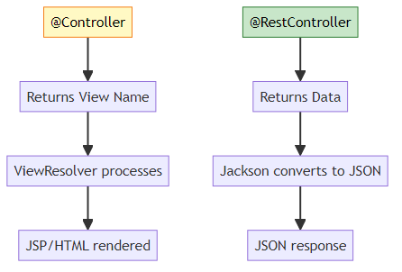

🎯 Service Layer (@Service)
Purpose: Business logic & transaction management
@Service // Business logic component
public class StudentService {
@Autowired
private StudentDao studentDao;
public void saveStudent(Student student) {
// Business validation
if (student.getName() == null || student.getName().isEmpty()) {
throw new IllegalArgumentException("Name cannot be empty");
}
// Delegate to repository
studentDao.save(student);
}
// Additional business methods
public List<Student> getAllStudents() {
return studentDao.findAll();
}
}
Why Service Layer? - Separates business logic from controllers - Reusable across multiple controllers - Transaction boundary (@Transactional) - Easy to test with mocks

🎯 Repository Layer (@Repository)
Purpose: Data access & persistence
Before (Manual DAO):
@Repository
public class StudentDao {
public void saveStudent(Student student) {
// Manual JDBC code
Connection conn = DriverManager.getConnection(...);
PreparedStatement ps = conn.prepareStatement(
"INSERT INTO StudentTable (name, email) VALUES (?, ?)");
ps.setString(1, student.getName());
ps.setString(2, student.getEmail());
ps.executeUpdate();
// Close resources...
}
}
After (JPA Repository):
@Repository
public interface StudentDao extends JpaRepository<Student, Long> {
// No implementation needed!
// Spring Data JPA provides:
// - save()
// - findAll()
// - findById()
// - delete()
// - count()
// + 20+ more methods
}
Magic Behind the Interface:
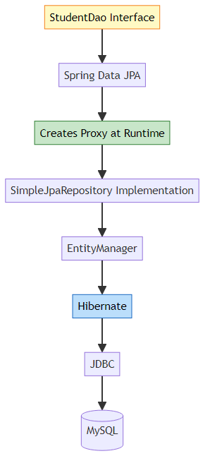

🎯 Model Layer (@Entity)
Purpose: Represent database tables as Java objects
@Entity // JPA entity
@Table(name = "StudentTable") // Custom table name
public class Student {
@Id // Primary key
@GeneratedValue(strategy = GenerationType.IDENTITY) // Auto-increment
private Long id;
@Column(nullable = false) // NOT NULL constraint
private String name;
@Email(message = "Invalid email") // Validation
@Column(unique = true) // UNIQUE constraint
private String email;
// Constructors, getters, setters
}
JPA Annotations:
Annotation | Purpose | SQL Equivalent
@Entity | Mark as JPA entity | CREATE TABLE
@Table | Custom table name | TABLE name
@Id | Primary key | PRIMARY KEY
@GeneratedValue | Auto-increment | AUTO_INCREMENT
@Column | Column properties | Column definition
@Email | Email validation | -

6. JPA VS HIBERNATE VS JDBC

📊 Technology Stack Comparison
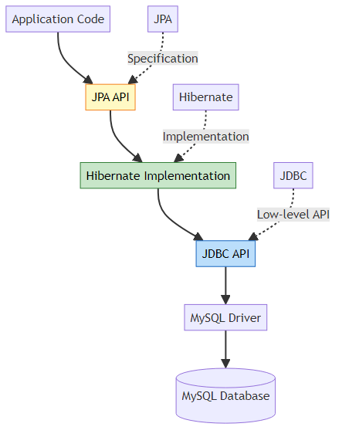

🎯 Detailed Comparison
Feature | JDBC | Hibernate | JPA
Type | API | ORM Framework | Specification
Code | Boilerplate heavy | Less boilerplate | Minimal code
SQL | Manual queries | Auto-generated | Auto-generated
Mapping | Manual | Automatic | Automatic
Caching | No | Yes (L1, L2) | Yes (via provider)
Lazy Loading | No | Yes | Yes
Vendor Lock | No | Yes | No
Learning Curve | Easy | Medium | Easy

📝 Code Comparison
JDBC Approach:
Connection conn = DriverManager.getConnection(url, user, pass);
PreparedStatement ps = conn.prepareStatement(
"INSERT INTO StudentTable (name, email) VALUES (?, ?)");
ps.setString(1, student.getName());
ps.setString(2, student.getEmail());
ps.executeUpdate();
ps.close();
conn.close();
Hibernate Approach:
Session session = sessionFactory.openSession();
Transaction tx = session.beginTransaction();
session.save(student);
tx.commit();
session.close();
JPA Approach:
EntityManager em = emf.createEntityManager();
em.getTransaction().begin();
em.persist(student);
em.getTransaction().commit();
em.close();
Spring Data JPA Approach:
studentDao.save(student); // That's it!

🎯 Why JPA?
Advantages: - Vendor-independent (switch from Hibernate to EclipseLink easily) - Standard API (portable across projects) - Less code (Spring Data JPA magic) - Built-in features (caching, lazy loading, transactions)
Relationship:
JPA (Specification)
↓
Hibernate (Implementation)
↓
JDBC (Low-level API)
↓
Database Driver
↓
Database

7. JPAREPOSITORY HIERARCHY

📌 Complete Repository Hierarchy
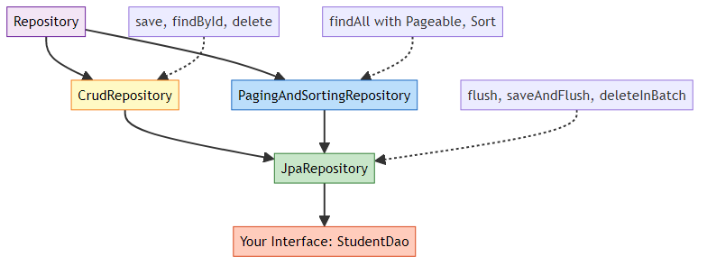

🎯 Interface Breakdown
1. Repository<T, ID> - Marker interface - No methods - Base for all Spring Data repositories
2. CrudRepository<T, ID>
public interface CrudRepository<T, ID> extends Repository<T, ID> {
<S extends T> S save(S entity);
Optional<T> findById(ID id);
Iterable<T> findAll();
long count();
void deleteById(ID id);
void delete(T entity);
void deleteAll();
}
3. PagingAndSortingRepository<T, ID>
public interface PagingAndSortingRepository<T, ID> extends CrudRepository<T, ID> {
Iterable<T> findAll(Sort sort);
Page<T> findAll(Pageable pageable);
}
4. JpaRepository<T, ID>
public interface JpaRepository<T, ID> extends PagingAndSortingRepository<T, ID> {
void flush();
<S extends T> S saveAndFlush(S entity);
void deleteInBatch(Iterable<T> entities);
void deleteAllInBatch();
T getOne(ID id); // Returns proxy
List<T> findAll(); // Returns List instead of Iterable
List<T> findAll(Sort sort);
}

📊 Method Comparison
Method | CrudRepository | JpaRepository | Difference
findAll() | Iterable | List | JPA returns List
save() | ✅ | ✅ | Same
flush() | ❌ | ✅ | JPA-specific
saveAndFlush() | ❌ | ✅ | JPA-specific
deleteInBatch() | ❌ | ✅ | Batch delete

🎯 Why Extend JpaRepository?
Reasons: 1. More Methods: 20+ ready-to-use methods 2. Better Return Types: List instead of Iterable 3. JPA-Specific Features: flush(), batch operations 4. Pagination & Sorting: Built-in support
Example Usage:
@Repository
public interface StudentDao extends JpaRepository<Student, Long> {
// Inherited methods (no code needed):
// - save(student)
// - findById(id)
// - findAll()
// - delete(student)
// - count()
// Custom query methods (Spring generates implementation):
List<Student> findByName(String name);
Optional<Student> findByEmail(String email);
List<Student> findByNameContaining(String keyword);
// Custom JPQL query:
@Query("SELECT s FROM Student s WHERE s.email LIKE %:domain")
List<Student> findByEmailDomain(@Param("domain") String domain);
}

📝 Query Method Naming Convention
Method Name | Generated Query
findByName(String name) | WHERE name = ?
findByNameAndEmail(…) | WHERE name = ? AND email = ?
findByNameContaining(…) | WHERE name LIKE %?%
findByNameStartingWith(…) | WHERE name LIKE ?%
findByAgeGreaterThan(int age) | WHERE age > ?
findByAgeBetween(int min, int max) | WHERE age BETWEEN ? AND ?
findByOrderByNameAsc() | ORDER BY name ASC

8. INTERNAL WORKING: DISPATCHERSERVLET

📌 DispatcherServlet: The Front Controller
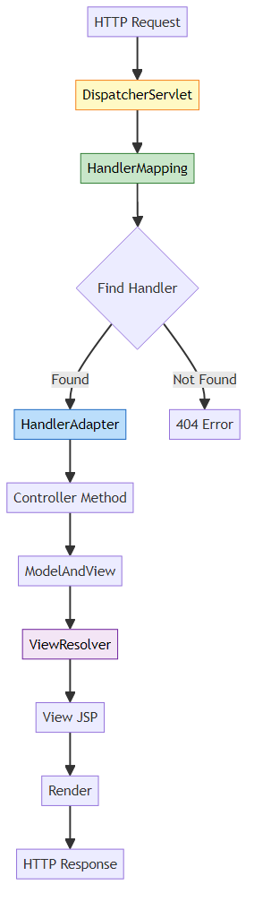

🎯 Step-by-Step Internal Process
Step 1: Request Arrives
Browser sends: GET /register
↓
Tomcat receives request
↓
DispatcherServlet.doGet() called
Step 2: Handler Mapping
// Spring internally does:
HandlerExecutionChain chain = handlerMapping.getHandler(request);
// Finds: StudentController.showForm() for @GetMapping("/register")
Step 3: Handler Adapter
// Spring internally:
HandlerAdapter adapter = getHandlerAdapter(handler);
ModelAndView mav = adapter.handle(request, response, handler);
// Calls: StudentController.showForm()
// Returns: ModelAndView with view name "register"
Step 4: View Resolution
// Spring internally:
View view = viewResolver.resolveViewName("register", locale);
// Resolves to: /WEB-INF/jsp/register.jsp
Step 5: Render View
// Spring internally:
view.render(mav.getModelMap(), request, response);
// JSP engine processes register.jsp
// Generates HTML

📊 Key Components
Component | Role | Configuration
DispatcherServlet | Front controller | Auto-configured by Spring Boot
HandlerMapping | Maps URLs to controllers | @GetMapping, @PostMapping
HandlerAdapter | Invokes controller methods | Handles @ModelAttribute, Model
ViewResolver | Resolves view names | application.properties
View | Renders response | JSP, Thymeleaf, etc.

🎯 Configuration in application.properties
# View Resolver Configuration
spring.mvc.view.prefix=/WEB-INF/jsp/
spring.mvc.view.suffix=.jsp
How it works:
Controller returns: "register"
↓
ViewResolver applies:
prefix + viewName + suffix
↓
Result: /WEB-INF/jsp/register.jsp

9. MODEL & MODELATTRIBUTE

📌 What is Model?
Model is an interface that holds data to be displayed in the view. It’s a map of key-value pairs.
public interface Model {
Model addAttribute(String name, Object value);
Model addAttribute(Object value);
Map<String, Object> asMap();
// ... more methods
}

🎯 Model in Action
@PostMapping("/register")
public String registerStudent(@ModelAttribute Student student, Model model) {
studentService.saveStudent(student);
// Add data to model
model.addAttribute("name", student.getName());
model.addAttribute("email", student.getEmail());
model.addAttribute("timestamp", LocalDateTime.now());
return "success"; // View can access ${name}, ${email}, ${timestamp}
}
In JSP:
<h2>Welcome, ${name}!</h2>
<p>Email: ${email}</p>
<p>Registered at: ${timestamp}</p>

📊 Model vs ModelAndView vs ModelMap
Type | Usage | Return Type
Model | Interface, parameter injection | String (view name)
ModelAndView | Contains both model & view | ModelAndView
ModelMap | Implementation of Model | String (view name)
Example with ModelAndView:
@PostMapping("/register")
public ModelAndView registerStudent(@ModelAttribute Student student) {
studentService.saveStudent(student);
ModelAndView mav = new ModelAndView();
mav.setViewName("success");
mav.addObject("name", student.getName());
return mav;
}

🎯 @ModelAttribute Deep Dive
Purpose: Binds HTTP request parameters to Java object
How it works:
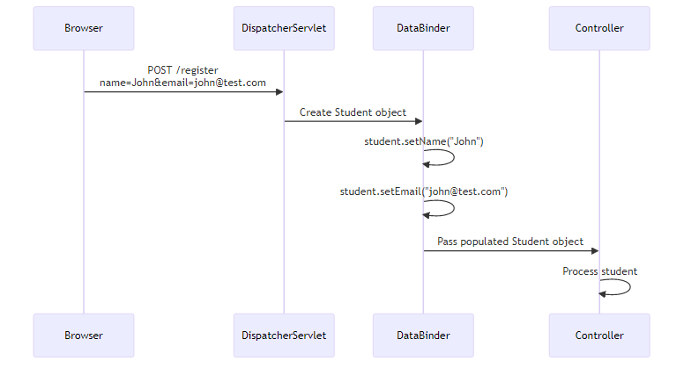
Without @ModelAttribute:
@PostMapping("/register")
public String register(HttpServletRequest request) {
String name = request.getParameter("name");
String email = request.getParameter("email");
Student student = new Student();
student.setName(name);
student.setEmail(email);
// ... rest of code
}
With @ModelAttribute:
@PostMapping("/register")
public String register(@ModelAttribute Student student) {
// student object already populated!
// Spring did all the binding automatically
}

📝 Form Binding Rules
HTML Form:
<form action="/register" method="post">
<input type="text" name="name" /> <!-- Binds to student.name -->
<input type="email" name="email" /> <!-- Binds to student.email -->
<button type="submit">Register</button>
</form>
Java Object:
public class Student {
private String name; // Matches form field "name"
private String email; // Matches form field "email"
// Getters and setters required for binding!
}
Key Points: - Form field names MUST match Java field names - Getters/setters are REQUIRED - Spring uses reflection to set values - Type conversion is automatic (String → int, String → Date, etc.)

🎯 Is Model an ORM?
No! Model is NOT an ORM.
Concept | Purpose | Example
Model (MVC) | Carries data between controller & view | Spring’s Model interface
ORM | Maps objects to database tables | Hibernate, JPA
Entity | Represents database table | @Entity Student
Confusion Clarified:
Model (MVC) → Data carrier for views
Entity (JPA) → Database table representation
ORM (Hibernate) → Framework that maps entities to DB

10. JSP VS HTML: VIEW RESOLUTION

📌 What is JSP?
JSP (JavaServer Pages) is a server-side technology that allows embedding Java code in HTML.

🎯 JSP vs HTML
Feature | HTML | JSP
Type | Static | Dynamic
Server Processing | No | Yes
Java Code | No | Yes
Access Model Data | No | Yes (${variable})
Location | Anywhere | WEB-INF (protected)
Extension | .html | .jsp

📝 Why JSP?
HTML (Static):
<h2>Welcome, John!</h2>
<!-- Name is hardcoded, cannot change dynamically -->
JSP (Dynamic):
<h2>Welcome, ${name}!</h2>
<!-- ${name} is replaced with actual value from Model -->

🎯 JSP Features
1. Expression Language (EL):
${name} <!-- Access model attribute -->
${student.email} <!-- Access object property -->
${student.name.toUpperCase()} <!-- Call methods -->
2. JSTL (JSP Standard Tag Library):
<%@ taglib uri="http://java.sun.com/jsp/jstl/core" prefix="c" %>
<c:forEach items="${students}" var="student">
<p>${student.name}</p>
</c:forEach>
<c:if test="${student.age >= 18}">
<p>Adult</p>
</c:if>
3. Java Code (Scriptlets - Not Recommended):
<%
String name = (String) request.getAttribute("name");
out.println("Welcome, " + name);
%>

📊 Why WEB-INF/jsp/?
Security Reason:
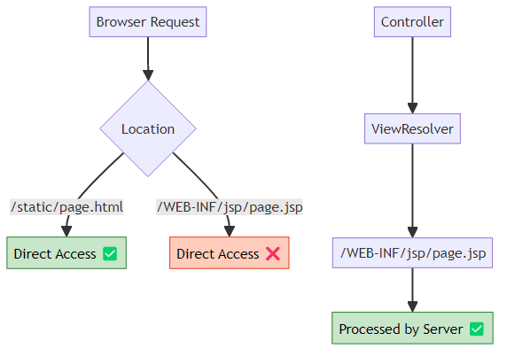
Key Points: - Files in WEB-INF are NOT directly accessible from browser - Must go through controller → view resolver - Prevents users from accessing raw JSP files - Forces proper MVC flow

🎯 Can We Use HTML Instead of JSP?
Yes, but with limitations:
Option 1: Static HTML
src/main/resources/static/register.html
- No dynamic data
- No model access
- Direct browser access
Option 2: Thymeleaf (Modern Alternative)
<!DOCTYPE html>
<html xmlns:th="http://www.thymeleaf.org">
<body>
<h2>Welcome, <span th:text="${name}">User</span>!</h2>
</body>
</html>
- Modern template engine
- Natural templates (valid HTML)
- Better than JSP for new projects
Comparison:
Feature | JSP | Thymeleaf | Static HTML
Dynamic Data | ✅ | ✅ | ❌
Modern Syntax | ❌ | ✅ | N/A
Valid HTML | ❌ | ✅ | ✅
Learning Curve | Medium | Easy | Easy
Industry Use | Legacy | Modern | Static sites

11. APPLICATION.PROPERTIES DEEP DIVE

📌 What is application.properties?
application.properties is Spring Boot’s configuration file using key-value pairs.

🎯 Complete Configuration Breakdown
# Application Name
spring.application.name=SpringMvc
# Server Configuration
server.port=8081
# JSP View Resolver
spring.mvc.view.prefix=/WEB-INF/jsp/
spring.mvc.view.suffix=.jsp
# Database Configuration
spring.datasource.url=jdbc:mysql://localhost:3306/springmvc?useSSL=false&serverTimezone=UTC
spring.datasource.username=root
spring.datasource.password=Asansol@0341
spring.datasource.driver-class-name=com.mysql.cj.jdbc.Driver
# JPA/Hibernate Configuration
spring.jpa.hibernate.ddl-auto=update
spring.jpa.show-sql=true
spring.jpa.properties.hibernate.format_sql=true
spring.jpa.database-platform=org.hibernate.dialect.MySQL8Dialect

📊 Configuration Categories
1. Server Configuration
server.port=8081 # Application runs on port 8081
server.servlet.context-path=/app # Base URL: http://localhost:8081/app
2. View Resolver Configuration
spring.mvc.view.prefix=/WEB-INF/jsp/
spring.mvc.view.suffix=.jsp
How it works:
Controller returns: "register"
↓
ViewResolver: prefix + "register" + suffix
↓
Result: /WEB-INF/jsp/register.jsp
3. Database Configuration
spring.datasource.url=jdbc:mysql://localhost:3306/springmvc
spring.datasource.username=root
spring.datasource.password=yourpassword
spring.datasource.driver-class-name=com.mysql.cj.jdbc.Driver
Equivalent to Hibernate XML:
<property name="hibernate.connection.url">jdbc:mysql://localhost:3306/springmvc</property>
<property name="hibernate.connection.username">root</property>
<property name="hibernate.connection.password">yourpassword</property>
<property name="hibernate.connection.driver_class">com.mysql.cj.jdbc.Driver</property>
4. JPA/Hibernate Configuration
Property | Values | Purpose
ddl-auto | create, update, validate, none | Schema management
show-sql | true, false | Print SQL queries
format_sql | true, false | Format SQL output
database-platform | Dialect class | Database-specific SQL
ddl-auto Options:
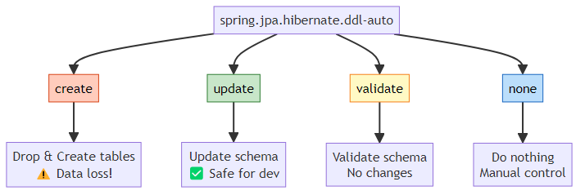

🎯 Properties vs YAML
application.properties:
spring.datasource.url=jdbc:mysql://localhost:3306/springmvc
spring.datasource.username=root
spring.datasource.password=password
application.yml (YAML):
spring:
datasource:
url: jdbc:mysql://localhost:3306/springmvc
username: root
password: password
Comparison:
Feature | Properties | YAML
Syntax | key=value | Hierarchical
Readability | Medium | High
Nesting | Repetitive | Clean
Comments | # | #
Spring Support | ✅ | ✅
Which to use? - Properties: Simple projects, legacy codebases - YAML: Complex configurations, modern projects

12. MAVEN & DEPENDENCY MANAGEMENT

📌 What is Maven?
Maven is a build automation and dependency management tool for Java projects.

🎯 Why Maven?
Without Maven:
1. Download spring-core.jar manually
2. Download spring-web.jar manually
3. Download hibernate.jar manually
4. Download mysql-connector.jar manually
5. Add all JARs to classpath
6. Manage version conflicts manually
7. Update each JAR individually
With Maven:
<dependency>
<groupId>org.springframework.boot</groupId>
<artifactId>spring-boot-starter-web</artifactId>
</dependency>
<!-- Maven downloads 50+ JARs automatically! -->

📊 pom.xml Structure
<project>
<parent>
<groupId>org.springframework.boot</groupId>
<artifactId>spring-boot-starter-parent</artifactId>
<version>3.5.11</version>
</parent>
<groupId>com.example</groupId>
<artifactId>SpringMvc</artifactId>
<version>0.0.1-SNAPSHOT</version>
<packaging>war</packaging>
<properties>
<java.version>21</java.version>
</properties>
<dependencies>
<!-- Dependencies here -->
</dependencies>
<build>
<plugins>
<!-- Build plugins -->
</plugins>
</build>
</project>

🎯 Key Dependencies Explained
1. spring-boot-starter-web
<dependency>
<groupId>org.springframework.boot</groupId>
<artifactId>spring-boot-starter-web</artifactId>
</dependency>
Includes: - Spring MVC - Embedded Tomcat - Jackson (JSON) - Validation - Logging
2. spring-boot-starter-data-jpa
<dependency>
<groupId>org.springframework.boot</groupId>
<artifactId>spring-boot-starter-data-jpa</artifactId>
</dependency>
Includes: - Spring Data JPA - Hibernate - JDBC - Transaction management
3. tomcat-embed-jasper
<dependency>
<groupId>org.apache.tomcat.embed</groupId>
<artifactId>tomcat-embed-jasper</artifactId>
</dependency>
Purpose: Compile and render JSP files
4. mysql-connector-j
<dependency>
<groupId>com.mysql</groupId>
<artifactId>mysql-connector-j</artifactId>
<scope>runtime</scope>
</dependency>
Purpose: MySQL JDBC driver

📊 Dependency Scopes
Scope | Availability | Example
compile | All phases | spring-boot-starter-web
runtime | Runtime & test | mysql-connector-j
test | Test only | junit
provided | Compile & test (not packaged) | servlet-api

🎯 Maven vs Gradle
Feature | Maven | Gradle
Config File | pom.xml | build.gradle
Language | XML | Groovy/Kotlin
Performance | Slower | Faster
Learning Curve | Easy | Medium
Industry Use | High | Growing

📝 Is This Spring Boot or Maven Project?
Answer: BOTH!
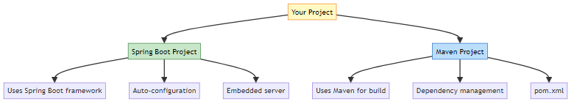
Clarification: - Spring Boot: Application framework - Maven: Build tool - Spring MVC: Web framework (part of Spring Boot)

13. REAL-WORLD PRODUCTION PATTERNS

🎯 Enhanced Student Registration System
1. Add Validation
@Entity
public class Student {
@Id
@GeneratedValue(strategy = GenerationType.IDENTITY)
private Long id;
@NotBlank(message = "Name is required")
@Size(min = 2, max = 50, message = "Name must be 2-50 characters")
private String name;
@NotBlank(message = "Email is required")
@Email(message = "Invalid email format")
@Column(unique = true)
private String email;
@Min(value = 18, message = "Must be 18 or older")
private Integer age;
}
2. Controller with Validation
@Controller
public class StudentController {
@Autowired
private StudentService studentService;
@PostMapping("/register")
public String registerStudent(
@Valid @ModelAttribute Student student,
BindingResult result,
Model model) {
if (result.hasErrors()) {
return "register"; // Return to form with errors
}
try {
studentService.saveStudent(student);
model.addAttribute("name", student.getName());
return "success";
} catch (DataIntegrityViolationException e) {
model.addAttribute("error", "Email already exists");
return "register";
}
}
}
3. Service with Business Logic
@Service
@Transactional
public class StudentService {
@Autowired
private StudentDao studentDao;
@Autowired
private EmailService emailService;
public void saveStudent(Student student) {
// Business validation
if (studentDao.existsByEmail(student.getEmail())) {
throw new DuplicateEmailException("Email already registered");
}
// Save to database
Student saved = studentDao.save(student);
// Send welcome email (async)
emailService.sendWelcomeEmail(saved.getEmail(), saved.getName());
// Log activity
log.info("New student registered: {}", saved.getEmail());
}
public List<Student> searchStudents(String keyword) {
return studentDao.findByNameContainingIgnoreCase(keyword);
}
public Page<Student> getAllStudents(Pageable pageable) {
return studentDao.findAll(pageable);
}
}
4. Repository with Custom Queries
@Repository
public interface StudentDao extends JpaRepository<Student, Long> {
// Query method
Optional<Student> findByEmail(String email);
boolean existsByEmail(String email);
List<Student> findByNameContainingIgnoreCase(String keyword);
// JPQL query
@Query("SELECT s FROM Student s WHERE s.age >= :minAge")
List<Student> findAdultStudents(@Param("minAge") int minAge);
// Native SQL query
@Query(value = "SELECT * FROM student_table WHERE email LIKE %:domain",
nativeQuery = true)
List<Student> findByEmailDomain(@Param("domain") String domain);
// Pagination
Page<Student> findByAgeGreaterThan(int age, Pageable pageable);
}

📊 Exception Handling
@ControllerAdvice
public class GlobalExceptionHandler {
@ExceptionHandler(DuplicateEmailException.class)
public String handleDuplicateEmail(DuplicateEmailException ex, Model model) {
model.addAttribute("error", ex.getMessage());
return "register";
}
@ExceptionHandler(Exception.class)
public String handleGenericException(Exception ex, Model model) {
model.addAttribute("error", "An error occurred. Please try again.");
log.error("Unexpected error", ex);
return "error";
}
}

🎯 RESTful API Version
@RestController
@RequestMapping("/api/students")
public class StudentRestController {
@Autowired
private StudentService studentService;
@PostMapping
public ResponseEntity<Student> createStudent(@Valid @RequestBody Student student) {
Student saved = studentService.saveStudent(student);
return ResponseEntity.status(HttpStatus.CREATED).body(saved);
}
@GetMapping
public ResponseEntity<Page<Student>> getAllStudents(
@RequestParam(defaultValue = "0") int page,
@RequestParam(defaultValue = "10") int size) {
Pageable pageable = PageRequest.of(page, size);
Page<Student> students = studentService.getAllStudents(pageable);
return ResponseEntity.ok(students);
}
@GetMapping("/{id}")
public ResponseEntity<Student> getStudent(@PathVariable Long id) {
return studentService.findById(id)
.map(ResponseEntity::ok)
.orElse(ResponseEntity.notFound().build());
}
@DeleteMapping("/{id}")
public ResponseEntity<Void> deleteStudent(@PathVariable Long id) {
studentService.deleteStudent(id);
return ResponseEntity.noContent().build();
}
}

14. COMMON PITFALLS & SOLUTIONS

❌ Pitfall 1: Missing No-Arg Constructor
Problem:
@Entity
public class Student {
private String name;
public Student(String name) { // Only parameterized constructor
this.name = name;
}
}
Error:
org.hibernate.InstantiationException: No default constructor for entity
Solution:
@Entity
public class Student {
private String name;
public Student() {} // Required by JPA
public Student(String name) {
this.name = name;
}
}

❌ Pitfall 2: Missing Getters/Setters
Problem:
@Entity
public class Student {
private String name;
// No getters/setters
}
Result: @ModelAttribute cannot bind form data
Solution:
@Entity
public class Student {
private String name;
public String getName() { return name; }
public void setName(String name) { this.name = name; }
}

❌ Pitfall 3: Wrong JSP Location
Problem:
src/main/resources/templates/register.jsp ❌
Error:
404 - JSP not found
Solution:
src/main/webapp/WEB-INF/jsp/register.jsp ✅

❌ Pitfall 4: Missing JSP Dependencies
Problem:
<!-- Missing tomcat-embed-jasper -->
Error:
HTTP 404 - JSP not rendered
Solution:
<dependency>
<groupId>org.apache.tomcat.embed</groupId>
<artifactId>tomcat-embed-jasper</artifactId>
</dependency>

❌ Pitfall 5: Incorrect Form Field Names
Problem:
<input type="text" name="studentName" /> <!-- Wrong -->
public class Student {
private String name; // Field name doesn't match
}
Result: Field remains null
Solution:
<input type="text" name="name" /> <!-- Matches field name -->

❌ Pitfall 6: Database Not Created
Problem:
spring.datasource.url=jdbc:mysql://localhost:3306/springmvc
Error:
Unknown database 'springmvc'
Solution:
CREATE DATABASE springmvc;
Or use:
spring.datasource.url=jdbc:mysql://localhost:3306/springmvc?createDatabaseIfNotExist=true

❌ Pitfall 7: Circular Dependency
Problem:
@Service
public class ServiceA {
@Autowired
private ServiceB serviceB;
}
@Service
public class ServiceB {
@Autowired
private ServiceA serviceA; // Circular!
}
Solution:
@Service
public class ServiceA {
@Autowired
@Lazy // Break circular dependency
private ServiceB serviceB;
}

15. TOP INTERVIEW QUESTIONS

Q1: Explain the complete flow when a user submits a form in Spring MVC
Answer:
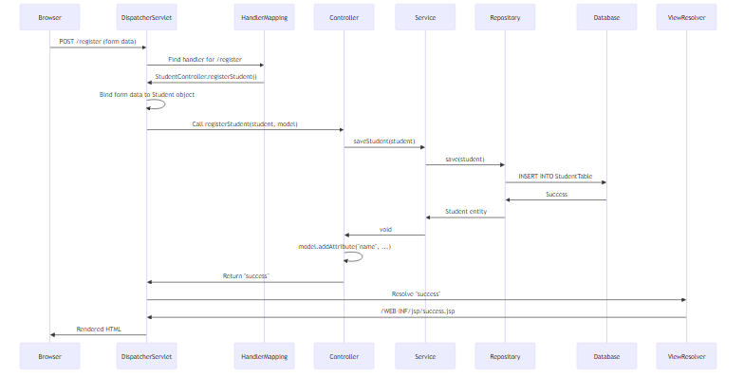
Key Steps: 1. Request Reception: DispatcherServlet receives POST request 2. Handler Mapping: Finds @PostMapping(“/register”) method 3. Data Binding: @ModelAttribute binds form data to Student object 4. Controller Execution: Calls registerStudent() method 5. Service Layer: Business logic execution 6. Repository Layer: JPA save() method 7. Hibernate: Generates SQL INSERT statement 8. Database: Executes query 9. Model Population: Adds attributes to Model 10. View Resolution: Resolves view name to JSP path 11. Rendering: JSP processes and generates HTML 12. Response: HTML sent to browser

Q2: Why do we extend JpaRepository instead of CrudRepository?
Answer:
JpaRepository provides:
- Better Return Types
// CrudRepository
Iterable<Student> findAll(); // Less convenient
// JpaRepository
List<Student> findAll(); // More convenient
- JPA-Specific Methods
void flush(); // Synchronize with database
<S extends T> S saveAndFlush(S entity); // Save and flush immediately
void deleteInBatch(Iterable<T> entities); // Batch delete (single query)
- Pagination & Sorting
Page<Student> findAll(Pageable pageable);
List<Student> findAll(Sort sort);
Hierarchy:
Repository (marker)
↓
CrudRepository (basic CRUD)
↓
PagingAndSortingRepository (pagination)
↓
JpaRepository (JPA-specific + all above)
When to use CrudRepository? - When you don’t need JPA-specific features - When working with non-JPA data stores (MongoDB, Redis)
When to use JpaRepository? - Most Spring Boot + JPA projects (recommended) - When you need batch operations - When you need flush control

Q3: What happens internally when you call studentDao.save(student)?
Answer:
Complete Internal Flow:
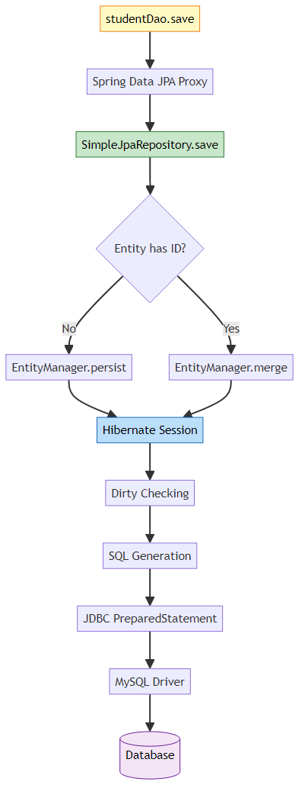
Step-by-Step:
- Proxy Invocation
studentDao.save(student); // Interface method call
↓
Spring creates proxy at runtime
↓
Delegates to SimpleJpaRepository
- SimpleJpaRepository Logic
public <S extends T> S save(S entity) {
if (entityInformation.isNew(entity)) {
em.persist(entity); // INSERT
return entity;
} else {
return em.merge(entity); // UPDATE
}
}
- EntityManager (JPA)
em.persist(student);
↓
Adds entity to persistence context
↓
Marks for INSERT operation
- Hibernate Session
Session session = em.unwrap(Session.class);
session.save(student);
↓
Generates SQL based on entity mapping
- SQL Generation
INSERT INTO StudentTable (name, email) VALUES (?, ?)
- JDBC Execution
PreparedStatement ps = conn.prepareStatement(sql);
ps.setString(1, "John");
ps.setString(2, "john@test.com");
ps.executeUpdate();
- Database Execution
MySQL receives query
↓
Executes INSERT
↓
Returns generated ID
↓
Hibernate sets ID on entity

Q4: Explain @ModelAttribute binding mechanism
Answer:
Internal Process:
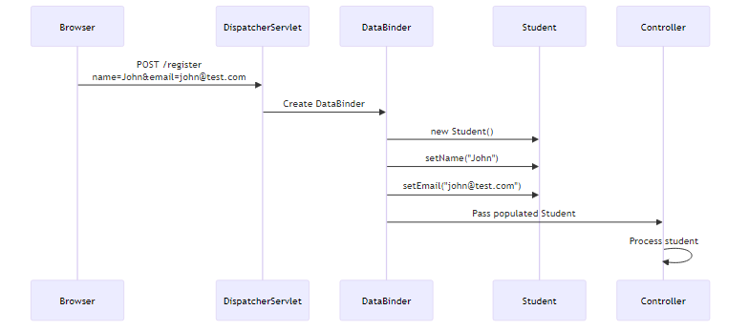
How It Works:
- Request Parameters
POST /register
Content-Type: application/x-www-form-urlencoded
name=John&email=john@test.com
- Spring Creates DataBinder
// Spring internally:
DataBinder binder = new DataBinder(new Student());
binder.bind(request.getParameterMap());
- Property Binding
// For each request parameter:
String paramName = "name";
String paramValue = "John";
// Spring uses reflection:
PropertyDescriptor pd = BeanUtils.getPropertyDescriptor(Student.class, paramName);
Method setter = pd.getWriteMethod(); // setName()
setter.invoke(student, paramValue); // student.setName("John")
- Type Conversion
// Automatic conversion:
String age = "25"; // From request
Integer ageInt = conversionService.convert(age, Integer.class);
student.setAge(ageInt);
Requirements: - Default no-arg constructor - Setter methods for each field - Field names match form parameter names

Q5: What’s the difference between @Controller and @RestController?
Answer:
Feature | @Controller | @RestController
Returns | View name (String) | Data (Object)
Response | HTML (via JSP) | JSON/XML
@ResponseBody | Required per method | Implicit on all methods
Use Case | Traditional web apps | REST APIs
@Controller:
@Controller
public class StudentController {
@GetMapping("/register")
public String showForm() {
return "register"; // View name → JSP
}
@GetMapping("/api/student")
@ResponseBody // Required for JSON response
public Student getStudent() {
return new Student("John", "john@test.com");
}
}
@RestController:
@RestController // = @Controller + @ResponseBody
public class StudentRestController {
@GetMapping("/api/student")
public Student getStudent() {
return new Student("John", "john@test.com");
// Automatically converted to JSON
}
}
Internal Difference:
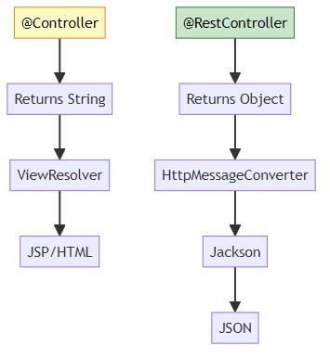

Q6: How does Spring resolve view names to JSP files?
Answer:
Configuration:
spring.mvc.view.prefix=/WEB-INF/jsp/
spring.mvc.view.suffix=.jsp
Resolution Process:
Internal Code:
// Spring internally:
public class InternalResourceViewResolver extends UrlBasedViewResolver {
@Override
protected String getUrl(String viewName) {
return getPrefix() + viewName + getSuffix();
// "/WEB-INF/jsp/" + "register" + ".jsp"
// = "/WEB-INF/jsp/register.jsp"
}
}
Multiple View Resolvers:
@Configuration
public class WebConfig {
@Bean
public ViewResolver thymeleafResolver() {
// Order 1: Try Thymeleaf first
}
@Bean
public ViewResolver jspResolver() {
// Order 2: Fallback to JSP
}
}

Q7: Why change StudentDao from class to interface?
Answer:
Before (Manual Implementation):
@Repository
public class StudentDao {
@PersistenceContext
private EntityManager em;
public void save(Student student) {
em.persist(student);
}
public Student findById(Long id) {
return em.find(Student.class, id);
}
public List<Student> findAll() {
return em.createQuery("SELECT s FROM Student s", Student.class)
.getResultList();
}
// 20+ more methods to write manually...
}
After (Spring Data JPA):
@Repository
public interface StudentDao extends JpaRepository<Student, Long> {
// No code needed!
// Spring Data JPA provides implementation at runtime
}
Why Interface?
- Spring Data JPA Magic
// At runtime, Spring creates:
class StudentDaoImpl implements StudentDao {
// Generated by Spring Data JPA
public Student save(Student entity) {
return em.merge(entity);
}
// ... all other methods
}
- Proxy Pattern
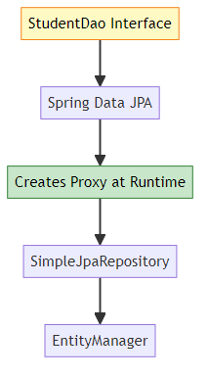
- Benefits
- No boilerplate code
- 20+ methods for free
- Custom query methods by naming convention
- Type-safe
Custom Methods:
public interface StudentDao extends JpaRepository<Student, Long> {
// Spring generates implementation automatically:
List<Student> findByName(String name);
Optional<Student> findByEmail(String email);
List<Student> findByAgeGreaterThan(int age);
}

Q8: Explain the difference between JPA and Hibernate
Answer:
JPA (Java Persistence API): - Specification (not implementation) - Defines interfaces and annotations - Vendor-independent - Part of Jakarta EE
Hibernate: - Implementation of JPA specification - ORM framework - Provides additional features beyond JPA - Most popular JPA provider
Analogy:
JPA = JDBC (Specification)
Hibernate = MySQL Driver (Implementation)
Comparison:
Aspect | JPA | Hibernate
Type | Specification | Implementation
Package | jakarta.persistence.* | org.hibernate.*
EntityManager | JPA interface | Hibernate implements
Session | No | Hibernate-specific
Caching | Defined in spec | Implemented by Hibernate
Vendor Lock | No | Yes
Code Example:
JPA Code (Portable):
@PersistenceContext
private EntityManager em;
public void save(Student student) {
em.persist(student); // JPA method
}
Hibernate Code (Vendor-specific):
@Autowired
private SessionFactory sessionFactory;
public void save(Student student) {
Session session = sessionFactory.getCurrentSession();
session.save(student); // Hibernate method
}
Relationship:
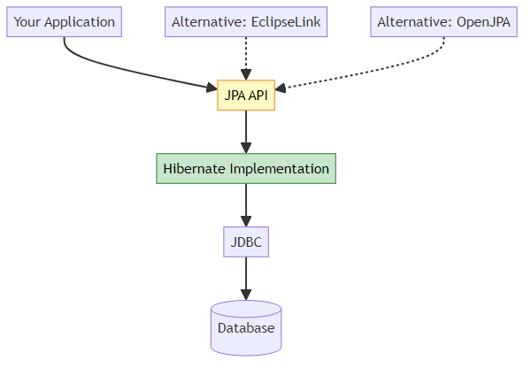
Why Use JPA Instead of Hibernate Directly? - Switch providers easily (Hibernate → EclipseLink) - Standard API (portable code) - Better for long-term maintenance

Q9: What is the purpose of @Transactional and where should it be placed?
Answer:
Purpose: - Manages database transactions - Ensures ACID properties - Automatic rollback on exceptions
Where to Place:
❌ Wrong: On Repository
@Repository
public interface StudentDao extends JpaRepository<Student, Long> {
@Transactional // Wrong! Repository methods already transactional
Student save(Student student);
}
✅ Correct: On Service
@Service
@Transactional // Correct! Service layer manages transactions
public class StudentService {
@Autowired
private StudentDao studentDao;
public void saveStudent(Student student) {
studentDao.save(student);
// If exception occurs, transaction rolls back
}
public void registerStudent(Student student) {
studentDao.save(student);
emailService.sendWelcomeEmail(student.getEmail());
// Both operations in same transaction
}
}
Why Service Layer?
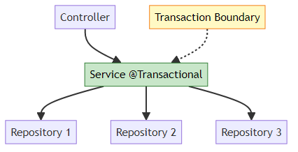
Transaction Propagation:
@Service
public class StudentService {
@Transactional // Creates new transaction
public void method1() {
// Transaction 1
method2(); // Joins Transaction 1
}
@Transactional(propagation = Propagation.REQUIRES_NEW)
public void method2() {
// Creates new Transaction 2 (independent)
}
}
Rollback Behavior:
@Transactional
public void saveStudent(Student student) {
studentDao.save(student); // Saved to DB
if (student.getAge() < 18) {
throw new RuntimeException("Age must be 18+");
// Transaction rolls back, student NOT saved
}
}

Q10: How does Spring Boot auto-configure DataSource without XML?
Answer:
Magic of Auto-Configuration:
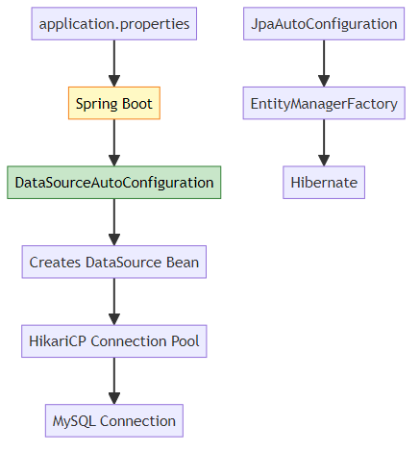
What Spring Boot Does Internally:
- Reads application.properties
spring.datasource.url=jdbc:mysql://localhost:3306/springmvc
spring.datasource.username=root
spring.datasource.password=password
- Creates DataSource Bean
// Spring Boot internally:
@Configuration
@ConditionalOnClass(DataSource.class)
public class DataSourceAutoConfiguration {
@Bean
@ConfigurationProperties(prefix = "spring.datasource")
public DataSource dataSource() {
return DataSourceBuilder.create()
.url(properties.getUrl())
.username(properties.getUsername())
.password(properties.getPassword())
.build();
}
}
- Creates EntityManagerFactory
// Spring Boot internally:
@Configuration
@ConditionalOnClass(EntityManager.class)
public class HibernateJpaAutoConfiguration {
@Bean
public LocalContainerEntityManagerFactoryBean entityManagerFactory(
DataSource dataSource) {
LocalContainerEntityManagerFactoryBean em =
new LocalContainerEntityManagerFactoryBean();
em.setDataSource(dataSource);
em.setPackagesToScan("com.example");
em.setJpaVendorAdapter(new HibernateJpaVendorAdapter());
return em;
}
}
Equivalent XML Configuration (Old Way):
<bean id="dataSource" class="org.apache.commons.dbcp.BasicDataSource">
<property name="url" value="jdbc:mysql://localhost:3306/springmvc"/>
<property name="username" value="root"/>
<property name="password" value="password"/>
</bean>
<bean id="entityManagerFactory"
class="org.springframework.orm.jpa.LocalContainerEntityManagerFactoryBean">
<property name="dataSource" ref="dataSource"/>
<property name="packagesToScan" value="com.example"/>
</bean>
Spring Boot Advantage: - No XML configuration - Convention over configuration - Auto-detects dependencies - Sensible defaults

Q11: What happens if you remove @Repository from StudentDao?
Answer:
Scenario:
// @Repository removed
public interface StudentDao extends JpaRepository<Student, Long> {
}
Result: Still Works! 🤔
Why?
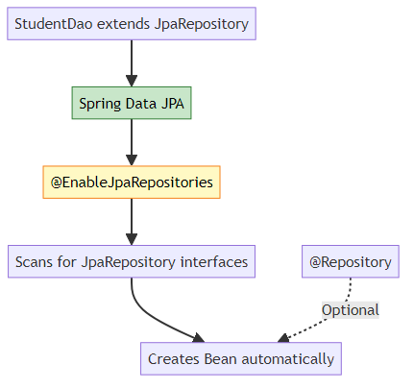
Spring Boot Auto-Configuration:
@SpringBootApplication // Includes @EnableJpaRepositories
public class SpringMvcApplication {
// Spring Data JPA automatically scans for repositories
}
When @Repository is Needed:
- Exception Translation
@Repository // Translates SQLException to DataAccessException
public class CustomDao {
@PersistenceContext
private EntityManager em;
public void customQuery() {
// SQLException → DataAccessException
}
}
- Component Scanning (Non-JPA)
@Repository // Required for non-JPA repositories
public class StudentDaoImpl {
// Manual implementation
}
Best Practice:
@Repository // Use it for clarity and consistency
public interface StudentDao extends JpaRepository<Student, Long> {
}

Q12: Explain the difference between Model, ModelMap, and ModelAndView
Answer:
1. Model (Interface)
@PostMapping("/register")
public String register(@ModelAttribute Student student, Model model) {
model.addAttribute("name", student.getName());
return "success"; // View name
}
2. ModelMap (Implementation)
@PostMapping("/register")
public String register(@ModelAttribute Student student, ModelMap model) {
model.addAttribute("name", student.getName());
model.put("email", student.getEmail()); // Additional method
return "success";
}
3. ModelAndView (Container)
@PostMapping("/register")
public ModelAndView register(@ModelAttribute Student student) {
ModelAndView mav = new ModelAndView();
mav.setViewName("success");
mav.addObject("name", student.getName());
return mav; // Contains both model and view
}
Comparison:
Feature | Model | ModelMap | ModelAndView
Type | Interface | Class | Class
Return | String (view) | String (view) | ModelAndView
View Setting | Separate | Separate | Included
Use Case | Simple | Extended | Complex
Internal Relationship:
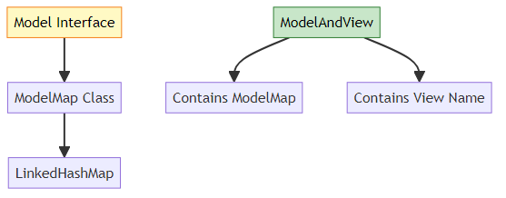
When to Use: - Model: Most cases (simple, clean) - ModelMap: Need Map operations - ModelAndView: Complex scenarios, multiple views

🎓 End of Spring MVC Architecture Guide

Created with dedication by Avinash Dhanuka

Happy Learning! 🚀
“Master the Architecture, Build the Future!” - Avinash Dhanuka

© 2026 Avinash Dhanuka | All Rights Reserved

