☕ Master Guide: Dependency Injection - From Core Java to Spring Framework

© 2026 Avinash Dhanuka
Master Guide: Dependency Injection Deep Dive
Crafted with ❤️ for Understanding Loose Coupling & DI

Learning Note: This guide demonstrates Dependency Injection using Core Java to build a strong foundation before diving into Spring Framework’s IoC Container. Understanding DI in plain Java helps you appreciate what Spring does behind the scenes.
Prerequisites: - Basic understanding of Java OOP concepts - Knowledge of Interfaces and Polymorphism - Understanding of Design Patterns (helpful but not required)

📑 Table of Contents
- What is Dependency Injection?
- Tight Coupling vs Loose Coupling
- Real-World Examples
- Types of Dependency Injection
- Project Structure & Implementation
- Internal Working Mechanism
- Spring Framework Connection
- Advantages & Disadvantages
- Best Practices
- Interview Questions

1. WHAT IS DEPENDENCY INJECTION?

📝 Author: Avinash Dhanuka | GitHub

📌 Definition
Dependency Injection (DI) is a design pattern where objects receive their dependencies from external sources rather than creating them internally.
Simple Analogy: - Without DI: You build your own car engine from scratch every time you need a car - With DI: Someone hands you a ready-made engine, and you just install it in your car

🎯 Core Concept
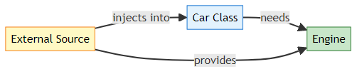
Key Principle: “Don’t create dependencies, receive them!”

📊 Problem Statement
Reference: Car.java
❌ Without Dependency Injection (Tight Coupling):
public class Car {
private DieselEngine engine; // Tightly coupled to DieselEngine
public Car() {
this.engine = new DieselEngine(); // Car creates its own dependency
}
public void start() {
engine.run();
}
}
Problems: 1. ❌ Car is locked to DieselEngine only 2. ❌ Cannot switch to PetrolEngine without modifying Car class 3. ❌ Hard to test (cannot mock engine) 4. ❌ Violates Open-Closed Principle 5. ❌ High coupling, low flexibility
✅ With Dependency Injection (Loose Coupling):
public class Car {
private Engine engine; // Depends on interface, not implementation
// Constructor Injection
public Car(Engine engine) {
this.engine = engine; // Dependency is injected
}
public void start() {
engine.run();
}
}
// Usage
Engine petrolEngine = new PetrolEngine();
Car car1 = new Car(petrolEngine); // Inject PetrolEngine
Engine dieselEngine = new DieselEngine();
Car car2 = new Car(dieselEngine); // Inject DieselEngine
Benefits: 1. ✅ Car works with any Engine implementation 2. ✅ Easy to switch engines without changing Car 3. ✅ Easy to test with mock engines 4. ✅ Follows SOLID principles 5. ✅ Low coupling, high flexibility

2. TIGHT COUPLING VS LOOSE COUPLING

📝 Understanding Coupling by: Avinash Dhanuka

📌 What is Coupling?
Coupling = The degree of dependency between classes/modules.
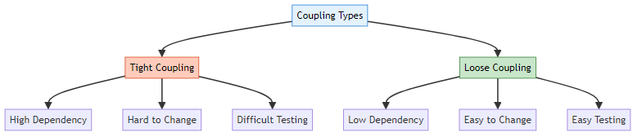

🔴 Tight Coupling (Rigid Coupling)

Definition: Classes are highly dependent on each other. Changes in one class require changes in dependent classes.

5 Real-World Examples of Tight Coupling

Example 1: Laptop with Soldered RAM
Real-Life Scenario: - Old MacBook Pro has RAM soldered directly to motherboard - Cannot upgrade RAM without replacing entire motherboard - Expensive and inflexible
Code Example:
public class Laptop {
private SolderedRAM ram; // Tightly coupled
public Laptop() {
this.ram = new SolderedRAM(8); // Fixed 8GB, cannot change
}
public void boot() {
ram.initialize();
}
}
class SolderedRAM {
private int size;
public SolderedRAM(int size) {
this.size = size;
}
public void initialize() {
System.out.println("Initializing " + size + "GB RAM");
}
}
// Problem: Want 16GB? Buy new laptop! 💸
Issues: - ❌ Cannot upgrade RAM - ❌ Laptop class must change if RAM changes - ❌ Cannot test with different RAM sizes - ❌ Expensive to modify

Example 2: Facebook App with Hardcoded Database
Real-Life Scenario: - Facebook app directly creates MySQL database connection - Want to switch to PostgreSQL? Rewrite entire app! - Cannot test without real database
Code Example:
public class FacebookApp {
private MySQLDatabase database; // Tightly coupled
public FacebookApp() {
this.database = new MySQLDatabase(); // Hardcoded dependency
}
public void savePost(String content) {
database.insert("posts", content);
}
}
class MySQLDatabase {
public void insert(String table, String data) {
System.out.println("Inserting into MySQL: " + data);
}
}
// Problem: Switching to PostgreSQL requires changing FacebookApp class
Issues: - ❌ Locked to MySQL only - ❌ Cannot switch databases easily - ❌ Hard to test (needs real MySQL) - ❌ Violates Single Responsibility Principle

Example 3: Free Fire Game with Fixed Graphics Engine
Real-Life Scenario: - Game directly instantiates DirectX graphics engine - Want to support OpenGL for Linux? Rewrite game! - Cannot run on different platforms
Code Example:
public class FreeFireGame {
private DirectXEngine graphics; // Tightly coupled
public FreeFireGame() {
this.graphics = new DirectXEngine(); // Windows only
}
public void render() {
graphics.drawFrame();
}
}
class DirectXEngine {
public void drawFrame() {
System.out.println("Rendering with DirectX (Windows only)");
}
}
// Problem: Cannot run on Mac or Linux!
Issues: - ❌ Windows-only game - ❌ Cannot support multiple platforms - ❌ Hard to add new graphics engines - ❌ Limited market reach

Example 4: Male-Female Relationship (Monogamous Marriage)
Real-Life Scenario: - Person class is hardcoded to marry only one specific person - Cannot change partner without “rewriting” the person - Inflexible relationship model
Code Example:
public class Male {
private Female wife; // Tightly coupled to specific Female
public Male() {
this.wife = new Female("Alice"); // Hardcoded wife
}
public void introduce() {
System.out.println("My wife is " + wife.getName());
}
}
class Female {
private String name;
public Female(String name) {
this.name = name;
}
public String getName() {
return name;
}
}
// Problem: Male is forever bound to Alice. No flexibility!
Issues: - ❌ Cannot change partner - ❌ Male class must be modified for different Female - ❌ Not reusable - ❌ Unrealistic model

Example 5: Coffee Machine with Built-in Grinder
Real-Life Scenario: - Coffee machine has grinder permanently attached - Grinder breaks? Throw away entire machine! - Cannot use pre-ground coffee
Code Example:
public class CoffeeMachine {
private BuiltInGrinder grinder; // Tightly coupled
public CoffeeMachine() {
this.grinder = new BuiltInGrinder(); // Cannot replace
}
public void makeCoffee() {
grinder.grind();
System.out.println("Brewing coffee...");
}
}
class BuiltInGrinder {
public void grind() {
System.out.println("Grinding beans...");
}
}
// Problem: Grinder breaks = entire machine useless
Issues: - ❌ Cannot replace broken grinder - ❌ Cannot use different grinder types - ❌ Wasteful (throw away working parts) - ❌ Expensive to maintain

🟢 Loose Coupling

Definition: Classes depend on abstractions (interfaces) rather than concrete implementations. Easy to swap dependencies.

5 Real-World Examples of Loose Coupling

Example 1: Laptop with Removable RAM
Real-Life Scenario: - Modern laptop has RAM slots - Can upgrade from 8GB to 16GB to 32GB - Just swap RAM modules, no motherboard change needed
Code Example:
// Interface (abstraction)
interface RAM {
void initialize();
int getSize();
}
// Implementations
class RAM8GB implements RAM {
public void initialize() {
System.out.println("Initializing 8GB RAM");
}
public int getSize() {
return 8;
}
}
class RAM16GB implements RAM {
public void initialize() {
System.out.println("Initializing 16GB RAM");
}
public int getSize() {
return 16;
}
}
// Laptop depends on interface, not implementation
public class Laptop {
private RAM ram; // Loosely coupled
public Laptop(RAM ram) { // Dependency Injection
this.ram = ram;
}
public void boot() {
ram.initialize();
System.out.println("Laptop booted with " + ram.getSize() + "GB RAM");
}
}
// Usage - Easy to swap!
RAM ram8 = new RAM8GB();
Laptop laptop1 = new Laptop(ram8); // 8GB laptop
RAM ram16 = new RAM16GB();
Laptop laptop2 = new Laptop(ram16); // 16GB laptop - no code change!
Benefits: - ✅ Easy to upgrade RAM - ✅ Laptop code never changes - ✅ Can test with mock RAM - ✅ Flexible and maintainable

Example 2: Facebook App with Database Interface
Real-Life Scenario: - Facebook can switch between MySQL, PostgreSQL, MongoDB - Same app code works with any database - Easy to test with in-memory database
Code Example:
// Interface (abstraction)
interface Database {
void insert(String table, String data);
String query(String table, String id);
}
// Implementations
class MySQLDatabase implements Database {
public void insert(String table, String data) {
System.out.println("MySQL: Inserting into " + table);
}
public String query(String table, String id) {
return "MySQL data from " + table;
}
}
class PostgreSQLDatabase implements Database {
public void insert(String table, String data) {
System.out.println("PostgreSQL: Inserting into " + table);
}
public String query(String table, String id) {
return "PostgreSQL data from " + table;
}
}
class MongoDBDatabase implements Database {
public void insert(String table, String data) {
System.out.println("MongoDB: Inserting into " + table);
}
public String query(String table, String id) {
return "MongoDB data from " + table;
}
}
// Facebook app depends on interface
public class FacebookApp {
private Database database; // Loosely coupled
public FacebookApp(Database database) { // Dependency Injection
this.database = database;
}
public void savePost(String content) {
database.insert("posts", content);
}
public String getPost(String id) {
return database.query("posts", id);
}
}
// Usage - Switch databases easily!
Database mysql = new MySQLDatabase();
FacebookApp app1 = new FacebookApp(mysql); // MySQL version
Database postgres = new PostgreSQLDatabase();
FacebookApp app2 = new FacebookApp(postgres); // PostgreSQL version
Database mongo = new MongoDBDatabase();
FacebookApp app3 = new FacebookApp(mongo); // MongoDB version
Benefits: - ✅ Switch databases without changing app code - ✅ Easy to test with mock database - ✅ Can use different databases for different environments - ✅ Follows Open-Closed Principle

Example 3: Free Fire Game with Graphics Interface
Real-Life Scenario: - Game supports DirectX (Windows), OpenGL (Linux), Metal (Mac) - Same game code runs on all platforms - Just inject appropriate graphics engine
Code Example:
// Interface (abstraction)
interface GraphicsEngine {
void drawFrame();
void renderTexture(String texture);
}
// Implementations
class DirectXEngine implements GraphicsEngine {
public void drawFrame() {
System.out.println("DirectX: Rendering frame (Windows)");
}
public void renderTexture(String texture) {
System.out.println("DirectX: Loading " + texture);
}
}
class OpenGLEngine implements GraphicsEngine {
public void drawFrame() {
System.out.println("OpenGL: Rendering frame (Linux/Mac)");
}
public void renderTexture(String texture) {
System.out.println("OpenGL: Loading " + texture);
}
}
class MetalEngine implements GraphicsEngine {
public void drawFrame() {
System.out.println("Metal: Rendering frame (Mac)");
}
public void renderTexture(String texture) {
System.out.println("Metal: Loading " + texture);
}
}
// Game depends on interface
public class FreeFireGame {
private GraphicsEngine graphics; // Loosely coupled
public FreeFireGame(GraphicsEngine graphics) { // Dependency Injection
this.graphics = graphics;
}
public void render() {
graphics.drawFrame();
graphics.renderTexture("player.png");
}
}
// Usage - Cross-platform support!
GraphicsEngine directX = new DirectXEngine();
FreeFireGame windowsGame = new FreeFireGame(directX); // Windows
GraphicsEngine openGL = new OpenGLEngine();
FreeFireGame linuxGame = new FreeFireGame(openGL); // Linux
GraphicsEngine metal = new MetalEngine();
FreeFireGame macGame = new FreeFireGame(metal); // Mac
Benefits: - ✅ Cross-platform game - ✅ Same code runs everywhere - ✅ Easy to add new graphics engines - ✅ Larger market reach

Example 4: Person with Partner Interface (Modern Relationships)
Real-Life Scenario: - Person can have different types of partners - Relationship is flexible and changeable - Realistic model of modern relationships
Code Example:
// Interface (abstraction)
interface Partner {
String getName();
void interact();
}
// Implementations
class Male implements Partner {
private String name;
public Male(String name) {
this.name = name;
}
public String getName() {
return name;
}
public void interact() {
System.out.println(name + " is interacting as male partner");
}
}
class Female implements Partner {
private String name;
public Female(String name) {
this.name = name;
}
public String getName() {
return name;
}
public void interact() {
System.out.println(name + " is interacting as female partner");
}
}
// Person depends on interface
public class Person {
private String name;
private Partner partner; // Loosely coupled
public Person(String name) {
this.name = name;
}
public void setPartner(Partner partner) { // Dependency Injection
this.partner = partner;
}
public void introduce() {
if (partner != null) {
System.out.println(name + "'s partner is " + partner.getName());
partner.interact();
}
}
}
// Usage - Flexible relationships!
Person john = new Person("John");
Partner alice = new Female("Alice");
john.setPartner(alice); // John with Alice
john.introduce();
Partner bob = new Male("Bob");
john.setPartner(bob); // John with Bob - no code change!
john.introduce();
Benefits: - ✅ Flexible relationship model - ✅ Person class never changes - ✅ Realistic and inclusive - ✅ Easy to extend

Example 5: Coffee Machine with Interchangeable Grinder
Real-Life Scenario: - Coffee machine accepts any grinder - Grinder breaks? Just replace it! - Can use different grinders for different beans
Code Example:
// Interface (abstraction)
interface Grinder {
void grind();
String getType();
}
// Implementations
class BurrGrinder implements Grinder {
public void grind() {
System.out.println("Burr grinder: Grinding beans uniformly");
}
public String getType() {
return "Burr";
}
}
class BladeGrinder implements Grinder {
public void grind() {
System.out.println("Blade grinder: Grinding beans quickly");
}
public String getType() {
return "Blade";
}
}
class ManualGrinder implements Grinder {
public void grind() {
System.out.println("Manual grinder: Grinding beans by hand");
}
public String getType() {
return "Manual";
}
}
// Coffee machine depends on interface
public class CoffeeMachine {
private Grinder grinder; // Loosely coupled
public CoffeeMachine(Grinder grinder) { // Dependency Injection
this.grinder = grinder;
}
public void setGrinder(Grinder grinder) {
this.grinder = grinder;
}
public void makeCoffee() {
System.out.println("Using " + grinder.getType() + " grinder");
grinder.grind();
System.out.println("Brewing coffee...");
}
}
// Usage - Swap grinders easily!
Grinder burr = new BurrGrinder();
CoffeeMachine machine = new CoffeeMachine(burr);
machine.makeCoffee();
// Grinder broke? Just replace it!
Grinder blade = new BladeGrinder();
machine.setGrinder(blade);
machine.makeCoffee();
// Want manual? No problem!
Grinder manual = new ManualGrinder();
machine.setGrinder(manual);
machine.makeCoffee();
Benefits: - ✅ Easy to replace grinder - ✅ Can use different grinders - ✅ Sustainable (replace only broken part) - ✅ Cost-effective

📊 Tight vs Loose Coupling Comparison
Aspect | Tight Coupling | Loose Coupling
Dependency | Concrete classes | Interfaces/Abstractions
Flexibility | Low | High
Maintainability | Hard | Easy
Testability | Difficult | Easy
Reusability | Low | High
Change Impact | High (ripple effect) | Low (isolated)
Example | new DieselEngine() | Engine engine (interface)
Real-Life | Soldered RAM | Removable RAM
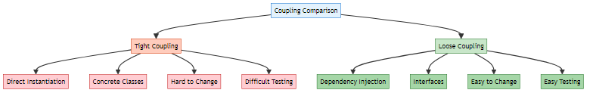

3. REAL-WORLD EXAMPLES

📝 Practical Understanding by: Avinash Dhanuka

🎯 Our Project: Car and Engine System
Reference: Driver.java
Scenario: A car needs an engine to run. The car should work with any type of engine (Petrol or Diesel).
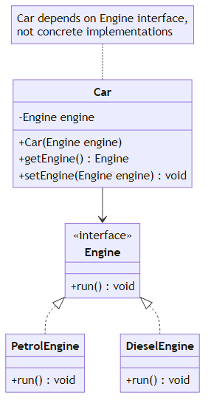
Real-Life Analogy: - Car = Your application - Engine = A service/dependency your app needs - PetrolEngine/DieselEngine = Different implementations of the service - Injection = Providing the engine to the car from outside

📱 More Real-World Examples

Example 1: Payment Gateway in E-Commerce
// Interface
interface PaymentGateway {
boolean processPayment(double amount);
}
// Implementations
class PayPal implements PaymentGateway {
public boolean processPayment(double amount) {
System.out.println("Processing $" + amount + " via PayPal");
return true;
}
}
class Stripe implements PaymentGateway {
public boolean processPayment(double amount) {
System.out.println("Processing $" + amount + " via Stripe");
return true;
}
}
class Razorpay implements PaymentGateway {
public boolean processPayment(double amount) {
System.out.println("Processing ₹" + amount + " via Razorpay");
return true;
}
}
// E-Commerce app
class ShoppingCart {
private PaymentGateway paymentGateway;
public ShoppingCart(PaymentGateway paymentGateway) {
this.paymentGateway = paymentGateway;
}
public void checkout(double amount) {
paymentGateway.processPayment(amount);
}
}
// Usage
PaymentGateway paypal = new PayPal();
ShoppingCart cart1 = new ShoppingCart(paypal); // PayPal checkout
PaymentGateway stripe = new Stripe();
ShoppingCart cart2 = new ShoppingCart(stripe); // Stripe checkout
Benefits: - ✅ Easy to add new payment gateways - ✅ Can switch gateways based on user preference - ✅ Easy to test with mock payment gateway

Example 2: Notification System
// Interface
interface NotificationService {
void send(String message, String recipient);
}
// Implementations
class EmailNotification implements NotificationService {
public void send(String message, String recipient) {
System.out.println("Email to " + recipient + ": " + message);
}
}
class SMSNotification implements NotificationService {
public void send(String message, String recipient) {
System.out.println("SMS to " + recipient + ": " + message);
}
}
class PushNotification implements NotificationService {
public void send(String message, String recipient) {
System.out.println("Push notification to " + recipient + ": " + message);
}
}
// User service
class UserService {
private NotificationService notificationService;
public UserService(NotificationService notificationService) {
this.notificationService = notificationService;
}
public void notifyUser(String message, String recipient) {
notificationService.send(message, recipient);
}
}
// Usage
NotificationService email = new EmailNotification();
UserService service1 = new UserService(email); // Email notifications
NotificationService sms = new SMSNotification();
UserService service2 = new UserService(sms); // SMS notifications

Example 3: Logger System
// Interface
interface Logger {
void log(String message);
}
// Implementations
class ConsoleLogger implements Logger {
public void log(String message) {
System.out.println("[CONSOLE] " + message);
}
}
class FileLogger implements Logger {
public void log(String message) {
System.out.println("[FILE] Writing to log.txt: " + message);
}
}
class DatabaseLogger implements Logger {
public void log(String message) {
System.out.println("[DATABASE] Inserting log: " + message);
}
}
// Application
class Application {
private Logger logger;
public Application(Logger logger) {
this.logger = logger;
}
public void doSomething() {
logger.log("Application started");
// Business logic
logger.log("Application finished");
}
}
// Usage - Switch loggers easily
Logger console = new ConsoleLogger();
Application app1 = new Application(console); // Console logging
Logger file = new FileLogger();
Application app2 = new Application(file); // File logging
Logger database = new DatabaseLogger();
Application app3 = new Application(database); // Database logging

4. TYPES OF DEPENDENCY INJECTION

📝 Three Ways to Inject Dependencies by: Avinash Dhanuka

📌 Overview
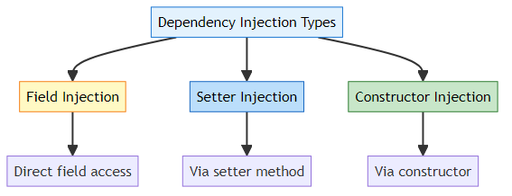
Reference: Driver.java:30-44

1️⃣ Field Injection (Direct Assignment)
Definition: Directly assigning dependency to a field.
Reference: Driver.java:32-34
Code Example:
public class Car {
// Field is accessible (not recommended in production)
public Engine engine; // or package-private
}
// Usage
Car car = new Car();
Engine engine = new PetrolEngine();
car.engine = engine; // Direct field injection
car.engine.run();
Pros: - ✅ Simple and straightforward - ✅ Less boilerplate code - ✅ Quick for prototyping
Cons: - ❌ Breaks encapsulation (field must be public/package-private) - ❌ Hard to make field final (immutability) - ❌ Difficult to test - ❌ Not recommended in production - ❌ Violates OOP principles
Real-Life Analogy: - Like putting engine directly into car without proper installation - No safety checks, no proper mounting - Works but not professional
When to Use: - ⚠️ Only for quick prototypes or demos - ⚠️ Not recommended for production code

2️⃣ Setter Injection (Method-Based)
Definition: Injecting dependency through a setter method.
Reference: Driver.java:37-39 | Car.java:9-15
Code Example:
public class Car {
private Engine engine; // Private field (encapsulated)
// Setter method for injection
public void setEngine(Engine engine) {
this.engine = engine;
}
// Getter method
public Engine getEngine() {
return engine;
}
}
// Usage
Car car = new Car();
Engine engine = new PetrolEngine();
car.setEngine(engine); // Setter injection
car.getEngine().run();
Pros: - ✅ Maintains encapsulation (private field) - ✅ Optional dependencies (can be null) - ✅ Can change dependency at runtime - ✅ Flexible for optional features
Cons: - ❌ Dependency can be null (NullPointerException risk) - ❌ Object can be in invalid state - ❌ Cannot make field final - ❌ Mutable (can be changed anytime)
Real-Life Analogy: - Like installing engine after car is built - Can swap engine later if needed - But car might run without engine (dangerous!)
When to Use: - ✅ Optional dependencies - ✅ Dependencies that might change at runtime - ✅ Circular dependencies (rare cases)
Example with Optional Dependency:
public class Car {
private Engine engine;
private GPS gps; // Optional feature
public void setEngine(Engine engine) {
this.engine = engine; // Required
}
public void setGPS(GPS gps) {
this.gps = gps; // Optional
}
public void start() {
if (engine == null) {
throw new IllegalStateException("Engine is required!");
}
engine.run();
if (gps != null) {
gps.navigate(); // Use GPS if available
}
}
}

3️⃣ Constructor Injection (Recommended ✅)
Definition: Injecting dependency through constructor parameters.
Reference: Driver.java:42-44 | Car.java:17-23
Code Example:
public class Car {
private final Engine engine; // Final = immutable
// Constructor injection
public Car(Engine engine) {
if (engine == null) {
throw new IllegalArgumentException("Engine cannot be null");
}
this.engine = engine;
}
public Engine getEngine() {
return engine;
}
}
// Usage
Engine engine = new PetrolEngine();
Car car = new Car(engine); // Constructor injection
car.getEngine().run();
Pros: - ✅ Best practice (recommended by Spring) - ✅ Immutable (field can be final) - ✅ Guarantees object is fully initialized - ✅ Easy to test (clear dependencies) - ✅ Compile-time safety - ✅ Cannot create object without dependencies
Cons: - ❌ More verbose for many dependencies - ❌ Cannot change dependency at runtime - ❌ Circular dependencies are harder to resolve
Real-Life Analogy: - Like building car with engine already installed - Car cannot exist without engine - Safe and professional approach
When to Use: - ✅ Always for required dependencies - ✅ Production code - ✅ When immutability is important - ✅ When you want compile-time safety
Example with Multiple Dependencies:
public class Car {
private final Engine engine;
private final Transmission transmission;
private final Brakes brakes;
// Constructor injection with multiple dependencies
public Car(Engine engine, Transmission transmission, Brakes brakes) {
if (engine == null || transmission == null || brakes == null) {
throw new IllegalArgumentException("All components are required");
}
this.engine = engine;
this.transmission = transmission;
this.brakes = brakes;
}
public void start() {
engine.run();
transmission.engage();
}
public void stop() {
brakes.apply();
engine.stop();
}
}
// Usage
Engine engine = new PetrolEngine();
Transmission transmission = new AutomaticTransmission();
Brakes brakes = new DiscBrakes();
Car car = new Car(engine, transmission, brakes); // All dependencies provided

📊 Comparison of Injection Types
Aspect | Field Injection | Setter Injection | Constructor Injection
Encapsulation | ❌ Broken | ✅ Maintained | ✅ Maintained
Immutability | ❌ No | ❌ No | ✅ Yes (final)
Null Safety | ❌ No | ❌ No | ✅ Yes
Testability | ⚠️ Moderate | ✅ Good | ✅ Excellent
Optional Dependencies | ✅ Yes | ✅ Yes | ❌ No
Runtime Changes | ✅ Yes | ✅ Yes | ❌ No
Spring Recommendation | ❌ Not recommended | ⚠️ For optional | ✅ Recommended
Use Case | Prototypes only | Optional features | Required dependencies
Visual Comparison:
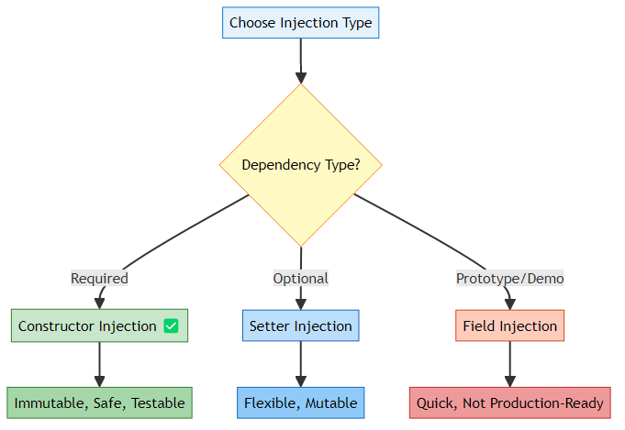

5. PROJECT STRUCTURE & IMPLEMENTATION

📝 Code Walkthrough by: Avinash Dhanuka

📁 Project Structure
DependencyInjections/
├── src/
│ ├── main/
│ │ └── java/
│ │ └── org/
│ │ └── example/
│ │ ├── App.java
│ │ ├── driver/
│ │ │ └── Driver.java # Main execution
│ │ └── entity/
│ │ ├── Engine.java # Interface
│ │ ├── PetrolEngine.java # Implementation 1
│ │ ├── DieselEngine.java # Implementation 2
│ │ └── Car.java # Dependent class
│ └── test/
│ └── java/
│ └── org/
│ └── example/
│ └── AppTest.java
├── pom.xml
└── README.md

🔍 Code Implementation

1️⃣ Engine Interface (Abstraction)
Reference: Engine.java
package org.example.entity;
public interface Engine {
void run();
}
Purpose: - Defines contract for all engine types - Enables loose coupling - Allows polymorphism
Real-Life Analogy: - Like a blueprint that says “all engines must have a run() method” - Doesn’t care HOW engine runs, just that it CAN run

2️⃣ PetrolEngine Implementation
Reference: PetrolEngine.java
package org.example.entity;
public class PetrolEngine implements Engine {
@Override
public void run() {
System.out.println("Running with LESS vibrations");
}
}
Characteristics: - Implements Engine interface - Provides specific behavior (less vibrations) - Can be injected into Car
Real-Life: - Petrol engines are smoother - Less noise and vibration - Higher RPM capability

3️⃣ DieselEngine Implementation
Reference: DieselEngine.java
package org.example.entity;
public class DieselEngine implements Engine {
@Override
public void run() {
System.out.println("Running with MORE vibrations");
}
}
Characteristics: - Implements Engine interface - Provides specific behavior (more vibrations) - Can be injected into Car
Real-Life: - Diesel engines are more powerful - More torque for heavy loads - More vibration and noise

4️⃣ Car Class (Dependent)
Reference: Car.java
package org.example.entity;
public class Car {
// Field for dependency
private Engine engine;
// Getter for Setter Injection
public Engine getEngine() {
return engine;
}
// Setter for Setter Injection
public void setEngine(Engine engine) {
this.engine = engine;
}
// Default constructor
public Car() {
// Empty constructor for Field/Setter injection
}
// Constructor for Constructor Injection
public Car(Engine engine) {
this.engine = engine;
}
}
Key Points: - Depends on Engine interface (not concrete class) - Supports all three injection types - Loose coupling achieved
Design Decisions: - private Engine engine - Encapsulation - Interface type - Polymorphism - Multiple constructors - Flexibility

5️⃣ Driver Class (Main Execution)
Reference: Driver.java
package org.example.driver;
import org.example.entity.Car;
import org.example.entity.DieselEngine;
import org.example.entity.Engine;
import org.example.entity.PetrolEngine;
import java.util.Scanner;
public class Driver {
public static void main(String[] args) {
Scanner sc = new Scanner(System.in);
// User menu
System.out.println("1. Petrol Engine");
System.out.println("2. Diesel Engine");
System.out.print("Enter Engine choice : ");
byte userInput = sc.nextByte();
sc.nextLine();
// Eager instantiation of Car
Car car = new Car();
Engine engine = null;
// Lazy instantiation of Engine based on user choice
switch (userInput) {
case 1:
engine = new PetrolEngine();
break;
case 2:
engine = new DieselEngine();
break;
default:
System.out.println("Wrong Input");
break;
}
System.out.println("Great Choice !!");
// ===== FIELD INJECTION (Commented) =====
// car.engine = engine;
// car.engine.run();
// System.out.println(car.engine.getClass());
// ===== SETTER INJECTION (Commented) =====
// car.setEngine(engine);
// car.getEngine().run();
// System.out.println(car.getEngine().getClass());
// ===== CONSTRUCTOR INJECTION (Active) =====
car = new Car(engine);
car.getEngine().run();
System.out.println(car.getEngine().getClass());
}
}
Execution Flow:
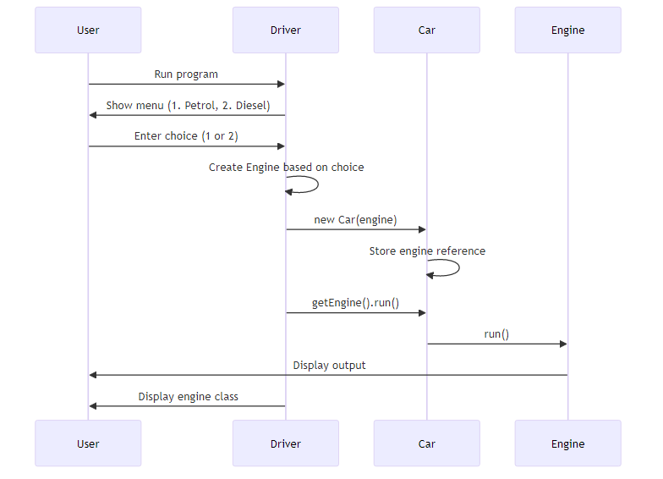
Key Concepts:
- Eager Instantiation:
- Car car = new Car(); // Created immediately
- Lazy Instantiation:
- Engine engine = null; // Created only when needed
switch (userInput) {
case 1: engine = new PetrolEngine(); break;
}
- Polymorphism:
- Engine engine = new PetrolEngine(); // Engine reference, PetrolEngine object
- Dependency Injection:
- car = new Car(engine); // Injecting dependency via constructor

🎮 Sample Execution
Scenario 1: Petrol Engine
1. Petrol Engine
2. Diesel Engine
Enter Engine choice : 1
Great Choice !!
Running with LESS vibrations
class org.example.entity.PetrolEngine
Scenario 2: Diesel Engine
1. Petrol Engine
2. Diesel Engine
Enter Engine choice : 2
Great Choice !!
Running with MORE vibrations
class org.example.entity.DieselEngine
Scenario 3: Invalid Input
1. Petrol Engine
2. Diesel Engine
Enter Engine choice : 5
Wrong Input
Great Choice !!
Exception in thread "main" java.lang.NullPointerException
⚠️ Note: The code has a bug - it doesn’t handle invalid input properly. Engine remains null, causing NullPointerException.
Fixed Version:
if (engine == null) {
System.out.println("Invalid choice. Exiting...");
return;
}
System.out.println("Great Choice !!");
car = new Car(engine);
car.getEngine().run();

6. INTERNAL WORKING MECHANISM

📝 Deep Dive into How DI Works by: Avinash Dhanuka

📌 Memory Allocation & Object Creation
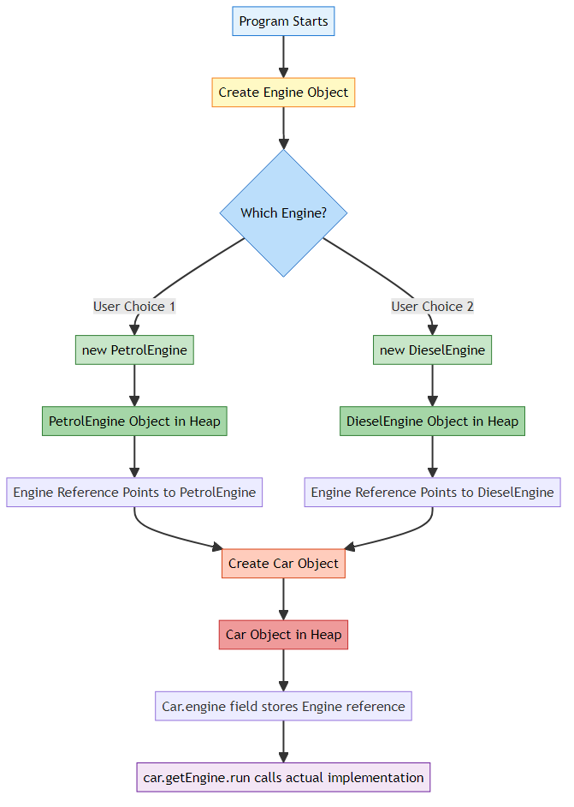

🧠 Step-by-Step Execution

Step 1: User Input
Scanner sc = new Scanner(System.in);
System.out.print("Enter Engine choice : ");
byte userInput = sc.nextByte(); // User enters 1
Memory State:
Stack:
userInput = 1
Heap:
Scanner object

Step 2: Create Car Object (Eager)
Car car = new Car();
Memory State:
Stack:
userInput = 1
car = reference to Car@123
Heap:
Car@123 {
engine = null
}

Step 3: Create Engine Object (Lazy)
Engine engine = null;
switch (userInput) {
case 1:
engine = new PetrolEngine(); // Executed
break;
}
Memory State:
Stack:
userInput = 1
car = reference to Car@123
engine = reference to PetrolEngine@456
Heap:
Car@123 {
engine = null
}
PetrolEngine@456 {
// PetrolEngine object
}
Key Point: engine is of type Engine (interface) but points to PetrolEngine object (polymorphism).

Step 4: Constructor Injection
car = new Car(engine);
What Happens: 1. New Car object is created 2. Constructor Car(Engine engine) is called 3. Parameter engine (PetrolEngine@456) is passed 4. Inside constructor: this.engine = engine; 5. Car’s engine field now points to PetrolEngine@456
Memory State:
Stack:
userInput = 1
car = reference to Car@789 (new object!)
engine = reference to PetrolEngine@456
Heap:
Car@123 { // Old car object (garbage collected later)
engine = null
}
Car@789 { // New car object
engine = reference to PetrolEngine@456
}
PetrolEngine@456 {
// PetrolEngine object
}

Step 5: Method Invocation
car.getEngine().run();
Execution Flow:
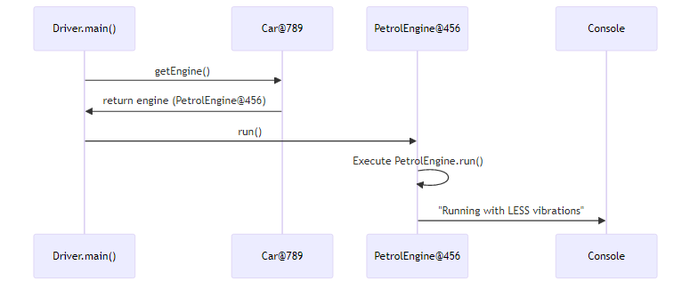
What Happens: 1. car.getEngine() returns the engine field (PetrolEngine@456) 2. .run() is called on PetrolEngine@456 3. JVM uses dynamic method dispatch to call PetrolEngine.run() 4. Output: “Running with LESS vibrations”

Step 6: Reflection (getClass())
System.out.println(car.getEngine().getClass());
Output:
class org.example.entity.PetrolEngine
Explanation: - getClass() returns the actual runtime class - Even though reference is Engine, actual object is PetrolEngine - This proves polymorphism is working

🔬 Polymorphism in Action
Compile-Time (Static Binding):
Engine engine = new PetrolEngine();
- Compiler sees: Engine type
- Compiler checks: Does Engine have run() method? ✅ Yes
Runtime (Dynamic Binding):
engine.run();
- JVM sees: Actual object is PetrolEngine
- JVM calls: PetrolEngine.run() (not Engine.run())
- This is called dynamic method dispatch
Visual Representation:
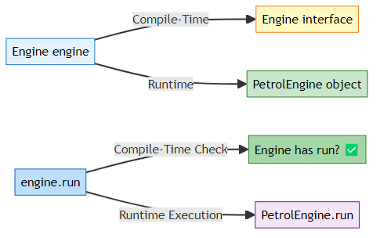

🎯 Why This Works (Technical Explanation)

1. Interface Reference, Concrete Object
Engine engine = new PetrolEngine();
What’s Happening: - Engine is an interface (contract) - PetrolEngine is a concrete class (implementation) - Reference type is Engine, object type is PetrolEngine - This is upcasting (automatic)
Memory Layout:
Stack:
engine (Engine type) --> Points to Heap
Heap:
PetrolEngine object {
- PetrolEngine data
- Implements Engine interface
- Has run() method
}

2. Method Resolution (Virtual Method Table)
How JVM Resolves engine.run():
- Compile-Time:
  - Check if Engine interface has run() method ✅
  - Compilation succeeds
- Runtime:
  - Look at actual object type: PetrolEngine
  - Find PetrolEngine.run() in Virtual Method Table (vtable)
  - Execute PetrolEngine.run()
Virtual Method Table (vtable):
Engine Interface:
- run() (abstract)
PetrolEngine vtable:
- run() --> PetrolEngine.run() implementation
DieselEngine vtable:
- run() --> DieselEngine.run() implementation
When engine.run() is called: - JVM looks up vtable of actual object (PetrolEngine) - Finds and executes PetrolEngine.run()

3. Dependency Injection Flow
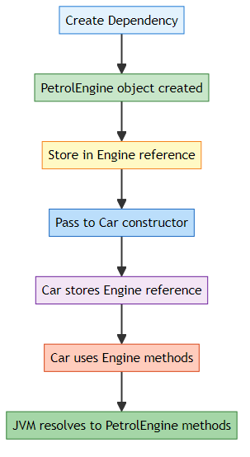
Code Flow:
// 1. Create dependency
Engine engine = new PetrolEngine(); // Heap: PetrolEngine@456
// 2. Inject into Car
Car car = new Car(engine); // Car.engine = PetrolEngine@456
// 3. Use dependency
car.getEngine().run(); // Calls PetrolEngine.run()
Memory References:
Stack:
engine --> PetrolEngine@456
car --> Car@789
Heap:
PetrolEngine@456 { ... }
Car@789 {
engine --> PetrolEngine@456 (same reference!)
}
Key Point: Both engine variable and car.engine field point to the SAME object in heap.

7. SPRING FRAMEWORK CONNECTION
📝 From Core Java to Spring by: Avinash Dhanuka

📌 What is Spring Framework?
Spring Framework is a comprehensive framework for building Java applications. Its core feature is Inversion of Control (IoC) container that manages dependency injection automatically.
Key Concept: Spring does automatically what we did manually in our project!
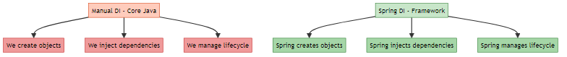

🔄 Manual DI vs Spring DI

Our Manual Implementation (Core Java)
Reference: Driver.java
// We manually create objects
Engine engine = new PetrolEngine();
// We manually inject dependencies
Car car = new Car(engine);
// We manually call methods
car.getEngine().run();
Problems: - ❌ We write boilerplate code - ❌ We manage object creation - ❌ We handle dependencies manually - ❌ Hard to manage in large applications

Spring Framework Implementation
Same functionality with Spring:
1. Define Beans (Components):
// Engine interface (same as before)
public interface Engine {
void run();
}
// PetrolEngine with Spring annotation
@Component // Spring will manage this
public class PetrolEngine implements Engine {
@Override
public void run() {
System.out.println("Running with LESS vibrations");
}
}
// DieselEngine with Spring annotation
@Component // Spring will manage this
public class DieselEngine implements Engine {
@Override
public void run() {
System.out.println("Running with MORE vibrations");
}
}
// Car with Spring annotation
@Component // Spring will manage this
public class Car {
private final Engine engine;
@Autowired // Spring will inject dependency automatically
public Car(Engine engine) {
this.engine = engine;
}
public Engine getEngine() {
return engine;
}
}
2. Spring Configuration:
@Configuration
@ComponentScan("org.example.entity") // Scan for @Component classes
public class AppConfig {
// Optional: Manually define which Engine to use
@Bean
@Primary // Use this when multiple implementations exist
public Engine engine() {
return new PetrolEngine(); // or new DieselEngine()
}
}
3. Usage (Spring Boot):
@SpringBootApplication
public class Application {
public static void main(String[] args) {
ApplicationContext context = SpringApplication.run(Application.class, args);
// Spring creates and injects everything automatically!
Car car = context.getBean(Car.class);
car.getEngine().run();
}
}
What Spring Does Behind the Scenes:
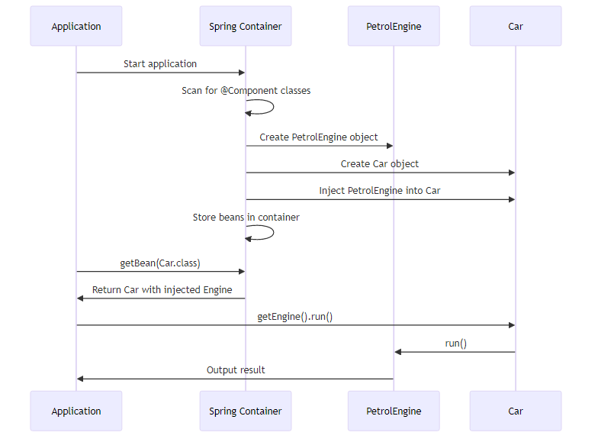

🎯 Spring Core Concepts

1. IoC Container (Inversion of Control)
Definition: Container that manages object creation and dependency injection.
Manual Control (Our Code):
// We control object creation
Engine engine = new PetrolEngine();
Car car = new Car(engine);
Inverted Control (Spring):
// Spring controls object creation
Car car = context.getBean(Car.class); // Spring created it
Inversion: - Before: We create objects → We control - After: Spring creates objects → Control inverted to Spring

2. Bean
Definition: An object managed by Spring IoC container.
Our Code:
Engine engine = new PetrolEngine(); // Regular object
Spring:
@Component
public class PetrolEngine implements Engine {
// This is a Spring Bean
}
Bean Lifecycle:

3. Dependency Injection in Spring
Three Ways (Same as our manual implementation!):
a) Constructor Injection (Recommended):
@Component
public class Car {
private final Engine engine;
@Autowired // Optional in Spring 4.3+
public Car(Engine engine) {
this.engine = engine;
}
}
b) Setter Injection:
@Component
public class Car {
private Engine engine;
@Autowired
public void setEngine(Engine engine) {
this.engine = engine;
}
}
c) Field Injection (Not Recommended):
@Component
public class Car {
@Autowired
private Engine engine; // Spring injects directly
}

4. Handling Multiple Implementations
Problem: What if we have both PetrolEngine and DieselEngine?
@Component
public class PetrolEngine implements Engine { ... }
@Component
public class DieselEngine implements Engine { ... }
@Component
public class Car {
private final Engine engine;
@Autowired
public Car(Engine engine) { // Which Engine? 🤔
this.engine = engine;
}
}
Solution 1: @Primary
@Component
@Primary // Use this by default
public class PetrolEngine implements Engine { ... }
@Component
public class DieselEngine implements Engine { ... }
Solution 2: @Qualifier
@Component
public class Car {
private final Engine engine;
@Autowired
public Car(@Qualifier("petrolEngine") Engine engine) {
this.engine = engine;
}
}
Solution 3: @Profile
@Component
@Profile("petrol") // Active when profile is "petrol"
public class PetrolEngine implements Engine { ... }
@Component
@Profile("diesel") // Active when profile is "diesel"
public class DieselEngine implements Engine { ... }

📊 Manual DI vs Spring DI Comparison
Aspect | Manual DI (Our Code) | Spring DI
Object Creation | new PetrolEngine() | @Component
Dependency Injection | new Car(engine) | @Autowired
Configuration | Java code | Annotations + Config
Lifecycle Management | Manual | Automatic
Boilerplate Code | High | Low
Flexibility | Low | High
Testing | Moderate | Easy (mocking)
Learning Curve | Easy | Moderate
Use Case | Small projects | Enterprise applications

🎓 Why Learn Manual DI First?
Benefits of Understanding Manual DI:
- ✅ Understand the Concept: Know what DI actually is
- ✅ Appreciate Spring: Understand what Spring does for you
- ✅ Debug Better: Know what’s happening behind annotations
- ✅ Interview Prep: Explain DI without framework dependency
- ✅ Foundation: Build strong OOP and design pattern knowledge
Analogy: - Learning manual DI = Learning to drive manual transmission car - Using Spring = Driving automatic transmission car - You appreciate automatic more when you know manual!

🔗 Spring Boot Auto-Configuration

Spring Boot takes it even further with auto-configuration:
@SpringBootApplication // Includes @Configuration, @ComponentScan, @EnableAutoConfiguration
public class Application {
public static void main(String[] args) {
SpringApplication.run(Application.class, args);
}
}
What Spring Boot Does: 1. Scans for components automatically 2. Configures beans automatically 3. Sets up database connections automatically 4. Configures web server automatically 5. And much more!
Our Manual Code: - 50+ lines of configuration - Manual object creation - Manual dependency wiring
Spring Boot: - 5 lines of code - Everything automatic - Just focus on business logic

8. ADVANTAGES & DISADVANTAGES
📝 Pros and Cons Analysis by: Avinash Dhanuka

✅ Advantages of Dependency Injection

1. Loose Coupling
Benefit: Classes depend on abstractions, not concrete implementations.
Example:
// Loose coupling - Car works with any Engine
public class Car {
private Engine engine; // Interface, not PetrolEngine
public Car(Engine engine) {
this.engine = engine;
}
}
// Easy to switch engines
Car car1 = new Car(new PetrolEngine());
Car car2 = new Car(new DieselEngine());
Car car3 = new Car(new ElectricEngine()); // New engine? No problem!

2. Easy Testing
Benefit: Can inject mock objects for testing.
Without DI:
public class Car {
private PetrolEngine engine = new PetrolEngine(); // Hard to test
public void start() {
engine.run(); // Always uses real PetrolEngine
}
}
// Testing is difficult - always uses real engine
With DI:
public class Car {
private Engine engine;
public Car(Engine engine) {
this.engine = engine;
}
public void start() {
engine.run();
}
}
// Testing is easy - inject mock engine
class MockEngine implements Engine {
public void run() {
System.out.println("Mock engine for testing");
}
}
// Test
Car car = new Car(new MockEngine()); // Inject mock
car.start(); // Uses mock engine

3. Reusability
Benefit: Same class can be used with different dependencies.
Example:
// Same Car class works with different engines
Car petrolCar = new Car(new PetrolEngine());
Car dieselCar = new Car(new DieselEngine());
Car electricCar = new Car(new ElectricEngine());
Car hybridCar = new Car(new HybridEngine());
// Same NotificationService works with different notifiers
NotificationService emailService = new NotificationService(new EmailNotifier());
NotificationService smsService = new NotificationService(new SMSNotifier());
NotificationService pushService = new NotificationService(new PushNotifier());

4. Maintainability
Benefit: Changes in dependencies don’t affect dependent classes.
Scenario: Need to add logging to all engines.
Without DI:
// Must modify Car class
public class Car {
private PetrolEngine engine = new PetrolEngine();
public void start() {
System.out.println("Starting car..."); // Add logging here
engine.run();
System.out.println("Car started"); // And here
}
}
With DI:
// Create LoggingEngine decorator
public class LoggingEngine implements Engine {
private Engine engine;
public LoggingEngine(Engine engine) {
this.engine = engine;
}
public void run() {
System.out.println("Starting engine...");
engine.run();
System.out.println("Engine started");
}
}
// Car class unchanged!
Engine engine = new LoggingEngine(new PetrolEngine());
Car car = new Car(engine);

5. Flexibility
Benefit: Easy to add new implementations without changing existing code.
Example:
// Add new ElectricEngine - no changes to Car class
public class ElectricEngine implements Engine {
public void run() {
System.out.println("Running silently with electric motor");
}
}
// Use immediately
Car electricCar = new Car(new ElectricEngine()); // Works!

6. Follows SOLID Principles
Single Responsibility: - Car is responsible for car operations - Engine is responsible for engine operations - Separate concerns
Open-Closed: - Open for extension (add new engines) - Closed for modification (Car class unchanged)
Liskov Substitution: - Any Engine implementation can replace another - Car works with all Engine types
Interface Segregation: - Engine interface has only necessary methods - No unnecessary methods
Dependency Inversion: - Car depends on Engine interface (abstraction) - Not on PetrolEngine (concrete class)

❌ Disadvantages of Dependency Injection

1. Increased Complexity
Problem: More classes and interfaces to manage.
Simple Code (No DI):
public class Car {
private PetrolEngine engine = new PetrolEngine();
}
- 1 class
- Simple and straightforward
With DI:
// Need interface
public interface Engine { ... }
// Need implementations
public class PetrolEngine implements Engine { ... }
public class DieselEngine implements Engine { ... }
// Need dependent class
public class Car { ... }
- 1 interface + 2 implementations + 1 dependent class = 4 files
- More complex structure

2. Learning Curve
Problem: Beginners find it confusing.
Questions Beginners Ask: - Why use interface when I only have one implementation? - Why not just new PetrolEngine()? - What’s the benefit of extra complexity? - How does polymorphism work?
Solution: Learn gradually, understand benefits through practice.

3. Runtime Errors
Problem: Errors appear at runtime, not compile-time.
Example:
Engine engine = null; // Forgot to initialize
Car car = new Car(engine); // Compiles fine
car.getEngine().run(); // NullPointerException at runtime!
Without DI:
public class Car {
private PetrolEngine engine = new PetrolEngine(); // Always initialized
}
- No null pointer risk

4. Debugging Difficulty
Problem: Harder to trace which implementation is being used.
Example:
Engine engine = getEngineFromSomewhere(); // Which engine?
Car car = new Car(engine);
car.getEngine().run(); // What will this print?
Need to: - Check where engine comes from - Trace through multiple layers - Use debugger to see actual type

5. Overhead for Small Projects
Problem: Overkill for simple applications.
Small Project:
// Just need a simple car with petrol engine
public class Car {
private PetrolEngine engine = new PetrolEngine(); // Simple and works
}
With DI:
// Need interface, implementations, injection...
// Too much for a simple project
Rule of Thumb: - Small project (< 10 classes): DI might be overkill - Medium project (10-50 classes): DI is beneficial - Large project (> 50 classes): DI is essential

📊 When to Use Dependency Injection?
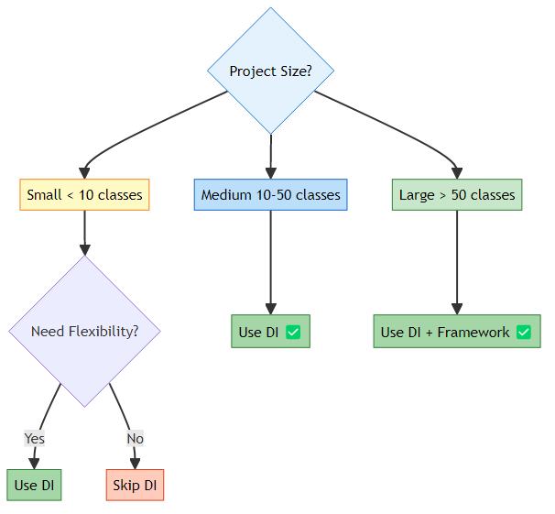
Use DI When: - ✅ Multiple implementations exist - ✅ Need to test with mocks - ✅ Code needs to be flexible - ✅ Working on team projects - ✅ Building enterprise applications - ✅ Following SOLID principles
Skip DI When: - ❌ Very small project - ❌ Only one implementation ever - ❌ Prototype or throwaway code - ❌ Learning basic Java - ❌ Performance is critical (rare cases)

9. BEST PRACTICES

📝 Professional Guidelines by: Avinash Dhanuka

🎯 Design Principles

1. Prefer Constructor Injection
✅ Good:
public class Car {
private final Engine engine; // Final = immutable
public Car(Engine engine) {
if (engine == null) {
throw new IllegalArgumentException("Engine cannot be null");
}
this.engine = engine;
}
}
❌ Bad:
public class Car {
private Engine engine; // Mutable
public void setEngine(Engine engine) {
this.engine = engine; // Can be changed anytime
}
}
Why Constructor Injection? - Immutability (final fields) - Null safety (check in constructor) - Clear dependencies (visible in constructor) - Easy testing (pass mocks in constructor)

2. Depend on Abstractions, Not Implementations
✅ Good:
public class Car {
private Engine engine; // Interface
}
❌ Bad:
public class Car {
private PetrolEngine engine; // Concrete class
}
Why? - Loose coupling - Easy to swap implementations - Follows Dependency Inversion Principle

3. Keep Interfaces Small and Focused
✅ Good:
public interface Engine {
void run();
void stop();
}
❌ Bad:
public interface Engine {
void run();
void stop();
void refuel(); // Not all engines need refueling (electric!)
void changeOil(); // Not all engines have oil
void checkSparkPlugs(); // Diesel engines don't have spark plugs
}
Why? - Interface Segregation Principle - Easier to implement - More flexible

4. Validate Dependencies
✅ Good:
public Car(Engine engine) {
if (engine == null) {
throw new IllegalArgumentException("Engine cannot be null");
}
this.engine = engine;
}
❌ Bad:
public Car(Engine engine) {
this.engine = engine; // No validation
}
Why? - Fail fast (catch errors early) - Clear error messages - Prevent NullPointerException

5. Use Meaningful Names
✅ Good:
public interface PaymentProcessor {
boolean processPayment(double amount);
}
public class PayPalPaymentProcessor implements PaymentProcessor { ... }
public class StripePaymentProcessor implements PaymentProcessor { ... }
❌ Bad:
public interface PP {
boolean process(double a);
}
public class PP1 implements PP { ... }
public class PP2 implements PP { ... }

6. Document Your Code
✅ Good:
/**
* Represents a car that requires an engine to operate.
* The engine is injected via constructor to ensure the car
* is always in a valid state.
*/
public class Car {
private final Engine engine;
/**
* Creates a new car with the specified engine.
*
* @param engine the engine to power this car (must not be null)
* @throws IllegalArgumentException if engine is null
*/
public Car(Engine engine) {
if (engine == null) {
throw new IllegalArgumentException("Engine cannot be null");
}
this.engine = engine;
}
}

🧪 Testing Best Practices

1. Use Mock Objects for Testing
// Mock engine for testing
class MockEngine implements Engine {
private boolean runCalled = false;
public void run() {
runCalled = true;
}
public boolean wasRunCalled() {
return runCalled;
}
}
// Test
@Test
public void testCarStart() {
MockEngine mockEngine = new MockEngine();
Car car = new Car(mockEngine);
car.start();
assertTrue(mockEngine.wasRunCalled());
}

2. Test with Different Implementations
@Test
public void testCarWithPetrolEngine() {
Engine petrol = new PetrolEngine();
Car car = new Car(petrol);
car.start();
// Assert expected behavior
}
@Test
public void testCarWithDieselEngine() {
Engine diesel = new DieselEngine();
Car car = new Car(diesel);
car.start();
// Assert expected behavior
}

🏗️ Architecture Best Practices

1. Layer Your Application
Presentation Layer (UI)
↓
Service Layer (Business Logic)
↓
Repository Layer (Data Access)
↓
Database
Example:
// Presentation Layer
public class CarController {
private CarService carService;
public CarController(CarService carService) {
this.carService = carService;
}
}
// Service Layer
public class CarService {
private CarRepository carRepository;
public CarService(CarRepository carRepository) {
this.carRepository = carRepository;
}
}
// Repository Layer
public class CarRepository {
private Database database;
public CarRepository(Database database) {
this.database = database;
}
}

2. Use Factory Pattern for Complex Creation
public class EngineFactory {
public static Engine createEngine(String type) {
switch (type.toLowerCase()) {
case "petrol":
return new PetrolEngine();
case "diesel":
return new DieselEngine();
case "electric":
return new ElectricEngine();
default:
throw new IllegalArgumentException("Unknown engine type: " + type);
}
}
}
// Usage
Engine engine = EngineFactory.createEngine("petrol");
Car car = new Car(engine);

10. TOP INTERVIEW QUESTIONS

📝 Interview Preparation by: Avinash Dhanuka

Q1: What is Dependency Injection?
Answer:
Dependency Injection is a design pattern where objects receive their dependencies from external sources rather than creating them internally. It promotes loose coupling and makes code more testable and maintainable.
Example:
// Without DI (tight coupling)
public class Car {
private PetrolEngine engine = new PetrolEngine(); // Creates own dependency
}
// With DI (loose coupling)
public class Car {
private Engine engine;
public Car(Engine engine) { // Receives dependency
this.engine = engine;
}
}
Key Points: - Promotes loose coupling - Improves testability - Follows SOLID principles - Makes code more flexible

Q2: What are the types of Dependency Injection?
Answer:
There are three types:
1. Constructor Injection (Recommended):
public class Car {
private final Engine engine;
public Car(Engine engine) {
this.engine = engine;
}
}
- Best for required dependencies
- Immutable (final fields)
- Null-safe
2. Setter Injection:
public class Car {
private Engine engine;
public void setEngine(Engine engine) {
this.engine = engine;
}
}
- Best for optional dependencies
- Mutable
- Can be null
3. Field Injection:
public class Car {
public Engine engine; // Direct access
}
- Not recommended
- Breaks encapsulation
- Hard to test

Q3: What is the difference between tight coupling and loose coupling?
Answer:
Aspect | Tight Coupling | Loose Coupling
Definition | Classes directly depend on concrete implementations | Classes depend on abstractions (interfaces)
Example | private PetrolEngine engine = new PetrolEngine(); | private Engine engine;
Flexibility | Low | High
Testability | Difficult | Easy
Maintainability | Hard | Easy
Tight Coupling Example:
public class Car {
private PetrolEngine engine = new PetrolEngine(); // Locked to PetrolEngine
}
Loose Coupling Example:
public class Car {
private Engine engine; // Works with any Engine
public Car(Engine engine) {
this.engine = engine;
}
}

Q4: What is Inversion of Control (IoC)?
Answer:
Inversion of Control is a principle where the control of object creation and dependency management is transferred from the application code to a framework or container.
Traditional Control:
// Application controls object creation
public class Main {
public static void main(String[] args) {
Engine engine = new PetrolEngine(); // We create
Car car = new Car(engine); // We inject
}
}
Inverted Control (Spring):
// Spring controls object creation
@Component
public class Car {
@Autowired
private Engine engine; // Spring creates and injects
}
Key Points: - Framework manages object lifecycle - Reduces boilerplate code - Centralized configuration - Easier to manage dependencies

Q5: Why is Constructor Injection preferred over Setter Injection?
Answer:
Constructor Injection is preferred because:
1. Immutability:
public class Car {
private final Engine engine; // Can be final
public Car(Engine engine) {
this.engine = engine;
}
}
2. Null Safety:
public Car(Engine engine) {
if (engine == null) {
throw new IllegalArgumentException("Engine cannot be null");
}
this.engine = engine;
}
3. Clear Dependencies: - All dependencies visible in constructor - Easy to see what’s required
4. Compile-Time Safety: - Cannot create object without dependencies - Compiler enforces dependency provision
5. Testability:
// Easy to test
Car car = new Car(new MockEngine());
When to use Setter Injection: - Optional dependencies - Circular dependencies (rare) - Need to change dependency at runtime

Q6: Explain the SOLID principles and how DI relates to them
Answer:
S - Single Responsibility Principle: - Each class has one responsibility - DI helps by separating concerns
// Car is responsible for car operations
public class Car {
private Engine engine; // Engine is responsible for engine operations
}
O - Open-Closed Principle: - Open for extension, closed for modification - DI allows adding new implementations without changing existing code
// Add new engine without modifying Car
public class ElectricEngine implements Engine { ... }
Car car = new Car(new ElectricEngine()); // Works!
L - Liskov Substitution Principle: - Subtypes must be substitutable for their base types - Any Engine implementation can replace another
Engine engine1 = new PetrolEngine();
Engine engine2 = new DieselEngine();
// Both can be used interchangeably
I - Interface Segregation Principle: - Clients shouldn’t depend on interfaces they don’t use - DI uses focused interfaces
public interface Engine {
void run(); // Only necessary methods
}
D - Dependency Inversion Principle: - Depend on abstractions, not concretions - DI enforces this principle
public class Car {
private Engine engine; // Depends on interface (abstraction)
// Not: private PetrolEngine engine; // Concrete class
}

Q7: How does Dependency Injection improve testability?
Answer:
DI improves testability by allowing mock objects to be injected:
Without DI (Hard to Test):
public class Car {
private PetrolEngine engine = new PetrolEngine(); // Always real engine
public void start() {
engine.run(); // Cannot test without real engine
}
}
// Testing requires real PetrolEngine
@Test
public void testStart() {
Car car = new Car(); // Uses real engine
car.start(); // Depends on PetrolEngine implementation
}
With DI (Easy to Test):
public class Car {
private Engine engine;
public Car(Engine engine) {
this.engine = engine;
}
public void start() {
engine.run();
}
}
// Testing with mock
class MockEngine implements Engine {
boolean runCalled = false;
public void run() {
runCalled = true;
}
}
@Test
public void testStart() {
MockEngine mock = new MockEngine();
Car car = new Car(mock); // Inject mock
car.start();
assertTrue(mock.runCalled); // Verify behavior
}
Benefits: - No external dependencies in tests - Fast test execution - Predictable test results - Easy to verify behavior

Q8: What is the difference between @Autowired and @Inject in Spring?
Answer:
Aspect | @Autowired | @Inject
Source | Spring-specific | Java standard (JSR-330)
Required | Has required attribute | No required attribute
Portability | Spring only | Works with any JSR-330 container
@Autowired (Spring):
@Component
public class Car {
@Autowired(required = false) // Optional dependency
private Engine engine;
}
@Inject (Java Standard):
@Component
public class Car {
@Inject // No required attribute
private Engine engine;
}
Recommendation: - Use @Inject for portability - Use @Autowired if you need Spring-specific features

Q9: What is circular dependency? How to resolve it?
Answer:
Circular Dependency: When two or more beans depend on each other.
Example:
@Component
public class A {
@Autowired
private B b; // A depends on B
}
@Component
public class B {
@Autowired
private A a; // B depends on A
}
Problem: - Spring cannot create A without B - Spring cannot create B without A - Results in BeanCurrentlyInCreationException
Solutions:
1. Redesign (Best Solution):
// Extract common functionality to a third class
@Component
public class C {
// Common functionality
}
@Component
public class A {
@Autowired
private C c; // Both depend on C
}
@Component
public class B {
@Autowired
private C c; // No circular dependency
}
2. Use @Lazy:
@Component
public class A {
@Autowired
@Lazy // Lazy initialization
private B b;
}
@Component
public class B {
@Autowired
private A a;
}
3. Use Setter Injection:
@Component
public class A {
private B b;
@Autowired
public void setB(B b) {
this.b = b;
}
}
@Component
public class B {
private A a;
@Autowired
public void setA(A a) {
this.a = a;
}
}

Q10: What are the advantages and disadvantages of Dependency Injection?
Answer:
Advantages:
- Loose Coupling: Classes depend on abstractions, not implementations
- Easy Testing: Can inject mock objects for unit testing
- Reusability: Same class works with different dependencies
- Maintainability: Changes in dependencies don’t affect dependent classes
- Flexibility: Easy to add new implementations
- SOLID Principles: Follows all SOLID principles
Disadvantages:
- Increased Complexity: More classes and interfaces to manage
- Learning Curve: Beginners find it confusing
- Runtime Errors: Errors appear at runtime, not compile-time
- Debugging Difficulty: Harder to trace which implementation is being used
- Overhead: Overkill for small projects
When to Use DI: - Multiple implementations exist - Need to test with mocks - Building enterprise applications - Working on team projects
When to Skip DI: - Very small projects - Only one implementation ever - Prototype or throwaway code

Q11: Explain the Bean lifecycle in Spring
Answer:
Bean Lifecycle Phases:
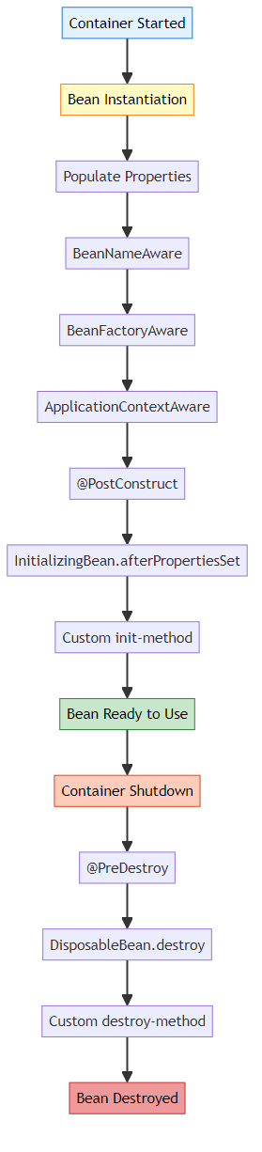
Example:
@Component
public class Car {
private Engine engine;
@Autowired
public Car(Engine engine) {
System.out.println("1. Constructor called");
this.engine = engine;
}
@PostConstruct
public void init() {
System.out.println("2. @PostConstruct - Bean initialized");
}
public void doSomething() {
System.out.println("3. Bean in use");
}
@PreDestroy
public void cleanup() {
System.out.println("4. @PreDestroy - Bean being destroyed");
}
}
Output:
1. Constructor called
2. @PostConstruct - Bean initialized
3. Bean in use
4. @PreDestroy - Bean being destroyed

Q12: What is the difference between @Component, @Service, @Repository, and @Controller?
Answer:
All are specializations of @Component for different layers:
Annotation | Layer | Purpose
@Component | Generic | Generic Spring-managed component
@Service | Service | Business logic layer
@Repository | Data Access | Database operations
@Controller | Presentation | Web controllers (MVC)
Example:
// Generic component
@Component
public class UtilityClass { ... }
// Service layer
@Service
public class CarService {
public void processCarData() { ... }
}
// Data access layer
@Repository
public class CarRepository {
public Car findById(int id) { ... }
}
// Web layer
@Controller
public class CarController {
@GetMapping("/cars")
public String getCars() { ... }
}
Why Different Annotations? - Clarity: Shows the role of the class - AOP: Can apply different aspects to different layers - Exception Translation: @Repository translates database exceptions

Q13: How would you implement DI without a framework?
Answer:
Manual DI Implementation (Our Project):
1. Define Interface:
public interface Engine {
void run();
}
2. Create Implementations:
public class PetrolEngine implements Engine {
public void run() {
System.out.println("Petrol engine running");
}
}
public class DieselEngine implements Engine {
public void run() {
System.out.println("Diesel engine running");
}
}
3. Create Dependent Class:
public class Car {
private Engine engine;
public Car(Engine engine) {
this.engine = engine;
}
public void start() {
engine.run();
}
}
4. Manual Injection:
public class Main {
public static void main(String[] args) {
// Create dependency
Engine engine = new PetrolEngine();
// Inject dependency
Car car = new Car(engine);
// Use
car.start();
}
}
5. Optional: Create Simple DI Container:
public class DIContainer {
private Map<Class<?>, Object> beans = new HashMap<>();
public <T> void register(Class<T> type, T instance) {
beans.put(type, instance);
}
public <T> T get(Class<T> type) {
return type.cast(beans.get(type));
}
}
// Usage
DIContainer container = new DIContainer();
container.register(Engine.class, new PetrolEngine());
container.register(Car.class, new Car(container.get(Engine.class)));
Car car = container.get(Car.class);
car.start();

Q14: What are the advantages of using Spring’s DI over manual DI?
Answer:
Aspect | Manual DI | Spring DI
Object Creation | Manual | Automatic
Lifecycle Management | Manual | Automatic
Configuration | Code | Annotations/XML
Scope Management | Manual | Built-in (Singleton, Prototype, etc.)
AOP Support | Manual | Built-in
Transaction Management | Manual | Declarative
Boilerplate Code | High | Low
Manual DI:
// Must create everything manually
Engine engine = new PetrolEngine();
Transmission transmission = new AutomaticTransmission();
Brakes brakes = new DiscBrakes();
Car car = new Car(engine, transmission, brakes);
Spring DI:
// Spring does everything
@Autowired
private Car car; // Fully configured and ready to use
Spring Benefits: - Automatic dependency resolution - Lifecycle callbacks (@PostConstruct, @PreDestroy) - Scope management (singleton, prototype, request, session) - AOP (logging, transactions, security) - Property injection from configuration files - Conditional bean creation (@Conditional)

Q15: Explain lazy initialization in Spring
Answer:
Lazy Initialization: Bean is created only when first requested, not at application startup.
Default (Eager Initialization):
@Component
public class HeavyService {
public HeavyService() {
System.out.println("HeavyService created at startup");
// Expensive initialization
}
}
// Created immediately when application starts
Lazy Initialization:
@Component
@Lazy // Created only when first used
public class HeavyService {
public HeavyService() {
System.out.println("HeavyService created on first use");
}
}
@Component
public class MyController {
@Autowired
@Lazy // Inject lazy proxy
private HeavyService heavyService;
public void doSomething() {
heavyService.process(); // NOW HeavyService is created
}
}
Benefits: - Faster application startup - Saves memory for unused beans - Useful for expensive initializations
Drawbacks: - Slower first request - Errors appear later (not at startup) - Harder to debug
When to Use: - Heavy initialization - Rarely used beans - Conditional features

🎓 End of Dependency Injection Master Guide
Created with dedication by Avinash Dhanuka

Happy Learning! 🚀
“Inject Dependencies, Not Problems!” - Avinash Dhanuka

