📚 Day 06: Hibernate Relationships Deep Dive

© 2026 Avinash Dhanuka
Complete Guide to Hibernate Relationships
Crafted with ❤️ for Mastering All Relationship Types

Day 06 Focus: Advanced Hibernate Relationships - One-to-Many, Many-to-One, and Many-to-Many with both Unidirectional and Bidirectional implementations

📑 Table of Contents
- Overview
- Project Structure
- Relationships Covered
- Key Concepts
- What I Learned
- Quick Reference

1. OVERVIEW
📝 Author: Avinash Dhanuka | GitHub

🎯 Day 06 Goals
Day 06 focuses on mastering THREE major Hibernate relationship types with BOTH Unidirectional and Bidirectional implementations:
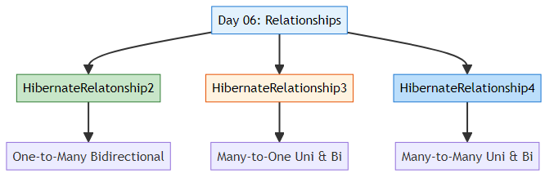

📊 Learning Path
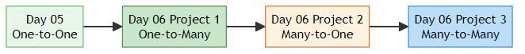

2. PROJECT STRUCTURE
📝 Organized Learning by: Avinash Dhanuka | © 2026

📁 Directory Structure
day06/
├── HibernateRelatonship2/ # One-to-Many Bidirectional
│ ├── src/
│ │ └── main/
│ │ ├── java/
│ │ │ └── org/example/
│ │ │ ├── entity/
│ │ │ │ ├── Customer.java
│ │ │ │ └── Order.java
│ │ │ ├── util/
│ │ │ │ └── HibernateUtil.java
│ │ │ └── App.java
│ │ └── resources/
│ │ └── hibernate.cfg.xml
│ ├── pom.xml
│ └── README.md # Detailed documentation
│
├── HibernateRelationship3/ # Many-to-One (Uni & Bi)
│ ├── src/
│ │ └── main/
│ │ ├── java/
│ │ │ └── org/example/
│ │ │ ├── unidirectional/
│ │ │ │ ├── Employee.java
│ │ │ │ ├── Department.java
│ │ │ │ └── UnidirectionalDemo.java
│ │ │ ├── bidirectional/
│ │ │ │ ├── EmployeeBi.java
│ │ │ │ ├── DepartmentBi.java
│ │ │ │ └── BidirectionalDemo.java
│ │ │ └── util/
│ │ │ └── HibernateUtil.java
│ │ └── resources/
│ │ └── hibernate.cfg.xml
│ ├── pom.xml
│ └── README.md # Detailed documentation
│
├── HibernateRelationship4/ # Many-to-Many (Uni & Bi)
│ ├── src/
│ │ └── main/
│ │ ├── java/
│ │ │ └── org/example/
│ │ │ ├── unidirectional/
│ │ │ │ ├── Student.java
│ │ │ │ ├── Course.java
│ │ │ │ └── UnidirectionalApp.java
│ │ │ ├── bidirectional/
│ │ │ │ ├── Student.java
│ │ │ │ ├── Course.java
│ │ │ │ └── BidirectionalApp.java
│ │ │ └── HibernateUtil.java
│ │ └── resources/
│ │ └── hibernate.cfg.xml
│ ├── pom.xml
│ └── README.md # Detailed documentation
│
├── info.txt # Day 06 notes
└── README.md # This file

3. RELATIONSHIPS COVERED
📝 Comprehensive Coverage by: Avinash Dhanuka | © 2026

📊 Project 1: HibernateRelatonship2
Relationship: One-to-Many Bidirectional
Example: Customer ↔ Orders
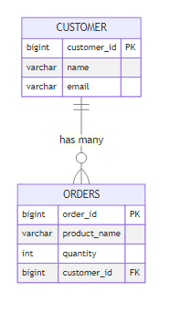
Key Features: - Bidirectional navigation (Customer ↔ Orders) - CASCADE operations (ALL, PERSIST, MERGE, REMOVE) - LAZY vs EAGER loading - Helper methods for consistency - orphanRemoval
Documentation: HibernateRelatonship2/README.md

📊 Project 2: HibernateRelationship3
Relationship: Many-to-One (Unidirectional & Bidirectional)
Example: Employee → Department (Uni) | Employee ↔ Department (Bi)
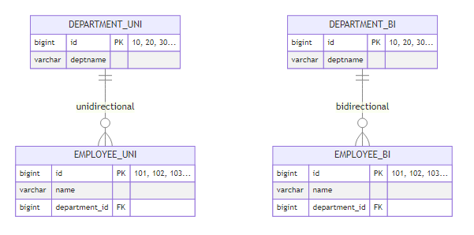
Key Features: - TWO implementations (Unidirectional & Bidirectional) - Sequence Generators with custom increments - Department IDs: 10, 20, 30… (increment by 10) - Employee IDs: 101, 102, 103… (increment by 1) - Comparison of both approaches - mappedBy usage
Documentation: HibernateRelationship3/README.md

📊 Project 3: HibernateRelationship4
Relationship: Many-to-Many (Unidirectional & Bidirectional)
Example: Student → Course (Uni) | Student ↔ Course (Bi)
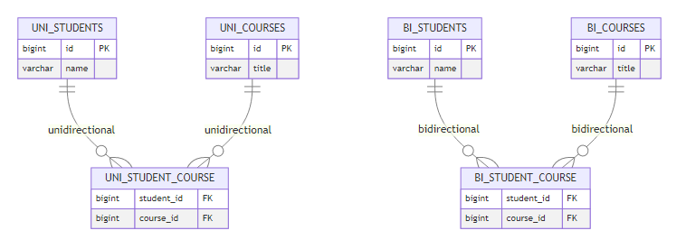
Key Features: - TWO implementations (Unidirectional & Bidirectional) - Join Table (@JoinTable) - Set collection type - CASCADE warnings (REMOVE is dangerous!) - LAZY loading (default) - LazyInitializationException handling
Documentation: HibernateRelationship4/README.md

4. KEY CONCEPTS
📝 Essential Learning by: Avinash Dhanuka | © 2026

🎯 Directionality
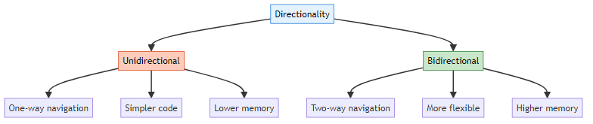
Unidirectional: - Navigation in one direction only - Example: Employee → Department (can’t go back) - Simpler, less memory - Use when reverse navigation not needed
Bidirectional: - Navigation in both directions - Example: Employee ↔ Department (can go both ways) - More complex, more memory - Use when full management needed

🔥 CASCADE Operations
Cascade Type | What It Does | Safe for M2M?
PERSIST | Save child when parent saved | ✅ Yes
MERGE | Update child when parent updated | ✅ Yes
REMOVE | Delete child when parent deleted | ⚠️ Dangerous for M2M
REFRESH | Reload child when parent refreshed | ✅ Yes
DETACH | Detach child when parent detached | ✅ Yes
ALL | All of the above | ⚠️ Dangerous for M2M
Important: - Use CASCADE carefully in Many-to-Many - NEVER use CASCADE.REMOVE in M2M (deletes shared entities!) - Use helper methods in Bidirectional relationships

🚀 LAZY vs EAGER Loading
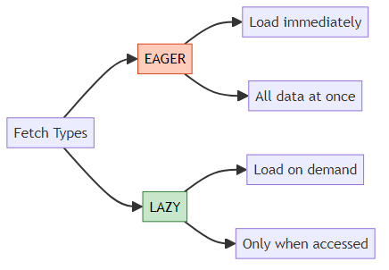
Default Fetch Types:
Relationship | Default
@OneToOne | EAGER
@ManyToOne | EAGER
@OneToMany | LAZY ⭐
@ManyToMany | LAZY ⭐
Real-World Analogy:
EAGER:
Food + Bill + Chef + Owner details all come together 😵
LAZY:
You only get food 🍔
If you ask for bill → then they give bill
If you ask for chef → then they give chef details

🎯 mappedBy
What it does: Tells Hibernate which side owns the relationship.
// Owner side (has @JoinColumn or @JoinTable)
@OneToMany
@JoinColumn(name = "customer_id")
private List<Order> orders;
// Inverse side (has mappedBy)
@ManyToOne
@JoinColumn(name = "customer_id")
private Customer customer;
// In Customer:
@OneToMany(mappedBy = "customer") // Points to Order's "customer" field
private List<Order> orders;
Golden Rule: Only ONE side has @JoinColumn/@JoinTable, other side uses mappedBy.

🔗 Join Tables (Many-to-Many)
Why needed: Cannot use simple FK for Many-to-Many.
@ManyToMany
@JoinTable(
name = "student_course", // Join table name
joinColumns = @JoinColumn(name = "student_id"), // FK to Student
inverseJoinColumns = @JoinColumn(name = "course_id") // FK to Course
)
private Set<Course> courses;
Important: - Always use Set (not List) for Many-to-Many - Only owner side has @JoinTable - Inverse side uses mappedBy

5. WHAT I LEARNED
📝 Personal Learning Journey by: Avinash Dhanuka | © 2026
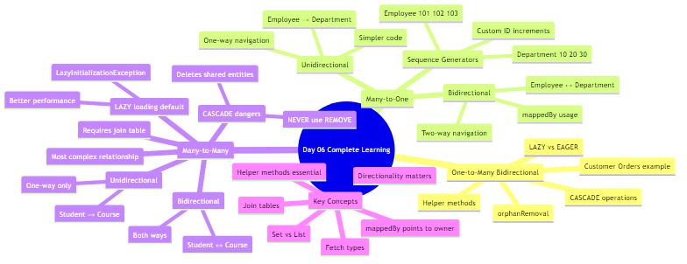

🎯 Key Takeaways
- Directionality is Crucial
  - Unidirectional = Simple, one-way navigation
  - Bidirectional = Flexible, two-way navigation
  - Choose based on requirements
- CASCADE with Caution
  - Safe: PERSIST, MERGE, REFRESH, DETACH
  - Dangerous in M2M: REMOVE, ALL
  - Always test cascade operations
- LAZY is Better
  - Default for @OneToMany and @ManyToMany
  - Better performance and memory
  - Watch for LazyInitializationException
- mappedBy is Essential
  - Only ONE side owns relationship
  - Other side uses mappedBy
  - Points to field name in owner
- Many-to-Many is Special
  - Always requires join table
  - Use Set (not List)
  - CASCADE.REMOVE is dangerous
- Helper Methods Matter
  - Maintain consistency in Bidirectional
  - Set both sides of relationship
  - Prevent bugs and data issues

6. QUICK REFERENCE
📝 Handy Reference by: Avinash Dhanuka | © 2026

📊 Relationship Comparison
Relationship | Example | FK Location | Join Table | Annotation
One-to-One | Person-Passport | Either table | No | @OneToOne
One-to-Many | Customer-Orders | Many side | No | @OneToMany
Many-to-One | Employees-Dept | Many side | No | @ManyToOne
Many-to-Many | Students-Courses | Join table | Yes | @ManyToMany

🎯 When to Use Which
Use Unidirectional when: - Simple lookups needed - One-way navigation sufficient - Memory optimization important - Simpler code preferred
Use Bidirectional when: - Full CRUD operations needed - Two-way navigation required - Complex business logic - Cascade operations needed

🔥 Common Pitfalls
❌ Don’t: - Use CASCADE.REMOVE in Many-to-Many - Forget to set both sides in Bidirectional - Use List for Many-to-Many (use Set) - Add @JoinColumn on both sides - Access LAZY collections after session closed
✅ Do: - Use helper methods in Bidirectional - Test cascade operations thoroughly - Keep session open for LAZY loading - Use mappedBy correctly - Choose right directionality

💻 Running the Projects
Project 1: One-to-Many
cd day06/HibernateRelatonship2
mvn clean compile exec:java -Dexec.mainClass="org.example.App"
Project 2: Many-to-One Unidirectional
cd day06/HibernateRelationship3
mvn exec:java -Dexec.mainClass="org.example.unidirectional.UnidirectionalDemo"
Project 2: Many-to-One Bidirectional
cd day06/HibernateRelationship3
mvn exec:java -Dexec.mainClass="org.example.bidirectional.BidirectionalDemo"
Project 3: Many-to-Many Unidirectional
cd day06/HibernateRelationship4
mvn exec:java -Dexec.mainClass="org.example.unidirectional.UnidirectionalApp"
Project 3: Many-to-Many Bidirectional
cd day06/HibernateRelationship4
mvn exec:java -Dexec.mainClass="org.example.bidirectional.BidirectionalApp"

📚 Documentation Links
- HibernateRelatonship2 - One-to-Many Bidirectional
- HibernateRelationship3 - Many-to-One (Uni & Bi)
- HibernateRelationship4 - Many-to-Many (Uni & Bi)

© 2026 Avinash Dhanuka
This comprehensive guide was crafted with ❤️ by Avinash Dhanuka

