☕ Hibernate Many-to-Many: Unidirectional vs Bidirectional

© 2026 Avinash Dhanuka
Mastering Unidirectional & Bidirectional Many-to-Many Relationships
Crafted with ❤️ for Understanding Complex Relationships

Learning Note: This guide demonstrates BOTH Unidirectional and Bidirectional Many-to-Many relationships using Student-Course example!
Prerequisites: - Complete understanding of Many-to-One Relationships - MySQL Server installed and running - Understanding of Join Tables

📑 Table of Contents
- What’s New?
- Understanding Many-to-Many
- Join Tables Explained
- Unidirectional Many-to-Many
- Bidirectional Many-to-Many
- Key Differences
- Cascade Operations
- LAZY vs EAGER Loading
- Running the Application
- What I Learned
- Interview Questions

1. WHAT’S NEW?
📝 Author: Avinash Dhanuka | GitHub

🎯 The Most Complex Relationship
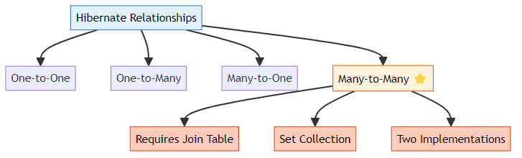

📊 What We’re Building
A Student-Course Management System with TWO implementations:
Unidirectional: - Student knows Courses - Course doesn’t know Students - One-way navigation only - Simpler implementation
Bidirectional: - Student knows Courses - Course knows Students - Two-way navigation - More flexible

🎯 Special Features
- Join Table for Many-to-Many mapping
- Set Collection (no duplicates)
- Two separate implementations in one project
- Interactive demos for both types
- Separate tables for each implementation

🔥 Why Many-to-Many is Special

📚 Learning Path Progress
One-to-One ✅ → One-to-Many ✅ → Many-to-One ✅ → Many-to-Many ✅
Created by Avinash Dhanuka | © 2026

2. UNDERSTANDING MANY-TO-MANY
📝 Comprehensive Guide by: Avinash Dhanuka | © 2026

🎯 What is Many-to-Many?
Many-to-Many = Multiple entities on BOTH sides can be associated with multiple entities on the OTHER side.
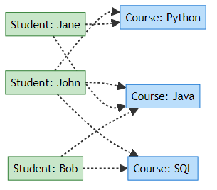
Real-World Examples: - Students ↔ Courses (One student takes many courses, one course has many students) - Authors ↔ Books (One author writes many books, one book can have many authors) - Actors ↔ Movies (One actor acts in many movies, one movie has many actors) - Products ↔ Categories (One product in many categories, one category has many products)

📊 Comparison with Other Relationships
Relationship | Left Side | Right Side | Example
One-to-One | 1 entity | 1 entity | Person ↔ Passport
One-to-Many | 1 entity | Many entities | Department → Employees
Many-to-One | Many entities | 1 entity | Employees → Department
Many-to-Many | Many entities | Many entities | Students ↔ Courses

🔍 Why Can’t We Use Foreign Key Directly?
Problem with Foreign Key:
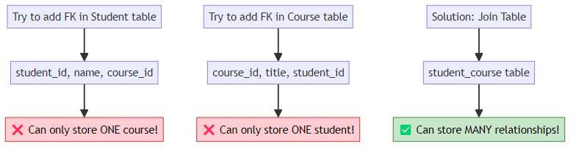
Solution: We need a JOIN TABLE (also called junction table or bridge table)!

💡 The Join Table Concept
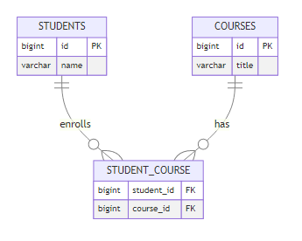
How it works: 1. Student table stores student data 2. Course table stores course data 3. Join table stores relationships (which student enrolled in which course)

🎓 Many-to-Many Always Requires a Join Table
Guide by Avinash Dhanuka | © 2026

3. JOIN TABLES EXPLAINED
📝 Author: Avinash Dhanuka | Contact via Gmail

🎯 What is a Join Table?
Join Table = A separate table that stores the relationships between two entities in a Many-to-Many relationship.
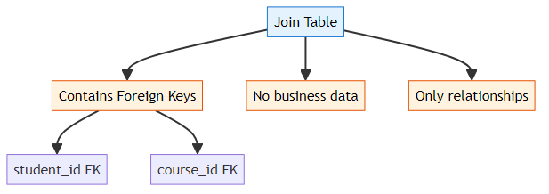

📊 Join Table Structure
Example Data:
Students Table: | id | name | |—-|——| | 1 | John | | 2 | Jane | | 3 | Bob |
Courses Table: | id | title | |—-|——–| | 1 | Java | | 2 | Python | | 3 | SQL |
Student_Course Join Table: | student_id | course_id | |————|———–| | 1 | 1 | (John enrolled in Java) | 1 | 2 | (John enrolled in Python) | 2 | 1 | (Jane enrolled in Java) | 2 | 3 | (Jane enrolled in SQL) | 3 | 1 | (Bob enrolled in Java)

🔄 How Join Table Works
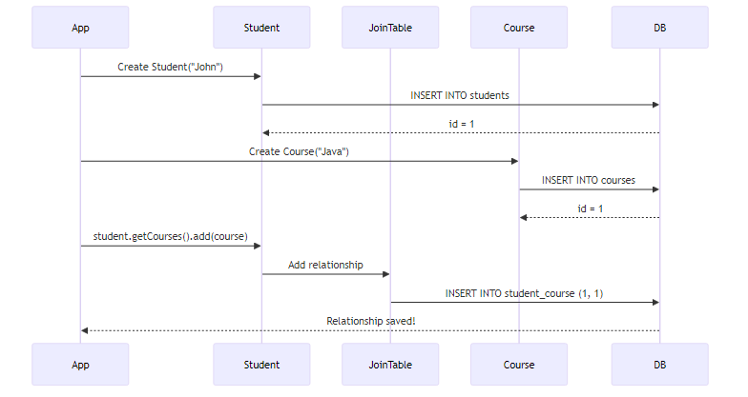

💻 @JoinTable Annotation
@ManyToMany
@JoinTable(
name = "student_course", // Join table name
joinColumns = @JoinColumn(name = "student_id"), // FK to Student
inverseJoinColumns = @JoinColumn(name = "course_id") // FK to Course
)
private Set<Course> courses = new HashSet<>();
Parameters Explained:
Parameter | Description | Example
name | Join table name | “student_course”
joinColumns | FK column for owning side | “student_id”
inverseJoinColumns | FK column for inverse side | “course_id”

🎯 Why Set Instead of List?
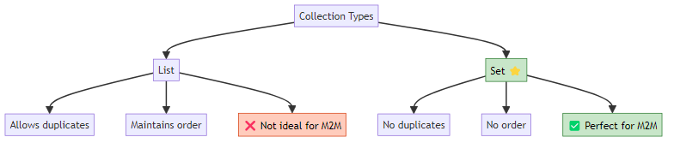
Why Set? - Prevents duplicate enrollments (John can’t enroll in Java twice) - Better performance for Many-to-Many - Matches database constraint (composite PK prevents duplicates)

🔥 Join Table Best Practices
DO: - Use meaningful table names (student_course, not sc) - Use Set collection type - Define composite primary key (student_id + course_id) - Keep join table simple (only FKs)
DON’T: - Add business data to join table (use separate entity instead) - Use List for Many-to-Many - Forget to define both FKs - Make join table name too long

🔗 Join Tables = The Bridge Between Many-to-Many Entities
© 2026 Avinash Dhanuka

4. UNIDIRECTIONAL MANY-TO-MANY
📝 Author: Avinash Dhanuka | GitHub

🎯 What is Unidirectional Many-to-Many?
Many Students → Many Courses (One-way navigation)
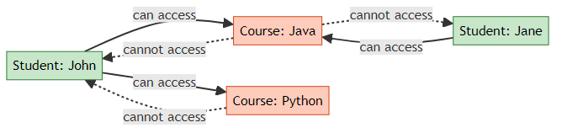
Key Point: Student can get Courses, but Course CANNOT get Students!

🏗️ Database Structure
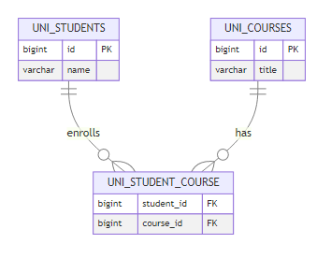

📝 Entity Classes

Student.java (Unidirectional)
@Entity(name = "UniStudent")
@Table(name = "uni_students")
public class Student {
@Id
@GeneratedValue(strategy = GenerationType.IDENTITY)
private Long id;
private String name;
// UNIDIRECTIONAL: Only Student knows about Course
@ManyToMany
@JoinTable(
name = "uni_student_course",
joinColumns = @JoinColumn(name = "student_id"),
inverseJoinColumns = @JoinColumn(name = "course_id")
)
private Set<Course> courses = new HashSet<>();
// Constructors, Getters, Setters
}
Key Points: - @ManyToMany annotation - @JoinTable defines join table structure - Set<Course> collection (no duplicates) - Course has NO reference to Student

Course.java (Unidirectional)
@Entity(name = "UniCourse")
@Table(name = "uni_courses")
public class Course {
@Id
@GeneratedValue(strategy = GenerationType.IDENTITY)
private Long id;
private String title;
// UNIDIRECTIONAL: Course does NOT have any reference to Student
// NO Set<Student> field!
// Constructors, Getters, Setters
}
Key Points: - Simple entity with no relationship mapping - No reference to Student - Cannot navigate to Students from Course

🔄 How It Works
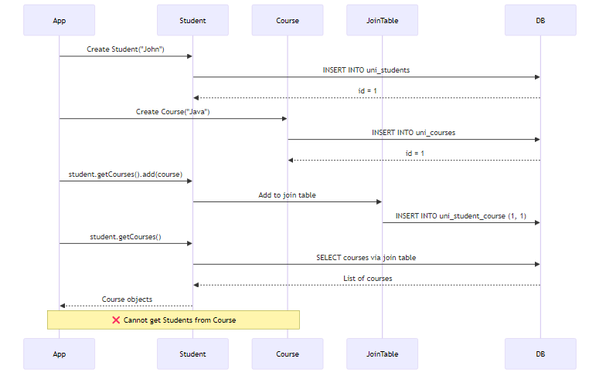

💻 Usage Example
Session session = sessionFactory.openSession();
Transaction tx = session.beginTransaction();
// Create Student
Student john = new Student("John");
// Create Courses
Course java = new Course("Java");
Course python = new Course("Python");
// Add courses to student (Unidirectional)
john.getCourses().add(java);
john.getCourses().add(python);
// Save
session.persist(john);
session.persist(java);
session.persist(python);
tx.commit();
// ✅ Can navigate from Student to Courses
System.out.println("John's courses:");
for (Course c : john.getCourses()) {
System.out.println(" - " + c.getTitle());
}
// ❌ Cannot navigate from Course to Students
// java.getStudents() - Method doesn't exist!

⚡ Advantages & Disadvantages
✅ Advantages: - Simpler code structure - Less memory overhead - Easier to maintain - Clear ownership - Faster for simple queries
❌ Disadvantages: - Cannot get Students from Course - Need HQL for reverse queries - Limited flexibility - One-way operations only

📊 Memory Representation
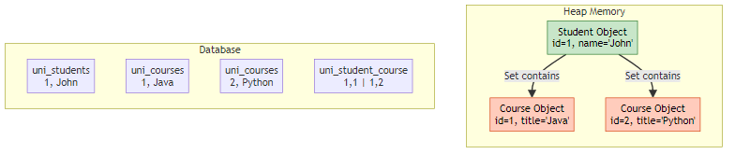

🔥 Unidirectional = Simple One-Way Navigation
© 2026 Avinash Dhanuka

5. BIDIRECTIONAL MANY-TO-MANY
📝 Comprehensive Guide by: Avinash Dhanuka | © 2026

🎯 What is Bidirectional Many-to-Many?
Many Students ↔ Many Courses (Two-way navigation)
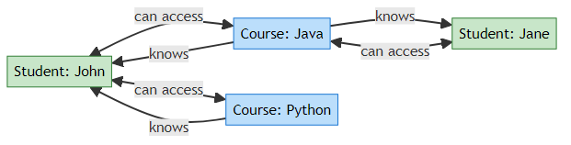
Key Point: Student can get Courses AND Course can get Students!

🏗️ Database Structure
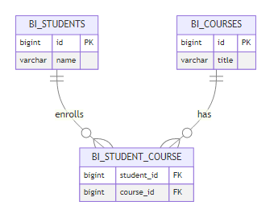
Note: Database structure is SAME as Unidirectional! The difference is in Java code only.

📝 Entity Classes

Student.java (Bidirectional - Owner Side)
@Entity(name = "BiStudent")
@Table(name = "bi_students")
public class Student {
@Id
@GeneratedValue(strategy = GenerationType.IDENTITY)
private Long id;
private String name;
// BIDIRECTIONAL: Student knows about Course (owning side)
@ManyToMany
@JoinTable(
name = "bi_student_course",
joinColumns = @JoinColumn(name = "student_id"),
inverseJoinColumns = @JoinColumn(name = "course_id")
)
private Set<Course> courses = new HashSet<>();
// Constructors, Getters, Setters
}
Key Points: - @ManyToMany with @JoinTable - Owner side (controls join table) - Defines join table structure

Course.java (Bidirectional - Inverse Side)
@Entity(name = "BiCourse")
@Table(name = "bi_courses")
public class Course {
@Id
@GeneratedValue(strategy = GenerationType.IDENTITY)
private Long id;
private String title;
// BIDIRECTIONAL: Course has reference back to Student
// mappedBy indicates this is the inverse side
@ManyToMany(mappedBy = "courses")
private Set<Student> students = new HashSet<>();
// Constructors, Getters, Setters
}
Key Points: - @ManyToMany(mappedBy = "courses") - Inverse side (doesn’t control join table) - Points to Student’s field name - No @JoinTable annotation

🎯 The Golden Rule of Bidirectional Many-to-Many
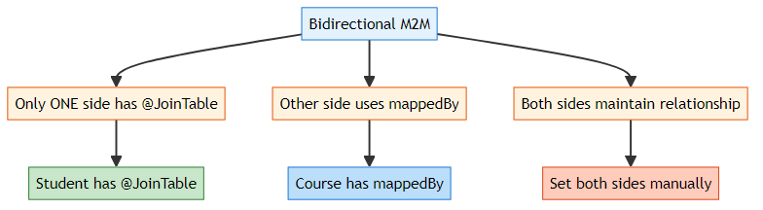
Why This Rule?
If you add @JoinTable on BOTH sides: - 💥 Hibernate creates TWO join tables - 💥 Data inconsistency - 💥 Confusion about ownership

🔄 How It Works
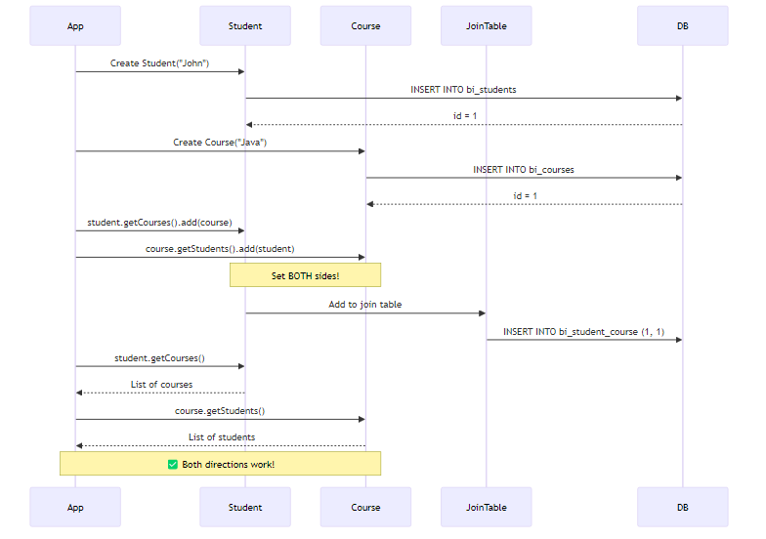

💻 Usage Example
Session session = sessionFactory.openSession();
Transaction tx = session.beginTransaction();
// Create Student
Student john = new Student("John");
// Create Courses
Course java = new Course("Java");
Course python = new Course("Python");
// BIDIRECTIONAL: Set BOTH sides of the relationship
john.getCourses().add(java);
john.getCourses().add(python);
java.getStudents().add(john);
python.getStudents().add(john);
// Save
session.persist(john);
session.persist(java);
session.persist(python);
tx.commit();
// ✅ Navigate from Student to Courses
System.out.println("John's courses:");
for (Course c : john.getCourses()) {
System.out.println(" - " + c.getTitle());
}
// ✅ Navigate from Course to Students
System.out.println("Java course students:");
for (Student s : java.getStudents()) {
System.out.println(" - " + s.getName());
}

🔥 Why Set Both Sides Manually?
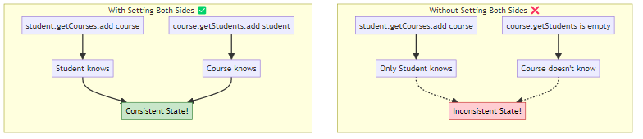
Important: In Many-to-Many Bidirectional, you MUST set both sides manually! Unlike One-to-Many, there are no helper methods in the entities.

⚡ Advantages & Disadvantages
✅ Advantages: - Two-way navigation - Full flexibility - Can query from both sides - Better for complex operations - More intuitive
❌ Disadvantages: - More complex code - Higher memory usage - Must maintain both sides - Risk of inconsistency - More maintenance

🎓 Bidirectional = Full Control with Two-Way Navigation
Crafted by Avinash Dhanuka | © 2026

6. KEY DIFFERENCES
📝 Comprehensive Comparison by: Avinash Dhanuka | © 2026

📊 Unidirectional vs Bidirectional
Aspect | Unidirectional | Bidirectional
Navigation | Student → Course only | Student ↔ Course
@JoinTable | In Student | In Student (owner)
@ManyToMany | In Student only | In both entities
mappedBy | Not needed | Required in Course
Set Both Sides | Not needed | Required manually
Code Complexity | Simple | More complex
Memory Usage | Lower | Higher
Query Flexibility | Limited | High
Use Case | Simple lookups | Full management
Maintenance | Easier | Requires care

🎯 Code Comparison
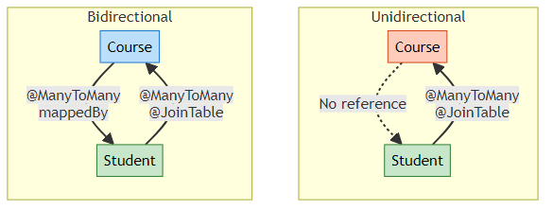

💻 Side-by-Side Code
Unidirectional:
// Student - Has reference to Course
@Entity
public class Student {
@Id
private Long id;
private String name;
@ManyToMany
@JoinTable(
name = "student_course",
joinColumns = @JoinColumn(name = "student_id"),
inverseJoinColumns = @JoinColumn(name = "course_id")
)
private Set<Course> courses = new HashSet<>();
}
// Course - NO reference to Student
@Entity
public class Course {
@Id
private Long id;
private String title;
// No students field!
}
Bidirectional:
// Student - Has reference to Course (Owner)
@Entity
public class Student {
@Id
private Long id;
private String name;
@ManyToMany
@JoinTable(
name = "student_course",
joinColumns = @JoinColumn(name = "student_id"),
inverseJoinColumns = @JoinColumn(name = "course_id")
)
private Set<Course> courses = new HashSet<>();
}
// Course - Has reference to Student (Inverse)
@Entity
public class Course {
@Id
private Long id;
private String title;
@ManyToMany(mappedBy = "courses")
private Set<Student> students = new HashSet<>();
}

🔍 Operation Comparison
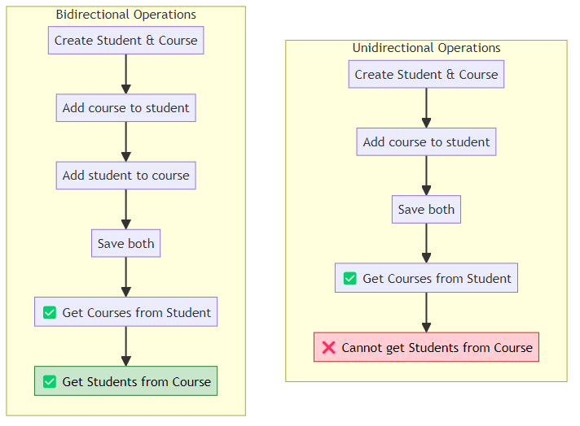

🎯 Decision Matrix
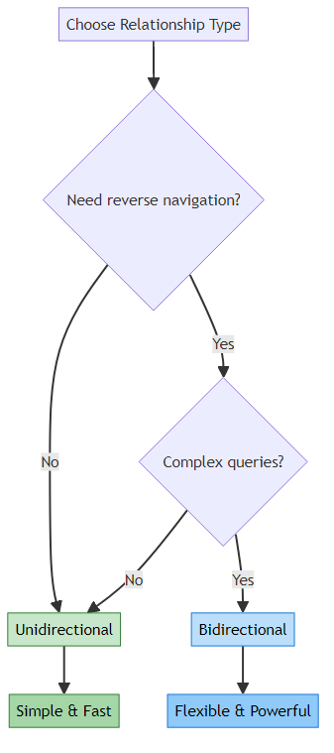

🎓 Choose Based on Navigation Needs
Guide by Avinash Dhanuka | © 2026

7. CASCADE OPERATIONS
📝 Detailed Guide by: Avinash Dhanuka | Contact

🎯 What is Cascade in Many-to-Many?
Cascade = Propagating operations from one entity to related entities automatically.
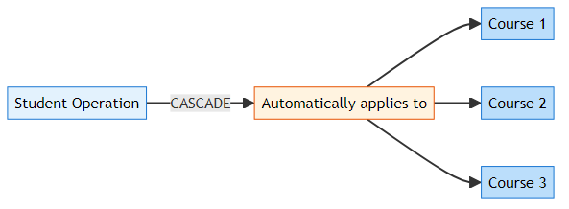

⚠️ CASCADE WARNING for Many-to-Many
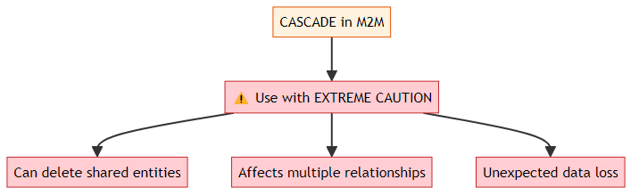
Why Dangerous?
Imagine: - John enrolled in Java course - Jane also enrolled in Java course - If you delete John with CASCADE.REMOVE - Java course gets deleted! - Jane loses her course too! 💥

📊 Cascade Types
Cascade Type | Safe for M2M? | Description
PERSIST | ✅ Safe | Save related entities
MERGE | ✅ Safe | Update related entities
REMOVE | ❌ DANGEROUS | Delete related entities
REFRESH | ✅ Safe | Reload related entities
DETACH | ✅ Safe | Detach related entities
ALL | ❌ DANGEROUS | All operations (includes REMOVE)

🔥 CASCADE.PERSIST (Safe)
What it does: When you save Student, Courses are saved automatically.
@ManyToMany(cascade = CascadeType.PERSIST)
@JoinTable(
name = "student_course",
joinColumns = @JoinColumn(name = "student_id"),
inverseJoinColumns = @JoinColumn(name = "course_id")
)
private Set<Course> courses = new HashSet<>();
// Usage
Student john = new Student("John");
Course java = new Course("Java");
john.getCourses().add(java);
session.persist(john); // Saves john AND java automatically!
Safe because: Only saves new entities, doesn’t delete anything.

🔥 CASCADE.MERGE (Safe)
What it does: When you update Student, Courses are updated automatically.
@ManyToMany(cascade = CascadeType.MERGE)
private Set<Course> courses = new HashSet<>();
// Usage
john.setName("John Doe");
john.getCourses().iterator().next().setTitle("Advanced Java");
session.merge(john); // Updates john AND course!
Safe because: Only updates existing entities, doesn’t delete anything.

🔥 CASCADE.REMOVE (DANGEROUS!)
What it does: When you delete Student, Courses are deleted automatically.
@ManyToMany(cascade = CascadeType.REMOVE)
private Set<Course> courses = new HashSet<>();
// Usage
session.delete(john); // Deletes john AND all his courses!
DANGEROUS because:
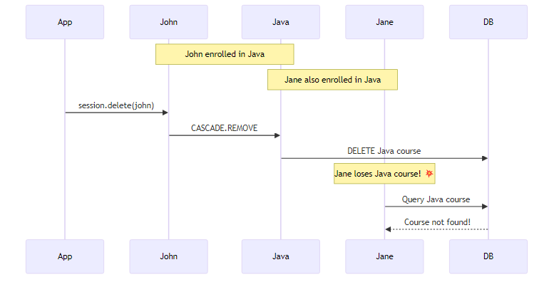
Never use CASCADE.REMOVE in Many-to-Many unless you’re absolutely sure!

🔥 CASCADE.REFRESH (Safe)
What it does: When you refresh Student, Courses are refreshed from DB.
@ManyToMany(cascade = CascadeType.REFRESH)
private Set<Course> courses = new HashSet<>();
// Usage
session.refresh(john); // Reloads john AND all courses from DB
Safe because: Only reloads data, doesn’t modify or delete anything.

🔥 CASCADE.DETACH (Safe)
What it does: When you detach Student, Courses are detached from session.
@ManyToMany(cascade = CascadeType.DETACH)
private Set<Course> courses = new HashSet<>();
// Usage
session.detach(john); // Detaches john AND all courses from session
Safe because: Only affects session state, doesn’t modify database.

💡 Best Practices for Many-to-Many Cascade
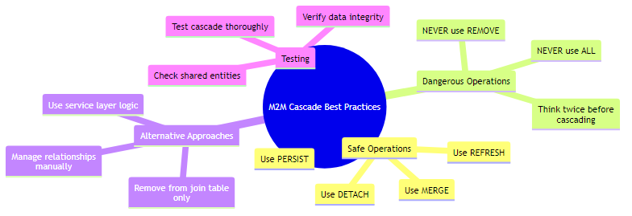
Golden Rules: 1. NEVER use CASCADE.REMOVE in Many-to-Many 2. NEVER use CASCADE.ALL in Many-to-Many (includes REMOVE) 3. Use PERSIST and MERGE for convenience 4. Manage deletions manually 5. Always test cascade operations

📊 Recommended Cascade Configuration
// ✅ RECOMMENDED: Safe cascades only
@ManyToMany(cascade = {CascadeType.PERSIST, CascadeType.MERGE})
@JoinTable(
name = "student_course",
joinColumns = @JoinColumn(name = "student_id"),
inverseJoinColumns = @JoinColumn(name = "course_id")
)
private Set<Course> courses = new HashSet<>();

🔄 Manual Relationship Management
Instead of CASCADE.REMOVE, do this:
// Remove relationship from join table only
Student john = session.get(Student.class, 1L);
Course java = session.get(Course.class, 1L);
// Remove from both sides
john.getCourses().remove(java);
java.getStudents().remove(john);
session.update(john);
// Java course still exists, only relationship removed!

⚠️ CASCADE in Many-to-Many = Use with Extreme Caution
© 2026 Avinash Dhanuka

8. LAZY VS EAGER LOADING
📝 Author: Avinash Dhanuka | GitHub

🎯 What is Fetch Type?
Fetch Type = When and how Hibernate loads related entities from the database.
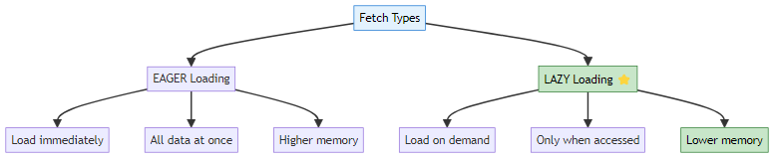

📊 Default Fetch Types
Relationship | Default Fetch Type
@OneToOne | EAGER
@ManyToOne | EAGER
@OneToMany | LAZY
@ManyToMany | LAZY ⭐
Many-to-Many defaults to LAZY - This is good for performance!

🔥 EAGER Loading
What it does: Loads Student AND all Courses immediately.
@ManyToMany(fetch = FetchType.EAGER)
@JoinTable(
name = "student_course",
joinColumns = @JoinColumn(name = "student_id"),
inverseJoinColumns = @JoinColumn(name = "course_id")
)
private Set<Course> courses = new HashSet<>();
How it works:
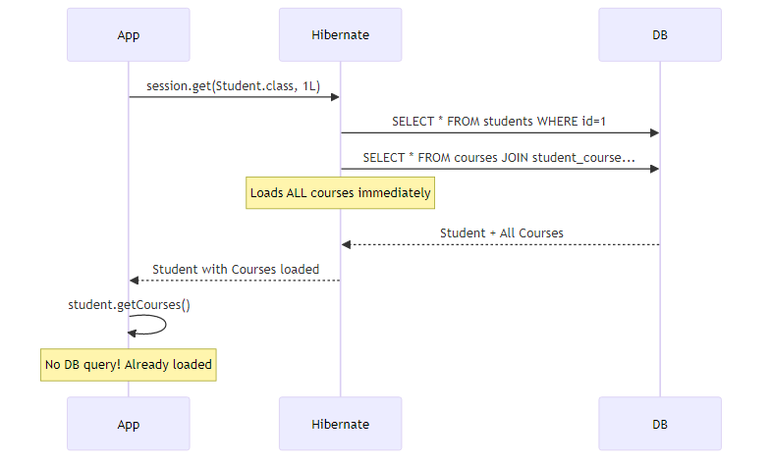
Real-World Analogy:
EAGER = Food + Bill + Chef details + Owner details all come together 😵
You order food, and they bring:
- Your food
- The bill
- Chef's biography
- Restaurant owner's life story
- Everything at once!
Advantages: - No LazyInitializationException - All data available immediately - Simpler code
Disadvantages: - Higher memory usage - Slower initial load - Loads unnecessary data - Performance issues with large collections

🔥 LAZY Loading (Default & Recommended)
What it does: Loads Student first, Courses only when accessed.
@ManyToMany(fetch = FetchType.LAZY) // Default, can omit
@JoinTable(
name = "student_course",
joinColumns = @JoinColumn(name = "student_id"),
inverseJoinColumns = @JoinColumn(name = "course_id")
)
private Set<Course> courses = new HashSet<>();
How it works:
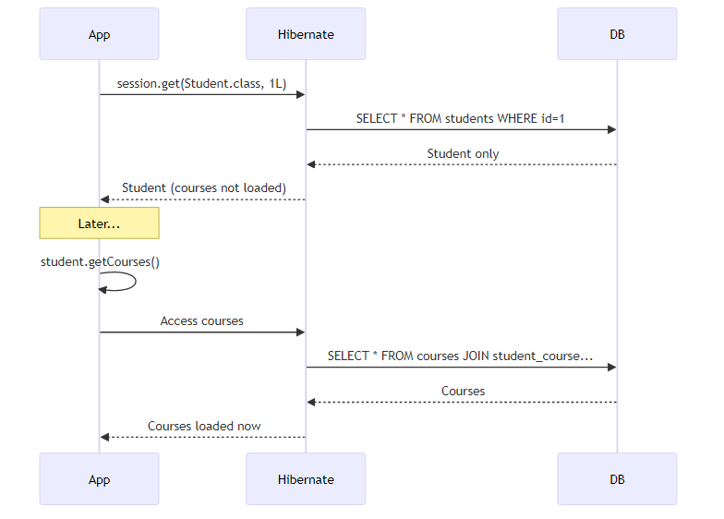
Real-World Analogy:
LAZY = You only get food 🍔
You order food, and they bring:
- Your food only
If you ask for bill → then they give bill
If you ask for chef → then they give chef details
If you ask for owner → then they give owner info
On-demand loading!
Advantages: - Lower memory usage - Faster initial load - Loads only needed data - Better performance
Disadvantages: - LazyInitializationException if session closed - Need to keep session open - More complex code

⚠️ LazyInitializationException
The Problem:
Session session = sessionFactory.openSession();
Student john = session.get(Student.class, 1L);
session.close(); // Session closed!
// ❌ LazyInitializationException!
john.getCourses().forEach(c -> System.out.println(c.getTitle()));
Why? - Courses are LAZY loaded - Session is closed - Hibernate can’t fetch courses anymore - Exception thrown!
Solutions:
1. Keep Session Open:
Session session = sessionFactory.openSession();
Student john = session.get(Student.class, 1L);
// Access courses while session is open
john.getCourses().forEach(c -> System.out.println(c.getTitle()));
session.close(); // Close after accessing
2. Use JOIN FETCH (HQL):
Session session = sessionFactory.openSession();
// Fetch student with courses in one query
Student john = session.createQuery(
"SELECT s FROM Student s JOIN FETCH s.courses WHERE s.id = :id",
Student.class
)
.setParameter("id", 1L)
.getSingleResult();
session.close();
// ✅ Works! Courses already loaded
john.getCourses().forEach(c -> System.out.println(c.getTitle()));
3. Initialize Collection:
Session session = sessionFactory.openSession();
Student john = session.get(Student.class, 1L);
// Force initialization
Hibernate.initialize(john.getCourses());
session.close();
// ✅ Works! Courses initialized
john.getCourses().forEach(c -> System.out.println(c.getTitle()));

📊 EAGER vs LAZY Comparison
Aspect | EAGER | LAZY
Loading Time | Immediate | On-demand
Memory Usage | Higher | Lower
Performance | Slower initial load | Faster initial load
Session Requirement | Not needed after load | Needed when accessing
LazyInitializationException | Never | Possible
Use Case | Small collections | Large collections
Default for M2M | No | Yes ⭐

💡 Best Practices
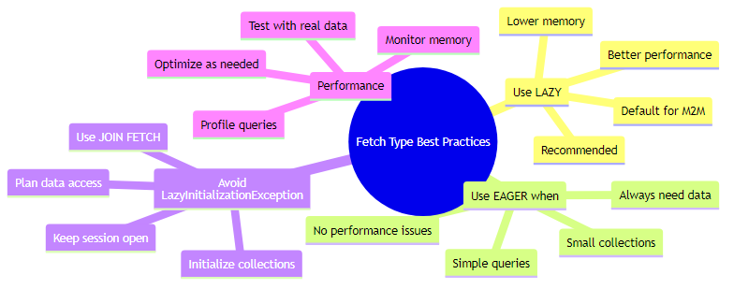
Golden Rules: 1. Stick with LAZY (default) for Many-to-Many 2. Use JOIN FETCH when you need data immediately 3. Keep session open when accessing LAZY collections 4. Profile and optimize based on real usage 5. Don’t use EAGER unless necessary

🚀 LAZY Loading = Better Performance for Many-to-Many
© 2026 Avinash Dhanuka

9. RUNNING THE APPLICATION
📝 Step-by-Step Guide by: Avinash Dhanuka | © 2026

🎯 Prerequisites
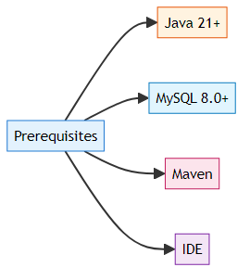

📝 Step 1: Database Setup
-- Create database
CREATE DATABASE hibernate_relationships_db;
-- Use database
USE hibernate_relationships_db;
-- Tables will be created automatically by Hibernate

📝 Step 2: Configure hibernate.cfg.xml
<hibernate-configuration>
<session-factory>
<property name="hibernate.connection.driver_class">com.mysql.cj.jdbc.Driver</property>
<property name="hibernate.connection.url">jdbc:mysql://localhost:3306/hibernate_relationships_db</property>
<property name="hibernate.connection.username">root</property>
<property name="hibernate.connection.password">your_password</property>
<property name="hibernate.dialect">org.hibernate.dialect.MySQLDialect</property>
<property name="hibernate.hbm2ddl.auto">update</property>
<property name="hibernate.show_sql">true</property>
<property name="hibernate.format_sql">true</property>
<!-- Entity mappings -->
<mapping class="org.example.unidirectional.Student"/>
<mapping class="org.example.unidirectional.Course"/>
<mapping class="org.example.bidirectional.Student"/>
<mapping class="org.example.bidirectional.Course"/>
</session-factory>
</hibernate-configuration>

📝 Step 3: Run Unidirectional Demo
# Navigate to project directory
cd day06/HibernateRelationship4
# Run Unidirectional Demo
mvn exec:java -Dexec.mainClass="org.example.unidirectional.UnidirectionalApp"
Sample Interaction:
========================================
UNIDIRECTIONAL ManyToMany Example
========================================
Navigation: Student -> Course (ONE WAY)
Course does NOT know about Student
Enter student name: John
Enter course title: Java
--- Saving Data ---
✓ Student saved with 1 course(s)
✓ Course saved (no student reference)
--- Testing Navigation ---
FROM Student -> Course:
Student 'John' enrolled in:
- Java
FROM Course -> Student:
Course 'Java' has students:
✗ CANNOT ACCESS - No reference exists!
(Course class has no 'students' field)

📝 Step 4: Run Bidirectional Demo
# Run Bidirectional Demo
mvn exec:java -Dexec.mainClass="org.example.bidirectional.BidirectionalApp"
Sample Interaction:
========================================
BIDIRECTIONAL ManyToMany Example
========================================
Navigation: Student <-> Course (TWO WAY)
Both entities know about each other
Enter student name: Jane
Enter course title: Python
--- Saving Data ---
✓ Student saved with 1 course(s)
✓ Course saved with 1 student(s)
--- Testing Navigation ---
FROM Student -> Course:
Student 'Jane' enrolled in:
- Python
FROM Course -> Student:
Course 'Python' has students:
- Jane
✓ SUCCESS - Both directions work!

🔄 Execution Flow
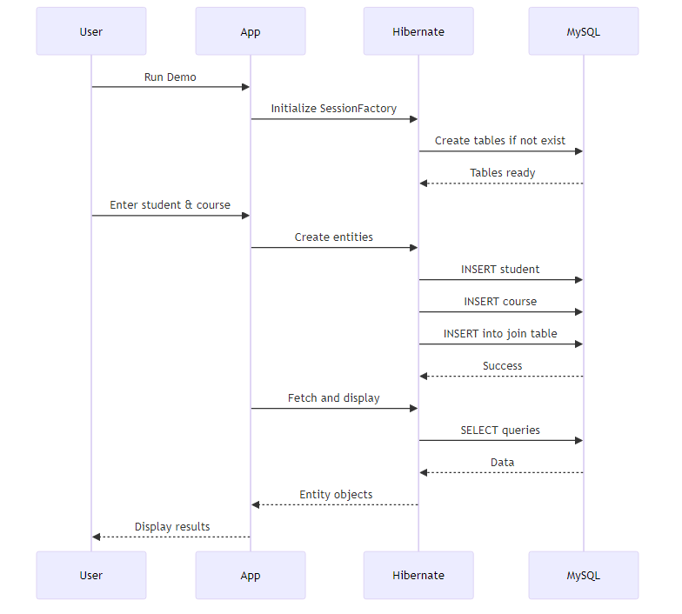

📊 Database Tables Created
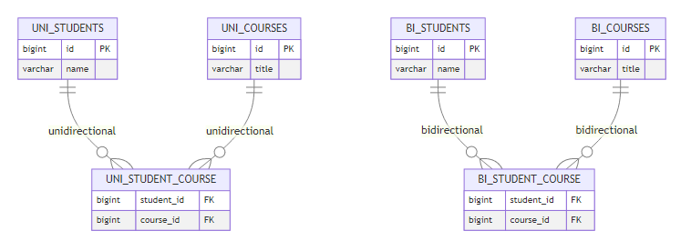

💻 Verify in MySQL
-- Check tables
SHOW TABLES;
-- Check unidirectional data
SELECT * FROM uni_students;
SELECT * FROM uni_courses;
SELECT * FROM uni_student_course;
-- Check bidirectional data
SELECT * FROM bi_students;
SELECT * FROM bi_courses;
SELECT * FROM bi_student_course;
-- Join query to see relationships
SELECT s.name, c.title
FROM uni_students s
JOIN uni_student_course sc ON s.id = sc.student_id
JOIN uni_courses c ON c.id = sc.course_id;

🚀 Both Implementations Running Successfully!
Setup Guide by Avinash Dhanuka | © 2026

10. WHAT I LEARNED
📝 Personal Learning Journey by: Avinash Dhanuka | © 2026
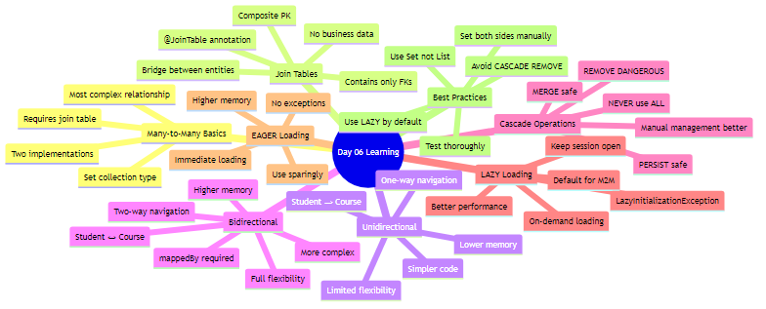

🎯 Key Takeaways
- Many-to-Many is Special
  - Always requires a join table
  - Cannot use simple foreign key
  - Most complex relationship type
  - Real-world scenarios everywhere
- Join Table is Essential
  - Stores relationships only
  - Contains two foreign keys
  - No business data
  - Managed by Hibernate automatically
- Set vs List
  - Always use Set for Many-to-Many
  - Prevents duplicate relationships
  - Better performance
  - Matches database constraints
- Directionality Matters
  - Unidirectional = Simple, one-way
  - Bidirectional = Flexible, two-way
  - Choose based on navigation needs
  - Database structure is same
- CASCADE is Dangerous
  - NEVER use CASCADE.REMOVE
  - NEVER use CASCADE.ALL
  - Use PERSIST and MERGE only
  - Manage deletions manually
- LAZY Loading is Default
  - Better performance
  - Lower memory usage
  - Watch for LazyInitializationException
  - Keep session open when accessing
- Bidirectional Requires Both Sides
  - Must set both sides manually
  - No automatic synchronization
  - Use helper methods if needed
  - Test consistency

💡 Real-World Applications
Many-to-Many Use Cases: - Students ↔ Courses (Education) - Actors ↔ Movies (Entertainment) - Authors ↔ Books (Publishing) - Products ↔ Categories (E-commerce) - Users ↔ Roles (Security) - Tags ↔ Posts (Blogging) - Doctors ↔ Patients (Healthcare) - Projects ↔ Employees (Management)

🔥 Interview-Ready Concepts
- Why Many-to-Many needs join table
- Difference between Unidirectional and Bidirectional
- Why use Set instead of List
- @JoinTable annotation parameters
- Why CASCADE.REMOVE is dangerous
- LAZY vs EAGER loading
- LazyInitializationException solutions
- mappedBy in Bidirectional
- When to use which directionality

🎓 Mastered Many-to-Many Relationships!
Learning documented by Avinash Dhanuka | © 2026

11. INTERVIEW QUESTIONS
📝 Comprehensive Q&A by: Avinash Dhanuka | GitHub

❓ Question 1: Why does Many-to-Many require a join table?
Answer:
Problem: Cannot use foreign key directly in either table.
Example:
Students table with course_id FK:
- Can only store ONE course per student ❌
Courses table with student_id FK:
- Can only store ONE student per course ❌
Solution: Join table stores all relationships.
student_course join table:
student_id | course_id
1 | 1 (John → Java)
1 | 2 (John → Python)
2 | 1 (Jane → Java)
✅ Can store MANY relationships!
Database Structure:
CREATE TABLE students (
id BIGINT PRIMARY KEY,
name VARCHAR(255)
);
CREATE TABLE courses (
id BIGINT PRIMARY KEY,
title VARCHAR(255)
);
CREATE TABLE student_course (
student_id BIGINT,
course_id BIGINT,
PRIMARY KEY (student_id, course_id),
FOREIGN KEY (student_id) REFERENCES students(id),
FOREIGN KEY (course_id) REFERENCES courses(id)
);
Interview Tip: Join table is the ONLY way to implement Many-to-Many in relational databases.

❓ Question 2: What is the difference between Unidirectional and Bidirectional Many-to-Many?
Answer:
Unidirectional: - Navigation only from Student to Course - Course has NO reference to Student - Simpler code - Cannot get Students from Course
// Student
@ManyToMany
@JoinTable(...)
private Set<Course> courses; // ✅ Has reference
// Course
// No students field! ❌
Bidirectional: - Navigation from both sides - Both have references to each other - More complex code - Can get Students from Course
// Student (Owner)
@ManyToMany
@JoinTable(...)
private Set<Course> courses; // ✅ Has reference
// Course (Inverse)
@ManyToMany(mappedBy = "courses")
private Set<Student> students; // ✅ Has reference
Database: SAME structure! Difference is only in Java code.
When to use: - Unidirectional: Simple lookups, one-way queries - Bidirectional: Full management, complex queries
Interview Tip: Database structure is identical; directionality is a Java-level concept.

❓ Question 3: Why use Set instead of List for Many-to-Many?
Answer:
Set Advantages: 1. No Duplicates: Student can’t enroll in same course twice 2. Better Performance: No need to check for duplicates 3. Matches Database: Composite PK prevents duplicates 4. Hibernate Recommendation: Official best practice
List Problems:
@ManyToMany
private List<Course> courses; // ❌ Problems
student.getCourses().add(java);
student.getCourses().add(java); // Duplicate allowed!
// Database constraint violation on save
Set Solution:
@ManyToMany
private Set<Course> courses; // ✅ Correct
student.getCourses().add(java);
student.getCourses().add(java); // Ignored, no duplicate
// No database error
Comparison:
Feature | List | Set
Duplicates | Allowed | Not allowed
Order | Maintained | Not maintained
Performance | Slower | Faster
M2M Suitability | ❌ Poor | ✅ Perfect
Interview Tip: Always use Set for Many-to-Many to prevent duplicate relationships.

❓ Question 4: Explain @JoinTable annotation with all parameters.
Answer:
@JoinTable defines the join table structure for Many-to-Many relationships.
Complete Example:
@ManyToMany
@JoinTable(
name = "student_course", // Join table name
joinColumns = @JoinColumn(name = "student_id"), // FK to Student
inverseJoinColumns = @JoinColumn(name = "course_id") // FK to Course
)
private Set<Course> courses;
Parameters Explained:
1. name: Join table name in database
name = "student_course"
// Creates table: student_course
2. joinColumns: Foreign key column for owning side (Student)
joinColumns = @JoinColumn(name = "student_id")
// Column in join table pointing to students.id
3. inverseJoinColumns: Foreign key column for inverse side (Course)
inverseJoinColumns = @JoinColumn(name = "course_id")
// Column in join table pointing to courses.id
Generated SQL:
CREATE TABLE student_course (
student_id BIGINT NOT NULL,
course_id BIGINT NOT NULL,
PRIMARY KEY (student_id, course_id),
FOREIGN KEY (student_id) REFERENCES students(id),
FOREIGN KEY (course_id) REFERENCES courses(id)
);
Interview Tip: Only the OWNER side has @JoinTable; inverse side uses mappedBy.

❓ Question 5: Why is CASCADE.REMOVE dangerous in Many-to-Many?
Answer:
CASCADE.REMOVE in Many-to-Many can delete shared entities, causing data loss.
Dangerous Scenario:
@ManyToMany(cascade = CascadeType.REMOVE) // ❌ DANGEROUS!
private Set<Course> courses;
// John enrolled in Java
// Jane also enrolled in Java
session.delete(john); // Delete John
// CASCADE.REMOVE deletes Java course!
// Jane loses her course! 💥
Why Dangerous:
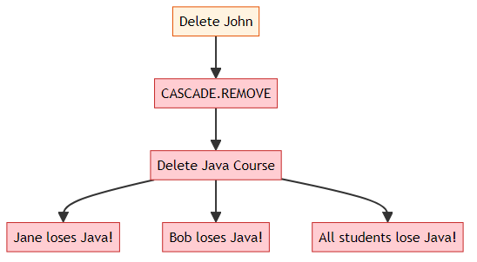
Safe Alternative:
// ✅ Remove relationship only, not entities
Student john = session.get(Student.class, 1L);
Course java = session.get(Course.class, 1L);
john.getCourses().remove(java);
java.getStudents().remove(john);
session.update(john);
// Only relationship removed from join table
// Java course still exists for other students
Safe Cascades:
@ManyToMany(cascade = {CascadeType.PERSIST, CascadeType.MERGE})
private Set<Course> courses;
Interview Tip: NEVER use CASCADE.REMOVE or CASCADE.ALL in Many-to-Many relationships.

❓ Question 6: What is LAZY loading and why is it default for Many-to-Many?
Answer:
LAZY Loading = Load related entities only when accessed, not immediately.
How it works:
// LAZY (default)
@ManyToMany(fetch = FetchType.LAZY)
private Set<Course> courses;
// Load student
Student john = session.get(Student.class, 1L);
// SQL: SELECT * FROM students WHERE id=1
// Courses NOT loaded yet
// Access courses
john.getCourses().forEach(...);
// SQL: SELECT * FROM courses JOIN student_course...
// Courses loaded NOW
Why Default for Many-to-Many:
- Performance: Many-to-Many can have MANY relationships
  - Student might have 50 courses
  - Loading all immediately is expensive
- Memory: Lower memory usage
  - Only load what you need
  - Avoid loading unnecessary data
- Scalability: Better for large datasets
  - Course might have 1000 students
  - EAGER would load all 1000 immediately
EAGER Alternative:
@ManyToMany(fetch = FetchType.EAGER)
private Set<Course> courses;
Student john = session.get(Student.class, 1L);
// SQL: SELECT * FROM students WHERE id=1
// SQL: SELECT * FROM courses JOIN student_course...
// Courses loaded IMMEDIATELY
Comparison:
Aspect | LAZY | EAGER
Loading | On-demand | Immediate
Performance | Better | Worse
Memory | Lower | Higher
Session | Must be open | Can close
Default | Yes ⭐ | No
Interview Tip: LAZY is default for @OneToMany and @ManyToMany; EAGER is default for @OneToOne and @ManyToOne.

❓ Question 7: What is LazyInitializationException and how to fix it?
Answer:
LazyInitializationException = Trying to access LAZY collection after session is closed.
Problem:
Session session = sessionFactory.openSession();
Student john = session.get(Student.class, 1L);
session.close(); // ❌ Session closed!
// LazyInitializationException!
john.getCourses().forEach(c -> System.out.println(c.getTitle()));
Why it happens: - Courses are LAZY loaded - Session is closed - Hibernate can’t fetch from database - Exception thrown
Solution 1: Keep Session Open
Session session = sessionFactory.openSession();
Student john = session.get(Student.class, 1L);
// Access while session is open
john.getCourses().forEach(c -> System.out.println(c.getTitle()));
session.close(); // Close after accessing
Solution 2: JOIN FETCH (HQL)
Student john = session.createQuery(
"SELECT s FROM Student s JOIN FETCH s.courses WHERE s.id = :id",
Student.class
)
.setParameter("id", 1L)
.getSingleResult();
session.close();
// ✅ Works! Courses already loaded
john.getCourses().forEach(c -> System.out.println(c.getTitle()));
Solution 3: Hibernate.initialize()
Session session = sessionFactory.openSession();
Student john = session.get(Student.class, 1L);
// Force initialization
Hibernate.initialize(john.getCourses());
session.close();
// ✅ Works! Courses initialized
john.getCourses().forEach(c -> System.out.println(c.getTitle()));
Solution 4: Use EAGER (Not Recommended)
@ManyToMany(fetch = FetchType.EAGER)
private Set<Course> courses;
Interview Tip: Best solution is JOIN FETCH for specific queries or keep session open for transaction scope.

❓ Question 8: How does mappedBy work in Bidirectional Many-to-Many?
Answer:
mappedBy tells Hibernate which side owns the relationship and controls the join table.
Without mappedBy (WRONG):
// Student
@ManyToMany
@JoinTable(name = "student_course", ...)
private Set<Course> courses;
// Course
@ManyToMany
@JoinTable(name = "course_student", ...) // ❌ Creates 2nd join table!
private Set<Student> students;
// Result: TWO join tables created! 💥
// student_course AND course_student
With mappedBy (CORRECT):
// Student (Owner)
@ManyToMany
@JoinTable(name = "student_course", ...)
private Set<Course> courses;
// Course (Inverse)
@ManyToMany(mappedBy = "courses") // ✅ Points to Student's field
private Set<Student> students;
// Result: ONE join table (student_course)
How mappedBy works: 1. Hibernate sees mappedBy = "courses" in Course 2. Looks for field named “courses” in Student 3. Finds @JoinTable definition there 4. Uses that join table for the relationship 5. No second table created
Rules: - Only ONE side has @JoinTable (owner) - Other side has mappedBy (inverse) - mappedBy value = field name in owner entity - Owner side controls join table structure
Interview Tip: mappedBy = “field name in the OTHER entity that owns the relationship”

❓ Question 9: What happens if you don’t set both sides in Bidirectional?
Answer:
Problem: Inconsistent state in memory, but database might be correct.
Scenario:
Student john = new Student("John");
Course java = new Course("Java");
// Only set one side
john.getCourses().add(java);
// java.getStudents().add(john); // ❌ Forgot this!
session.persist(john);
session.persist(java);
session.flush();
// Database: Relationship saved (because Student is owner)
// Memory: java.getStudents() is empty!
Memory vs Database:
In Memory:
john.getCourses() → [Java] ✅
java.getStudents() → [] ❌ Empty!
In Database:
SELECT * FROM student_course;
-- student_id | course_id
-- 1 | 1 ✅ Relationship exists!
Why Database is Correct: - Student is the OWNER (has @JoinTable) - Hibernate uses owner side to persist - Inverse side (Course) is ignored for persistence
Why Memory is Wrong: - Course’s students Set was never updated - In-memory object is inconsistent - Can cause bugs in same session
Correct Way:
Student john = new Student("John");
Course java = new Course("Java");
// Set BOTH sides
john.getCourses().add(java);
java.getStudents().add(john); // ✅ Set both!
session.persist(john);
session.persist(java);
// Memory: Both sides consistent
// Database: Relationship saved
Interview Tip: Always set both sides in Bidirectional relationships for consistency, even though only owner side is persisted.

❓ Question 10: Compare all Hibernate relationships with examples.
Answer:
1. One-to-One - One entity relates to exactly one other entity - Example: Person ↔ Passport - FK in either table - Use @OneToOne
@OneToOne
@JoinColumn(name = "passport_id")
private Passport passport;
2. One-to-Many - One entity relates to many other entities - Example: Department → Employees - FK in “many” side table - Use @OneToMany
@OneToMany(mappedBy = "department")
private List<Employee> employees;
3. Many-to-One - Many entities relate to one entity - Example: Employees → Department - FK in “many” side table - Use @ManyToOne
@ManyToOne
@JoinColumn(name = "department_id")
private Department department;
4. Many-to-Many - Many entities relate to many other entities - Example: Students ↔ Courses - Requires join table - Use @ManyToMany
@ManyToMany
@JoinTable(
name = "student_course",
joinColumns = @JoinColumn(name = "student_id"),
inverseJoinColumns = @JoinColumn(name = "course_id")
)
private Set<Course> courses;
Comparison Table:
Relationship | Example | FK Location | Join Table | Annotation
One-to-One | Person-Passport | Either table | No | @OneToOne
One-to-Many | Dept-Employees | Many side | No | @OneToMany
Many-to-One | Employees-Dept | Many side | No | @ManyToOne
Many-to-Many | Students-Courses | Join table | Yes | @ManyToMany
Default Fetch Types:
Relationship | Default Fetch
@OneToOne | EAGER
@ManyToOne | EAGER
@OneToMany | LAZY
@ManyToMany | LAZY
Interview Tip: Many-to-Many is the only relationship that REQUIRES a join table.

© 2026 Avinash Dhanuka
This comprehensive guide was crafted with ❤️ by Avinash Dhanuka

