☕ Hibernate Many-to-One: Unidirectional vs Bidirectional

© 2026 Avinash Dhanuka
Mastering Unidirectional & Bidirectional Many-to-One Relationships
Crafted with ❤️ for Understanding Relationship Directions

Learning Note: This guide demonstrates BOTH Unidirectional and Bidirectional Many-to-One relationships using Department-Employee example!
Prerequisites: - Complete understanding of One-to-Many Bidirectional - MySQL Server installed and running

📑 Table of Contents
- What’s New?
- Unidirectional vs Bidirectional
- Unidirectional Many-to-One
- Bidirectional Many-to-One
- Sequence Generators
- Key Differences
- Cascade Operations
- Running the Application
- What I Learned
- Interview Questions

1. WHAT’S NEW?
📝 Author: Avinash Dhanuka | GitHub

🎯 Two Implementations in One Project
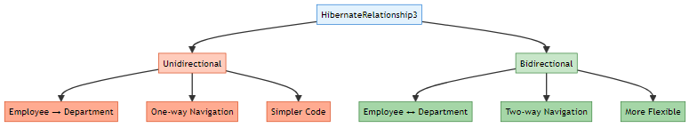

📊 What We’re Building
A Department-Employee Management System with TWO implementations:
Unidirectional: - Employee knows Department - Department doesn’t know Employees - One-way navigation only
Bidirectional: - Employee knows Department - Department knows Employees - Two-way navigation

🎯 Special Features
- Sequence Generators with custom increments
- Department IDs: 10, 20, 30, 40… (increment by 10)
- Employee IDs: 101, 102, 103, 104… (increment by 1)
- Interactive Menu for both implementations
- Separate Tables for each implementation

📚 Learning Path Progress
One-to-Many Bidirectional → Many-to-One (Uni & Bi) ✅ → Many-to-Many
Created by Avinash Dhanuka | © 2026

2. UNIDIRECTIONAL VS BIDIRECTIONAL
📝 Comprehensive Guide by: Avinash Dhanuka | © 2026

📌 What is Directionality?
Directionality = The ability to navigate between entities in your code.
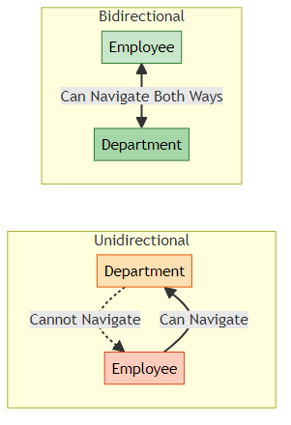

🔍 Real-World Analogy
Unidirectional = One-Way Street
Employee knows their Department
But Department doesn't track Employees
Bidirectional = Two-Way Street
Employee knows their Department
AND Department tracks all Employees

📊 Comparison Table
Feature | Unidirectional | Bidirectional
Navigation | Employee → Department only | Employee ↔ Department
Code Complexity | Simpler | More complex
Memory Usage | Lower | Higher
Use Case | Simple lookups | Full management
@JoinColumn | In Employee only | In Employee only
mappedBy | Not needed | Required in Department
Helper Methods | Not needed | Recommended
Cascade | Limited options | Full control

💡 When to Use Which?
Use Unidirectional When: - You only need to find Department from Employee - Simpler code is priority - Memory optimization matters - Read-only operations
Use Bidirectional When: - You need to find Employees from Department - Full CRUD operations required - Cascade operations needed - Complex business logic

🎓 Understanding Directionality is Key to Mastering Relationships
Guide by Avinash Dhanuka | © 2026

3. UNIDIRECTIONAL MANY-TO-ONE
📝 Author: Avinash Dhanuka | Contact via Gmail

🎯 What is Unidirectional Many-to-One?
Many Employees → One Department (One-way navigation)
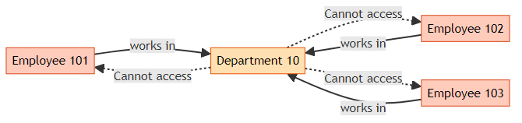

🏗️ Database Structure
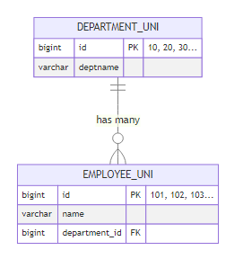

📝 Entity Classes

Department.java (Unidirectional)
@Entity
@Table(name = "department_uni")
public class Department {
@Id
@GeneratedValue(strategy = GenerationType.SEQUENCE, generator = "dept_seq")
@SequenceGenerator(name = "dept_seq", initialValue = 10, allocationSize = 10)
private Long id;
private String deptname;
// NO reference to Employee!
// Department doesn't know about Employees
// Constructors, Getters, Setters, toString()
}

Employee.java (Unidirectional)
@Entity
@Table(name = "employee_uni")
public class Employee {
@Id
@GeneratedValue(strategy = GenerationType.SEQUENCE, generator = "emp_seq")
@SequenceGenerator(name = "emp_seq", initialValue = 101, allocationSize = 1)
private Long id;
private String name;
// Employee knows Department (Unidirectional)
@ManyToOne
@JoinColumn(name = "department_id")
private Department department;
// Constructors, Getters, Setters, toString()
}
Key Points: - @ManyToOne in Employee only - @JoinColumn defines FK column name - Department has NO reference to Employee - Simple and straightforward

🔄 How It Works
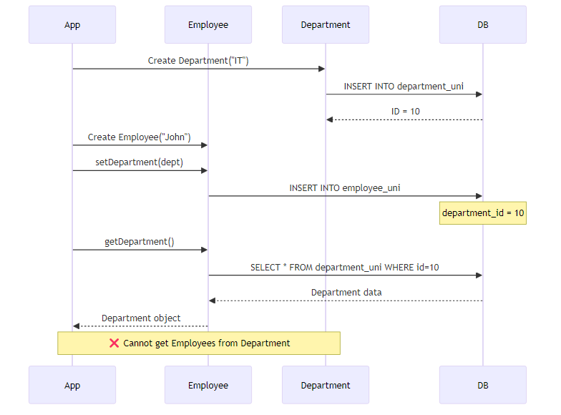

💻 Usage Example
// Create Department
Department dept = new Department("IT");
session.save(dept); // ID = 10
// Create Employees
Employee emp1 = new Employee("John");
emp1.setDepartment(dept);
session.save(emp1); // ID = 101
Employee emp2 = new Employee("Jane");
emp2.setDepartment(dept);
session.save(emp2); // ID = 102
// ✅ Can navigate from Employee to Department
System.out.println(emp1.getDepartment().getDeptname()); // "IT"
// ❌ Cannot navigate from Department to Employees
// dept.getEmployees() - Method doesn't exist!

⚡ Advantages & Disadvantages
✅ Advantages: - Simpler code structure - Less memory overhead - Easier to maintain - No risk of circular references - Faster for simple queries
❌ Disadvantages: - Cannot get Employees from Department - Limited cascade options - Need HQL/SQL for reverse queries - Less flexible for complex operations

📊 Memory Representation
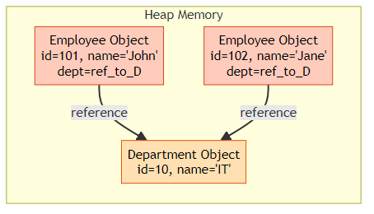

🔥 Unidirectional = Simple & Efficient for One-Way Navigation
© 2026 Avinash Dhanuka

4. BIDIRECTIONAL MANY-TO-ONE
📝 Comprehensive Guide by: Avinash Dhanuka | © 2026

🎯 What is Bidirectional Many-to-One?
Many Employees ↔ One Department (Two-way navigation)
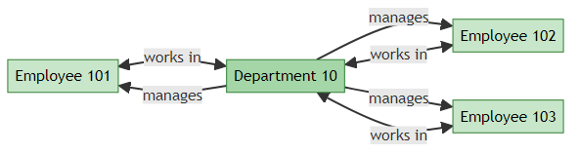

🏗️ Database Structure
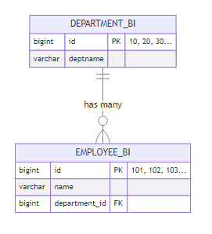
Note: Database structure is SAME as Unidirectional! The difference is in Java code only.

📝 Entity Classes

DepartmentBi.java (Bidirectional)
@Entity
@Table(name = "department_bi")
public class DepartmentBi {
@Id
@GeneratedValue(strategy = GenerationType.SEQUENCE, generator = "dept_bi_seq")
@SequenceGenerator(name = "dept_bi_seq", initialValue = 10, allocationSize = 10)
private Long id;
private String deptname;
// Department now knows about Employees!
@OneToMany(mappedBy = "department", cascade = CascadeType.ALL, orphanRemoval = true)
private List<EmployeeBi> employees = new ArrayList<>();
// Helper methods to maintain bidirectional relationship
public void addEmployee(EmployeeBi employee) {
employees.add(employee);
employee.setDepartment(this);
}
public void removeEmployee(EmployeeBi employee) {
employees.remove(employee);
employee.setDepartment(null);
}
// Constructors, Getters, Setters, toString()
}
Key Points: - @OneToMany(mappedBy = "department") - Points to Employee’s field - cascade = CascadeType.ALL - Operations cascade to Employees - orphanRemoval = true - Removes orphaned Employees - Helper methods maintain both sides

EmployeeBi.java (Bidirectional)
@Entity
@Table(name = "employee_bi")
public class EmployeeBi {
@Id
@GeneratedValue(strategy = GenerationType.SEQUENCE, generator = "emp_bi_seq")
@SequenceGenerator(name = "emp_bi_seq", initialValue = 101, allocationSize = 1)
private Long id;
private String name;
// Employee knows Department (Owner side)
@ManyToOne
@JoinColumn(name = "department_id")
private Department department;
// Constructors, Getters, Setters, toString()
}
Key Points: - @ManyToOne with @JoinColumn - Owner side - Only ONE side has @JoinColumn - Other side uses mappedBy

🔄 How It Works
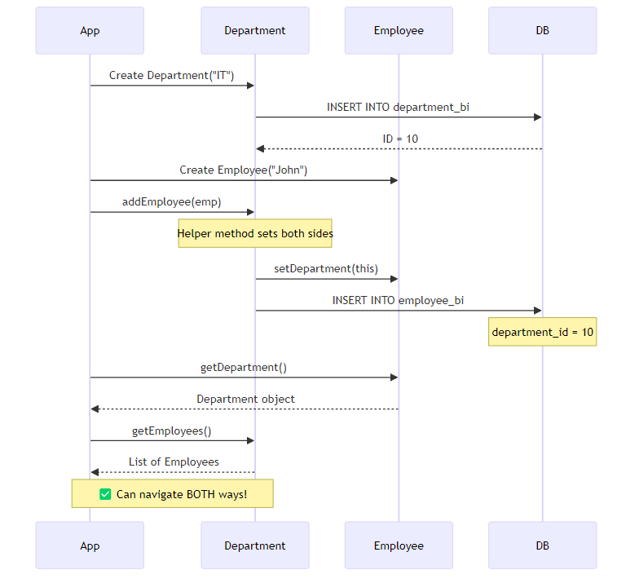

🎯 The Golden Rule of Bidirectional
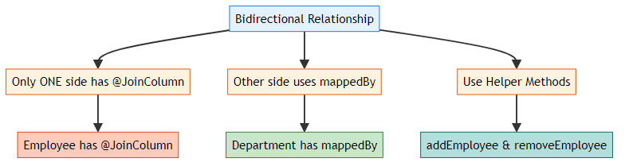
Why This Rule?
If you add @JoinColumn on BOTH sides: - 💥 Hibernate gets confused - 💥 Doesn’t know which controls FK - 💥 Throws AnnotationException

💻 Usage Example
// Create Department
DepartmentBi dept = new DepartmentBi("IT");
session.save(dept); // ID = 10
// Create Employees using helper method
EmployeeBi emp1 = new EmployeeBi("John");
dept.addEmployee(emp1); // Sets both sides automatically
EmployeeBi emp2 = new EmployeeBi("Jane");
dept.addEmployee(emp2);
session.update(dept); // Cascade saves employees
// ✅ Navigate from Employee to Department
System.out.println(emp1.getDepartment().getDeptname()); // "IT"
// ✅ Navigate from Department to Employees
for (EmployeeBi emp : dept.getEmployees()) {
System.out.println(emp.getName());
}

🔥 Why Helper Methods?
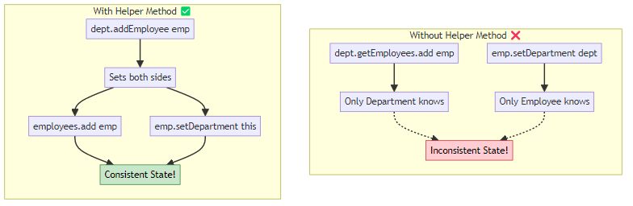
Helper Method Benefits: - Maintains consistency on both sides - Prevents bugs and data inconsistency - Cleaner code - Easier to maintain

⚡ Advantages & Disadvantages
✅ Advantages: - Two-way navigation - Full cascade control - Flexible operations - Better for complex logic - Can get Employees from Department
❌ Disadvantages: - More complex code - Higher memory usage - Risk of circular references - Need helper methods - More maintenance

🎓 Bidirectional = Full Control with Two-Way Navigation
Crafted by Avinash Dhanuka | © 2026

5. SEQUENCE GENERATORS
📝 Author: Avinash Dhanuka | GitHub

🎯 What are Sequence Generators?
Sequence Generators = Custom ID generation strategies in Hibernate

📊 Our Custom Sequences
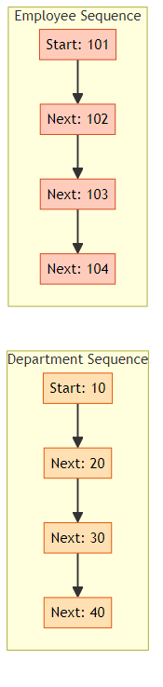

💻 Department Sequence Configuration
@Id
@GeneratedValue(strategy = GenerationType.SEQUENCE, generator = "dept_seq")
@SequenceGenerator(
name = "dept_seq", // Generator name
initialValue = 10, // Start from 10
allocationSize = 10 // Increment by 10
)
private Long id;
Result: 10, 20, 30, 40, 50…

💻 Employee Sequence Configuration
@Id
@GeneratedValue(strategy = GenerationType.SEQUENCE, generator = "emp_seq")
@SequenceGenerator(
name = "emp_seq", // Generator name
initialValue = 101, // Start from 101
allocationSize = 1 // Increment by 1
)
private Long id;
Result: 101, 102, 103, 104, 105…

📊 Sequence Parameters Explained
Parameter | Description | Example
name | Unique generator name | “dept_seq”
initialValue | Starting value | 10 or 101
allocationSize | Increment step | 10 or 1
sequenceName | DB sequence name (optional) | “dept_id_seq”

🔄 How Sequences Work
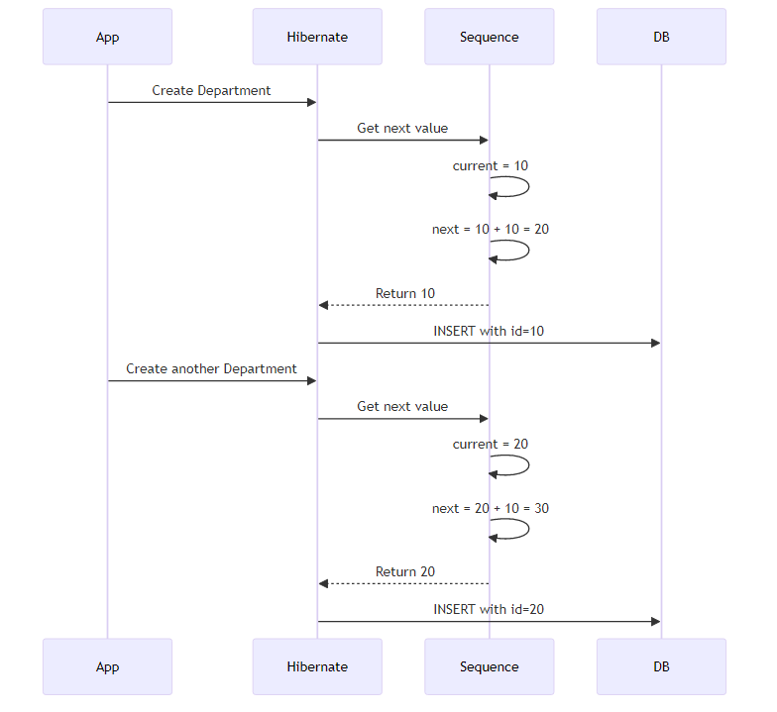

💡 Why Custom Sequences?
Benefits: - Meaningful IDs (10, 20, 30 easier to remember than 1, 2, 3) - Room for manual insertions between IDs - Better organization - Professional appearance - Easier debugging
Real-World Example:
Department IDs: 10, 20, 30, 40
Employee IDs: 101, 102, 103, 104
Easy to identify:
- ID 30 = Department
- ID 103 = Employee

🔢 Custom Sequences = Professional ID Management
© 2026 Avinash Dhanuka

6. KEY DIFFERENCES
📝 Comprehensive Comparison by: Avinash Dhanuka | © 2026

📊 Unidirectional vs Bidirectional
Aspect | Unidirectional | Bidirectional
Navigation | Employee → Department only | Employee ↔ Department
@JoinColumn | In Employee | In Employee
@OneToMany | Not present | In Department with mappedBy
mappedBy | Not needed | Required
Helper Methods | Not needed | Strongly recommended
Cascade | Limited | Full control
orphanRemoval | Not applicable | Available
Code Complexity | Simple | More complex
Memory Usage | Lower | Higher
Query Flexibility | Limited | High
Use Case | Simple lookups | Full management
Maintenance | Easier | Requires care

🎯 Code Comparison
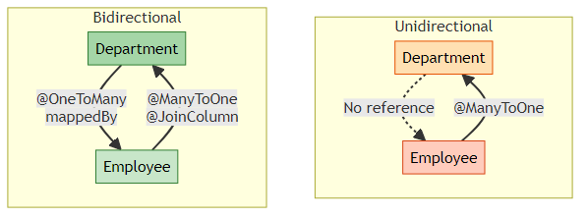

💻 Side-by-Side Code
Unidirectional:
// Department - NO reference to Employee
@Entity
public class Department {
@Id
private Long id;
private String deptname;
// No employees field!
}
// Employee - Has reference to Department
@Entity
public class Employee {
@Id
private Long id;
private String name;
@ManyToOne
@JoinColumn(name = "department_id")
private Department department;
}
Bidirectional:
// Department - Has reference to Employees
@Entity
public class DepartmentBi {
@Id
private Long id;
private String deptname;
@OneToMany(mappedBy = "department", cascade = CascadeType.ALL)
private List<EmployeeBi> employees = new ArrayList<>();
public void addEmployee(EmployeeBi emp) {
employees.add(emp);
emp.setDepartment(this);
}
}
// Employee - Has reference to Department
@Entity
public class EmployeeBi {
@Id
private Long id;
private String name;
@ManyToOne
@JoinColumn(name = "department_id")
private DepartmentBi department;
}

🔍 Operation Comparison
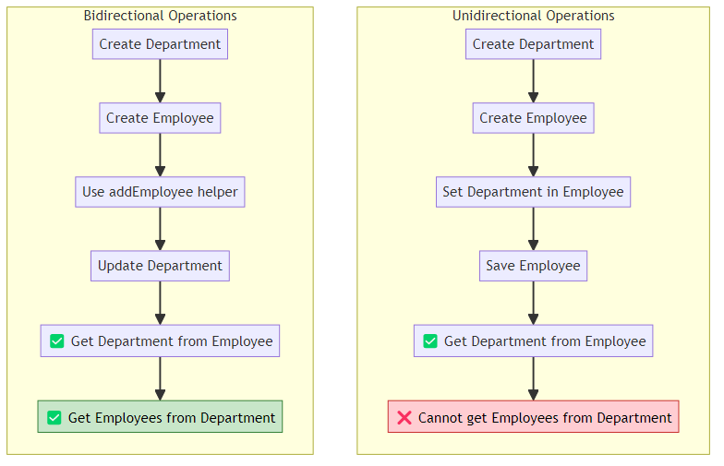

📈 Performance Comparison
Operation | Unidirectional | Bidirectional
Insert Employee | Fast | Fast
Get Department | Fast | Fast
Get Employees | Need HQL | Direct access
Cascade Save | Limited | Full support
Memory | Lower | Higher
Lazy Loading | Simple | Complex

🎯 Decision Matrix
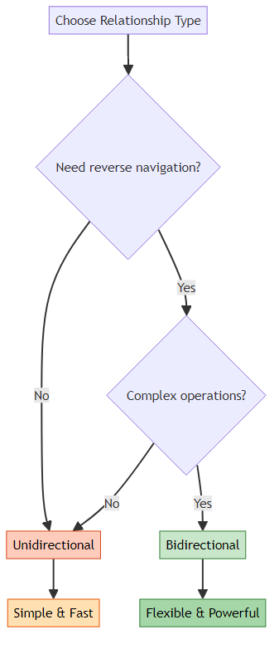

🎓 Choose Based on Your Requirements, Not Complexity
Guide by Avinash Dhanuka | © 2026

7. CASCADE OPERATIONS
📝 Detailed Guide by: Avinash Dhanuka | Contact

🎯 What is Cascade?
Cascade = Propagating operations from parent to child entities automatically.
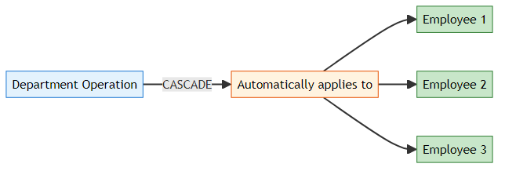

📊 Cascade Types
Cascade Type | What It Does | When to Use
PERSIST | Save child when parent is saved | Creating new entities
MERGE | Update child when parent is updated | Updating entities
REMOVE | Delete child when parent is deleted | Deleting entities
REFRESH | Reload child when parent is refreshed | Syncing with DB
DETACH | Detach child when parent is detached | Session management
ALL | All of the above | Full lifecycle management

🔥 CASCADE.PERSIST
What it does: When you save Department, Employees are saved automatically.
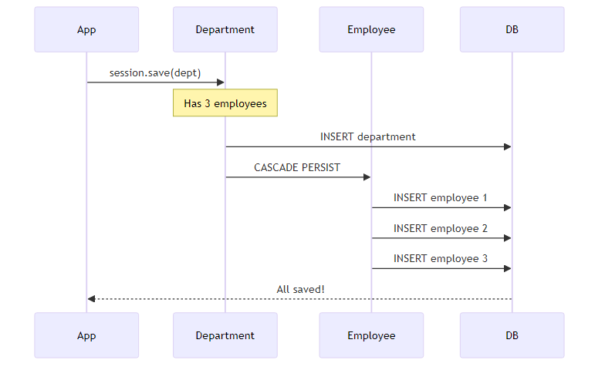
Code Example:
@OneToMany(mappedBy = "department", cascade = CascadeType.PERSIST)
private List<EmployeeBi> employees;
// Usage
DepartmentBi dept = new DepartmentBi("IT");
dept.addEmployee(new EmployeeBi("John"));
dept.addEmployee(new EmployeeBi("Jane"));
session.save(dept); // Saves department AND employees!

🔥 CASCADE.MERGE
What it does: When you update Department, Employees are updated automatically.
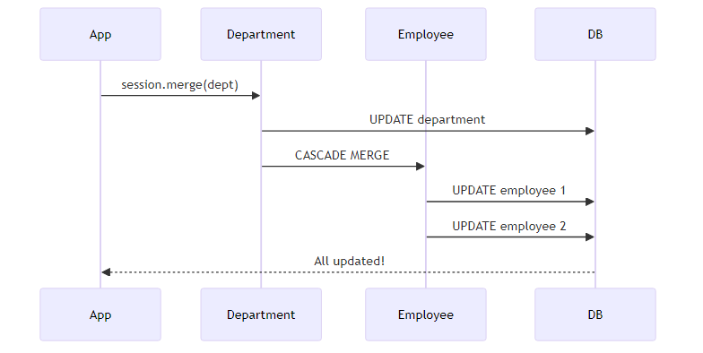
Code Example:
@OneToMany(mappedBy = "department", cascade = CascadeType.MERGE)
private List<EmployeeBi> employees;
// Usage
dept.setDeptname("IT Department");
dept.getEmployees().get(0).setName("John Doe");
session.merge(dept); // Updates department AND employees!

🔥 CASCADE.REMOVE
What it does: When you delete Department, Employees are deleted automatically.
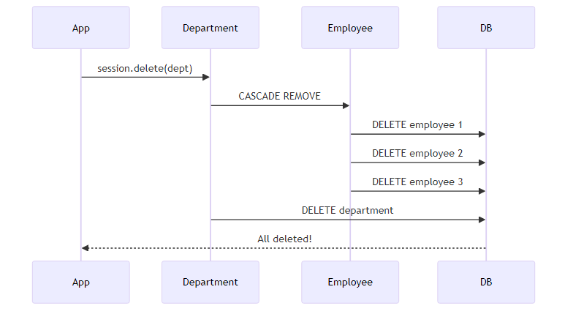
Code Example:
@OneToMany(mappedBy = "department", cascade = CascadeType.REMOVE)
private List<EmployeeBi> employees;
// Usage
session.delete(dept); // Deletes department AND all employees!
⚠️ Warning: Use carefully! This will delete all child records.

🔥 CASCADE.REFRESH
What it does: When you refresh Department, Employees are refreshed from DB.
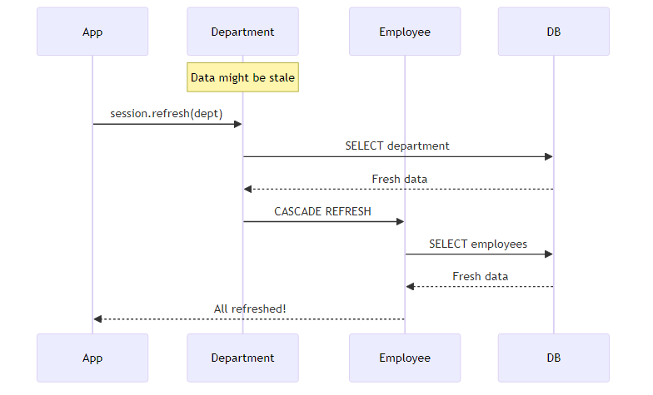
Code Example:
@OneToMany(mappedBy = "department", cascade = CascadeType.REFRESH)
private List<EmployeeBi> employees;
// Usage
session.refresh(dept); // Reloads department AND employees from DB!

🔥 CASCADE.DETACH
What it does: When you detach Department, Employees are detached from session.
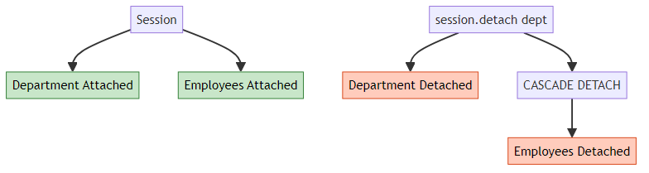
Code Example:
@OneToMany(mappedBy = "department", cascade = CascadeType.DETACH)
private List<EmployeeBi> employees;
// Usage
session.detach(dept); // Detaches department AND employees!

🔥 CASCADE.ALL
What it does: Applies ALL cascade types (PERSIST, MERGE, REMOVE, REFRESH, DETACH).
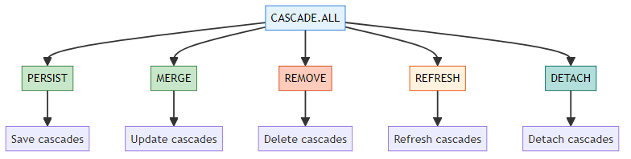
Code Example:
@OneToMany(mappedBy = "department", cascade = CascadeType.ALL, orphanRemoval = true)
private List<EmployeeBi> employees;
// Usage - Everything cascades!
session.save(dept); // Saves employees
session.merge(dept); // Updates employees
session.delete(dept); // Deletes employees
session.refresh(dept); // Refreshes employees
session.detach(dept); // Detaches employees

🎯 orphanRemoval
What it does: Removes child entities that are no longer referenced by parent.
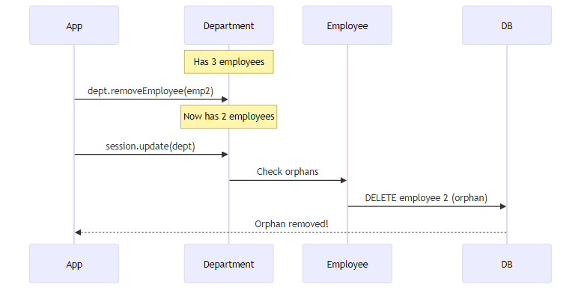
Code Example:
@OneToMany(mappedBy = "department", cascade = CascadeType.ALL, orphanRemoval = true)
private List<EmployeeBi> employees;
// Usage
dept.removeEmployee(emp); // Employee is removed from list
session.update(dept); // Employee is deleted from DB!

📊 Cascade Comparison
Scenario | Without Cascade | With Cascade
Save Department | Manual save each Employee | Auto-saves Employees
Update Department | Manual update each Employee | Auto-updates Employees
Delete Department | Manual delete each Employee | Auto-deletes Employees
Refresh Department | Manual refresh each Employee | Auto-refreshes Employees
Remove from List | Employee remains in DB | Employee deleted (orphanRemoval)

💡 Best Practices
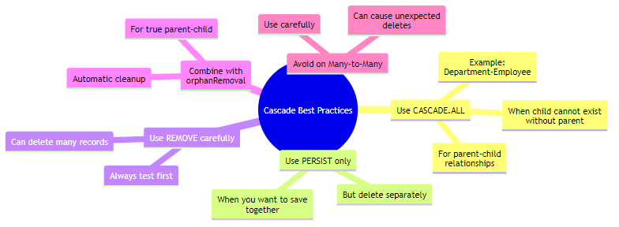
Golden Rules: 1. Use CASCADE.ALL for true parent-child relationships 2. Always combine with orphanRemoval = true for cleanup 3. Use helper methods to maintain consistency 4. Test cascade operations thoroughly 5. Be careful with REMOVE - it deletes data!

🔥 Cascade = Automatic Propagation of Operations
© 2026 Avinash Dhanuka

8. RUNNING THE APPLICATION
📝 Step-by-Step Guide by: Avinash Dhanuka | © 2026

🎯 Prerequisites
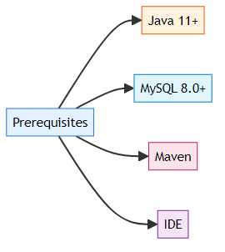

📝 Step 1: Database Setup
-- Create database
CREATE DATABASE hibernate_relationship3;
-- Use database
USE hibernate_relationship3;
-- Tables will be created automatically by Hibernate

📝 Step 2: Configure hibernate.cfg.xml
<hibernate-configuration>
<session-factory>
<property name="hibernate.connection.driver_class">com.mysql.cj.jdbc.Driver</property>
<property name="hibernate.connection.url">jdbc:mysql://localhost:3306/hibernate_relationship3</property>
<property name="hibernate.connection.username">root</property>
<property name="hibernate.connection.password">your_password</property>
<property name="hibernate.dialect">org.hibernate.dialect.MySQL8Dialect</property>
<property name="hibernate.hbm2ddl.auto">update</property>
<property name="hibernate.show_sql">true</property>
<property name="hibernate.format_sql">true</property>
<!-- Entity mappings -->
<mapping class="org.example.unidirectional.Department"/>
<mapping class="org.example.unidirectional.Employee"/>
<mapping class="org.example.bidirectional.DepartmentBi"/>
<mapping class="org.example.bidirectional.EmployeeBi"/>
</session-factory>
</hibernate-configuration>

📝 Step 3: Run Unidirectional Demo
# Navigate to project directory
cd day06/HibernateRelationship3
# Run Unidirectional Demo
mvn exec:java -Dexec.mainClass="org.example.unidirectional.UnidirectionalDemo"
Menu Options:
--- MENU ---
1. Create Department
2. Create Employee
3. Display All Departments
4. Display All Employees
5. Exit
Sample Flow:
1. Create Department "IT" → ID: 10
2. Create Department "HR" → ID: 20
3. Create Employee "John" → Assign to Dept 10 → ID: 101
4. Create Employee "Jane" → Assign to Dept 10 → ID: 102
5. Display Employees → Shows John (IT), Jane (IT)

📝 Step 4: Run Bidirectional Demo
# Run Bidirectional Demo
mvn exec:java -Dexec.mainClass="org.example.bidirectional.BidirectionalDemo"
Menu Options:
--- MENU ---
1. Create Department
2. Create Employee
3. Display All Departments with Employees
4. Display All Employees
5. Exit
Sample Flow:
1. Create Department "IT" → ID: 10
2. Create Employee "John" → Assign to Dept 10 → ID: 101
3. Create Employee "Jane" → Assign to Dept 10 → ID: 102
4. Display Departments with Employees → Shows IT with John, Jane

🔄 Execution Flow
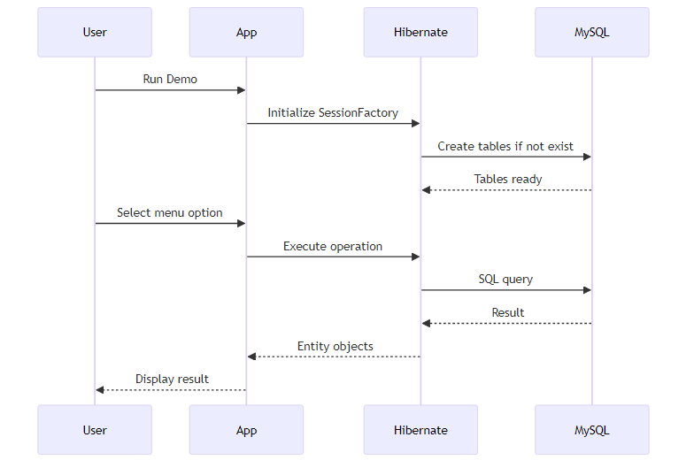

📊 Database Tables Created
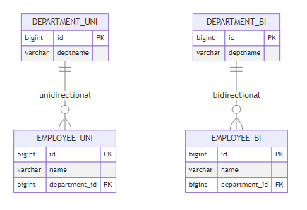

💻 Expected Output
Unidirectional Demo:
=== Unidirectional Many-to-One Relationship Demo ===
Department IDs: Auto-generated (10, 20, 30...)
Employee IDs: Auto-generated (101, 102, 103...)
--- MENU ---
1. Create Department
2. Create Employee
3. Display All Departments
4. Display All Employees
5. Exit
Enter your choice: 1
Enter Department Name: IT
✓ Department created successfully with ID: 10
Enter your choice: 2
Enter Employee Name: John
Available Departments:
ID: 10 - IT
Enter Department ID to assign: 10
✓ Employee created successfully with ID: 101
Bidirectional Demo:
=== Bidirectional Many-to-One Relationship Demo ===
--- MENU ---
1. Create Department
2. Create Employee
3. Display All Departments with Employees
4. Display All Employees
5. Exit
Enter your choice: 3
=== All Departments with Employees ===
Department [id=10, deptname=IT]
Employees:
- ID: 101, Name: John
- ID: 102, Name: Jane

🚀 Both Implementations Running Successfully!
Setup Guide by Avinash Dhanuka | © 2026

9. WHAT I LEARNED
📝 Personal Learning Journey by: Avinash Dhanuka | © 2026
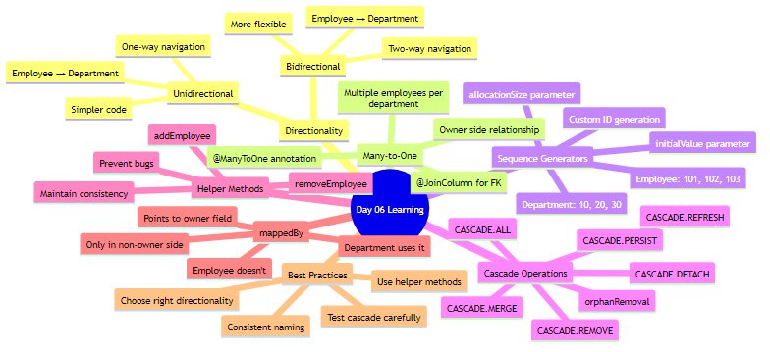

🎯 Key Takeaways
- Directionality Matters
  - Unidirectional = Simple, one-way navigation
  - Bidirectional = Flexible, two-way navigation
  - Choose based on requirements, not complexity
- The Golden Rule
  - Only ONE side has @JoinColumn
  - Other side uses mappedBy
  - Never put @JoinColumn on both sides
- Helper Methods are Essential
  - Maintain consistency on both sides
  - Prevent data inconsistency bugs
  - Make code cleaner and safer
- Cascade is Powerful
  - Automates operation propagation
  - Use CASCADE.ALL for parent-child
  - Combine with orphanRemoval = true
  - Test thoroughly before production
- Sequence Generators
  - Custom ID generation strategies
  - Professional ID management
  - Easier debugging and organization
- Database Structure is Same
  - Unidirectional and Bidirectional have same DB structure
  - Difference is only in Java code
  - Foreign key always in child table

💡 Real-World Applications
Unidirectional Use Cases: - Employee → Department lookup - Product → Category - Order → Customer (simple) - Comment → Post (read-only)
Bidirectional Use Cases: - Department ↔ Employees (full management) - Customer ↔ Orders (with cascade) - Author ↔ Books - Teacher ↔ Students

🔥 Interview-Ready Concepts
- Difference between Unidirectional and Bidirectional
- Why only one side has @JoinColumn
- What mappedBy does internally
- All CASCADE types and their uses
- When to use orphanRemoval
- How Sequence Generators work
- Helper methods importance

🎓 Mastered Unidirectional & Bidirectional Many-to-One Relationships!
Learning documented by Avinash Dhanuka | © 2026

10. INTERVIEW QUESTIONS
📝 Comprehensive Q&A by: Avinash Dhanuka | GitHub

❓ Question 1: What is the difference between Unidirectional and Bidirectional Many-to-One?
Answer:
Unidirectional: - Navigation only from Employee to Department - Department doesn’t have reference to Employees - Simpler code, less memory - Cannot get Employees from Department directly
Bidirectional: - Navigation from both sides - Department has List of Employees - More complex, more memory - Can get Employees from Department
Code Difference:
// Unidirectional - Department has NO employees field
@Entity
public class Department {
@Id
private Long id;
private String deptname;
}
// Bidirectional - Department HAS employees field
@Entity
public class DepartmentBi {
@Id
private Long id;
private String deptname;
@OneToMany(mappedBy = "department")
private List<EmployeeBi> employees;
}
Database: Both have SAME structure! Difference is only in Java code.

❓ Question 2: Why can only ONE side have @JoinColumn in Bidirectional?
Answer:
Reason: Hibernate needs to know which side controls the foreign key.
What happens if both have @JoinColumn:
// ❌ WRONG - Both sides have @JoinColumn
@Entity
public class Employee {
@ManyToOne
@JoinColumn(name = "department_id") // ❌
private Department department;
}
@Entity
public class Department {
@OneToMany
@JoinColumn(name = "department_id") // ❌
private List<Employee> employees;
}
// Result: AnnotationException - Hibernate is confused!
Correct Way:
// ✅ CORRECT - Only Employee has @JoinColumn
@Entity
public class Employee {
@ManyToOne
@JoinColumn(name = "department_id") // ✅ Owner side
private Department department;
}
@Entity
public class Department {
@OneToMany(mappedBy = "department") // ✅ Points to Employee's field
private List<Employee> employees;
}
Rule: Owner side (Many side) has @JoinColumn, other side uses mappedBy.

❓ Question 3: What does mappedBy do internally?
Answer:
mappedBy tells Hibernate: “Don’t create a new column, use the existing one from the other side.”
Without mappedBy:
@OneToMany
private List<Employee> employees;
// Hibernate creates a JOIN TABLE:
// department_employee (department_id, employee_id)
With mappedBy:
@OneToMany(mappedBy = "department")
private List<Employee> employees;
// Hibernate uses existing FK in employee table:
// employee (id, name, department_id)
How it works: 1. Hibernate sees mappedBy = "department" 2. Looks for field named “department” in Employee 3. Finds @JoinColumn(name = "department_id") 4. Uses that column for the relationship 5. No extra table created!
Interview Tip: mappedBy = “field name in the other entity”

❓ Question 4: Explain all CASCADE types with examples.
Answer:
1. CASCADE.PERSIST - Save child when parent is saved
dept.addEmployee(new Employee("John"));
session.save(dept); // Saves department AND John
2. CASCADE.MERGE - Update child when parent is updated
dept.setDeptname("IT Dept");
session.merge(dept); // Updates department AND employees
3. CASCADE.REMOVE - Delete child when parent is deleted
session.delete(dept); // Deletes department AND all employees
4. CASCADE.REFRESH - Reload child when parent is refreshed
session.refresh(dept); // Reloads department AND employees from DB
5. CASCADE.DETACH - Detach child when parent is detached
session.detach(dept); // Detaches department AND employees from session
6. CASCADE.ALL - All of the above
@OneToMany(mappedBy = "department", cascade = CascadeType.ALL)
private List<Employee> employees;
Interview Tip: CASCADE.ALL = PERSIST + MERGE + REMOVE + REFRESH + DETACH

❓ Question 5: What is orphanRemoval and when to use it?
Answer:
orphanRemoval = Automatically delete child entities that are no longer referenced by parent.
Without orphanRemoval:
@OneToMany(mappedBy = "department", cascade = CascadeType.ALL)
private List<Employee> employees;
dept.removeEmployee(emp); // Removes from list
session.update(dept); // Employee still in DB! (orphan)
With orphanRemoval:
@OneToMany(mappedBy = "department", cascade = CascadeType.ALL, orphanRemoval = true)
private List<Employee> employees;
dept.removeEmployee(emp); // Removes from list
session.update(dept); // Employee deleted from DB! ✅
When to use: - True parent-child relationships - Child cannot exist without parent - Example: Department-Employee, Order-OrderItem
When NOT to use: - Child can exist independently - Shared relationships - Example: Student-Course (student can exist without course)
Interview Tip: orphanRemoval = true means “delete child if removed from parent’s collection”

❓ Question 6: Why use helper methods in Bidirectional relationships?
Answer:
Problem without helper methods:
// ❌ Inconsistent state
dept.getEmployees().add(emp); // Department knows Employee
// But emp.getDepartment() is null! // Employee doesn't know Department
// OR
emp.setDepartment(dept); // Employee knows Department
// But dept.getEmployees() is empty! // Department doesn't know Employee
Solution with helper methods:
// ✅ Consistent state
public void addEmployee(Employee emp) {
employees.add(emp); // Department knows Employee
emp.setDepartment(this); // Employee knows Department
}
// Usage
dept.addEmployee(emp); // Both sides updated automatically!
Benefits: 1. Maintains consistency on both sides 2. Prevents bugs and data inconsistency 3. Cleaner, more maintainable code 4. Single point of control 5. Easier to test
Interview Tip: Helper methods are ESSENTIAL for Bidirectional relationships to maintain consistency.

❓ Question 7: How do Sequence Generators work in Hibernate?
Answer:
Sequence Generator = Custom ID generation strategy with configurable start and increment.
Configuration:
@Id
@GeneratedValue(strategy = GenerationType.SEQUENCE, generator = "dept_seq")
@SequenceGenerator(
name = "dept_seq", // Generator name
initialValue = 10, // Start from 10
allocationSize = 10 // Increment by 10
)
private Long id;
How it works: 1. First entity: ID = 10 2. Second entity: ID = 10 + 10 = 20 3. Third entity: ID = 20 + 10 = 30 4. And so on…
Parameters: - name: Unique generator name - initialValue: Starting value (default: 1) - allocationSize: Increment step (default: 50) - sequenceName: Database sequence name (optional)
Real-World Example:
// Department: 10, 20, 30, 40...
@SequenceGenerator(name = "dept_seq", initialValue = 10, allocationSize = 10)
// Employee: 101, 102, 103, 104...
@SequenceGenerator(name = "emp_seq", initialValue = 101, allocationSize = 1)
Benefits: - Meaningful IDs - Easy to identify entity type - Room for manual insertions - Professional appearance
Interview Tip: allocationSize is the increment, NOT the total number of IDs!

❓ Question 8: When to use Unidirectional vs Bidirectional?
Answer:
Use Unidirectional when: - Only need to navigate from child to parent - Simpler code is priority - Memory optimization matters - Read-only operations - Example: Comment → Post (just need to know which post)
Use Bidirectional when: - Need to navigate from both sides - Full CRUD operations required - Cascade operations needed - Complex business logic - Example: Department ↔ Employees (need to manage both)
Decision Matrix:
Requirement | Unidirectional | Bidirectional
Get parent from child | ✅ | ✅
Get children from parent | ❌ (need HQL) | ✅
Cascade operations | Limited | Full
Code complexity | Simple | Complex
Memory usage | Lower | Higher
Maintenance | Easier | Requires care
Interview Tip: Choose based on navigation needs, not complexity!

❓ Question 9: What’s the difference between CASCADE.REMOVE and orphanRemoval?
Answer:
CASCADE.REMOVE: - Triggered when parent is DELETED - Deletes all children - Explicit delete operation
@OneToMany(mappedBy = "department", cascade = CascadeType.REMOVE)
private List<Employee> employees;
session.delete(dept); // Deletes department AND all employees
orphanRemoval: - Triggered when child is REMOVED from collection - Deletes only orphaned children - Implicit delete operation
@OneToMany(mappedBy = "department", orphanRemoval = true)
private List<Employee> employees;
dept.removeEmployee(emp); // Removes from list
session.update(dept); // Deletes emp from DB
Key Differences:
Aspect | CASCADE.REMOVE | orphanRemoval
Trigger | Parent deleted | Child removed from collection
Scope | All children | Only orphaned children
Operation | Explicit delete | Implicit delete
Use Case | Delete entire hierarchy | Remove specific child
Combined Usage:
@OneToMany(mappedBy = "department",
cascade = CascadeType.ALL,
orphanRemoval = true)
private List<Employee> employees;
// Now both work:
session.delete(dept); // CASCADE.REMOVE deletes all
dept.removeEmployee(emp); // orphanRemoval deletes emp
Interview Tip: CASCADE.REMOVE = delete parent → delete children. orphanRemoval = remove from list → delete child.

❓ Question 10: Explain the complete flow of Bidirectional relationship with code.
Answer:
Complete Flow:
Step 1: Entity Setup
// Employee (Owner side)
@Entity
public class Employee {
@Id
@GeneratedValue(strategy = GenerationType.SEQUENCE, generator = "emp_seq")
@SequenceGenerator(name = "emp_seq", initialValue = 101, allocationSize = 1)
private Long id;
private String name;
@ManyToOne
@JoinColumn(name = "department_id")
private Department department;
// Getters, Setters
}
// Department (Non-owner side)
@Entity
public class Department {
@Id
@GeneratedValue(strategy = GenerationType.SEQUENCE, generator = "dept_seq")
@SequenceGenerator(name = "dept_seq", initialValue = 10, allocationSize = 10)
private Long id;
private String deptname;
@OneToMany(mappedBy = "department", cascade = CascadeType.ALL, orphanRemoval = true)
private List<Employee> employees = new ArrayList<>();
// Helper methods
public void addEmployee(Employee emp) {
employees.add(emp);
emp.setDepartment(this);
}
public void removeEmployee(Employee emp) {
employees.remove(emp);
emp.setDepartment(null);
}
// Getters, Setters
}
Step 2: Create and Save
Session session = sessionFactory.openSession();
Transaction tx = session.beginTransaction();
// Create Department
Department dept = new Department("IT");
session.save(dept); // ID = 10
// Create Employees
Employee emp1 = new Employee("John");
Employee emp2 = new Employee("Jane");
// Use helper method
dept.addEmployee(emp1); // Sets both sides
dept.addEmployee(emp2);
session.update(dept); // Cascade saves employees
tx.commit();
// Result:
// department: id=10, deptname='IT'
// employee: id=101, name='John', department_id=10
// employee: id=102, name='Jane', department_id=10
Step 3: Navigate Both Ways
// From Employee to Department
System.out.println(emp1.getDepartment().getDeptname()); // "IT"
// From Department to Employees
for (Employee emp : dept.getEmployees()) {
System.out.println(emp.getName()); // "John", "Jane"
}
Step 4: Remove Employee
dept.removeEmployee(emp1); // Removes from list
session.update(dept); // orphanRemoval deletes from DB
tx.commit();
// Result: emp1 deleted from database
Interview Tip: Always use helper methods, always use cascade, always test both navigation directions!

© 2026 Avinash Dhanuka
This comprehensive guide was crafted with ❤️ by Avinash Dhanuka

