☕ Hibernate One-to-Many & Many-to-One Bidirectional Relationship

© 2026 Avinash Dhanuka
Mastering One-to-Many & Many-to-One Bidirectional Relationships
Crafted with ❤️ for Understanding Complex Entity Relationships

Learning Note: This guide covers One-to-Many and Many-to-One bidirectional relationships - the most common relationship type in real-world applications!
Prerequisites: - Complete understanding of Day 05 - One-to-One Relationships - MySQL Server installed and running - Basic understanding of foreign keys

📑 Table of Contents
- What’s New?
- One-to-Many vs Many-to-One
- Bidirectional Relationship Explained
- Database Structure
- Entity Classes
- Key Annotations
- Cascade Operations Deep Dive
- Fetch Types: LAZY vs EAGER
- The mappedBy Attribute
- Helper Methods
- CRUD Operations
- Running the Application
- What I Learned
- Interview Questions

1. WHAT’S NEW?
📝 Author: Avinash Dhanuka | GitHub

🎯 Evolution from One-to-One
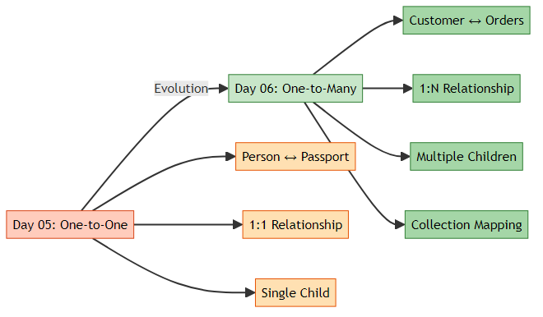

📊 What We’re Building
A Customer-Orders Management System where: - One Customer can have Multiple Orders (One-to-Many) - Many Orders belong to One Customer (Many-to-One) - Bidirectional navigation between Customer and Orders - Cascade operations automatically manage child entities - LAZY loading for better performance
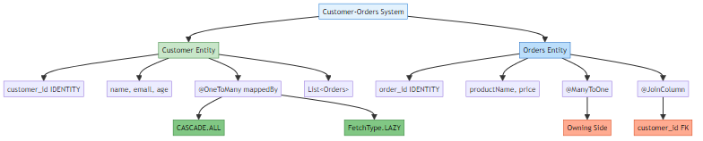

📚 Learning Path Progress
Day 05 (One-to-One) → Day 06 Part 1 (One-to-Many Bidirectional) ✅ → Day 06 Part 2 (Many-to-Many)
Created by Avinash Dhanuka | © 2026

2. ONE-TO-MANY VS MANY-TO-ONE
📝 Comprehensive Guide by: Avinash Dhanuka | © 2026

📌 What is One-to-Many?
One-to-Many = One entity (parent) is associated with multiple entities (children).
Real-World Examples: - 🧑 Customer → 📦 Orders (Our Project) - 🏢 Department → 👥 Employees - 📚 Author → 📖 Books - 🏫 Teacher → 👨‍🎓 Students - 🏠 House → 🚪 Rooms

📌 What is Many-to-One?
Many-to-One = Multiple entities (children) are associated with one entity (parent).
It’s the SAME relationship, viewed from the other side!
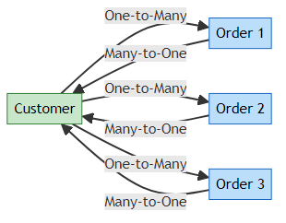

📊 Comparison Table
Aspect | One-to-Many | Many-to-One
Perspective | Parent’s view | Child’s view
Example | Customer has many Orders | Many Orders belong to Customer
Annotation | @OneToMany | @ManyToOne
Collection | Uses List/Set | Single object reference
Foreign Key | In child table | In child table (same!)
Owning Side | Child (Orders) | Child (Orders)
Key Point: In a bidirectional relationship, we use BOTH annotations!

3. BIDIRECTIONAL RELATIONSHIP EXPLAINED
📝 Navigation Guide by: Avinash Dhanuka | © 2026

📌 What is Bidirectional?
Bidirectional = You can navigate from Customer to Orders AND from Orders to Customer.
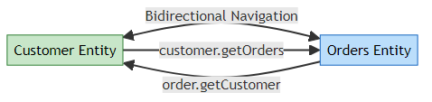
Code Example:
// Navigate from Customer to Orders
Customer customer = session.get(Customer.class, 1);
List<Orders> orders = customer.getOrders(); // ✅ Works!
// Navigate from Order to Customer
Orders order = session.get(Orders.class, 1);
Customer customer = order.getCustomer(); // ✅ Also works!

🎯 Golden Rule of Bidirectional Relationships
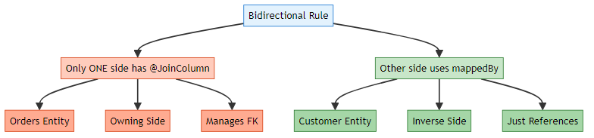
Remember for Interviews: 🔥 - Only ONE side defines @JoinColumn - The other side uses mappedBy - The side with @JoinColumn is the “owning side” - Hibernate looks at the owning side for FK definition

⚠️ What Happens if You Add @JoinColumn on Both Sides?
// ❌ WRONG: Both sides have @JoinColumn
@Entity
public class Customer {
@OneToMany
@JoinColumn(name = "customer_id") // ❌ Wrong!
private List<Orders> orders;
}
@Entity
public class Orders {
@ManyToOne
@JoinColumn(name = "customer_id") // ❌ Duplicate!
private Customer customer;
}
Result: - 💥 Hibernate gets confused - 💥 Doesn’t know which side controls FK - 💥 Throws AnnotationException - 💥 May create duplicate columns
✅ CORRECT Way:
// Customer (Inverse Side)
@OneToMany(mappedBy = "customer") // ✅ Uses mappedBy
private List<Orders> orders;
// Orders (Owning Side)
@ManyToOne
@JoinColumn(name = "customer_id") // ✅ Only here!
private Customer customer;

4. DATABASE STRUCTURE
📝 Database Design by: Avinash Dhanuka | © 2026

🏗️ Entity-Relationship Diagram
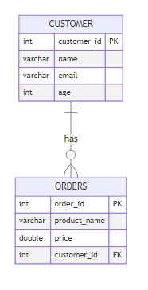

📊 Table Structure
┌─────────────────┐ ┌──────────────────┐
│ CUSTOMER │ │ ORDERS │
├─────────────────┤ ├──────────────────┤
│ customer_id(PK) │◄─────────────│ order_id (PK) │
│ name │ 1:N │ product_name │
│ email │ │ price │
│ age │ │ customer_id (FK) │
└─────────────────┘ └──────────────────┘
Key Points: - CUSTOMER table has NO foreign key - ORDERS table has customer_id as foreign key - customer_id in ORDERS is NOT UNIQUE (allows multiple orders per customer) - ORDERS is the “owning side” (has the FK) - CUSTOMER is the “inverse side” (referenced by FK)

📝 SQL Tables Created by Hibernate
-- Customer table (no foreign key)
CREATE TABLE customer (
customer_id INT AUTO_INCREMENT PRIMARY KEY,
name VARCHAR(255),
email VARCHAR(255),
age INT
);
-- Orders table (has foreign key to customer)
CREATE TABLE orders (
order_id INT AUTO_INCREMENT PRIMARY KEY,
product_name VARCHAR(255),
price DOUBLE,
customer_id INT,
FOREIGN KEY (customer_id) REFERENCES customer(customer_id)
);
Notice: Unlike One-to-One, there’s NO UNIQUE constraint on customer_id in orders table!

5. ENTITY CLASSES
📝 Entity Design by: Avinash Dhanuka | © 2026

⚠️ COPYRIGHT NOTICE ⚠️
This documentation is the intellectual property of Avinash Dhanuka.
© 2026 Avinash Dhanuka. All Rights Reserved.
For permissions: avunashdhanuka@gmail.com

👤 Customer Entity (Inverse Side)
File: src/main/java/org/example/entity/Customer.java
@Entity
@Table(name = "customer")
public class Customer {
@Id
@GeneratedValue(strategy = GenerationType.IDENTITY)
@Column(name = "customer_id")
private int customerId;
private String name;
private String email;
private int age;
// One-to-Many relationship (inverse side)
@OneToMany(mappedBy = "customer", cascade = CascadeType.ALL,
fetch = FetchType.LAZY)
private List<Orders> orders;
// Helper Methods for Bidirectional sync
public void addOrder(Orders order) {
orders.add(order);
order.setCustomer(this); // Sync both sides
}
public void removeOrder(Orders order) {
orders.remove(order);
order.setCustomer(null); // Sync both sides
}
// Constructors, getters, setters...
}
Key Points: - Uses List<Orders> to hold multiple orders - mappedBy = "customer" indicates this is the inverse side - cascade = CascadeType.ALL means all operations cascade to Orders - fetch = FetchType.LAZY means Orders load only when accessed - Helper methods addOrder() and removeOrder() keep both sides synchronized

📦 Orders Entity (Owning Side)
File: src/main/java/org/example/entity/Orders.java
@Entity
@Table(name = "orders")
public class Orders {
@Id
@GeneratedValue(strategy = GenerationType.IDENTITY)
private int orderId;
private String productName;
private double price;
// Many-to-One relationship (owning side)
@ManyToOne(fetch = FetchType.LAZY)
@JoinColumn(name = "customer_id")
private Customer customer;
// Constructors, getters, setters...
}
Key Points: - Uses @ManyToOne annotation (child’s perspective) - @JoinColumn(name = "customer_id") creates the foreign key column - fetch = FetchType.LAZY means Customer loads only when accessed - This is the “owning side” because it has the foreign key - Single Customer object reference (not a collection)

📊 Owning Side vs Inverse Side
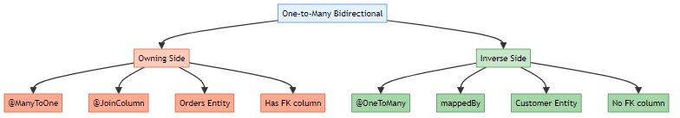
Aspect | Owning Side (Orders) | Inverse Side (Customer)
Annotation | @ManyToOne + @JoinColumn | @OneToMany + mappedBy
Foreign Key | ✅ Has FK column | ❌ No FK
Database Column | customer_id exists | No extra column
Collection | Single object | List/Set
Responsibility | Manages relationship | Just references it
Update FK | ✅ Can update | ❌ Cannot update

6. KEY ANNOTATIONS
📝 Annotation Guide by: Avinash Dhanuka | © 2026

📌 Relationship Annotations
Annotation | Purpose | Used In | Example
@OneToMany | Defines 1-to-N relationship | Parent (Customer) | @OneToMany(mappedBy = "customer")
@ManyToOne | Defines N-to-1 relationship | Child (Orders) | @ManyToOne
@JoinColumn | Specifies FK column | Owning side (Orders) | @JoinColumn(name = "customer_id")
mappedBy | Defines inverse side | Inverse side (Customer) | mappedBy = "customer"

📌 Collection Types
Type | Ordered | Duplicates | Use Case
List | ✅ Yes | ✅ Allowed | Most common, maintains order
Set | ❌ No | ❌ Not allowed | Unique elements only
Map | ❌ No | ❌ Keys unique | Key-value pairs
Our Project Uses: List<Orders> - Most common and practical choice

7. CASCADE OPERATIONS DEEP DIVE
📝 Cascade Guide by: Avinash Dhanuka | Understanding Operation Propagation

📝 AUTHOR SIGNATURE
This comprehensive guide is created by Avinash Dhanuka
© 2026 | All Rights Reserved

📌 What is Cascade?
Cascade = Automatically propagating operations from parent (Customer) to children (Orders).
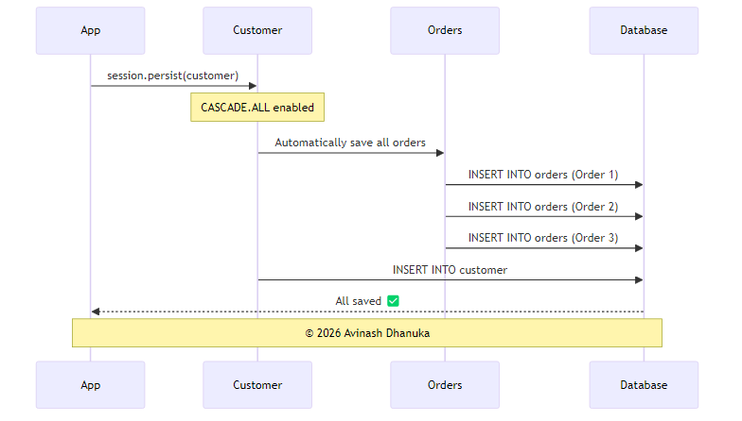

📊 All Cascade Types Explained
Cascade Type | What It Does | When to Use | Example
CascadeType.PERSIST | Save child when parent saved | Creating new entities | session.persist(customer) saves orders
CascadeType.MERGE | Update child when parent updated | Updating entities | session.merge(customer) updates orders
CascadeType.REMOVE | Delete child when parent deleted | Deleting entities | session.remove(customer) deletes orders
CascadeType.REFRESH | Reload child when parent reloaded | Refreshing from DB | session.refresh(customer) refreshes orders
CascadeType.DETACH | Detach child when parent detached | Detaching from session | session.detach(customer) detaches orders
CascadeType.ALL | All of the above | Parent-child relationships | All operations cascade

🔍 CASCADE.PERSIST in Detail
What it does: When you save the parent, children are automatically saved.
// WITHOUT CASCADE.PERSIST
Customer customer = new Customer("John", "john@email.com", 30);
Orders order1 = new Orders("Laptop", 50000);
Orders order2 = new Orders("Mouse", 500);
session.persist(customer); // Save customer
session.persist(order1); // Must save order1 separately ❌
session.persist(order2); // Must save order2 separately ❌
// WITH CASCADE.PERSIST (or CASCADE.ALL)
Customer customer = new Customer("John", "john@email.com", 30);
Orders order1 = new Orders("Laptop", 50000);
Orders order2 = new Orders("Mouse", 500);
List<Orders> orderList = new ArrayList<>();
orderList.add(order1);
orderList.add(order2);
customer.setOrders(orderList);
session.persist(customer); // All orders saved automatically! ✅
SQL Generated:
INSERT INTO customer (name, email, age) VALUES ('John', 'john@email.com', 30);
-- customer_id = 1
INSERT INTO orders (product_name, price, customer_id) VALUES ('Laptop', 50000, 1);
INSERT INTO orders (product_name, price, customer_id) VALUES ('Mouse', 500, 1);

🔍 CASCADE.MERGE in Detail
What it does: When you update the parent, children are automatically updated.
// Fetch existing customer with orders
Customer customer = session.get(Customer.class, 1);
customer.setName("John Updated");
// Update one of the orders
Orders firstOrder = customer.getOrders().get(0);
firstOrder.setPrice(55000); // Update price
session.merge(customer); // Customer AND orders updated! ✅
SQL Generated:
UPDATE customer SET name = 'John Updated' WHERE customer_id = 1;
UPDATE orders SET price = 55000 WHERE order_id = 1;

🔍 CASCADE.REMOVE in Detail
What it does: When you delete the parent, children are automatically deleted.
Customer customer = session.get(Customer.class, 1);
session.remove(customer); // Customer AND all orders deleted! ✅
SQL Generated:
-- Delete all orders first (foreign key constraint)
DELETE FROM orders WHERE customer_id = 1;
-- Then delete customer
DELETE FROM customer WHERE customer_id = 1;
⚠️ Warning: Be careful with CASCADE.REMOVE! It will delete ALL child records.

🔍 CASCADE.REFRESH in Detail
What it does: When you reload the parent from database, children are also reloaded.
Customer customer = session.get(Customer.class, 1);
customer.setName("Modified in memory"); // Not saved to DB
session.refresh(customer); // Reloads from DB, discards memory changes
// Customer AND orders refreshed from database ✅

🔍 CASCADE.DETACH in Detail
What it does: When you detach the parent from session, children are also detached.
Customer customer = session.get(Customer.class, 1);
// customer is in PERSISTENT state
session.detach(customer); // Customer AND orders detached
// Now in DETACHED state, changes won't be saved

🔍 CASCADE.ALL - The Complete Package
What it does: Combines ALL cascade types.
@OneToMany(mappedBy = "customer", cascade = CascadeType.ALL)
private List<Orders> orders;
Equivalent to:
@OneToMany(mappedBy = "customer",
cascade = {CascadeType.PERSIST, CascadeType.MERGE,
CascadeType.REMOVE, CascadeType.REFRESH,
CascadeType.DETACH})
private List<Orders> orders;

📊 When to Use Which Cascade Type?
Scenario | Recommended Cascade | Reason
Parent-Child (Orders) | CASCADE.ALL | Children can’t exist without parent
Shared Entities | PERSIST, MERGE only | Don’t delete shared entities
Independent Entities | NONE | Manage separately
Lookup Tables | NONE | Never cascade to lookup data

⚠️ Cascade Best Practices
// ✅ GOOD: Cascade on true parent-child
@OneToMany(mappedBy = "customer", cascade = CascadeType.ALL)
private List<Orders> orders;
// ⚠️ CAREFUL: Cascade on shared entities
@ManyToOne(cascade = CascadeType.PERSIST) // Only PERSIST, not REMOVE
private Category category;
// ❌ BAD: Cascade on lookup tables
@ManyToOne(cascade = CascadeType.ALL) // ❌ Never do this!
private Country country; // Deleting user would delete country!

8. FETCH TYPES: LAZY VS EAGER
📝 Performance Guide by: Avinash Dhanuka | Understanding Loading Strategies

📌 What is Fetch Type?
Fetch Type = When and how Hibernate loads related entities from the database.
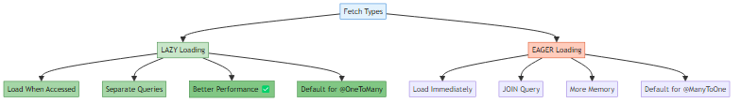

📊 Default Fetch Types
Relationship | Default Fetch Type | Reason
@OneToOne | EAGER | Usually need related data
@ManyToOne | EAGER | Usually need parent data
@OneToMany | LAZY | May have many children
@ManyToMany | LAZY | May have many related entities
Our Project: Both use FetchType.LAZY for better performance!

⚡ LAZY Loading (Our Implementation)
// Customer side
@OneToMany(mappedBy = "customer", fetch = FetchType.LAZY)
private List<Orders> orders;
// Orders side
@ManyToOne(fetch = FetchType.LAZY)
private Customer customer;
How LAZY Works:
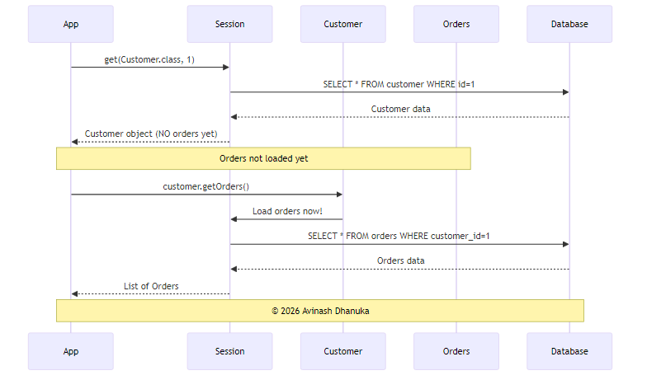
Code Example:
Session session = factory.openSession();
// Load customer - Orders NOT loaded yet
Customer customer = session.get(Customer.class, 1);
// SQL: SELECT * FROM customer WHERE customer_id = 1
System.out.println("Customer: " + customer.getName()); // No additional query
// Access orders - NOW they load
List<Orders> orders = customer.getOrders();
// SQL: SELECT * FROM orders WHERE customer_id = 1
for (Orders order : orders) {
System.out.println("Order: " + order.getProductName());
}
session.close();

🔥 EAGER Loading (Alternative)
@OneToMany(mappedBy = "customer", fetch = FetchType.EAGER)
private List<Orders> orders;
How EAGER Works:
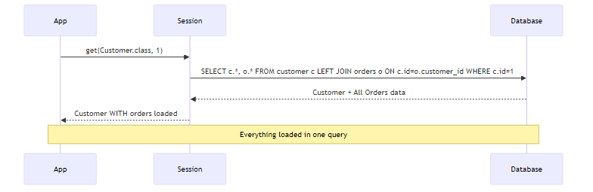
Code Example:
Session session = factory.openSession();
Customer customer = session.get(Customer.class, 1);
// SQL: SELECT * FROM customer c LEFT JOIN orders o ON c.customer_id = o.customer_id WHERE c.customer_id = 1
// Both Customer AND Orders loaded immediately!
List<Orders> orders = customer.getOrders(); // No additional query!
System.out.println("Orders: " + orders.size());
session.close();

📊 LAZY vs EAGER Comparison
Aspect | LAZY | EAGER
Loading Time | When accessed | Immediately
SQL Queries | 2 separate queries | 1 query with JOIN
Performance | Better (load on demand) | Slower (loads everything)
Memory Usage | Lower | Higher
LazyInitializationException | Can occur | Never
Use Case | Sometimes need data | Always need data
Our Choice | ✅ Yes | ❌ No

🎯 Real-World Analogy
EAGER Loading:
🍔 Food + 🧾 Bill + 👨‍🍳 Chef details + 👔 Owner details all come together 😵
LAZY Loading:
🍔 You only get food
📄 If you ask for bill → then they give bill
👨‍🍳 If you ask for chef → then they give chef details

⚠️ LazyInitializationException
The Problem:
Session session = factory.openSession();
Customer customer = session.get(Customer.class, 1);
session.close(); // Session closed!
// Try to access orders AFTER session closed
List<Orders> orders = customer.getOrders(); // ❌ LazyInitializationException!
Error Message:
org.hibernate.LazyInitializationException: failed to lazily initialize a collection of role:
org.example.entity.Customer.orders, could not initialize proxy - no Session
Solutions:
// Solution 1: Access within session
Session session = factory.openSession();
Customer customer = session.get(Customer.class, 1);
List<Orders> orders = customer.getOrders(); // ✅ Access before closing
session.close();
// Solution 2: Initialize explicitly
Session session = factory.openSession();
Customer customer = session.get(Customer.class, 1);
Hibernate.initialize(customer.getOrders()); // Force load
session.close();
List<Orders> orders = customer.getOrders(); // ✅ Works now
// Solution 3: Use JOIN FETCH in HQL
List<Customer> customers = session.createQuery(
"FROM Customer c JOIN FETCH c.orders", Customer.class
).list();
session.close();
// ✅ Orders already loaded

9. THE MAPPEDBY ATTRIBUTE
📝 mappedBy Explained by: Avinash Dhanuka | © 2026

📌 What is mappedBy?
mappedBy = Tells Hibernate which side of the relationship owns the foreign key.
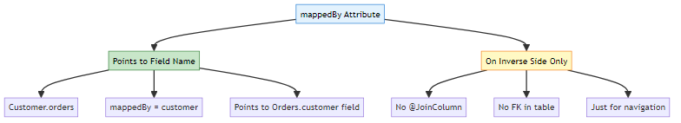

🔍 How mappedBy Works Internally
// Customer (Inverse Side)
@OneToMany(mappedBy = "customer") // Points to "customer" field in Orders
private List<Orders> orders;
// Orders (Owning Side)
@ManyToOne
@JoinColumn(name = "customer_id")
private Customer customer; // This is the field mappedBy points to!
What Hibernate Does:
- Sees mappedBy = "customer" in Customer entity
- Looks for a field named customer in Orders entity
- Finds @JoinColumn(name = "customer_id") there
- Uses that to manage the foreign key

⚠️ What Happens if You Remove mappedBy?
// ❌ WITHOUT mappedBy
@OneToMany
@JoinColumn(name = "customer_id") // Now Customer tries to own it
private List<Orders> orders;
@ManyToOne
@JoinColumn(name = "customer_id") // Orders also tries to own it
private Customer customer;
Result: - 💥 Hibernate creates TWO foreign keys - 💥 Or creates a join table (unintended) - 💥 Confusion about which side controls the relationship - 💥 Data inconsistency

✅ Correct Usage
// Customer (Inverse Side)
@OneToMany(mappedBy = "customer") // ✅ Uses mappedBy
private List<Orders> orders;
// Orders (Owning Side)
@ManyToOne
@JoinColumn(name = "customer_id") // ✅ Only here!
private Customer customer;

10. HELPER METHODS
📝 Synchronization Guide by: Avinash Dhanuka | © 2026

📌 Why Helper Methods?
In bidirectional relationships, you must keep BOTH sides synchronized!
Problem Without Helper Methods:
// ❌ BAD: Not synchronized
Customer customer = new Customer("John", "john@email.com", 30);
Orders order = new Orders("Laptop", 50000);
customer.getOrders().add(order); // Added to customer
// But order.getCustomer() is still null! ❌
session.persist(customer);
// Foreign key NOT set because Orders doesn't know about Customer!

✅ Solution: Helper Methods
@Entity
public class Customer {
@OneToMany(mappedBy = "customer", cascade = CascadeType.ALL)
private List<Orders> orders = new ArrayList<>();
// Helper method to add order
public void addOrder(Orders order) {
orders.add(order); // Add to customer's list
order.setCustomer(this); // Set customer in order
}
// Helper method to remove order
public void removeOrder(Orders order) {
orders.remove(order); // Remove from customer's list
order.setCustomer(null); // Remove customer from order
}
}
Usage:
// ✅ GOOD: Both sides synchronized
Customer customer = new Customer("John", "john@email.com", 30);
Orders order = new Orders("Laptop", 50000);
customer.addOrder(order); // Syncs both sides automatically!
session.persist(customer); // ✅ Works perfectly!

📊 With vs Without Helper Methods
Aspect | Without Helper | With Helper
Code | More verbose | Clean and simple
Synchronization | Manual | Automatic
Error-prone | ✅ Yes | ❌ No
Maintainability | Difficult | Easy
Best Practice | ❌ No | ✅ Yes

11. CRUD OPERATIONS
📝 CRUD Guide by: Avinash Dhanuka | Operations with One-to-Many

1️⃣ CREATE - Save Customer with Orders
Session session = factory.openSession();
Transaction tx = session.beginTransaction();
// Create customer
Customer customer = new Customer("John Doe", "john@email.com", 30);
// Create orders
Orders order1 = new Orders("Laptop", 50000);
Orders order2 = new Orders("Mouse", 500);
Orders order3 = new Orders("Keyboard", 1500);
// Create list and add orders
List<Orders> orderList = new ArrayList<>();
orderList.add(order1);
orderList.add(order2);
orderList.add(order3);
// Set customer for each order (bidirectional sync)
order1.setCustomer(customer);
order2.setCustomer(customer);
order3.setCustomer(customer);
customer.setOrders(orderList);
// Save customer (CASCADE saves all orders)
session.persist(customer);
tx.commit();
session.close();
SQL Generated:
INSERT INTO customer (name, email, age) VALUES ('John Doe', 'john@email.com', 30);
-- customer_id = 1
INSERT INTO orders (product_name, price, customer_id) VALUES ('Laptop', 50000, 1);
INSERT INTO orders (product_name, price, customer_id) VALUES ('Mouse', 500, 1);
INSERT INTO orders (product_name, price, customer_id) VALUES ('Keyboard', 1500, 1);

2️⃣ READ - Fetch Customer with Orders
Session session = factory.openSession();
// Fetch customer
Customer customer = session.get(Customer.class, 1);
System.out.println("Customer: " + customer.getName());
// Access orders (LAZY loading triggers here)
List<Orders> orders = customer.getOrders();
System.out.println("Total Orders: " + orders.size());
for (Orders order : orders) {
System.out.println(" - " + order.getProductName() + ": ₹" + order.getPrice());
}
session.close();

3️⃣ UPDATE - Modify Customer and Orders
Session session = factory.openSession();
Transaction tx = session.beginTransaction();
Customer customer = session.get(Customer.class, 1);
customer.setEmail("newemail@example.com");
// Update an order
Orders firstOrder = customer.getOrders().get(0);
firstOrder.setPrice(55000);
session.merge(customer); // CASCADE updates orders too
tx.commit();
session.close();

4️⃣ DELETE - Remove Customer (CASCADE deletes Orders)
Session session = factory.openSession();
Transaction tx = session.beginTransaction();
Customer customer = session.get(Customer.class, 1);
session.remove(customer); // All orders deleted automatically!
tx.commit();
session.close();

12. RUNNING THE APPLICATION
🔒 PROTECTED CONTENT 🔒
Created by: Avinash Dhanuka
© 2026 Avinash Dhanuka
GitHub Profile | Contact Me

📋 Prerequisites
- MySQL Server installed and running
- Java 11 or higher
- Maven installed

🚀 Setup Steps
Step 1: Create Database
CREATE DATABASE hibernate_relationships_db;
USE hibernate_relationships_db;
Step 2: Update hibernate.cfg.xml
<property name="hibernate.connection.username">your_username</property>
<property name="hibernate.connection.password">your_password</property>
Step 3: Run the Application
mvn clean install
mvn exec:java -Dexec.mainClass="org.example.App"

📱 Sample Interaction
Enter Customer Name:
John Doe
Enter Customer Age:
30
Enter Customer Email:
john@email.com
How many orders you want to add?
2
Enter Order 1 Product Name:
Laptop
Enter Order 1 Price:
50000
Enter Order 2 Product Name:
Mouse
Enter Order 2 Price:
500
Data Saved Successfully ✅

13. WHAT I LEARNED
📝 Learning Summary by: Avinash Dhanuka | © 2026
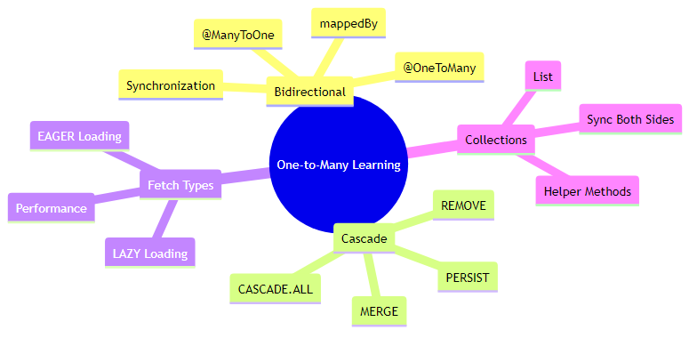

✅ Core Concepts Mastered
1. One-to-Many & Many-to-One Relationships - One Customer has Many Orders - Many Orders belong to One Customer - Same relationship, different perspectives - Using List<Orders> for collections
2. Bidirectional Mapping - Navigate from Customer to Orders - Navigate from Orders to Customer - Must synchronize both sides - Helper methods for synchronization
3. Owning Side vs Inverse Side - Orders is owning side (has @JoinColumn) - Customer is inverse side (has mappedBy) - Only owning side can update FK - Golden rule: Only ONE side has @JoinColumn
4. Cascade Operations - CASCADE.ALL propagates all operations - PERSIST saves children automatically - MERGE updates children automatically - REMOVE deletes children automatically - REFRESH reloads children automatically - DETACH detaches children automatically
5. Fetch Strategies - FetchType.LAZY loads data when accessed - FetchType.EAGER loads data immediately - LAZY is default for @OneToMany - EAGER is default for @ManyToOne - Chose LAZY for better performance
6. mappedBy Attribute - Points to field name on owning side - Only used on inverse side - Tells Hibernate where FK is defined - Prevents duplicate FK columns
7. Helper Methods - addOrder() synchronizes both sides - removeOrder() synchronizes both sides - Prevents synchronization errors - Best practice for bidirectional relationships
8. LazyInitializationException - Occurs when accessing LAZY data after session closed - Solutions: Access within session, Hibernate.initialize(), JOIN FETCH - Important to understand for production code

📊 Comparison with One-to-One
Aspect | One-to-One | One-to-Many
Child Entities | Single object | Collection (List/Set)
FK Constraint | UNIQUE | No UNIQUE
Use Case | Person-Passport | Customer-Orders
Complexity | Simpler | More complex
Helper Methods | Not needed | Recommended

14. INTERVIEW QUESTIONS
📝 Curated by: Avinash Dhanuka | © 2026 | GitHub
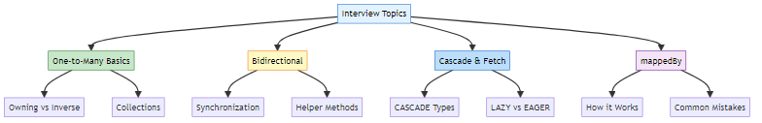

Q1: What is the difference between One-to-Many and Many-to-One?
Answer:
They are the SAME relationship viewed from different perspectives!
One-to-Many (Parent’s view): - One Customer has Many Orders - Uses @OneToMany annotation - Uses List<Orders> or Set<Orders> - Example: customer.getOrders()
Many-to-One (Child’s view): - Many Orders belong to One Customer - Uses @ManyToOne annotation - Uses single object reference - Example: order.getCustomer()
In Bidirectional Relationship:
// Customer (One-to-Many)
@OneToMany(mappedBy = "customer")
private List<Orders> orders;
// Orders (Many-to-One)
@ManyToOne
@JoinColumn(name = "customer_id")
private Customer customer;
Key Point: The foreign key is ALWAYS in the “Many” side (Orders table).

Q2: Explain the Golden Rule of Bidirectional Relationships.
Answer:
Golden Rule: Only ONE side defines @JoinColumn, the other side uses mappedBy.
Why? - Prevents duplicate foreign keys - Avoids confusion about which side controls the relationship - Hibernate needs to know which side manages the FK
Correct Implementation:
// Customer (Inverse Side)
@OneToMany(mappedBy = "customer") // ✅ Uses mappedBy
private List<Orders> orders;
// Orders (Owning Side)
@ManyToOne
@JoinColumn(name = "customer_id") // ✅ Only here!
private Customer customer;
Wrong Implementation:
// ❌ Both sides have @JoinColumn
@OneToMany
@JoinColumn(name = "customer_id") // ❌ Wrong!
private List<Orders> orders;
@ManyToOne
@JoinColumn(name = "customer_id") // ❌ Duplicate!
private Customer customer;
Result of Wrong Implementation: - Hibernate throws AnnotationException - May create duplicate columns - Confusion about FK management

Q3: What is mappedBy and how does it work internally?
Answer:
mappedBy = Attribute that tells Hibernate which field on the owning side manages the relationship.
How it Works:
// Customer
@OneToMany(mappedBy = "customer") // Points to field name
private List<Orders> orders;
// Orders
@ManyToOne
@JoinColumn(name = "customer_id")
private Customer customer; // This is the field mappedBy points to!
Internal Process: 1. Hibernate sees mappedBy = "customer" in Customer entity 2. Looks for a field named customer in Orders entity 3. Finds @JoinColumn(name = "customer_id") there 4. Uses that definition to manage the foreign key
What Happens Without mappedBy: - Hibernate may create a join table - Or create duplicate foreign keys - Relationship management becomes ambiguous

Q4: Explain all CASCADE types with examples.
Answer:
Cascade Type | What It Does | Example
PERSIST | Save children when parent saved | session.persist(customer) saves orders
MERGE | Update children when parent updated | session.merge(customer) updates orders
REMOVE | Delete children when parent deleted | session.remove(customer) deletes orders
REFRESH | Reload children when parent reloaded | session.refresh(customer) refreshes orders
DETACH | Detach children when parent detached | session.detach(customer) detaches orders
ALL | All of the above | All operations cascade
Code Examples:
// CASCADE.PERSIST
@OneToMany(cascade = CascadeType.PERSIST)
private List<Orders> orders;
Customer customer = new Customer("John", "john@email.com", 30);
Orders order = new Orders("Laptop", 50000);
customer.addOrder(order);
session.persist(customer); // ✅ Order also saved
// CASCADE.REMOVE
@OneToMany(cascade = CascadeType.REMOVE)
private List<Orders> orders;
session.remove(customer); // ✅ All orders also deleted
// CASCADE.ALL
@OneToMany(cascade = CascadeType.ALL)
private List<Orders> orders;
// All operations cascade
When to Use: - CASCADE.ALL: True parent-child relationships (Orders) - PERSIST, MERGE: Shared entities - NONE: Independent entities, lookup tables

Q5: What is the difference between LAZY and EAGER loading?
Answer:
Aspect | LAZY | EAGER
Loading Time | When accessed | Immediately
SQL Queries | Separate queries | JOIN query
Performance | Better | Slower
Memory | Lower | Higher
Default for @OneToMany | ✅ Yes | ❌ No
Default for @ManyToOne | ❌ No | ✅ Yes
LAZY Example:
@OneToMany(fetch = FetchType.LAZY)
private List<Orders> orders;
Customer customer = session.get(Customer.class, 1);
// SQL: SELECT * FROM customer WHERE customer_id = 1
// Orders NOT loaded yet
List<Orders> orders = customer.getOrders(); // NOW loads
// SQL: SELECT * FROM orders WHERE customer_id = 1
EAGER Example:
@OneToMany(fetch = FetchType.EAGER)
private List<Orders> orders;
Customer customer = session.get(Customer.class, 1);
// SQL: SELECT c.*, o.* FROM customer c LEFT JOIN orders o ...
// Both loaded immediately
Best Practice: Use LAZY by default, use EAGER only when you ALWAYS need the data.

Q6: Why do we need Helper Methods in bidirectional relationships?
Answer:
Problem Without Helper Methods:
// ❌ Not synchronized
Customer customer = new Customer("John", "john@email.com", 30);
Orders order = new Orders("Laptop", 50000);
customer.getOrders().add(order); // Added to customer
// But order.getCustomer() is null! ❌
session.persist(customer);
// FK not set, data inconsistency!
Solution With Helper Methods:
// Customer entity
public void addOrder(Orders order) {
orders.add(order); // Add to list
order.setCustomer(this); // Set customer in order
}
// Usage
customer.addOrder(order); // ✅ Both sides synchronized!
session.persist(customer); // ✅ Works perfectly!
Benefits: - Automatic synchronization - Prevents data inconsistency - Cleaner code - Less error-prone - Best practice for bidirectional relationships

Q7: What is LazyInitializationException and how to fix it?
Answer:
What is it?
Exception thrown when trying to access LAZY-loaded data after the session is closed.
Example:
Session session = factory.openSession();
Customer customer = session.get(Customer.class, 1);
session.close(); // Session closed!
List<Orders> orders = customer.getOrders(); // ❌ LazyInitializationException!
Solutions:
// Solution 1: Access within session
Session session = factory.openSession();
Customer customer = session.get(Customer.class, 1);
List<Orders> orders = customer.getOrders(); // ✅ Before closing
session.close();
// Solution 2: Hibernate.initialize()
Session session = factory.openSession();
Customer customer = session.get(Customer.class, 1);
Hibernate.initialize(customer.getOrders()); // Force load
session.close();
List<Orders> orders = customer.getOrders(); // ✅ Works
// Solution 3: JOIN FETCH in HQL
List<Customer> customers = session.createQuery(
"FROM Customer c JOIN FETCH c.orders", Customer.class
).list();
session.close();
// ✅ Orders already loaded
// Solution 4: Use EAGER (not recommended)
@OneToMany(fetch = FetchType.EAGER)
private List<Orders> orders;

Q8: What SQL queries are generated when you save a Customer with Orders?
Answer:
Code:
Customer customer = new Customer("John", "john@email.com", 30);
Orders order1 = new Orders("Laptop", 50000);
Orders order2 = new Orders("Mouse", 500);
customer.addOrder(order1);
customer.addOrder(order2);
session.persist(customer);
SQL Generated:
-- 1. Insert customer
INSERT INTO customer (name, email, age)
VALUES ('John', 'john@email.com', 30);
-- customer_id = 1
-- 2. Insert order 1 (CASCADE effect)
INSERT INTO orders (product_name, price, customer_id)
VALUES ('Laptop', 50000, 1);
-- 3. Insert order 2 (CASCADE effect)
INSERT INTO orders (product_name, price, customer_id)
VALUES ('Mouse', 500, 1);
Key Points: - Only need to persist Customer (CASCADE persists Orders) - Foreign key (customer_id) set automatically - All inserts happen in one transaction

Q9: Can you have One-to-Many without Many-to-One (Unidirectional)?
Answer:
Yes! You can have unidirectional One-to-Many.
Unidirectional One-to-Many:
// Customer (only side)
@OneToMany
@JoinColumn(name = "customer_id") // No mappedBy!
private List<Orders> orders;
// Orders (no reference to Customer)
@Entity
public class Orders {
// No Customer field!
}
Characteristics: - Can navigate from Customer to Orders - Cannot navigate from Orders to Customer - Simpler but less flexible - Still uses foreign key in Orders table
When to Use: - When you only need one-way navigation - Simpler relationships - Less code to maintain
Bidirectional vs Unidirectional:
Aspect | Bidirectional | Unidirectional
Navigation | Both ways | One way only
Complexity | More complex | Simpler
Flexibility | High | Limited
Use Case | Most common | Simple relationships

Q10: What happens if you delete a Customer with CASCADE.ALL?
Answer:
Code:
@OneToMany(mappedBy = "customer", cascade = CascadeType.ALL)
private List<Orders> orders;
Customer customer = session.get(Customer.class, 1);
session.remove(customer);
What Happens:
- Hibernate checks cascade settings
- Finds CASCADE.ALL (includes REMOVE)
- Deletes all child Orders first
- Then deletes Customer
SQL Generated:
-- Step 1: Delete all orders (foreign key constraint)
DELETE FROM orders WHERE customer_id = 1;
-- Step 2: Delete customer
DELETE FROM customer WHERE customer_id = 1;
Why This Order? - Orders has foreign key to Customer - Must delete children before parent - Otherwise: Foreign key constraint violation
Without CASCADE.REMOVE:
@OneToMany(mappedBy = "customer") // No cascade
private List<Orders> orders;
session.remove(customer);
// ❌ ERROR: Cannot delete customer because orders still reference it

🎓 End of One-to-Many Bidirectional Guide

Created with dedication by Avinash Dhanuka

Happy Learning! 🚀
“Master One-to-Many, Master Real-World Applications!” - Avinash Dhanuka

Next: Many-to-Many Relationships

