
☕ Master Guide: JUnit 5 Testing Framework

© 2026 Avinash Dhanuka
Master Guide: Unit Testing with JUnit 5
Crafted with ❤️ for Test-Driven Development

Learning Note: This guide provides a complete understanding of JUnit 5 testing framework, from basic assertions to advanced parameterized testing, with real-world examples and internal execution flow.

1.1 📑 Table of Contents
- What is JUnit? (The Foundation)
- Why Do We Need JUnit?
- Project Structure Deep Dive
- JUnit Lifecycle & Annotations
- Assertion Methods (The Core)
- Parameterized Testing (Advanced)
- Internal Execution Flow
- Topics Covered in This Project
- Spring Boot vs Plain Java Structure
- Interview Questions

1.2 1. WHAT IS JUNIT? (THE FOUNDATION)

1.2.1 📌 Definition
JUnit is an open-source Unit Testing Framework for Java. It is used to write and run repeatable automated tests to ensure that individual units of code (methods, classes) work as expected.

1.2.2 🏗️ Key Characteristics
- Framework Type: Testing Framework (Not a library)
- Current Version: JUnit 5 (Jupiter) - Released in 2017
- Architecture: Modular (JUnit Platform + JUnit Jupiter + JUnit Vintage)
- Annotations-Based: Uses Java annotations like @Test, @BeforeEach
- Assertion Library: Built-in assertion methods for validation

1.2.3 📊 JUnit Evolution
Version | Year | Key Features
JUnit 3 | 2000 | Test classes extend TestCase, method names start with test
JUnit 4 | 2006 | Annotation-based (@Test), no need to extend classes
JUnit 5 | 2017 | Modular architecture, Lambda support, Parameterized tests

1.2.4 🏛️ JUnit 5 Architecture
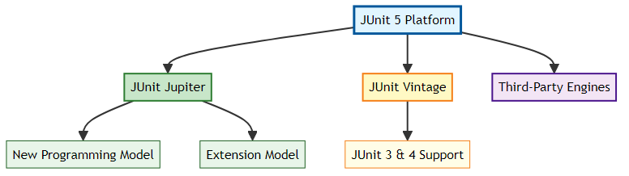
Components Explained: 1. JUnit Platform: Foundation for launching testing frameworks on the JVM 2. JUnit Jupiter: New programming model and extension model for JUnit 5 3. JUnit Vintage: Provides backward compatibility with JUnit 3 and 4

1.3 2. WHY DO WE NEED JUNIT?

1.3.1 🎯 The Problem Without Testing
Imagine you have a Calculator class with 10 methods. Every time you make a change: - ❌ You manually test each method by running main() - ❌ You write System.out.println() statements everywhere - ❌ You forget to test edge cases (divide by zero, negative numbers) - ❌ When bugs appear in production, you don’t know which method broke

1.3.2 ✅ The Solution: Automated Testing with JUnit
- Automated Verification: Write tests once, run them thousands of times
- Regression Prevention: Ensure new code doesn’t break existing functionality
- Documentation: Tests serve as living documentation of how code should behave
- Confidence: Refactor code fearlessly knowing tests will catch errors
- CI/CD Integration: Automated tests run in build pipelines before deployment

1.3.3 📈 Testing Pyramid
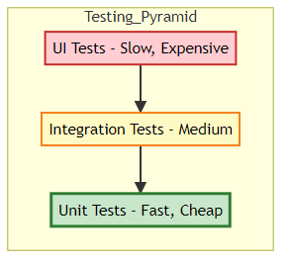
JUnit focuses on the base: Unit Tests (70% of all tests should be unit tests)

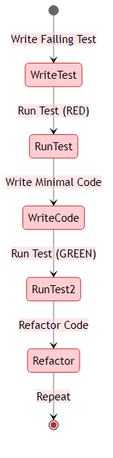
1.3.4 🔄 Test-Driven Development (TDD) Cycle

1.4 3. PROJECT STRUCTURE DEEP DIVE
📝 Documentation by: Avinash Dhanuka | GitHub Profile

1.4.1 📂 Complete Folder Hierarchy
JUnitOne/
├── .idea/ # IntelliJ IDEA configuration files
├── out/ # Compiled .class files (bytecode)
├── src/
│ ├── main/ # Production code
│ │ └── com.tyss/ # Package structure
│ │ ├── Calculator.java
│ │ └── StudentEligibilityService.java
│ └── test/ # Test code
│ ├── com/tyss/ # Mirror package structure
│ │ ├── Calculator_Test.java
│ │ └── StudentServiceTest.java
│ └── resources/ # Test resources
│ └── calculator-data.csv
├── .gitignore
└── JUnitOne.iml # IntelliJ module file

1.4.2 🏗️ Package Structure Explained

1.4.2.1 Why com.tyss?
Java follows reverse domain naming convention: - If your company domain is tyss.com - Package becomes com.tyss - This ensures global uniqueness (no package name conflicts)

1.4.2.2 Main vs Test Separation
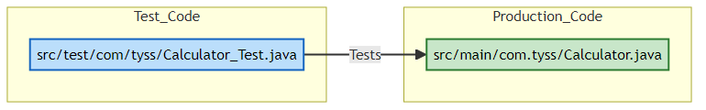
Critical Rule: Test classes must be in the same package as the class they test (but in the test folder)

1.4.3 📦 How Packages Work in Java
Package Declaration (Line 1 of every file):
package com.tyss; // This file belongs to com.tyss package
What Happens Internally: 1. Compilation: javac creates folder structure matching package name 2. Bytecode Location: Calculator.class is placed in out/com/tyss/ 3. Import Resolution: JVM searches for classes using package path
Example:
// File: Calculator.java
package com.tyss; // Declares package
public class Calculator {
// Class code
}
When compiled:
out/
└── com/
└── tyss/
└── Calculator.class ← Bytecode stored here

1.4.4 🔍 File-by-File Breakdown

1.4.4.1 1. Calculator.java (Production Code)
Location: src/main/com.tyss/Calculator.java
Purpose: Business logic for arithmetic operations
Key Methods:
public static int add(int a, int b) // Addition
public static int divide(int a, int b) // Division with exception handling
public static boolean isEven(int a) // Even number check
Why Static? No need to create object instances for simple utility methods.

1.4.4.2 2. StudentEligibilityService.java (Production Code)
Location: src/main/com.tyss/StudentEligibilityService.java
Purpose: Business logic for student eligibility validation
Key Method:
public boolean isEligible(int age) // Returns true if age >= 18
Exception Handling: Throws IllegalArgumentException for negative age

1.4.4.3 3. Calculator_Test.java (Test Code)
Location: src/test/com/tyss/Calculator_Test.java
Purpose: Comprehensive testing of Calculator class
Topics Covered: - ✅ Lifecycle annotations (@BeforeAll, @AfterEach) - ✅ Basic assertions (assertEquals, assertTrue) - ✅ Exception testing (assertThrows) - ✅ Parameterized tests (9 different sources!) - ✅ Test watchers (custom test result tracking) - ✅ Repeated tests (@RepeatedTest) - ✅ Disabled tests (@Disabled)
Reference: See Calculator_Test.java:21 for lifecycle implementation

1.4.4.4 4. StudentServiceTest.java (Test Code)
Location: src/test/com/tyss/StudentServiceTest.java
Purpose: Testing StudentEligibilityService
Topics Covered: - ✅ All basic assertions - ✅ assertAll() for grouped assertions - ✅ fail() method for manual test failure - ✅ Object reference testing (assertSame, assertNotSame)

1.4.4.5 5. calculator-data.csv (Test Resource)
Location: src/test/resources/calculator-data.csv
Purpose: External test data for @CsvFileSource
Format:
2,3,5 ← input1, input2, expected_output
10,5,15
20,4,24
Why External Files? - Separates test data from test logic - Easy to modify without changing code - Can be managed by non-developers (QA team)

1.5 4. JUNIT LIFECYCLE & ANNOTATIONS

1.5.1 📌 What are Annotations?
Annotations are metadata that provide information to the compiler and JVM about how to execute code.
Syntax: @AnnotationName

1.5.2 🔄 Test Execution Lifecycle
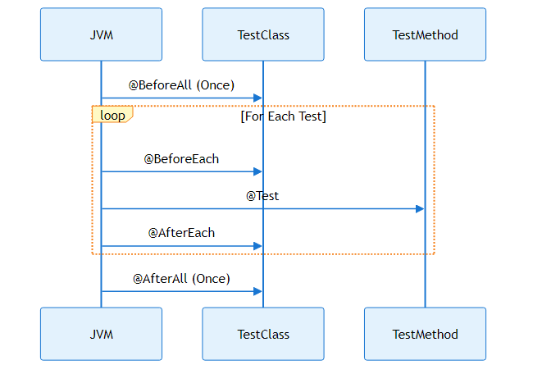

1.5.3 📋 Core Lifecycle Annotations
Annotation | Execution | Method Type | Use Case
@BeforeAll | Once before all tests | static | Database connection, load config
@BeforeEach | Before each test | Instance | Create fresh object instances
@Test | Test execution | Instance | Actual test logic
@AfterEach | After each test | Instance | Cleanup resources, reset state
@AfterAll | Once after all tests | static | Close connections, print summary

1.5.4 🔍 Real Example from Calculator_Test.java
Reference: Calculator_Test.java:46
@BeforeAll
static void beforeAllTests() {
System.out.println("-- Start All Tests --");
}
@BeforeEach
void setup() {
calc = new Calculator(); // Fresh instance for each test
}
@AfterEach
void tearDown() {
calc = null; // Cleanup
}
Why Fresh Instances? Ensures test isolation - one test’s changes don’t affect another.

1.5.5 🎯 Test Annotations
Annotation | Purpose | Example
@Test | Marks method as test | @Test void testAdd() {}
@DisplayName | Custom test name | @DisplayName("Division Success Test")
@Disabled | Skip test execution | @Disabled @Test void skip() {}
@RepeatedTest(n) | Run test n times | @RepeatedTest(5)
Reference: Calculator_Test.java:217
@RepeatedTest(2)
void testRepeated() {
assertEquals(4, calc.add(2, 2)); // Runs twice
}

1.6 5. ASSERTION METHODS (THE CORE)

1.6.1 📌 What is an Assertion?
An assertion is a statement that checks if a condition is true. If false, the test fails.
Syntax: assertXxx(expected, actual, message)

1.6.2 🏗️ Internal Working of Assertions
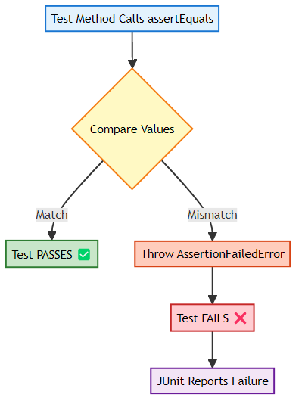

1.6.3 📊 Complete Assertion Methods Table
Method | Purpose | Example | Reference
assertEquals | Check equality | assertEquals(5, calc.add(2,3)) | Calculator_Test.java:163
assertNotEquals | Check inequality | assertNotEquals(10, calc.subtract(8,3)) | Calculator_Test.java:168
assertTrue | Check boolean true | assertTrue(calc.isEven(4)) | Calculator_Test.java:173
assertFalse | Check boolean false | assertFalse(calc.isEven(5)) | Calculator_Test.java:178
assertNull | Check if null | assertNull(obj) | Calculator_Test.java:184
assertNotNull | Check if not null | assertNotNull(calc) | Calculator_Test.java:189
assertSame | Check same reference | assertSame(ref1, ref2) | Calculator_Test.java:195
assertNotSame | Check different reference | assertNotSame(new Calc(), new Calc()) | Calculator_Test.java:202
assertThrows | Check exception thrown | assertThrows(ArithmeticException.class, ...) | Calculator_Test.java:208
assertAll | Group multiple assertions | assertAll(() -> ..., () -> ...) | StudentServiceTest.java:60
fail | Manually fail test | fail("Should not reach here") | StudentServiceTest.java:74

1.6.4 🔍 Deep Dive: assertEquals vs assertSame
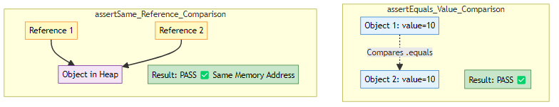
Example:
Integer a = 100;
Integer b = 100;
assertEquals(a, b); // ✅ PASS (values are equal)
assertSame(a, b); // ✅ PASS (Integer cache: same object)
Integer x = 200;
Integer y = 200;
assertEquals(x, y); // ✅ PASS (values are equal)
assertSame(x, y); // ❌ FAIL (different objects in heap)

1.6.5 🎯 assertThrows: Exception Testing
Why Important? Ensures your code handles errors correctly.
Reference: Calculator_Test.java:208
@Test
void testAssertThrows() {
assertThrows(ArithmeticException.class, () -> {
calc.divide(10, 0); // Should throw exception
});
}
Internal Flow: 1. JUnit executes the lambda () -> calc.divide(10, 0) 2. If ArithmeticException is thrown → Test PASSES ✅ 3. If no exception or different exception → Test FAILS ❌

1.7 6. PARAMETERIZED TESTING (ADVANCED)
📝 Comprehensive Guide by: Avinash Dhanuka | © 2026

1.7.1 📌 What is Parameterized Testing?
Running the same test logic with different input data without duplicating code.

1.7.2 🎯 The Problem Without Parameterization
// ❌ BAD: Repetitive code
@Test void testAdd1() { assertEquals(5, calc.add(2, 3)); }
@Test void testAdd2() { assertEquals(0, calc.add(0, 0)); }
@Test void testAdd3() { assertEquals(5, calc.add(-5, 10)); }
// ... 100 more tests? 😱

1.7.3 ✅ The Solution: @ParameterizedTest
// ✅ GOOD: One test, multiple data sets
@ParameterizedTest
@CsvSource({"2,3,5", "0,0,0", "-5,10,5"})
void testAdd(int a, int b, int expected) {
assertEquals(expected, calc.add(a, b));
}

1.7.4 📊 All 9 Parameterized Sources Covered
Source | Use Case | Example | Reference
@CsvSource | Multiple parameters inline | @CsvSource({"2,3,5"}) | Calculator_Test.java:64
@ValueSource | Single parameter | @ValueSource(ints={2,4,6}) | Calculator_Test.java:77
@MethodSource | Complex/dynamic data | @MethodSource("provideData") | Calculator_Test.java:105
@CsvFileSource | External CSV file | @CsvFileSource(resources="/data.csv") | Calculator_Test.java:113
@NullSource | Null values | @NullSource | Calculator_Test.java:120
@EmptySource | Empty strings/collections | @EmptySource | Calculator_Test.java:128
@NullAndEmptySource | Both null and empty | @NullAndEmptySource | Calculator_Test.java:136
@EnumSource | Enum values | @EnumSource(Operation.class) | Calculator_Test.java:149

1.7.5 🔍 Deep Dive: Each Source Type

1.7.5.1 1️⃣ @CsvSource (Comma-Separated Values)
When to Use: Multiple parameters with expected output
Reference: Calculator_Test.java:64
@ParameterizedTest
@CsvSource({
"2, 3, 5", // Test case 1
"0, 0, 0", // Test case 2
"-5, 10, 5" // Test case 3
})
void testAdd(int a, int b, int expected) {
assertEquals(expected, calc.add(a, b));
}
Internal Execution:
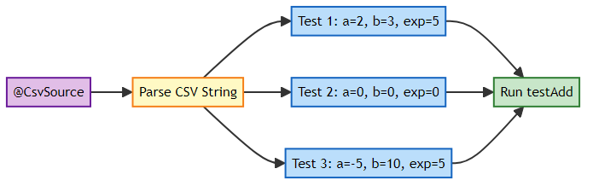

1.7.5.2 2️⃣ @ValueSource (Single Parameter)
When to Use: Testing with single input values
Reference: Calculator_Test.java:77
@ParameterizedTest
@ValueSource(ints = {2, 4, 6, 8, 10})
void testIsEven(int number) {
assertTrue(calc.isEven(number));
}
Supported Types: ints, strings, doubles, longs, booleans, shorts, bytes, chars, floats, classes

1.7.5.3 3️⃣ @MethodSource (Dynamic Data)
When to Use: Complex test data, reusable data sets
Reference: Calculator_Test.java:93
// Data provider method
private static Stream<Arguments> provideDivisionTestCases() {
return Stream.of(
Arguments.of(20, 4, 5),
Arguments.of(10, 2, 5)
);
}
@ParameterizedTest
@MethodSource("provideDivisionTestCases")
void testDivide(int a, int b, int expected) {
assertEquals(expected, calc.divide(a, b));
}
Rules: - Method must be static - Must return Stream<Arguments> - Method name matches annotation value

1.7.5.4 4️⃣ @CsvFileSource (External Data)
When to Use: Large data sets, data managed by QA team
Reference: Calculator_Test.java:113
@ParameterizedTest
@CsvFileSource(resources = "/resources/calculator-data.csv", numLinesToSkip = 0)
void testAddUsingCsvFile(int a, int b, int expected) {
assertEquals(expected, calc.add(a, b));
}
CSV File Format: calculator-data.csv
2,3,5
10,5,15
20,4,24
Advantages: - ✅ Separate test data from code - ✅ Easy to add/modify test cases - ✅ Can be version controlled separately

1.7.5.5 5️⃣ @NullSource, @EmptySource, @NullAndEmptySource
When to Use: Testing null/empty handling
Reference: Calculator_Test.java:120
@ParameterizedTest
@NullSource
void testNull(Integer value) {
assertNull(value); // value will be null
}
@ParameterizedTest
@EmptySource
void testEmpty(String value) {
assertTrue(value.isEmpty()); // value will be ""
}
@ParameterizedTest
@NullAndEmptySource
void testBoth(String value) {
assertTrue(value == null || value.isEmpty());
}

1.7.5.6 6️⃣ @EnumSource (Enum Testing)
When to Use: Testing all enum values
Reference: Calculator_Test.java:149
enum Operation { ADD, SUBTRACT, MULTIPLY, DIVIDE }
@ParameterizedTest
@EnumSource(Operation.class)
void testEnum(Operation op) {
assertNotNull(op); // Runs 4 times (one per enum)
}

1.8 7. INTERNAL EXECUTION FLOW
📝 Deep Dive by: Avinash Dhanuka | Understanding JVM Internals

1.8.1 🏭 How JUnit Executes Tests (JVM Level)
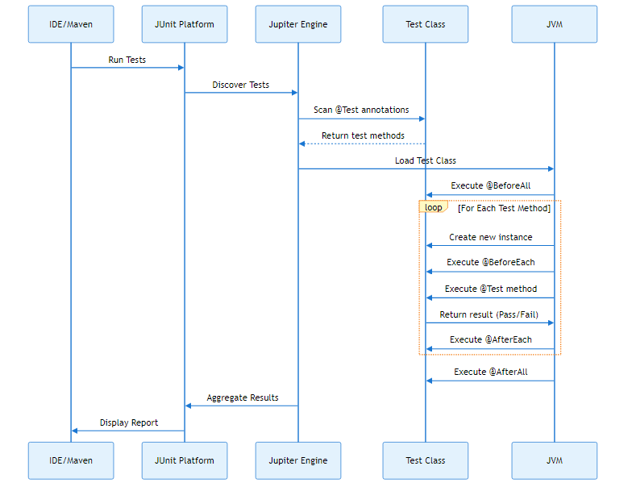

1.8.2 🔍 Step-by-Step Execution
Example Test: Calculator_Test.testAdd()
- Class Loading:
- JVM loads Calculator_Test.class into memory
- Static Initialization:
- static int passed = 0; // Initialized once
@BeforeAll static void beforeAllTests() { ... } // Runs once
- Instance Creation (Per Test):
- Calculator_Test testInstance = new Calculator_Test(); // Fresh instance
- Setup:
- @BeforeEach void setup() {
calc = new Calculator(); // New Calculator object
}
- Test Execution:
- @Test void testAdd() {
assertEquals(5, calc.add(2, 3)); // Assertion checked
}
- Teardown:
- @AfterEach void tearDown() {
calc = null; // Cleanup
}
- Final Cleanup:
- @AfterAll static void afterAllTests() {
System.out.println("Tests: " + passed); // Summary
}

1.8.3 🧠 Memory Architecture During Testing
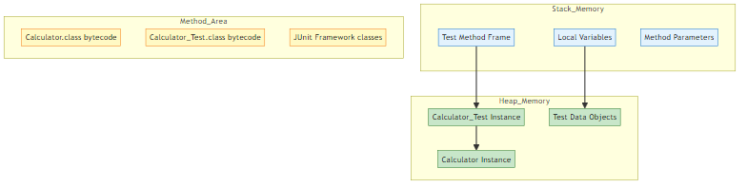
Key Points: - Each @Test method gets a new instance of the test class - Static variables (passed, failed) persist across all tests - @BeforeAll and @AfterAll execute in static context (no instance)

1.8.4 🎯 TestWatcher Extension (Advanced)
Reference: Calculator_Test.java:21
@RegisterExtension
TestWatcher watcher = new TestWatcher() {
@Override
public void testSuccessful(ExtensionContext context) {
passed++; // Increment on success
}
@Override
public void testFailed(ExtensionContext context, Throwable cause) {
failed++; // Increment on failure
}
};
What is TestWatcher? - An Extension that hooks into test lifecycle - Allows custom logic after each test completes - Used here to track pass/fail/skip counts
Execution Flow:
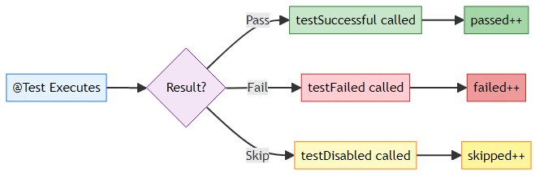

1.9 8. TOPICS COVERED IN THIS PROJECT

1.9.1 ✅ Complete Checklist

1.9.1.1 🎯 Core JUnit Concepts
- ✅ Test Class Structure: Proper naming convention (ClassName_Test)
- ✅ Package Organization: Mirroring production code structure
- ✅ Lifecycle Annotations: @BeforeAll, @BeforeEach, @AfterEach, @AfterAll
- ✅ Test Annotations: @Test, @DisplayName, @Disabled, @RepeatedTest

1.9.1.2 🔍 Assertion Methods (11 Types)
- ✅ assertEquals - Value equality
- ✅ assertNotEquals - Value inequality
- ✅ assertTrue - Boolean true check
- ✅ assertFalse - Boolean false check
- ✅ assertNull - Null check
- ✅ assertNotNull - Not null check
- ✅ assertSame - Reference equality
- ✅ assertNotSame - Reference inequality
- ✅ assertThrows - Exception testing
- ✅ assertAll - Grouped assertions
- ✅ fail - Manual test failure

1.9.1.3 🎲 Parameterized Testing (9 Sources)
- ✅ @CsvSource - Inline CSV data
- ✅ @ValueSource - Single parameter arrays
- ✅ @MethodSource - Dynamic data from methods
- ✅ @CsvFileSource - External CSV files
- ✅ @NullSource - Null value testing
- ✅ @EmptySource - Empty value testing
- ✅ @NullAndEmptySource - Combined null/empty
- ✅ @EnumSource - Enum value testing

1.9.1.4 🔧 Advanced Features
- ✅ TestWatcher Extension: Custom test result tracking
- ✅ @RegisterExtension: Extension registration
- ✅ Exception Handling: Testing expected exceptions
- ✅ Test Resources: External data files
- ✅ Static vs Instance Methods: Understanding context

1.9.2 📚 Learning Path Progression
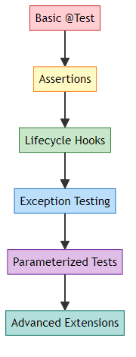
Beginner → Intermediate → Advanced

1.9.3 🎓 Real-World Applications
Concept | Real-World Use Case
@CsvSource | Testing payment calculations with different amounts
@MethodSource | Testing user authentication with various credentials
@CsvFileSource | Testing data import from Excel/CSV files
assertThrows | Validating API error responses
@BeforeEach | Setting up database connections before each test
TestWatcher | Generating custom test reports for stakeholders
@RepeatedTest | Stress testing concurrent operations

1.10 9. SPRING BOOT VS PLAIN JAVA STRUCTURE
📝 Detailed Comparison by: Avinash Dhanuka | Connect on GitHub

1.10.1 🏗️ Architectural Comparison

1.10.2 📊 Detailed Comparison Table
Aspect | Plain Java (This Project) | Spring Boot
Project Type | Simple Java Application | Enterprise Web Application
Build Tool | None (IDE managed) | Maven/Gradle (pom.xml/build.gradle)
Dependency Management | Manual JAR files | Automatic via Maven Central
Main Folder | src/main/com.tyss/ | src/main/java/com/company/
Resources Folder | src/test/resources/ only | src/main/resources/ + src/test/resources/
Configuration | None | application.properties or application.yml
Entry Point | public static void main() | @SpringBootApplication class
Dependency Injection | Manual object creation | @Autowired, @Component
Testing | JUnit 5 (Jupiter) | JUnit 5 + Spring Test (@SpringBootTest)
Web Layer | Not applicable | Controllers (@RestController)
Database | Not applicable | JPA, Hibernate (@Entity, @Repository)
Packaging | .jar (plain) | .jar (executable with embedded Tomcat)

1.10.3 🔍 Folder Structure Comparison

1.10.3.1 Plain Java (Current Project)
JUnitOne/
├── src/
│ ├── main/
│ │ └── com.tyss/ ← Business logic only
│ │ ├── Calculator.java
│ │ └── StudentEligibilityService.java
│ └── test/
│ ├── com/tyss/ ← Test classes
│ └── resources/ ← Test data files
├── out/ ← Compiled classes
└── JUnitOne.iml ← IntelliJ config

1.10.3.2 Spring Boot Project
spring-boot-app/
├── src/
│ ├── main/
│ │ ├── java/com/company/
│ │ │ ├── SpringBootAppApplication.java ← Entry point
│ │ │ ├── controller/ ← REST APIs
│ │ │ │ └── UserController.java
│ │ │ ├── service/ ← Business logic
│ │ │ │ └── UserService.java
│ │ │ ├── repository/ ← Database access
│ │ │ │ └── UserRepository.java
│ │ │ └── model/ ← Data entities
│ │ │ └── User.java
│ │ └── resources/
│ │ ├── application.properties ← Configuration
│ │ ├── static/ ← CSS, JS files
│ │ └── templates/ ← HTML templates
│ └── test/
│ └── java/com/company/
│ └── UserServiceTest.java
├── target/ ← Build output
├── pom.xml ← Maven dependencies
└── mvnw ← Maven wrapper

1.10.4 🎯 Key Differences Explained

1.10.4.1 1. Dependency Management
Plain Java:
// Manual import of JUnit JAR
import org.junit.jupiter.api.Test;
You must download junit-jupiter-5.x.x.jar and add to classpath manually.
Spring Boot (pom.xml):
<dependency>
<groupId>org.springframework.boot</groupId>
<artifactId>spring-boot-starter-test</artifactId>
<scope>test</scope>
</dependency>
Maven automatically downloads JUnit + Mockito + AssertJ + Spring Test.

1.10.4.2 2. Object Creation
Plain Java:
@BeforeEach
void setup() {
calc = new Calculator(); // Manual instantiation
}
Spring Boot:
@Autowired
private Calculator calc; // Spring creates and injects automatically

1.10.4.3 3. Testing Approach
Plain Java (Unit Test):
@Test
void testAdd() {
Calculator calc = new Calculator();
assertEquals(5, calc.add(2, 3)); // Pure unit test
}
Spring Boot (Integration Test):
@SpringBootTest
class UserServiceTest {
@Autowired
private UserService userService; // Tests with real Spring context
@Test
void testCreateUser() {
User user = userService.createUser("John");
assertNotNull(user.getId()); // Tests database interaction
}
}

1.10.4.4 4. Application Entry Point
Plain Java:
public class Calculator {
public static void main(String[] args) {
System.out.println("Hello"); // Simple console app
}
}
Spring Boot:
@SpringBootApplication
public class Application {
public static void main(String[] args) {
SpringApplication.run(Application.class, args); // Starts web server
}
}

1.10.5 🌐 When to Use What?
Use Case | Choose
Learning Java basics | Plain Java
Simple utility libraries | Plain Java
Command-line tools | Plain Java
REST APIs | Spring Boot
Microservices | Spring Boot
Database applications | Spring Boot
Enterprise applications | Spring Boot

1.10.6 🔄 Migration Path
Steps to Convert This Project to Spring Boot: 1. Create pom.xml with Spring Boot dependencies 2. Move com.tyss to src/main/java/com/tyss/ 3. Add @Component to Calculator and StudentEligibilityService 4. Create @SpringBootApplication main class 5. Change tests to use @SpringBootTest and @Autowired

1.11 10. TOP INTERVIEW QUESTIONS
📝 Curated by: Avinash Dhanuka | © 2026 | GitHub

1.11.1 🧠 JUnit Fundamentals

1.11.1.1 Q1: What is the difference between JUnit 4 and JUnit 5?
Feature | JUnit 4 | JUnit 5
Architecture | Monolithic | Modular (Platform + Jupiter + Vintage)
Annotations | @Before, @After | @BeforeEach, @AfterEach
Assertions | org.junit.Assert | org.junit.jupiter.api.Assertions
Test Instance | One per class | One per method (default)
Parameterized | @RunWith(Parameterized.class) | @ParameterizedTest
Lambda Support | No | Yes (assertThrows(() -> ...))

1.11.1.2 Q2: Why does JUnit create a new instance for each test method?
Answer: To ensure test isolation. If tests shared the same instance, one test could modify state that affects another test, causing unpredictable failures.
Example:
class MyTest {
int counter = 0; // Instance variable
@Test void test1() { counter++; } // counter = 1
@Test void test2() { counter++; } // counter = 1 (new instance!)
}
Each test gets counter = 0 because JUnit creates a fresh instance.

1.11.1.3 Q3: What is the difference between assertEquals and assertSame?
Answer: - assertEquals: Compares values using .equals() method - assertSame: Compares memory references using == operator
Example:
String s1 = new String("hello");
String s2 = new String("hello");
assertEquals(s1, s2); // ✅ PASS (values are equal)
assertSame(s1, s2); // ❌ FAIL (different objects in heap)

1.11.1.4 Q4: When should you use @BeforeAll vs @BeforeEach?
Annotation | Use Case | Example
@BeforeAll | Expensive setup (once) | Database connection, load config file
@BeforeEach | Fresh state (per test) | Create new object instances, reset variables
Reference: Calculator_Test.java:46

1.11.1.5 Q5: How do you test if a method throws an exception?
Answer: Use assertThrows()
Reference: Calculator_Test.java:208
@Test
void testDivideByZero() {
assertThrows(ArithmeticException.class, () -> {
calc.divide(10, 0);
});
}
Why Lambda? JUnit needs to execute the code and catch the exception. Lambda delays execution until JUnit is ready.

1.11.2 🎯 Parameterized Testing

1.11.2.1 Q6: What is the advantage of @MethodSource over @CsvSource?
Answer:
Feature | @CsvSource | @MethodSource
Data Type | Strings only | Any Java object
Complexity | Simple values | Complex objects, lists
Reusability | No | Yes (method can be reused)
Dynamic Data | No | Yes (can read from DB/API)
Example:
// @MethodSource can return complex objects
private static Stream<Arguments> provideUsers() {
return Stream.of(
Arguments.of(new User("John", 25)),
Arguments.of(new User("Jane", 30))
);
}

1.11.2.2 Q7: How does @CsvFileSource find the CSV file?
Answer: It looks in the classpath under src/test/resources/
Reference: Calculator_Test.java:113
@CsvFileSource(resources = "/resources/calculator-data.csv")
Path Resolution: 1. JUnit looks in src/test/resources/resources/calculator-data.csv 2. During build, files are copied to out/test/resources/ 3. JVM loads from classpath

1.11.2.3 Q8: Can you use multiple parameterized sources on one test?
Answer: No, but you can combine some:
// ✅ VALID: Combines null and empty
@ParameterizedTest
@NullAndEmptySource
@ValueSource(strings = {" ", "\t", "\n"})
void testBlankStrings(String input) {
assertTrue(input == null || input.trim().isEmpty());
}

1.11.3 🔧 Advanced Concepts

1.11.3.1 Q9: What is a TestWatcher and when would you use it?
Answer: A TestWatcher is a JUnit extension that hooks into test lifecycle events.
Use Cases: - Custom logging - Screenshot capture on test failure (Selenium) - Performance metrics tracking - Custom reporting
Reference: Calculator_Test.java:21

1.11.3.2 Q10: Why are @BeforeAll and @AfterAll methods static?
Answer: Because they run before any instance is created. JUnit needs to call them without instantiating the test class.
Memory Timeline:
1. Load Calculator_Test.class into Method Area
2. Execute @BeforeAll (static context)
3. Create instance #1 → run test1
4. Create instance #2 → run test2
5. Execute @AfterAll (static context)

1.11.3.3 Q11: What happens if an assertion fails in @BeforeEach?
Answer: The test is skipped and marked as failed. The @Test method never executes.
Execution Flow:
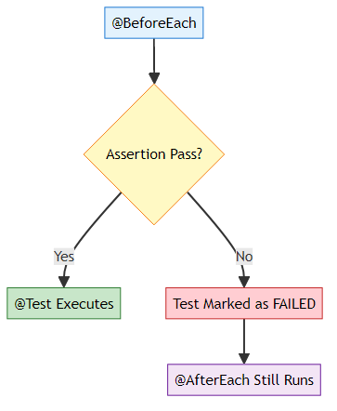

1.11.3.4 Q12: How do you skip a test conditionally?
Answer: Use Assumptions.assumeTrue()
@Test
void testOnlyOnWindows() {
Assumptions.assumeTrue(System.getProperty("os.name").contains("Windows"));
// Test only runs on Windows
}
Difference from @Disabled: - @Disabled: Always skips - Assumptions: Skips based on runtime condition

1.11.4 🎓 Scenario-Based Questions

1.11.4.1 Q13: You have 100 test methods. How do you run only tests related to “addition”?
Answer: Use @Tag annotation
@Test
@Tag("addition")
void testAdd() { ... }
@Test
@Tag("division")
void testDivide() { ... }
Run Command:
mvn test -Dgroups="addition"

1.11.4.2 Q14: How would you test a method that takes 10 seconds to execute?
Answer: Use @Timeout annotation
@Test
@Timeout(value = 5, unit = TimeUnit.SECONDS)
void testSlowMethod() {
slowService.process(); // Fails if takes > 5 seconds
}

1.11.4.3 Q15: Your test passes locally but fails in CI/CD. What could be wrong?
Possible Causes: 1. Environment Variables: Missing in CI 2. File Paths: Absolute paths instead of relative 3. Time Zones: Date/time assertions 4. Test Order Dependency: Tests not isolated 5. Resource Files: Not included in build
Solution: Use @TestInstance(Lifecycle.PER_CLASS) to debug state issues.

1.11.5 💡 Best Practices

1.11.5.1 Q16: What are the characteristics of a good unit test?
FIRST Principles: - Fast: Runs in milliseconds - Independent: No dependencies between tests - Repeatable: Same result every time - Self-Validating: Pass/fail, no manual verification - Timely: Written before or with production code (TDD)

1.11.5.2 Q17: Should you test private methods?
Answer: No. Test public methods only. Private methods are implementation details.
Reasoning: - Private methods are tested indirectly through public methods - Testing private methods couples tests to implementation - Refactoring becomes difficult
If you must test private methods:
// Use reflection (not recommended)
Method method = Calculator.class.getDeclaredMethod("privateMethod");
method.setAccessible(true);
method.invoke(calc);

1.11.6 🚀 Real-World Scenarios

1.11.6.1 Q18: How do you test a REST API controller in Spring Boot?
Answer: Use @WebMvcTest + MockMvc
@WebMvcTest(UserController.class)
class UserControllerTest {
@Autowired
private MockMvc mockMvc;
@Test
void testGetUser() throws Exception {
mockMvc.perform(get("/users/1"))
.andExpect(status().isOk())
.andExpect(jsonPath("$.name").value("John"));
}
}

1.11.6.2 Q19: How do you test database operations?
Answer: Use @DataJpaTest with H2 in-memory database
@DataJpaTest
class UserRepositoryTest {
@Autowired
private UserRepository repository;
@Test
void testSaveUser() {
User user = new User("John");
User saved = repository.save(user);
assertNotNull(saved.getId());
}
}

1.11.6.3 Q20: What is the difference between Unit Test and Integration Test?
Aspect | Unit Test | Integration Test
Scope | Single method/class | Multiple components
Dependencies | Mocked | Real (database, APIs)
Speed | Fast (milliseconds) | Slow (seconds)
Annotation | @Test | @SpringBootTest
Example | Testing Calculator.add() | Testing REST API → Service → Database
This Project: Pure Unit Tests (no external dependencies)

1.11.7 🎓 End of Master Guide
Created with dedication by Avinash Dhanuka


© 2026 Avinash Dhanuka | All Rights Reserved
This documentation is protected intellectual property. Unauthorized reproduction or distribution is prohibited.

Happy Testing! 🎉
“Write tests, not bugs!” - Avinash Dhanuka

