☕ Master Guide: Mockito Testing Framework with Maven



© 2026 Avinash Dhanuka
Master Guide: Mocking & Dependency Testing
Crafted with ❤️ for Advanced Unit Testing

Learning Note: This guide builds upon Day 01 (JUnit 5) and introduces Mockito - the most popular mocking framework for Java. Learn how to test classes with dependencies without needing real implementations.
Prerequisites: Complete understanding of Day 01 - JUnit 5 Fundamentals

📑 Table of Contents
- What is Mockito? (The Foundation)
- Why Do We Need Mockito?
- Maven Project Structure
- Understanding Dependencies
- Mockito Core Concepts
- Annotations Deep Dive
- Stubbing & Verification
- Internal Execution Flow
- Topics Covered in This Project
- Day 01 vs Day 02 Comparison
- Interview Questions

1. WHAT IS MOCKITO? (THE FOUNDATION)
📝 Author: Avinash Dhanuka | GitHub

📌 Definition
Mockito is a powerful mocking framework for Java that allows you to create and configure mock objects (fake objects) for testing. It works seamlessly with JUnit 5 to test classes that have dependencies on other classes.

🏗️ Key Characteristics
- Framework Type: Mocking Framework (Works with JUnit)
- Current Version: Mockito 5.12.0 (Used in this project)
- Purpose: Create fake objects to isolate unit tests
- Integration: Works with JUnit 4, JUnit 5, TestNG
- Behavior: Allows you to define how mock objects should behave

📊 Evolution Timeline
Version | Year | Key Features
Mockito 1.x | 2008 | Basic mocking, when().thenReturn()
Mockito 2.x | 2016 | Java 8 support, better error messages
Mockito 3.x | 2019 | Java 11 support, inline mocking
Mockito 4.x | 2021 | Java 17 support, improved performance
Mockito 5.x | 2023 | Java 21 support, enhanced annotations

🎯 What is a “Mock”?
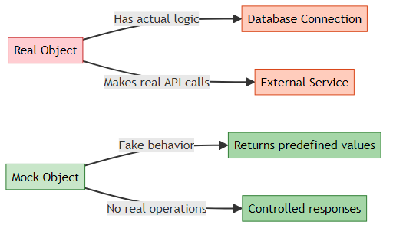
Simple Analogy: - Real Object: A real bank that processes actual money - Mock Object: A toy bank that pretends to process money (for testing)

2. WHY DO WE NEED MOCKITO?

🎯 The Problem Without Mocking
Imagine you’re testing an OrderService that depends on a PaymentService:
public class OrderService {
private PaymentService paymentService;
public String placeOrder(double amount) {
boolean success = paymentService.processPayment(amount);
return success ? "ORDER PLACED" : "PAYMENT FAILED";
}
}
Problems when testing WITHOUT Mockito: 1. ❌ PaymentService might connect to a real payment gateway (costs money!) 2. ❌ Tests become slow (network calls, database queries) 3. ❌ Tests fail if external service is down 4. ❌ Hard to test error scenarios (what if payment fails?) 5. ❌ Cannot test in isolation (testing OrderService + PaymentService together)

✅ The Solution: Mockito
@Test
void testPlaceOrder() {
// Create a FAKE PaymentService
PaymentService mockPayment = mock(PaymentService.class);
// Tell the fake: "When processPayment is called, return true"
when(mockPayment.processPayment(500.0)).thenReturn(true);
// Now test OrderService with the fake
OrderService orderService = new OrderService(mockPayment);
String result = orderService.placeOrder(500.0);
assertEquals("ORDER PLACED", result); // ✅ Test passes!
}
Benefits: 1. ✅ No real payment processing (fast & free) 2. ✅ Tests run in milliseconds 3. ✅ Can simulate any scenario (success, failure, exceptions) 4. ✅ True unit testing (test ONE class at a time) 5. ✅ No external dependencies needed

📈 Testing Pyramid with Mocking
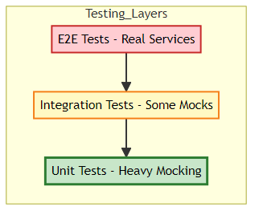
Mockito is used heavily in Unit Tests (the base of the pyramid)

3. MAVEN PROJECT STRUCTURE
📝 Documentation by: Avinash Dhanuka | GitHub Profile

📂 Complete Folder Hierarchy
MockitoMaven/
├── .idea/ # IntelliJ IDEA configuration
├── .mvn/ # Maven wrapper files
├── src/
│ ├── main/
│ │ ├── java/org/example/
│ │ │ ├── Main.java # Entry point (not used in tests)
│ │ │ ├── OrderService.java # Class under test
│ │ │ └── PaymentService.java # Dependency (will be mocked)
│ │ └── resources/ # Application resources
│ └── test/
│ └── java/org/example/
│ └── OrderServiceTest.java # Mockito test class
├── target/ # Compiled classes (Maven output)
├── .gitignore
└── pom.xml # Maven configuration file

🆚 Day 01 vs Day 02 Structure
Aspect | Day 01 (JUnit Only) | Day 02 (Mockito + Maven)
Build Tool | None (IDE managed) | Maven (pom.xml)
Dependencies | Manual JAR files | Automatic via Maven
Project Type | Plain Java | Maven Project
Folder Structure | src/main/com.tyss/ | src/main/java/org/example/
Dependency Injection | Not used | Constructor Injection
Testing Focus | Basic assertions | Mocking dependencies

🏗️ What is Maven?
Maven is a build automation tool and dependency manager for Java projects.
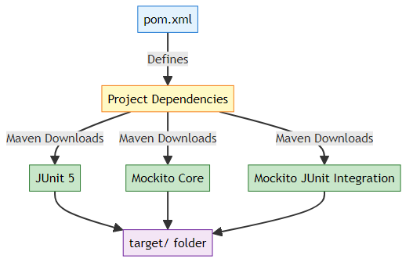
Key Maven Concepts:
- pom.xml - Project Object Model (configuration file)
- Dependencies - External libraries your project needs
- target/ - Where Maven puts compiled .class files
- Maven Central - Online repository of Java libraries

📦 Understanding pom.xml
Reference: pom.xml
<project>
<groupId>org.example</groupId> <!-- Company/Organization -->
<artifactId>MockitoMaven</artifactId> <!-- Project Name -->
<version>1.0-SNAPSHOT</version> <!-- Project Version -->
<properties>
<maven.compiler.source>21</maven.compiler.source> <!-- Java 21 -->
<maven.compiler.target>21</maven.compiler.target>
</properties>
<dependencies>
<!-- JUnit 5 -->
<dependency>
<groupId>org.junit.jupiter</groupId>
<artifactId>junit-jupiter</artifactId>
<version>5.10.2</version>
<scope>test</scope> <!-- Only for testing -->
</dependency>
<!-- Mockito Core -->
<dependency>
<groupId>org.mockito</groupId>
<artifactId>mockito-core</artifactId>
<version>5.12.0</version>
<scope>test</scope>
</dependency>
<!-- Mockito + JUnit 5 Integration -->
<dependency>
<groupId>org.mockito</groupId>
<artifactId>mockito-junit-jupiter</artifactId>
<version>5.12.0</version>
<scope>test</scope>
</dependency>
</dependencies>
</project>
What Each Dependency Does:
Dependency | Purpose
junit-jupiter | JUnit 5 testing framework (from Day 01)
mockito-core | Core Mockito library for creating mocks
mockito-junit-jupiter | Integrates Mockito with JUnit 5 annotations
How Maven Works:
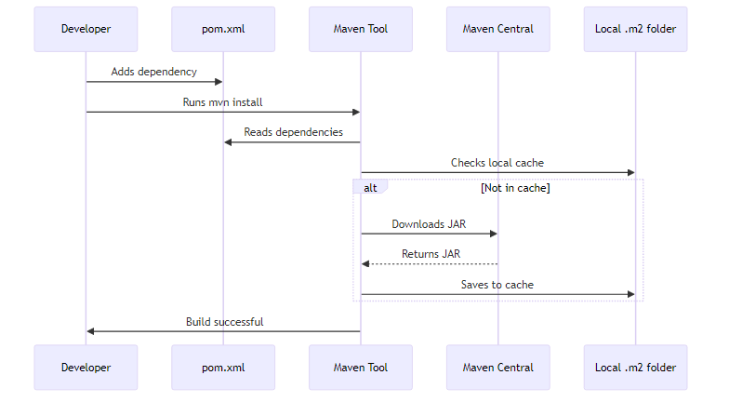
Maven Local Repository: C:\Users\YourName\.m2\repository\ (Windows)

4. UNDERSTANDING DEPENDENCIES

📌 What is a Dependency?
A dependency is when one class needs another class to function.
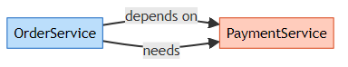
Real-World Analogy: - You (OrderService) want to buy something online - You need a payment method (PaymentService) to complete the purchase - You depend on the payment service

🔍 Code Analysis: PaymentService.java
Reference: PaymentService.java:3
public class PaymentService {
public boolean processPayment(double amount) {
System.out.println("Processing Payment of $" + amount);
return true; // Simulates successful payment
}
public String getTransactionId(double amount) {
return "TXN" + System.currentTimeMillis();
}
}
What This Class Does: - processPayment() - Simulates processing a payment - getTransactionId() - Generates a transaction ID - In real life, this would connect to Stripe, PayPal, etc.

🔍 Code Analysis: OrderService.java
Reference: OrderService.java:3
public class OrderService {
private PaymentService paymentservice; // Dependency
// Constructor Injection
public OrderService(PaymentService paymentservice) {
this.paymentservice = paymentservice;
}
public String placeOrder(double amount) {
boolean paymentSuccess = paymentservice.processPayment(amount);
if (paymentSuccess) {
return "ORDER PLACED";
}
return "PAYMENT FAILED";
}
}
Key Concepts:
- Dependency Declaration:
- private PaymentService paymentservice; // OrderService NEEDS PaymentService
- Constructor Injection:
- public OrderService(PaymentService paymentservice) {
this.paymentservice = paymentservice; // Inject dependency
}
  - Why? Allows us to pass a MOCK PaymentService during testing!
- Using the Dependency:
- paymentservice.processPayment(amount); // Calls the dependency

🎯 Dependency Injection Explained
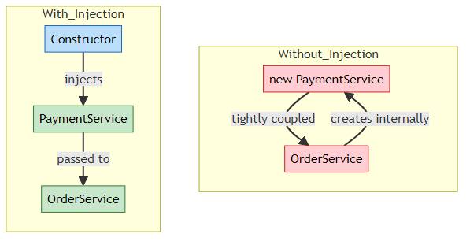
Bad (Tight Coupling):
public class OrderService {
private PaymentService paymentservice = new PaymentService(); // ❌ Hard to test
}
Good (Dependency Injection):
public class OrderService {
private PaymentService paymentservice;
public OrderService(PaymentService paymentservice) { // ✅ Easy to test
this.paymentservice = paymentservice;
}
}
Why is this important for testing? - With injection, we can pass a MOCK PaymentService - Without injection, OrderService always uses the real PaymentService

5. MOCKITO CORE CONCEPTS
📝 Comprehensive Guide by: Avinash Dhanuka | © 2026

📌 The Three Pillars of Mockito
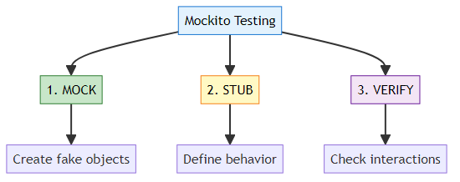

1️⃣ MOCK - Creating Fake Objects
What is Mocking? Creating a fake version of a class that looks real but doesn’t do anything.
// Create a mock (fake) PaymentService
PaymentService mockPayment = mock(PaymentService.class);
What happens internally: - Mockito creates a fake PaymentService object - All methods return default values (false, null, 0) - No real code from PaymentService executes

2️⃣ STUB - Defining Behavior
What is Stubbing? Telling the mock object how to behave when methods are called.
// Tell the mock: "When processPayment(500.0) is called, return true"
when(mockPayment.processPayment(500.0)).thenReturn(true);
Stubbing Syntax:
when(mockObject.method(arguments)).thenReturn(value);

3️⃣ VERIFY - Checking Interactions
What is Verification? Confirming that a method was actually called on the mock.
// Check: Was processPayment(500.0) called?
verify(mockPayment).processPayment(500.0);

🔄 Complete Mockito Flow
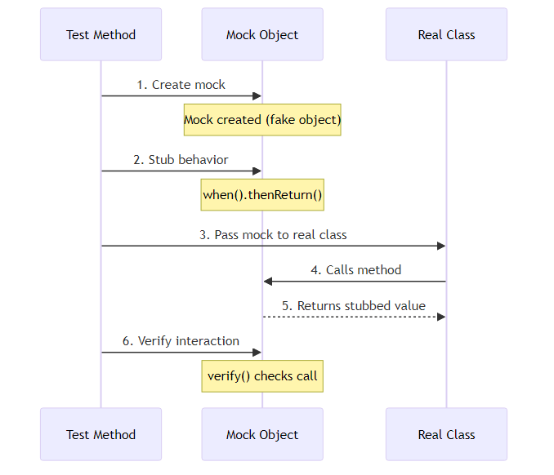
Step-by-Step Example:
// Step 1: Create mock
PaymentService mockPayment = mock(PaymentService.class);
// Step 2: Stub behavior
when(mockPayment.processPayment(500.0)).thenReturn(true);
// Step 3: Pass mock to real class
OrderService orderService = new OrderService(mockPayment);
// Step 4 & 5: Real class calls mock, gets stubbed value
String result = orderService.placeOrder(500.0);
// Step 6: Verify interaction
verify(mockPayment).processPayment(500.0);

📊 Mock vs Real Object Comparison
Aspect | Real Object | Mock Object
Creation | new PaymentService() | mock(PaymentService.class)
Behavior | Executes actual code | Returns predefined values
Speed | Slow (real operations) | Fast (no operations)
Dependencies | Needs database, network | No dependencies
Control | Cannot control output | Full control over output
Use Case | Production code | Testing only

6. ANNOTATIONS DEEP DIVE

📌 Mockito Annotations
Mockito provides annotations to simplify mock creation and injection.

🏷️ Core Annotations
Annotation | Purpose | Example
@Mock | Creates a mock object | @Mock PaymentService paymentService;
@InjectMocks | Injects mocks into this object | @InjectMocks OrderService orderService;
@Spy | Creates a partial mock | @Spy PaymentService paymentService;
@Captor | Captures method arguments | @Captor ArgumentCaptor<String> captor;

1️⃣ @Mock Annotation
Reference: OrderServiceTest.java:18
@Mock
PaymentService paymentServiceMock;
What it does: - Creates a mock (fake) PaymentService - Equivalent to: PaymentService paymentServiceMock = mock(PaymentService.class);
Internal Working:

2️⃣ @InjectMocks Annotation
Reference: OrderServiceTest.java:21
@InjectMocks
OrderService orderService;
What it does: - Creates a real OrderService object - Automatically injects all @Mock objects into it - Equivalent to: OrderService orderService = new OrderService(paymentServiceMock);
Injection Process:
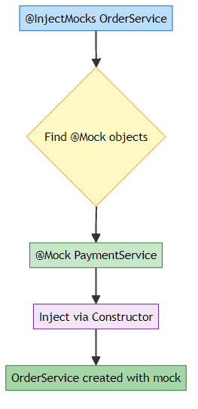
How Mockito Injects: 1. Constructor Injection (preferred) - Passes mock via constructor 2. Setter Injection - Calls setter methods 3. Field Injection - Directly sets private fields (reflection)

3️⃣ MockitoAnnotations.openMocks()
Reference: OrderServiceTest.java:24
@BeforeEach
void setUp() {
MockitoAnnotations.openMocks(this);
}
What it does: - Initializes all @Mock and @InjectMocks annotations - Must be called before tests run - Usually placed in @BeforeEach
Without this line: - @Mock creates null objects - @InjectMocks doesn’t inject anything - Tests will fail with NullPointerException
Alternative (JUnit 5 Extension):
@ExtendWith(MockitoExtension.class) // Automatically initializes mocks
public class OrderServiceTest {
@Mock PaymentService paymentServiceMock;
@InjectMocks OrderService orderService;
// No need for MockitoAnnotations.openMocks(this)
}

📊 Annotation Comparison
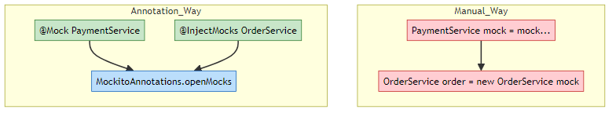
Benefits of Annotations: - ✅ Less boilerplate code - ✅ Cleaner test classes - ✅ Automatic injection - ✅ Better readability

7. STUBBING & VERIFICATION
📝 Deep Dive by: Avinash Dhanuka | Understanding Mock Behavior

📌 Stubbing Methods
Stubbing = Defining how a mock should behave when its methods are called.

1️⃣ Basic Stubbing: when().thenReturn()
Reference: OrderServiceTest.java:36
@Test
void testPlaceOrder_Success() {
// STUB: Tell mock what to return
when(paymentServiceMock.processPayment(500.0))
.thenReturn(true);
// ACT: Call the method being tested
String result = orderService.placeOrder(500.0);
// ASSERT: Check the result
assertEquals("ORDER PLACED", result);
// VERIFY: Confirm mock was called
verify(paymentServiceMock).processPayment(500.0);
}
Breakdown:
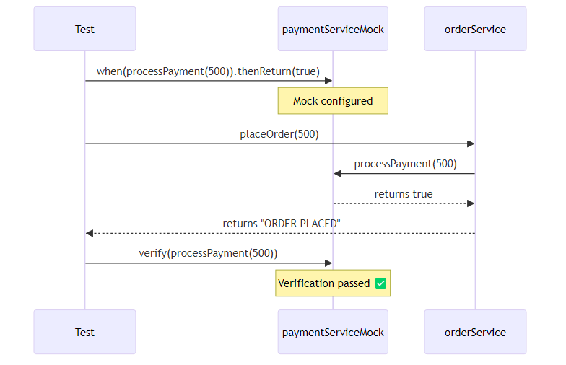

2️⃣ Stubbing with anyDouble()
Reference: OrderServiceTest.java:64
@Test
void testPlaceOrder_AnyAmount() {
// STUB: Return true for ANY double value
when(paymentServiceMock.processPayment(anyDouble()))
.thenReturn(true);
String result = orderService.placeOrder(999.99); // Any amount works!
assertEquals("ORDER PLACED", result);
}
Argument Matchers:
Matcher | Purpose | Example
anyDouble() | Matches any double | anyDouble()
anyInt() | Matches any int | anyInt()
anyString() | Matches any String | anyString()
any(Class) | Matches any object of type | any(User.class)
eq(value) | Matches exact value | eq(500.0)
When to use: - anyDouble() - When you don’t care about the exact value - 500.0 - When you want to test a specific value

3️⃣ Stubbing Exceptions: when().thenThrow()
Reference: OrderServiceTest.java:85
@Test
void testPlaceOrder_Exception() {
// STUB: Throw exception when method is called
when(paymentServiceMock.processPayment(anyDouble()))
.thenThrow(new RuntimeException("Bank API down!"));
// ASSERT: Expect exception to be thrown
RuntimeException exception = assertThrows(
RuntimeException.class,
() -> orderService.placeOrder(100.0)
);
assertEquals("Bank API down!", exception.getMessage());
}
Use Cases for thenThrow(): - Simulate network failures - Test error handling - Simulate database connection errors - Test timeout scenarios

4️⃣ Multiple Stubbing
// Return different values on consecutive calls
when(mockPayment.processPayment(anyDouble()))
.thenReturn(true) // First call returns true
.thenReturn(false) // Second call returns false
.thenThrow(new RuntimeException()); // Third call throws exception

📊 Stubbing Methods Summary
Method | Purpose | Example
thenReturn() | Return a value | .thenReturn(true)
thenThrow() | Throw exception | .thenThrow(new RuntimeException())
thenAnswer() | Custom logic | .thenAnswer(invocation -> ...)
thenCallRealMethod() | Call actual method | .thenCallRealMethod()
doNothing() | Do nothing (void methods) | doNothing().when(mock).method()

🔍 Verification Methods
Purpose: Confirm that mock methods were called as expected.

1️⃣ Basic Verification
// Verify method was called once with exact arguments
verify(paymentServiceMock).processPayment(500.0);

2️⃣ Verification with Times
// Verify method was called exactly 2 times
verify(paymentServiceMock, times(2)).processPayment(anyDouble());
// Verify method was never called
verify(paymentServiceMock, never()).processPayment(anyDouble());
// Verify method was called at least once
verify(paymentServiceMock, atLeastOnce()).processPayment(anyDouble());
// Verify method was called at most 3 times
verify(paymentServiceMock, atMost(3)).processPayment(anyDouble());

3️⃣ Verification Order
InOrder inOrder = inOrder(paymentServiceMock);
inOrder.verify(paymentServiceMock).processPayment(100.0);
inOrder.verify(paymentServiceMock).getTransactionId(100.0);

🎯 Complete Test Anatomy
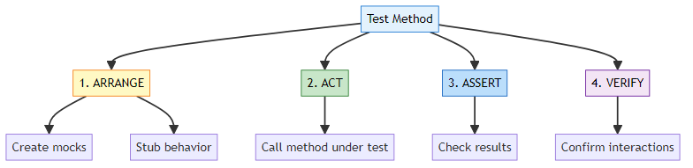
AAA Pattern (Arrange-Act-Assert):
@Test
void testExample() {
// ARRANGE: Set up test data and mocks
when(mockPayment.processPayment(500.0)).thenReturn(true);
// ACT: Execute the method being tested
String result = orderService.placeOrder(500.0);
// ASSERT: Verify the result
assertEquals("ORDER PLACED", result);
// VERIFY: Confirm mock interactions (optional)
verify(mockPayment).processPayment(500.0);
}

8. INTERNAL EXECUTION FLOW
📝 Deep Dive by: Avinash Dhanuka | Understanding JVM + Mockito Internals

🏭 How Mockito Works Internally
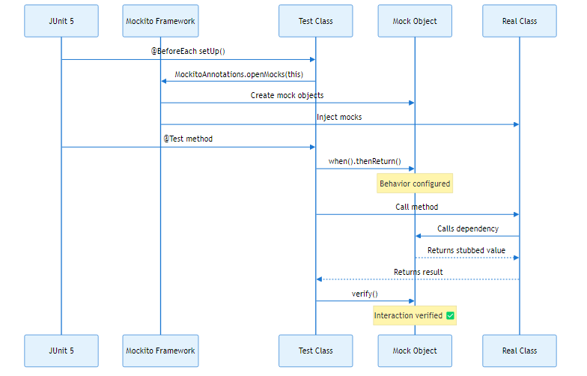

🧠 Memory Architecture with Mocks
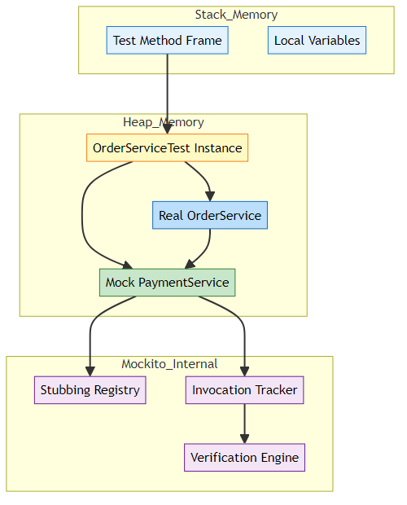
Key Components:
- Stubbing Registry: Stores all when().thenReturn() configurations
- Invocation Tracker: Records every method call on mocks
- Verification Engine: Checks if expected calls were made

🔍 Step-by-Step Execution
Test Code:
@Test
void testPlaceOrder_Success() {
when(paymentServiceMock.processPayment(500.0)).thenReturn(true);
String result = orderService.placeOrder(500.0);
assertEquals("ORDER PLACED", result);
verify(paymentServiceMock).processPayment(500.0);
}
Execution Steps:

Step 1: Test Initialization
JUnit calls @BeforeEach setUp()
└─> MockitoAnnotations.openMocks(this)
└─> Scans for @Mock annotations
└─> Creates mock PaymentService (proxy object)
└─> Scans for @InjectMocks
└─> Creates OrderService
└─> Injects mock via constructor

Step 2: Stubbing
when(paymentServiceMock.processPayment(500.0)).thenReturn(true);
Internal Process:
1. Mockito intercepts the call to processPayment(500.0)
2. Stores in Stubbing Registry:
{
method: "processPayment",
arguments: [500.0],
returnValue: true
}
3. Does NOT execute real processPayment code

Step 3: Method Execution
String result = orderService.placeOrder(500.0);
Internal Process:
1. orderService.placeOrder(500.0) is called
2. Inside placeOrder:
paymentservice.processPayment(500.0) is called
3. Mockito intercepts this call
4. Checks Stubbing Registry for matching stub
5. Finds: processPayment(500.0) → return true
6. Returns true (without executing real code)
7. placeOrder returns "ORDER PLACED"

Step 4: Verification
verify(paymentServiceMock).processPayment(500.0);
Internal Process:
1. Mockito checks Invocation Tracker
2. Looks for: processPayment(500.0)
3. Found: ✅ Called once
4. Verification passes

🎯 Mock Object Creation (Bytecode Level)
What happens when you create a mock:
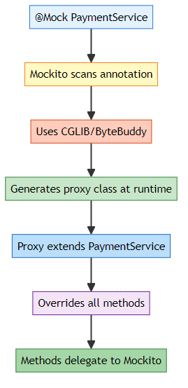
Generated Proxy (Simplified):
// Mockito generates something like this at runtime
public class PaymentService$MockitoMock extends PaymentService {
private MockHandler handler;
@Override
public boolean processPayment(double amount) {
// Delegate to Mockito's handler
return (boolean) handler.handle(
this,
"processPayment",
new Object[]{amount}
);
}
}

📊 Real vs Mock Execution Comparison
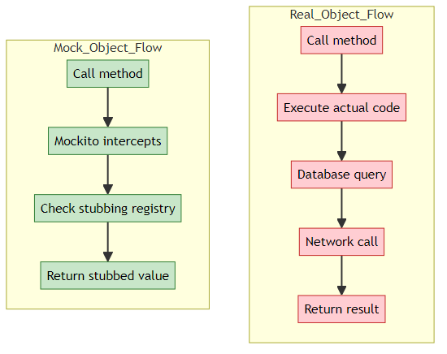
Performance Impact: - Real Object: 100ms (database + network) - Mock Object: <1ms (in-memory lookup)

9. TOPICS COVERED IN THIS PROJECT

✅ Complete Checklist

🎯 Maven & Build Tools
- ✅ Maven Project Structure: Understanding pom.xml
- ✅ Dependency Management: Automatic JAR downloads
- ✅ Maven Central Repository: Where libraries come from
- ✅ Build Lifecycle: compile, test, package
- ✅ Scope: Understanding <scope>test</scope>

🔧 Dependency Injection
- ✅ Constructor Injection: Passing dependencies via constructor
- ✅ Tight vs Loose Coupling: Why injection matters
- ✅ Testability: How injection enables testing
- ✅ Dependency Declaration: private PaymentService paymentservice;

🎭 Mockito Fundamentals
- ✅ Mock Creation: @Mock annotation
- ✅ Mock Injection: @InjectMocks annotation
- ✅ Mock Initialization: MockitoAnnotations.openMocks(this)
- ✅ Alternative: @ExtendWith(MockitoExtension.class)

📝 Stubbing Techniques
- ✅ Basic Stubbing: when().thenReturn()
- ✅ Exception Stubbing: when().thenThrow()
- ✅ Argument Matchers: anyDouble(), anyInt(), anyString()
- ✅ Exact Matching: Specific values vs any values
- ✅ Multiple Returns: Consecutive call stubbing

✔️ Verification Methods
- ✅ Basic Verification: verify(mock).method()
- ✅ Times Verification: times(), never(), atLeastOnce()
- ✅ Argument Verification: Checking exact arguments
- ✅ Interaction Tracking: What was called and when

🧪 Testing Patterns
- ✅ AAA Pattern: Arrange-Act-Assert
- ✅ Test Isolation: Each test independent
- ✅ Success Scenarios: Testing happy path
- ✅ Failure Scenarios: Testing error cases
- ✅ Exception Testing: Using assertThrows()

📚 Learning Path Progression
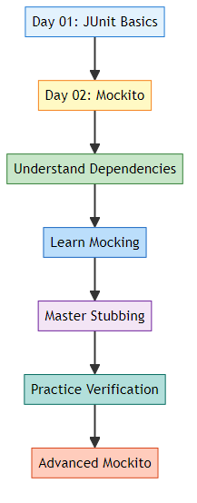

🎓 Real-World Applications
Concept | Real-World Use Case
Mocking PaymentService | Test order processing without charging real money
Stubbing Exceptions | Test how app handles payment gateway failures
Argument Matchers | Test with various input amounts without writing 100 tests
Verification | Ensure audit logs are created for every transaction
Constructor Injection | Swap real database with mock for testing
Maven Dependencies | Automatically get latest security patches

10. DAY 01 VS DAY 02 COMPARISON
📝 Detailed Comparison by: Avinash Dhanuka | Connect on GitHub

🔄 Evolution of Learning
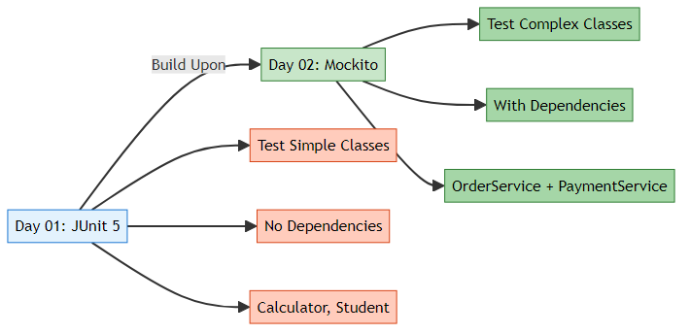

📊 Comprehensive Comparison Table
Aspect | Day 01 (JUnit Only) | Day 02 (Mockito + Maven)
Main Topic | Unit Testing Basics | Mocking Dependencies
Framework | JUnit 5 | JUnit 5 + Mockito
Build Tool | None (IDE) | Maven (pom.xml)
Dependencies | Manual JARs | Automatic via Maven
Classes Tested | Calculator, StudentService | OrderService
Dependencies in Code | None | PaymentService
Testing Approach | Direct testing | Mock dependencies
Complexity | Simple (no external deps) | Complex (with deps)
New Concepts | Assertions, Lifecycle | Mocking, Stubbing, Verification
Annotations | @Test, @BeforeEach | @Mock, @InjectMocks
Test Speed | Fast | Even Faster (no real deps)
Real-World Readiness | Basic | Production-ready

🎯 What Day 01 Taught Us
// Day 01: Testing a simple class
@Test
void testAdd() {
Calculator calc = new Calculator();
assertEquals(5, calc.add(2, 3)); // Direct testing
}
Limitations: - ❌ Cannot test classes with dependencies - ❌ No way to isolate units - ❌ Cannot simulate failures

🎯 What Day 02 Teaches Us
// Day 02: Testing a class with dependencies
@Mock
PaymentService paymentServiceMock; // Fake dependency
@InjectMocks
OrderService orderService; // Real class with fake dependency
@Test
void testPlaceOrder() {
when(paymentServiceMock.processPayment(500.0)).thenReturn(true);
String result = orderService.placeOrder(500.0);
assertEquals("ORDER PLACED", result);
}
Advantages: - ✅ Can test classes with dependencies - ✅ True unit testing (isolated) - ✅ Can simulate any scenario - ✅ Production-ready testing

🔄 How They Work Together
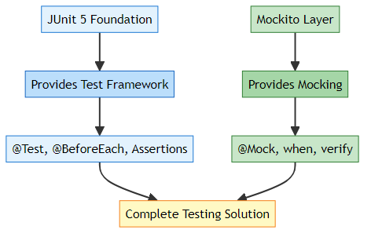
Relationship: - JUnit 5 = Test execution engine - Mockito = Mocking library - Together = Complete testing toolkit

📈 Skill Progression
Skill Level | Day 01 | Day 02
Beginner | ✅ Write basic tests | ✅ Understand dependencies
Intermediate | ✅ Use assertions | ✅ Create mocks
Advanced | ✅ Parameterized tests | ✅ Stub complex behaviors
Expert | ✅ Test lifecycle | ✅ Verify interactions

🌐 When to Use What?
Scenario | Use Day 01 Approach | Use Day 02 Approach
Testing utility methods | ✅ Yes | ❌ Overkill
Testing business logic | ✅ If no deps | ✅ If has deps
Testing with database | ❌ Cannot | ✅ Mock database
Testing with APIs | ❌ Cannot | ✅ Mock API calls
Testing calculations | ✅ Perfect | ❌ Not needed
Testing services | ❌ Limited | ✅ Perfect

11. TOP INTERVIEW QUESTIONS
📝 Curated by: Avinash Dhanuka | © 2026 | GitHub

🧠 Mockito Fundamentals

Q1: What is the difference between Mock and Spy in Mockito?
Feature | Mock | Spy
Creation | @Mock or mock() | @Spy or spy()
Behavior | All methods return default values | Calls real methods unless stubbed
Use Case | Complete fake object | Partial mocking
Real Code | Never executes | Executes by default
Example:
// Mock - No real code executes
@Mock PaymentService mockPayment;
when(mockPayment.processPayment(100)).thenReturn(true); // Must stub
// Spy - Real code executes unless stubbed
@Spy PaymentService spyPayment;
// processPayment() will execute real code
when(spyPayment.processPayment(100)).thenReturn(true); // Override specific call

Q2: What is the difference between @Mock and mock()?
Answer: They do the same thing, but syntax differs.
// Annotation way (cleaner)
@Mock
PaymentService paymentService;
// Manual way
PaymentService paymentService = mock(PaymentService.class);
When to use: - @Mock - When using annotations (recommended) - mock() - When creating mocks dynamically in test methods

Q3: Why do we need MockitoAnnotations.openMocks(this)?
Answer: To initialize all @Mock and @InjectMocks annotations.
Without it:
@Mock PaymentService payment; // This is NULL!
With it:
@BeforeEach
void setUp() {
MockitoAnnotations.openMocks(this); // Now payment is initialized
}
Alternative:
@ExtendWith(MockitoExtension.class) // Automatic initialization
public class MyTest { }

Q4: What is the difference between when().thenReturn() and doReturn().when()?
Answer:
Syntax | Type Safety | Use Case
when().thenReturn() | Type-safe | Normal methods
doReturn().when() | Not type-safe | Void methods, Spies
Example:
// Normal stubbing
when(mock.method()).thenReturn(value);
// For void methods
doNothing().when(mock).voidMethod();
// For spies (avoids calling real method)
doReturn(value).when(spy).method();

Q5: How do you verify a method was never called?
Answer: Use verify() with never().
verify(mockPayment, never()).processPayment(anyDouble());
Other verification modes:
verify(mock, times(2)).method(); // Called exactly 2 times
verify(mock, atLeastOnce()).method(); // Called at least once
verify(mock, atMost(3)).method(); // Called at most 3 times

🎯 Stubbing & Verification

Q6: What are Argument Matchers and when should you use them?
Answer: Argument matchers allow flexible stubbing without specifying exact values.
// Without matcher - must match exactly
when(mock.processPayment(500.0)).thenReturn(true);
// With matcher - matches any double
when(mock.processPayment(anyDouble())).thenReturn(true);
Common Matchers: - anyInt(), anyDouble(), anyString() - any(Class.class) - Any object of type - eq(value) - Exact value (when mixing matchers)
Rule: If you use one matcher, use matchers for ALL arguments.
// ❌ WRONG - Mixing matcher and exact value
when(mock.method(anyInt(), 100)).thenReturn(true);
// ✅ CORRECT - All matchers
when(mock.method(anyInt(), eq(100))).thenReturn(true);

Q7: How do you stub a method to throw an exception?
Answer: Use when().thenThrow() or doThrow().when().
// For methods that return values
when(mock.processPayment(anyDouble()))
.thenThrow(new RuntimeException("Payment failed"));
// For void methods
doThrow(new RuntimeException()).when(mock).voidMethod();

Q8: Can you stub the same method multiple times?
Answer: Yes! Last stubbing wins, or use consecutive returns.
// Last stubbing wins
when(mock.method()).thenReturn(1);
when(mock.method()).thenReturn(2); // This one is used
// Consecutive returns
when(mock.method())
.thenReturn(1) // First call
.thenReturn(2) // Second call
.thenReturn(3); // Third call

🔧 Advanced Concepts

Q9: What is @InjectMocks and how does it work?
Answer: @InjectMocks creates a real instance and injects all @Mock objects into it.
Injection Order: 1. Constructor Injection (preferred) 2. Setter Injection 3. Field Injection (reflection)
@Mock PaymentService paymentMock;
@InjectMocks OrderService orderService; // Injects paymentMock
// Equivalent to:
OrderService orderService = new OrderService(paymentMock);

Q10: What is the difference between Unit Test and Integration Test with Mockito?
Aspect | Unit Test | Integration Test
Mocking | Heavy (all dependencies) | Minimal (only external)
Speed | Very fast | Slower
Scope | Single class | Multiple classes
Example | Mock PaymentService | Real PaymentService + Mock Bank API
Unit Test (Day 02 approach):
@Mock PaymentService payment; // Mock everything
@InjectMocks OrderService order;
Integration Test:
PaymentService payment = new PaymentService(); // Real service
OrderService order = new OrderService(payment); // Test together

Q11: How do you test void methods?
Answer: Use verify() to check if they were called.
// Void method
public void sendEmail(String to) {
// Sends email
}
// Test
@Test
void testSendEmail() {
doNothing().when(mockEmailService).sendEmail(anyString());
orderService.placeOrder(100); // This calls sendEmail internally
verify(mockEmailService).sendEmail("customer@example.com");
}

Q12: What is the difference between Mockito and PowerMock?
Feature | Mockito | PowerMock
Static Methods | ❌ Cannot mock | ✅ Can mock
Private Methods | ❌ Cannot mock | ✅ Can mock
Final Classes | ❌ Cannot mock (Mockito 4-) | ✅ Can mock
Constructors | ❌ Cannot mock | ✅ Can mock
Recommendation | ✅ Use this | ❌ Avoid (bad design)
Why avoid PowerMock? - If you need to mock static/private methods, your design is probably wrong - Refactor code to use dependency injection instead

💡 Best Practices

Q13: Should you verify every mock interaction?
Answer: No! Only verify what matters for the test.
// ❌ BAD - Over-verification
verify(mock).method1();
verify(mock).method2();
verify(mock).method3();
// ... 20 more verifications
// ✅ GOOD - Verify what matters
verify(mock).criticalMethod(); // Only verify important interactions

Q14: When should you NOT use Mockito?
Answer: 1. Testing simple utility classes (use real objects) 2. Testing data classes (POJOs) 3. Integration tests (use real dependencies) 4. When mocking makes test more complex than code
Example - Don’t mock this:
// Simple utility - no need to mock
public class MathUtils {
public int add(int a, int b) {
return a + b;
}
}

Q15: What is the difference between @ExtendWith(MockitoExtension.class) and MockitoAnnotations.openMocks()?
Answer:
Approach | When | Pros | Cons
@ExtendWith | Class level | Automatic, cleaner | JUnit 5 only
openMocks() | @BeforeEach | Works everywhere | Manual setup
// Approach 1: Automatic (recommended)
@ExtendWith(MockitoExtension.class)
public class MyTest {
@Mock PaymentService payment;
}
// Approach 2: Manual
public class MyTest {
@Mock PaymentService payment;
@BeforeEach
void setUp() {
MockitoAnnotations.openMocks(this);
}
}

🚀 Real-World Scenarios

Q16: How do you test a method that calls multiple dependencies?
Answer: Mock all dependencies and verify each interaction.
public class OrderService {
private PaymentService payment;
private EmailService email;
private InventoryService inventory;
public void placeOrder(Order order) {
inventory.reserve(order);
payment.process(order.getAmount());
email.send(order.getCustomer());
}
}
@Test
void testPlaceOrder() {
// Mock all dependencies
when(inventory.reserve(any())).thenReturn(true);
when(payment.process(anyDouble())).thenReturn(true);
doNothing().when(email).send(anyString());
orderService.placeOrder(order);
// Verify all interactions
verify(inventory).reserve(order);
verify(payment).process(100.0);
verify(email).send("customer@example.com");
}

Q17: How do you test asynchronous methods with Mockito?
Answer: Use CompletableFuture or @Timeout.
@Test
@Timeout(value = 5, unit = TimeUnit.SECONDS)
void testAsyncMethod() throws Exception {
CompletableFuture<String> future = orderService.placeOrderAsync(100);
String result = future.get(); // Wait for completion
assertEquals("ORDER PLACED", result);
}

Q18: How do you mock a chain of method calls?
Answer: Use RETURNS_DEEP_STUBS.
// Chain: user.getAddress().getCity().getName()
User mockUser = mock(User.class, RETURNS_DEEP_STUBS);
when(mockUser.getAddress().getCity().getName()).thenReturn("New York");
Warning: This is a code smell. Better to refactor.

Q19: What is ArgumentCaptor and when to use it?
Answer: Captures arguments passed to mocked methods for verification.
@Captor
ArgumentCaptor<String> emailCaptor;
@Test
void testEmailSent() {
orderService.placeOrder(100);
verify(emailService).send(emailCaptor.capture());
String capturedEmail = emailCaptor.getValue();
assertEquals("customer@example.com", capturedEmail);
}

Q20: How do you test legacy code with Mockito?
Answer: 1. Identify dependencies 2. Refactor to use constructor injection 3. Mock dependencies 4. Write tests
Before (untestable):
public class OrderService {
public void placeOrder() {
PaymentService payment = new PaymentService(); // Hard-coded
payment.process();
}
}
After (testable):
public class OrderService {
private PaymentService payment;
public OrderService(PaymentService payment) { // Injected
this.payment = payment;
}
}

🎓 End of Day 02 Master Guide


Created with dedication by Avinash Dhanuka

© 2026 Avinash Dhanuka | All Rights Reserved
This documentation is protected intellectual property. Unauthorized reproduction or distribution is prohibited.

Happy Mocking! 🎭
“Mock it till you make it!” - Avinash Dhanuka

