☕ Master Guide: Hibernate ORM Framework with MySQL

© 2026 Avinash Dhanuka
Master Guide: Database Persistence with Hibernate
Crafted with ❤️ for Object-Relational Mapping

Learning Note: This guide builds upon Day 01 (JUnit 5) and Day 02 (Mockito) by introducing database persistence. Learn how to map Java objects to database tables without writing SQL!
Prerequisites: - Complete understanding of Day 01 - JUnit 5 Fundamentals - Complete understanding of Day 02 - Mockito Testing - MySQL Server installed and running

📑 Table of Contents
- What is Hibernate? (The Foundation)
- Why Do We Need Hibernate?
- Maven Project Structure
- Understanding ORM (Object-Relational Mapping)
- Hibernate Core Concepts
- JPA Annotations Deep Dive
- Hibernate Configuration
- CRUD Operations Explained
- Internal Execution Flow
- Topics Covered in This Project
- Day 01 vs Day 02 vs Day 03 Comparison
- Interview Questions

1. WHAT IS HIBERNATE? (THE FOUNDATION)
📝 Author: Avinash Dhanuka | GitHub

📌 Definition
Hibernate is a powerful Object-Relational Mapping (ORM) framework for Java that simplifies database operations by mapping Java objects to database tables automatically. It eliminates the need to write complex SQL queries manually.

🏗️ Key Characteristics
- Framework Type: ORM Framework (Database Persistence)
- Current Version: Hibernate 6.4.4 (Used in this project)
- Purpose: Bridge between Java objects and relational databases
- Standard: Implements JPA (Jakarta Persistence API)
- Database Support: MySQL, PostgreSQL, Oracle, SQL Server, etc.

📊 Hibernate Evolution
Version | Year | Key Features
Hibernate 3.x | 2005 | Annotations support, JPA 1.0
Hibernate 4.x | 2011 | Multi-tenancy, improved performance
Hibernate 5.x | 2015 | Java 8 support, JPA 2.1
Hibernate 6.x | 2022 | Jakarta EE, Java 17+, JPA 3.0

🎯 What Problem Does Hibernate Solve?
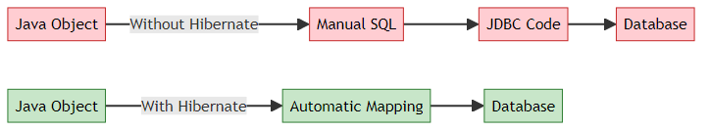
Simple Analogy: - Without Hibernate: You’re a translator who manually translates every sentence between two languages - With Hibernate: You have an automatic translation tool that does it for you

2. WHY DO WE NEED HIBERNATE?

🎯 The Problem Without Hibernate (Using Plain JDBC)
Imagine you want to save a Student object to the database:
// ❌ WITHOUT HIBERNATE - Manual JDBC Code (Painful!)
public void saveStudent(Student student) {
Connection conn = null;
PreparedStatement stmt = null;
try {
// 1. Load driver
Class.forName("com.mysql.cj.jdbc.Driver");
// 2. Create connection
conn = DriverManager.getConnection(
"jdbc:mysql://localhost:3306/mydb", "root", "password"
);
// 3. Write SQL manually
String sql = "INSERT INTO students (name, age) VALUES (?, ?)";
stmt = conn.prepareStatement(sql);
// 4. Set parameters manually
stmt.setString(1, student.getName());
stmt.setInt(2, student.getAge());
// 5. Execute
stmt.executeUpdate();
} catch (Exception e) {
e.printStackTrace();
} finally {
// 6. Close resources manually
try {
if (stmt != null) stmt.close();
if (conn != null) conn.close();
} catch (SQLException e) {
e.printStackTrace();
}
}
}
Problems: 1. ❌ Too much boilerplate code (20+ lines for simple save!) 2. ❌ Manual SQL writing (error-prone) 3. ❌ Manual type conversion (Java int → SQL INT) 4. ❌ Manual resource management (connections, statements) 5. ❌ Database-specific SQL (not portable) 6. ❌ No automatic relationship handling

✅ The Solution: Hibernate
// ✅ WITH HIBERNATE - Simple & Clean!
public void saveStudent(Student student) {
Session session = factory.openSession();
Transaction tx = session.beginTransaction();
session.persist(student); // That's it! 🎉
tx.commit();
session.close();
}
Benefits: 1. ✅ Minimal code (5 lines vs 30+ lines) 2. ✅ No SQL writing (Hibernate generates it) 3. ✅ Automatic type conversion 4. ✅ Automatic resource management 5. ✅ Database-independent (works with any DB) 6. ✅ Automatic relationship handling

📈 JDBC vs Hibernate Comparison
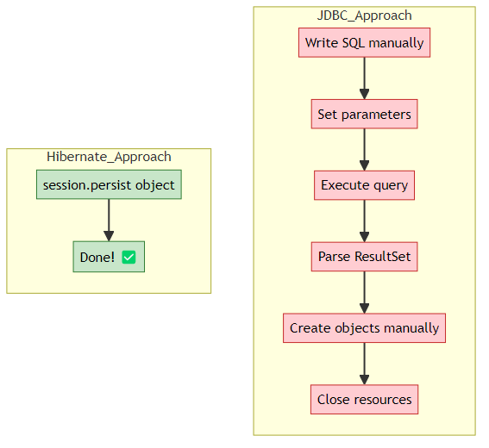

3. MAVEN PROJECT STRUCTURE
📝 Documentation by: Avinash Dhanuka | GitHub Profile

📂 Complete Folder Hierarchy
HibernateDemo/
├── .idea/ # IntelliJ IDEA configuration
├── .mvn/ # Maven wrapper files
├── src/
│ ├── main/
│ │ ├── java/org/example/
│ │ │ ├── entity/
│ │ │ │ └── Student.java # Entity class (maps to table)
│ │ │ └── App.java # Main application
│ │ └── resources/
│ │ └── hibernate.cfg.xml # Hibernate configuration
│ └── test/
│ └── java/org/example/
│ └── AppTest.java # Test class
├── target/ # Compiled classes (Maven output)
├── .gitignore
├── pom.xml # Maven dependencies
├── info.txt # Project notes
└── HIBERNATE-SUCCESS.md # Setup verification

🆚 Day 02 vs Day 03 Structure
Aspect | Day 02 (Mockito) | Day 03 (Hibernate)
Focus | Testing with mocks | Database persistence
Main Package | org.example | org.example + entity
New Folder | None | resources/ (for config)
Configuration | None | hibernate.cfg.xml
External System | None | MySQL Database
Dependencies | JUnit + Mockito | Hibernate + MySQL

📦 Understanding pom.xml Dependencies
Reference: pom.xml
<dependencies>
<!-- Hibernate Core -->
<dependency>
<groupId>org.hibernate.orm</groupId>
<artifactId>hibernate-core</artifactId>
<version>6.4.4.Final</version>
</dependency>
<!-- MySQL Connector -->
<dependency>
<groupId>com.mysql</groupId>
<artifactId>mysql-connector-j</artifactId>
<version>8.3.0</version>
</dependency>
<!-- HikariCP Connection Pool -->
<dependency>
<groupId>com.zaxxer</groupId>
<artifactId>HikariCP</artifactId>
<version>5.1.0</version>
</dependency>
</dependencies>

🔍 What Each Dependency Does
Dependency | Purpose | Why We Need It
hibernate-core | Core Hibernate ORM framework | Maps Java objects to database tables
mysql-connector-j | MySQL JDBC driver | Connects Java to MySQL database
HikariCP | Connection pool manager | Manages database connections efficiently
hibernate-hikaricp | Hibernate + HikariCP integration | Integrates connection pooling with Hibernate
slf4j-api | Logging API | Logs Hibernate operations
slf4j-simple | Simple logger implementation | Displays logs in console

🏊 What is Connection Pooling?
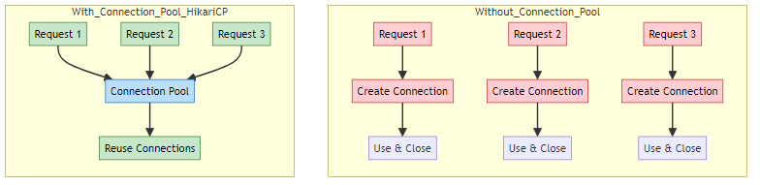
Real-World Analogy: - Without Pool: Every time you want water, you dig a new well (slow!) - With Pool: You have a swimming pool with water ready to use (fast!)
HikariCP Benefits: - ✅ Reuses database connections (faster) - ✅ Manages connection lifecycle automatically - ✅ Prevents connection leaks - ✅ Optimizes performance

4. UNDERSTANDING ORM (OBJECT-RELATIONAL MAPPING)

📌 What is ORM?
ORM = Object-Relational Mapping
It’s a technique that maps: - Java Objects (classes, fields) ↔ Database Tables (tables, columns)

🔄 The Mapping Process
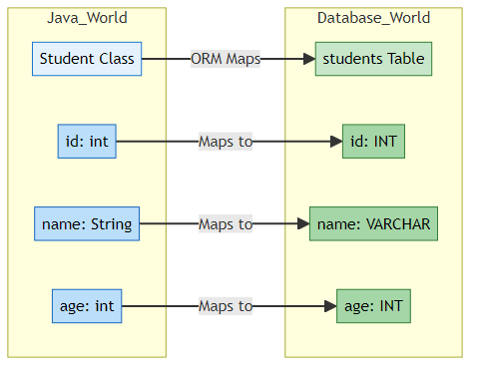

📊 Java vs Database Mapping
Java Concept | Database Concept | Example
Class | Table | Student class → students table
Object | Row | new Student() → One row in table
Field | Column | name field → name column
Data Type | SQL Type | String → VARCHAR, int → INT
Primary Key | Primary Key | @Id → PRIMARY KEY
Relationship | Foreign Key | @ManyToOne → FOREIGN KEY

🎯 Real-World Example
Java Code:
@Entity
@Table(name = "students")
public class Student {
@Id
@GeneratedValue(strategy = GenerationType.IDENTITY)
private int id;
@Column(name = "name")
private String name;
@Column(name = "age")
private int age;
}
Hibernate Generates This SQL:
CREATE TABLE students (
id INT AUTO_INCREMENT PRIMARY KEY,
name VARCHAR(100),
age INT
);
When you save an object:
Student student = new Student();
student.setName("John");
student.setAge(20);
session.persist(student); // Hibernate generates INSERT SQL
Hibernate Executes:
INSERT INTO students (name, age) VALUES ('John', 20);

5. HIBERNATE CORE CONCEPTS
📝 Comprehensive Guide by: Avinash Dhanuka | © 2026

📌 The Four Pillars of Hibernate
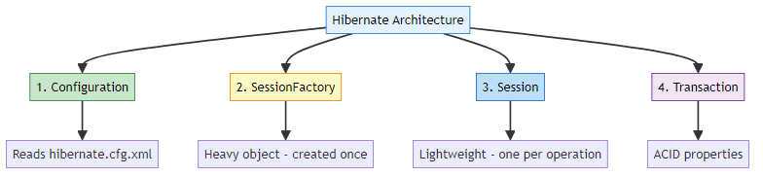

1️⃣ Configuration
What is it? The Configuration object reads settings from hibernate.cfg.xml and prepares Hibernate.
Code Example:
Configuration configuration = new Configuration()
.configure("hibernate.cfg.xml"); // Reads config file
What it does internally: 1. Reads database connection details (URL, username, password) 2. Loads entity mappings (which classes map to tables) 3. Sets Hibernate properties (show SQL, auto-create tables, etc.)

2️⃣ SessionFactory
What is it? A heavy, thread-safe object that creates Session objects. Created ONCE per application.
Code Example:
SessionFactory factory = configuration.buildSessionFactory();
Key Characteristics:
Property | Value
Weight | Heavy (expensive to create)
Thread Safety | Thread-safe (can be shared)
Lifecycle | Created once, used throughout app
Purpose | Factory for creating Sessions
Real-World Analogy: - SessionFactory = A car factory (built once, produces many cars) - Session = Individual cars (produced by the factory)
Internal Working:
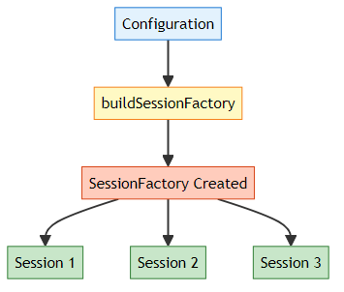

3️⃣ Session
What is it? A lightweight, short-lived object that represents a connection to the database. Created for each operation.
Code Example:
Session session = factory.openSession(); // Open connection
// ... perform database operations ...
session.close(); // Close connection
Key Characteristics:
Property | Value
Weight | Lightweight (cheap to create)
Thread Safety | NOT thread-safe (one per thread)
Lifecycle | Created per operation, closed after use
Purpose | Performs CRUD operations
Session Methods:
Method | Purpose | Example
persist() | Save new object | session.persist(student)
get() | Retrieve by ID | session.get(Student.class, 1)
merge() | Update object | session.merge(student)
remove() | Delete object | session.remove(student)
createQuery() | Execute HQL | session.createQuery("FROM Student")

4️⃣ Transaction
What is it? Represents a unit of work that follows ACID properties.
Code Example:
Transaction tx = session.beginTransaction();
try {
session.persist(student); // Database operation
tx.commit(); // Save changes permanently
} catch (Exception e) {
tx.rollback(); // Undo changes if error
}
ACID Properties:
Property | Meaning | Example
Atomicity | All or nothing | Either all operations succeed or all fail
Consistency | Valid state | Database remains in valid state
Isolation | Independent | Transactions don’t interfere with each other
Durability | Permanent | Committed changes are permanent
Transaction Flow:
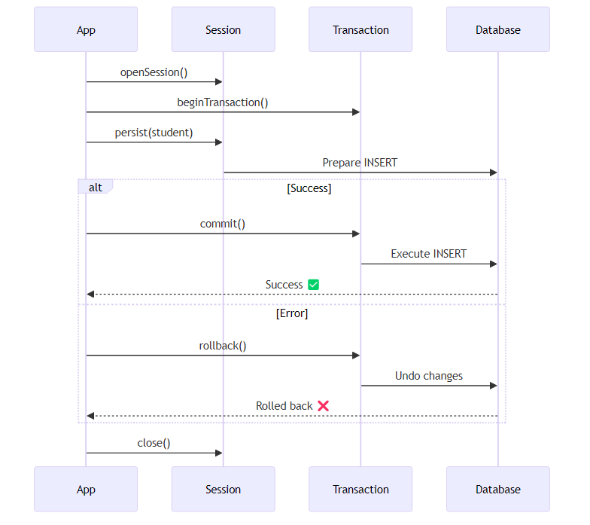

🔄 Complete Hibernate Workflow
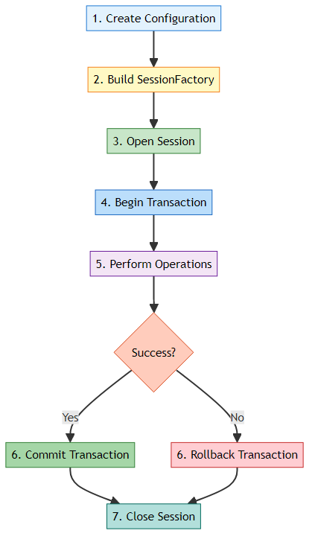

6. JPA ANNOTATIONS DEEP DIVE
📝 Deep Dive by: Avinash Dhanuka | Understanding Entity Mapping

📌 What is JPA?
JPA = Jakarta Persistence API (formerly Java Persistence API)
- Standard specification for ORM in Java
- Hibernate is one implementation of JPA
- Other implementations: EclipseLink, OpenJPA
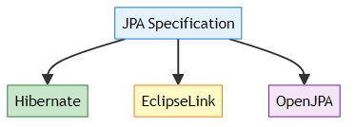

🏷️ Core JPA Annotations
Reference: Student.java

1️⃣ @Entity
Purpose: Marks a class as a database entity (maps to a table)
@Entity
public class Student {
// This class will be mapped to a database table
}
What Hibernate does: - Creates a table named student (lowercase class name) - Maps all fields to columns

2️⃣ @Table
Purpose: Customizes the table name and properties
@Entity
@Table(name = "students") // Custom table name
public class Student {
// Maps to "students" table instead of "student"
}
Additional Options:
@Table(
name = "students",
schema = "school_db", // Database schema
indexes = {@Index(name = "idx_name", columnList = "name")} // Create index
)

3️⃣ @Id
Purpose: Marks a field as the primary key
@Id
private int id; // This becomes PRIMARY KEY
What Hibernate generates:
CREATE TABLE students (
id INT PRIMARY KEY,
...
);

4️⃣ @GeneratedValue
Purpose: Specifies how the primary key is generated
@Id
@GeneratedValue(strategy = GenerationType.IDENTITY)
private int id; // Auto-increment
Generation Strategies:
Strategy | Description | Database Support
IDENTITY | Database auto-increment | MySQL, PostgreSQL
SEQUENCE | Database sequence | Oracle, PostgreSQL
TABLE | Separate table for IDs | All databases
AUTO | Hibernate chooses best | All databases
Example SQL Generated:
CREATE TABLE students (
id INT AUTO_INCREMENT PRIMARY KEY, -- IDENTITY strategy
...
);

5️⃣ @Column
Purpose: Customizes column properties
@Column(name = "student_name", nullable = false, length = 100)
private String name;
Column Properties:
Property | Purpose | Example
name | Custom column name | name = "student_name"
nullable | Allow NULL values | nullable = false
length | String length | length = 100
unique | Unique constraint | unique = true
insertable | Allow insert | insertable = true
updatable | Allow update | updatable = true
Generated SQL:
CREATE TABLE students (
student_name VARCHAR(100) NOT NULL,
...
);

📊 Complete Student Entity Breakdown
Reference: Student.java:6
@Entity // 1. Mark as entity
@Table(name = "students") // 2. Custom table name
public class Student {
@Id // 3. Primary key
@GeneratedValue(strategy = GenerationType.IDENTITY) // 4. Auto-increment
@Column(name = "id") // 5. Column name
private int id;
@Column(name = "name", nullable = false, length = 100)
private String name;
@Column(name = "age")
private int age;
// Constructors, Getters, Setters, toString()
}
What Hibernate Generates:
CREATE TABLE students (
id INT AUTO_INCREMENT PRIMARY KEY,
name VARCHAR(100) NOT NULL,
age INT
);

🔍 Annotation Mapping Visualization
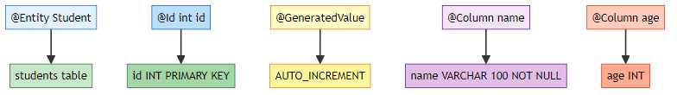

🎯 Why POJO (Plain Old Java Object)?
POJO = A simple Java class with: - Private fields - Public getters/setters - No-argument constructor - No special requirements
// ✅ This is a POJO
public class Student {
private int id;
private String name;
public Student() {} // No-arg constructor
public int getId() { return id; }
public void setId(int id) { this.id = id; }
// ... more getters/setters
}
Why Hibernate needs POJOs: - Hibernate uses reflection to access fields - No-arg constructor needed to create instances - Getters/setters for property access

7. HIBERNATE CONFIGURATION
📝 Configuration Guide by: Avinash Dhanuka

📌 Understanding hibernate.cfg.xml
Reference: hibernate.cfg.xml
This XML file contains all Hibernate settings.

🔍 Configuration Breakdown

1️⃣ Database Connection Settings
<!-- JDBC Driver -->
<property name="hibernate.connection.driver_class">
com.mysql.cj.jdbc.Driver
</property>
<!-- Database URL -->
<property name="hibernate.connection.url">
jdbc:mysql://localhost:3306/hibernate_db?useSSL=false&amp;serverTimezone=UTC
</property>
<!-- Credentials -->
<property name="hibernate.connection.username">root</property>
<property name="hibernate.connection.password">Asansol@0341</property>
URL Breakdown:
jdbc:mysql://localhost:3306/hibernate_db?useSSL=false&serverTimezone=UTC
│ │ │ │ │ │
│ │ │ │ │ └─ Parameters
│ │ │ │ └─ Database name
│ │ │ └─ Port (default MySQL port)
│ │ └─ Host (localhost = your computer)
│ └─ Database type
└─ Protocol

2️⃣ Connection Pool Settings (HikariCP)
<!-- Use HikariCP for connection pooling -->
<property name="hibernate.connection.provider_class">
org.hibernate.hikaricp.internal.HikariCPConnectionProvider
</property>
<!-- Minimum idle connections -->
<property name="hibernate.hikari.minimumIdle">5</property>
<!-- Maximum pool size -->
<property name="hibernate.hikari.maximumPoolSize">20</property>
<!-- Idle timeout (milliseconds) -->
<property name="hibernate.hikari.idleTimeout">30000</property>
What these settings mean:
Setting | Value | Meaning
minimumIdle | 5 | Keep at least 5 connections ready
maximumPoolSize | 20 | Maximum 20 connections at once
idleTimeout | 30000 | Close idle connections after 30 seconds
Visualization:
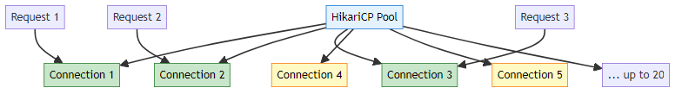

3️⃣ Hibernate Behavior Settings
<!-- Show SQL in console -->
<property name="hibernate.show_sql">true</property>
<!-- Format SQL for readability -->
<property name="hibernate.format_sql">true</property>
<!-- Auto-create/update tables -->
<property name="hibernate.hbm2ddl.auto">update</property>
hibernate.hbm2ddl.auto Options:
Value | Behavior | Use Case
create | Drop and recreate tables every time | Development (data loss!)
create-drop | Create on start, drop on exit | Testing
update | Update schema if needed | Development
validate | Only validate schema | Production
none | Do nothing | Production (manual schema)
⚠️ Warning: Never use create or update in production!

4️⃣ Entity Mapping
<!-- Register entity classes -->
<mapping class="org.example.entity.Student"/>
What this does: - Tells Hibernate which classes are entities - Hibernate scans these classes for annotations - Creates/updates tables based on annotations

🎯 Complete Configuration Flow
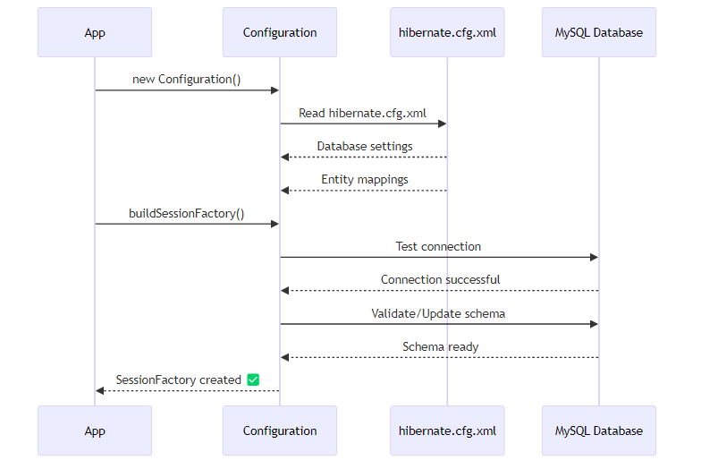

📊 Dialect: Database-Specific SQL
What is Dialect? Hibernate generates SQL, but each database has slightly different SQL syntax. Dialect tells Hibernate which database you’re using.
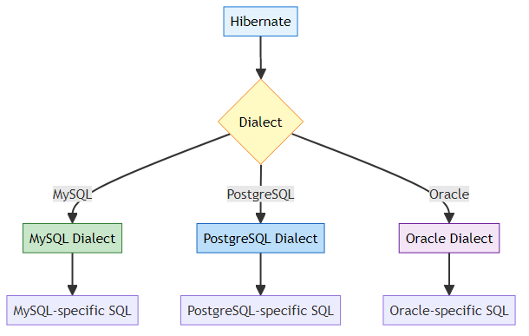
Example: - MySQL: AUTO_INCREMENT - PostgreSQL: SERIAL - Oracle: SEQUENCE
Hibernate automatically detects the dialect from the JDBC URL in version 6.x!

8. CRUD OPERATIONS EXPLAINED
📝 CRUD Guide by: Avinash Dhanuka | Create, Read, Update, Delete

📌 What is CRUD?
CRUD = The four basic database operations
Operation | SQL | Hibernate Method
Create | INSERT | session.persist()
Read | SELECT | session.get()
Update | UPDATE | session.merge()
Delete | DELETE | session.remove()

1️⃣ CREATE - Saving Data
Reference: App.java:14
public static void createStudent(SessionFactory factory) {
// 1. Open session
Session session = factory.openSession();
// 2. Begin transaction
Transaction transaction = session.beginTransaction();
try {
// 3. Create object
Student student = new Student();
student.setName("John Doe");
student.setAge(20);
// 4. Save to database
session.persist(student);
// 5. Commit transaction
transaction.commit();
System.out.println("Student Saved: " + student);
} catch (Exception e) {
// 6. Rollback on error
transaction.rollback();
e.printStackTrace();
} finally {
// 7. Close session
session.close();
}
}
What Hibernate Executes:
INSERT INTO students (name, age) VALUES ('John Doe', 20);
Step-by-Step Flow:
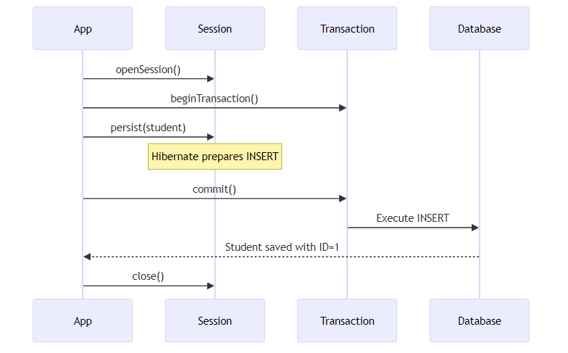

2️⃣ READ - Retrieving Data
public static void readStudent(SessionFactory factory, int id) {
Session session = factory.openSession();
try {
// Retrieve by ID
Student student = session.get(Student.class, id);
if (student != null) {
System.out.println("Found: " + student);
} else {
System.out.println("Student not found");
}
} finally {
session.close();
}
}
What Hibernate Executes:
SELECT id, name, age FROM students WHERE id = 1;
get() vs find():
Method | Behavior | When to Use
get() | Returns null if not found | When you expect it might not exist
find() | Same as get() (JPA standard) | JPA compatibility

3️⃣ UPDATE - Modifying Data
public static void updateStudent(SessionFactory factory, int id) {
Session session = factory.openSession();
Transaction tx = session.beginTransaction();
try {
// 1. Retrieve existing student
Student student = session.get(Student.class, id);
if (student != null) {
// 2. Modify fields
student.setName("John Updated");
student.setAge(21);
// 3. Update in database
session.merge(student);
tx.commit();
System.out.println("Student Updated: " + student);
}
} catch (Exception e) {
tx.rollback();
e.printStackTrace();
} finally {
session.close();
}
}
What Hibernate Executes:
UPDATE students SET name = 'John Updated', age = 21 WHERE id = 1;

4️⃣ DELETE - Removing Data
public static void deleteStudent(SessionFactory factory, int id) {
Session session = factory.openSession();
Transaction tx = session.beginTransaction();
try {
// 1. Retrieve student
Student student = session.get(Student.class, id);
if (student != null) {
// 2. Delete from database
session.remove(student);
tx.commit();
System.out.println("Student Deleted: " + student);
}
} catch (Exception e) {
tx.rollback();
e.printStackTrace();
} finally {
session.close();
}
}
What Hibernate Executes:
DELETE FROM students WHERE id = 1;

📊 CRUD Operations Comparison
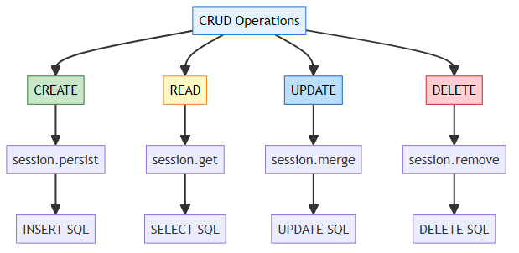

🎯 Best Practices

1. Always Use Try-Catch-Finally
Session session = factory.openSession();
Transaction tx = session.beginTransaction();
try {
// Database operations
tx.commit();
} catch (Exception e) {
tx.rollback(); // Undo changes on error
e.printStackTrace();
} finally {
session.close(); // Always close session
}

2. Check for Null
Student student = session.get(Student.class, id);
if (student != null) {
// Safe to use student
} else {
System.out.println("Not found");
}

3. Use Transactions for Write Operations
// ✅ GOOD - With transaction
Transaction tx = session.beginTransaction();
session.persist(student);
tx.commit();
// ❌ BAD - Without transaction (may not save!)
session.persist(student);

9. INTERNAL EXECUTION FLOW
📝 Deep Dive by: Avinash Dhanuka | Understanding Hibernate Internals

🏭 Complete Application Flow
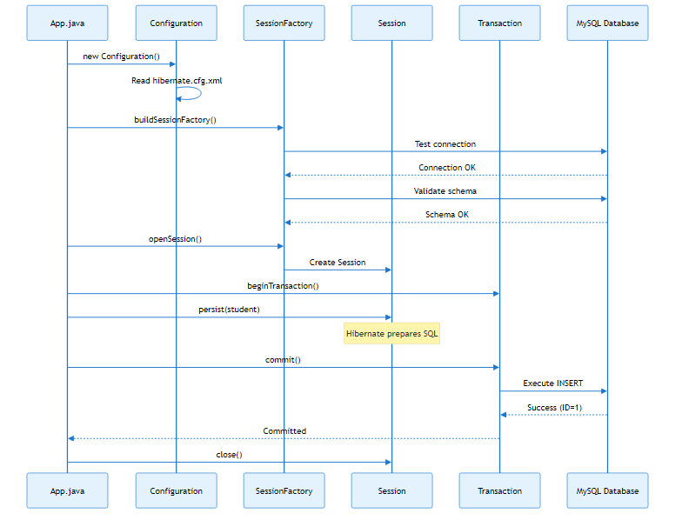

🧠 Memory Architecture
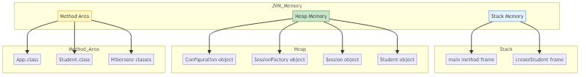

🔍 What Happens When You Call persist()?
Code:
session.persist(student);
Internal Steps:
- Hibernate checks if object is transient (new)
- Is student.id == 0? → Yes, it's new
- Hibernate generates SQL
- INSERT INTO students (name, age) VALUES (?, ?)
- Hibernate prepares statement
- PreparedStatement stmt = connection.prepareStatement(sql);
stmt.setString(1, student.getName());
stmt.setInt(2, student.getAge());
- On commit(), SQL is executed
- Database executes INSERT
Returns generated ID (e.g., 1)
- Hibernate updates object
- student.setId(1); // Hibernate sets the generated ID

📊 Entity States in Hibernate
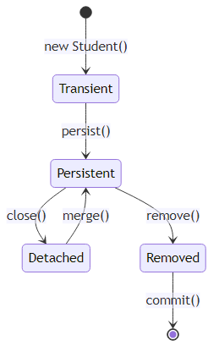
State Explanations:
State | Description | Example
Transient | New object, not in database | Student s = new Student()
Persistent | Managed by Hibernate, in database | After persist()
Detached | Was persistent, session closed | After session.close()
Removed | Marked for deletion | After remove()
Code Example:
// Transient state
Student student = new Student();
student.setName("John");
// Persistent state (Hibernate tracks changes)
session.persist(student);
student.setAge(20); // Hibernate will UPDATE this automatically!
// Detached state (Hibernate no longer tracks)
session.close();
student.setAge(21); // This change is NOT saved
// Back to Persistent
Session newSession = factory.openSession();
newSession.merge(student); // Now changes are tracked again

🎯 Hibernate Caching
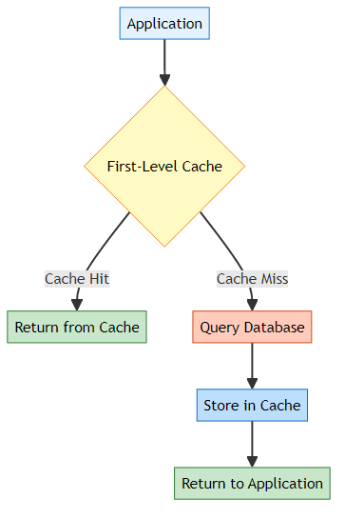
First-Level Cache (Session Cache): - Enabled by default - Lives within a Session - Cleared when session closes
Example:
Session session = factory.openSession();
// First call - queries database
Student s1 = session.get(Student.class, 1);
// Second call - returns from cache (no SQL!)
Student s2 = session.get(Student.class, 1);
System.out.println(s1 == s2); // true (same object!)
session.close();

🔄 Transaction Isolation Levels
What is Isolation? How transactions interact with each other.
Level | Description | Problems Prevented
READ_UNCOMMITTED | Can read uncommitted changes | None
READ_COMMITTED | Only read committed changes | Dirty reads
REPEATABLE_READ | Same read results in transaction | Dirty reads, Non-repeatable reads
SERIALIZABLE | Complete isolation | All problems
Default in MySQL: REPEATABLE_READ

10. TOPICS COVERED IN THIS PROJECT

✅ Complete Checklist

🎯 Hibernate Fundamentals
- ✅ ORM Concept: Object-Relational Mapping explained
- ✅ Hibernate Architecture: Configuration, SessionFactory, Session, Transaction
- ✅ JPA vs Hibernate: Understanding the relationship
- ✅ POJO: Plain Old Java Objects as entities

🏗️ Configuration & Setup
- ✅ Maven Dependencies: hibernate-core, mysql-connector, HikariCP
- ✅ hibernate.cfg.xml: Complete configuration file
- ✅ Connection Pooling: HikariCP integration
- ✅ Dialect: Database-specific SQL generation
- ✅ Schema Management: hbm2ddl.auto options

🏷️ JPA Annotations
- ✅ @Entity: Mark class as entity
- ✅ @Table: Customize table name
- ✅ @Id: Primary key
- ✅ @GeneratedValue: Auto-increment strategies
- ✅ @Column: Column customization

💾 CRUD Operations
- ✅ CREATE: session.persist() - Insert data
- ✅ READ: session.get() - Retrieve data
- ✅ UPDATE: session.merge() - Modify data
- ✅ DELETE: session.remove() - Remove data

🔧 Advanced Concepts
- ✅ Transaction Management: ACID properties
- ✅ Entity States: Transient, Persistent, Detached, Removed
- ✅ First-Level Cache: Session-level caching
- ✅ Exception Handling: Rollback on errors
- ✅ Resource Management: Proper session closing

📚 Learning Path Progression
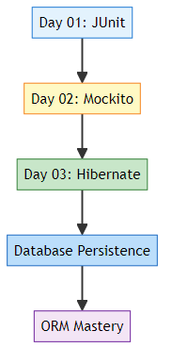

🎓 Real-World Applications
Concept | Real-World Use Case
Hibernate ORM | E-commerce product catalog management
Connection Pooling | High-traffic web applications
Transaction Management | Banking systems (money transfers)
Entity Mapping | User management systems
CRUD Operations | Any database-driven application
Caching | Improve performance in read-heavy apps

11. DAY 01 VS DAY 02 VS DAY 03 COMPARISON
📝 Comprehensive Comparison by: Avinash Dhanuka | Connect on GitHub

🔄 Evolution of Learning
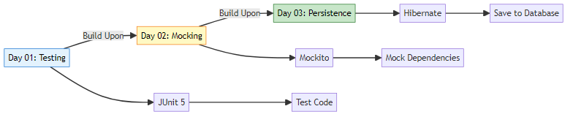

📊 Comprehensive Comparison Table
Aspect | Day 01 (JUnit) | Day 02 (Mockito) | Day 03 (Hibernate)
Main Topic | Unit Testing | Mocking Dependencies | Database Persistence
Framework | JUnit 5 | JUnit 5 + Mockito | Hibernate ORM
Purpose | Test code correctness | Test with fake objects | Save/retrieve data
External System | None | None | MySQL Database
Key Classes | Calculator, Student | OrderService, PaymentService | Student (Entity)
Key Annotations | @Test, @BeforeEach | @Mock, @InjectMocks | @Entity, @Id, @Column
Main Operations | Assertions | Stubbing, Verification | CRUD (Create, Read, Update, Delete)
Configuration | None | None | hibernate.cfg.xml
Dependencies | junit-jupiter | mockito-core | hibernate-core, mysql-connector
Complexity | Simple | Medium | Advanced
Real-World Use | Verify logic | Test without real services | Store data permanently

🎯 What Each Day Teaches

Day 01: Foundation
// Testing simple methods
@Test
void testAdd() {
Calculator calc = new Calculator();
assertEquals(5, calc.add(2, 3));
}
Focus: Verify code works correctly

Day 02: Isolation
// Testing with dependencies
@Mock PaymentService paymentMock;
@InjectMocks OrderService orderService;
@Test
void testOrder() {
when(paymentMock.process(100)).thenReturn(true);
assertEquals("SUCCESS", orderService.placeOrder(100));
}
Focus: Test without real dependencies

Day 03: Persistence
// Saving to database
Session session = factory.openSession();
Transaction tx = session.beginTransaction();
Student student = new Student();
student.setName("John");
session.persist(student); // Saves to MySQL!
tx.commit();
session.close();
Focus: Store data permanently

🔄 How They Work Together
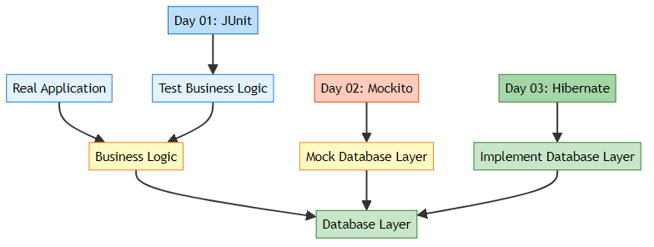
Example: E-commerce Application
// Day 03: Database layer (Hibernate)
public class ProductRepository {
public void save(Product product) {
session.persist(product); // Hibernate saves to DB
}
}
// Day 02: Business logic (uses repository)
public class OrderService {
private ProductRepository repository; // Will be mocked in tests
public String createOrder(Product product) {
repository.save(product);
return "Order created";
}
}
// Day 01: Test the business logic
@Test
void testCreateOrder() {
@Mock ProductRepository mockRepo; // Mock the database layer
@InjectMocks OrderService orderService;
String result = orderService.createOrder(product);
assertEquals("Order created", result);
verify(mockRepo).save(product); // Veri
fy save was called
}

📈 Skill Progression
Skill Level | Day 01 | Day 02 | Day 03
Beginner | ✅ Write basic tests | ✅ Understand dependencies | ✅ Understand databases
Intermediate | ✅ Use assertions | ✅ Create mocks | ✅ Map entities
Advanced | ✅ Parameterized tests | ✅ Stub complex behaviors | ✅ Manage transactions
Expert | ✅ Test lifecycle | ✅ Verify interactions | ✅ Optimize queries

🌐 When to Use What?
Scenario | Day 01 (JUnit) | Day 02 (Mockito) | Day 03 (Hibernate)
Testing utility methods | ✅ Perfect | ❌ Overkill | ❌ Not needed
Testing business logic | ✅ If no deps | ✅ If has deps | ❌ Not for testing
Saving user data | ❌ Cannot | ❌ Cannot | ✅ Perfect
Testing with database | ❌ Cannot | ✅ Mock it | ✅ Real DB (integration)
Building REST API | ❌ Limited | ✅ For testing | ✅ For data layer
Simple calculations | ✅ Perfect | ❌ Not needed | ❌ Not needed

🔄 Complete Application Stack
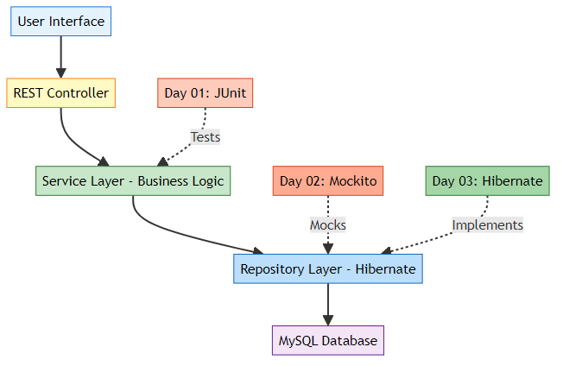

12. TOP INTERVIEW QUESTIONS
📝 Curated by: Avinash Dhanuka | © 2026 | GitHub

🧠 Hibernate Fundamentals

Q1: What is the difference between JPA and Hibernate?
Answer:
Aspect | JPA | Hibernate
Type | Specification (Interface) | Implementation (Framework)
Provider | Standard API | One of many implementations
Annotations | jakarta.persistence.* | org.hibernate.*
Portability | Can switch providers | Vendor-specific
Features | Basic ORM | Advanced features (caching, etc.)
Real-World Analogy: - JPA = JDBC (standard interface) - Hibernate = MySQL Driver (specific implementation)
Code Example:
// JPA annotations (portable)
import jakarta.persistence.Entity;
import jakarta.persistence.Id;
@Entity
public class Student {
@Id
private int id;
}
// Hibernate-specific (not portable)
import org.hibernate.annotations.Cache;
@Entity
@Cache(usage = CacheConcurrencyStrategy.READ_WRITE)
public class Student { }

Q2: What is ORM and why do we need it?
Answer: ORM (Object-Relational Mapping) bridges the gap between object-oriented programming and relational databases.
Without ORM (Plain JDBC):
// ❌ Manual SQL, type conversion, resource management
String sql = "INSERT INTO students (name, age) VALUES (?, ?)";
PreparedStatement stmt = conn.prepareStatement(sql);
stmt.setString(1, student.getName());
stmt.setInt(2, student.getAge());
stmt.executeUpdate();
stmt.close();
With ORM (Hibernate):
// ✅ Simple, clean, automatic
session.persist(student);
Benefits: 1. ✅ No SQL writing (Hibernate generates it) 2. ✅ Database independence (works with any DB) 3. ✅ Automatic type conversion 4. ✅ Relationship management 5. ✅ Caching support

Q3: Explain the Hibernate architecture (4 core components)
Answer:
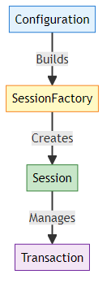
Component | Purpose | Lifecycle | Thread-Safe
Configuration | Reads hibernate.cfg.xml | Created once | Yes
SessionFactory | Factory for Sessions | Created once, reused | Yes
Session | Database connection | Per operation | No
Transaction | ACID operations | Per operation | No
Code Flow:
// 1. Configuration (once)
Configuration config = new Configuration().configure();
// 2. SessionFactory (once)
SessionFactory factory = config.buildSessionFactory();
// 3. Session (per operation)
Session session = factory.openSession();
// 4. Transaction (per operation)
Transaction tx = session.beginTransaction();
session.persist(student);
tx.commit();
session.close();

Q4: What is the difference between Session and SessionFactory?
Aspect | SessionFactory | Session
Weight | Heavy (expensive to create) | Lightweight
Thread-Safe | Yes (shared across threads) | No (one per thread)
Lifecycle | Application lifetime | Short-lived
Creation | Once per application | Many times
Purpose | Factory for Sessions | Performs DB operations
Cost | High memory/CPU | Low memory/CPU
Real-World Analogy: - SessionFactory = Car factory (built once, produces many cars) - Session = Individual car (produced by factory, used for one trip)
Best Practice:
// ✅ GOOD: One SessionFactory for entire app
public class HibernateUtil {
private static SessionFactory factory;
static {
factory = new Configuration().configure().buildSessionFactory();
}
public static Session getSession() {
return factory.openSession(); // Create new session each time
}
}

Q5: What are the different states of an entity in Hibernate?
Answer:
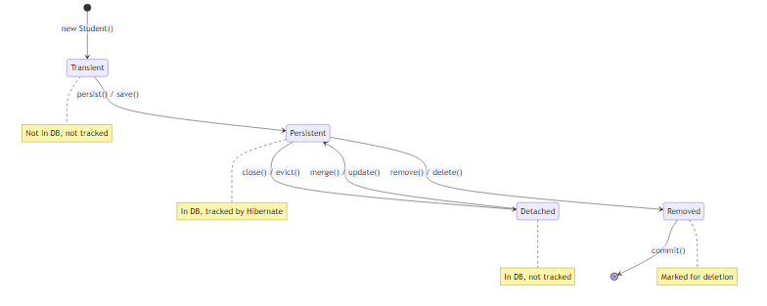
Code Example:
// 1. TRANSIENT - New object, not in database
Student student = new Student();
student.setName("John");
// 2. PERSISTENT - Saved to DB, tracked by Hibernate
session.persist(student);
student.setAge(20); // Hibernate will UPDATE this automatically!
// 3. DETACHED - Session closed, no longer tracked
session.close();
student.setAge(21); // This change is NOT saved
// 4. PERSISTENT again - Reattach to new session
Session newSession = factory.openSession();
newSession.merge(student); // Now changes are tracked
// 5. REMOVED - Marked for deletion
newSession.remove(student);

🏷️ Annotations & Mapping

Q6: Explain @Entity, @Table, @Id, @GeneratedValue, @Column
Answer:
Annotation | Purpose | Example
@Entity | Marks class as database entity | @Entity public class Student
@Table | Customizes table name | @Table(name = "students")
@Id | Marks primary key field | @Id private int id;
@GeneratedValue | Auto-generate primary key | @GeneratedValue(strategy = IDENTITY)
@Column | Customizes column properties | @Column(name = "student_name", length = 100)
Complete Example:
@Entity // This class maps to a table
@Table(name = "students") // Table name is "students"
public class Student {
@Id // Primary key
@GeneratedValue(strategy = GenerationType.IDENTITY) // Auto-increment
@Column(name = "id")
private int id;
@Column(name = "name", nullable = false, length = 100)
private String name;
@Column(name = "age")
private int age;
}
Generated SQL:
CREATE TABLE students (
id INT AUTO_INCREMENT PRIMARY KEY,
name VARCHAR(100) NOT NULL,
age INT
);

Q7: What are the different @GeneratedValue strategies?
Answer:
Strategy | Description | Database Support | Use Case
IDENTITY | Database auto-increment | MySQL, PostgreSQL | Most common
SEQUENCE | Database sequence | Oracle, PostgreSQL | High performance
TABLE | Separate table for IDs | All databases | Portable
AUTO | Hibernate chooses | All databases | Let Hibernate decide
Examples:
// IDENTITY (MySQL, PostgreSQL)
@GeneratedValue(strategy = GenerationType.IDENTITY)
private int id;
// SEQUENCE (Oracle, PostgreSQL)
@GeneratedValue(strategy = GenerationType.SEQUENCE, generator = "student_seq")
@SequenceGenerator(name = "student_seq", sequenceName = "student_sequence")
private int id;
// TABLE (All databases)
@GeneratedValue(strategy = GenerationType.TABLE, generator = "student_gen")
@TableGenerator(name = "student_gen", table = "id_generator")
private int id;
// AUTO (Hibernate decides)
@GeneratedValue(strategy = GenerationType.AUTO)
private int id;

Q8: What is the difference between @Column(nullable = false) and @NotNull?
Answer:
Annotation | Package | Validation Level | When Checked
@Column(nullable = false) | JPA | Database level | When SQL executes
@NotNull | Bean Validation | Application level | Before saving
Example:
@Entity
public class Student {
// Database constraint (SQL level)
@Column(nullable = false)
private String name;
// Application validation (Java level)
@NotNull
@Column(nullable = false) // Both for extra safety
private String email;
}
Best Practice: Use both for complete validation!

💾 CRUD Operations

Q9: What is the difference between persist() and save()?
Answer:
Method | Return Type | JPA Standard | Behavior
persist() | void | Yes (JPA) | Doesn’t return generated ID immediately
save() | Serializable | No (Hibernate) | Returns generated ID immediately
Code Example:
// persist() - JPA standard
session.persist(student);
// student.getId() might be 0 until flush/commit
// save() - Hibernate specific
Serializable id = session.save(student);
System.out.println("Generated ID: " + id); // Immediate ID
Recommendation: Use persist() for JPA compatibility.

Q10: What is the difference between get() and load()?
Answer:
Method | Eager/Lazy | Returns | Exception if Not Found
get() | Eager (immediate query) | Actual object or null | No exception
load() | Lazy (proxy object) | Proxy object | LazyInitializationException
Code Example:
// get() - Immediate database hit
Student student = session.get(Student.class, 1);
if (student == null) {
System.out.println("Not found");
}
// load() - Returns proxy, queries only when accessed
Student student = session.load(Student.class, 1); // No SQL yet
System.out.println(student.getName()); // SQL executes here
When to use: - get(): When you need the object immediately - load(): When you only need the reference (e.g., setting foreign key)

Q11: What is the difference between update() and merge()?
Answer:
Method | Entity State | Behavior | JPA Standard
update() | Detached | Reattaches existing entity | No (Hibernate)
merge() | Detached | Creates new persistent copy | Yes (JPA)
Code Example:
// Scenario: Entity is detached
Student student = new Student();
student.setId(1);
student.setName("Updated Name");
// update() - Reattaches the same object
session.update(student); // student becomes persistent
// merge() - Creates a new persistent copy
Student merged = session.merge(student); // Returns new object
// student is still detached, merged is persistent
Recommendation: Use merge() for JPA compatibility.

⚙️ Configuration & Performance

Q12: What is hibernate.hbm2ddl.auto and what are its values?
Answer:
Value | Behavior | Use Case | Data Loss Risk
create | Drop and recreate tables | Development | ⚠️ HIGH (deletes all data)
create-drop | Create on start, drop on exit | Testing | ⚠️ HIGH
update | Update schema if needed | Development | ⚠️ MEDIUM
validate | Only validate schema | Production | ✅ SAFE
none | Do nothing | Production | ✅ SAFE
Configuration:
<property name="hibernate.hbm2ddl.auto">update</property>
⚠️ WARNING: Never use create or update in production!
Production Best Practice:
<!-- Production -->
<property name="hibernate.hbm2ddl.auto">validate</property>
<!-- Use Flyway or Liquibase for schema migrations -->

Q13: What is connection pooling and why do we need it?
Answer: Connection pooling reuses database connections instead of creating new ones for each request.
Without Connection Pool:
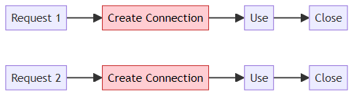
With Connection Pool (HikariCP):
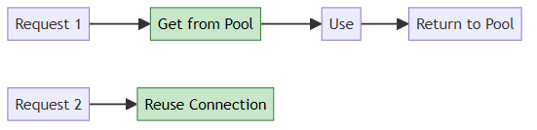
Configuration:
<property name="hibernate.connection.provider_class">
org.hibernate.hikaricp.internal.HikariCPConnectionProvider
</property>
<property name="hibernate.hikari.minimumIdle">5</property>
<property name="hibernate.hikari.maximumPoolSize">20</property>
Benefits: - ✅ Faster (reuse connections) - ✅ Efficient (limited connections) - ✅ Scalable (handles high traffic)

Q14: What is the difference between show_sql and format_sql?
Answer:
Property | Purpose | Output
show_sql | Display SQL in console | Single line SQL
format_sql | Pretty-print SQL | Multi-line formatted SQL
Configuration:
<property name="hibernate.show_sql">true</property>
<property name="hibernate.format_sql">true</property>
Output without format_sql:
insert into students (age, name) values (?, ?)
Output with format_sql:
insert
into
students
(age, name)
values
(?, ?)

🔄 Transactions & Caching

Q15: What are ACID properties in transactions?
Answer:
Property | Meaning | Example
Atomicity | All or nothing | Transfer money: debit AND credit both succeed or both fail
Consistency | Valid state always | Account balance never negative
Isolation | Independent transactions | Two users booking same seat don’t conflict
Durability | Permanent after commit | Power failure after commit doesn’t lose data
Code Example:
Transaction tx = session.beginTransaction();
try {
// Atomicity: Both operations succeed or both fail
account1.setBalance(account1.getBalance() - 100);
account2.setBalance(account2.getBalance() + 100);
session.merge(account1);
session.merge(account2);
tx.commit(); // Durability: Changes are permanent
} catch (Exception e) {
tx.rollback(); // Atomicity: Undo all changes
}

Q16: What is Hibernate caching? Explain first-level and second-level cache.
Answer:
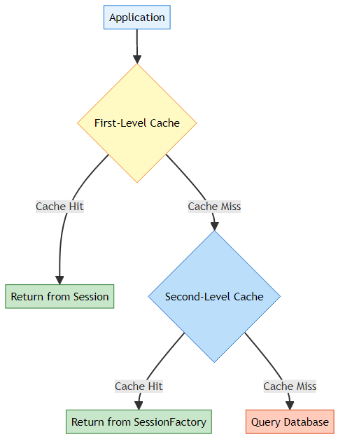
Cache Level | Scope | Enabled By Default | Shared Across Sessions
First-Level | Session | Yes | No
Second-Level | SessionFactory | No | Yes
First-Level Cache Example:
Session session = factory.openSession();
// First call - queries database
Student s1 = session.get(Student.class, 1);
// Second call - returns from cache (no SQL!)
Student s2 = session.get(Student.class, 1);
System.out.println(s1 == s2); // true (same object!)
session.close(); // Cache cleared
Second-Level Cache (requires configuration):
<property name="hibernate.cache.use_second_level_cache">true</property>
<property name="hibernate.cache.region.factory_class">
org.hibernate.cache.jcache.JCacheRegionFactory
</property>

Q17: What happens if you don’t close a Session?
Answer:
Problems: 1. ❌ Memory Leak: Session objects accumulate in memory 2. ❌ Connection Leak: Database connections not returned to pool 3. ❌ Resource Exhaustion: Eventually runs out of connections 4. ❌ Application Crash: “Too many connections” error
Best Practice:
Session session = null;
try {
session = factory.openSession();
// ... operations ...
} finally {
if (session != null) {
session.close(); // Always close!
}
}
// Or use try-with-resources (Java 7+)
try (Session session = factory.openSession()) {
// ... operations ...
} // Automatically closed

🎯 Real-World Scenarios

Q18: How do you handle exceptions in Hibernate?
Answer:
Session session = factory.openSession();
Transaction tx = null;
try {
tx = session.beginTransaction();
// Database operations
session.persist(student);
tx.commit();
} catch (HibernateException e) {
// Rollback on any Hibernate error
if (tx != null) {
tx.rollback();
}
e.printStackTrace();
} catch (Exception e) {
// Rollback on any other error
if (tx != null) {
tx.rollback();
}
e.printStackTrace();
} finally {
// Always close session
session.close();
}
Common Exceptions: - HibernateException: Base exception for all Hibernate errors - ConstraintViolationException: Database constraint violated - StaleStateException: Optimistic locking failure - LazyInitializationException: Accessing lazy-loaded data after session closed

Q19: What is N+1 query problem and how to solve it?
Answer: The N+1 problem occurs when Hibernate executes 1 query to fetch N records, then N additional queries to fetch related data.
Problem Example:
// 1 query to fetch all students
List<Student> students = session.createQuery("FROM Student").list();
// N queries (one per student) to fetch courses
for (Student student : students) {
System.out.println(student.getCourses()); // Lazy loading triggers query
}
// Total: 1 + N queries!
Solution 1: JOIN FETCH
// Single query with JOIN
List<Student> students = session.createQuery(
"FROM Student s JOIN FETCH s.courses"
).list();
// Total: 1 query!
Solution 2: @BatchSize
@Entity
public class Student {
@OneToMany
@BatchSize(size = 10) // Fetch 10 at a time
private List<Course> courses;
}

Q20: How would you implement soft delete in Hibernate?
Answer: Soft delete marks records as deleted instead of actually deleting them.
Implementation:
@Entity
@Table(name = "students")
@SQLDelete(sql = "UPDATE students SET deleted = true WHERE id = ?")
@Where(clause = "deleted = false")
public class Student {
@Id
@GeneratedValue(strategy = GenerationType.IDENTITY)
private int id;
private String name;
@Column(name = "deleted")
private boolean deleted = false;
// Getters and setters
}
Usage:
// This executes UPDATE instead of DELETE
session.remove(student);
// Queries automatically filter deleted records
List<Student> students = session.createQuery("FROM Student").list();
// Only returns students where deleted = false

🚀 Advanced Topics

Q21: What is the difference between Eager and Lazy loading?
Answer:
Loading Type | When Data Loaded | Performance | Use Case
Eager | Immediately with parent | Slower (more data) | Small related data
Lazy | Only when accessed | Faster (less data) | Large related data
Code Example:
@Entity
public class Student {
@Id
private int id;
// Eager loading - courses loaded immediately
@OneToMany(fetch = FetchType.EAGER)
private List<Course> courses;
// Lazy loading - address loaded only when accessed
@OneToOne(fetch = FetchType.LAZY)
private Address address;
}
// Usage
Student student = session.get(Student.class, 1);
// courses are already loaded (EAGER)
// address is NOT loaded yet (LAZY)
System.out.println(student.getAddress()); // NOW address is loaded
Default Behavior: - @OneToOne, @ManyToOne → EAGER - @OneToMany, @ManyToMany → LAZY

Q22: What is HQL (Hibernate Query Language)?
Answer: HQL is an object-oriented query language similar to SQL but works with entities instead of tables.
SQL vs HQL:
Aspect | SQL | HQL
Works With | Tables and columns | Entities and properties
Case Sensitive | No | Yes (for entity names)
Syntax | SELECT * FROM students | FROM Student
Examples:
// HQL - Query by entity name
List<Student> students = session.createQuery(
"FROM Student WHERE age > 18", Student.class
).list();
// HQL - With parameters
List<Student> students = session.createQuery(
"FROM Student s WHERE s.name = :name", Student.class
)
.setParameter("name", "John")
.list();
// HQL - Joins
List<Student> students = session.createQuery(
"FROM Student s JOIN FETCH s.courses WHERE s.age > 18",
Student.class
).list();
// HQL - Aggregate functions
Long count = session.createQuery(
"SELECT COUNT(s) FROM Student s", Long.class
).uniqueResult();

Q23: What is Criteria API?
Answer: Criteria API is a type-safe, programmatic way to build queries without writing HQL strings.
HQL vs Criteria API:
// HQL - String-based (error-prone)
List<Student> students = session.createQuery(
"FROM Student WHERE age > 18", Student.class
).list();
// Criteria API - Type-safe
CriteriaBuilder cb = session.getCriteriaBuilder();
CriteriaQuery<Student> cq = cb.createQuery(Student.class);
Root<Student> root = cq.from(Student.class);
cq.select(root).where(cb.gt(root.get("age"), 18));
List<Student> students = session.createQuery(cq).list();
Advantages: - ✅ Type-safe (compile-time checking) - ✅ No string concatenation - ✅ IDE auto-completion - ✅ Refactoring-friendly

Q24: What is the difference between save(), persist(), merge(), and update()?
Answer:
Method | Return Type | JPA Standard | Transient → Persistent | Detached → Persistent
save() | Serializable | No | ✅ Yes | ❌ No
persist() | void | Yes | ✅ Yes | ❌ No
merge() | Entity | Yes | ✅ Yes | ✅ Yes
update() | void | No | ✅ Yes | ✅ Yes
Code Examples:
// save() - Returns generated ID
Serializable id = session.save(student);
System.out.println("ID: " + id);
// persist() - No return value
session.persist(student);
// merge() - Returns managed entity
Student managed = session.merge(detachedStudent);
// update() - Reattaches entity
session.update(detachedStudent);
Best Practice: Use persist() and merge() for JPA compatibility.

Q25: How do you implement one-to-many relationship in Hibernate?
Answer:
Scenario: One Department has many Employees
// Parent Entity
@Entity
@Table(name = "departments")
public class Department {
@Id
@GeneratedValue(strategy = GenerationType.IDENTITY)
private int id;
private String name;
// One department has many employees
@OneToMany(mappedBy = "department", cascade = CascadeType.ALL)
private List<Employee> employees = new ArrayList<>();
// Helper method
public void addEmployee(Employee employee) {
employees.add(employee);
employee.setDepartment(this);
}
}
// Child Entity
@Entity
@Table(name = "employees")
public class Employee {
@Id
@GeneratedValue(strategy = GenerationType.IDENTITY)
private int id;
private String name;
// Many employees belong to one department
@ManyToOne
@JoinColumn(name = "department_id")
private Department department;
}
Usage:
Department dept = new Department();
dept.setName("IT");
Employee emp1 = new Employee();
emp1.setName("John");
Employee emp2 = new Employee();
emp2.setName("Jane");
dept.addEmployee(emp1);
dept.addEmployee(emp2);
session.persist(dept); // Saves department and employees (cascade)
Generated Tables:
CREATE TABLE departments (
id INT AUTO_INCREMENT PRIMARY KEY,
name VARCHAR(255)
);
CREATE TABLE employees (
id INT AUTO_INCREMENT PRIMARY KEY,
name VARCHAR(255),
department_id INT,
FOREIGN KEY (department_id) REFERENCES departments(id)
);

💡 Best Practices & Tips

Q26: What are Hibernate best practices?
Answer:
1. Always Use Transactions
// ✅ GOOD
Transaction tx = session.beginTransaction();
session.persist(student);
tx.commit();
// ❌ BAD
session.persist(student); // May not save!
2. Always Close Sessions
// ✅ GOOD - Try-with-resources
try (Session session = factory.openSession()) {
// operations
}
// ❌ BAD
Session session = factory.openSession();
// ... forgot to close
3. Use Connection Pooling
<!-- ✅ GOOD -->
<property name="hibernate.connection.provider_class">
org.hibernate.hikaricp.internal.HikariCPConnectionProvider
</property>
4. Enable SQL Logging in Development Only
<!-- Development -->
<property name="hibernate.show_sql">true</property>
<!-- Production -->
<property name="hibernate.show_sql">false</property>
5. Use Proper Fetch Strategies
// ✅ GOOD - Lazy for large collections
@OneToMany(fetch = FetchType.LAZY)
private List<Order> orders;
// ❌ BAD - Eager for large collections
@OneToMany(fetch = FetchType.EAGER)
private List<Order> orders; // Loads all orders always!
6. Never Use hbm2ddl.auto=create in Production
<!-- ❌ NEVER in production -->
<property name="hibernate.hbm2ddl.auto">create</property>
<!-- ✅ Production -->
<property name="hibernate.hbm2ddl.auto">validate</property>
7. Use Named Queries for Reusability
@Entity
@NamedQuery(
name = "Student.findByAge",
query = "FROM Student s WHERE s.age > :age"
)
public class Student { }
// Usage
List<Student> students = session.createNamedQuery("Student.findByAge", Student.class)
.setParameter("age", 18)
.list();

Q27: Common Hibernate errors and solutions
Answer:
1. LazyInitializationException
Error: could not initialize proxy - no Session
Cause: Accessing lazy-loaded data after session closed Solution:
// ✅ Access within session
try (Session session = factory.openSession()) {
Student student = session.get(Student.class, 1);
student.getCourses().size(); // Force loading
}
// Or use EAGER fetch
@OneToMany(fetch = FetchType.EAGER)
2. NonUniqueObjectException
Error: a different object with the same identifier value was already associated with the session
Cause: Two objects with same ID in one session Solution:
// ✅ Use merge instead of persist
session.merge(student);
3. ConstraintViolationException
Error: Duplicate entry for key 'PRIMARY'
Cause: Trying to insert duplicate primary key Solution:
// ✅ Check if exists first
Student existing = session.get(Student.class, id);
if (existing == null) {
session.persist(student);
}
4. Connection Pool Exhausted
Error: Timeout waiting for connection from pool
Cause: Not closing sessions Solution:
// ✅ Always close sessions
try (Session session = factory.openSession()) {
// operations
}

📚 Additional Resources

Q28: What are the alternatives to Hibernate?
Answer:
ORM Framework | Language | Pros | Cons
Hibernate | Java | Feature-rich, mature | Complex, heavy
EclipseLink | Java | JPA reference implementation | Less popular
MyBatis | Java | SQL control, lightweight | More manual work
JOOQ | Java | Type-safe SQL | Not full ORM
Spring Data JPA | Java | Built on Hibernate, simpler | Less control
When to use what: - Hibernate: Complex domain models, relationships - MyBatis: Need SQL control, legacy databases - Spring Data JPA: Spring Boot applications - JOOQ: Type-safe SQL, complex queries

Q29: How does Hibernate compare to JDBC?
Answer:
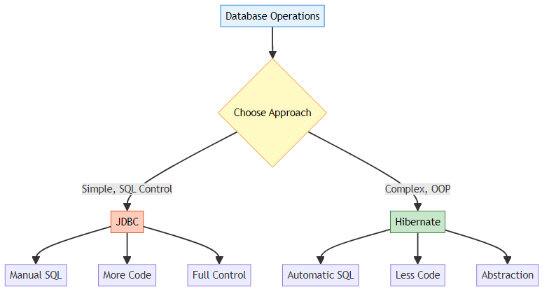
Aspect | JDBC | Hibernate
Code Amount | More (30+ lines) | Less (5 lines)
SQL Writing | Manual | Automatic
Database Independence | No | Yes
Caching | Manual | Built-in
Relationships | Manual | Automatic
Learning Curve | Easy | Moderate
Performance | Can be faster | Good with tuning
Use Case | Simple queries | Complex applications
Example Comparison:
JDBC (30+ lines):
Connection conn = null;
PreparedStatement stmt = null;
ResultSet rs = null;
try {
Class.forName("com.mysql.cj.jdbc.Driver");
conn = DriverManager.getConnection(url, user, password);
String sql = "INSERT INTO students (name, age) VALUES (?, ?)";
stmt = conn.prepareStatement(sql);
stmt.setString(1, student.getName());
stmt.setInt(2, student.getAge());
stmt.executeUpdate();
} catch (Exception e) {
e.printStackTrace();
} finally {
if (rs != null) rs.close();
if (stmt != null) stmt.close();
if (conn != null) conn.close();
}
Hibernate (5 lines):
Session session = factory.openSession();
Transaction tx = session.beginTransaction();
session.persist(student);
tx.commit();
session.close();

Q30: What’s next after learning Hibernate?
Answer:
Learning Path:
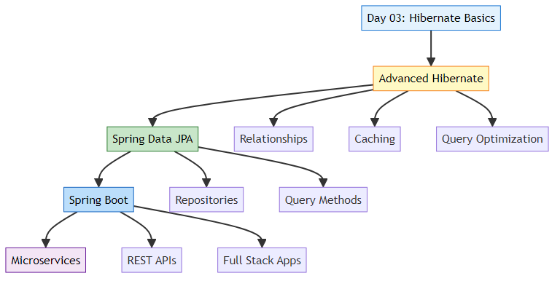
Next Steps:
- Advanced Hibernate Topics
  - One-to-Many, Many-to-Many relationships
  - Inheritance mapping
  - Second-level caching
  - Query optimization
- Spring Data JPA
  - Repository pattern
  - Query methods
  - Specifications
  - Pagination
- Spring Boot
  - Auto-configuration
  - REST APIs
  - Security
  - Microservices
- Real-World Projects
  - E-commerce application
  - Blog platform
  - Social media app
  - Banking system

📝 Project Summary

What We Built in Day 03
This project demonstrates a complete Hibernate ORM implementation with:
✅ Entity Mapping: Student class mapped to database table
✅ Configuration: hibernate.cfg.xml with MySQL connection
✅ Connection Pooling: HikariCP for efficient database connections
✅ CRUD Operations: Create operation with user input
✅ Transaction Management: Proper commit/rollback handling
✅ Auto Schema Generation: Hibernate creates tables automatically

Key Files in This Project
File | Purpose | Lines
Student.java | Entity class with JPA annotations | 65
App.java | Main application with CRUD operations | 50
hibernate.cfg.xml | Hibernate configuration | 40
pom.xml | Maven dependencies | 70
info.txt | Project notes and setup instructions | 80

What You Learned
Core Concepts: - 🎯 Object-Relational Mapping (ORM) - 🎯 JPA Annotations (@Entity, @Id, @Column) - 🎯 Hibernate Architecture (Configuration, SessionFactory, Session, Transaction) - 🎯 CRUD Operations (Create, Read, Update, Delete) - 🎯 Connection Pooling with HikariCP - 🎯 Transaction Management (ACID properties)
Practical Skills: - ✅ Setting up Hibernate with Maven - ✅ Configuring MySQL database connection - ✅ Creating entity classes - ✅ Performing database operations without SQL - ✅ Handling transactions and exceptions - ✅ Using connection pooling for performance

🎯 Quick Reference

Essential Code Snippets
1. Create SessionFactory (Once per application)
SessionFactory factory = new Configuration()
.configure("hibernate.cfg.xml")
.buildSessionFactory();
2. Save Entity (CREATE)
Session session = factory.openSession();
Transaction tx = session.beginTransaction();
try {
session.persist(student);
tx.commit();
} catch (Exception e) {
tx.rollback();
} finally {
session.close();
}
3. Retrieve Entity (READ)
Session session = factory.openSession();
Student student = session.get(Student.class, 1);
session.close();
4. Update Entity (UPDATE)
Session session = factory.openSession();
Transaction tx = session.beginTransaction();
try {
Student student = session.get(Student.class, 1);
student.setName("Updated Name");
session.merge(student);
tx.commit();
} catch (Exception e) {
tx.rollback();
} finally {
session.close();
}
5. Delete Entity (DELETE)
Session session = factory.openSession();
Transaction tx = session.beginTransaction();
try {
Student student = session.get(Student.class, 1);
session.remove(student);
tx.commit();
} catch (Exception e) {
tx.rollback();
} finally {
session.close();
}

🔗 Related Projects

Day 01: JUnit 5 Testing
- Location: day01/JUnitOne/
- Focus: Unit testing fundamentals
- README: Day 01 README

Day 02: Mockito Testing
- Location: day02/MockitoMaven/
- Focus: Mocking dependencies in tests
- README: Day 02 README

Day 04: Advanced Hibernate (Coming Soon)
- Topics: Relationships, HQL, Criteria API
- Focus: Advanced ORM features

🎓 End of Day 03 Master Guide

Created with dedication by Avinash Dhanuka

Happy Coding! 🚀
“From Java Objects to Database Tables - The Magic of ORM!” - Avinash Dhanuka

Stay tuned for more learning!

