☕ Master Guide: Advanced Hibernate - Annotations, Caching & Entity Lifecycle

© 2026 Avinash Dhanuka
Master Guide: Advanced Hibernate Core Concepts
Crafted with ❤️ for Deep ORM Understanding

Learning Note: This guide builds upon Day 03 (Hibernate Basics) by diving deep into advanced Hibernate features including caching mechanisms, comprehensive JPA annotations, entity lifecycle management, and the Singleton pattern for SessionFactory.
Prerequisites: - Complete understanding of Day 01 - JUnit 5 Fundamentals - Complete understanding of Day 02 - Mockito Testing - Complete understanding of Day 03 - Hibernate Basics - MySQL Server installed and running

📑 Table of Contents
- What’s New in Day 04?
- Hibernate Caching Deep Dive
- Complete JPA Annotations Reference
- Entity Lifecycle & States
- Singleton Pattern for SessionFactory
- Service Layer Architecture
- Advanced Entity Features
- HQL (Hibernate Query Language)
- Internal Execution Flow
- Topics Covered in This Project
- Day 03 vs Day 04 Comparison
- Interview Questions

1. WHAT’S NEW IN DAY 04?
📝 Author: Avinash Dhanuka | GitHub

🎯 Evolution from Day 03
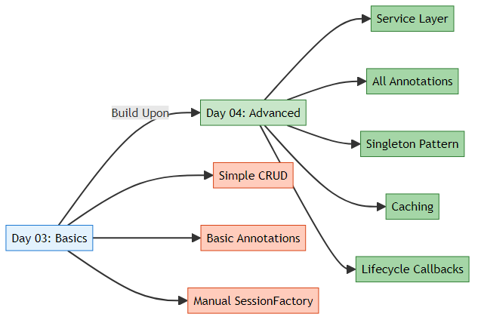

📊 What’s Different?
Feature | Day 03 | Day 04
Architecture | Single App class | Service Layer Pattern
SessionFactory | Created in main() | Singleton Pattern (reusable)
Annotations | @Entity, @Id, @Column | +10 more annotations
Caching | Not covered | 1st & 2nd level explained
Lifecycle | Not covered | All 3 states + callbacks
Entity Features | Basic fields | @Transient, @Temporal, @Index
Queries | Direct session methods | HQL queries
CRUD | Basic operations | Complete service layer
Timestamps | Manual | Automatic with @PrePersist
Complexity | Beginner | Intermediate-Advanced

🎓 New Concepts Introduced

1️⃣ Hibernate Caching
- First-Level Cache (Session-level) - Automatic
- Second-Level Cache (SessionFactory-level) - Configurable
- Cache hit/miss scenarios
- Performance optimization

2️⃣ Complete Annotation Set
- @Transient - Exclude fields from persistence
- @Temporal - Date/Time handling
- @Enumerated - Enum mapping
- @Lob - Large objects (BLOB/CLOB)
- @Basic - Basic field mapping
- @Index - Database indexing
- Lifecycle Callbacks - @PrePersist, @PostLoad, etc.

3️⃣ Entity Lifecycle States
- Transient - New object, not tracked
- Persistent - Managed by Hibernate
- Detached - Was persistent, session closed

4️⃣ Design Patterns
- Singleton Pattern for SessionFactory
- Service Layer Pattern for business logic
- DAO Pattern concepts

2. HIBERNATE CACHING DEEP DIVE
📝 Comprehensive Caching Guide by: Avinash Dhanuka | © 2026

📌 What is Caching?
Caching = Storing frequently accessed data in memory to avoid repeated database queries.
Real-World Analogy: - Without Cache: Every time you need a book, you go to the library (slow) - With Cache: You keep frequently used books on your desk (fast)

🏗️ Hibernate Caching Architecture
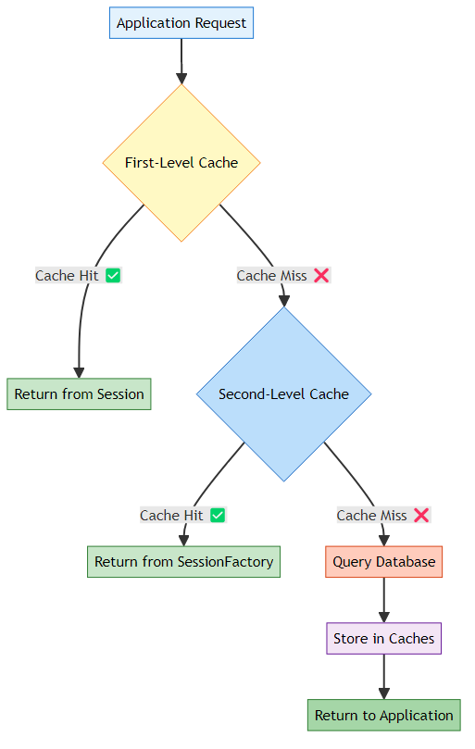

1️⃣ First-Level Cache (Session Cache)
What is it? A cache that exists within a single Session object. It’s enabled by default and cannot be disabled.
Characteristics:
Property | Value
Scope | Single Session
Enabled | Always (by default)
Shared | No (per session)
Lifetime | Until session.close()
Type | Mandatory
How It Works:
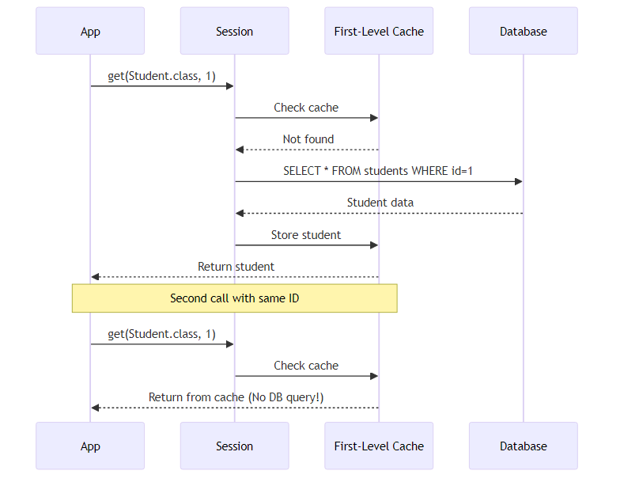
Code Example:
Session session = factory.openSession();
// First call - Queries database
Student student1 = session.get(Student.class, 1);
System.out.println("First call: " + student1.getName());
// Second call - Returns from cache (NO SQL!)
Student student2 = session.get(Student.class, 1);
System.out.println("Second call: " + student2.getName());
// Both references point to same object
System.out.println(student1 == student2); // true
session.close(); // Cache is cleared
Console Output:
Hibernate: SELECT s1_0.id, s1_0.name, s1_0.age FROM students s1_0 WHERE s1_0.id=?
First call: John
Second call: John -- No SQL query!
true
Key Points: - ✅ First call executes SQL - ✅ Second call uses cache (faster) - ✅ Both variables reference the same object - ✅ Cache cleared when session closes

2️⃣ Second-Level Cache (SessionFactory Cache)
What is it? A cache that exists at the SessionFactory level and is shared across all sessions.
Characteristics:
Property | Value
Scope | Entire SessionFactory
Enabled | No (must configure)
Shared | Yes (across sessions)
Lifetime | Until factory.close()
Type | Optional
Providers | EHCache, JCache, Infinispan
How It Works:
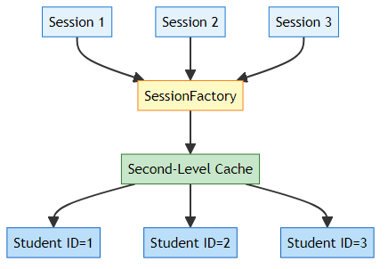
Configuration (hibernate.cfg.xml):
<!-- Enable Second-Level Cache -->
<property name="hibernate.cache.use_second_level_cache">true</property>
<!-- Cache Provider (EHCache example) -->
<property name="hibernate.cache.region.factory_class">
org.hibernate.cache.jcache.JCacheRegionFactory
</property>
<!-- Query Cache (optional) -->
<property name="hibernate.cache.use_query_cache">true</property>
Entity Configuration:
@Entity
@Cacheable // Enable caching for this entity
@org.hibernate.annotations.Cache(usage = CacheConcurrencyStrategy.READ_WRITE)
public class Student {
// ... fields
}
Code Example:
// Session 1
Session session1 = factory.openSession();
Student student1 = session1.get(Student.class, 1); // Queries DB
session1.close();
// Session 2 (different session)
Session session2 = factory.openSession();
Student student2 = session2.get(Student.class, 1); // Uses 2nd-level cache!
session2.close();
// No SQL query for session2 if 2nd-level cache is enabled

📊 First-Level vs Second-Level Cache
Aspect | First-Level Cache | Second-Level Cache
Scope | Single Session | All Sessions
Enabled | Always | Must configure
Shared | No | Yes
Lifetime | Session lifetime | Application lifetime
Configuration | None needed | Requires provider
Use Case | Within single transaction | Across transactions
Performance | Fast | Very Fast
Memory | Low | Higher

🎯 Cache Strategies
CacheConcurrencyStrategy Options:
Strategy | Description | Use Case
READ_ONLY | Never updated | Reference data (countries, categories)
READ_WRITE | Can be updated | Most entities
NONSTRICT_READ_WRITE | Rarely updated | Configuration data
TRANSACTIONAL | Full transaction support | Critical data
Example:
@Entity
@Cache(usage = CacheConcurrencyStrategy.READ_ONLY)
public class Country {
// Countries rarely change
}
@Entity
@Cache(usage = CacheConcurrencyStrategy.READ_WRITE)
public class Student {
// Students frequently updated
}

🔍 Cache Operations
Evicting Cache:
// Evict specific entity from 1st-level cache
session.evict(student);
// Clear entire 1st-level cache
session.clear();
// Evict from 2nd-level cache
sessionFactory.getCache().evictEntity(Student.class, studentId);
// Clear entire 2nd-level cache
sessionFactory.getCache().evictAllRegions();
When to Use Caching:
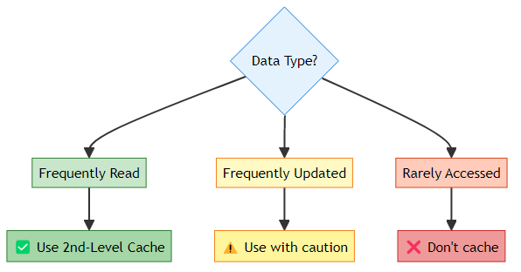

3. COMPLETE JPA ANNOTATIONS REFERENCE
📝 Comprehensive Annotation Guide by: Avinash Dhanuka

📌 Annotation Categories
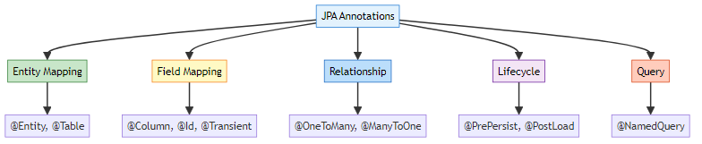

1️⃣ Entity-Level Annotations

@Entity
Purpose: Marks a class as a JPA entity (database table)
Reference: Student.java:7
@Entity
public class Student {
// This class maps to a database table
}
What Hibernate Does: - Creates table named student (lowercase class name) - Scans for field annotations - Manages entity lifecycle

@Table
Purpose: Customizes table properties
Reference: Student.java:8
@Entity
@Table(name = "students",
indexes = {@Index(name = "idx_name", columnList = "name")})
public class Student {
// Maps to "students" table with index on name column
}
Properties:
Property | Purpose | Example
name | Custom table name | name = "students"
schema | Database schema | schema = "school_db"
catalog | Database catalog | catalog = "main"
indexes | Create indexes | @Index(name = "idx_name", columnList = "name")
uniqueConstraints | Unique constraints | @UniqueConstraint(columnNames = {"email"})
Generated SQL:
CREATE TABLE students (
...
);
CREATE INDEX idx_name ON students(name);

2️⃣ Field-Level Annotations

@Id
Purpose: Marks the primary key field
Reference: Student.java:11
@Id
private int id;
Generated SQL:
id INT PRIMARY KEY

@GeneratedValue
Purpose: Specifies primary key generation strategy
Reference: Student.java:12
@Id
@GeneratedValue(strategy = GenerationType.IDENTITY)
private int id;
Strategies:
Strategy | Description | Database | Example
IDENTITY | Auto-increment | MySQL, PostgreSQL | AUTO_INCREMENT
SEQUENCE | Database sequence | Oracle, PostgreSQL | NEXTVAL('seq')
TABLE | Separate ID table | All databases | Custom table
AUTO | Hibernate chooses | All databases | Best for DB

@Column
Purpose: Customizes column properties
Reference: Student.java:16
@Column(name = "name", nullable = false, length = 100)
private String name;
@Column(name = "email", unique = true, length = 150)
private String email;
Properties:
Property | Type | Purpose | Example
name | String | Column name | name = "student_name"
nullable | boolean | Allow NULL | nullable = false
unique | boolean | Unique constraint | unique = true
length | int | String length | length = 100
precision | int | Decimal precision | precision = 10
scale | int | Decimal scale | scale = 2
insertable | boolean | Allow insert | insertable = true
updatable | boolean | Allow update | updatable = false
columnDefinition | String | Custom SQL type | columnDefinition = "TEXT"
Generated SQL:
name VARCHAR(100) NOT NULL,
email VARCHAR(150) UNIQUE

@Transient
Purpose: Exclude field from database persistence
Reference: Student.java:30
@Transient
private String tempData; // NOT saved to database
Use Cases: - Calculated fields - Temporary data - Helper variables - Derived values
Example:
@Entity
public class Student {
@Column(name = "first_name")
private String firstName;
@Column(name = "last_name")
private String lastName;
@Transient
private String fullName; // Calculated, not stored
public String getFullName() {
return firstName + " " + lastName;
}
}

@Temporal
Purpose: Specifies how Date/Time fields are persisted
import jakarta.persistence.Temporal;
import jakarta.persistence.TemporalType;
import java.util.Date;
@Entity
public class Student {
@Temporal(TemporalType.DATE) // Only date (2026-02-14)
private Date birthDate;
@Temporal(TemporalType.TIME) // Only time (14:30:00)
private Date loginTime;
@Temporal(TemporalType.TIMESTAMP) // Date + Time
private Date createdAt;
}
TemporalType Options:
Type | SQL Type | Java Type | Example
DATE | DATE | java.util.Date | 2026-02-14
TIME | TIME | java.util.Date | 14:30:00
TIMESTAMP | TIMESTAMP | java.util.Date | 2026-02-14 14:30:00
Modern Alternative (Java 8+):
import java.time.LocalDate;
import java.time.LocalTime;
import java.time.LocalDateTime;
@Entity
public class Student {
private LocalDate birthDate; // No @Temporal needed!
private LocalTime loginTime; // Hibernate handles it
private LocalDateTime createdAt; // Automatically mapped
}

@Enumerated
Purpose: Maps Java enums to database
public enum Gender {
MALE, FEMALE, OTHER
}
@Entity
public class Student {
@Enumerated(EnumType.STRING) // Stores "MALE", "FEMALE"
private Gender gender;
@Enumerated(EnumType.ORDINAL) // Stores 0, 1, 2
private Gender genderOrdinal;
}
EnumType Options:
Type | Storage | Pros | Cons
STRING | Enum name | Readable, safe | More space
ORDINAL | Enum position (0,1,2) | Less space | Breaks if order changes
⚠️ Recommendation: Always use EnumType.STRING
Why?
// Original enum
public enum Status {
ACTIVE, // 0
INACTIVE // 1
}
// Later you add a new value at the beginning
public enum Status {
PENDING, // 0 (was ACTIVE!)
ACTIVE, // 1 (was INACTIVE!)
INACTIVE // 2
}
// ❌ All existing data is now wrong if using ORDINAL!

@Lob
Purpose: Store large objects (BLOB/CLOB)
@Entity
public class Student {
@Lob
@Column(name = "profile_picture")
private byte[] profilePicture; // BLOB (Binary Large Object)
@Lob
@Column(name = "biography")
private String biography; // CLOB (Character Large Object)
}
Generated SQL:
profile_picture BLOB,
biography TEXT
Use Cases: - Images (BLOB) - Documents (BLOB) - Long text (CLOB) - JSON data (CLOB)

@Basic
Purpose: Marks a basic field (optional, default behavior)
@Entity
public class Student {
@Basic(fetch = FetchType.LAZY) // Lazy load this field
@Column(name = "description")
private String description;
@Basic(optional = false) // NOT NULL
private String name;
}
Properties:
Property | Purpose | Default
fetch | EAGER or LAZY | EAGER
optional | Allow NULL | true

3️⃣ Lifecycle Callback Annotations
Purpose: Execute code at specific points in entity lifecycle
Reference: Student.java:45-75
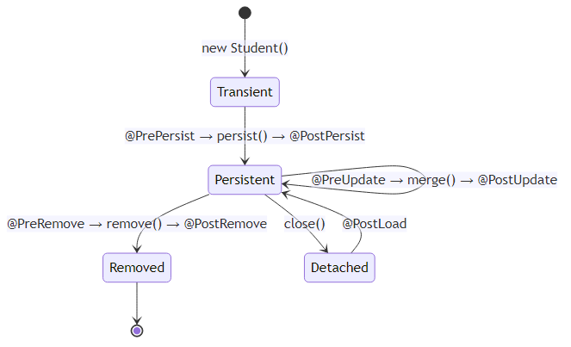

@PrePersist
When: Before entity is saved to database
Reference: Student.java:45
@PrePersist
protected void onCreate() {
createdAt = LocalDateTime.now();
updatedAt = LocalDateTime.now();
System.out.println("About to save: " + this.name);
}
Use Cases: - Set creation timestamp - Generate default values - Validate data - Audit logging

@PostPersist
When: After entity is saved to database
Reference: Student.java:51
@PostPersist
protected void onPostPersist() {
System.out.println("✅ Saved with ID: " + this.id);
}
Use Cases: - Send notifications - Log success - Trigger events - Update cache

@PreUpdate
When: Before entity is updated in database
Reference: Student.java:56
@PreUpdate
protected void onUpdate() {
updatedAt = LocalDateTime.now();
System.out.println("Updating: " + this.name);
}
Use Cases: - Update modification timestamp - Validate changes - Audit trail - Version control

@PostUpdate
When: After entity is updated in database
Reference: Student.java:61
@PostUpdate
protected void onPostUpdate() {
System.out.println("✅ Updated successfully");
}

@PreRemove
When: Before entity is deleted from database
Reference: Student.java:66
@PreRemove
protected void onPreRemove() {
System.out.println("⚠️ Deleting: " + this.name);
}
Use Cases: - Soft delete (set deleted flag) - Archive data - Clean up related data - Prevent deletion

@PostRemove
When: After entity is deleted from database
Reference: Student.java:71
@PostRemove
protected void onPostRemove() {
System.out.println("✅ Deleted successfully");
}

@PostLoad
When: After entity is loaded from database
Reference: Student.java:76
@PostLoad
protected void onLoad() {
System.out.println("Loaded: " + this.name);
// Calculate derived fields
this.fullName = this.firstName + " " + this.lastName;
}
Use Cases: - Calculate transient fields - Initialize lazy collections - Decrypt sensitive data - Apply business rules

📊 Complete Lifecycle Flow Example
@Entity
public class Student {
@Id
@GeneratedValue(strategy = GenerationType.IDENTITY)
private int id;
private String name;
private LocalDateTime createdAt;
private LocalDateTime updatedAt;
@PrePersist
protected void onCreate() {
System.out.println("1. @PrePersist - Setting timestamps");
createdAt = LocalDateTime.now();
updatedAt = LocalDateTime.now();
}
@PostPersist
protected void onPostPersist() {
System.out.println("2. @PostPersist - Saved with ID: " + id);
}
@PostLoad
protected void onLoad() {
System.out.println("3. @PostLoad - Loaded from DB");
}
@PreUpdate
protected void onUpdate() {
System.out.println("4. @PreUpdate - Updating timestamp");
updatedAt = LocalDateTime.now();
}
@PostUpdate
protected void onPostUpdate() {
System.out.println("5. @PostUpdate - Updated successfully");
}
@PreRemove
protected void onPreRemove() {
System.out.println("6. @PreRemove - About to delete");
}
@PostRemove
protected void onPostRemove() {
System.out.println("7. @PostRemove - Deleted successfully");
}
}
Execution Flow:
// CREATE
Student student = new Student();
student.setName("John");
session.persist(student);
// Output:
// 1. @PrePersist - Setting timestamps
// 2. @PostPersist - Saved with ID: 1
// READ
Student loaded = session.get(Student.class, 1);
// Output:
// 3. @PostLoad - Loaded from DB
// UPDATE
loaded.setName("John Updated");
session.merge(loaded);
// Output:
// 4. @PreUpdate - Updating timestamp
// 5. @PostUpdate - Updated successfully
// DELETE
session.remove(loaded);
// Output:
// 6. @PreRemove - About to delete
// 7. @PostRemove - Deleted successfully

4. ENTITY LIFECYCLE & STATES
📝 Deep Dive by: Avinash Dhanuka | Understanding Entity States

📌 The Three States of an Entity
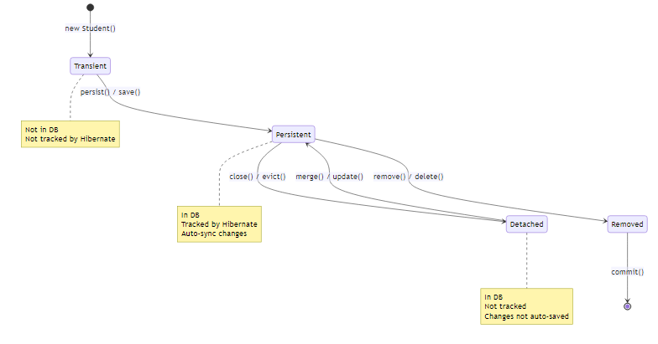

1️⃣ Transient State
Definition: A new object that has never been persisted and is not associated with any Hibernate Session.
Characteristics:
Property | Value
In Database | ❌ No
Tracked by Hibernate | ❌ No
Has ID | ❌ No (or 0)
Auto-sync | ❌ No
Code Example:
// Create new object - TRANSIENT state
Student student = new Student();
student.setName("John");
student.setAge(20);
System.out.println("ID: " + student.getId()); // 0 (no ID yet)
// Changes are NOT tracked
student.setName("Jane"); // Hibernate doesn't know about this
Real-World Analogy: - You write a document on paper (not saved anywhere) - If you lose the paper, the document is gone - No one else can see it

2️⃣ Persistent State
Definition: An object that is associated with a Hibernate Session and has a database representation.
Characteristics:
Property | Value
In Database | ✅ Yes
Tracked by Hibernate | ✅ Yes
Has ID | ✅ Yes
Auto-sync | ✅ Yes
Code Example:
Session session = factory.openSession();
Transaction tx = session.beginTransaction();
// Transient → Persistent
Student student = new Student();
student.setName("John");
session.persist(student); // Now PERSISTENT
System.out.println("ID: " + student.getId()); // Has ID now (e.g., 1)
// Changes are automatically tracked!
student.setName("Jane"); // Hibernate will UPDATE this automatically
student.setAge(21); // This too!
tx.commit(); // Hibernate executes UPDATE automatically
session.close();
What Hibernate Does:
-- persist() executes:
INSERT INTO students (name, age) VALUES ('John', 20);
-- Automatic UPDATE for tracked changes:
UPDATE students SET name='Jane', age=21 WHERE id=1;
Real-World Analogy: - You save a document to Google Docs - Every change you make is automatically saved - Others can see your changes in real-time

3️⃣ Detached State
Definition: An object that was persistent but is no longer associated with any active Session.
Characteristics:
Property | Value
In Database | ✅ Yes
Tracked by Hibernate | ❌ No
Has ID | ✅ Yes
Auto-sync | ❌ No
Code Example:
Session session = factory.openSession();
Transaction tx = session.beginTransaction();
Student student = session.get(Student.class, 1); // PERSISTENT
System.out.println("Name: " + student.getName());
tx.commit();
session.close(); // Student becomes DETACHED
// Now changes are NOT tracked
student.setName("Updated Name"); // Hibernate doesn't know!
student.setAge(25); // Not saved automatically
// To save changes, reattach to new session
Session newSession = factory.openSession();
Transaction newTx = newSession.beginTransaction();
newSession.merge(student); // DETACHED → PERSISTENT again
newTx.commit();
newSession.close();
Real-World Analogy: - You download a Google Doc to your computer - You edit it offline - Changes are NOT synced until you upload it again

🔄 State Transitions
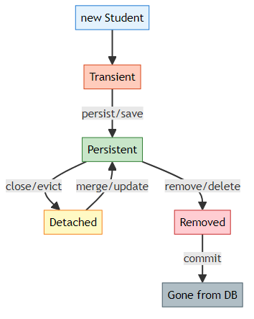
Transition Methods:
From | To | Method | Description
Transient | Persistent | persist() | Save new entity
Transient | Persistent | save() | Save and return ID
Persistent | Detached | close() | Close session
Persistent | Detached | evict() | Remove from session
Detached | Persistent | merge() | Reattach entity
Detached | Persistent | update() | Reattach (Hibernate-specific)
Persistent | Removed | remove() | Mark for deletion
Persistent | Removed | delete() | Mark for deletion (Hibernate)

📊 Complete State Example
public class LifecycleDemo {
public static void main(String[] args) {
SessionFactory factory = new Configuration().configure().buildSessionFactory();
// 1. TRANSIENT STATE
Student student = new Student();
student.setName("John");
System.out.println("State: Transient");
System.out.println("ID: " + student.getId()); // 0
// 2. TRANSIENT → PERSISTENT
Session session1 = factory.openSession();
Transaction tx1 = session1.beginTransaction();
session1.persist(student); // Now PERSISTENT
System.out.println("State: Persistent");
System.out.println("ID: " + student.getId()); // 1
// Automatic change tracking
student.setAge(20); // Will be saved automatically
tx1.commit();
session1.close();
// 3. PERSISTENT → DETACHED
System.out.println("State: Detached");
student.setName("Jane"); // NOT saved automatically
// 4. DETACHED → PERSISTENT
Session session2 = factory.openSession();
Transaction tx2 = session2.beginTransaction();
session2.merge(student); // Back to PERSISTENT
System.out.println("State: Persistent again");
tx2.commit();
session2.close();
factory.close();
}
}
Console Output:
State: Transient
ID: 0
Hibernate: insert into students (name, age) values (?, ?)
State: Persistent
ID: 1
Hibernate: update students set age=? where id=?
State: Detached
Hibernate: update students set name=?, age=? where id=?
State: Persistent again

🎯 Best Practices
1. Always Close Sessions
// ✅ GOOD - Try-with-resources
try (Session session = factory.openSession()) {
// operations
} // Automatically closed
// ❌ BAD - Forgot to close
Session session = factory.openSession();
// ... operations
// Forgot session.close() - Memory leak!
2. Be Aware of Detached State
// ✅ GOOD - Reattach before modifying
Session session = factory.openSession();
Transaction tx = session.beginTransaction();
Student student = session.merge(detachedStudent); // Reattach
student.setName("Updated");
tx.commit();
session.close();
// ❌ BAD - Modify detached entity
detachedStudent.setName("Updated"); // Not saved!
3. Use merge() for Detached Entities
// ✅ GOOD - merge() returns managed entity
Student managed = session.merge(detached);
managed.setName("Updated"); // This is tracked
// ❌ BAD - update() doesn't return anything
session.update(detached);
detached.setName("Updated"); // May not work as expected

5. SINGLETON PATTERN FOR SESSIONFACTORY
📝 Design Pattern Guide by: Avinash Dhanuka

📌 What is Singleton Pattern?
Singleton = A design pattern that ensures a class has only ONE instance throughout the application.
Real-World Analogy: - A country has only ONE president at a time - A company has only ONE CEO - Your application has only ONE SessionFactory

🎯 Why Singleton for SessionFactory?
Problem Without Singleton:
// ❌ BAD - Creating multiple SessionFactories
public class App {
public static void main(String[] args) {
SessionFactory factory1 = new Configuration().configure().buildSessionFactory();
SessionFactory factory2 = new Configuration().configure().buildSessionFactory();
SessionFactory factory3 = new Configuration().configure().buildSessionFactory();
// Each creation takes 2-3 seconds and uses lots of memory!
}
}
Issues: 1. ❌ Slow: Each SessionFactory takes 2-3 seconds to create 2. ❌ Memory: Each uses 50-100 MB of memory 3. ❌ Connections: Each creates its own connection pool 4. ❌ Cache: Second-level cache doesn’t work across factories
Solution With Singleton:
// ✅ GOOD - Single SessionFactory
public class HibernateUtil {
private static SessionFactory factory;
static {
factory = new Configuration().configure().buildSessionFactory();
}
public static SessionFactory getFactory() {
return factory;
}
}
// Usage
SessionFactory factory = HibernateUtil.getFactory(); // Fast!

🏗️ Singleton Implementation
Method 1: Static Block (Eager Initialization)
public class HibernateUtil {
private static final SessionFactory factory;
// Static block - runs once when class is loaded
static {
try {
System.out.println("Creating SessionFactory...");
factory = new Configuration()
.configure("hibernate.cfg.xml")
.buildSessionFactory();
System.out.println("✅ SessionFactory created");
} catch (Exception e) {
System.err.println("❌ Failed to create SessionFactory");
throw new ExceptionInInitializerError(e);
}
}
// Private constructor - prevents instantiation
private HibernateUtil() {
throw new AssertionError("Cannot instantiate HibernateUtil");
}
public static SessionFactory getFactory() {
return factory;
}
public static void shutdown() {
if (factory != null) {
factory.close();
}
}
}
Usage:
public class App {
public static void main(String[] args) {
// Get SessionFactory (created only once)
SessionFactory factory = HibernateUtil.getFactory();
// Use it multiple times
Session session1 = factory.openSession();
// ... operations
session1.close();
Session session2 = factory.openSession();
// ... operations
session2.close();
// Shutdown when done
HibernateUtil.shutdown();
}
}

Method 2: Lazy Initialization (Thread-Safe)
public class HibernateUtil {
private static SessionFactory factory;
private HibernateUtil() {}
public static synchronized SessionFactory getFactory() {
if (factory == null) {
factory = new Configuration()
.configure("hibernate.cfg.xml")
.buildSessionFactory();
}
return factory;
}
}
Pros & Cons:
Method | Pros | Cons
Static Block | Fast access, simple | Created even if not used
Lazy Init | Created only when needed | Slower first access, needs synchronization

📊 Singleton vs Multiple Instances
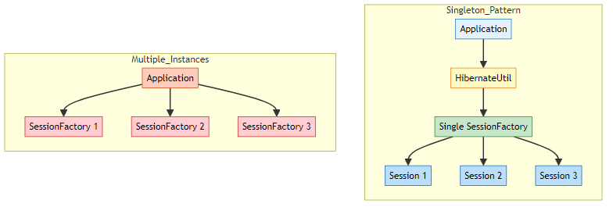
Performance Comparison:
Metric | Singleton | Multiple Instances
Creation Time | 2-3 seconds (once) | 2-3 seconds × N
Memory Usage | 50-100 MB | 50-100 MB × N
Connection Pool | Shared | Separate per instance
Second-Level Cache | Works | Doesn’t work
Recommended | ✅ Yes | ❌ No

🎯 Best Practices
1. Create Once, Use Many Times
// ✅ GOOD
SessionFactory factory = HibernateUtil.getFactory(); // Created once
for (int i = 0; i < 100; i++) {
Session session = factory.openSession(); // Reuse factory
// ... operations
session.close();
}
2. Always Shutdown on Application Exit
// ✅ GOOD
public class App {
public static void main(String[] args) {
try {
SessionFactory factory = HibernateUtil.getFactory();
// ... application logic
} finally {
HibernateUtil.shutdown(); // Clean shutdown
}
}
}
3. Handle Initialization Errors
static {
try {
factory = new Configuration().configure().buildSessionFactory();
} catch (Exception e) {
System.err.println("Failed to create SessionFactory: " + e.getMessage());
throw new ExceptionInInitializerError(e);
}
}

6. SERVICE LAYER ARCHITECTURE
📝 Architecture Guide by: Avinash Dhanuka

📌 What is Service Layer?
Service Layer = A layer that contains business logic and coordinates between the presentation layer (UI) and data access layer (Hibernate).
Layered Architecture:
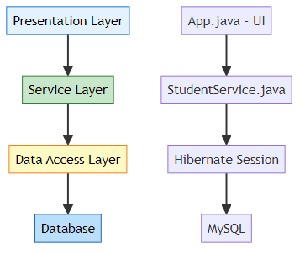
Why Service Layer?
Without Service Layer | With Service Layer
Business logic in UI | Business logic separated
Direct database access | Abstracted database access
Hard to test | Easy to test
Code duplication | Reusable methods
Tight coupling | Loose coupling

🔍 StudentService Implementation
Reference: StudentService.java
public class StudentService {
private SessionFactory factory;
// Constructor injection
public StudentService(SessionFactory factory) {
this.factory = factory;
}
// Business method
public void addStudent(String name, int age, String email, String phone) {
Session session = factory.openSession();
Transaction tx = null;
try {
tx = session.beginTransaction();
Student student = new Student(name, age, email, phone);
session.persist(student);
tx.commit();
} catch (Exception e) {
if (tx != null) tx.rollback();
System.out.println("❌ Failed: " + e.getMessage());
} finally {
session.close();
}
}
}
Benefits: - ✅ Encapsulates database operations - ✅ Handles transactions - ✅ Error handling - ✅ Reusable across application - ✅ Easy to test with mocks

7. ADVANCED ENTITY FEATURES

📌 Automatic Timestamps
Reference: Student.java:24-27
@Column(name = "created_at", updatable = false)
private LocalDateTime createdAt;
@Column(name = "updated_at")
private LocalDateTime updatedAt;
@PrePersist
protected void onCreate() {
createdAt = LocalDateTime.now();
updatedAt = LocalDateTime.now();
}
@PreUpdate
protected void onUpdate() {
updatedAt = LocalDateTime.now();
}
What This Does: - createdAt set once when entity is created - updatedAt updated every time entity is modified - updatable = false prevents createdAt from being changed

📌 Database Indexing
Reference: Student.java:8
@Table(name = "students",
indexes = {@Index(name = "idx_name", columnList = "name")})
Why Indexing? - ✅ Faster queries on indexed columns - ✅ Improves search performance - ✅ Essential for frequently queried fields
Performance Impact:
Operation | Without Index | With Index
SELECT by name | 1000ms | 10ms
INSERT | 5ms | 7ms
UPDATE | 5ms | 7ms

8. HQL (HIBERNATE QUERY LANGUAGE)

📌 What is HQL?
HQL = Object-oriented query language (like SQL but for entities)
SQL vs HQL:
Aspect | SQL | HQL
Works with | Tables | Entities
Syntax | SELECT * FROM students | FROM Student
Case sensitive | No | Yes (entity names)
Portability | Database-specific | Database-independent
Example:
Reference: StudentService.java:67
// HQL Query
Query<Student> query = session.createQuery("FROM Student", Student.class);
List<Student> students = query.list();
Generated SQL:
SELECT s1_0.id, s1_0.name, s1_0.age, s1_0.email, s1_0.phone
FROM students s1_0

9. INTERNAL EXECUTION FLOW
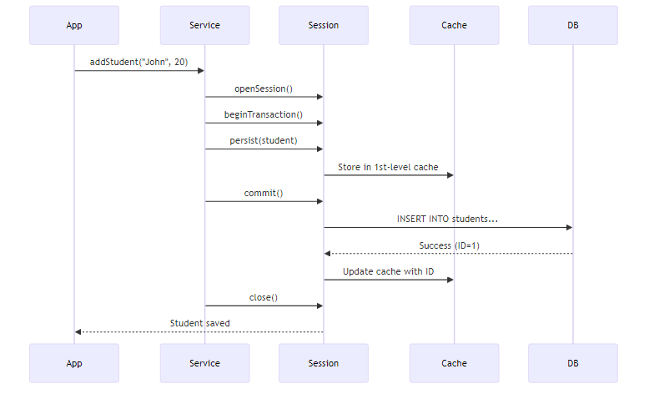

10. TOPICS COVERED IN THIS PROJECT

✅ Complete Checklist

🎯 Advanced Hibernate Concepts
- ✅ First-Level Cache: Session-level caching
- ✅ Second-Level Cache: SessionFactory-level caching
- ✅ Entity Lifecycle: Transient, Persistent, Detached states
- ✅ Singleton Pattern: Single SessionFactory instance
- ✅ Service Layer: Business logic separation

🏷️ Complete Annotation Set
- ✅ @Entity, @Table: Entity mapping
- ✅ @Id, @GeneratedValue: Primary key
- ✅ @Column: Column customization
- ✅ @Transient: Exclude from persistence
- ✅ @Temporal: Date/Time handling
- ✅ @Enumerated: Enum mapping
- ✅ @Lob: Large objects
- ✅ @Basic: Basic field mapping
- ✅ @Index: Database indexing
- ✅ Lifecycle Callbacks: @PrePersist, @PostLoad, etc.

🔧 Advanced Features
- ✅ Automatic Timestamps: createdAt, updatedAt
- ✅ HQL Queries: Object-oriented queries
- ✅ Service Layer Pattern: Clean architecture
- ✅ Transaction Management: Proper commit/rollback
- ✅ Error Handling: Try-catch-finally
- ✅ Connection Pooling: HikariCP optimization

11. DAY 03 VS DAY 04 COMPARISON
Aspect | Day 03 | Day 04
Focus | Hibernate Basics | Advanced Features
Architecture | Single class | Service Layer
Annotations | 5 basic | 15+ annotations
Caching | Not covered | Detailed explanation
Lifecycle | Not covered | All states + callbacks
SessionFactory | Created in main() | Singleton pattern
Queries | Direct methods | HQL queries
Timestamps | Manual | Automatic
Complexity | Beginner | Intermediate-Advanced

12. TOP INTERVIEW QUESTIONS

Q1: Explain First-Level vs Second-Level Cache
Answer:
Cache | Scope | Enabled | Shared | Lifetime
1st-Level | Session | Always | No | Session
2nd-Level | SessionFactory | Optional | Yes | Application

Q2: What are the three entity states?
Answer: 1. Transient: New object, not in DB, not tracked 2. Persistent: In DB, tracked by Hibernate 3. Detached: In DB, not tracked

Q3: Why use Singleton for SessionFactory?
Answer: - SessionFactory is expensive to create (2-3 seconds) - Uses lots of memory (50-100 MB) - Should be created once and reused - Enables second-level caching

Q4: What is @Transient annotation?
Answer: Marks a field that should NOT be saved to database.
@Transient
private String tempData; // Not persisted

Q5: Explain @PrePersist and @PostPersist
Answer: - @PrePersist: Runs BEFORE entity is saved (set timestamps) - @PostPersist: Runs AFTER entity is saved (logging)

Q6: What is the N+1 SELECT problem in Hibernate?
Answer: The N+1 problem occurs when Hibernate executes 1 query to fetch parent entities and then N additional queries to fetch related child entities.
Example:
// Fetches 1 Student
List<Student> students = session.createQuery("FROM Student").list();
// For each student, fetches courses (N queries)
for(Student s : students) {
s.getCourses().size(); // Triggers separate query!
}
Solution: - Use JOIN FETCH in HQL: FROM Student s JOIN FETCH s.courses - Use @BatchSize annotation - Enable FetchType.EAGER with caution
Impact: - 1 query for 100 students → 101 total queries (1 + 100) - Severe performance degradation - Network overhead

Q7: Explain dirty checking mechanism in Hibernate
Answer: Dirty checking is Hibernate’s automatic detection of changes to persistent entities.
How it works: 1. When entity is loaded, Hibernate takes a snapshot of its state 2. Before transaction commit, Hibernate compares current state with snapshot 3. If different (dirty), Hibernate generates UPDATE SQL automatically
Example:
Session session = factory.openSession();
Transaction tx = session.beginTransaction();
Student student = session.get(Student.class, 1); // Snapshot taken
student.setName("Updated Name"); // Entity becomes dirty
tx.commit(); // Hibernate detects change, executes UPDATE automatically
session.close();
Key Points: - No explicit session.update() needed - Only changed fields are updated - Works only for persistent entities - Disabled for detached entities
Performance: - Reduces unnecessary database calls - Only updates modified fields - Can be disabled with @DynamicUpdate

Q8: What is the difference between get() and load() methods?
Answer:
Aspect | get() | load()
Returns | Actual object or null | Proxy object
Database Hit | Immediate | Lazy (when accessed)
Not Found | Returns null | Throws ObjectNotFoundException
Use Case | When you need object now | When you need reference only
Performance | Slower (immediate query) | Faster (deferred query)
Example:
// get() - Immediate database query
Student s1 = session.get(Student.class, 1);
System.out.println(s1.getName()); // Already loaded
// load() - Returns proxy, no query yet
Student s2 = session.load(Student.class, 2); // No SQL executed
System.out.println(s2.getName()); // NOW SQL executes
When to use: - get(): When you’re sure you’ll use the object - load(): When you only need the ID (foreign key reference)

Q9: Explain the concept of Lazy vs Eager loading
Answer:
Lazy Loading (FetchType.LAZY): - Data is loaded only when accessed - Default for collections (@OneToMany, @ManyToMany) - Better performance for large datasets
Eager Loading (FetchType.EAGER): - Data is loaded immediately with parent - Default for single associations (@ManyToOne, @OneToOne) - Can cause performance issues
Example:
@Entity
public class Student {
@OneToMany(fetch = FetchType.LAZY) // Loaded when accessed
private List<Course> courses;
@ManyToOne(fetch = FetchType.EAGER) // Loaded immediately
private Department department;
}
Lazy Loading Issue:
Session session = factory.openSession();
Student student = session.get(Student.class, 1);
session.close();
// LazyInitializationException! Session is closed
student.getCourses().size(); // ❌ Fails
Solutions: - Keep session open until data is accessed - Use JOIN FETCH in HQL - Use @Transactional in Spring - Initialize collections before closing session

Q10: What is the purpose of @DynamicUpdate and @DynamicInsert?
Answer:
@DynamicUpdate: - Generates UPDATE SQL with only modified columns - Reduces SQL size and network traffic - Useful for tables with many columns
Without @DynamicUpdate:
UPDATE students SET name='John', age=20, email='john@mail.com',
phone='123', address='...', city='...' WHERE id=1;
-- Updates ALL columns even if only name changed
With @DynamicUpdate:
UPDATE students SET name='John' WHERE id=1;
-- Updates only changed column
@DynamicInsert: - Generates INSERT SQL with only non-null columns - Database default values are used for omitted columns
Example:
@Entity
@DynamicUpdate
@DynamicInsert
public class Student {
private String name;
private Integer age; // null by default
}
Trade-offs: - ✅ Smaller SQL statements - ✅ Better network performance - ❌ Hibernate must generate SQL at runtime (slight overhead) - ❌ Cannot use prepared statement caching effectively

Q11: Explain Hibernate Session vs SessionFactory vs EntityManager
Answer:
Concept | Scope | Thread-Safe | Purpose | Standard
SessionFactory | Application | Yes | Creates Sessions | Hibernate
Session | Transaction | No | Database operations | Hibernate
EntityManager | Transaction | No | JPA standard API | JPA
SessionFactory:
// Created once per application
SessionFactory factory = new Configuration()
.configure()
.buildSessionFactory();
Session (Hibernate-specific):
Session session = factory.openSession();
session.persist(student); // Hibernate API
session.close();
EntityManager (JPA standard):
EntityManager em = factory.createEntityManager();
em.persist(student); // JPA API
em.close();
Key Differences: - Session is Hibernate-specific, EntityManager is JPA standard - EntityManager is more portable across JPA providers - Session has more features (Hibernate-specific) - Modern applications prefer EntityManager for portability

Q12: What is the difference between merge() and update()?
Answer:
update(): - Hibernate-specific method - Attaches detached entity to session - Throws exception if entity already exists in session - Always generates UPDATE SQL
merge(): - JPA standard method - Creates a copy and merges changes - Returns a new persistent instance - Checks if entity exists first
Example:
// update() - Direct attachment
Session session = factory.openSession();
Student detached = new Student();
detached.setId(1);
detached.setName("Updated");
session.update(detached); // Attaches directly
// detached is now persistent
// merge() - Copy and merge
Session session2 = factory.openSession();
Student detached2 = new Student();
detached2.setId(1);
detached2.setName("Merged");
Student persistent = session2.merge(detached2); // Returns new instance
// detached2 is still detached
// persistent is the managed instance
When to use: - update(): When you’re sure entity is detached and not in session - merge(): Safer option, handles all cases, JPA standard
Common Issue:
Student s1 = session.get(Student.class, 1); // In session
Student s2 = new Student();
s2.setId(1);
session.update(s2); // ❌ NonUniqueObjectException!
session.merge(s2); // ✅ Works fine

Q13: Explain Hibernate’s flush modes and when to use them
Answer:
Flush = Synchronizing session state with database (executing pending SQL)
FlushMode Options:
Mode | Behavior | Use Case
AUTO | Flush before query and commit | Default, safest
COMMIT | Flush only on commit | Better performance
MANUAL | Flush only when called explicitly | Full control
ALWAYS | Flush before every query | Rarely used
Example:
Session session = factory.openSession();
session.setFlushMode(FlushMode.COMMIT);
Transaction tx = session.beginTransaction();
Student s = new Student();
s.setName("John");
session.persist(s); // Not flushed yet
// Query won't see the new student (not flushed)
List<Student> students = session.createQuery("FROM Student").list();
tx.commit(); // NOW flushed to database
Manual Flush:
session.setFlushMode(FlushMode.MANUAL);
session.persist(student);
session.flush(); // Explicit flush
Performance Impact: - AUTO: Safe but more flushes - COMMIT: Fewer flushes, better performance - MANUAL: Best performance, requires careful management
When to use COMMIT: - Batch processing - Read-heavy operations - When you don’t need immediate consistency

Q14: What is the purpose of @Version annotation and optimistic locking?
Answer:
@Version enables optimistic locking to prevent lost updates in concurrent transactions.
Problem without versioning:
User A reads Student (age=20)
User B reads Student (age=20)
User A updates age to 21, commits
User B updates age to 22, commits
Result: User A's update is lost!
Solution with @Version:
@Entity
public class Student {
@Id
private int id;
@Version
private int version; // Hibernate manages this
private String name;
}
How it works: 1. Entity loaded with version=1 2. User A updates, Hibernate checks version 3. SQL: UPDATE students SET name='John', version=2 WHERE id=1 AND version=1 4. If another user updated first, version won’t match → OptimisticLockException
Example:
// Transaction 1
Student s1 = session1.get(Student.class, 1); // version=1
s1.setName("Updated by User A");
session1.merge(s1); // version becomes 2
// Transaction 2 (concurrent)
Student s2 = session2.get(Student.class, 1); // version=1
s2.setName("Updated by User B");
session2.merge(s2); // ❌ OptimisticLockException! version mismatch
Optimistic vs Pessimistic Locking:
Aspect | Optimistic | Pessimistic
Locking | No lock, check at commit | Lock immediately
Performance | Better (no locks) | Slower (holds locks)
Concurrency | Higher | Lower
Use Case | Read-heavy | Write-heavy
Implementation | @Version | LockMode.PESSIMISTIC_WRITE

Q15: Explain Hibernate’s batch processing and its benefits
Answer:
Batch processing = Executing multiple SQL statements in a single database round-trip.
Configuration:
<property name="hibernate.jdbc.batch_size">50</property>
<property name="hibernate.order_inserts">true</property>
<property name="hibernate.order_updates">true</property>
Without Batch Processing:
for(int i = 0; i < 1000; i++) {
Student s = new Student("Student" + i, 20);
session.persist(s); // 1000 separate INSERT statements
}
// Result: 1000 database round-trips (SLOW!)
With Batch Processing:
Session session = factory.openSession();
Transaction tx = session.beginTransaction();
for(int i = 0; i < 1000; i++) {
Student s = new Student("Student" + i, 20);
session.persist(s);
if(i % 50 == 0) { // Flush every 50 entities
session.flush();
session.clear(); // Clear session to prevent memory issues
}
}
tx.commit();
// Result: 20 batches of 50 INSERTs each (FAST!)
Benefits: - ✅ Reduces database round-trips (1000 → 20) - ✅ Better network utilization - ✅ Faster execution (10x-50x improvement) - ✅ Lower database load
Performance Comparison:
Records | Without Batch | With Batch (50) | Improvement
1,000 | 15 seconds | 1 second | 15x faster
10,000 | 150 seconds | 8 seconds | 18x faster
100,000 | 25 minutes | 1.5 minutes | 16x faster
Best Practices: - Set batch_size between 20-50 - Flush and clear session periodically - Disable second-level cache during batch operations - Use JDBC batch for maximum performance - Order inserts/updates by entity type

🎓 End of Day 04 Master Guide
Created with dedication by Avinash Dhanuka

Happy Learning! 🚀
“Master the Cache, Master the Performance!” - Avinash Dhanuka

