☕ Day 05: Hibernate One-to-One Relationship

© 2026 Avinash Dhanuka
Day 05: Mastering One-to-One Relationships in Hibernate
Crafted with ❤️ for Understanding Entity Relationships

Learning Note: This guide builds upon Day 04 (Advanced Hibernate) by introducing One-to-One entity relationships. Learn how to map real-world relationships between entities using Hibernate!
Prerequisites: - Complete understanding of Day 03 - Hibernate Basics - Complete understanding of Day 04 - Advanced Hibernate - MySQL Server installed and running

📑 Table of Contents
- What’s New in Day 05?
- Database Relationships Overview
- One-to-One Relationship (Deep Dive)
- Project Structure
- Entity Classes Explained
- Key Annotations
- Bidirectional Relationship
- Cascade Operations
- Fetch Types: LAZY vs EAGER
- ID Generation Strategies
- Lifecycle Callbacks (@PrePersist)
- CRUD Operations
- Running the Application
- What I Learned
- Interview Questions

1. WHAT’S NEW IN DAY 05?
📝 Author: Avinash Dhanuka | GitHub

🎯 Evolution from Day 04
In Day 04, we worked with single entities (Student). Now in Day 05, we’re learning how to connect multiple entities together!
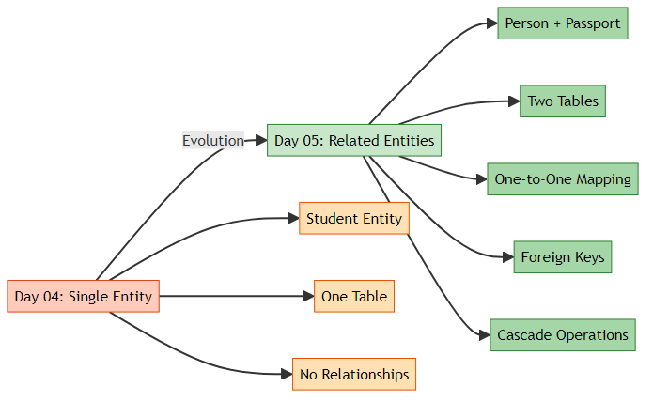
Day 04: - Single entity (Student) - One table - No relationships
Day 05: - Multiple entities (Person + Passport) - Two related tables - One-to-One relationship - Foreign keys - Cascade operations

📊 What We Built
A Person-Passport Management System where: - One Person has exactly One Passport - One Passport belongs to exactly One Person - Deleting a Person automatically deletes their Passport - Passport number is auto-generated - Can search by passport number and find the person
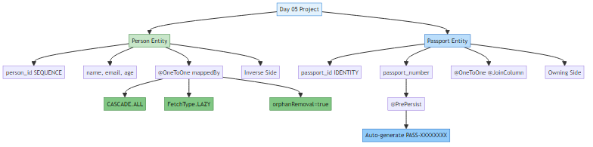

📚 Learning Path Progress
Day 01 (JUnit) → Day 02 (Mockito) → Day 03 (Hibernate Basics) → Day 04 (Advanced Hibernate) → Day 05 (Relationships) ✅
Created by Avinash Dhanuka | © 2026

2. DATABASE RELATIONSHIPS OVERVIEW
� Comprehensive Guide by: Avinash Dhanuka | © 2026

📌 What are Database Relationships?
Relationships = Connections between tables that represent how data relates to each other.

🔍 Types of Relationships (Brief Overview)
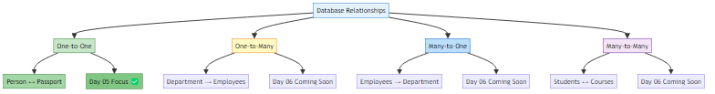
Relationship | Description | Example | Day 05 Coverage
One-to-One | One entity ↔ One entity | Person ↔ Passport | ✅ Detailed
One-to-Many | One entity → Many entities | Department → Employees | ⏭️ Day 06
Many-to-One | Many entities → One entity | Employees → Department | ⏭️ Day 06
Many-to-Many | Many entities ↔ Many entities | Students ↔ Courses | ⏭️ Day 06
Note: Day 05 focuses ONLY on One-to-One relationships. Other relationships will be covered in Day 06.

🎯 Real-World One-to-One Examples
- 🧑 Person ↔ 🛂 Passport (Our Project)
- 👤 User ↔ 👤 Profile
- 🏠 House ↔ 🚪 Main Door
- 💳 Person ↔ 💳 Social Security Number
- 🚗 Vehicle ↔ 📄 Registration

3. ONE-TO-ONE RELATIONSHIP (DEEP DIVE)
� WDeep Dive by: Avinash Dhanuka | Understanding One-to-One Mapping

📌 What is One-to-One?
One-to-One = Each record in Table A is associated with exactly ONE record in Table B, and vice versa.

🏗️ Database Structure
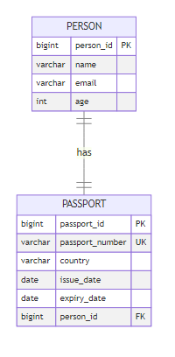
┌─────────────────┐ ┌──────────────────┐
│ PERSON │ │ PASSPORT │
├─────────────────┤ ├──────────────────┤
│ person_id (PK) │◄─────────────│ passport_id (PK) │
│ name │ │ passport_number │
│ email │ │ country │
│ age │ │ issue_date │
└─────────────────┘ │ expiry_date │
│ person_id (FK) │
└──────────────────┘
Key Points: - PERSON table has NO foreign key - PASSPORT table has person_id as foreign key - person_id in PASSPORT must be UNIQUE (ensures 1-to-1) - PASSPORT is the “owning side” (has the FK) - PERSON is the “inverse side” (referenced by FK)

📊 SQL Tables Created by Hibernate
-- Person table (no foreign key)
CREATE TABLE person (
person_id BIGINT PRIMARY KEY,
name VARCHAR(100) NOT NULL,
email VARCHAR(100) UNIQUE,
age INT
);
-- Passport table (has foreign key to person)
CREATE TABLE passport (
passport_id BIGINT AUTO_INCREMENT PRIMARY KEY,
passport_number VARCHAR(50) UNIQUE NOT NULL,
country VARCHAR(100) NOT NULL,
issue_date DATE,
expiry_date DATE,
person_id BIGINT UNIQUE NOT NULL,
FOREIGN KEY (person_id) REFERENCES person(person_id)
);
-- Sequence for person_id generation
CREATE SEQUENCE person_sequence START WITH 1 INCREMENT BY 1;

4. PROJECT STRUCTURE
📝 Project Architecture by: Avinash Dhanuka | © 2026

© 2026 Avinash Dhanuka. All Rights Reserved. avunashdhanuka@gmail.com

HibernateRelationships/
├── src/
│ ├── main/
│ │ ├── java/
│ │ │ └── org/example/
│ │ │ ├── entity/
│ │ │ │ ├── Person.java ← Person entity (inverse side)
│ │ │ │ └── Passport.java ← Passport entity (owning side)
│ │ │ ├── util/
│ │ │ │ └── HibernateUtil.java ← SessionFactory singleton
│ │ │ └── App.java ← Main application with CRUD
│ │ └── resources/
│ │ └── hibernate.cfg.xml ← Hibernate configuration
├── pom.xml ← Maven dependencies
├── database_setup.sql ← Database creation script
└── README.md ← This file

5. ENTITY CLASSES EXPLAINED

👤 Person Entity (Inverse Side)
File: src/main/java/org/example/entity/Person.java
@Entity
@Table(name = "person")
public class Person {
@Id
@GeneratedValue(strategy = GenerationType.SEQUENCE, generator = "person_seq")
@SequenceGenerator(name = "person_seq", sequenceName = "person_sequence",
initialValue = 1, allocationSize = 1)
@Column(name = "person_id")
private Long personId;
@Column(name = "name", nullable = false, length = 100)
private String name;
@Column(name = "email", unique = true, length = 100)
private String email;
@Column(name = "age")
private Integer age;
// One-to-One relationship (inverse side)
@OneToOne(mappedBy = "person", cascade = CascadeType.ALL,
fetch = FetchType.LAZY, orphanRemoval = true)
private Passport passport;
// Constructors, getters, setters...
}
Key Points: - Uses @SequenceGenerator for ID generation - mappedBy = "person" indicates this is the inverse side - cascade = CascadeType.ALL means all operations cascade to Passport - fetch = FetchType.LAZY means Passport loads only when accessed - orphanRemoval = true deletes Passport if unlinked from Person

🛂 Passport Entity (Owning Side)
File: src/main/java/org/example/entity/Passport.java
@Entity
@Table(name = "passport")
public class Passport {
@Id
@GeneratedValue(strategy = GenerationType.IDENTITY)
@Column(name = "passport_id")
private Long passportId;
@Column(name = "passport_number", unique = true, nullable = false, length = 50)
private String passportNumber;
@Column(name = "country", nullable = false, length = 100)
private String country;
@Column(name = "issue_date")
private LocalDate issueDate;
@Column(name = "expiry_date")
private LocalDate expiryDate;
// One-to-One relationship (owning side)
@OneToOne(fetch = FetchType.LAZY)
@JoinColumn(name = "person_id", unique = true, nullable = false)
private Person person;
// Auto-generate passport number before saving
@PrePersist
public void generatePassportNumber() {
if (this.passportNumber == null) {
this.passportNumber = "PASS-" +
UUID.randomUUID().toString().substring(0, 8).toUpperCase();
}
}
// Constructors, getters, setters...
}
Key Points: - Uses @GeneratedValue(strategy = IDENTITY) for ID - @JoinColumn(name = "person_id") creates the foreign key column - unique = true ensures one-to-one relationship - @PrePersist auto-generates passport number before saving - This is the “owning side” because it has the foreign key

6. KEY ANNOTATIONS

📌 Relationship Annotations
Annotation | Purpose | Used In | Example
@OneToOne | Defines 1-to-1 relationship | Both entities | @OneToOne
@JoinColumn | Specifies FK column | Owning side (Passport) | @JoinColumn(name = "person_id")
mappedBy | Defines inverse side | Inverse side (Person) | mappedBy = "person"

📌 Cascade Types
Cascade Type | What It Does | Example
CascadeType.ALL | All operations cascade | Save Person → Save Passport
CascadeType.PERSIST | Only save cascades | session.save(person) saves passport
CascadeType.MERGE | Only update cascades | session.update(person) updates passport
CascadeType.REMOVE | Only delete cascades | session.delete(person) deletes passport
Our Project Uses: CascadeType.ALL - All operations cascade from Person to Passport

📌 Fetch Types
Fetch Type | When Data Loads | Performance | Use Case
FetchType.LAZY | When accessed | Better | Load only when needed
FetchType.EAGER | Immediately | Slower | Always need the data
Our Project Uses: FetchType.LAZY - Better performance, loads Passport only when accessed

📌 ID Generation Strategies
Strategy | How It Works | Used In | Database Support
SEQUENCE | Database sequence | Person | Oracle, PostgreSQL, MySQL 8+
IDENTITY | AUTO_INCREMENT | Passport | MySQL, SQL Server

7. BIDIRECTIONAL RELATIONSHIP
� Navigiation Guide by: Avinash Dhanuka | © 2026

📌 What is Bidirectional?
Bidirectional = You can navigate from Person to Passport AND from Passport to Person.
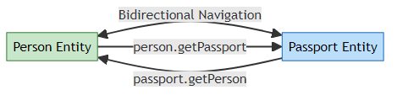
// Navigate from Person to Passport
Person person = session.get(Person.class, 1L);
Passport passport = person.getPassport(); // ✅ Works!
// Navigate from Passport to Person
Passport passport = session.get(Passport.class, 1L);
Person person = passport.getPerson(); // ✅ Also works!

🔄 Synchronization
Important: When setting relationships, both sides must be synchronized!
// ✅ CORRECT: Person.setPassport() synchronizes both sides
public void setPassport(Passport passport) {
this.passport = passport;
if (passport != null) {
passport.setPerson(this); // Sync both sides
}
}

📊 Owning Side vs Inverse Side
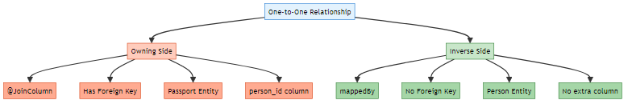
Aspect | Owning Side (Passport) | Inverse Side (Person)
Annotation | @JoinColumn | mappedBy
Foreign Key | ✅ Has FK column | ❌ No FK
Database Column | person_id exists | No extra column
Responsibility | Manages relationship | Just references it

8. CASCADE OPERATIONS

📝 AUTHOR SIGNATURE
This comprehensive guide is created by Avinash Dhanuka
© 2026 | All Rights Reserved

📝 Cascade Guide by: Avinash Dhanuka | Understanding Operation Propagation

📌 What is Cascade?
Cascade = Automatically propagating operations from parent (Person) to child (Passport).
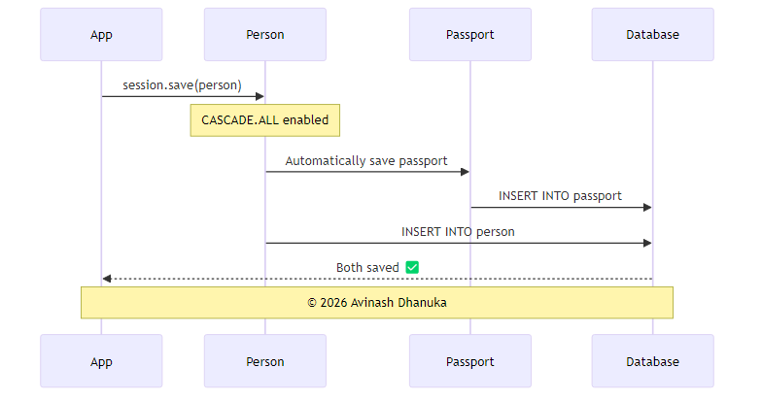

🔄 How CASCADE.ALL Works
// WITHOUT CASCADE - Must save both manually
Person person = new Person("John", "john@email.com", 30);
Passport passport = new Passport("USA", issueDate, expiryDate);
person.setPassport(passport);
session.save(person); // Save person
session.save(passport); // Must save passport separately ❌
// WITH CASCADE.ALL - Automatic!
Person person = new Person("John", "john@email.com", 30);
Passport passport = new Passport("USA", issueDate, expiryDate);
person.setPassport(passport);
session.save(person); // Passport saved automatically! ✅

📊 Cascade Operations in Our Project
Operation | Code | Effect on Passport
Save | session.save(person) | Passport also saved
Update | session.update(person) | Passport also updated
Delete | session.delete(person) | Passport also deleted
Refresh | session.refresh(person) | Passport also refreshed

🗑️ Orphan Removal
orphanRemoval = true means if you unlink the Passport from Person, it gets deleted automatically.
Person person = session.get(Person.class, 1L);
person.setPassport(null); // Unlink passport
session.update(person);
// Passport is automatically deleted from database! ✅

9. FETCH TYPES: LAZY VS EAGER
📝 Performance Guide by: Avinash Dhanuka | Understanding Loading Strategies

📌 What is Fetch Type?
Fetch Type = When Hibernate loads related entities from the database.
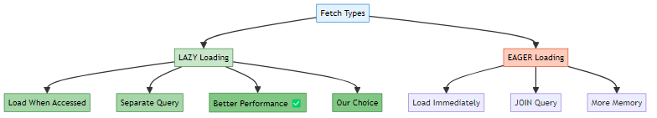

⚡ LAZY Loading (Our Implementation)
@OneToOne(fetch = FetchType.LAZY)
private Passport passport;
How it works:
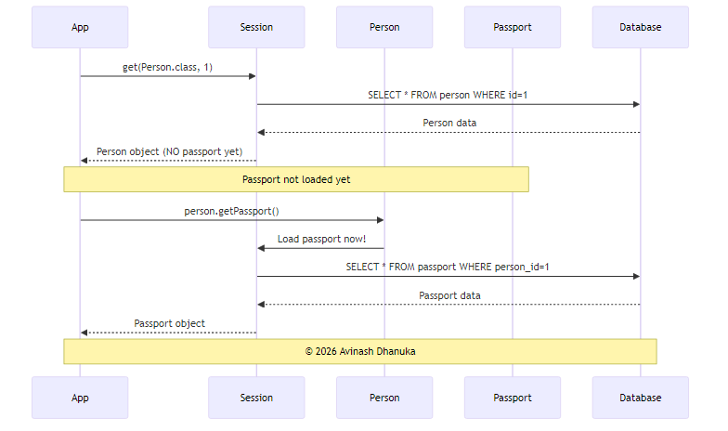
// Load person - Passport NOT loaded yet
Person person = session.get(Person.class, 1L);
// SQL: SELECT * FROM person WHERE person_id = 1
System.out.println(person.getName()); // No additional query
// Access passport - NOW it loads
Passport passport = person.getPassport();
// SQL: SELECT * FROM passport WHERE person_id = 1

📊 LAZY vs EAGER Comparison
Aspect | LAZY | EAGER
Loading Time | When accessed | Immediately
SQL Queries | 2 separate queries | 1 query with JOIN
Performance | Better | Slower
Memory Usage | Lower | Higher
Our Choice | ✅ Yes | ❌ No
Why LAZY? Better performance - load Passport only when you actually need it!

10. ID GENERATION STRATEGIES
📝 ID Generation Guide by: Avinash Dhanuka | Understanding Primary Key Strategies

📌 Two Different Strategies in Our Project
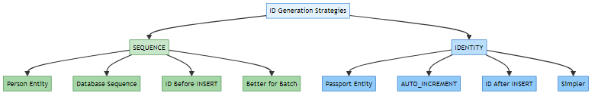

🔢 SEQUENCE Strategy (Person)
@Id
@GeneratedValue(strategy = GenerationType.SEQUENCE, generator = "person_seq")
@SequenceGenerator(name = "person_seq", sequenceName = "person_sequence",
initialValue = 1, allocationSize = 1)
private Long personId;
How it works: 1. Hibernate creates a sequence: CREATE SEQUENCE person_sequence 2. Before INSERT, gets next value: SELECT NEXT VALUE FOR person_sequence 3. Then INSERT with known ID
Benefits: - ✅ ID available before INSERT - ✅ Better for batch operations - ✅ More control

🔢 IDENTITY Strategy (Passport)
@Id
@GeneratedValue(strategy = GenerationType.IDENTITY)
private Long passportId;
How it works: 1. Column has AUTO_INCREMENT 2. INSERT without ID 3. Database assigns ID automatically
Benefits: - ✅ Simple to use - ✅ Widely supported - ✅ No extra database objects

📊 Comparison
Aspect | SEQUENCE (Person) | IDENTITY (Passport)
ID Available | Before INSERT | After INSERT
Batch Insert | ✅ Efficient | ❌ Not efficient
Database Object | Creates SEQUENCE | No extra object
Complexity | More complex | Simple

11. LIFECYCLE CALLBACKS (@PrePersist)
📝 Lifecycle Guide by: Avinash Dhanuka | Auto-Generation Before Save

📌 What is @PrePersist?
@PrePersist = A method that runs automatically BEFORE an entity is saved to the database.

🔧 Our Implementation
@PrePersist
public void generatePassportNumber() {
if (this.passportNumber == null) {
this.passportNumber = "PASS-" +
UUID.randomUUID().toString().substring(0, 8).toUpperCase();
}
}

🔄 Execution Flow
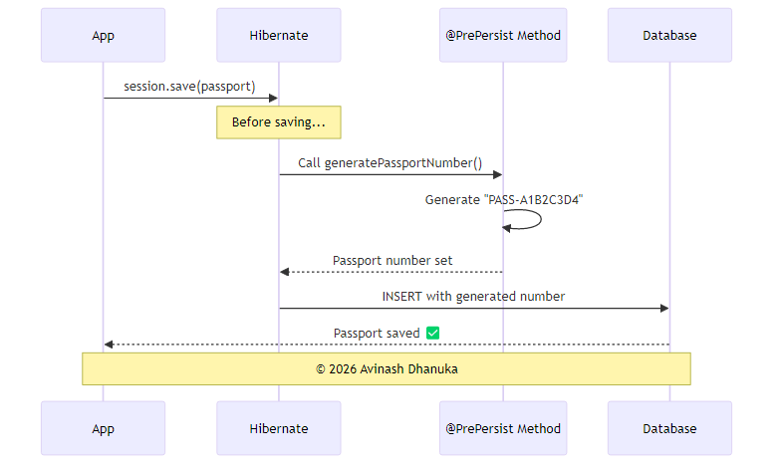
1. Create Passport (passportNumber = null)
↓
2. session.save(passport)
↓
3. @PrePersist method executes
↓
4. passportNumber = "PASS-A1B2C3D4"
↓
5. INSERT INTO passport with generated number
Example Output:
Passport Number: PASS-A1B2C3D4 (@PrePersist auto-generated)

📌 Other Lifecycle Callbacks (Brief)
Callback | When It Runs | Use Case
@PrePersist | Before INSERT | Generate values, set defaults
@PostPersist | After INSERT | Logging, notifications
@PreUpdate | Before UPDATE | Update timestamps
@PostUpdate | After UPDATE | Audit trail
@PreRemove | Before DELETE | Soft delete
@PostRemove | After DELETE | Cleanup

12. CRUD OPERATIONS
📝 CRUD Guide by: Avinash Dhanuka | Operations with Related Entities
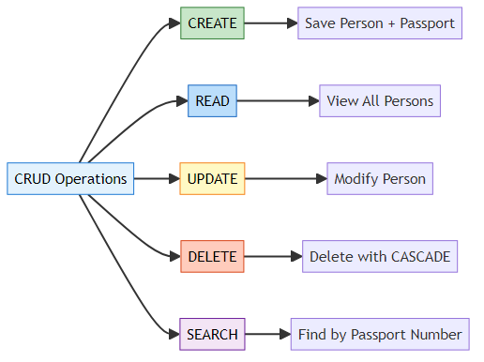

1️⃣ CREATE - Save Person with Passport
// Create entities
Person person = new Person("John Doe", "john@email.com", 30);
Passport passport = new Passport("USA", LocalDate.now(), LocalDate.now().plusYears(10));
// Establish relationship
person.setPassport(passport);
// Save - CASCADE saves passport automatically!
session.save(person);
What Happens: 1. Person saved with ID from SEQUENCE 2. Passport number auto-generated by @PrePersist 3. Passport saved automatically (CASCADE) 4. Foreign key set automatically
SQL Generated:
SELECT NEXT VALUE FOR person_sequence; -- Gets 1
INSERT INTO person (person_id, name, email, age) VALUES (1, 'John Doe', 'john@email.com', 30);
INSERT INTO passport (passport_number, country, issue_date, expiry_date, person_id)
VALUES ('PASS-A1B2C3D4', 'USA', '2026-02-14', '2036-02-14', 1);

2️⃣ READ - View All Persons
List<Person> persons = session.createQuery("FROM Person", Person.class).list();
for (Person p : persons) {
System.out.println("Name: " + p.getName());
// Access passport (LAZY loading triggers here)
if (p.getPassport() != null) {
Passport pass = p.getPassport();
System.out.println("Passport: " + pass.getPassportNumber());
}
}
SQL Generated:
-- First query: Get all persons
SELECT person_id, name, email, age FROM person;
-- For each person (LAZY loading):
SELECT passport_id, passport_number, country, issue_date, expiry_date, person_id
FROM passport WHERE person_id = ?;

3️⃣ UPDATE - Modify Person
Person person = session.get(Person.class, 1L);
person.setName("John Smith");
person.setEmail("johnsmith@email.com");
session.update(person);
SQL Generated:
UPDATE person SET name = 'John Smith', email = 'johnsmith@email.com' WHERE person_id = 1;

4️⃣ DELETE - Remove Person (CASCADE deletes Passport)
Person person = session.get(Person.class, 1L);
session.delete(person);
// Passport automatically deleted due to CASCADE.ALL
SQL Generated:
-- Delete passport first (foreign key constraint)
DELETE FROM passport WHERE person_id = 1;
-- Then delete person
DELETE FROM person WHERE person_id = 1;

5️⃣ SEARCH - Find by Passport Number (Bidirectional)
String hql = "FROM Passport WHERE passportNumber = :number";
Passport passport = session.createQuery(hql, Passport.class)
.setParameter("number", "PASS-A1B2C3D4")
.uniqueResult();
// Navigate to Person (bidirectional relationship)
Person person = passport.getPerson();
System.out.println("Person: " + person.getName());

13. RUNNING THE APPLICATION
Created by: Avinash Dhanuka © 2026 Avinash Dhanuka
GitHub Profile | Contact Me

📋 Prerequisites
- MySQL Server installed and running
- Java 11 or higher
- Maven installed

🚀 Step-by-Step Setup
Step 1: Create Database
mysql -u root -p
CREATE DATABASE hibernate_relationships_db;
USE hibernate_relationships_db;
Or run the provided script:
mysql -u root -p < database_setup.sql
Step 2: Update Database Credentials
Edit src/main/resources/hibernate.cfg.xml:
<property name="hibernate.connection.username">your_username</property>
<property name="hibernate.connection.password">your_password</property>
Step 3: Build the Project
mvn clean install
Step 4: Run the Application
mvn exec:java -Dexec.mainClass="org.example.App"

📱 Application Menu
--- MENU ---
1. Create Person with Passport
2. View All Persons
3. Update Person
4. Delete Person
5. Search by Passport Number
6. Exit

🎯 Sample Interaction
Choose option: 1
--- Create Person with Passport ---
Enter Name: John Doe
Enter Email: john@email.com
Enter Age: 30
Enter Country: USA
Enter Issue Date (YYYY-MM-DD): 2026-01-01
Enter Expiry Date (YYYY-MM-DD): 2036-01-01
✓ Success! Person and Passport created.
Person ID: 1 (@SequenceGenerator)
Passport Number: PASS-A1B2C3D4 (@PrePersist auto-generated)
Annotations Used:
- @SequenceGenerator for Person ID
- @PrePersist for Passport Number generation
- CASCADE saves Passport automatically

14. WHAT I LEARNED
📝 Learning Summary by: Avinash Dhanuka | © 2026
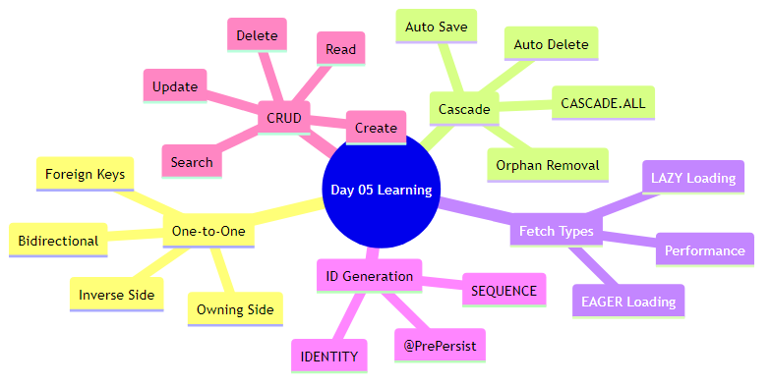

✅ Core Concepts Mastered
1. One-to-One Relationship - How to map 1-to-1 relationships between entities - Understanding owning side vs inverse side - Using @OneToOne, @JoinColumn, and mappedBy
2. Bidirectional Navigation - Can navigate from Person to Passport - Can navigate from Passport to Person - Synchronizing both sides of the relationship
3. Cascade Operations - CASCADE.ALL propagates all operations - Save Person → Passport saved automatically - Delete Person → Passport deleted automatically - No need to manually save/delete child entities
4. Fetch Strategies - FetchType.LAZY loads data when accessed (better performance) - FetchType.EAGER loads data immediately - Chose LAZY for better performance
5. Orphan Removal - orphanRemoval = true deletes orphaned entities - If you unlink Passport from Person, it’s deleted - Keeps database clean
6. ID Generation - SEQUENCE strategy for Person (more control) - IDENTITY strategy for Passport (simpler) - Understanding when to use which
7. Lifecycle Callbacks - @PrePersist runs before INSERT - Used to auto-generate passport number - Can set default values, timestamps, etc.
8. Foreign Keys - Passport has person_id foreign key - UNIQUE constraint ensures 1-to-1 - Hibernate manages FK automatically

📊 Day 04 vs Day 05 Comparison
Feature | Day 04 | Day 05
Entities | 1 (Student) | 2 (Person + Passport)
Tables | 1 table | 2 related tables
Relationships | None | One-to-One
Foreign Keys | Not used | Used (person_id)
Cascade | Not covered | CASCADE.ALL
Fetch Strategy | Not covered | LAZY vs EAGER
Orphan Removal | Not covered | Implemented
ID Generation | IDENTITY only | SEQUENCE + IDENTITY
@PrePersist | Not used | Auto-generate passport number
Navigation | N/A | Bidirectional

🎯 Practical Skills Gained
✅ Built a complete Person-Passport management system ✅ Implemented CRUD operations with relationships ✅ Used HQL to query related entities ✅ Handled bidirectional navigation ✅ Applied cascade operations correctly ✅ Optimized with LAZY loading ✅ Auto-generated values with @PrePersist<br> ✅ Managed foreign keys automatically

15. INTERVIEW QUESTIONS
📝 Curated by: Avinash Dhanuka | © 2026 | GitHub
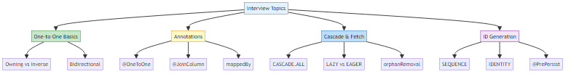

Q1: What is a One-to-One relationship? Give a real-world example.
Answer:
A One-to-One relationship means each record in Table A is associated with exactly ONE record in Table B, and vice versa.
Real-World Examples: - Person ↔ Passport (one person has one passport) - User ↔ Profile (one user has one profile) - Employee ↔ Desk (one employee assigned one desk)
Database Structure:
CREATE TABLE person (person_id BIGINT PRIMARY KEY, name VARCHAR(100));
CREATE TABLE passport (
passport_id BIGINT PRIMARY KEY,
passport_number VARCHAR(50),
person_id BIGINT UNIQUE, -- UNIQUE ensures 1-to-1
FOREIGN KEY (person_id) REFERENCES person(person_id)
);
Key Point: The UNIQUE constraint on the foreign key ensures it’s truly one-to-one.

Q2: What is the difference between Owning Side and Inverse Side?
Answer:
Aspect | Owning Side | Inverse Side
Annotation | @JoinColumn | mappedBy
Foreign Key | Has FK column | No FK
Example | Passport (has person_id) | Person (no FK)
Responsibility | Manages relationship | Just references it
Code Example:
// OWNING SIDE (Passport)
@OneToOne
@JoinColumn(name = "person_id")
private Person person;
// INVERSE SIDE (Person)
@OneToOne(mappedBy = "person")
private Passport passport;
Why It Matters: Only the owning side can update the foreign key in the database.

Q3: Explain CASCADE operations with an example.
Answer:
Cascade = Automatically propagating operations from parent to child entity.
CASCADE.ALL includes: - PERSIST (save) - MERGE (update) - REMOVE (delete) - REFRESH (reload) - DETACH (detach)
Example:
@OneToOne(cascade = CascadeType.ALL)
private Passport passport;
// Save person - passport saved automatically
Person person = new Person("John", "john@email.com", 30);
Passport passport = new Passport("USA", dates...);
person.setPassport(passport);
session.save(person); // ✅ Passport also saved
// Delete person - passport deleted automatically
session.delete(person); // ✅ Passport also deleted
Without CASCADE:
session.save(person); // Save person
session.save(passport); // Must save passport separately ❌

Q4: What is the difference between LAZY and EAGER loading?
Answer:
Aspect | LAZY | EAGER
Loading Time | When accessed | Immediately
SQL Queries | Separate query | JOIN or separate
Performance | Better | Slower
Memory | Lower | Higher
LAZY Example:
@OneToOne(fetch = FetchType.LAZY)
private Passport passport;
Person person = session.get(Person.class, 1L);
// SQL: SELECT * FROM person WHERE person_id = 1
// Passport NOT loaded yet
Passport passport = person.getPassport(); // NOW it loads
// SQL: SELECT * FROM passport WHERE person_id = 1
EAGER Example:
@OneToOne(fetch = FetchType.EAGER)
private Passport passport;
Person person = session.get(Person.class, 1L);
// SQL: SELECT * FROM person p LEFT JOIN passport ps ON p.id = ps.person_id
// Both loaded immediately
Best Practice: Use LAZY by default for better performance.

Q5: What is orphanRemoval and how is it different from CASCADE.REMOVE?
Answer:
orphanRemoval = Automatically delete child when it’s no longer referenced by parent.
Scenario | CASCADE.REMOVE | orphanRemoval
Delete parent | ✅ Deletes child | ✅ Deletes child
Unlink child | ❌ Child remains | ✅ Deletes child
Example:
@OneToOne(cascade = CascadeType.ALL, orphanRemoval = true)
private Passport passport;
// Scenario 1: Delete parent
session.delete(person);
// Both CASCADE.REMOVE and orphanRemoval delete passport
// Scenario 2: Unlink child
person.setPassport(null);
session.update(person);
// Only orphanRemoval deletes the passport!
// Without orphanRemoval, passport remains in database (orphaned)
Use Case: Use orphanRemoval for true parent-child relationships where child cannot exist without parent.

Q6: Explain @PrePersist with an example.
Answer:
@PrePersist = A lifecycle callback that runs automatically BEFORE an entity is saved.
Example:
@Entity
public class Passport {
private String passportNumber;
@PrePersist
public void generatePassportNumber() {
if (this.passportNumber == null) {
this.passportNumber = "PASS-" +
UUID.randomUUID().toString().substring(0, 8).toUpperCase();
}
}
}
Execution Flow:
1. Create passport (passportNumber = null)
2. session.save(passport)
3. @PrePersist executes → passportNumber = "PASS-A1B2C3D4"
4. INSERT INTO passport with generated number
Other Lifecycle Callbacks: - @PostPersist (after INSERT) - @PreUpdate (before UPDATE) - @PostUpdate (after UPDATE) - @PreRemove (before DELETE) - @PostRemove (after DELETE)

Q7: What is the difference between SEQUENCE and IDENTITY generation strategies?
Answer:
Aspect | SEQUENCE | IDENTITY
How It Works | Database sequence | AUTO_INCREMENT
ID Available | Before INSERT | After INSERT
Batch Insert | ✅ Efficient | ❌ Not efficient
Database Support | Oracle, PostgreSQL, MySQL 8+ | MySQL, SQL Server
SEQUENCE Example:
@Id
@GeneratedValue(strategy = GenerationType.SEQUENCE, generator = "person_seq")
@SequenceGenerator(name = "person_seq", sequenceName = "person_sequence")
private Long personId;
CREATE SEQUENCE person_sequence;
SELECT NEXT VALUE FOR person_sequence; -- Gets ID before INSERT
INSERT INTO person (person_id, ...) VALUES (1, ...);
IDENTITY Example:
@Id
@GeneratedValue(strategy = GenerationType.IDENTITY)
private Long passportId;
CREATE TABLE passport (passport_id BIGINT AUTO_INCREMENT PRIMARY KEY, ...);
INSERT INTO passport (...) VALUES (...); -- ID assigned by database
When to Use: - SEQUENCE: Better performance, batch operations - IDENTITY: Simplicity, legacy databases

Q8: How do you ensure both sides of a bidirectional relationship are synchronized?
Answer:
Problem: In bidirectional relationships, you must keep both sides in sync.
Solution: Add synchronization logic in setter methods.
// ❌ BAD: Not synchronized
Person person = new Person("John", "john@email.com", 30);
Passport passport = new Passport("USA", dates...);
passport.setPerson(person); // Set one side only
// person.getPassport() returns null! ❌
// ✅ GOOD: Synchronized
@Entity
public class Person {
public void setPassport(Passport passport) {
this.passport = passport;
if (passport != null) {
passport.setPerson(this); // Sync both sides
}
}
}
// Usage
person.setPassport(passport);
// Both sides synchronized automatically! ✅
Best Practice: Always synchronize both sides in the setter method of the inverse side.

Q9: What SQL queries are generated when you save a Person with Passport?
Answer:
Code:
Person person = new Person("John", "john@email.com", 30);
Passport passport = new Passport("USA", issueDate, expiryDate);
person.setPassport(passport);
session.save(person);
SQL Generated:
-- 1. Get next person_id from sequence
SELECT NEXT VALUE FOR person_sequence; -- Returns 1
-- 2. Insert person
INSERT INTO person (person_id, name, email, age)
VALUES (1, 'John', 'john@email.com', 30);
-- 3. Insert passport (CASCADE effect)
INSERT INTO passport (passport_number, country, issue_date, expiry_date, person_id)
VALUES ('PASS-A1B2C3D4', 'USA', '2026-01-01', '2036-01-01', 1);
Key Points: - Only need to save Person (CASCADE saves Passport) - Passport number auto-generated by @PrePersist - Foreign key (person_id) set automatically

Q10: How do you query from the Passport side to find the Person?
Answer:
HQL Query:
String hql = "FROM Passport WHERE passportNumber = :number";
Passport passport = session.createQuery(hql, Passport.class)
.setParameter("number", "PASS-A1B2C3D4")
.uniqueResult();
// Navigate to Person (bidirectional relationship)
Person person = passport.getPerson();
System.out.println("Person: " + person.getName());
SQL Generated:
-- First query: Find passport
SELECT passport_id, passport_number, country, issue_date, expiry_date, person_id
FROM passport WHERE passport_number = 'PASS-A1B2C3D4';
-- Second query: Load person (LAZY loading)
SELECT person_id, name, email, age FROM person WHERE person_id = 1;
This demonstrates: - Bidirectional navigation (Passport → Person) - HQL with parameters - LAZY loading of Person

📚 Related Learning Resources

Previous Days
Day 03: Hibernate Basics - Location: day03/HibernateDemo/ - Focus: Introduction to Hibernate ORM - View README
Day 04: Advanced Hibernate - Location: day04/HibernateCore/ - Focus: Caching, lifecycle states, batch operations - View README

Next Steps
Day 06: More Relationships (Coming Soon) - One-to-Many relationships - Many-to-One relationships - Many-to-Many relationships - Join tables and composite keys

🎯 Key Takeaways
✅ Mastered One-to-One bidirectional relationships ✅ Understood owning side vs inverse side ✅ Implemented CASCADE operations for automatic propagation ✅ Used LAZY loading for better performance ✅ Applied orphanRemoval to prevent orphaned records ✅ Learned SEQUENCE vs IDENTITY ID generation ✅ Used @PrePersist for auto-generation ✅ Built complete CRUD with relationships ✅ Handled foreign keys automatically ✅ Navigated relationships bidirectionally

🎓 End of Day 05 Master Guide

Created with dedication by Avinash Dhanuka

Happy Learning! 🚀
“Master the Relationships, Master the Database!” - Avinash Dhanuka

