☕ Spring Boot CRUD with Thymeleaf: Modern Web Application

© 2026 Avinash Dhanuka
Master Guide: Spring Boot CRUD with Thymeleaf
Crafted with ❤️ for Modern Web Development

Learning Note: This project demonstrates complete CRUD operations with Spring Boot and Thymeleaf - the modern alternative to JSP. Master in-memory data storage, RESTful patterns, and natural template engine.
Prerequisites: - Understanding of Spring MVC (day11/SpringMvc, day12/MavenApp) - Basic knowledge of HTML/CSS - Familiarity with Spring Boot auto-configuration - HTTP methods (GET, POST)

📑 Table of Contents
- What is This Project?
- Thymeleaf vs JSP
- Project Architecture
- Complete CRUD Operations
- Request Flow
- Thymeleaf Syntax Deep Dive
- Spring Boot Dependencies
- Internal Working
- Real-World Patterns
- Common Pitfalls & Solutions
- Interview Questions

1. WHAT IS THIS PROJECT?

📝 Author: Avinash Dhanuka | GitHub

📌 Definition
ProductCRUD is a Spring Boot web application demonstrating complete CRUD (Create, Read, Update, Delete) operations using Thymeleaf template engine and in-memory data storage.
Key Features: - Complete CRUD operations - Thymeleaf natural templates - In-memory ArrayList storage - RESTful URL patterns - Modern UI with CSS styling - No database required

🎯 Why This Project?
Feature | Benefit
Thymeleaf | Modern alternative to JSP
In-Memory Storage | No database setup needed
CRUD Operations | Real-world pattern
Spring Boot | Auto-configuration magic
RESTful URLs | Industry standard

2. THYMELEAF VS JSP

📊 Technology Comparison
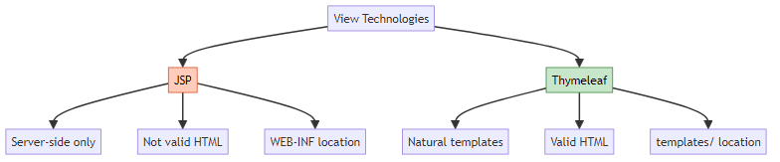

🎯 Detailed Comparison
Feature | JSP (Day 11/12) | Thymeleaf (Day 13)
Syntax | ${name} | th:text="${name}"
Valid HTML | No | Yes
Preview | Cannot open in browser | Can open in browser
Location | webapp/WEB-INF/jsp/ | resources/templates/
Dependency | tomcat-embed-jasper | spring-boot-starter-thymeleaf
Modern | Legacy | Modern
Spring Boot | Manual config | Auto-configured

📝 Syntax Examples
JSP:
<%@ taglib uri="http://java.sun.com/jsp/jstl/core" prefix="c" %>
<c:forEach var="product" items="${products}">
<td>${product.name}</td>
</c:forEach>
Thymeleaf:
<tr th:each="product : ${products}">
<td th:text="${product.name}"></td>
</tr>

3. PROJECT ARCHITECTURE

📝 Author: Avinash Dhanuka | GitHub

📁 Complete Project Structure
ProductCRUD/
├── src/
│ └── main/
│ ├── java/
│ │ └── com/example/
│ │ ├── ProductCrudApplication.java # Entry Point
│ │ ├── controller/
│ │ │ └── ProductController.java # @Controller
│ │ ├── service/
│ │ │ └── ProductService.java # @Service
│ │ ├── repository/
│ │ │ └── ProductDao.java # @Repository
│ │ └── model/
│ │ └── Product.java # POJO
│ └── resources/
│ ├── application.properties # Configuration
│ ├── static/
│ │ └── style.css # CSS Styling
│ └── templates/
│ ├── home.html # Home page
│ ├── product-list.html # List view
│ └── product-form.html # Add/Edit form
├── pom.xml # Dependencies
└── README.md

🎯 Layered Architecture
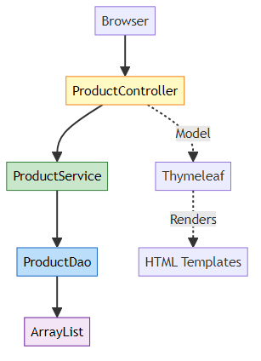

📊 Layer Responsibilities
Layer | Annotation | File | Responsibility
Controller | @Controller | ProductController.java | Handle HTTP requests
Service | @Service | ProductService.java | Business logic
Repository | @Repository | ProductDao.java | Data access (in-memory)
Model | POJO | Product.java | Data representation
View | Thymeleaf | *.html | UI presentation

4. COMPLETE CRUD OPERATIONS

📌 CRUD Mapping
Operation | HTTP Method | URL | Controller Method
Create | POST | /products/save | saveProduct()
Read (All) | GET | /products/list | listProducts()
Read (One) | GET | /products/edit/{id} | showEditForm()
Update | POST | /products/save | saveProduct()
Delete | GET | /products/delete/{id} | deleteProduct()

🎯 Controller Implementation
@Controller
@RequestMapping("/products")
public class ProductController {
@Autowired
private ProductService productService;
// CREATE - Show form
@GetMapping("/add")
public String showAddForm(Model model) {
model.addAttribute("product", new Product());
return "product-form";
}
// CREATE/UPDATE - Save product
@PostMapping("/save")
public String saveProduct(@ModelAttribute Product product) {
productService.saveProduct(product);
return "redirect:/products/list";
}
// READ - List all
@GetMapping("/list")
public String listProducts(Model model) {
model.addAttribute("products", productDao.findAll());
return "product-list";
}
// UPDATE - Show edit form
@GetMapping("/edit/{id}")
public String showEditForm(@PathVariable Long id, Model model) {
Optional<Product> product = productService.findById(id);
model.addAttribute("product", product.get());
return "product-form";
}
// DELETE
@GetMapping("/delete/{id}")
public String deleteProduct(@PathVariable Long id) {
productService.delete(id);
return "redirect:/products/list";
}
}

📊 Repository Logic
@Repository
public class ProductDao {
private List<Product> productList = new ArrayList<>();
private Long idCounter = 1L;
public void save(Product product) {
if (product.getId() == null) {
product.setId(idCounter++); // Auto-increment ID
productList.add(product);
} else {
update(product); // Update existing
}
}
public Optional<Product> findBy(Long id) {
return productList.stream()
.filter(p -> p.getId().equals(id))
.findFirst();
}
public void deleteById(Long id) {
productList.removeIf(p -> p.getId().equals(id));
}
}

5. REQUEST FLOW

📝 Author: Avinash Dhanuka | GitHub

📌 Complete CRUD Flow
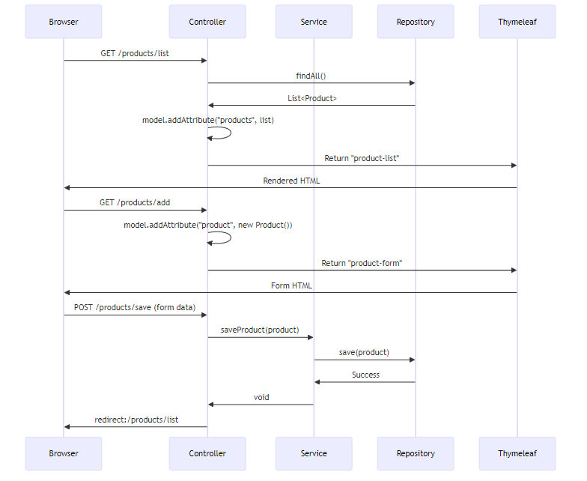

🎯 Step-by-Step: Add Product
1. User clicks "Add Product" → GET /products/add
2. Controller creates new Product() → adds to Model
3. Returns "product-form" → Thymeleaf renders form
4. User fills form (name, price, quantity) → clicks Save
5. Browser sends POST /products/save with form data
6. @ModelAttribute binds data to Product object
7. Controller calls productService.saveProduct(product)
8. Service calls productDao.save(product)
9. Repository adds to ArrayList with auto-increment ID
10. Controller returns "redirect:/products/list"
11. Browser redirects to GET /products/list
12. Product list displayed with new product

🎯 Step-by-Step: Edit Product
1. User clicks "Edit" link → GET /products/edit/1
2. @PathVariable extracts id=1
3. Service finds product by ID from repository
4. Controller adds product to Model
5. Returns "product-form" → form pre-filled with data
6. User modifies fields → clicks Save
7. POST /products/save with existing ID
8. Repository detects existing ID → calls update()
9. Updates product in ArrayList
10. Redirect to list → updated product shown

6. THYMELEAF SYNTAX DEEP DIVE

📌 Essential Thymeleaf Attributes
Attribute | Purpose | Example
th:text | Set text content | <td th:text="${product.name}"></td>
th:each | Loop iteration | <tr th:each="p : ${products}">
th:href | Dynamic URL | <a th:href="@{/products/edit/{id}(id=${p.id})}">
th:action | Form action | <form th:action="@{/products/save}">
th:object | Form binding | <form th:object="${product}">
th:field | Input binding | <input th:field="*{name}" />

🎯 URL Expressions
Static URL:
<a href="/products/list">List</a>
Thymeleaf URL:
<a th:href="@{/products/list}">List</a>
URL with Path Variable:
<a th:href="@{/products/edit/{id}(id=${product.id})}">Edit</a>
<!-- Generates: /products/edit/1 -->
URL with Query Parameters:
<a th:href="@{/products/search(name=${searchTerm})}">Search</a>
<!-- Generates: /products/search?name=laptop -->

🎯 Form Binding
product-form.html:
<form th:action="@{/products/save}" th:object="${product}" method="post">
<!-- Hidden field for ID (edit mode) -->
<input type="hidden" th:field="*{id}" />
<!-- Name field -->
<input type="text" th:field="*{name}" required />
<!-- Price field -->
<input type="number" th:field="*{price}" required />
<!-- Quantity field -->
<input type="number" th:field="*{quantity}" required />
<button type="submit">Save</button>
</form>
How th:field works: - *{name} → binds to product.getName() and product.setName() - Generates name="name" attribute - Pre-fills value in edit mode - Binds to @ModelAttribute Product product in controller

🎯 Iteration with th:each
<table>
<tr th:each="product : ${products}">
<td th:text="${product.id}"></td>
<td th:text="${product.name}"></td>
<td th:text="${product.price}"></td>
<td th:text="${product.quantity}"></td>
<td>
<a th:href="@{/products/edit/{id}(id=${product.id})}">Edit</a>
<a th:href="@{/products/delete/{id}(id=${product.id})}">Delete</a>
</td>
</tr>
</table>
Iteration Variables:
<tr th:each="product, iterStat : ${products}">
<td th:text="${iterStat.index}"></td> <!-- 0, 1, 2... -->
<td th:text="${iterStat.count}"></td> <!-- 1, 2, 3... -->
<td th:text="${iterStat.first}"></td> <!-- true/false -->
<td th:text="${iterStat.last}"></td> <!-- true/false -->
</tr>

7. SPRING BOOT DEPENDENCIES

📝 Author: Avinash Dhanuka | GitHub

📌 What Does Each Dependency Do?
pom.xml:
<dependencies>
<!-- 1. Spring Web -->
<dependency>
<groupId>org.springframework.boot</groupId>
<artifactId>spring-boot-starter-web</artifactId>
</dependency>
<!-- 2. Thymeleaf -->
<dependency>
<groupId>org.springframework.boot</groupId>
<artifactId>spring-boot-starter-thymeleaf</artifactId>
</dependency>
<!-- 3. Spring Data JPA -->
<dependency>
<groupId>org.springframework.boot</groupId>
<artifactId>spring-boot-starter-data-jpa</artifactId>
</dependency>
<!-- 4. DevTools -->
<dependency>
<groupId>org.springframework.boot</groupId>
<artifactId>spring-boot-devtools</artifactId>
</dependency>
</dependencies>

🎯 Dependency Breakdown
Dependency | Purpose | What It Includes
spring-boot-starter-web | Web development | Spring MVC, Embedded Tomcat, Jackson (JSON), Validation
spring-boot-starter-thymeleaf | Template engine | Thymeleaf 3.x, Auto-configuration for templates/
spring-boot-starter-data-jpa | Database access | Spring Data JPA, Hibernate, JDBC (not used in this project)
spring-boot-devtools | Development tools | Auto-restart, LiveReload, Configurations

📊 What Each Starter Does
1. spring-boot-starter-web: - Enables @Controller, @RestController - Provides @GetMapping, @PostMapping - Embedded Tomcat server - JSON serialization with Jackson - Exception handling
2. spring-boot-starter-thymeleaf: - Auto-configures Thymeleaf template engine - Sets spring.thymeleaf.prefix=classpath:/templates/ - Sets spring.thymeleaf.suffix=.html - Enables th:* attributes - Natural template support
3. spring-boot-starter-data-jpa: - Provides JPA annotations (@Entity, @Id) - Hibernate ORM framework - JpaRepository interface - Transaction management - Note: Not used in this project (in-memory ArrayList instead)
4. spring-boot-devtools: - Auto-restart on code changes - LiveReload browser extension support - Disables template caching in development - Faster development cycle

🎯 Why JPA Dependency Without Database?
Answer: Added for future migration to database.
Current: In-memory ArrayList storage Future: Can easily switch to MySQL/H2 by: 1. Adding database driver dependency 2. Configuring application.properties 3. Changing ProductDao to extend JpaRepository 4. Adding @Entity to Product model

8. INTERNAL WORKING

📝 Author: Avinash Dhanuka | GitHub

📌 Spring Boot Auto-Configuration
What happens when you run ProductCrudApplication?
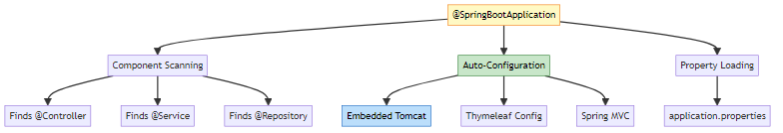

🎯 Request Processing Flow
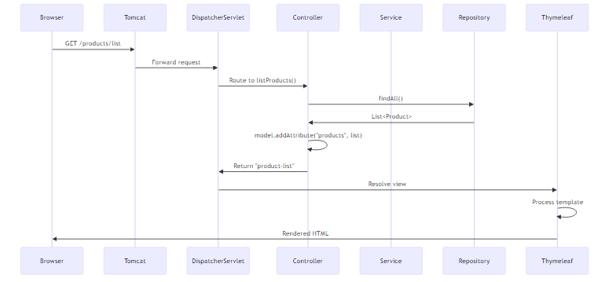

📊 Component Lifecycle
Phase | Action | Example
1. Startup | Component scanning | Finds @Controller, @Service
2. Bean Creation | Instantiate classes | new ProductController()
3. Dependency Injection | @Autowired wiring | Inject ProductService
4. Initialization | @PostConstruct | Setup methods
5. Ready | Application running | Accepts requests

🎯 How @Autowired Works
@Controller
public class ProductController {
@Autowired
private ProductService productService; // How does this work?
}
Internal Process:
1. Spring scans @Controller annotation
2. Creates ProductController bean
3. Detects @Autowired field
4. Looks for ProductService bean in context
5. Injects ProductService instance
6. ProductController ready to use

📝 In-Memory Storage Mechanism
@Repository
public class ProductDao {
private List<Product> productList = new ArrayList<>(); // Singleton
private Long idCounter = 1L;
}
Key Points: - ProductDao is singleton (one instance per application) - ArrayList persists during application runtime - Data lost on restart (no database) - Thread-safe? No (use ConcurrentHashMap for production)

9. REAL-WORLD PATTERNS

📌 Production-Ready Enhancements
1. Add Validation
public class Product {
@NotNull(message = "ID cannot be null")
private Long id;
@NotBlank(message = "Name is required")
@Size(min = 2, max = 100)
private String name;
@Min(value = 0, message = "Price must be positive")
private double price;
@Min(value = 0, message = "Quantity cannot be negative")
private int quantity;
}
2. Exception Handling
@ControllerAdvice
public class GlobalExceptionHandler {
@ExceptionHandler(ProductNotFoundException.class)
public String handleNotFound(Model model) {
model.addAttribute("error", "Product not found");
return "error";
}
}
3. RESTful API Version
@RestController
@RequestMapping("/api/products")
public class ProductRestController {
@GetMapping
public ResponseEntity<List<Product>> getAllProducts() {
return ResponseEntity.ok(productService.getAllProducts());
}
@PostMapping
public ResponseEntity<Product> createProduct(@RequestBody Product product) {
productService.saveProduct(product);
return ResponseEntity.status(HttpStatus.CREATED).body(product);
}
}

🎯 Database Migration Path
Current: In-Memory ArrayList
@Repository
public class ProductDao {
private List<Product> productList = new ArrayList<>();
}
Future: JPA with Database
@Entity
@Table(name = "products")
public class Product {
@Id
@GeneratedValue(strategy = GenerationType.IDENTITY)
private Long id;
// ... fields
}
@Repository
public interface ProductDao extends JpaRepository<Product, Long> {
// Spring Data JPA provides all methods
}
Migration Steps: 1. Add database dependency (MySQL/H2) 2. Configure datasource in application.properties 3. Add @Entity to Product model 4. Change ProductDao to extend JpaRepository 5. Remove manual ArrayList logic

📊 Comparison: In-Memory vs Database
Feature | In-Memory (Current) | Database (Production)
Data Persistence | Lost on restart | Permanent
Scalability | Single instance | Multiple instances
Transactions | No | Yes
Concurrency | Not thread-safe | Thread-safe
Query Capability | Limited | Full SQL
Use Case | Learning, prototyping | Production apps

10. COMMON PITFALLS & SOLUTIONS

📝 Author: Avinash Dhanuka | GitHub

❌ Pitfall 1: CSS Not Loading
Problem:
src/main/resources/templates/style.css ❌
Error: 404 - CSS not found
Solution:
src/main/resources/static/style.css ✅
Why? - static/ folder is for static resources (CSS, JS, images) - templates/ folder is for Thymeleaf templates only

❌ Pitfall 2: Thymeleaf Syntax Errors
Problem:
<td>${product.name}</td> <!-- JSP syntax -->
Solution:
<td th:text="${product.name}"></td> <!-- Thymeleaf syntax -->

❌ Pitfall 3: Missing No-Arg Constructor
Problem:
public class Product {
public Product(Long id, String name) { // Only parameterized
this.id = id;
this.name = name;
}
}
Error: Cannot instantiate Product for form binding
Solution:
public class Product {
public Product() {} // Required for @ModelAttribute
public Product(Long id, String name, double price, int quantity) {
this.id = id;
this.name = name;
this.price = price;
this.quantity = quantity;
}
}

❌ Pitfall 4: Wrong Form Field Names
Problem:
<input type="text" name="productName" /> <!-- Wrong -->
public class Product {
private String name; // Field name doesn't match
}
Solution:
<input type="text" name="name" /> <!-- Matches field name -->

❌ Pitfall 5: Port Already in Use
Problem:
Port 8080 is already in use
Solution 1: Change port in application.properties
server.port=8082
Solution 2: Kill process using port
# Windows
netstat -ano | findstr :8080
taskkill /PID <process_id> /F
# Linux/Mac
lsof -i :8080
kill -9 <process_id>

❌ Pitfall 6: Redirect Loop
Problem:
@GetMapping("/list")
public String listProducts() {
return "redirect:/products/list"; // Infinite loop!
}
Solution:
@GetMapping("/list")
public String listProducts(Model model) {
model.addAttribute("products", productDao.findAll());
return "product-list"; // Return view name, not redirect
}

❌ Pitfall 7: NullPointerException on Edit
Problem:
@GetMapping("/edit/{id}")
public String showEditForm(@PathVariable Long id, Model model) {
Optional<Product> product = productService.findById(id);
model.addAttribute("product", product.get()); // NPE if not found!
return "product-form";
}
Solution:
@GetMapping("/edit/{id}")
public String showEditForm(@PathVariable Long id, Model model) {
Optional<Product> product = productService.findById(id);
if (product.isPresent()) {
model.addAttribute("product", product.get());
return "product-form";
}
return "redirect:/products/list"; // Redirect if not found
}

11. TOP INTERVIEW QUESTIONS

Q1: What does spring-boot-starter-web do?
Answer:
spring-boot-starter-web is a dependency aggregator that includes everything needed for web development.
Includes: 1. Spring MVC - Web framework (@Controller, @GetMapping, @PostMapping) 2. Embedded Tomcat - No need for external server 3. Jackson - JSON serialization/deserialization 4. Validation - Bean validation (@Valid, @NotNull) 5. Spring Boot Auto-configuration - Automatic setup
Without spring-boot-starter-web:
<dependency><artifactId>spring-webmvc</artifactId></dependency>
<dependency><artifactId>tomcat-embed-core</artifactId></dependency>
<dependency><artifactId>tomcat-embed-el</artifactId></dependency>
<dependency><artifactId>jackson-databind</artifactId></dependency>
<!-- ... 20+ more dependencies -->
With spring-boot-starter-web:
<dependency>
<groupId>org.springframework.boot</groupId>
<artifactId>spring-boot-starter-web</artifactId>
</dependency>
<!-- All 20+ dependencies included automatically! -->

Q2: What does Thymeleaf do?
Answer:
Thymeleaf is a modern server-side template engine for rendering dynamic HTML.
Key Features:
- Natural Templates
<!-- Can be opened directly in browser -->
<p th:text="${name}">Default Name</p>
<!-- Shows "Default Name" in browser, "${name}" when processed -->
- Server-Side Rendering
Controller → Model → Thymeleaf → HTML → Browser
- Expression Language
<td th:text="${product.name}"></td>
<a th:href="@{/products/edit/{id}(id=${product.id})}">Edit</a>
<tr th:each="product : ${products}">
Thymeleaf vs JSP:
Feature | Thymeleaf | JSP
Valid HTML | Yes | No
Preview in Browser | Yes | No
Modern | Yes | Legacy
Spring Boot | Auto-configured | Manual config
Location | resources/templates/ | webapp/WEB-INF/jsp/

Q3: What does spring-boot-devtools do?
Answer:
spring-boot-devtools provides development-time features for faster development.
Features:
- Auto-Restart
Change Java code → Save → Application restarts automatically
- LiveReload
Change HTML/CSS → Save → Browser refreshes automatically
- Disable Template Caching
# Automatically set in development:
spring.thymeleaf.cache=false
# See template changes without restart
- Property Defaults
Optimizes settings for development environment
How it works:
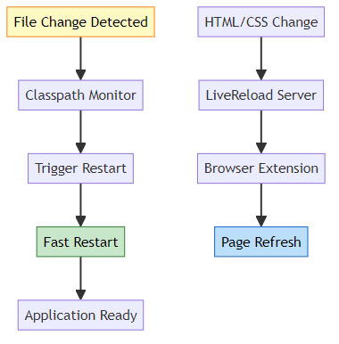
Production Note: DevTools is automatically disabled in production (when running as packaged JAR).

Q4: Explain the complete CRUD flow for editing a product
Answer:
Step-by-Step Edit Flow:
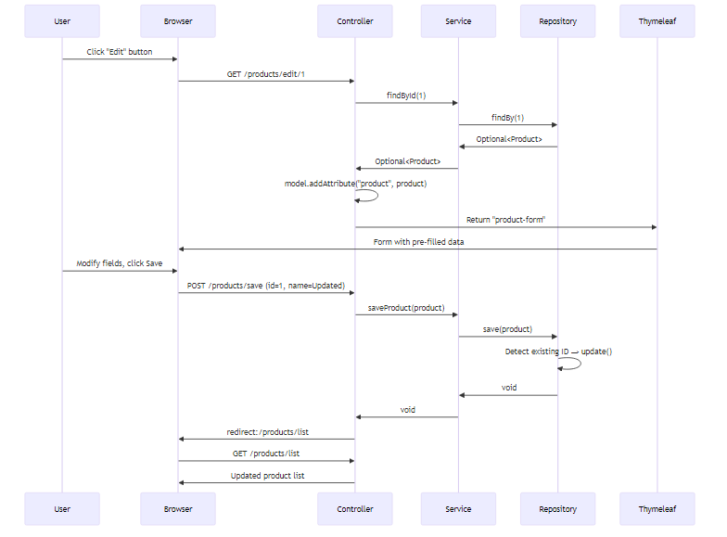
Code Flow:
- User clicks Edit:
<a th:href="@{/products/edit/{id}(id=${product.id})}">Edit</a>
<!-- Generates: /products/edit/1 -->
- Controller receives request:
@GetMapping("/edit/{id}")
public String showEditForm(@PathVariable Long id, Model model) {
Optional<Product> product = productService.findById(id);
model.addAttribute("product", product.get());
return "product-form"; // Same form as Add
}
- Form pre-filled with data:
<form th:action="@{/products/save}" th:object="${product}" method="post">
<input type="hidden" th:field="*{id}" /> <!-- ID=1 -->
<input type="text" th:field="*{name}" /> <!-- Pre-filled -->
<input type="number" th:field="*{price}" /> <!-- Pre-filled -->
</form>
- User submits form:
@PostMapping("/save")
public String saveProduct(@ModelAttribute Product product) {
// product.id = 1 (from hidden field)
productService.saveProduct(product);
return "redirect:/products/list";
}
- Repository detects existing ID:
public void save(Product product) {
if (product.getId() == null) {
product.setId(idCounter++); // New product
productList.add(product);
} else {
update(product); // Existing product - UPDATE
}
}

Q5: Why use @ModelAttribute instead of HttpServletRequest?
Answer:
Without @ModelAttribute (Manual Binding):
@PostMapping("/save")
public String saveProduct(HttpServletRequest request) {
String name = request.getParameter("name");
String priceStr = request.getParameter("price");
String quantityStr = request.getParameter("quantity");
// Manual type conversion
double price = Double.parseDouble(priceStr);
int quantity = Integer.parseInt(quantityStr);
// Manual object creation
Product product = new Product();
product.setName(name);
product.setPrice(price);
product.setQuantity(quantity);
productService.saveProduct(product);
return "redirect:/products/list";
}
With @ModelAttribute (Automatic Binding):
@PostMapping("/save")
public String saveProduct(@ModelAttribute Product product) {
// product object already populated!
productService.saveProduct(product);
return "redirect:/products/list";
}
Benefits:
Feature | Manual | @ModelAttribute
Code Lines | 15+ | 3
Type Conversion | Manual | Automatic
Null Handling | Manual | Automatic
Validation | Manual | @Valid support
Maintainability | Low | High
How @ModelAttribute works:
1. Spring detects @ModelAttribute annotation
2. Creates new Product() instance
3. Reads form parameters (name, price, quantity)
4. Calls setters: product.setName(), product.setPrice()
5. Performs type conversion (String → double, String → int)
6. Passes populated object to controller method

Q6: What is the difference between @Controller and @RestController?
Answer:
@Controller:
@Controller
public class ProductController {
@GetMapping("/list")
public String listProducts(Model model) {
model.addAttribute("products", productDao.findAll());
return "product-list"; // Returns view name (HTML)
}
}
- Returns view name (String)
- Thymeleaf/JSP renders HTML
- Used for web pages
@RestController:
@RestController
public class ProductRestController {
@GetMapping("/api/products")
public List<Product> listProducts() {
return productDao.findAll(); // Returns JSON
}
}
- Returns data directly (JSON/XML)
- No view rendering
- Used for REST APIs
Equivalent Code:
@Controller
public class ProductController {
@GetMapping("/api/products")
@ResponseBody // Converts return value to JSON
public List<Product> listProducts() {
return productDao.findAll();
}
}
// @RestController = @Controller + @ResponseBody on every method

Q7: How does Thymeleaf th:field work?
Answer:
th:field does 3 things:
- Generates name attribute
- Generates id attribute
- Pre-fills value (in edit mode)
Example:
<form th:object="${product}">
<input type="text" th:field="*{name}" />
</form>
Generated HTML (Add mode):
<input type="text" id="name" name="name" value="" />
Generated HTML (Edit mode with product.name=“Laptop”):
<input type="text" id="name" name="name" value="Laptop" />
How it works:
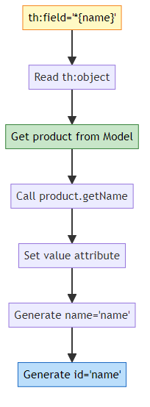
Binding on Submit:
1. User submits form
2. Browser sends: name=Laptop&price=50000
3. Spring reads name attribute
4. Calls product.setName("Laptop")
5. Calls product.setPrice(50000)
6. Passes to controller method

Q8: Why is ProductDao a singleton? Is it thread-safe?
Answer:
Singleton by Default:
@Repository
public class ProductDao {
private List<Product> productList = new ArrayList<>();
// One instance per application
}
Why Singleton? - Spring beans are singleton by default - One instance shared across all requests - Maintains data consistency (same ArrayList for all users)
Is it Thread-Safe? NO!
Problem:
// User 1 (Thread 1)
productDao.save(product1); // Modifying ArrayList
// User 2 (Thread 2) - Same time
productDao.save(product2); // Modifying same ArrayList
// Result: Race condition, data corruption possible
Solution for Production:
Option 1: Synchronized Methods
@Repository
public class ProductDao {
private List<Product> productList = new ArrayList<>();
public synchronized void save(Product product) {
// Only one thread at a time
}
}
Option 2: ConcurrentHashMap
@Repository
public class ProductDao {
private Map<Long, Product> productMap = new ConcurrentHashMap<>();
// Thread-safe by design
}
Option 3: Database (Best)
@Repository
public interface ProductDao extends JpaRepository<Product, Long> {
// Database handles concurrency with transactions
}

Q9: Explain redirect vs forward in Spring MVC
Answer:
Redirect:
return "redirect:/products/list";
- Browser receives 302 status
- Browser makes NEW request to /products/list
- URL changes in browser
- Model data is lost
- Used after POST (PRG pattern)
Forward:
return "forward:/products/list";
- Server-side forward
- Same request object
- URL doesn’t change
- Model data preserved
- Used for internal routing
Visual Difference:
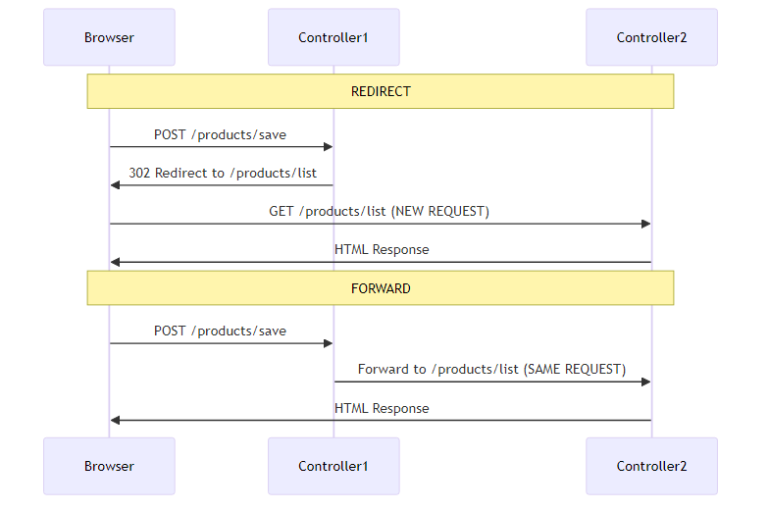
Post-Redirect-Get (PRG) Pattern:
@PostMapping("/save")
public String saveProduct(@ModelAttribute Product product) {
productService.saveProduct(product);
return "redirect:/products/list"; // Prevents duplicate submission
}
Why redirect after POST? - Prevents duplicate form submission on browser refresh - Separates POST action from GET display - Industry standard pattern

Q10: How would you migrate this project to use a database?
Answer:
Step 1: Add Database Dependency
<dependency>
<groupId>com.mysql</groupId>
<artifactId>mysql-connector-j</artifactId>
</dependency>
Step 2: Configure application.properties
spring.datasource.url=jdbc:mysql://localhost:3306/productdb
spring.datasource.username=root
spring.datasource.password=password
spring.jpa.hibernate.ddl-auto=update
spring.jpa.show-sql=true
Step 3: Add @Entity to Product
@Entity
@Table(name = "products")
public class Product {
@Id
@GeneratedValue(strategy = GenerationType.IDENTITY)
private Long id;
@Column(nullable = false)
private String name;
private double price;
private int quantity;
// Constructors, getters, setters
}
Step 4: Change ProductDao to JpaRepository
@Repository
public interface ProductDao extends JpaRepository<Product, Long> {
// All CRUD methods provided by Spring Data JPA
// No need for manual implementation!
}
Step 5: Update ProductService
@Service
public class ProductService {
@Autowired
private ProductDao productDao;
public void saveProduct(Product product) {
productDao.save(product); // JPA handles INSERT/UPDATE
}
public Optional<Product> findById(Long id) {
return productDao.findById(id); // JPA query
}
public List<Product> getAllProducts() {
return productDao.findAll(); // JPA query
}
public void delete(Long id) {
productDao.deleteById(id); // JPA delete
}
}
Step 6: Remove Manual Logic
// DELETE THIS:
private List<Product> productList = new ArrayList<>();
private Long idCounter = 1L;
// DELETE update() method
// DELETE manual save logic
// Spring Data JPA handles everything!
Benefits After Migration:
Feature | Before (ArrayList) | After (Database)
Persistence | Lost on restart | Permanent
Concurrency | Not thread-safe | Thread-safe
Transactions | No | Yes (@Transactional)
Queries | Manual loops | SQL/JPQL
Scalability | Single instance | Multiple instances

🎉 Congratulations!
You’ve mastered Spring Boot CRUD with Thymeleaf
Ready for production-level web applications

📊 Project Statistics:
11 Sections • 12 Mermaid Diagrams • 10 Interview Questions
Complete CRUD • Thymeleaf Templates • In-Memory Storage
Production Patterns • Migration Guide • Best Practices

© 2026 Avinash Dhanuka | Spring Boot Learning Series
Day 13: Spring Boot CRUD with Thymeleaf

