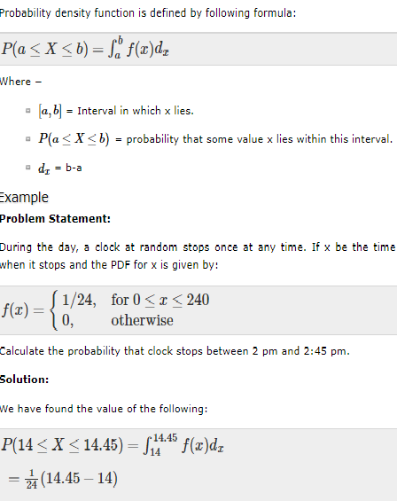



What is the Normal Distribution?

The **normal distribution** refers to a family of [continuous probability distributions](http://stattrek.com/Help/Glossary.aspx?Target=Continuous%20probability%20distribution) described by the normal equation.

The Normal Equation

The normal distribution is defined by the following equation:

**Normal equation.** The value of the random variable *Y* is:

Y = { 1/[ σ * sqrt(2π) ] } * e-(x - μ)2/2σ2

where *X* is a normal random variable, μ is the mean, σ is the standard deviation, π is approximately 3.14159, and *e* is approximately 2.71828.

The random variable *X* in the normal equation is called the **normal random variable**. The normal equation is the [probability density function](http://stattrek.com/Help/Glossary.aspx?Target=Probability%20density%20function) for the normal distribution.

The Normal Curve

The graph of the normal distribution depends on two factors - the mean and the standard deviation. The mean of the distribution determines the location of the center of the graph, and the standard deviation determines the height and width of the graph. When the standard deviation is large, the curve is short and wide; when the standard deviation is small, the curve is tall and narrow. All normal distributions look like a symmetric, bell-shaped curve, as shown below.

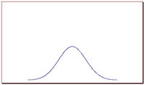             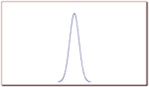

The curve on the left is shorter and wider than the curve on the right, because the curve on the left has a bigger standard deviation.

Probability and the Normal Curve

The normal distribution is a continuous probability distribution. This has several implications for probability.

* The total area under the normal curve is equal to 1.
* The probability that a normal random variable *X* equals any particular value is 0.
* The probability that *X* is greater than *a* equals the area under the normal curve bounded by *a*and plus infinity (as indicated by the *non-shaded* area in the figure below).
* The probability that *X* is less than *a* equals the area under the normal curve bounded by *a* and minus infinity (as indicated by the *shaded* area in the figure below).

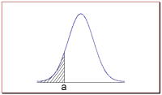

Additionally, every normal curve (regardless of its mean or standard deviation) conforms to the following "rule".

* About 68% of the area under the curve falls within 1 standard deviation of the mean.
* About 95% of the area under the curve falls within 2 standard deviations of the mean.
* About 99.7% of the area under the curve falls within 3 standard deviations of the mean.

Collectively, these points are known as the **empirical rule** or the **68-95-99.7 rule**. Clearly, given a normal distribution, most outcomes will be within 3 standard deviations of the mean.

To find the probability associated with a normal random variable, use a graphing calculator, an online normal distribution calculator, or a normal distribution table. In the examples below, we illustrate the use of Stat Trek's [Normal Distribution Calculator](http://stattrek.com/Tables/Normal.aspx), a free tool available on this site. In the next lesson, we demonstrate the use of normal distribution tables.

Normal Distribution Calculator

The normal calculator solves common statistical problems, based on the normal distribution. The calculator computes cumulative probabilities, based on three simple inputs. Simple instructions guide you to an accurate solution, quickly and easily. If anything is unclear, frequently-asked questions and sample problems provide straightforward explanations. The calculator is free. It can be found under the Stat Tables tab, which appears in the header of every Stat Trek web page.

|  |
| --- |
| [Normal Calculator](http://stattrek.com/Tables/Normal.aspx) |

**Example 1**  
  
An average light bulb manufactured by the Acme Corporation lasts 300 days with a standard deviation of 50 days. Assuming that bulb life is normally distributed, what is the probability that an Acme light bulb will last at most 365 days?

*Solution:* Given a mean score of 300 days and a standard deviation of 50 days, we want to find the cumulative probability that bulb life is less than or equal to 365 days. Thus, we know the following:

* The value of the normal random variable is 365 days.
* The mean is equal to 300 days.
* The standard deviation is equal to 50 days.

We enter these values into the Normal Distribution Calculator and compute the cumulative probability. The answer is: P( X < 365) = 0.90. Hence, there is a 90% chance that a light bulb will burn out within 365 days.

**Example 2**  
  
Suppose scores on an IQ test are normally distributed. If the test has a mean of 100 and a standard deviation of 10, what is the probability that a person who takes the test will score between 90 and 110?

*Solution:* Here, we want to know the probability that the test score falls between 90 and 110. The "trick" to solving this problem is to realize the following:

P( 90 < *X* < 110 ) = P( X < 110 ) - P( X < 90 )

We use the Normal Distribution Calculator to compute both probabilities on the right side of the above equation.

* To compute P( X < 110 ), we enter the following inputs into the calculator: The value of the normal random variable is 110, the mean is 100, and the standard deviation is 10. We find that P( X < 110 ) is 0.84.
* To compute P( X < 90 ), we enter the following inputs into the calculator: The value of the normal random variable is 90, the mean is 100, and the standard deviation is 10. We find that P( X < 90 ) is 0.16.

We use these findings to compute our final answer as follows:

P( 90 < *X* < 110 ) = P( X < 110 ) - P( X < 90 )  
P( 90 < *X* < 110 ) = 0.84 - 0.16  
P( 90 < *X* < 110 ) = 0.68

Thus, about 68% of the test scores will fall between 90 and 110.

In statistics, kernel density estimation (KDE) is a non-parametric way to estimate the probability density function of a random variable.

Kernel density estimation is a fundamental data smoothing problem where inferences about the population are made, based on a finite data sample.

In statistics, kernel density estimation (KDE) is a non-parametricway to estimate the probability density function of a random variable. Kernel density estimation is a fundamental data smoothing problem where inferences about the population are made, based on a finite data sample.

