**Docker:**

**# To install Docker**

$ yum install docker

**# To download docker image**

$ docker pull Ubuntu

**# Check docker images**

$ docker images

**# Build docker image/app**

$ docker build -t IMAGE_NAME ( Path of the app file )

**# Check container**

$ docker ps –l

$ docker container ls

**# Run container**

$ docker run –it CONTAINER_NAME /bin/bash

$ docker run –itd Image_Name /bin/bash ( It makes the container and run it, also container runs in background)

$ docker attach container_name

**# Attach running docker** ( Need to start Docker container)

$ docker attach CONTAINER_ID

**# Login into Docker hub repo**

$ docker login

**# Tag the image**

$ docker tag image username/repository:tag

Ex: docker tag friendlyhello 37318918/get-started:part2

**# Start/Stop docker container**

$ docker container start CONTAINER_ID

$ docker container stop CONTAINER_ID

**# Publish the image**

$docker push username/repository:tag

**# Pull and run the image from remote repository**

$ docker run –p 4000:80 37318918/get-started:part2

**Service:**

**# Launch stack**

$ docker stack deploy –c docker-compose.yml getstartedlab

**# Check docker services**

$ docker service ls

**# Inspect the task**

$ docker inspect

**# Command to list container**

$ docker container ls –q

**# Remove stack**

$ docker stack rm getstartedlab

**Swarm:**

**# Swarm initialization**

$ docker swarm init --advertise-addr 10.0.0.xx

**# Deploy the app on swarm manager**

$ docker stack deploy –c docker-compose.yml getstartedlab

$ docker stack ps getstartedlab

**# take don node sarm from the manager**

$ docker swarm leave –force

**Docker Engine:**

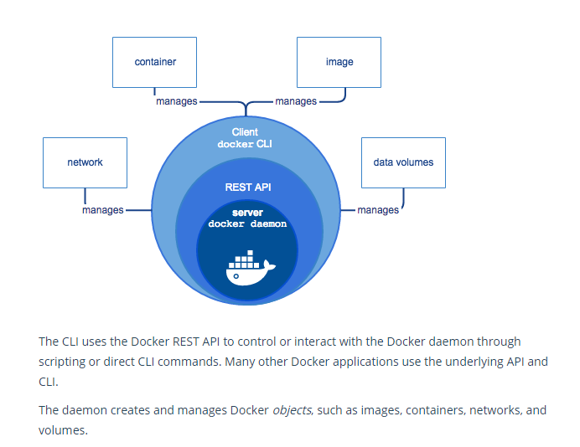

**Docker Architecture:**  
  
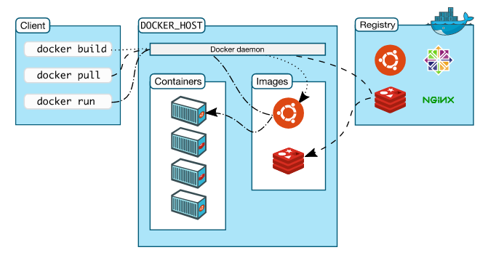

Note: Docker written in **GO** language.

**Docker container Networking:**

Docker creates three network automatically.

$ docker network ls

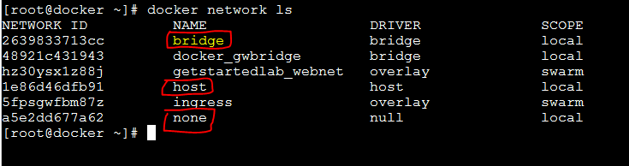

Note: By default Docker container connects Docker bridge network.

**Default bridge network:**

**# Check default bridge network, also shows containers network**

$ docker network inspect bridge



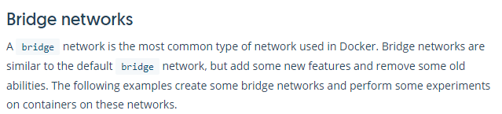

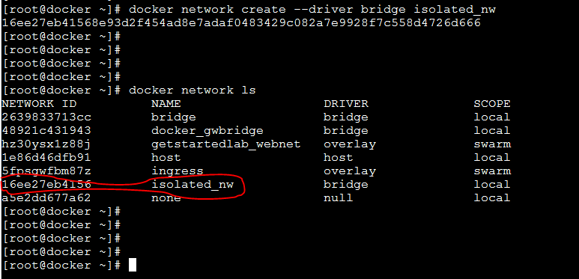

After you create the network, you can launch container using it.

$ docker run --network=isolated_nw –itd –name=Container_Name or ID /bin/bash

