KVM (Kernel-based Virtual Machine)

KVM Features:

Over committing: Allocating more virtualized CPUs or memory than the available resources on the system.

Thin Provisioning: Allows the allocation of flexible storage and optimizes the available space for every guest virtual machine.

Disk I/O throttling: Provides the ability to set a limit on disk I/O request sent from virtual machine to the host machine.

Automatic NUMA balancing: Improve the performance of the application running on NUMA hardware systems.

Virtual CPU hot add capability: Provides the ability to increase processing power as needed on running virtual machines, without downtime.

* Make sure your system has the hardware virtualization extension.

For Intel based host verify ‘VMX’ extension.



*Note: If there is no output make sure the virtualization extensions is enabled in BIOS. Verify that KVM modules are loaded in the kernel “It should be loaded by default”.



*System should be updated

# yum update

* Make sure Selinux be in permissive mode.

# setenforce 0

Step 1: KVM installation and deployment.

1. Install qemu-kvm and qemu-img packages at first.

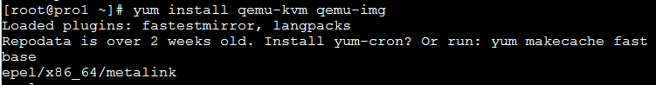

1. Minimum requirements to deploy virtual platform.

* **Virt-manager** provides GUI tool to administrate your virtual machines

* **libvirt-client** provides a CL tool to administrative your virtual ENV, called “VIRSH”.

* **Virt-Install** provides the command “virt-install” to create your VM from CLI.

* **libvirt** provides the server and host side libraries for interacting with hypervisor and host systems. 

3. For RHEL/CENTOS7 also having additional package group.



1. Virtualization daemon which manage all of the platform is “libvirtd” restart and check status.

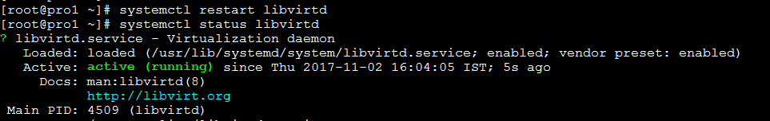

1. Create VMs using KVM.

