**Name: Avinash singh**

**Roll no: AC-1255**

**Course Name: B.Sc. Hons Computer Science**

**Subject: Internet Technologies**

**Code:**

const http = require('http');

*// Create a server object*

const server = http.createServer((req, res) => {

 res.statusCode = 200;

 res.setHeader('Content-Type', 'text/html');

*// Write a response to client*

 res.write('Hello World this is a nodejs server on browser\n');

 res.end();

});

server.listen(10000, () => {

 console.log('Server is running at port 10000');

});

**RUN:**

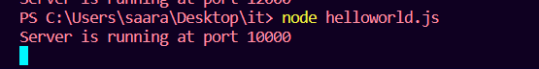

OUTPUT:

