**Name: Avinash singh**

**Roll: AC-1255**

**Internet Technologies**

**ASSIGNMENT**

**Practical** **-2**. With help of ping, check if you are connected to other systems of your network and find the route to connect to that system using tracert. List all the processes which are using ports for TCP protocol.

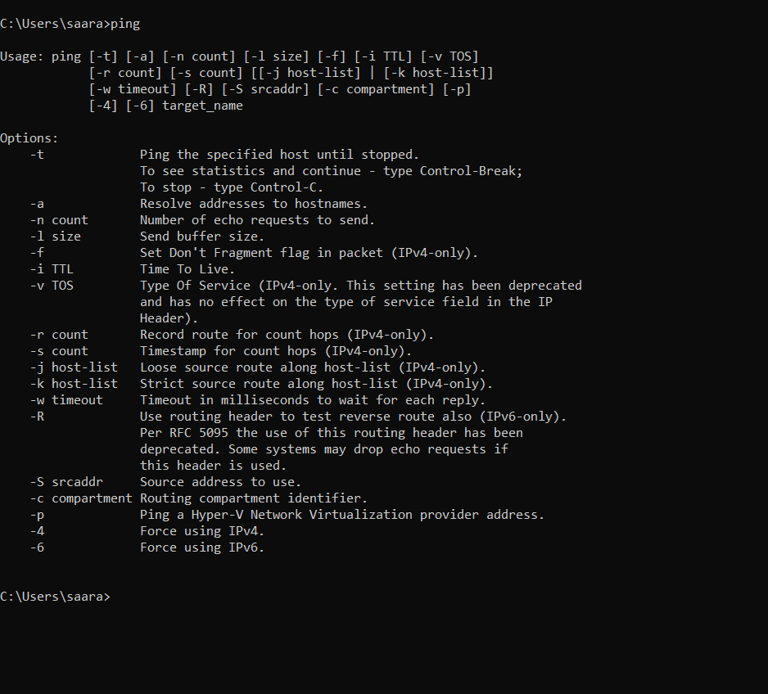

tracert 10.135.2.150:

