Name: Avinash singh

Roll number: AC-1255

Internet Technologies, 5th Semester

Q5. Create an HTML page with a paragraph written on it and under which 9 buttons are placed in a 3X3 grid. The first row is for buttons labeled with colors names Red, Green, and Blue, the second row with numbers 10, 20, 30, and the third row with different font names. Click event of each of the buttons should make the appropriate change in the style of paragraph

<!DOCTYPE html>

<html lang="en">

<head>

    <meta charset="UTF-8">

    <meta http-equiv="X-UA-Compatible" content="IE=edge">

    <meta name="viewport" content="width=device-width, initial-scale=1.0">

    <title>Practical-Q5</title>

    <link rel="stylesheet" href="Q5.css">

    <script src="./Q5.js" defer></script>

</head>

<body>

    <div class="container">

        <h1>Hey there, Its Avinash here. Hope you are doing Great</h1>

            <p id="mypara">

                Lorem ipsum dolor sit amet, consectetur adipisicing elit. Quaerat laborum illo, odio cupiditate distinctio odit reprehenderit sit fugiat necessitatibus corporis voluptatibus esse est totam. Ipsum nam error exercitationem, eum fugit, quia suscipit dolorum sed nostrum facere ducimus perspiciatis? Excepturi cupiditate eveniet debitis hic laboriosam quas?

                Lorem ipsum dolor sit amet consectetur adipisicing elit. Ex amet praesentium iusto consectetur dolorem eos necessitatibus officia odit, id qui. Eum sapiente est distinctio! Totam facere officia ex harum sequi quaerat ad temporibus sapiente. Dicta sint, itaque soluta provident voluptas id sit quo consectetur illum.

            </p>

        <ul class="unorder">

            <li id="blue" >Blue</li>

            <li id="red">Red</li>

            <li id="green">Green</li>

            <li id="ten">10</li>

            <li id="twenty">20</li>

            <li id="thirty">30</li>

            <li id="font1">Monospace</li>

            <li id="font2">Bold</li>

            <li id="font3">Sans-serif</li>

        </ul>

    </div>

</body>

</html>

Q5.js

var Blue = document.getElementById("blue");

var red = document.getElementById("red");

var green = document.getElementById("green");

var ten = document.getElementById("ten");

var twenty = document.getElementById("twenty");

var thirty = document.getElementById("thirty");

var font1 = document.getElementById("font1");

var font2 = document.getElementById("font2");

var font3 = document.getElementById("font3");

Blue.addEventListener("click", myblue);

red.addEventListener("click", myred);

green.addEventListener("click", mygreen);

ten.addEventListener("click", myten);

twenty.addEventListener("click", mytwenty);

thirty.addEventListener("click", mythirty);

font1.addEventListener("click", myfont1);

font2.addEventListener("click", myfont2);

font3.addEventListener("click", myfont3);

var mypara = document.getElementById("mypara");

function myblue() {

    mypara.style.backgroundColor = "blue";

}

function myred() {

    mypara.style.backgroundColor = "red";

}

function mygreen() {

    mypara.style.backgroundColor = "green";

}

function myten() {

    mypara.style.fontSize = "10px";

}

function mytwenty() {

    mypara.style.fontSize = "20px";

}

function mythirty() {

    mypara.style.fontSize = "30px";

}

function myfont1() {

    mypara.style.fontFamily = "cursive";

}

function myfont2() {

    mypara.style.fontFamily = "sans-serif";

}

function myfont3() {

    mypara.style.fontFamily = "Charcoal";

}

Q5.css

body {

    background-color: #08AEEA;

    background-image: linear-gradient(0deg, #08AEEA 0%, #2AF598 100%);

}

.container {

    text-align: center;

}

.unorder {

    display: grid;

    grid-template-columns: auto auto auto;

    background-color: #2196F3;

    padding: 10px;

    list-style: none;

    gap: 14px;

}

li {

    background-color: rgba(255, 255, 255, 0.8);

    border: 1px solid rgb(60, 39, 39);

    border-radius: 12px;

    padding: 25px;

    font-size: 30px;

    text-align: center;

}

.para {

    background-color: #2196F3;

    padding: 54px;

    border-radius: 12px;

    background-color: blue;

}

li:hover {

    border: #2AF598;

}

OUTPUT:

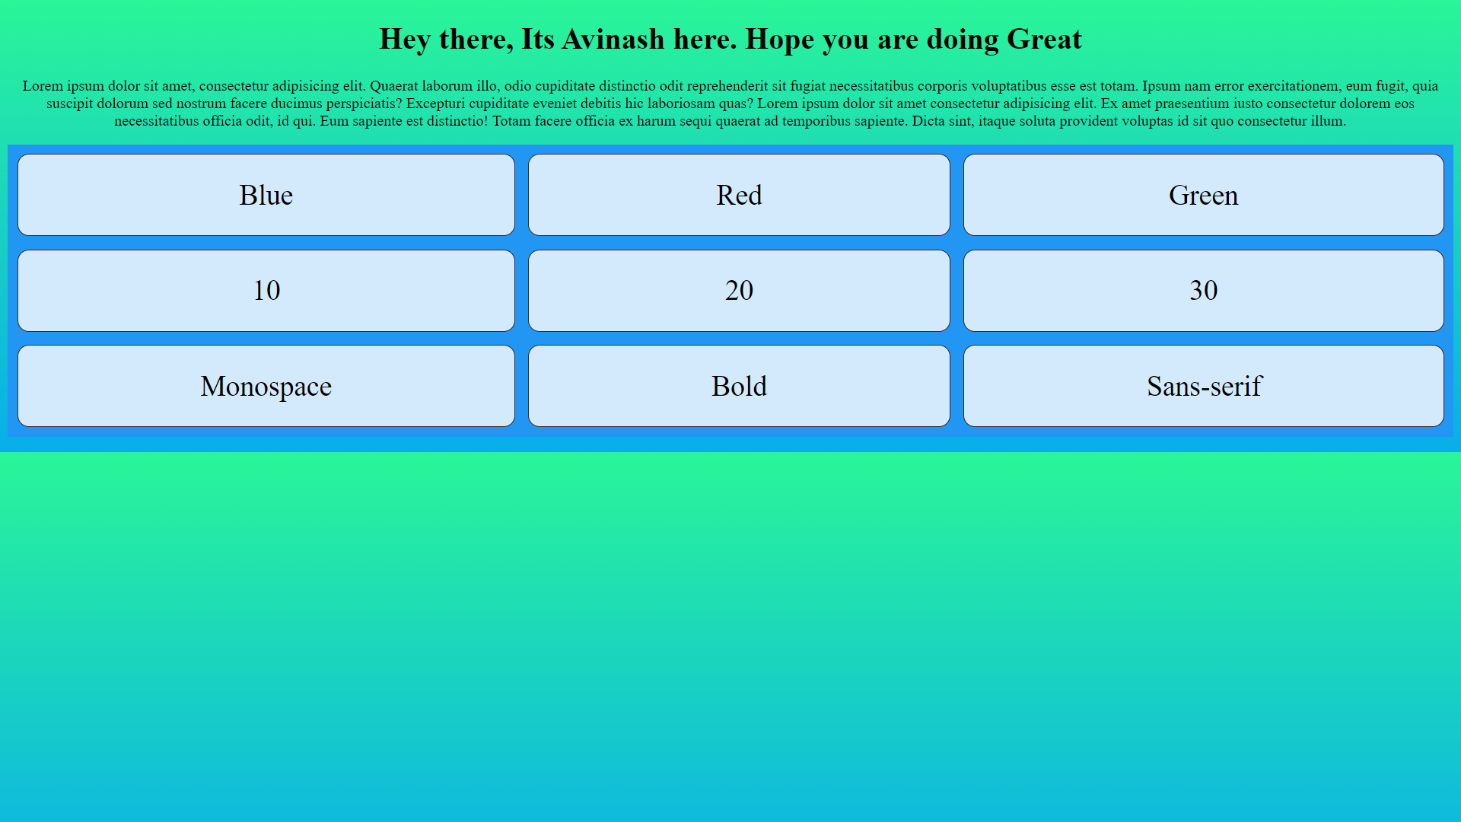

On Click Blue

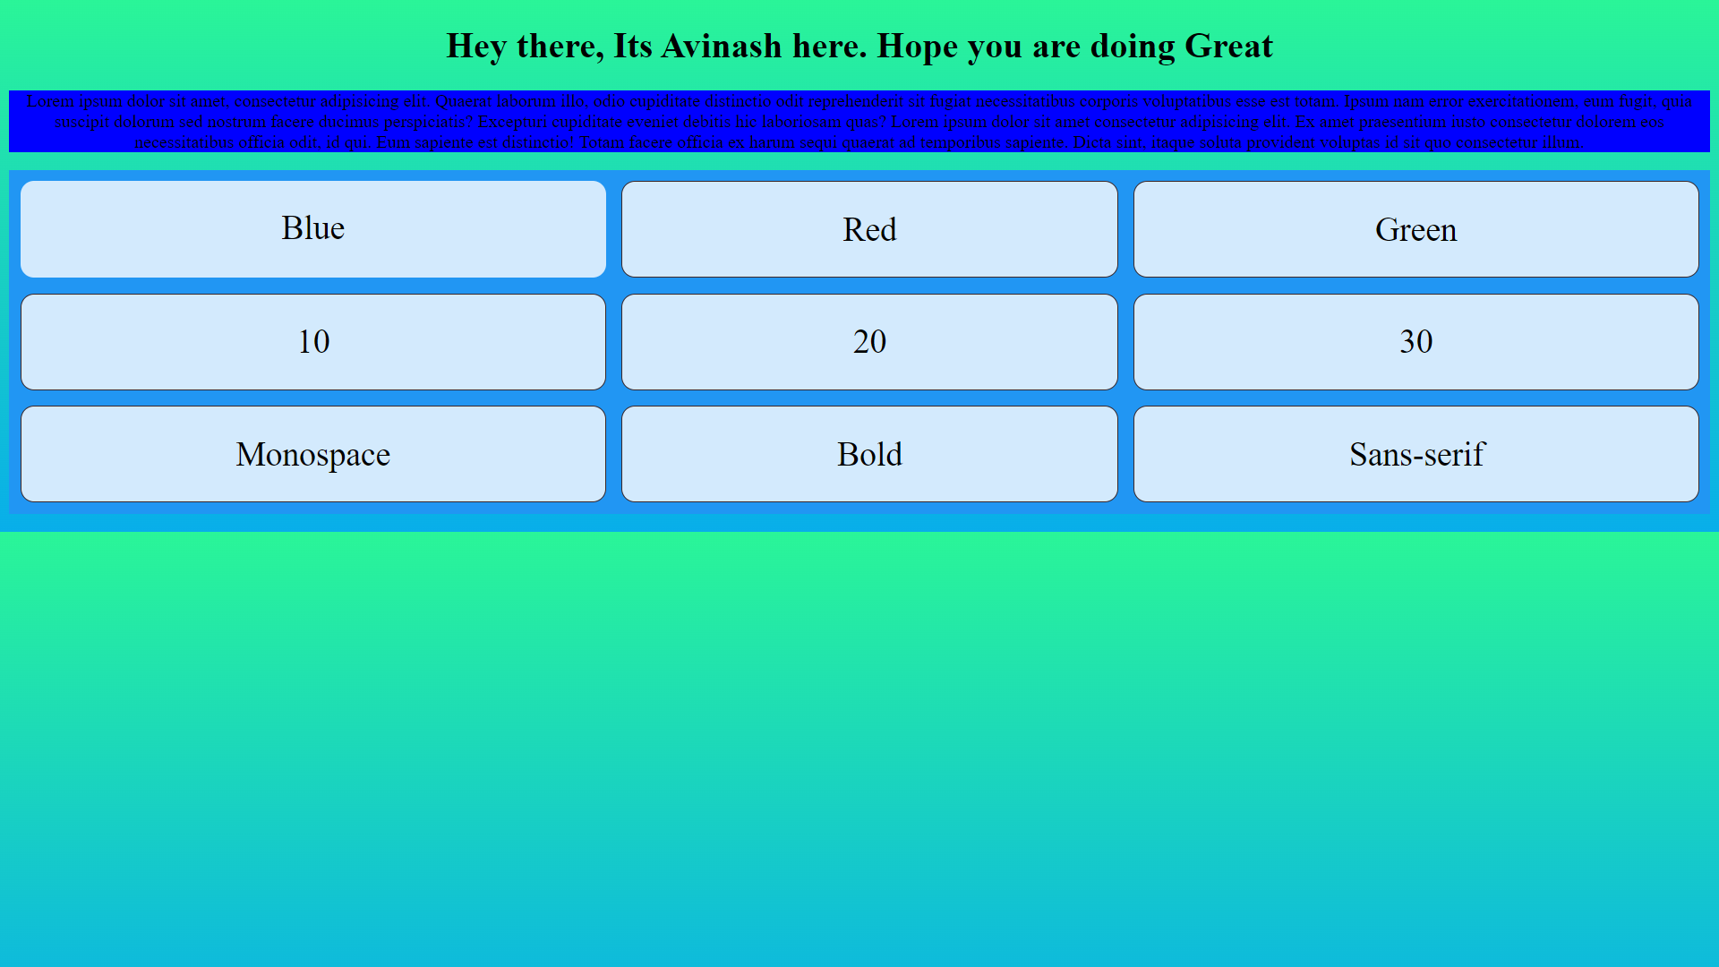

Red

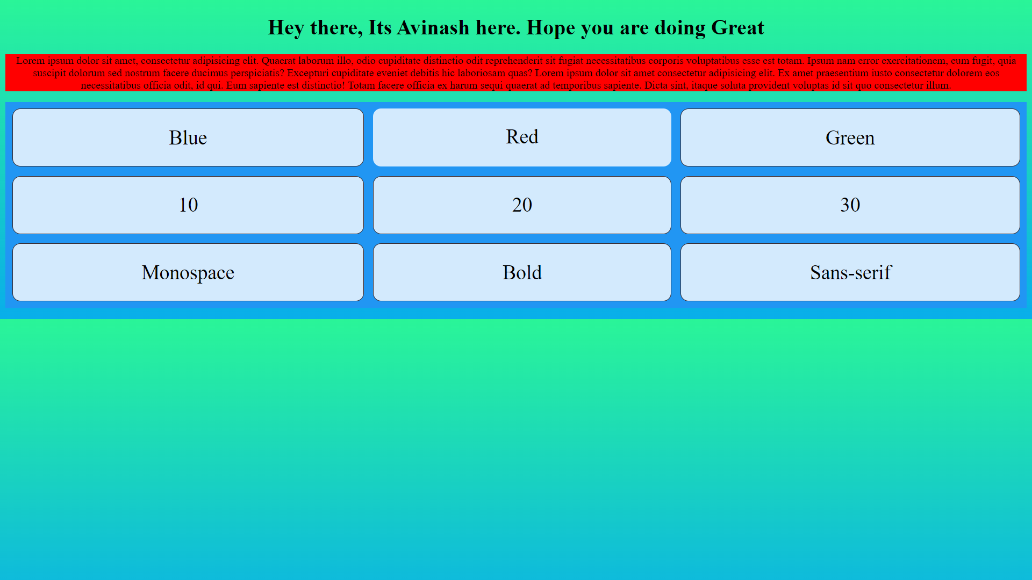

Green

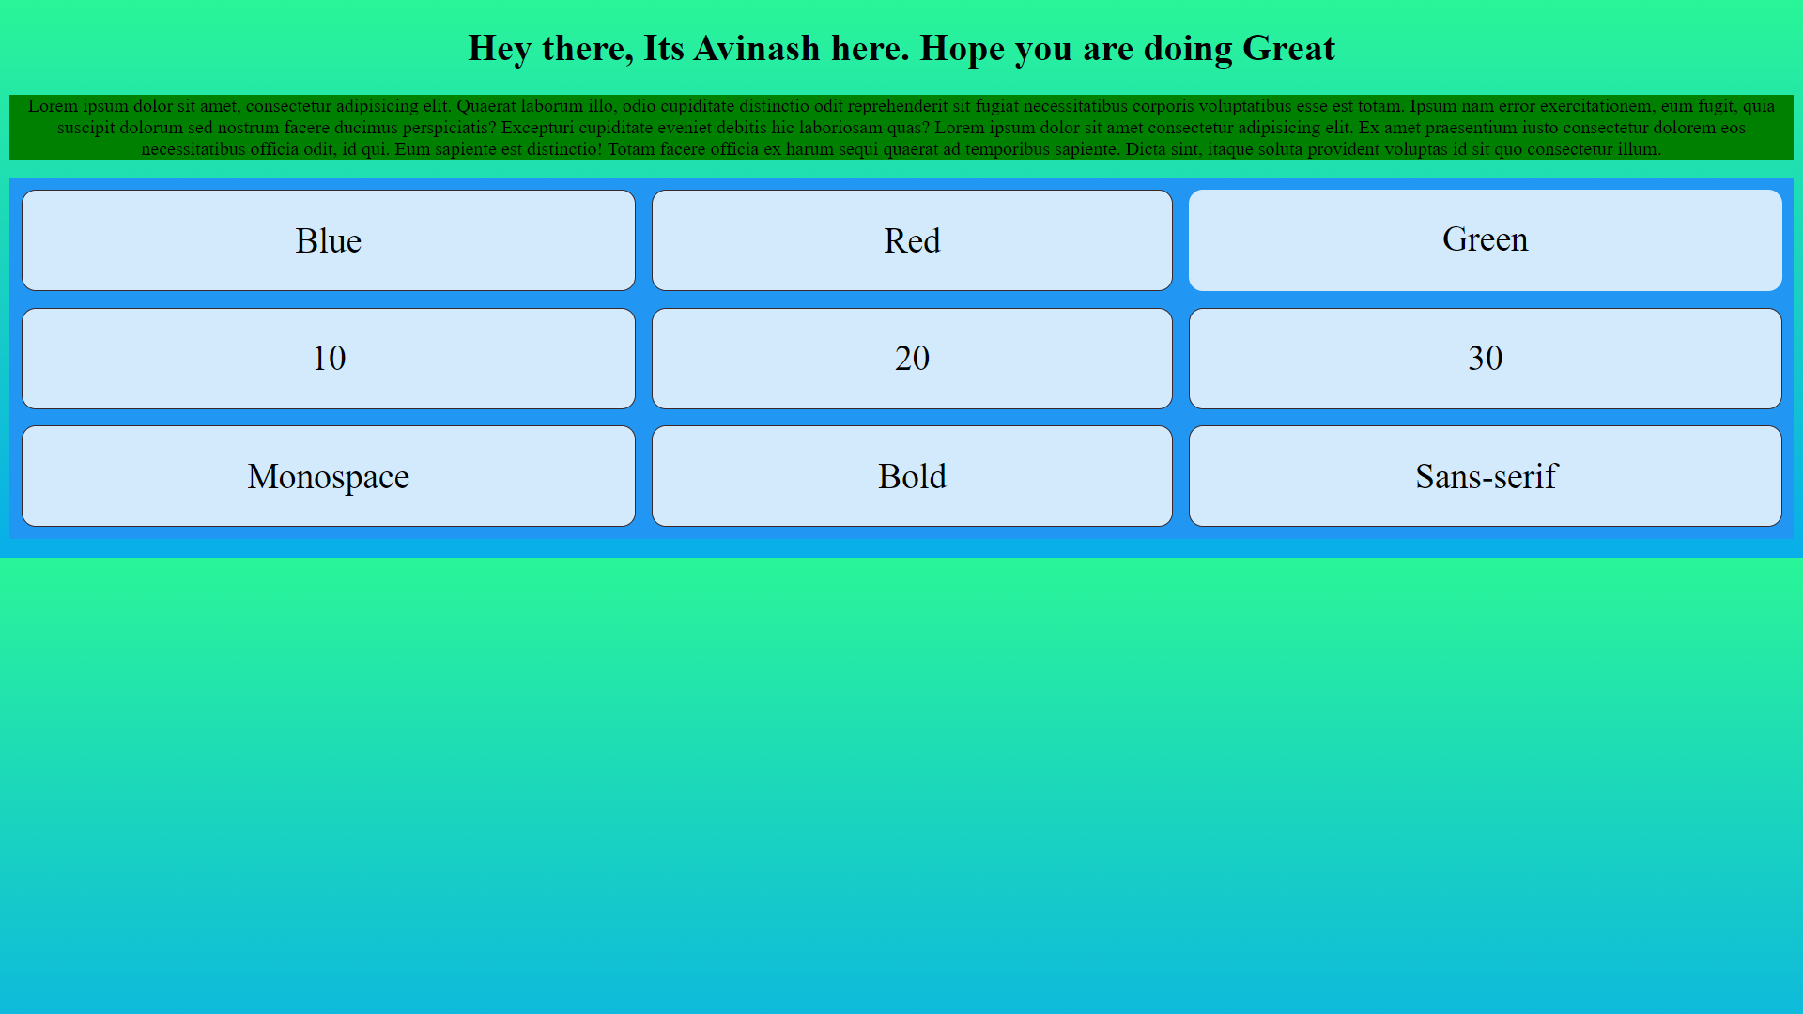

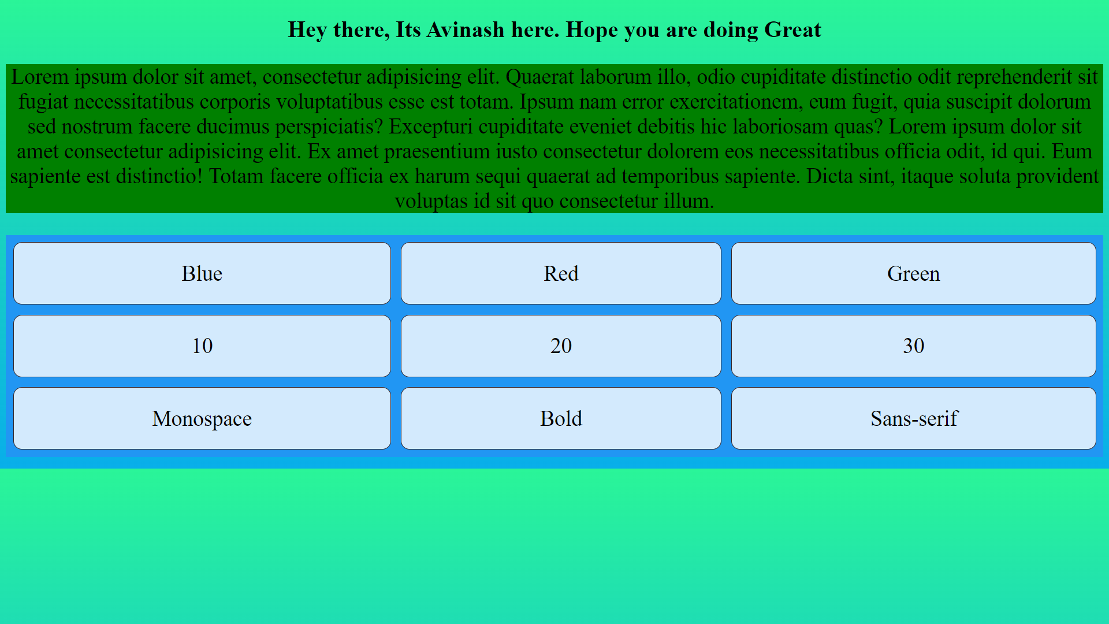 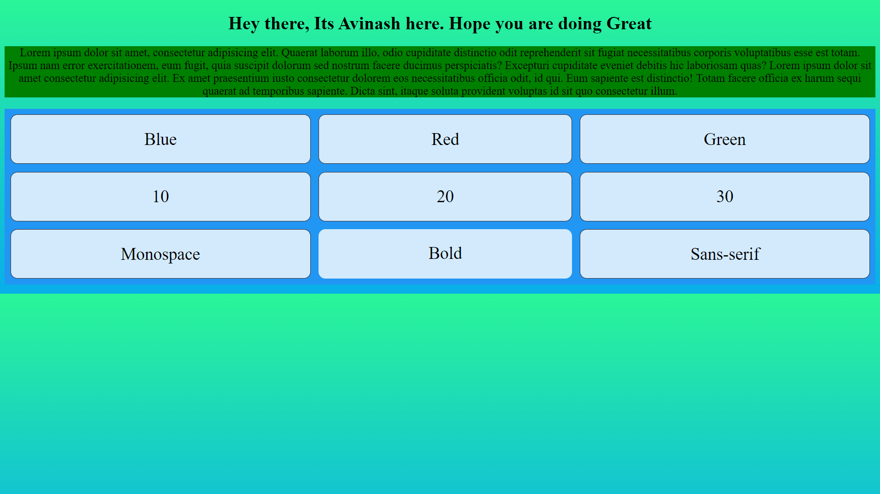 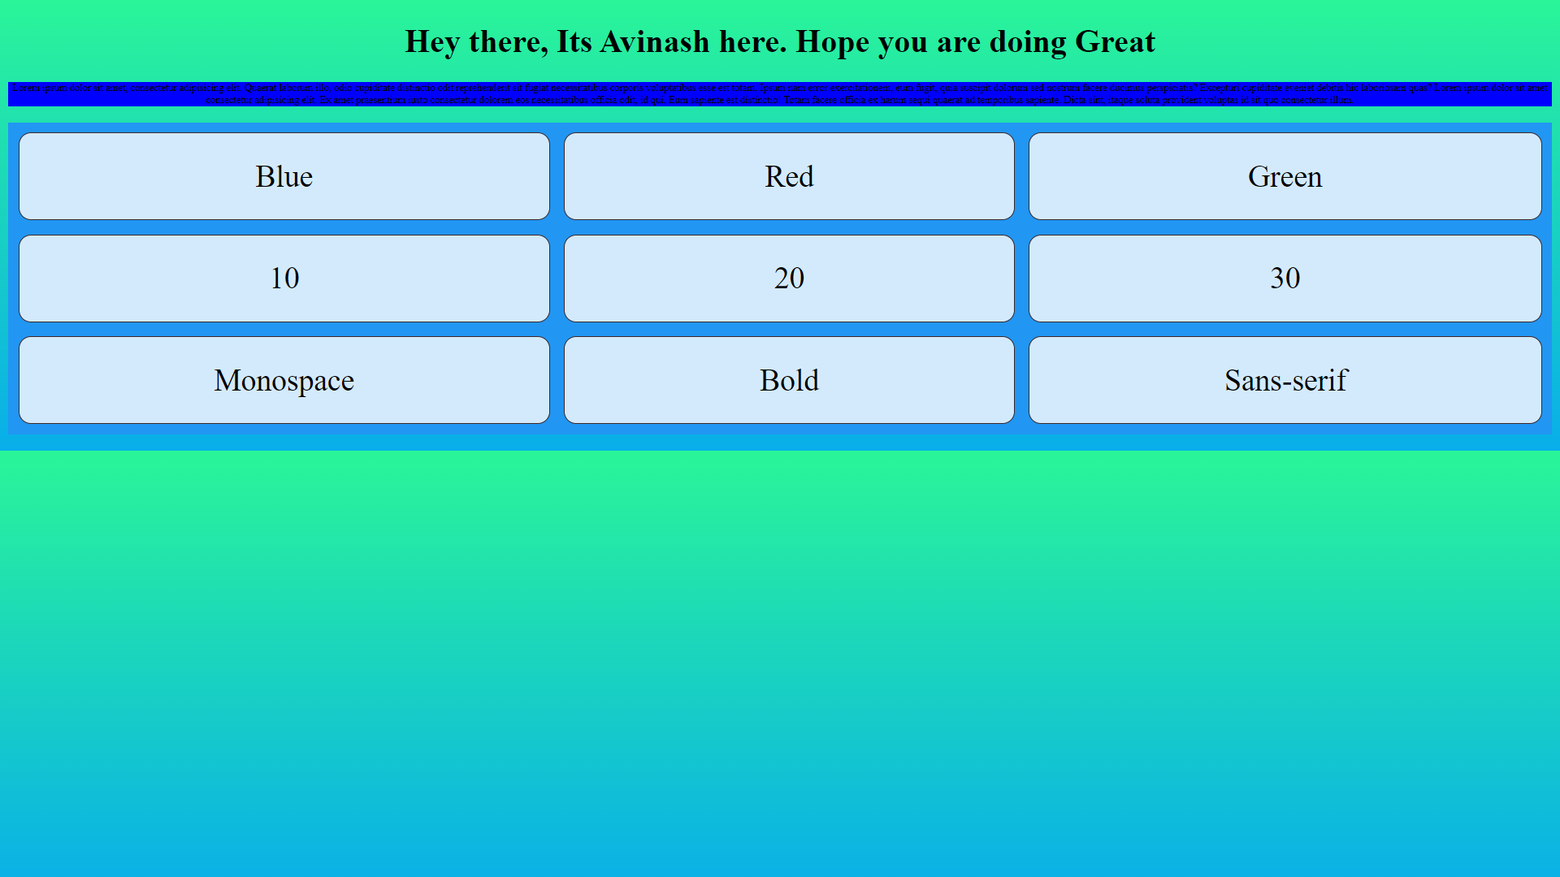

Monospace

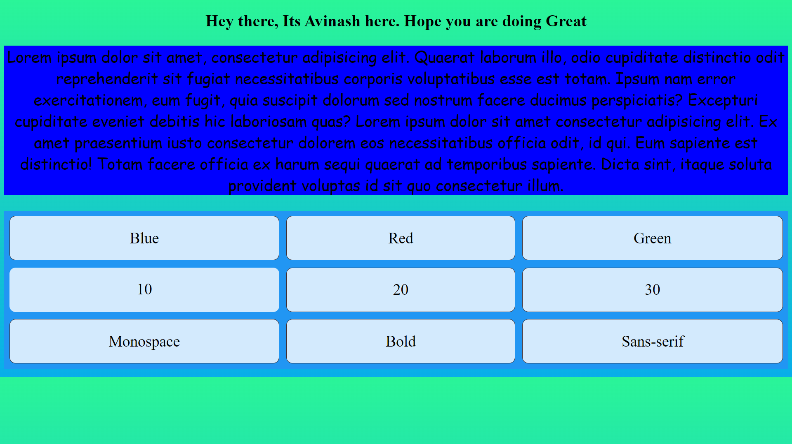

Sans-serif

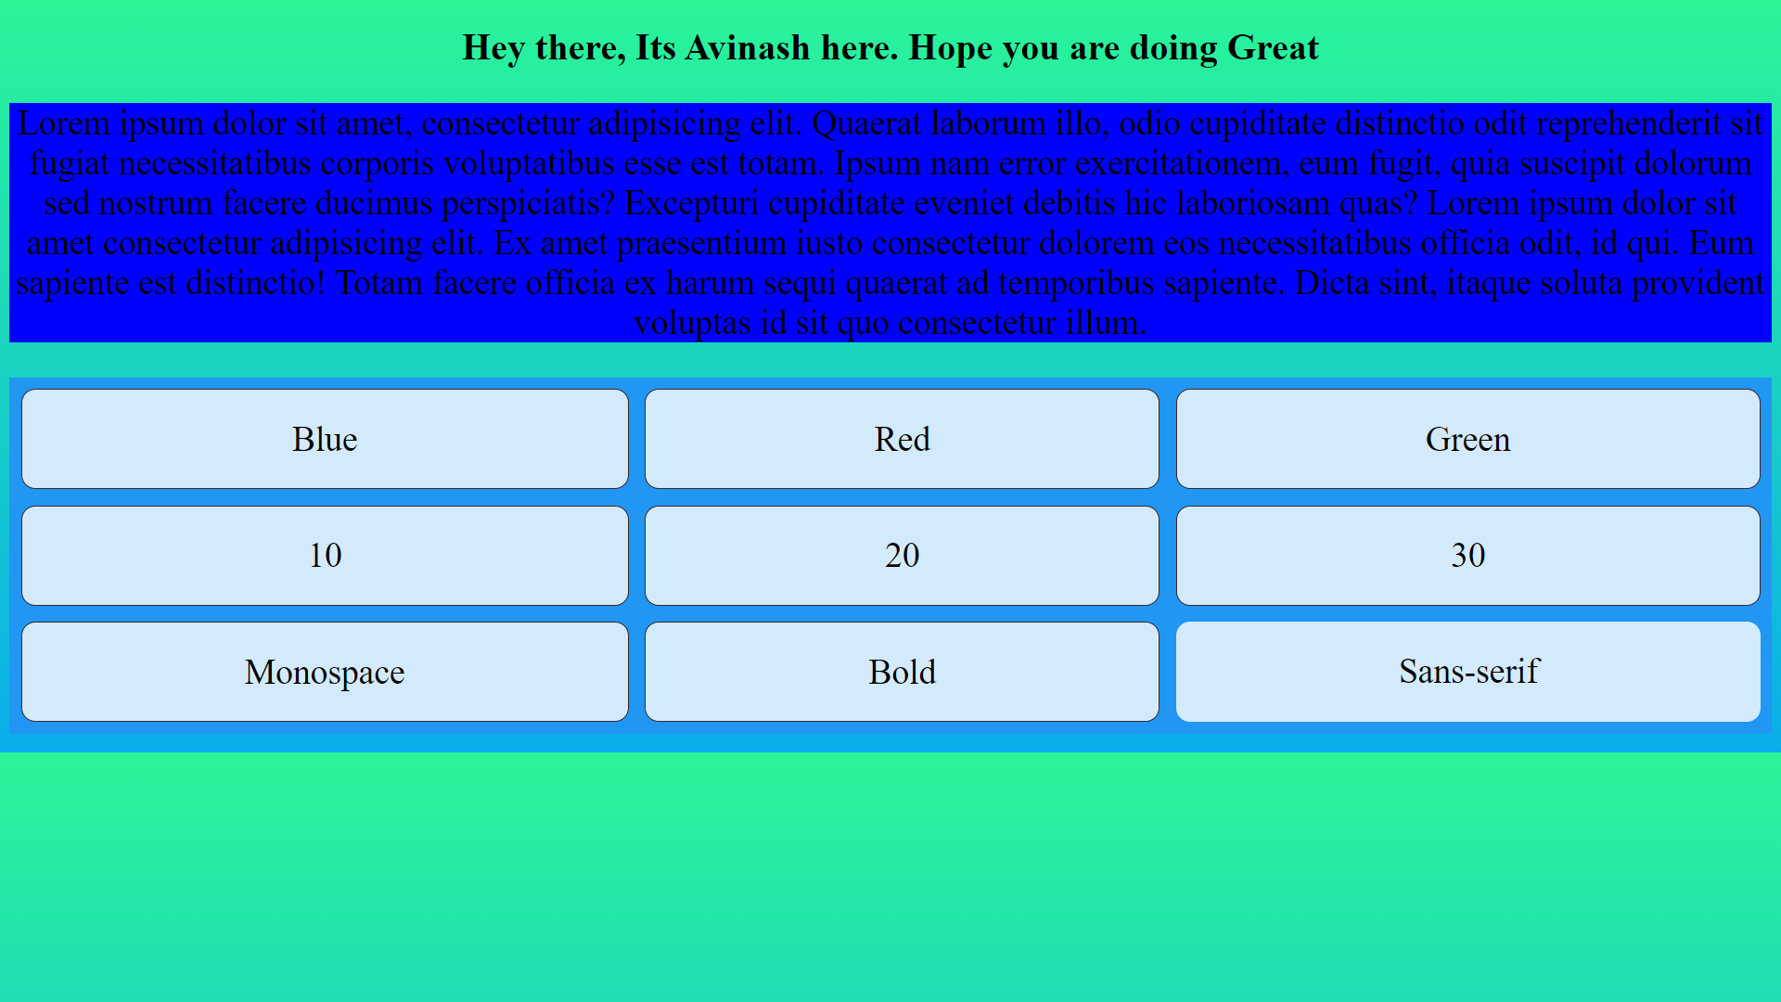

Bold

