**Name: Avinash Singh**

**Roll No: AC-1255**

**Subject: Internet technologies**

**Index.html with jQuery above the body tag**

<!DOCTYPE html>

<html lang="en">

<head>

    <meta charset="UTF-8">

    <meta http-equiv="X-UA-Compatible" content="IE=edge">

    <meta name="viewport" content="width=device-width, initial-scale=1.0">

    <title>Question8</title>

    <!-- bootstrap css -->

    <link rel="stylesheet" href="https://cdn.jsdelivr.net/npm/bootstrap@4.3.1/dist/css/bootstrap.min.css" integrity="sha384-ggOyR0iXCbMQv3Xipma34MD+dH/1fQ784/j6cY/iJTQUOhcWr7x9JvoRxT2MZw1T" crossorigin="anonymous">

    <link rel="stylesheet" href="style.css">

</head>

<body id="red">

    <!-- navbar code here START -->

    <!-- <div class="navbar"> -->

        <nav class="navbar navbar-expand-lg navbar-dark bg-dark">

            <div class="collapse navbar-collapse" id="navbarSupportedContent">

              <ul class="navbar-nav mr-auto">

                <li class="nav-item active">

                  <a class="nav-link" href="#">Welcome To Assignment 8 <span class="sr-only">(current)</span></a>

                </li>

                <li class="nav-item active">

                  <a class="nav-link" href="#">Submited By : Avinash singh</a>

                </li>

                <li class="nav-item active">

                  <a class="nav-link " href="#">Submited To : Mahesh Sir</a>

                </li>

              </ul>

              <form class="form-inline my-2 my-lg-0">

                <input class="form-control mr-sm-2" type="search" placeholder="Search" aria-label="Search">

                <button class="btn btn-outline-success my-2 my-sm-0" type="submit">Search</button>

              </form>

            </div>

          </nav>

    <!-- </div> -->

    <!-- navbar code here END  -->

    <div class="container">

        <h1 class="card text-center my-3">Courses Details</h1>

        <!-- form starts here  -->

        <form>

            <br>

                       <!-- cards code  -->

                       <div class="card">

                        <div class="card-body">

                          <h1 class="card-text">Course</h1>

                          <h5 class="card-title">Bsc(hons) computer science </h5>

                        </div>

                      </div>

                    <!-- cards code  -->

                <!-- cards code  -->

                <div class="card">

                    <!-- <div class="card-header">

                      Eligibility

                    </div> -->

                    <div class="card-body">

                      <h5 class="card-title">Eligibility </h5>

                      <p class="card-text">

                        Higher Secondary (10 + 2) qualification from a recognized educational Board with Mathematics as one of the main subjects

A minimum aggregate score of 45% at the 10+2 level.

Candidates awaiting their 10+2 exam results may also apply on provisional basis. Admission is confirmed on the basis of final results.

                      </p>

                    </div>

                  </div>

                <!-- cards code  -->

                <!--fee  cards code  -->

                <div class="card">

                    <!-- <div class="card-header">

                      Fee structure

                    </div> -->

                    <div class="card-body">

                      <h3 class="card-title">Fee structure </h3>

                      <p class="card-text">Tuition Fees ₹74,100 </p>

                    </div>

                  </div>

                <!-- fee cards code  -->

                <!--fee  cards code  -->

                <div class="card">

                    <div class="card-body">

                      <h3 class="card-title">B.Sc. (Hons.) Computer Science: What is it about? </h3>

                      <p class="card-text">B.Sc. (Hons.) Computer Science course offers to eligible candidates basic knowledge and understanding of the concepts of computer science and information technology. A combined advanced study of such concepts and software training tools equips students to adapt to the ever-evolving domain of technology. The program primarily intends to serve as a foundation for higher academic programs in computer science and to build a firm foundation in Mathematics, besides including modules on electronics and humanities.

The first year of the course lays emphasis on building the candidate’s foundation in computer science in areas such as programming, algorithms, and Mathematics. B.Sc. (Hons.) Computer Science curriculum is structured to incorporate the major academic subjects of the computer science industry and its many areas of specialization. Besides that, B.Sc. (Hons.) Computer Science course also includes components of study such as programming techniques, database development, requirement-capturing, and functioning of computing operating systems.

Such graduates may choose to pursue research in the field, go for pursuing post-graduation in the subject or pursue Lectureship in colleges or universities. Employment opportunities for such graduates abound in multi-national companies, computer hardware system design and development companies, computer networking companies, software development companies, and others such.

B.Sc. (Hons.) Computer Science course curriculum covers a wide range of topics including object-oriented programming, artificial intelligence, mobile computing and computational mathematics, computer languages and tools such as Java, C++, Android, SQL, Python, MATLAB and assembler, and specialist hardware such as Arduino microcontrollers.</p>

                    </div>

                  </div>

                <!-- fee cards code  -->

                <!--fee  cards code  -->

                <div class="card">

                    <div class="card-body">

                      <h3 class="card-title"> Career Options After BSc Computer Science </h3>

                      <p class="card-text">  Career Options After BSc Computer Science</p>

                      <ol>

                        <li>INFORMATION SYSTEMS MANAGER

                          </li>

                        <li>

                          WEB DESIGNER

                          </li>

                        <li>

                          TECHNICAL SUPPORT REPRESENTATIVE

                          </li>

                        <li>

                          DATABASE ADMINISTRATOR

                          </li>

                        <li>

                          SOFTWARE ENGINEER

                          </li>

                      </ol>

                    </div>

                  </div>

                <!-- fee cards code  -->

                <!-- courses and credits -->

                <div class="card text-center">

                    <h3 class="card-title"> Papers with names and credits </h3>

                </div>

                <div class="container">

                  <div id="carouselExampleIndicators" class="carousel slide" data-ride="carousel">

                    <ol class="carousel-indicators">

                      <li data-target="#carouselExampleIndicators" data-slide-to="0" class="active"></li>

                      <li data-target="#carouselExampleIndicators" data-slide-to="1"></li>

                      <li data-target="#carouselExampleIndicators" data-slide-to="2"></li>

                    </ol>

                    <div class="carousel-inner">

                      <div class="carousel-item active">

                        <img src="./courses_and_credit.png" width="50" height="700" class="d-block w-100" alt="...">

                      </div>

                      <div class="carousel-item">

                        <img src="./courses_and_credit2.png" width="50" height="700" class="d-block w-100" alt="...">

                      </div>

                    </div>

                    <a class="carousel-control-prev" href="#carouselExampleIndicators" role="button" data-slide="prev">

                      <span class="carousel-control-prev-icon" aria-hidden="true"></span>

                      <span class="sr-only">Previous</span>

                    </a>

                    <a class="carousel-control-next" href="#carouselExampleIndicators" role="button" data-slide="next">

                      <span class="carousel-control-next-icon" aria-hidden="true"></span>

                      <span class="sr-only">Next</span>

                    </a>

                  </div>

                </div>

                <!-- Buttons for styling start  -->

                <nav>

                    <!-- styling using js  -->

                <!-- <button  type="button" class="btn btn-primary" onclick="Red()">Red</button> -->

                <button id="Red"  type="button" class="btn btn-danger" onclick="Red()">Red</button>

                <button id="Blue" type="button" class="btn btn-primary" onclick="blue()">Blue</button>

                <button id="Grey" type="button" class="btn btn-dark" onclick="yellow()">Grey</button>

                <button id="Green" type="button" class="btn btn-success" onclick="green()">Green</button>

                  </nav>

                  <!-- Buttons for styling ends here  -->

                <nav>

                    <!-- styling using js  -->

                <!-- <button  type="button" class="btn btn-primary" onclick="Red()">Red</button> -->

                <button id="font1" type="button" class="btn btn-success" >Font 1</button>

                <button id="font2"  type="button" class="btn btn-danger" >Font 2</button>

                <button id="font3"  type="button" class="btn btn-danger" >Font 3</button>

                <button id="font4"  type="button" class="btn btn-danger" >Font 4</button>

                  </nav>

                  <!-- Buttons for styling ends here  -->

          </form>

          <!-- forms ends here  -->

</div>

<!-- bootstrap js  -->

<script src="https://code.jquery.com/jquery-3.3.1.slim.min.js" integrity="sha384-q8i/X+965DzO0rT7abK41JStQIAqVgRVzpbzo5smXKp4YfRvH+8abtTE1Pi6jizo" crossorigin="anonymous"></script>

<script src="https://cdn.jsdelivr.net/npm/popper.js@1.14.7/dist/umd/popper.min.js" integrity="sha384-UO2eT0CpHqdSJQ6hJty5KVphtPhzWj9WO1clHTMGa3JDZwrnQq4sF86dIHNDz0W1" crossorigin="anonymous"></script>

<script src="https://cdn.jsdelivr.net/npm/bootstrap@4.3.1/dist/js/bootstrap.min.js" integrity="sha384-JjSmVgyd0p3pXB1rRibZUAYoIIy6OrQ6VrjIEaFf/nJGzIxFDsf4x0xIM+B07jRM" crossorigin="anonymous"></script>

<!-- <script src="./index.js"></script> -->

<script src="https://ajax.googleapis.com/ajax/libs/jquery/3.6.0/jquery.min.js"></script>

<script>

$(document).ready(function(){

  $("#Red").click(function(){

    body_color = document.getElementById("red");

    body_color.style.backgroundColor = "red";

  });

});

$(document).ready(function(){

  $("#Blue").click(function(){

    body_color = document.getElementById("red");

    body_color.style.backgroundColor = "aqua";

  });

});

$(document).ready(function(){

  $("#Grey").click(function(){

    body_color = document.getElementById("red");

    body_color.style.backgroundColor = "grey";

  });

});

$(document).ready(function(){

  $("#Green").click(function(){

    body_color = document.getElementById("red");

    body_color.style.backgroundColor = "rgb(166, 238, 98)";

  });

});

        $(document).ready(function() {

            $('#font1').click(function() {

                $(".card").css("fontSize", "12px");

            });

        });

        $(document).ready(function() {

            $('#font2').click(function() {

                $(".card").css("fontSize", "24px");

            });

        });

        $(document).ready(function() {

            $('#font3').click(function() {

                $(".card").css("fontSize", "36px");

            });

        });

        $(document).ready(function() {

            $('#font4').click(function() {

                $(".card").css("fontSize", "48px");

            });

        });

</script>

</body>

</html>

Css

Style.css

nav{

    display: flex;

    justify-content: space-around;

    margin-bottom: 23px;

}

body{

    background-color: #98f1ea;

}

.card:nth-child( odd ) {

      background-color: #CFFF8D;

}

.card:nth-child( even ) {

    background-color: #a2a2f1;

}

img{

    border-radius: 12px;

}

OUTPUT:

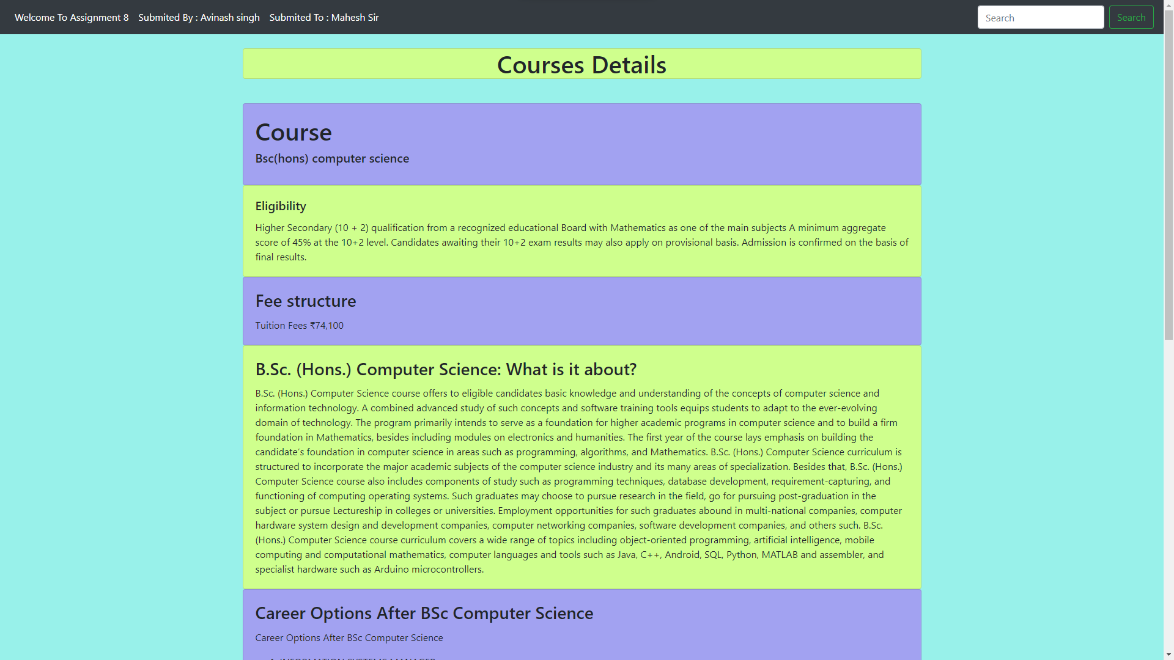

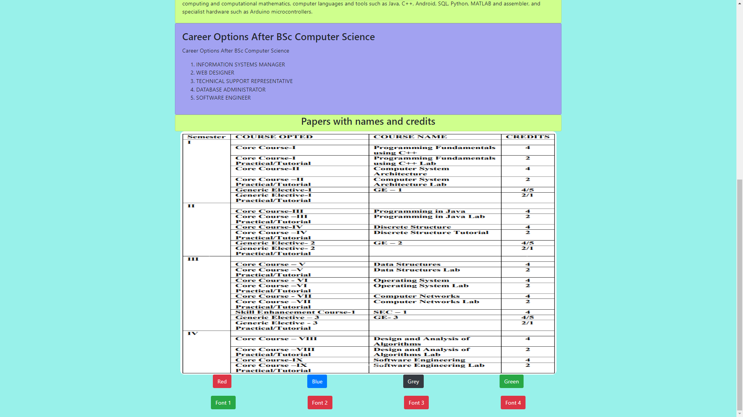

**Buttons**