**Name: Avinash singh**

**Roll no: AC-1255**

**Subject of Assignment: Internet Technologies**

**Practical 6:**

Create a form that takes data about a pet. The form must be well designed and should accept the pet’s name, age, weight, type, and what it likes most. At the submission of this form create a Pet object in JavaScript filled with these values and log that object and equivalent JSON on the console

<!DOCTYPE html>

<html lang="en">

<head>

    <meta charset="UTF-8">

    <meta http-equiv="X-UA-Compatible" content="IE=edge">

    <meta name="viewport" content="width=device-width, initial-scale=1.0">

    <title>Form </title>

    <!-- css starts from here  -->

    <style>

        body {

            background-color: rgb(213, 190, 234);

            background-image: linear-gradient(to right, rgb(74, 181, 220), rgb(28, 76, 153), rgb(57, 99, 136), rgb(33, 157, 202), blue, indigo, violet);

        }

        .container {

            text-align: center;

            font-size: 20px;

        }

        input {

            border-radius: 5px;

            width: 250px;

            height: 30px;

            text-align: center;

        }

        input,

        h1 {

            margin: auto;

            display: block;

        }

        button {

            background-color: #4b5aa7;

            border-radius: 4px;

            border: #c0c8f0;

            padding: 10px 14px 10px 14px;

        }

        button:hover {

            /* background-color: #233494; */

            border: 3px solid whitesmoke;

        }

        h1 {

            margin-top: 12px;

            margin-bottom: 32px;

            color: azure;

        }

    </style>

    <!-- css ends here -->

</head>

<body>

    <div class="container">

        <h1>Pet Information</h1>

        <label for="">Name</label>

        <input type="" name="" id="name" placeholder="Enter your Pet Name" required><br>

        <label for="">Age</label>

        <input type="number" name="" id="age" placeholder="Only integer value" required><br>

        <label for="">Weight</label>

        <input type="number" name="" id="weight" placeholder="In Kg" required><br>

        <label for="">Pet type</label>

        <input type="text" name="" id="type" required><br>

        <label for="">Favourite food</label>

        <input type="text" name="" id="like" required><br>

        <button id="btn" onclick="convertData()">Submit</button>

        <p id="json"></p>

    </div>

    <!-- javascript starts here  -->

    <script>

        function convertData() {

            let name = document.querySelector("#name").value;

            let age = document.querySelector("#age").value;

            let weight = document.querySelector("#weight").value;

            let type = document.querySelector("#type").value;

            let likes = document.querySelector("#like").value;

            if (name == "" || age == "" || weight == "" || type == "" || likes == "") {

                alert("Please Fill all the fields");

            }

            else {

                var Myobject = {

                    Name: name,

                    Age: age,

                    Weight: weight,

                    Type: type,

                    Likes: likes

                };

                console.log(Myobject)

                var myjson = JSON.stringify(Myobject);

                console.log("-----------------------------------");

                console.log("Object into json")

                console.log("-----------------------------------");

                console.log(myjson)

                document.getElementById("json").innerHTML = "Json Output <br> <br>" + myjson

        }

        }

    </script>

</body>

</html>

OUTPUT:

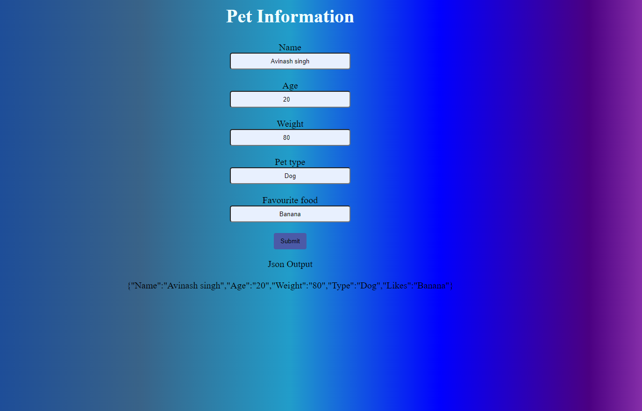

Console:

