SCHUMACHER · TRADE ANALYTICS
RFM-Based Customer Segmentation
Technical Report | K-Means Clustering Implementation & Findings
Data Range: January 1 – December 31, 2025 | 1,983,549 Transactions | 27,374 Trade Accounts

1. Executive Summary
This report documents the design, implementation, and findings of an RFM (Recency, Frequency, Monetary) segmentation model applied to Schumacher’s trade account base. The analysis was conducted as part of a broader customer analytics pipeline spanning conversion funnel analysis, product affinity modeling, and lead scoring.
Using K-Means clustering (k=4) on log-normalized, standardized RFM features derived from 1,983,549 transactions, 27,374 trade accounts were assigned to four behaviorally distinct segments. The corrected implementation using fit_predict() produced clean, geometrically valid cluster assignments and revealed a highly concentrated revenue structure: the Champions segment (29.6% of accounts) drives 76.6% of total revenue.

Key Finding
Cluster 2 (Champions) represents 29.6% of the account base but generates 76.6% of all revenue — a Pareto concentration more extreme than the initial (buggy) implementation revealed. This finding directly informs where sales and marketing resources should be concentrated.

2. Data & Methodology
2.1 Dataset
The source dataset is a master analytical file constructed from Schumacher’s order management system, containing all sample and sale transactions for the full calendar year 2025. Key fields used in this analysis include:
- trade_account_id — unique identifier for each trade (designer) account
- shipped_dt — transaction date, used to compute recency and temporal features
- order_id — unique order identifier, used to compute order frequency
- netrevenue — net revenue per transaction line, aggregated for monetary value
- type — transaction classification (SAMPLE or SALE)

2.2 RFM Feature Engineering
RFM features were computed at the trade account level by aggregating all transactions (both SAMPLE and SALE types) per account. The snapshot date was set to one day after the latest transaction in the dataset to ensure recency is calculated correctly as a relative measure.

snapshot_date = df_master['shipped_dt'].max() + timedelta(days=1)
Recency = (snapshot_date - last_transaction_date).days
Frequency = count of unique order_ids per account
Monetary = sum of netrevenue per account

A sample count feature () was also engineered and appended to the RFM table, counting the total number of sample transactions per account. This feature was used in downstream scatter analysis but excluded from clustering inputs to keep the model focused on purchase behavior.

2.3 Preprocessing Pipeline
Raw RFM values exhibit strong right-skew — a small number of accounts have extremely high frequency and monetary values. Two preprocessing steps were applied before clustering:

- Log transformation: np.log(value + 1) applied to all three features to compress outliers and normalize distributions. The +1 offset handles zero-valued monetary accounts without producing -infinity.
- Standard scaling: StandardScaler applied to the log-transformed features, centering each to zero mean and unit variance. This ensures no single RFM dimension dominates the distance calculation in K-Means.

data_log = np.log(data_to_scale + 1)
scaler = StandardScaler()
rfm_scaled = scaler.fit_transform(data_log)

2.4 Cluster Count Selection — Elbow Method
The optimal number of clusters k was determined empirically using the elbow method. Inertia (within-cluster sum of squared distances) was computed for k = 1 through 10. The elbow in the inertia curve occurs at k=4, after which incremental gains diminish significantly. This was selected as the final cluster count.

2.5 K-Means Implementation — Bug Fix & Correction
The initial implementation contained a methodological error in how cluster labels were assigned:

# INCORRECT (original)
rfm['Cluster'] = kmeans.fit_transform(rfm_scaled).argmax(axis=1)

The method on a KMeans object returns a distance matrix of shape (n_samples, n_clusters) — the Euclidean distance from each point to each cluster centroid. Applying returns the index of the largest distance, which is the cluster the point is furthest from — the exact opposite of correct cluster assignment.

# CORRECT (corrected)
rfm['Cluster'] = kmeans.fit_predict(rfm_scaled)

The method fits the model and returns the nearest centroid label directly for each sample — the standard and correct approach. The correction produced materially different cluster assignments with cleaner separation and more extreme revenue concentration, as detailed in Section 4.

3. Cluster Profiles
3.1 Summary Statistics

Cluster | Name | Accounts | Avg Revenue | Avg Recency | Avg Frequency
2 | Champions | 8,103 | $10,680 | 25 days | 22.8 orders
0 | At-Risk / Lapsed | 9,655 | $2,737 | 126 days | 4.9 orders
3 | New Prospects | 3,316 | $14 | 36 days | 4.8 orders
1 | Hibernating/Lost | 6,300 | $1 | 181 days | 2.3 orders

3.2 Cluster 2 — Champions
Cluster 2
8,103 accounts | $10,680 avg revenue | 25-day avg recency | 22.8 avg orders

Champions are the highest-value, most active accounts in the Schumacher trade ecosystem. They are defined by the simultaneous presence of high recency (purchased within the last 25 days on average), high frequency (22.8 orders), and high monetary value ($10,680 average). Despite representing only 29.6% of total accounts, this segment drives 76.6% of total revenue — a Pareto concentration confirmed across multiple visualizations.
The cluster is geometrically well-separated from all others on both the Monetary and Frequency axes. Within this segment, a positive relationship exists between sampling volume and revenue: accounts that request more samples transact more. This confirms that the sample program functions as a sales driver for high-value accounts, not merely as overhead.
- Strategic priority: Retain at all costs — churn risk in this segment has outsized revenue impact
- White-glove treatment: dedicated rep assignment, early collection access, exclusive trade pricing
- Proactive outreach before seasonal buying cycles to defend purchase frequency

3.3 Cluster 0 — At-Risk / Lapsed
Cluster 0
9,655 accounts | $2,737 avg revenue | 126-day avg recency | 4.9 avg orders

At-Risk accounts are the most strategically important segment for immediate intervention. These accounts have demonstrated genuine purchase behavior historically — averaging $2,737 per account — but have not engaged in approximately four months. They are not churned, but the recency gap is widening.
On the pairwise separation chart, Cluster 0 occupies the mid-range on both Recency and Frequency axes, sitting distinctly between active (Cluster 2) and fully lapsed (Cluster 1) populations. On the spending power scatter, these accounts are distributed across the middle band — moderate historical sampling, moderate spend — confirming they were once engaged but have decelerated.
- Highest win-back ROI: proven buyers with addressable reasons for lapse
- Personalized outreach referencing specific past purchase categories and sampled motifs
- Targeted re-sampling of new arrivals aligned to historical preferences
- Time-limited trade incentives to create urgency; prioritize accounts with historical spend above $5,000

3.4 Cluster 3 — New Prospects
Cluster 3
3,316 accounts | $14 avg revenue | 36-day avg recency | 4.8 avg orders

New Prospects are recently active accounts that are sampling actively but have not yet converted to purchase. Their recency (36 days) confirms they are currently in market, but near-zero monetary value indicates they remain in the evaluation phase. This is expected behavior: conversion funnel analysis (Notebook 03) established that accounts require an average of 37 samples before completing a first sale, placing most of this segment within the normal pre-purchase nurture window.
On the spending power scatter, Cluster 3 (yellow) appears in the low-to-mid sampling range with minimal revenue — consistent with accounts still accumulating sample touchpoints before committing. Applying sales pressure before the natural conversion threshold is counterproductive.
- Sustain sampling support without aggressive closing tactics
- Product education focus: lookbooks, specification guides, project inspiration
- Flag accounts approaching the 37-sample threshold for priority sales rep outreach
- Monitor 30-day sample velocity — accounts exceeding 10 samples/month are highest-probability near-term converters

3.5 Cluster 1 — Hibernating / Lost
Cluster 1
6,300 accounts | $1 avg revenue | 181-day avg recency | 2.3 avg orders

Hibernating accounts have been inactive for approximately six months and show near-zero lifetime revenue. They represent 23% of the total account base but 0.0% of revenue. These accounts are effectively churned. The combination of high recency, low frequency, and negligible monetary value places them in the most disengaged quadrant across all RFM dimensions.
On the boxplot, Cluster 1 (teal/blue) sits at the high end of the Recency axis and compressed near the bottom on both Frequency and Monetary — clear visual confirmation of disengagement. On the pairwise separation, these accounts form a dispersed, low-density population on all axes.
- Maximum 2–3 touch automated re-engagement email sequence
- Suppress from high-cost outreach programs and sample priority queues
- Re-qualify any respondents into the appropriate active segment
- Redirect resources saved here toward Cluster 0 (win-back) and Cluster 3 (nurture)

4. Visualization Analysis
4.1 Cluster Profiles: RFM Distribution (Boxplot)

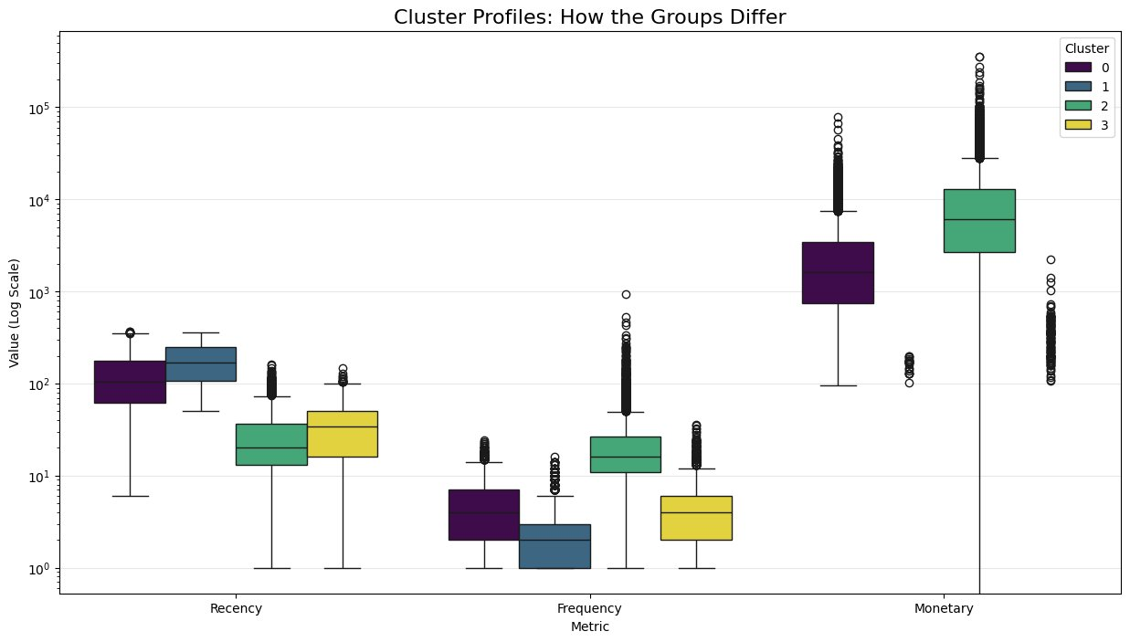
Figure 1. Cluster Profiles: How the Groups Differ — RFM distributions on log scale per cluster

The boxplot on a log scale reveals clean separation across all three RFM dimensions. On the Monetary axis, Cluster 2 (green) stands completely apart from all other clusters, with a median in the $5,000–7,000 range and a long upper tail extending beyond $100,000. No other cluster’s interquartile range approaches this level, confirming that revenue concentration is not an artifact of a few outliers but a structural property of the segment.
On the Recency axis, Clusters 2 and 3 are compressed at low values (recent activity), while Clusters 0 and 1 are shifted toward higher recency values (longer inactivity). The model cleanly separates active vs. inactive accounts independent of their spend level, which is the key methodological requirement for actionable segmentation.
Frequency follows a similar pattern: Cluster 0 (purple) shows moderate frequency consistent with historical engagement, Cluster 2 dominates the high end, and Clusters 1 and 3 are tightly compressed near the low end.

4.2 Pairwise Cluster Separation

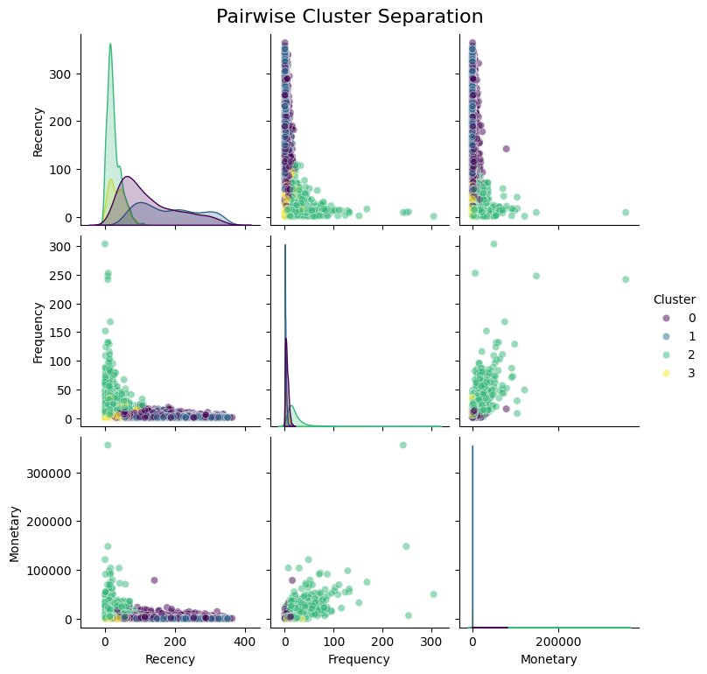
Figure 2. Pairwise Cluster Separation — scatter plots and KDE diagonals across RFM dimensions

The pairwise plot confirms that the four clusters occupy distinct regions in RFM space with minimal overlap, validating the quality of the segmentation.
The Recency KDE (diagonal, top-left) shows Cluster 2 spiking sharply near zero — highly recent activity — while Clusters 0 and 1 have flat, spread distributions confirming extended inactivity. The Frequency vs. Recency scatter shows Cluster 2 dominating the high-frequency zone, with all other clusters compressed near the origin.
The Monetary vs. Frequency panel (bottom-center) is the most revealing: Cluster 2 fans outward to the right and upward in a diagonal spread, showing that higher frequency directly correlates with higher spend within the Champions segment. This relationship does not exist in any other cluster — a structural difference that justifies differentiated treatment of these accounts.

4.3 Strategic Importance: Population vs. Revenue Share

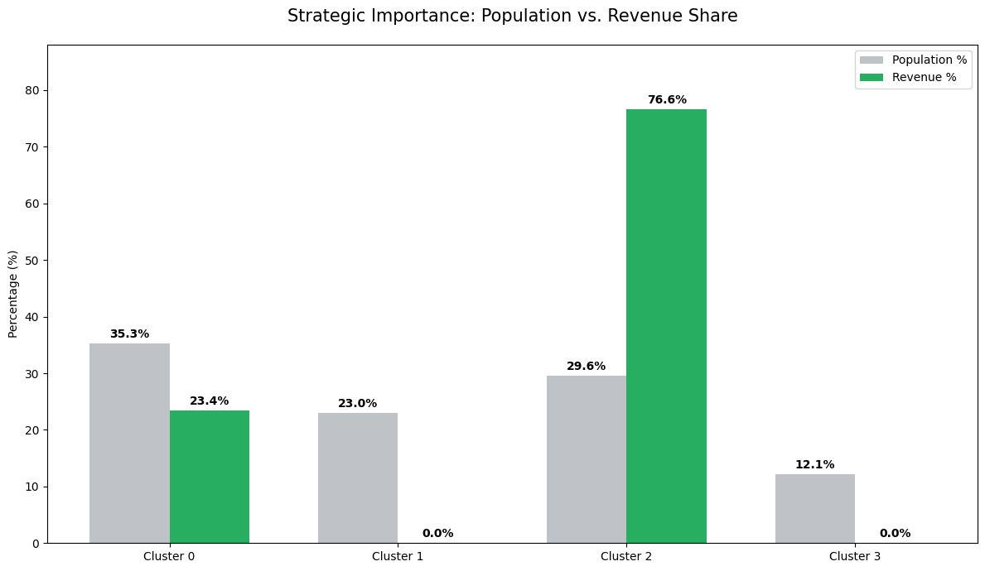
Figure 3. Strategic Importance: Population vs. Revenue Share — Pareto concentration by cluster

This chart is the single most important output of the segmentation analysis. Cluster 2 (Champions), representing 29.6% of all accounts, generates 76.6% of total revenue. Clusters 1 and 3 together account for 35.1% of the account base but contribute 0.0% of revenue. Cluster 0 (At-Risk), at 35.3% of accounts, generates 23.4% of revenue — meaningful historical contribution that is now at risk of being lost.
This is a more extreme revenue concentration than the original (buggy) implementation revealed. The corrected clustering exposed the true Pareto structure that was being masked by incorrect cluster assignments, where Champions accounts were diluted with misassigned lower-value accounts.

4.4 Spending Power vs. Sampling Appetite

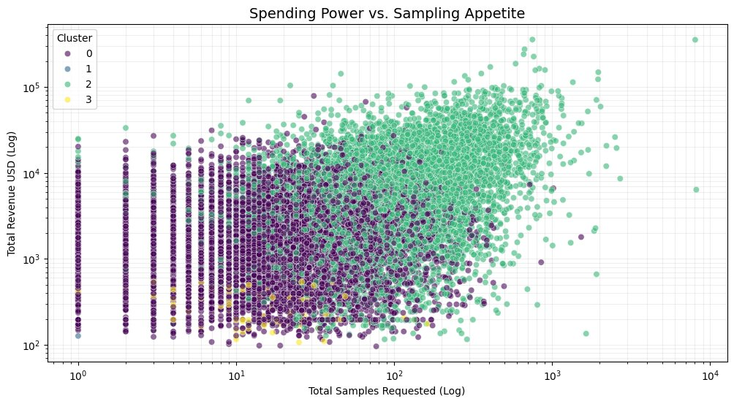
Figure 4. Spending Power vs. Sampling Appetite — revenue (log) vs. total samples requested (log) by cluster

This scatter plot on dual log axes reveals the relationship between sampling behavior and purchase output across segments. Cluster 2 (green) occupies the upper-right quadrant exclusively: high sampling volume and high revenue. The diagonal spread within this cluster confirms a positive correlation — accounts that request more samples generate more revenue. This is not true of any other segment.
Cluster 0 (purple) spreads across the middle-left zone: moderate historical sampling, moderate spend, with no upward trajectory. Cluster 3 (yellow) appears in the low-revenue band regardless of sampling volume — consistent with pre-conversion accounts that have not yet crossed the purchase threshold. Cluster 1 (blue) is barely visible, compressed at the bottom-left.
The practical implication: sampling is not a cost center — it is the primary revenue mechanism for the highest-value accounts. Restricting sample access to Champions would directly reduce revenue. Conversely, high sampling volume in Cluster 3 predicts near-term conversion, supporting continued investment in that segment’s nurture pipeline.

5. Technical Notes & Limitations
5.1 The fit_transform vs. fit_predict Correction
The original implementation called to assign cluster labels. This is incorrect for two reasons: (1) returns a matrix of distances to each centroid, not cluster assignments; and (2) selects the index of the maximum value, which is the cluster the point is farthest from, inverting the assignment logic entirely.
The corrected implementation uses , which directly returns the nearest centroid label for each sample. This is the standard sklearn interface for cluster assignment and produces geometrically valid results.

5.2 Known Limitations
- RFM aggregates all transaction types (SAMPLE + SALE). Frequency therefore reflects all order interactions, not purchase frequency alone. A purchase-only frequency metric would produce a more conservative view of buyer engagement.
- K-Means assumes spherical clusters of equal variance in scaled feature space. Real customer distributions are not perfectly spherical, which explains the overlap visible at cluster boundaries in the pairwise plots.
- Cluster labels (0, 1, 2, 3) are assigned arbitrarily by K-Means and may differ across runs with different random seeds. The names assigned (Champions, At-Risk, etc.) are interpretive labels applied post-hoc based on centroid profiles.
- The analysis covers a single calendar year (2025). Seasonal effects and year-over-year trends are not captured in the current segmentation.

5.3 Deprecation Warnings
Several FutureWarnings were generated during execution related to deprecated pandas groupby behavior (observed=False default) and seaborn palette usage without hue assignment. These do not affect analytical outputs but should be resolved before production deployment by passing observed=True to groupby calls and assigning hue explicitly in seaborn barplots.

6. Strategic Recommendations
The segmentation findings support the following resource allocation priorities, ordered by expected ROI:

Priority 1 — Protect Champions (Cluster 2)
Revenue concentration in this segment is extreme. Losing even a small number of these accounts creates outsized revenue impact. Dedicated retention investment is fully justified: dedicated rep assignment, early collection access, loyalty pricing tiers, and proactive pre-season outreach.
Priority 2 — Win Back At-Risk Accounts (Cluster 0)
This is the highest-ROI commercial opportunity. These are proven buyers with a known purchase history who are currently drifting. A structured win-back program — personalized outreach, targeted re-sampling, and time-limited incentives — should be the top near-term commercial initiative.
Priority 3 — Nurture New Prospects (Cluster 3)
These accounts are in a normal pre-conversion state. Forcing conversion before the natural 37-sample threshold is counterproductive. Sustained sampling support, product education content, and velocity-based flagging for sales outreach will yield conversions within a predictable time horizon.
Priority 4 — Deprioritize Hibernating Accounts (Cluster 1)
A light automated re-engagement sequence (2–3 touches) is sufficient. Resources currently directed at this segment — in sample allocation, sales outreach, and marketing spend — should be redirected to Clusters 0 and 2 where conversion probability is materially higher.

Analysis: Notebook 04 — Customer Segmentation RFM | Pipeline: Notebooks 02–06 | Data: 1,983,549 transactions, Jan–Dec 2025 | Method: K-Means (k=4), log-normalized StandardScaler RFM features

