Automated Car Catalog System for Enhanced Showroom Management

# Problem Statement

Car showrooms often deal with a vast collection of vehicles, which can be difficult to manage manually. This leads to delayed approvals, inefficient task handling, and customer dissatisfaction. To resolve this, an automated car catalog system was built using ServiceNow, improving workflow, approvals, and catalog accessibility.

# 1. Service Catalog

## 1.1 Create Catalog

Steps to Create a Catalog:

* • Go to All >> Maintain Catalog
* • Click on New and name it 'Mahendra'
* • Application: Global
* • Description: It is a car showroom
* • Click Submit

📌 Screenshot: Capture the created catalog screen.

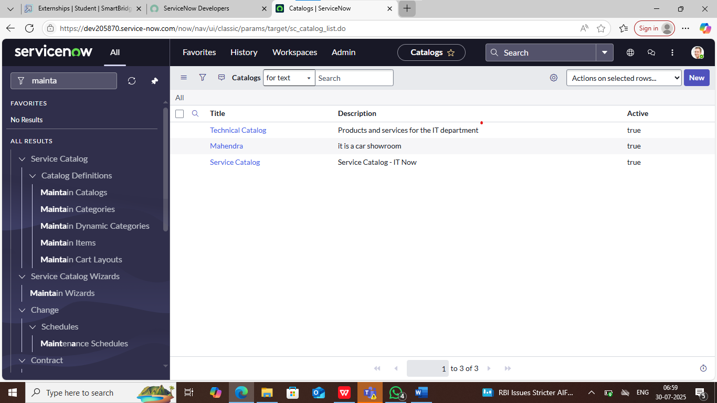

## 1.2 Create Categories

* • Go to Mahendra Catalog >> Categories >> New
* • Titles: Sudden, XUV, Sports

📌 Screenshot: Show category listing.

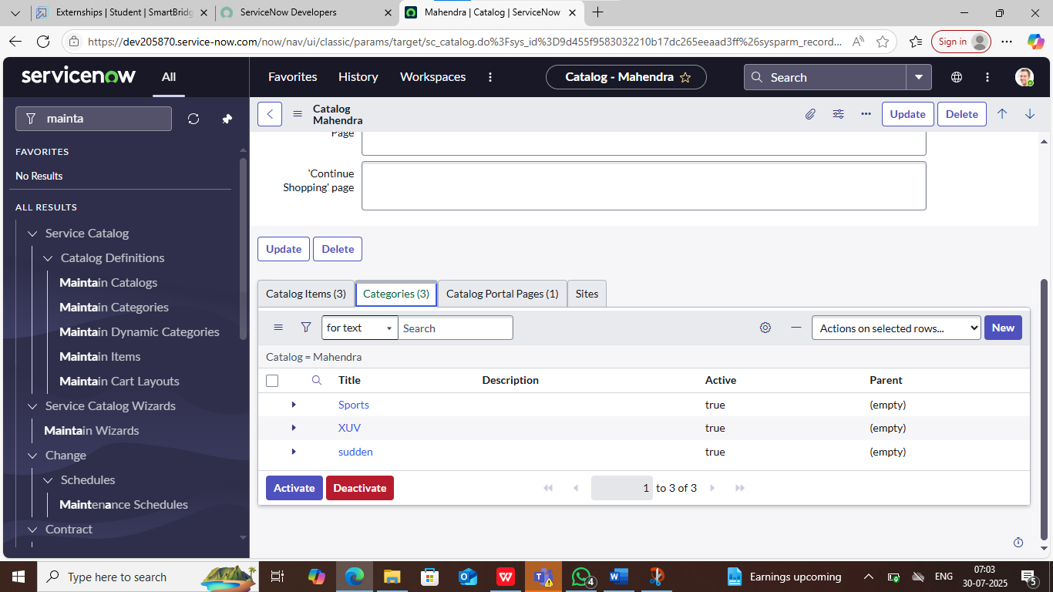

## 1.3 Create Catalog Items

Example Cars Added:

* Polo
* • Category: Sudden
* • Price: 70 | Recurring: 90
* • Description: Volkswagen Polo is a compact car with comfort and great mileage.
* • Request Method: Request
* Thar
* • Category: XUV
* • Price: 150 | Recurring: 170
* XUV700
* • Category: Sports
* • Price: 200 | Recurring: 211

📌 Screenshot: Include catalog item form for each car.

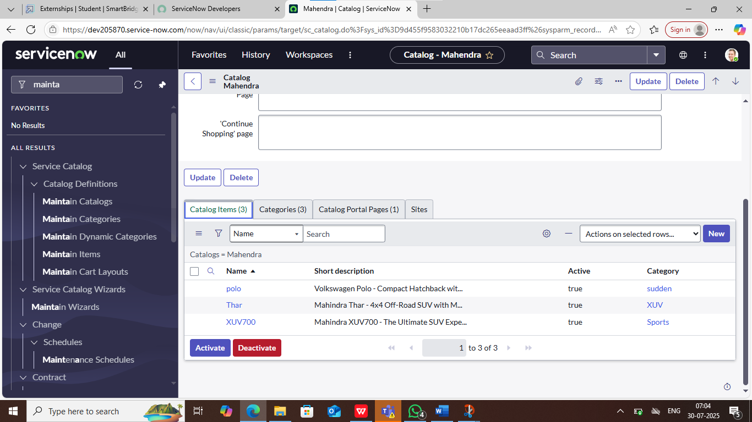

# 2. User Creation

* • Go to All >> Users >> New
* • UserID: 01 | Name: Salesperson | Role: emp1

# 3. Role Creation

* • Go to All >> Roles >> New
* • Name: emp1

# 4. Group Creation

* • Go to All >> Groups >> New
* • Group Name: showroom | Manager: Abraham Lincoln
* • Add members: Salesperson, Salesperson2, Salesperson3

# 5. Table Creation

* • Go to All >> Tables >> New
* • Name: cars fulfillment | Extends: Task Table

# 6. Workflow Setup

* • Create a new workflow with approvals and tasks.
* • Two Approvals: Salesperson and Supervisor
* • Task: Car Company (Ready to Pickup), Car Production (Deployment Failed)
* • Notifications: For Approved and Rejected

📌 Screenshot: Workflow canvas and notification config.

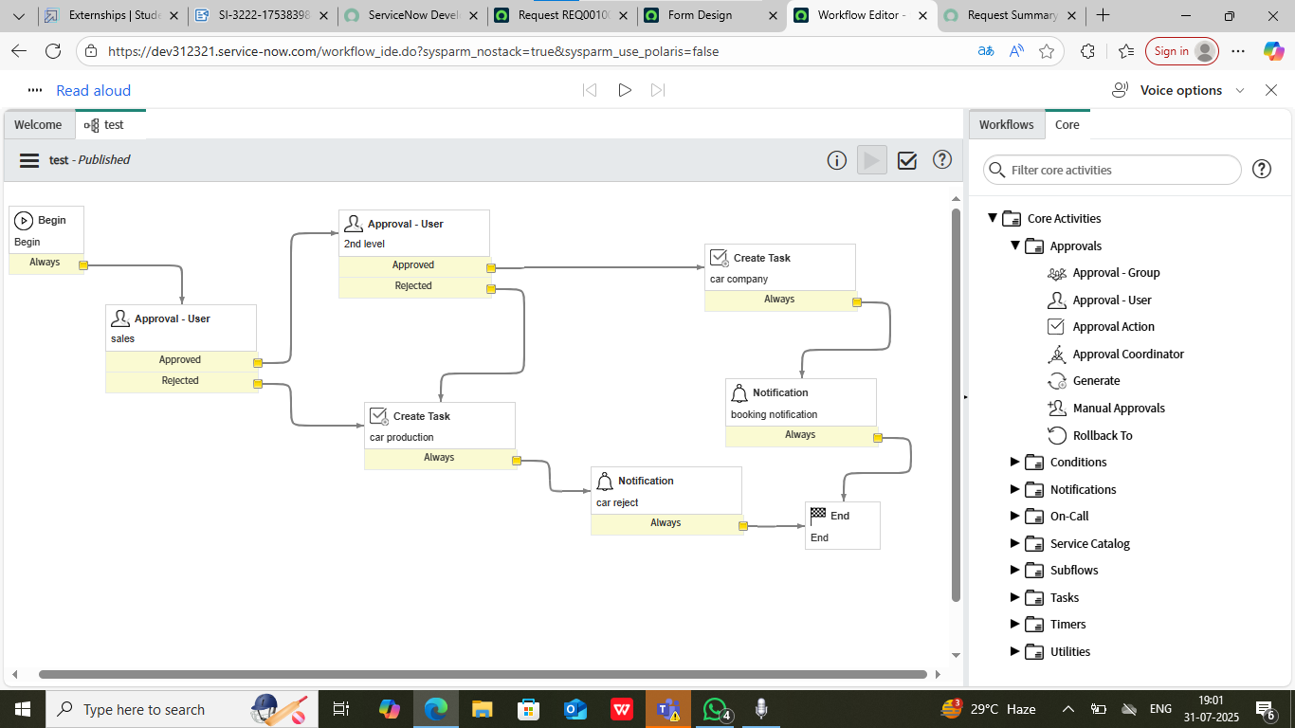

# 7. Service Portal

* • Go to: https://<instance>.service-now.com/sp
* • Search created items like 'Thar' and place an order
* • Request visible in Task Table to approve or reject

# Conclusion

The Automated Car Catalog System on ServiceNow has made car management more efficient. It reduces manual work, streamlines requests, improves workflow handling, and offers faster customer service. With better visibility and automation, the system brings enhanced user experience to showroom management.