Solar Farm Maintenance Analysis

Question Code: Q9405

1. Problem Statement
A renewable-energy operator tracks inspection records from solar farms.
Build a Pandas analyzer that creates the inspection table, cleans invalid records, flags excessive downtime, summarizes site performance, identifies low-output sites, and calculates completed-maintenance cost by region.
Complete the class in solution.py.
Do not change the class name, method names, parameter lists, or return types.
Every analysis method receives a complete DataFrame and must work independently.

2. Input Schema
Inspection DataFrames use these columns in this exact order:
- InspectionID
- SiteID
- Region
- InspectionDate
- OutputMWh
- DowntimeHours
- MaintenanceStatus
Keep InspectionDate as supplied; datetime conversion is not required.

3. Class
class SolarMaintenanceAnalyzer:

No constructor state is required.

4. Operations

Operation 1: Create the inspection DataFrame

Function
def create_inspections_df(
self,
inspection_data: list
) -> pd.DataFrame:

Implementation flow
- Create one row for each inner list.
- Use the seven required columns in the exact stated order.
- Preserve input row order and return a Pandas DataFrame.

Operation 2: Clean inspection data

Function
def clean_inspection_data(self, df: pd.DataFrame) -> pd.DataFrame:

Implementation flow
Retain only rows satisfying all rules:
- No column value is missing.
- OutputMWh is strictly greater than 0.
- DowntimeHours is greater than or equal to 0.
- MaintenanceStatus is either "Completed" or "Scheduled".

Return requirements
Return a copy with:
- the original seven-column order,
- retained row order, and
- a zero-based index.
Do not modify the input DataFrame.

Operation 3: Add the attention flag

Function
def add_attention_flag(
self,
df: pd.DataFrame,
downtime_threshold: float
) -> pd.DataFrame:

Implementation flow
- Return a copy of df.
- Add NeedsAttention as the last column.
- Store integer 1 when DowntimeHours > downtime_threshold; otherwise store integer 0.
- Equality with the threshold must produce 0.

Operation 4: Create the site performance summary

Function
def site_performance_summary(self, df: pd.DataFrame) -> pd.DataFrame:

Implementation flow
Group by SiteID and return these columns:
- SiteID
- InspectionCount: number of inspection rows
- TotalOutputMWh: sum of OutputMWh
- AverageDowntime: mean of DowntimeHours, rounded to two decimals

Return requirements
- Sort by SiteID ascending.
- Return a zero-based index.

Operation 5: Find low-output sites

Function
def low_output_sites(
self,
df: pd.DataFrame,
output_threshold: float
) -> pd.DataFrame:

Implementation flow
- Sum OutputMWh by SiteID.
- Keep sites whose total is strictly less than output_threshold.
- Equality with the threshold must not be included.

Return requirements
Return:
SiteID
TotalOutputMWh

- Sort by SiteID.
- Return a zero-based index.

Operation 6: Create the regional maintenance-cost summary

Function
def regional_maintenance_cost(self, df: pd.DataFrame) -> pd.DataFrame:

Implementation flow
- Use only rows where MaintenanceStatus == "Completed".
- Calculate row cost as DowntimeHours * 250.0.
- Sum the cost by Region.

Return requirements
Return:
Region
MaintenanceCost

- Sort by Region.
- Return a zero-based index.

Example
A completed inspection with 2.0 downtime hours contributes:
500.0

2. Museum Artifact Loan Registry

Question code: Q9203

1. Problem Statement
A museum records artifacts temporarily loaned to external institutions. Build a small in-memory registry that can register a loan, change its destination, look up one loan, and list loans sent to a destination.
Complete the class in solution.py. Do not change the class name, state attribute, method names, parameter lists, or return types.

2. Class and State
class MuseumLoanRegistry:
def __init__(self):
self.loans = {}

self.loans maps each loan_id to a dictionary with exactly these keys:
{
"artifact_name": str,
"destination": str,
"status": "On Loan"
}

3. Operations

Operation 1: Register an artifact loan
def register_loan(
self,
loan_id: str,
artifact_name: str,
destination: str
) -> dict:

Purpose: add a new loan to the registry.
Implementation flow:
- Check whether loan_id already exists.
- If it exists, raise ValueError("Loan already registered") without changing the stored record.
- Otherwise store the artifact name, destination, and status "On Loan".
- Return the complete updated self.loans dictionary.
Example:
registry.register_loan("L201", "Bronze Lamp", "City Gallery")

Expected result:
{
"L201": {
"artifact_name": "Bronze Lamp",
"destination": "City Gallery",
"status": "On Loan"
}
}

Operation 2: Change a loan destination
def change_destination(
self,
loan_id: str,
new_destination: str
) -> dict:

Implementation flow:
- If loan_id does not exist, raise KeyError("Loan not found").
- Update only the destination field of the matching loan.
- Preserve its artifact name and status.
- Return the complete updated self.loans dictionary.

Operation 3: Get loan details
def get_loan_details(self, loan_id: str) -> dict:

- If loan_id does not exist, raise KeyError("Loan not found").
- Return the stored details dictionary for that loan.

Operation 4: List loans by destination
def loans_by_destination(self, destination: str) -> list:

- Return loan IDs whose stored destination exactly equals destination.
- Matching is case-sensitive.
- Preserve the insertion order of self.loans.
- Return an empty list when there are no matches.

3. Cold-Storage Temperature Analyzer

Question Code: Q9303

1. Problem Statement
A food distribution centre records cold-room temperatures in degrees Celsius.
Implement five independent NumPy functions that create, validate, summarize, categorize, and scan those readings.
Complete solution.py without changing the function names, parameter lists, or return types.
A valid recorded temperature is from -30.0 through 10.0, inclusive.

2. Operations

Operation 1: Create a temperature array

Function
def create_temperature_array(values: list) -> np.ndarray:

Implementation flow
- Convert values to a one-dimensional NumPy array.
- Return dtype must be np.float64.
- Preserve the input order.

Example
[-22, -18.5, 4] becomes a float64 array containing:
[-22.0, -18.5, 4.0]

Operation 2: Validate a temperature array

Function
def validate_temperature_array(arr: np.ndarray) -> bool:

Implementation flow
Return the Python boolean True only when all conditions hold:
- arr is not empty.
- Its dtype is a numeric NumPy subtype.
- Every value is from -30.0 to 10.0, inclusive.
Return False for:
- an empty array,
- a non-numeric array, or
- an out-of-range reading.
A non-numeric array must not cause an exception.

Operation 3: Compute temperature statistics

Function
def compute_temperature_stats(arr: np.ndarray) -> tuple:

Return value
Return:
(mean, standard_deviation, maximum, minimum)

Implementation flow
- Calculate the mean with np.mean.
- Calculate population standard deviation with np.std and default ddof=0.
- Find maximum and minimum values.
- Round all four returned values to two decimal places and return Python float values.

Example
Input:
[-20.0, -10.0, 0.0]

Returns:
(-10.0, 8.16, 0.0, -20.0)

Operation 4: Categorize temperatures

Function
def categorize_temperatures(arr: np.ndarray) -> np.ndarray:

Return a NumPy string array with one category per input value:
CategoryTemperature RangeFrozen-30.0 <= value <= -18.0Chilled-18.0 < value <= 5.0Warning5.0 < value <= 10.0Invalidvalue below -30.0 or above 10.0

Boundary example
Input:
[-30, -18, -17.9, 5, 5.1, 10, 10.1]

Output:
[Frozen, Frozen, Chilled, Chilled, Warning, Warning, Invalid]

Operation 5: Find the longest warning streak

Function
def longest_warning_streak(arr: np.ndarray) -> int:

Implementation flow
- A warning reading satisfies 5.0 < value <= 10.0.
- Return the greatest number of consecutive warning readings.
- Any other value, including an invalid value, breaks the current streak.
- Return 0 when no warning reading exists.

SQL NEW QUESTION 2

SQL Question: Event Average Finish Time
Marks: 20
Difficulty: Medium
Database: ATHLETICS_RESULTS_DB

Schema Details
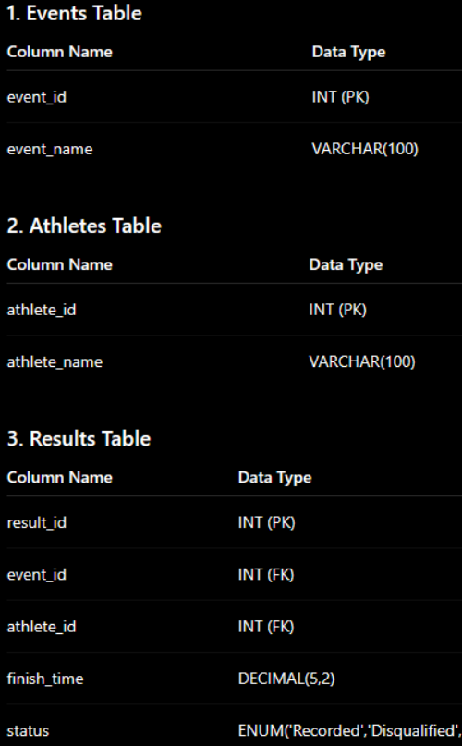
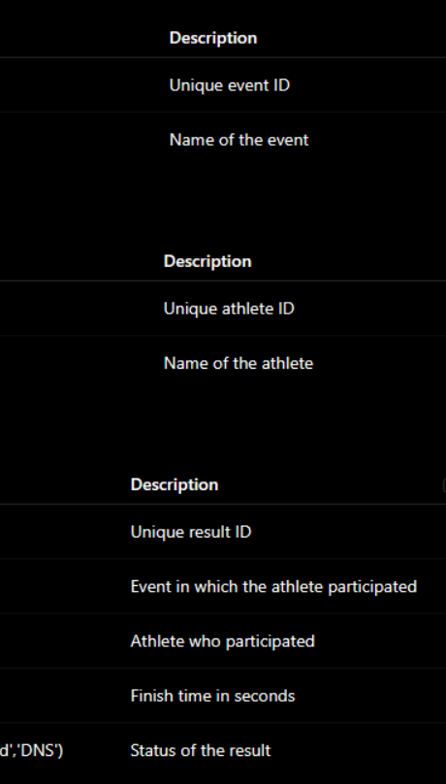

Problem Statement
A national athletics federation stores athlete performance data for multiple track events.
Generate a report that, for every recorded result, displays:
- The event name
- The athlete name
- The athlete's finish time in seconds
- The average finish time of all recorded performances within the same event

Use the AVG() window function with PARTITION BY to calculate the average finish time separately for each event.
Only results where status = 'Recorded' should be included.
Results with statuses such as Disqualified or DNS must not appear in the final output and must not be included while calculating the event average.
Round the calculated average finish time to 2 decimal places.

Sort the final result by:
- event_name
- finish_time
- athlete_name

Required Output Columns
- event_name
- athlete_name
- finish_time
- avg_event_time
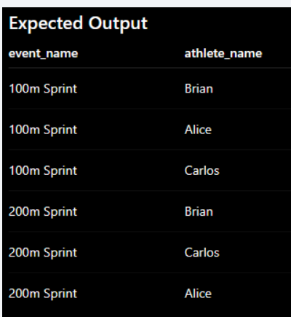
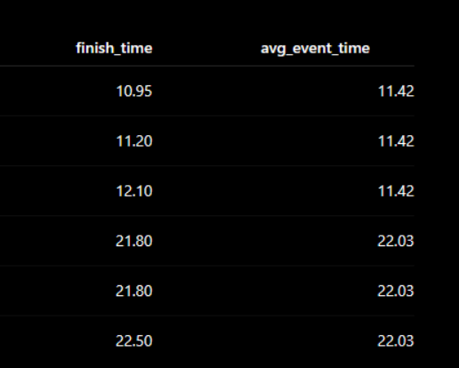

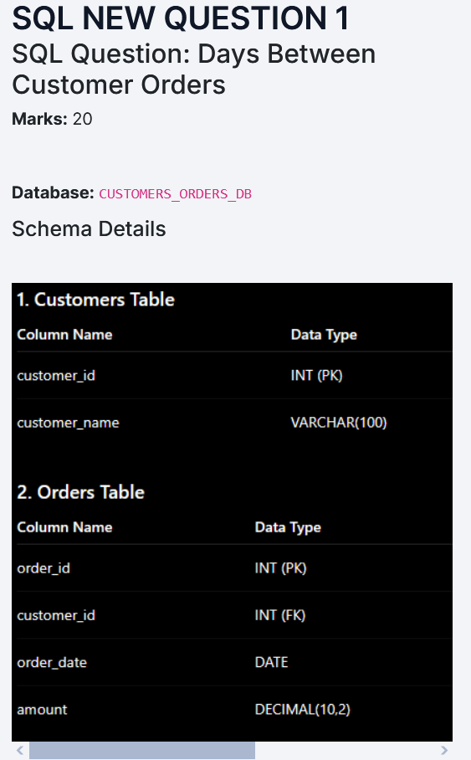
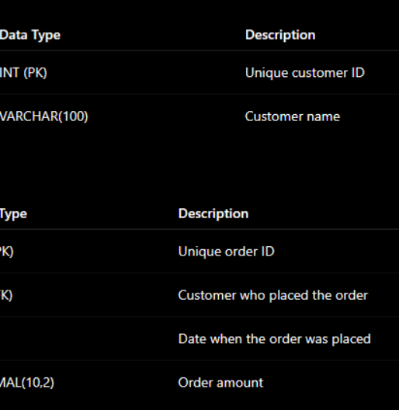

Problem Statement

For each order placed by a customer, calculate the number of days that have passed since the customer's immediately previous order.
Use the LAG() window function to retrieve the previous order date for the same customer.

Requirements
- Process the orders separately for each customer using customer_id.
- Use LAG() to retrieve the immediately previous order_date for each customer.
- Determine the sequence of orders using order_date and then order_id.
- Calculate the number of days between the current order date and the previous order date.
- For the first order of each customer, days_since_previous_order should be NULL.
- Sort the final result by:
- customer_name
- order_date
- order_id
﻿

Required Output Columns
- customer_name
- order_id
- order_date
- days_since_previous_order

Expected Output
