SDLC Overview – Infographic Document
This document presents a one-page styled overview of the Software Development Life Cycle (SDLC) with simple infographic elements representing each phase.


Requirements
Defines what the system should do. This phase gathers and analyzes user needs. It drives all downstream work.


Design
Outlines system architecture, UI plans, and module structure. A strong design reduces complexity during development.
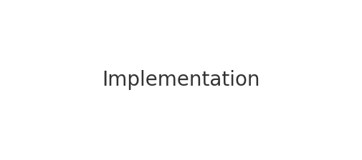

Implementation
Developers write code according to the design. Code quality determines system stability.


Testing
Validates functionality, performance, and security. Ensures the product meets requirements before release.


Deployment
Releases the solution to users or production. Often leads to new requirements and improvements.

