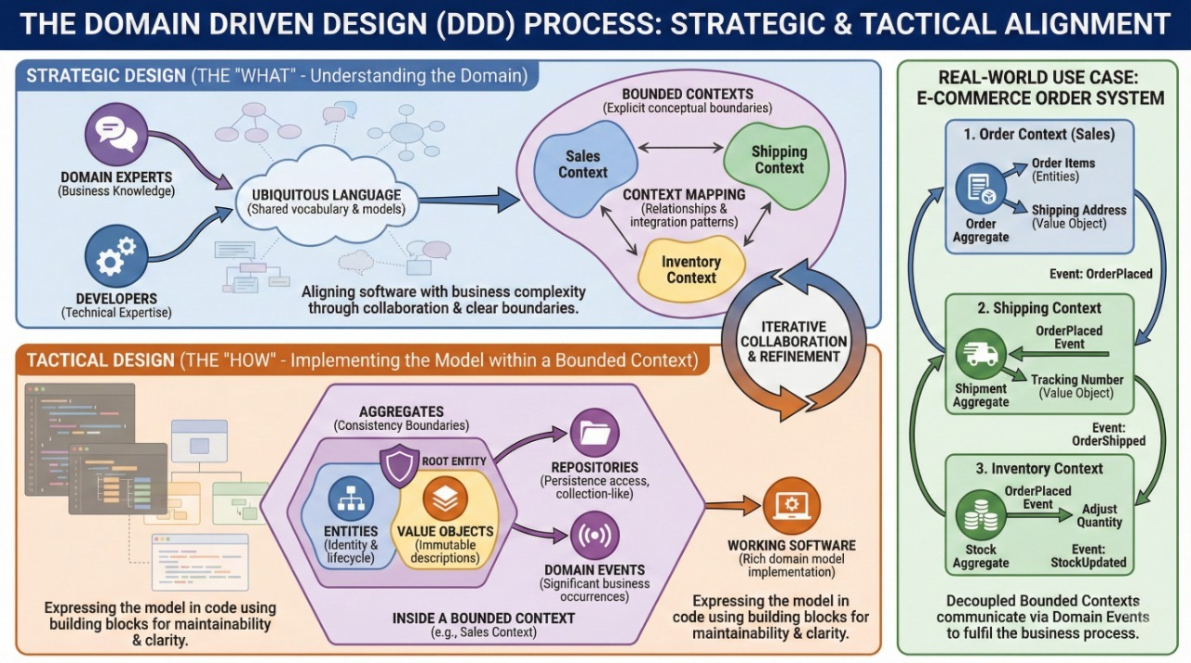
Scenario: A large online store.
1. The Problem: A "Product" means something different to the Sales Team (description, price, photos) than it does to the Shipping Team (weight, dimensions, warehouse location). Trying to make one "Product" object for both creates messy code.
2. The DDD Solution:
- Context A (Sales Context): Here, "Product" is an entity focused on pricing and display.
- Context B (Shipping Context): Here, the concept is renamed "Cargo," focused on weight and tracking.
3. The Result: By separating these contexts, the Shipping logic can change without breaking the Sales logic. The software accurately reflects how the business actually operates.

