**Chapter 1: Introduction**

1.1 Overview ……………………………………………………………………………………………………… 1

1.2 Background Study ………………………………………………………………………………………… 1

1.3 Project Planning ………………………………………………………………………………………….. 2

1.4 Purposes ………………………………………………………………………………………………………

**2 Chapter 2: System Design**

2.1 Design …………………………………………………………………………………………………………. 3

2.2 User Characteristics …………………………………………………………………………………….. 3

2.3 System Information ……………………………………………………………………………………… 4

2.4 System Analysis ……………………………………………………………………………………………. 4

2.5 Feasibility Analysis ……………………………………………………………………………………….. 4

2.6 Context Design ……………………………………………………………………………………………… 5

**Chapter 3: Hardware and Software Requirement**

3.1 Hardware Required ……………………………………………………………………………………… 6

3.2 Software Required ………………………………………………………………………………………. 6

**Chapter 4: Implementing Tools for the Project**

4.1 Tools ……………………………………………………………………………………………………………. 7

4.2 What is XAMPP …………………………………………………………………………………………… 7

4.3 What is included in XAMPP …………………………………………………………………………. 7

4.4 HTML …………………………………………………………………………………………………………… 8

4.5 CSS ………………………………………………………………………………………………………………. 8

4.6 LARAVEL ………………………………………………………………………………………………………. 8

4.7 VUE JS ………………………………………………………………………………………………………….. 8

4.8 MySQL …………………………………………………………………………………………………………. 9

**Chapter 5: Project Database & Table**

5.1 Database Design …………………………………………………………………………………………… 10

5.2 All Table List …………………………………………………………………………………………………. 11

5.3 Admin table ………………………………………………………………………………………………….. 11

5.4 User table ……………………………………………………………………………………………………… 11

5.5 Product table ………………………………………………………………………………………………… 12

5.6 Category table ………………………………………………………………………………………………. 12

5.7 Brand table ……………………………………………………………………………………………………. 13

5.8 Cart table ………………………………………………………………………………………………………. 13

5.9 Order table ………………………………………………………………………………………………….... 13

**Chapter 6: Project Model View**

6.1 Home page …………………………………………………………………………………………………… 14

6.2 Single product page ………………………………………………………………………………………. 14

6.3 Cart page ………………………………………………………………………………………………………. 14

6.4 Checkout page ………………………………………………………………………………………………. 15

6.5 Admin login page ………………………………………………………………………………………….. 15

6.6 Add Brand page …………………………………………………………………………………………….. 16

6.7 Brand List page ……………………………………………………………………………………………… 17

6.8 Add Category page ………………………………………………………………………………………… 17

6.9 Category List page ………………………………………………………………………………………. 17

6.10 Add Product page …………………………………………………………………………………. 18

6.11 Product List page ………………………………………………………………………………….. 19

6.12 Order List page ……………………………………………………………………………………… 20

6.13 View Order page …………………………………………………………………………………… 21

**Chapter 7: Software Testing**

7.1 Why software testing is needed ………………………………………………………………….. 22

7.2 Testing Strategy ………………………………………………………………………………………….. 22

7.3 White box testing ……………………………………………………………………………………….. 23

7.4 Black box testing …………………………………………………………………………………………. 23

**Chapter 8: Conclusion**

8.1 Conclusion ……………………………………………………………………………………………….... 24

8.2 Future aspect ……………………………………………………………………………………………. 24

**E- Commerce website**

**(REPORT)**

**Introduction**

**1.1 Overview**

The ‘Online E-commerce Web application’ Services department strives to provide solutions to develop and transfer easy and efficient way in the digital age and to help reduces the human pressure and time. To help support shop collections, the digital initiatives, and external partner institution digital projects, It provide services that include the digitization of analog objects, metadata management, digital preservation, and discovery and access of digital collections. “Shop Management System” is a web application written for all operating systems, designed to help users maintain and organize shop virtually. This software is easy to use for both beginners and advanced users. It features a familiar and well thoughtout, an attractive user interface, combined with strong searching Insertion and reporting capabilities. The report generation facility of shop system helps to get a good idea of which are the various items brought by the members, makes users possible to get the product easily. The ‘Online E-commerce Web application’ Services department strives to provide solutions to develop and transfer easy and efficient way in the digital age and to help reduces the human pressure and time. To help support shop collections, the digital initiatives, and external partner institution digital projects, It provides services that include the digitization of analog objects, metadata management, digital preservation, and discovery and access of digital collections. “Shop Management System” is a web application written for all operating systems, designed to help users maintain and organize shop virtually. This software is easy to use for both beginners and advanced users. It features a familiar and well thoughtout, an attractive user interface, combined with strong searching Insertion and reporting capabilities. The report generation facility of shop system helps to get a good idea of which are the various items brought by the members, makes users possible to get the product easily.

**1.2 Background Study**

E-commerce is fast gaining ground as an accepted and used business paradigm. More and more business houses are implementing web sites providing functionality for performing commercial transactions over the web. It is reasonable to say that the process of shopping on the web is becoming commonplace. The objective of this project is to develop a general-purpose e-commerce store where any product (such as books, CDs, computers, mobile phones, electronic items, and home appliances) can be bought from the comfort of home through the Internet. However, for implementation purposes, this paper will deal with an online ecommerce store. An online store is a virtual store on the Internet where customers can browse the catalog and select products of interest. The selected items may be collected in a shopping cart. At checkout time, the items in the shopping cart will be presented as an order. At that time, more information will be needed to complete the transaction.

**1.3 Project Planning**

Project planning is part of project management, which relates to the use of schedules such as Gantt charts to plan and subsequently report progress within the project environment. Initially, the project scope is defined and the appropriate methods for completing the project are determined. Following this step, the durations for the various tasks necessary to complete the work are listed and grouped into a work breakdown structure. The logical dependencies between tasks are defined using an activity network diagram that enables identification of the critical path. Float or slack time in the schedule can be calculated using project management software. Then the necessary resources can be estimated and costs for each activity can be allocated to each resource, giving the total project cost. At this stage, the project plan may be optimized to achieve the appropriate balance between resource usage and project duration to comply with the project objectives. Once established and agreed, the plan becomes what is known as the baseline. Progress will be measured against the baseline throughout the life of the project.

**1.4 Purposes**

The project is about to handle all the information of the shop regarding members. Also it manages resources which were managed and handled by manpower previously. The main purpose of the project is to integrate distinct sections of the shop into consistent manner so that complex functions can be handled smoothly.

The project aims at the following matters

• Automation of product manipulation.

• Buying products.

• To manage information of different types of items.

• Consistently update information of all the item.

• Managing security by providing authorized email & password. Manages database efficiently.

**System Design**

**2.1 Design**

The system is divided into some parts these are Register system, Login System, Search System, Buying System, Order Received System, Viewing System side with database represent the server using PHP , MYSQL and APACHE with XAMPP server. System diagram and system database diagram illustrated in figure.

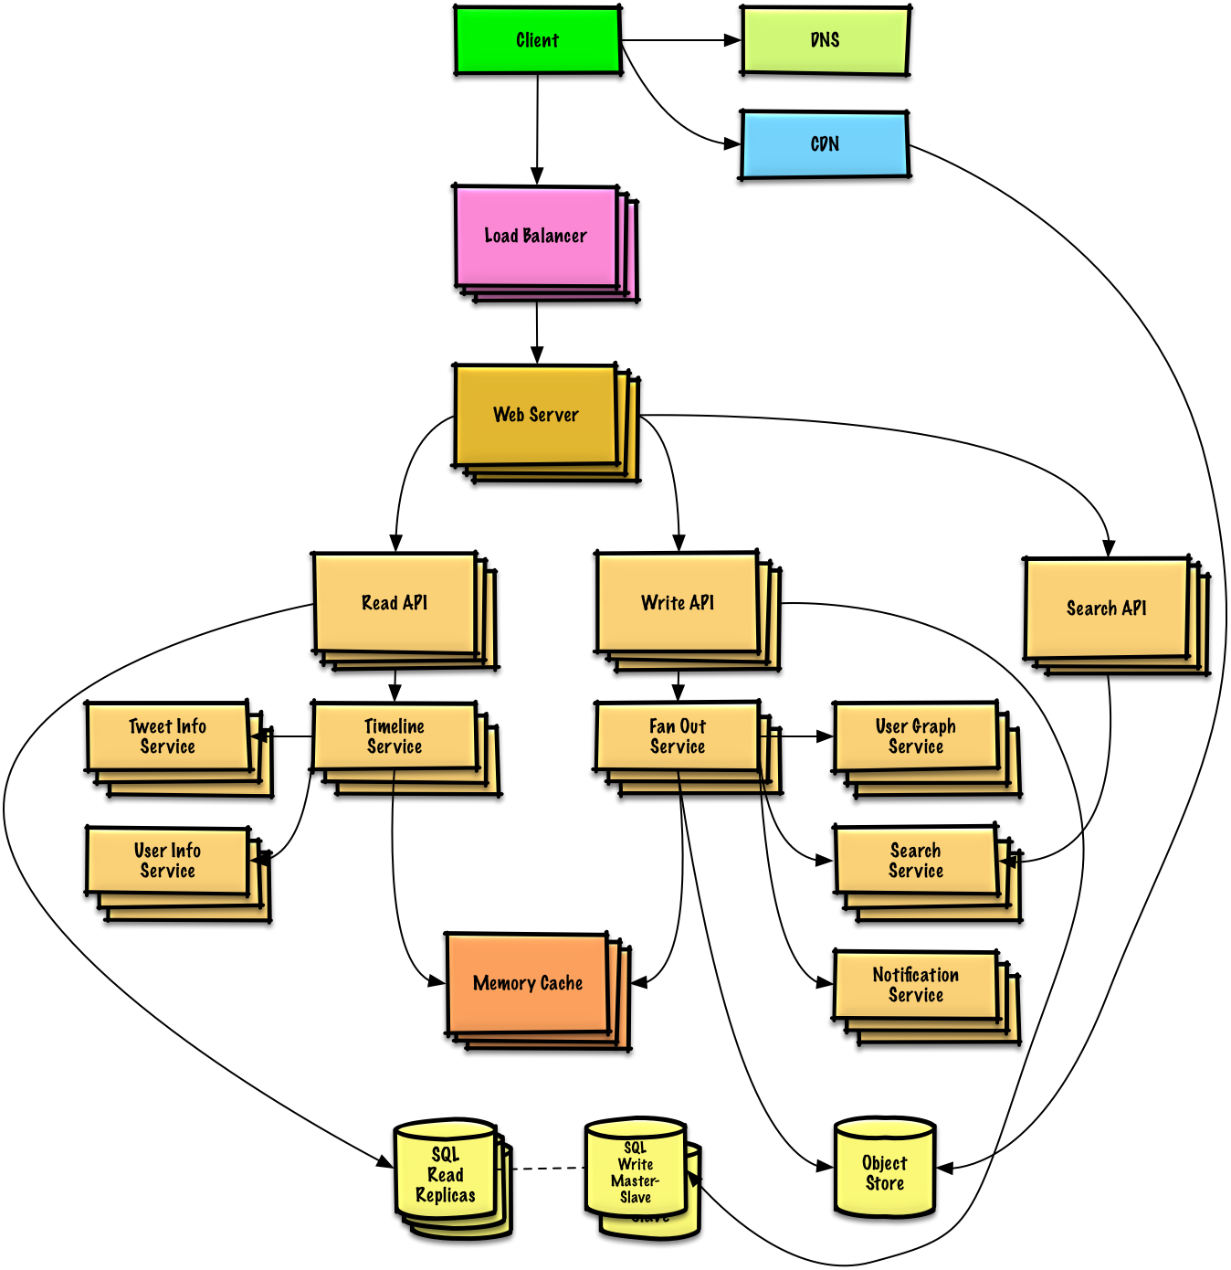

**2.2 User Characteristics**

**Admin** The administrator has all the rights to access the system. He is the one who has all rights to view the members and product details, modify those details. He can add various product based on the category. He can also set the available quantity of a product and its reasonable price. Also he can also set discount in various occasion. Admin can also view the details of a member. The admin have the power to generate the scratch card so that users can also use the recharge card to buy various product.

**Users** The user can log in to the system by using his specific email and password. User can view the products and order the products according to their own needs. He can view his profile and update his details. He can update his personal information by logging into the system. User can find various product by using search option easily. update his details. He can update his personal information by logging into the system. User can find various product by using search option easily.

**2.3 System Information**

This system is an automated Shop Management System. Through the software user can add members, add product, search product, update information, edit information, buy the product in quick time. The system has the following advantages:

• User friendly interface

• Fast access to database

• Search facility

• Look and Feel Environment

**2.4 System Analysis**

System Analysis refers into the process of examining a situation with the intent of improving it through better procedures and methods. System Analysis is the process of planning a new system to either replace or complement an existing system. But before any planning is done the old system must be thoroughly understood and the requirements determined. System analysis is therefore, the process of gathering and interpreting facts, diagnosing problems and using the information to recomment improvements in the system. System analysis is conducted with the following objectives in mind:

>> Evaluate the system concept for feasibility.

>>Perform economic and technical analysis.

>> Allocate functions to hardware, software people, database and other system elements.

>>Establish cost and schedule constraints.

>>Create a system definition that forms the foundation for all the subsequent engineering work.

**2.5 Feasibility Analysis**

Whatever we think need not be feasible .It is wise to think about the feasibility of any problem we undertake. Feasibility is the study of impact, which happens in the organization by the development of a system. The impact can be either positive or negative. When the positives nominate the negatives, then the system is considered feasible. Here the feasibility study can be performed in two ways such as technical feasibility and Economical Feasibility.

**Technical Feasibility:** It is technically feasible, since there will not be much difficulty in getting required resources for the development and maintaining the system as well. All the resources needed for the development of the software as well as the maintenance.

**Economical Feasibility:** Development of this application is highly economically feasible .The organization needed not spend much m one for the development of the system already available. The only thing is to be done is making an environment for the development with an effective supervision. I f we are doing so , we can attain the maximum usability of the corresponding resources .Even after the development , the organization will not be in a condition to invest more in the organization .Therefore , the system is economically feasible.

**2.7 Context Diagram**

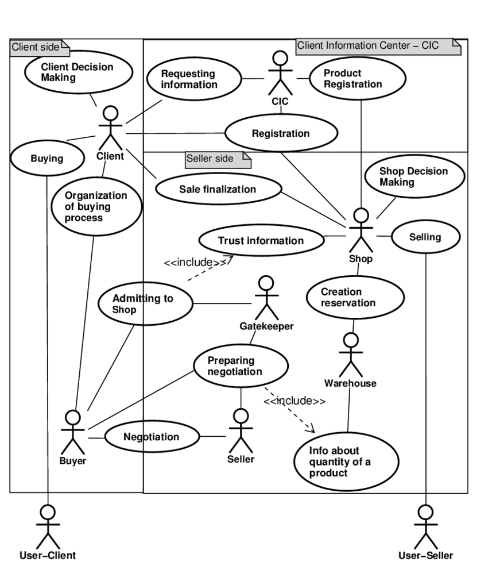

**Hardware and Software Requirement**

**3.1 Hardware Required**

Processor : Pentium IV or Above

RAM : 2GB or above

Hard Disk : 50GB or above

Input Devices : Keyboard, Mouse

Output Devices : Monitor

**3.2 Software Required**

Operating System : Linux, Ubuntu, Mac, Windows XP, 7, 8, 8.1, 10

Frontend : HTML,CSS, Bootstrap, JavaScript

Backend : Laravel, Vue js, MySQL

Local host : XAMPP/WAMP/LAMP/MAMP

**Implementing Tools for the Project**

**4.1 Tools**

>HTML

>CSS

>Bootstrap

>Laravel

>Vue Js

>MySQL

>XAMPP

**4.2 What is XAMPP**

XAMPP stands for Cross-Platform (X), Apache (A), MySQL (M), PHP (P) and Perl (P). It is a simple, lightweight Apache distribution that makes it extremely easy for developers to create a local web server for testing purposes. Everything you need to set up a web server – server application (Apache), database (MySQL), and scripting language (PHP) – is included in a simple extractable file. XAMPP is also cross-platform, which means it works equally well on Linux, Mac and Windows. Since most actual web server deployments use the same components as XAMPP, it makes transitioning from a local test server to a live server is extremely easy as well. Web development using XAMPP is especially beginner friendly.

**4.3What’s included in XAMPP**

XAMPP has four primary components. These are:

**Apache:** Apache is the actual web server application that processes and delivers web content to a computer. Apache is the most popular web server online, powering nearly 54% of all websites.

**MySQL:** Every web application, howsoever simple or complicated, requires a database for storing collected data. MySQL, which is open source, is the world’s most popular database management system. It powers everything from hobbyist websites to professional platforms like Word Press.

**PHP:** PHP stands for Hypertext Pre processor. It is a server-side scripting language that powers some of the most popular websites in the world, including Word Press and Facebook. It is open source, relatively easy to learn, and works perfectly with MySQL, making it a popular choice for web developers.

**Perl:** Perl is a high-level, dynamic programming language used extensively in network programming, system admin, etc. Although less popular for web development purposes.

**4.4 HTML**

Every webpage you look at is written in a language called HTML. You can think of HTML as the skeleton that gives every webpage structure. In this course, we'll use HTML to add paragraphs, headings, images and links to a webpage. In the editor to the right, there's a tab called test.html. This is the file we'll type our HTML into. Like any language, it has its own special syntax. A browser's job is to transform the code in test.html into a recognizable webpage! It knows how to lay out the page by following the HTML syntax.

**4.5 CSS**

Cascading Style Sheets (CSS) is a style sheet language used for describing the presentation of a document written in a markup language.[1] Most often used to set the visual style of web pages and user interfaces written in HTML and XHTML, and is applicable to rendering in speech, or on other media. Along with HTML and JavaScript, CSS is a cornerstone technology used by most websites to create visually engaging webpages, user interfaces for web applications, and user interfaces for many mobile applications. CSS is designed primarily to enable the separation of document content from document presentation, including aspects such as the layout, colors, and fonts.[3] This separation can improve content accessibility, provide more flexibility and control in the specification of presentation characteristics, enable multiple HTML pages to share formatting by specifying the relevant CSS in a separate .CSS file, and reduce complexity and repetition in the structural content.

**4.6 LARAVEL**

LARAVEL is a free open source PHP web frame work, created by taylor otwell and intended for the development of web applications following the model-view-controller architectural pattern and based on symphony. LARAVEL attempts to take the pain out of development by easing common tasks used in the majority of web projects, such as authentication , routing, sessions, and caching. LARAVEL aims to make the development process a pleasing one for the developer without sacrificing application functionality LARAVEL is a scripting language that is often used to develop a variety of web pages and Internet applications. Files that have the .LARAVEL extension can contain text, HTML tags and scripts. These files are processed by a remote server and are then returned to the user's Web browser as plain

**4.7 VUE JS**

Vue.js actually a java Script framework with various optional tools for building user interfaces.Vue.js is one of the those new software technologies that are being widely used across the world for web development. It is an open-source java Script framework for building user interfaces and single-page applications. Vue.js is a programming language that is run by most modern browsers. It supports object oriented programming and procedural programming. It can be used to control web pages on the client side of the browser, server-side programs, and even mobile applications. To write a Vue.js, you need a Web browser and either a text editor or an HTML editor. Once you have the software in place, you can begin writing JavaScript code. To add vue.js code to an HTML document, you need to create or open an HTML file with your text/HTML.

**4.8 MySQL**

> MySQL is a database system used on the web.

> MySQL is a database system that runs on a server.

> MySQL is ideal for both small and large applications.

>MySQL is very fast, reliable, and easy to use.

> MySQL uses standard SQL.

> MySQL compiles on a number of platforms.

>MySQL is free to download and use.

> MySQL is developed, distributed, and supported by Oracle Corporation.

**Project Database and Table**

**5.1 Database Design**

Database is critical for all businesses. A good database does not allow any form of anomalies and stores only relevant information in an ordered manner. If a database has anomalies, it is affecting the efficiency and data integrity. For example, delete anomaly arise upon the deletion of a row which also forces other useful data to be lost. As such, the tables need to be normalized. This fulfils the last objective of ensuring data are accurate and retrieved correctly.

Database files are the key source of information into the system. It is the process of designing database files, which are the key source of information to the system.

The files should be properly designed and planned for collection, accumulation, editing and retrieving the required information.

The organization of data in database aims to achieve three major objectives: -

> Data integration

>Data integrity

>Data independence

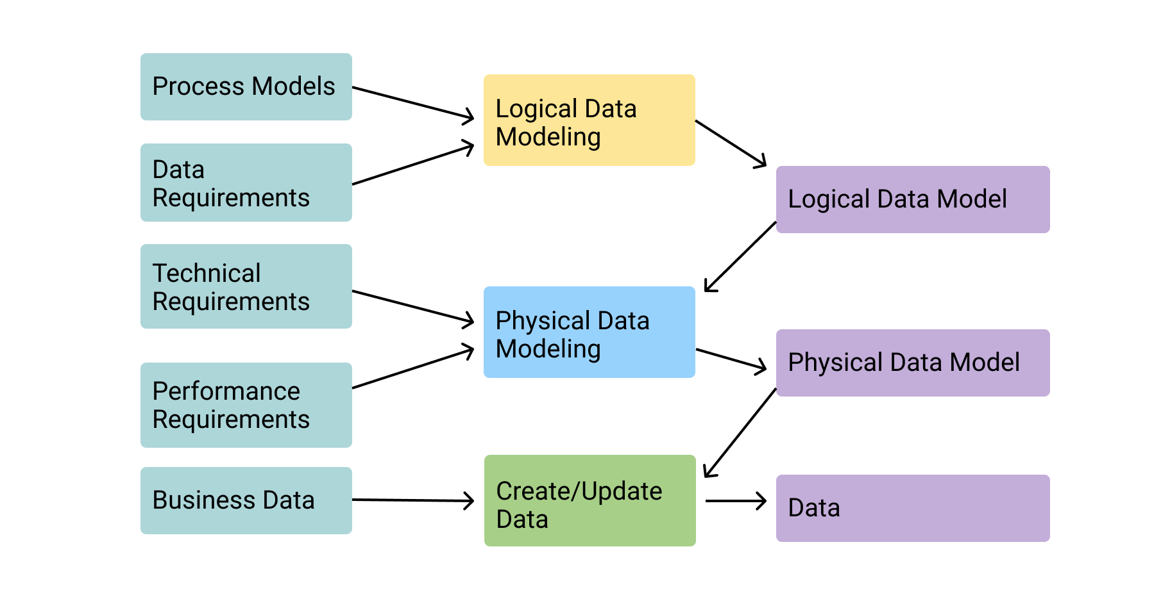

**5.2 All TABLE LIST**

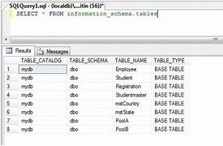

**5.3 Admin table**

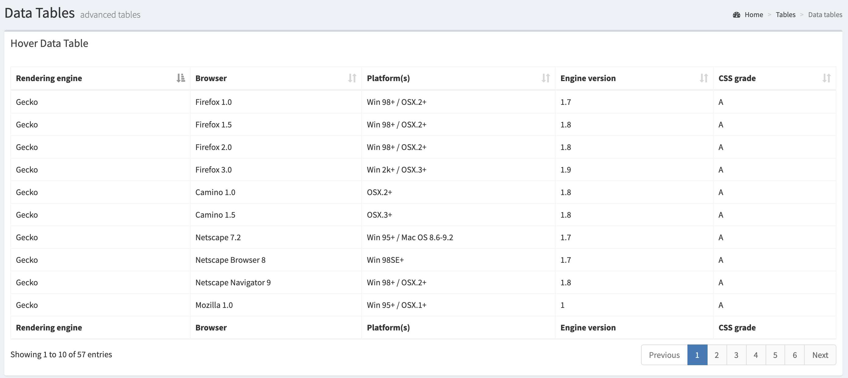

**5.4 User Table**

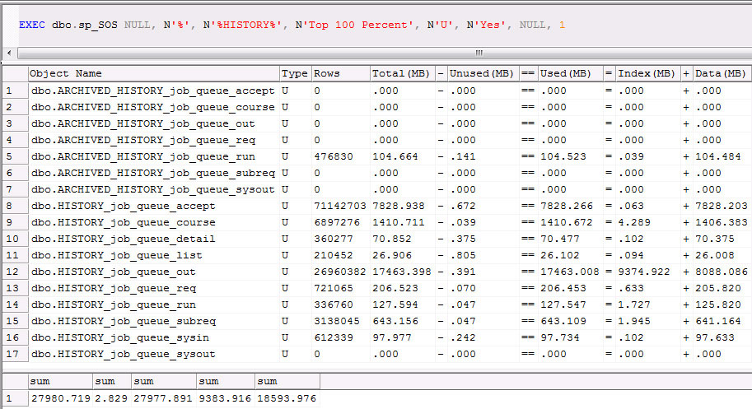

**5.5 product table**

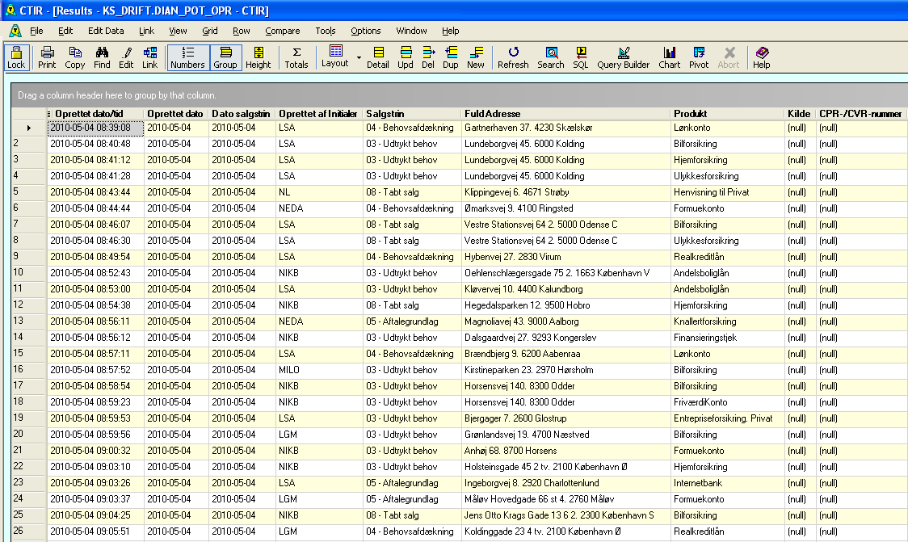

**5.6 category table**



**5.7 order table**

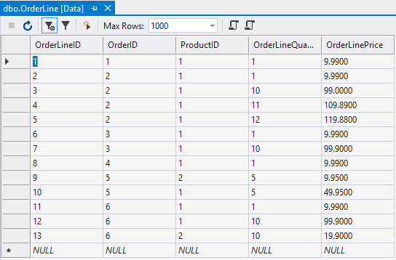

**Project Model View**

**6.1 Home Page**

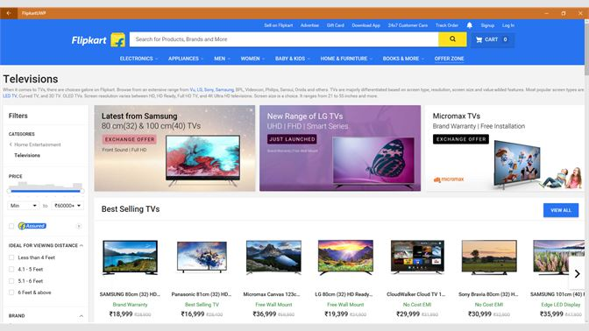

**6.2 login page**

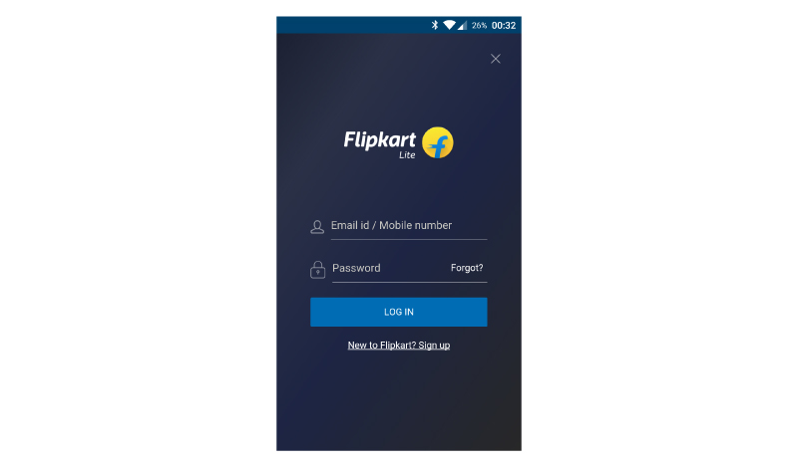

**6.3 mobile application**

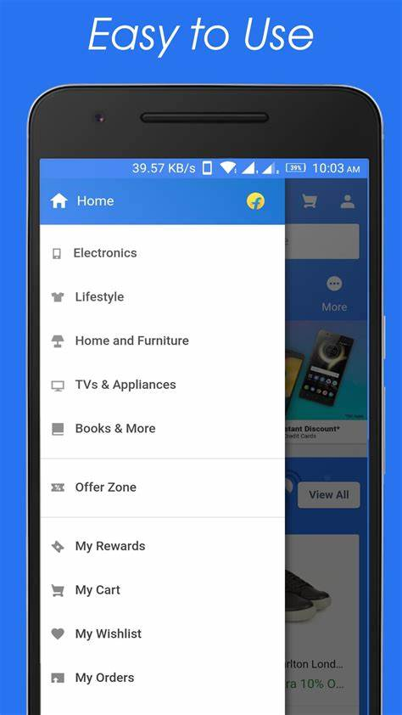

**Software Testing**

**7.1 Why Software Testing is Needed**

Tool-bars work properly? Are all menu function and pull down sub function properly listed? Is it possible to invoke each menu function using a logical assumptions that if all parts of the system are correct, the goal will be successfully achieved? In adequate testing or non-testing will leads to errors that may appear few months later. Testing represents an interesting anomaly for the software engineer. During earlier software engineering activities, the engineer attempts to build software from an abstract concept to a tangible product. Now comes testing. The engineer creates a series of test cases that are intended to “demolish” the software that has been built. In fact, testing is the one step in the software process that could be viewed (psychologically, at least) as destructive rather than constructive. Testing requires that the developer discard preconceived notions of the “correctness” of software just developed and overcome a conflict of interest that occurs when errors are uncovered.

**7.2 Testing Strategy**

There are types of testing that we implement. They are as follows: While deciding on the focus of testing activities, study project priorities. For example, for an online system, pay more attention to response time. Spend more time on the features used frequently. Decide on the effort required for testing based on the usage of the system. If the system is to be used by a large number of users, evaluate the impact on users due to a system failure before deciding on the effort.

This create two problem :

> Time delay between the cause and appearance of the problem.

> The effect of the system errors on files and records within the system.

The purpose of the system testing is to consider all the likely variations to which it will be suggested and push the systems to limits. The testing process focuses on the logical intervals of the software ensuring that all statements have been tested and on functional interval is conducting tests to uncover errors and ensure that defined input will produce actual results that agree with the required results. Program level testing, modules level testing integrated and carried out.

There are two major type of testing they are:

>White Box Testing.

>Black Box Testing.

**7.3 White Box Testing**

White box sometimes called “Glass box testing” is a test case design uses the control structure of the procedural design to drive test case. Using white box testing methods, the following tests where made on the system

a) All independent paths within a module have been exercised once. In our system, ensuring that case was selected and executed checked all case structures. The bugs that were prevailing in some part of the code where fixed.

b) All logical decisions were checked for the truth and falsity of the values

**7.4 Black Box Testing**

Black box testing focuses on the functional requirements of the software. This is black box testing enables the software engineering to derive a set of input conditions that will fully exercise all functional requirements for a program. Black box testing is not an alternative to white box testing rather it is complementary approach that is likely to uncover a different class of errors that white box methods like.

> Interface errors.

> Performance in data structure.

> Performance errors.

> Initializing and termination errors.

**Conclusion & Future Enhancement**

**8.1 Conclusion:**

This project is only a humble venture to satisfy the needs in a shop. Several user friendly coding have also adopted. This package shall prove to be a powerful package in satisfying all the requirements of the organization. The objective of software planning is to provide a frame work that enables the manger to make reasonable estimates made within a limited time frame at the beginning of the software project and should be updated regularly as the project progresses.

This website provides a computerized version of shop manipulate system which will benefit the users as well as the visitor of the shop. It makes entire process online where users can search product, and buy various product. It also has a facility for common user by login into the system where user can login and can see status of ordered item as well request for items or give some suggestions. It provide the facility of admin’s login where admins can add various item, review users activity and also give occasional discount and also add info about different events for the customer.

**8.1 Future aspect:**

The project has a very vast scope in future. The project can be implemented on intranet in future. Project can be updated in near future as and when requirement for the same arises, as it is very flexible in terms of expansion. With the proposed software of database Space Manager ready and fully functional the client is now able to manage and hence run the entire work in a much better, accurate and error free manner.

The following are the future scope for the project.

>Should be added payment gateway

>Can be added inventory management system

>Can be added multiple branches

>Can be added multilingual to this site

>And many features can be added this project to make it more robust.

DEPLOYEMENT DAIGRAM

