Assignment – 2
Wipro Pre-Skilling training
15-12-2025
Day-2

1. Write a script to Accept a value from user and print it.

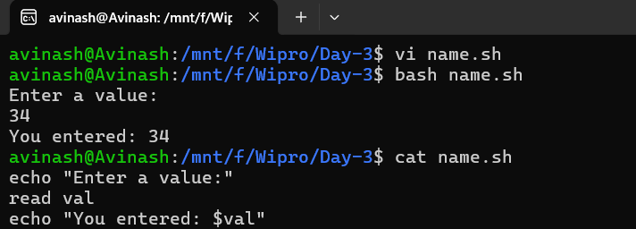
======================================================================
2. Accept two values from the user, and expression from the user and print the result.

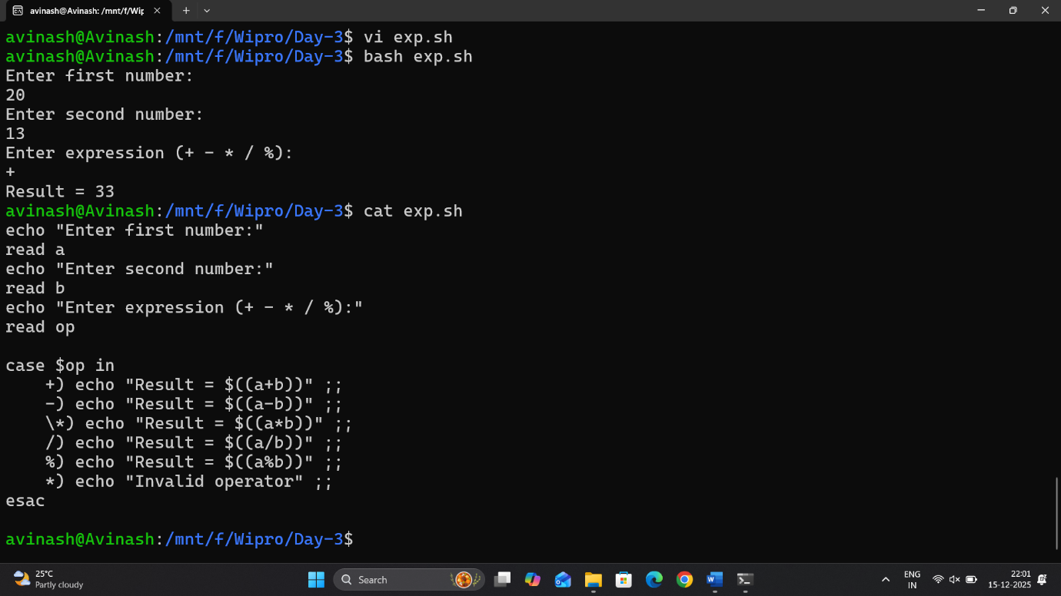

3. accept a number, check whether the number is even or odd.

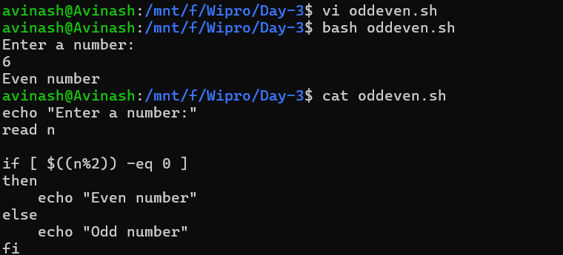
================================================================
4. Check whether a file exist and it is regular file or directory.
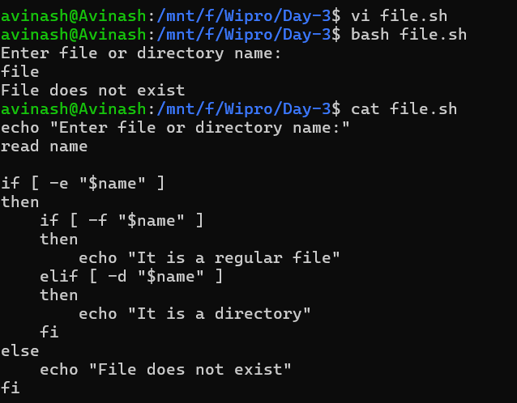
5. Accept a num: 100
Even: 100 102 104 106 108
Accept a num: 101
Odd: 101 103 105 107 109
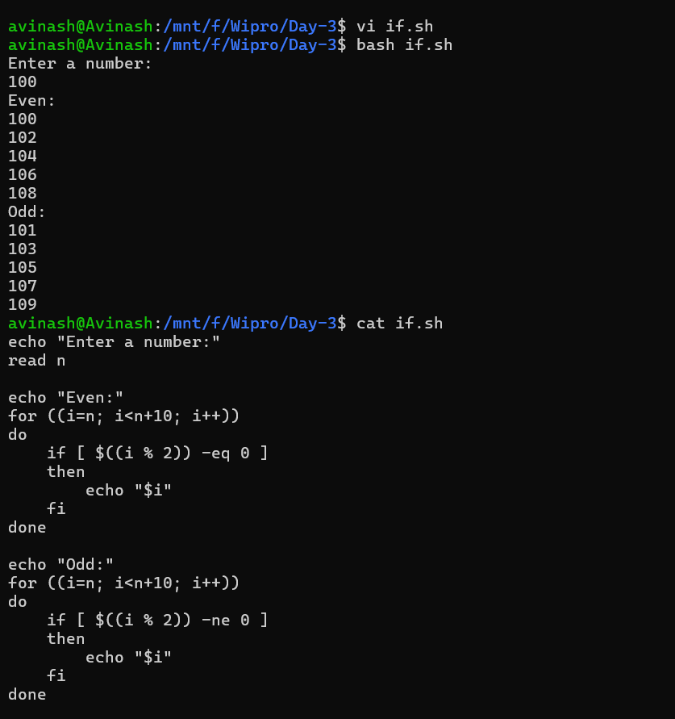

6. Folder name as input. get all files and sub-folder names from the given folder and print the same.

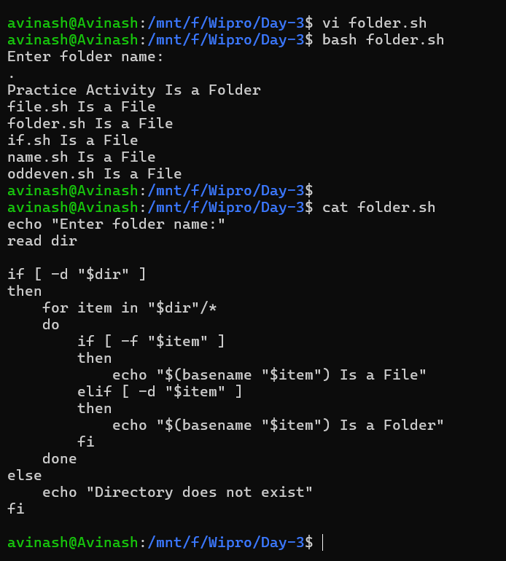

7. Update the second program, where you take num1, num2 and operators like (+, -, *, / , %)
print the result.

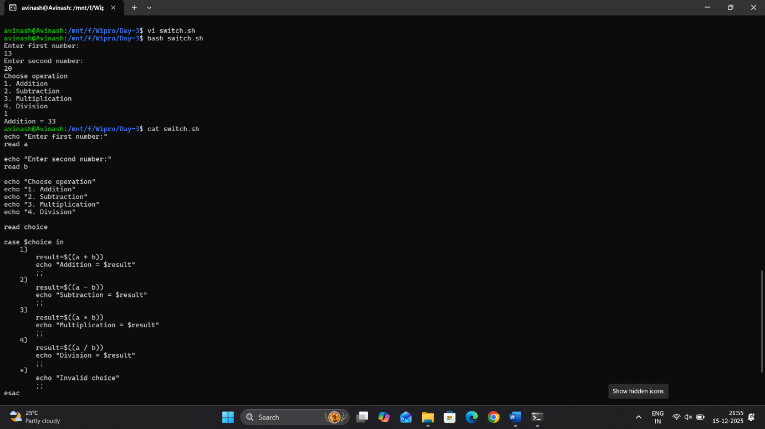

======================================================================

Another 7 programs: - (Tasks)

"Task 1: Ensure the script checks if a specific file (e.g., myfile.txt) exists in the current directory. If it exists, print ""File exists"", otherwise print ""File not found"".

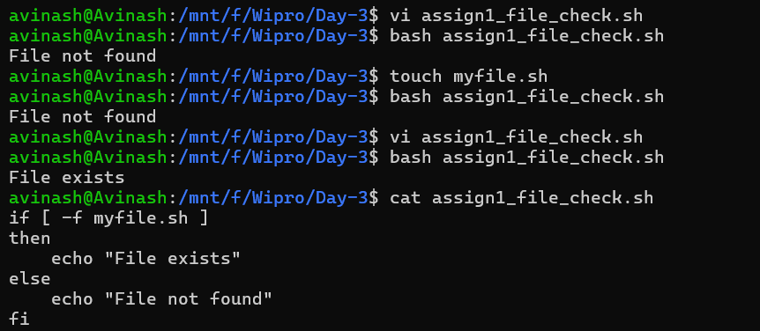

Task 2: Write a script that reads numbers from the user until they enter '0'. The script should also print whether each number is odd or even.

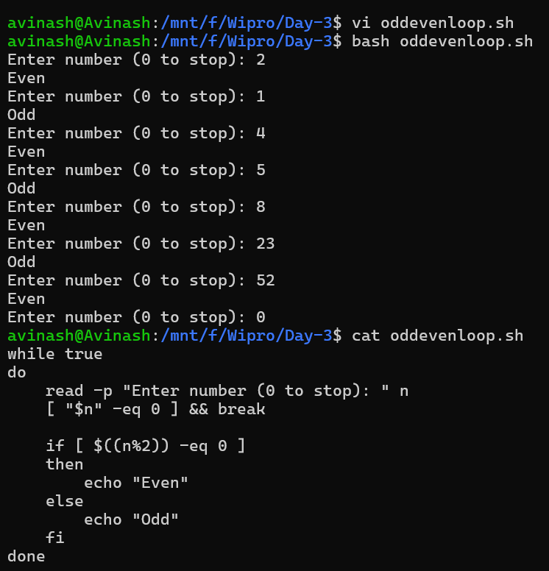

Task 3: Create a function that takes a filename as an argument and prints the number of lines in the file. Call this function from your script with different filenames.

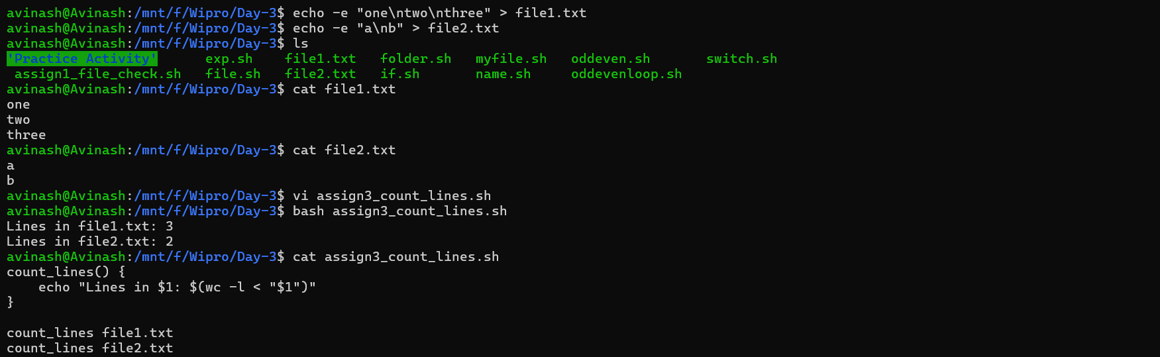

======================================================================

Task 4: Write a script that creates a directory named TestDir and inside it, create ten files named File1.txt, File2.txt, ... File10.txt. Each file should contain its filename as its content (e.g., File1.txt contains ""File1.txt"").

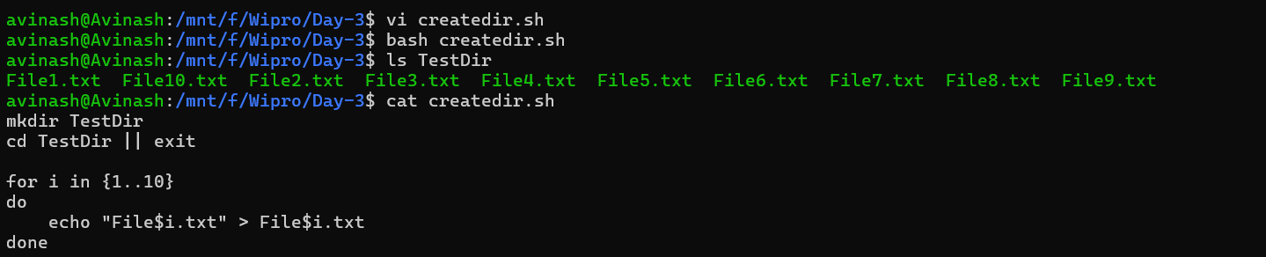

Task 5: Modify the script to handle errors, such as the directory already existing or lacking permissions to create files.
Add a debugging mode that prints additional information when enabled.

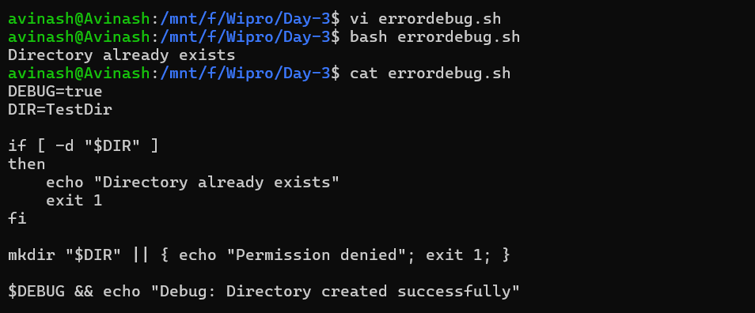
======================================================================
Task 6: Given a sample log file, write a script using grep to extract all lines containing ""ERROR"". Use awk to print the date, time, and error message of each extracted line.
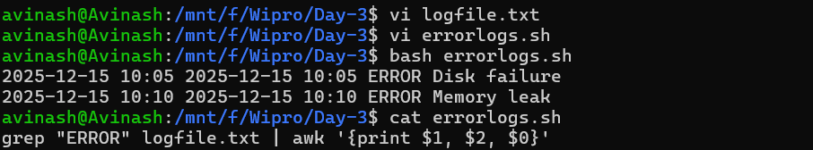
======================================================================
Task 7: Create a script that takes a text file and replaces all occurrences of ""old_text"" with ""new_text"". Use sed to perform this operation and output the result to a new file.
