12-12-2025
Day-2 Assignment -1
Today’s topics:-
Git Introduction, Initializing a Repository (git init), Git Operations and Workflow, Viewing Commit History (git log), Branching and Merging, Complex Merging Techniques, Forking and Cloning Repositories, Pushing and Pulling Branches, Creating and Managing Pull Requests.

TASK - 1: Initialize a new Git repository in a directory of your choice. Add a simple text file to the repository and make the first commit.

-> Completed using PowerShell, Repository initialised, file added, and First commit created Successfully.

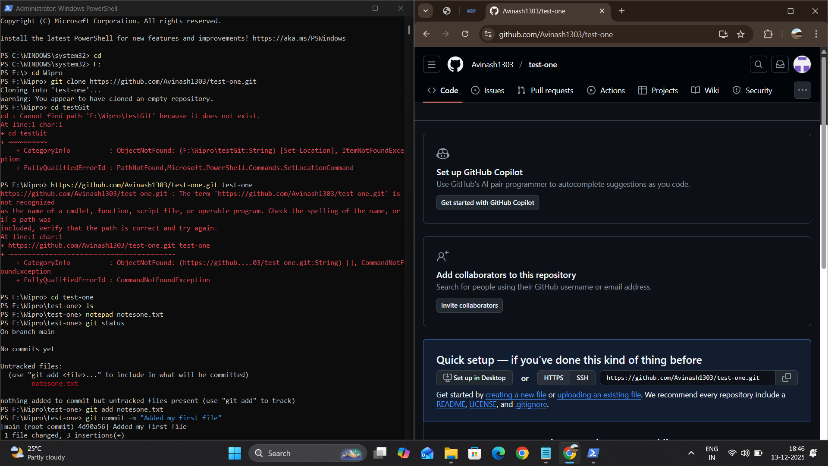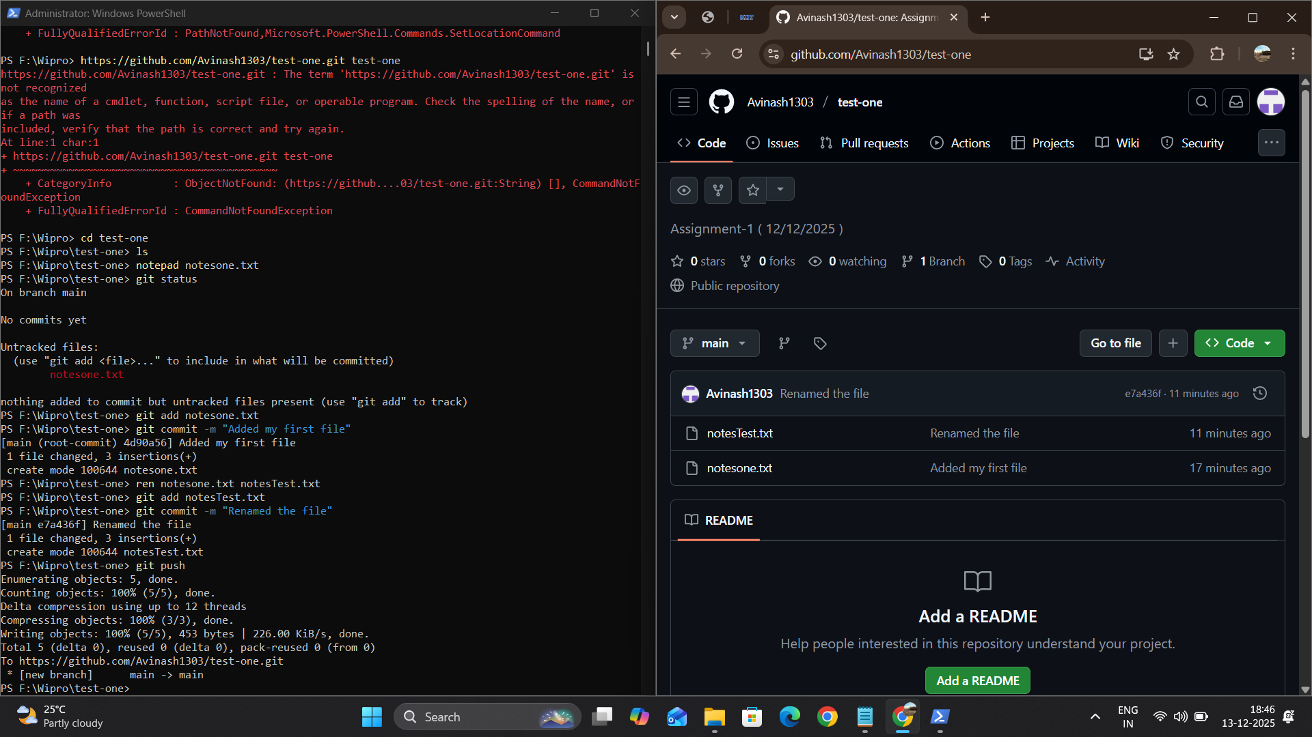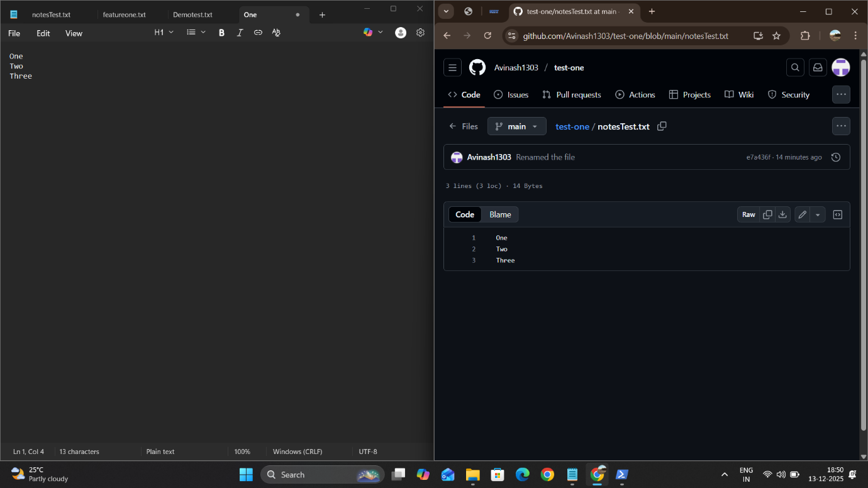

TASK - 2: Branch Creation and Switching Create a new branch named 'feature' and switch to it. Make changes in the 'feature' branch and commit them.

-> Feature branch created, changes committed, and branch pushed to GitHub.

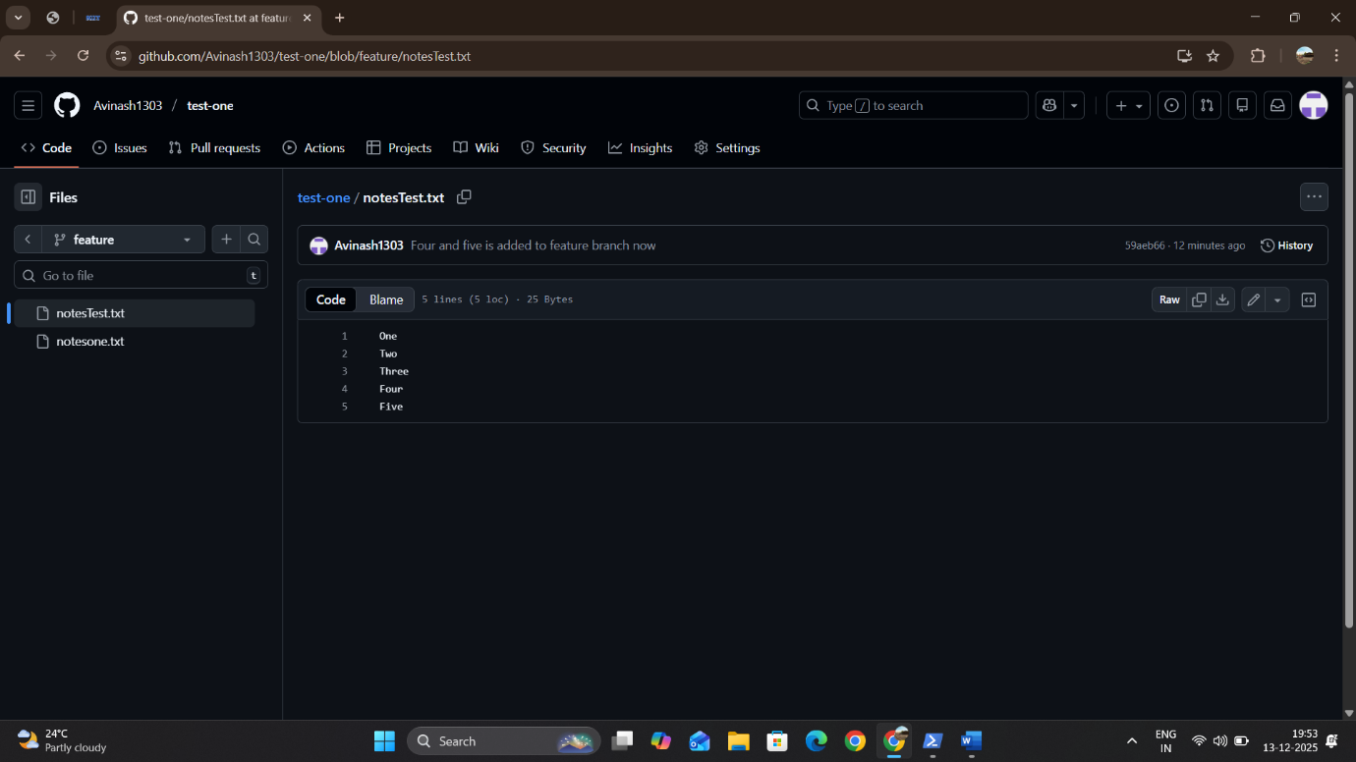

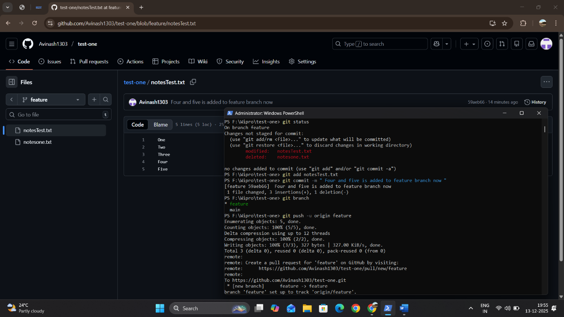
TASK - 3: Feature Branches and Hotfixes Create a 'hotfix' branch to fix an issue in the main code. Merge the 'hotfix' branch into 'main' ensuring that the issue is resolved.

Hotfix branch created, issue fixed, merged into main, and pushed to GitHub.

