Contract Testing Business Demo
Complete Architecture and Flow Guide

Repository: Avinash258/contract-testing-business-demo
Prepared for: QA / Test Architecture learners
Document date: 27 October 2026
Source: docs-analysis/00 … 06 Markdown pack (explain-only analysis)
Diagrams: 19 Mermaid figures rendered to PNG

This document merges the docs-analysis Markdown files without rewriting their content. Mermaid diagrams are embedded as figures. Commands described in the source were not executed for the analysis.

Table of Contents
Right-click → Update Field to refresh Table of Contents.

Document outline (static)
- Index and Discovery — source section “Index and Discovery”
- Beginner Concepts — source section “Beginner Concepts”
- Architecture — source section “Architecture”
- File-by-File Guide — source section “File-by-File Guide”
- End-to-End Flow — source section “End-to-End Flow”
- How It Runs (Explained) — source section “How It Runs (Explained)”
- Glossary and Q&A — source section “Glossary and Q&A”

List of Diagrams
- Figure 1: How to read these analysis files _(source: section “Index and Discovery”, type: flowchart)_
- Figure 2: With vs without contracts _(source: section “Beginner Concepts”, type: flowchart)_
- Figure 3: Test pyramid speed layers _(source: section “Beginner Concepts”, type: flowchart)_
- Figure 4: Downstream and upstream example _(source: section “Beginner Concepts”, type: flowchart)_
- Figure 5: Business problem this demo solves _(source: section “Beginner Concepts”, type: flowchart)_
- Figure 6: System context (C4-style) _(source: section “Architecture”, type: C4Context)_
- Figure 7: Gateway to six microservices _(source: section “Architecture”, type: flowchart)_
- Figure 8: Component diagram _(source: section “Architecture”, type: flowchart)_
- Figure 9: Contract data flow sequence _(source: section “Architecture”, type: sequenceDiagram)_
- Figure 10: Contract mesh CT-00 to CT-17 _(source: section “Architecture”, type: flowchart)_
- Figure 11: Upload-driven filing flow _(source: section “Architecture”, type: flowchart)_
- Figure 12: Module class diagram _(source: section “Architecture”, type: classDiagram)_
- Figure 13: Recommended beginner read order _(source: section “File-by-File Guide”, type: flowchart)_
- Figure 14: Contract lifecycle sequence _(source: section “End-to-End Flow”, type: sequenceDiagram)_
- Figure 15: Happy path verification _(source: section “End-to-End Flow”, type: flowchart)_
- Figure 16: Contract broken path _(source: section “End-to-End Flow”, type: flowchart)_
- Figure 17: Filing happy path sequence _(source: section “End-to-End Flow”, type: sequenceDiagram)_
- Figure 18: test:contracts check flow _(source: section “How It Runs (Explained)”, type: flowchart)_
- Figure 19: Learning path progression _(source: section “Glossary and Q&A”, type: flowchart)_

00 — Index and Discovery
Source file: 00-README-INDEX.md

TaxMesh Contract-Testing Demo — Analysis Index
Repo analyzed: contract-testing-business-demo (TaxMesh Form 1065 microservices)
Mode: Explain-only / read-only (no installs, builds, or test runs)
Created: docs-analysis/ (analysis artifacts only)

How to read these files
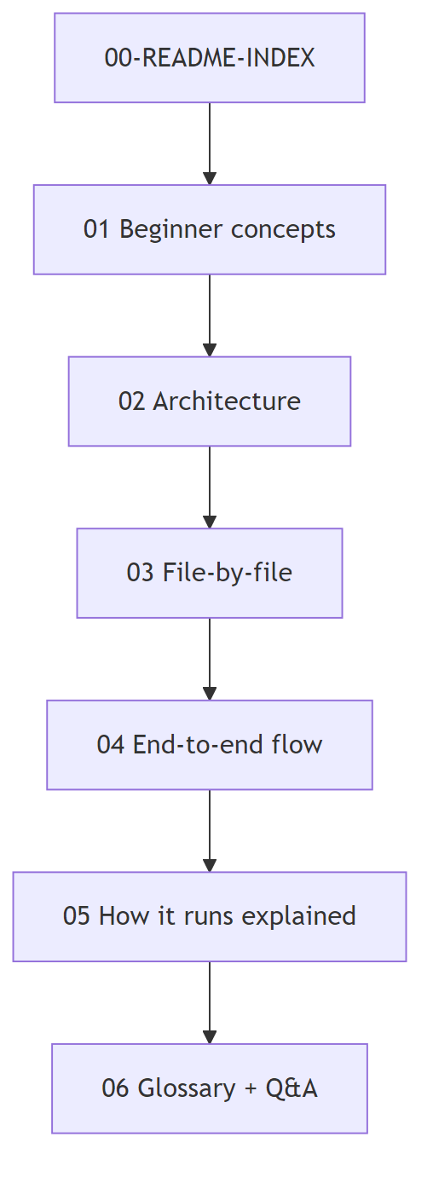
Figure 1: How to read these analysis files
Order | File | Read when you want…
0 | section “Index and Discovery” | Map of the pack + Phase 1 discovery table
1 | section “Beginner Concepts” | What contract testing is in this repo
2 | section “Architecture” | Services, deps, diagrams
3 | section “File-by-File Guide” | Every important file + deep dives
4 | section “End-to-End Flow” | Lifecycle, happy/fail paths, sample CT
5 | section “How It Runs (Explained)” | Commands explained (not executed)
6 | section “Glossary and Q&A” | Terms, interview Qs, 2-min pitch

Tip: Prefer tables and Mermaid diagrams; use prose only as captions.

One-line verdict
Question | Answer
What is this? | Node/Express TaxMesh demo: 6 microservices + gateway for Form 1065
Contract tool? | Custom shape checker — not Pact / Spring Cloud Contract
How verified? | npm run test:contracts → contracts/run-contracts.js HTTP GETs producers
Broker / CI gate? | Not found in repo

Phase 1 discovery table (full)
Item | Found | Evidence (file path)
Language | JavaScript (Node.js) | package.json, **/*.js
Package manager | npm | package.json, package-lock.json
Runtime (container) | Node 20 Alpine | Dockerfile
Web framework | Express ^4.21.2 | package.json
Contract testing tool | Custom runner | contracts/run-contracts.js
Pact library | Not found | no dependency / import
Spring Cloud Contract | Not found | no Java/Maven
Pact Broker | Not found | —
can-i-deploy | Not found | —
Jest / Mocha / JUnit | Not found | only test:contracts
CI (GitHub Actions, Jenkins) | Not found | no workflow files
Docker | Yes | Dockerfile, docker-compose.yml
Frontend | Vanilla SPA | frontend/
OpenAPI / Swagger | Yes | swagger-ui-express, shared/openapi.js
Demo data | Excel sets | testdata/set-01 … set-05
Domain docs | Yes | README.md, docs/ARCHITECTURE.md, CASE_STUDY.md

Repo tree + purpose
Path | One-line purpose
services/ | Microservice entrypoints (CLM…DOC + alias folders)
gateway/ | Port 4100 — UI host, proxy, filing, Swagger
frontend/ | Browser SPA
shared/ | Contracts, payloads, service factory, filing engine
contracts/ | Contract verification runner
testdata/ | Demo Excel uploads
docs/ | Human architecture/API manuals
postman/ | API collection
scripts/ | start-all + generators
docker-compose.yml | Multi-container run
docs-analysis/ | This teaching pack

Phase gate checklist
Gate | Topic | Status
1 | Discovery / tech stack | Complete (table above)
2 | Beginner concepts mapped to repo | See section “Beginner Concepts”
3 | Architecture boxes → real files | See section “Architecture”
4 | Important files documented | See section “File-by-File Guide”
5 | Flows match code/test names | See section “End-to-End Flow”
6 | Commands explained, not executed | See section “How It Runs (Explained)”
7 | Glossary + uncertainties | See section “Glossary and Q&A”

Related upstream docs (already in repo)
File | Use
README.md | Quick start
docs/ARCHITECTURE.md | Official architecture
docs/API.md | API reference
CASE_STUDY.md | Case-study brief

01 — Beginner Concepts
Source file: 01-beginner-concepts.md

01 — Beginner Concepts (mapped to THIS repo)
Evidence paths are relative to contract-testing-business-demo/.

1. What is contract testing?
Idea: Two services agree on a message shape (fields + meaning). Tests check that shape without spinning up the full real stack every time.
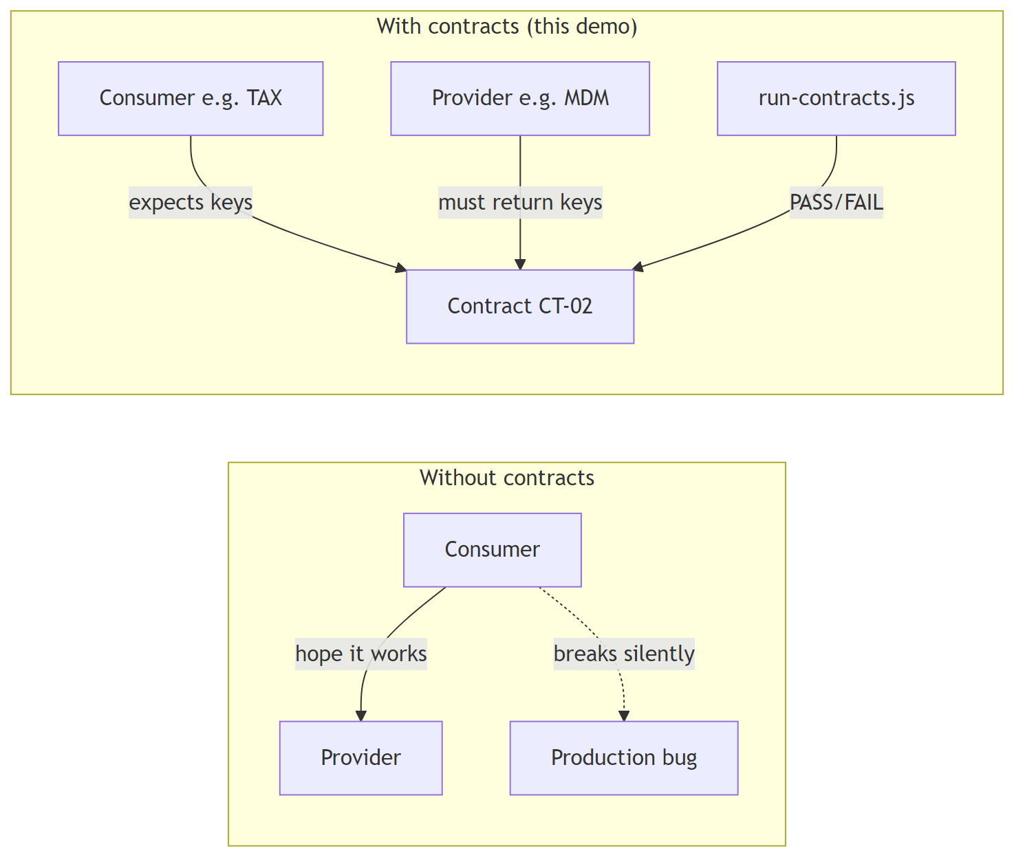
Figure 2: With vs without contracts
Question | Answer in THIS repo
What is the “contract”? | JSON payload shape for CT-00…CT-17 in shared/payloads.js + metadata in shared/contracts.js
How is it checked? | contracts/run-contracts.js → check(ct) fetches producer URL, asserts contractId + requiredKeys
Is it Pact / Spring Cloud Contract? | No — custom Node runner (Not found: pact, broker, can-i-deploy)

2. Why it exists (vs Integration vs E2E)
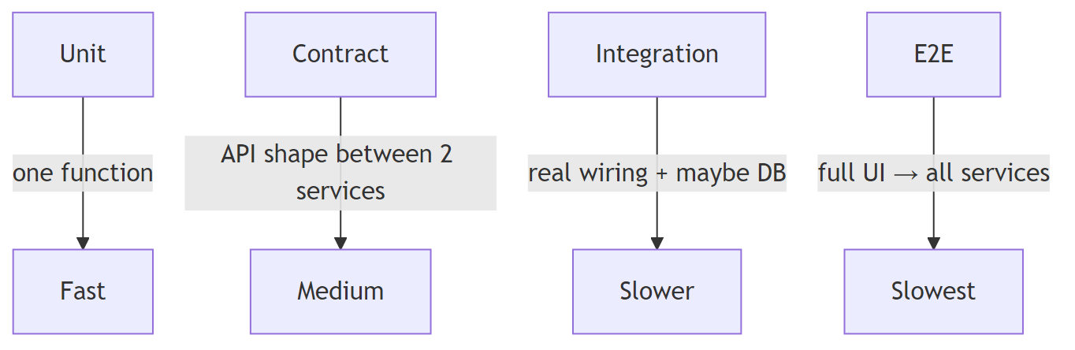
Figure 3: Test pyramid speed layers
Type | What it proves | Speed | Cost when it fails | In THIS repo?
Unit | One function works | Fast | Cheap | Not found (no Jest/Mocha)
Contract | Producer JSON has expected keys / contractId | Fast-ish | Cheap | Yes — npm run test:contracts → contracts/run-contracts.js
Integration | Services + shared store/filing talk correctly | Medium | Medium | Partial — filing APIs / uploads (gateway/filingRoutes.js, shared/filingEngine.js) act as demo integration, not a separate test suite
E2E | User journey in UI to e-file | Slow | Expensive | UI demo (frontend/) — not an automated E2E suite

3. Core terms — only what THIS repo uses
Term | Simple meaning | Used here? | Evidence
Consumer | Service that reads another’s data | Yes | CONTRACTS[].consumer in shared/contracts.js
Producer / Provider | Service that exposes the JSON | Yes | CONTRACTS[].producer; routes in shared/createService.js
Contract / Pact file | Agreement on shape | Yes (as JS objects, not .json pact files) | shared/payloads.js PAYLOADS, shared/contracts.js CONTRACTS
Broker | Central store for contracts | Not found in repo | —
Provider verification | Provider proves it still matches consumer contracts | Partial / custom | Runner hits live producer HTTP endpoints (run-contracts.js check)
Mocks / Stubs | Fake responses | In-memory samples | Producers return PAYLOADS[ct.id] from createService.js
can-i-deploy | Deploy safety check via broker | Not found in repo | —
Downstream | Forward along journey | Yes | direction: 'downstream'
Upstream / reverse | Feedback ask back to earlier service | Yes | direction: 'reverse' ≡ API upstream (apiDirection in contracts.js)

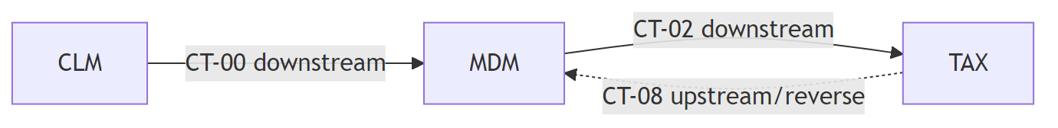
Figure 4: Downstream and upstream example

4. Comparison table (memorize this)
 | Contract (TaxMesh) | Integration | E2E | Unit
Scope | One CT payload shape | Several modules + filing store | Full Form 1065 UI path | Single function
Needs all 6 services up? | Yes for test:contracts (HTTP fetch) | Often yes | Yes + browser | No
Fails when | Missing key / wrong contractId / HTTP error | Wrong business flow | UI or any layer broken | Logic bug
Command (if any) | npm run test:contracts | Manual via UI/API | Manual UI | Not found
File | contracts/run-contracts.js | shared/filingEngine.js | frontend/app.js | —

5. Business problem THIS demo solves
Domain: US partnership Form 1065 tax filing across microservices (TaxMesh).
Workspace | Code | Port | Job | Evidence
Client Management | CLM | 4101 | Engagement / project / job | SERVICES.CLM in shared/contracts.js
Master Data | MDM | 4102 | Entity, partners, ownership | SERVICES.MDM
Accounting | ACC | 4103 | Trial balance / books | SERVICES.ACC
Tax Computation | TAX | 4104 | Federal/state calc | SERVICES.TAX
Allocations | ALC | 4105 | Partner K-1 amounts | SERVICES.ALC
Forms & Documents | DOC | 4106 | 1065 / K-1 package | SERVICES.DOC
Gateway + UI | — | 4100 | Orchestration + SPA | gateway/index.js, frontend/

Problem in plain English:
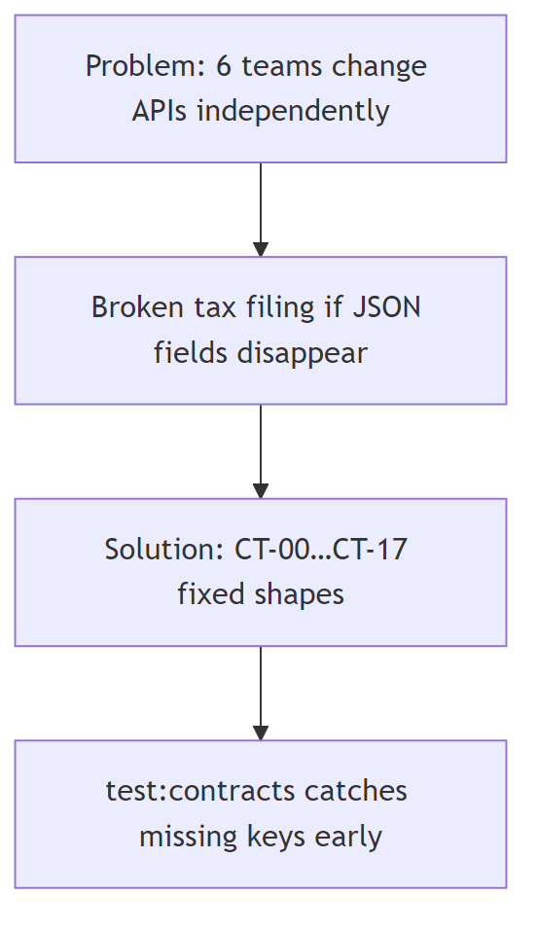
Figure 5: Business problem this demo solves
Pain | How demo addresses it | File
MDM changes entity fields → TAX breaks | CT-02 shape fixed in PAYLOADS['CT-02'] | shared/payloads.js
TAX needs MDM correction | Upstream CT-08 | shared/contracts.js
Need demo data without real banks | Excel sets | testdata/set-0N/*.xlsx
Need one UI to drive journey | Gateway SPA | frontend/, /api/filing/*

Journey (from README.md / CASE_STUDY.md):
CLM → MDM → ACC → TAX → ALC → DOC / MeF

6. Mini glossary of THIS project’s “contract”
Piece | Role | File
Catalog row | Who produces/consumes, path, direction | CONTRACTS in shared/contracts.js
Sample body | The agreed JSON fields | PAYLOADS in shared/payloads.js
HTTP produce | GET path returns sample + metadata | createService.js loop over produced
HTTP consume | Consumer pulls producer | GET /consume/:contractId in createService.js
Verification | Assert keys exist | requiredKeys + check in run-contracts.js

Gate 2
Check | Status
Concepts mapped to this repo (not only theory) | Done
Broker / Pact / can-i-deploy | Correctly marked Not found
Business domain = Form 1065 TaxMesh | Done
Uncertain | Alias folders (services/cem vs services name codes) — both valid entry points

02 — Architecture
Source file: 02-architecture.md

02 — Architecture
Every box maps to a real folder/file under contract-testing-business-demo/.

1. System context (C4-style)
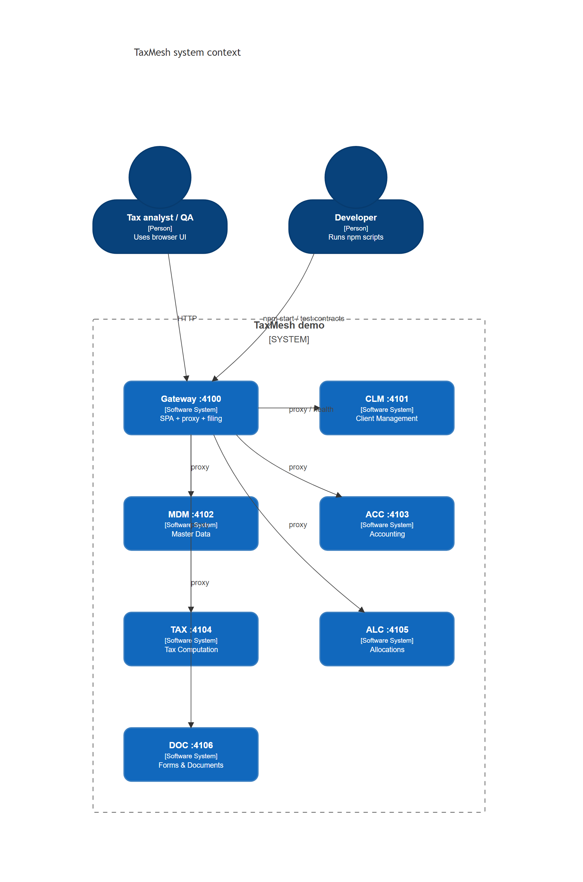
Figure 6: System context (C4-style)
Box | Real path
Gateway | gateway/index.js, gateway/filingRoutes.js
CLM | services/cem/index.js → createService('CLM')
MDM | services/mad/index.js → createService('MDM')
ACC | services/cam/index.js → createService('ACC')
TAX | services/tim/index.js → createService('TAX')
ALC | services/rpam/index.js → createService('ALC')
DOC | services/forms-print/index.js → createService('DOC')
SPA | frontend/index.html, frontend/app.js, frontend/styles.css
Shared catalog | shared/contracts.js, shared/payloads.js
Contract runner | contracts/run-contracts.js

Simpler flowchart (same as docs/ARCHITECTURE.md):
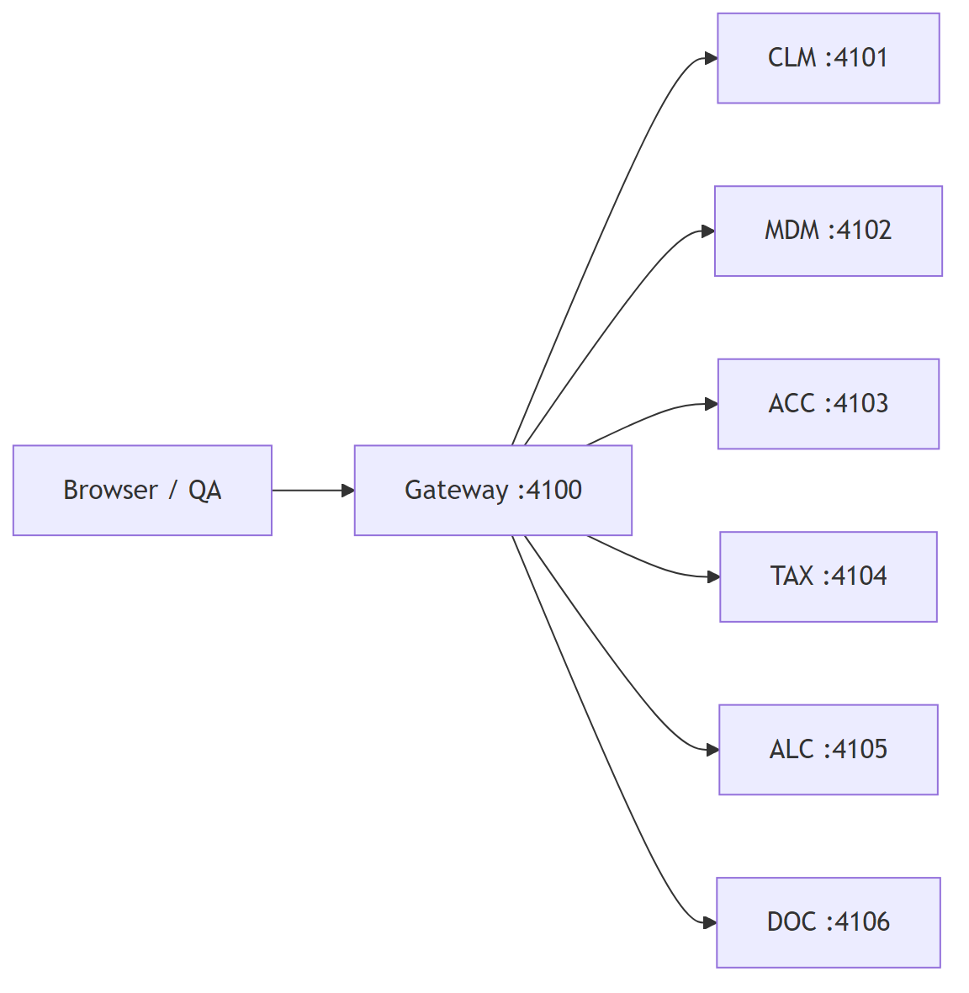
Figure 7: Gateway to six microservices

2. Component diagram
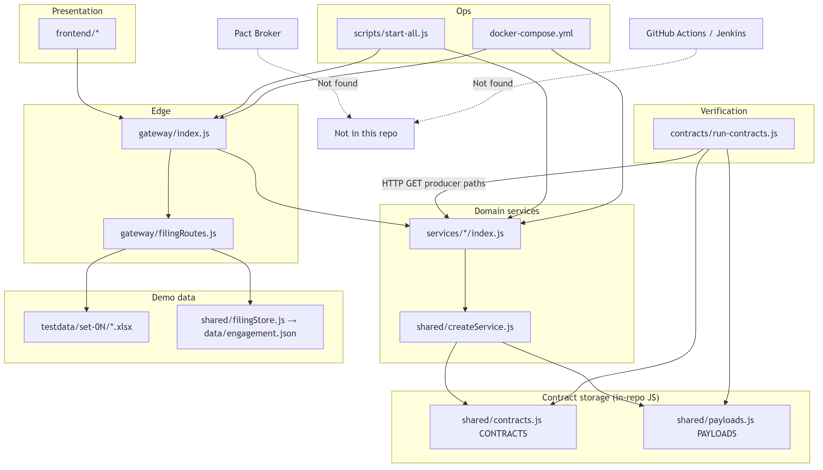
Figure 8: Component diagram
Component | Technology | Folder/File
Consumers / Producers | Express microservices | services/ + shared/createService.js
Contract catalog | JS arrays/objects | shared/contracts.js
Sample payloads | JS objects | shared/payloads.js
Contract storage | In source code (not broker) | same files
Broker | Not found | —
CI gate | Not found | —
Verification runner | Node fetch script | contracts/run-contracts.js

3. Tech stack table
Layer | Technology | Version | Purpose | Evidence
Runtime | Node.js | 20 (Docker); local version Not found pinned in README | Run services | Dockerfile FROM node:20-alpine
Package manager | npm | lockfile present | Install deps | package-lock.json
HTTP API | Express | ^4.21.2 | Microservices + gateway | package.json
CORS | cors | ^2.8.5 | Cross-origin | package.json
Uploads | multer | ^2.5.0 | Excel upload | gateway/filingRoutes.js
Excel | xlsx | ^0.18.5 | Parse/generate sheets | shared/excelImport.js
OpenAPI UI | swagger-ui-express | ^5.0.1 | Swagger at /api-docs | gateway/index.js
ZIP | archiver | ^5.3.2 | Postman/testdata zips | gateway/index.js
DOCX gen | docx | ^9.14.0 | Guide generation | scripts/generate-guide-docx.js
Frontend | Vanilla HTML/CSS/JS | — | SPA | frontend/
Containers | Docker Compose | compose file v-style | Multi-service | docker-compose.yml
Contract tool | Custom runner | 1.0.0 app | Shape checks | contracts/run-contracts.js

4. Dependency table (module → depends on → why)
Module | Depends on | Why | Evidence
services/*/index.js | shared/createService.js | Build Express app | each service file
shared/createService.js | contracts.js, payloads.js, flowApis.js, serviceUploads.js, serviceValidation.js, serviceV2Apis.js | Routes + payloads | requires at top
shared/flowApis.js | contracts.js, payloads.js | Downstream/upstream APIs | requires
contracts/run-contracts.js | shared/contracts.js, shared/payloads.js | Verify shapes | requires
gateway/index.js | contracts.js, payloads.js, openapi.js, filingRoutes.js, flowApis.js | Proxy + docs + UI | requires
gateway/filingRoutes.js | filingEngine.js, filingStore.js, contracts.js | Filing orchestration | requires
shared/filingEngine.js | filingStore.js, payloads.js, excelImport.js, dataFlow.js, businessValidation.js | Form 1065 journey | requires
frontend/app.js | Gateway HTTP APIs | UI calls /api/* | fetch usage in file
scripts/start-all.js | child processes of services + gateway | Boot everything | spawn list
Docker services | same Node images | Isolated ports | docker-compose.yml

5. Data / contract flow
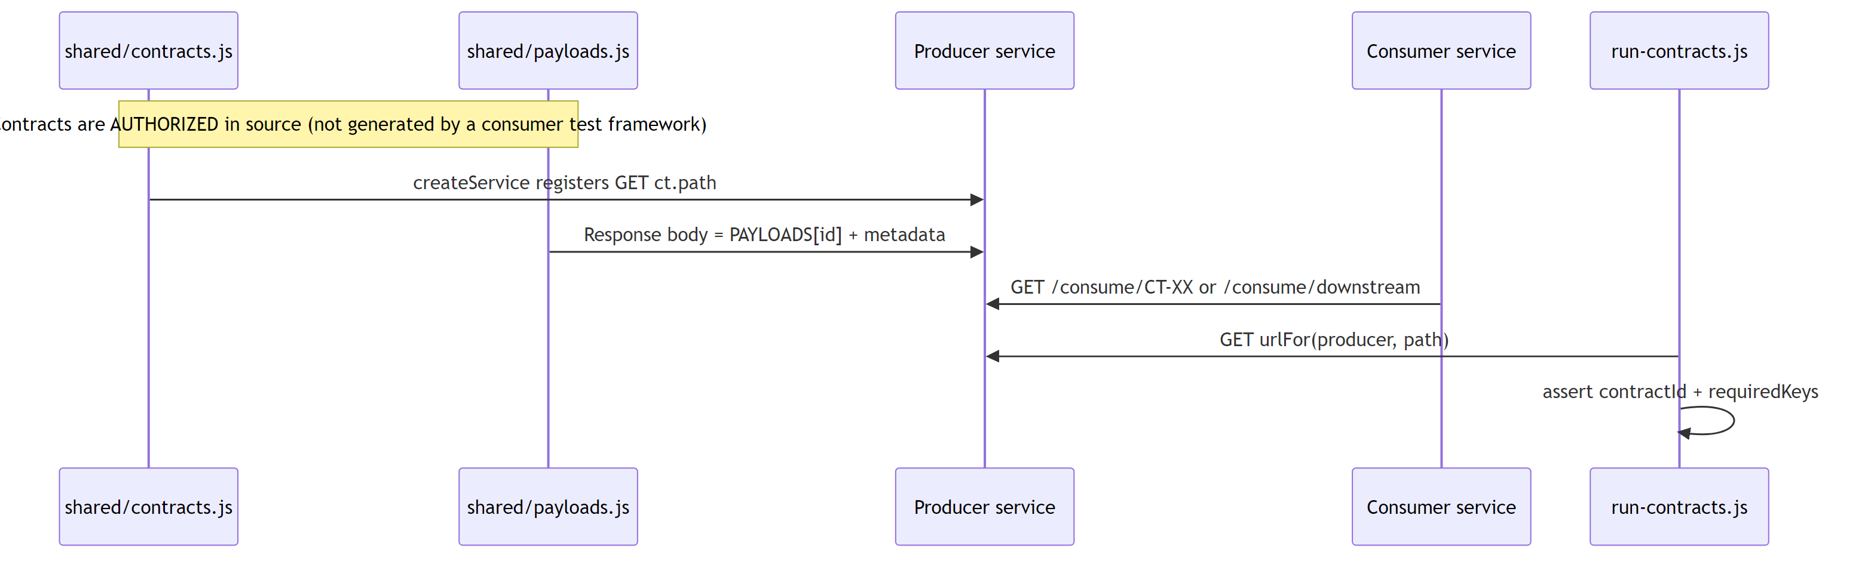
Figure 9: Contract data flow sequence
Step | Where | File
Contract defined | JS catalog | shared/contracts.js CONTRACTS
Shape defined | Sample payloads | shared/payloads.js PAYLOADS
Contract “generated” | Not generated at runtime from consumer tests — hand-authored | Not found: Pact generate step
Stored | In git as JS | same files
Served | Producer HTTP | createService.js app.get(ct.path, …)
Verified | Runner | contracts/run-contracts.js check
Published to broker | Not found | —

Contract mesh (downstream solid / upstream dashed)
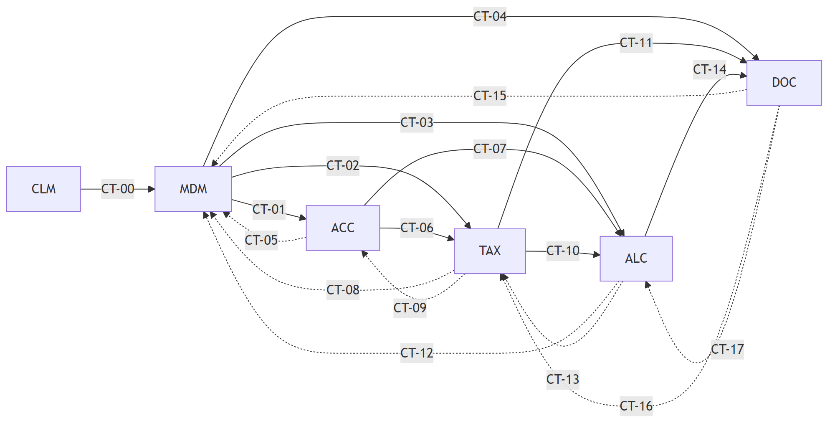
Figure 10: Contract mesh CT-00 to CT-17
Evidence: rows in shared/contracts.js lines ~96–122; diagram also in docs/ARCHITECTURE.md.

Upload-driven filing flow (separate from CT runner)
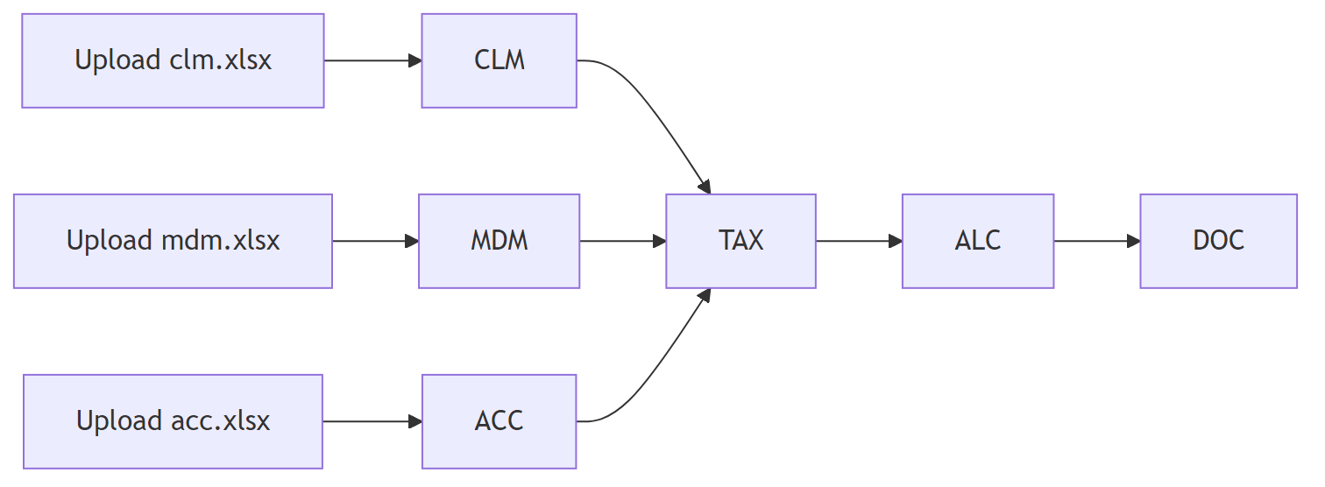
Figure 11: Upload-driven filing flow
Evidence: shared/dataFlow.js header comments; README.md “Data flow”.

6. Class / module diagram (logical)
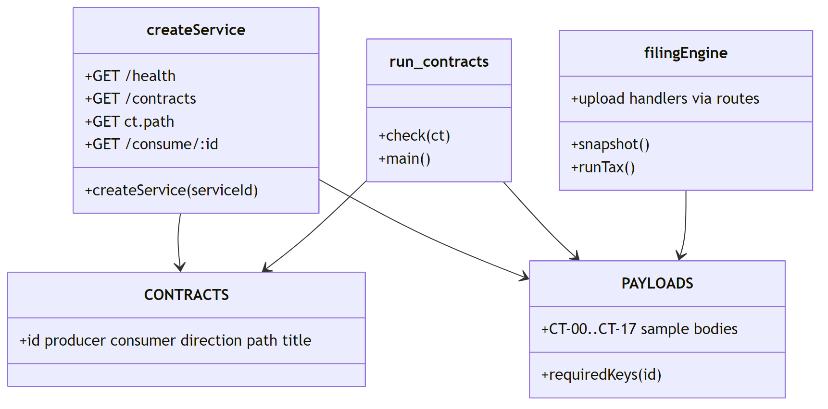
Figure 12: Module class diagram

Gate 3
Check | Status
Every diagram box → real folder/file | Done
Broker / CI | Marked Not found
Contract storage = in-repo JS | Confirmed
Uncertain | Exact local Node version outside Docker (README does not pin)

03 — File-by-File Guide
Source file: 03-file-by-file-guide.md

03 — File-by-File Guide
Priority: Must understand first. Paths relative to contract-testing-business-demo/.

Priority legend
Tag | Meaning
Must understand | Core to contract testing + architecture
Should know | Filing demo / ops
Can ignore at first | Generators, patches, binaries, Word/PDF case studies

1. Master inventory table

Root / config
File Path | Type | What it does | Key classes/methods/config | Who uses it | Related files | Priority
package.json | npm config | Scripts + deps | start, test:contracts, docker:* | Humans, Docker | package-lock.json | Must
package-lock.json | lockfile | Pins dependency versions | npm lock | npm install | package.json | Can ignore at first
README.md | docs | Quick start, ports, v2 notes | URLs, commands | Humans | docs/* | Must
CASE_STUDY.md | docs | Business case brief | Journey table | Humans | case study PDFs | Should know
.gitignore | git | Ignores node_modules, data/, .env | patterns | git | — | Can ignore at first
Dockerfile | Docker | Image: Node 20, npm start | EXPOSE 4100-4106 | docker compose | docker-compose.yml | Should know
docker-compose.yml | Docker | 6 services + gateway | cem…forms-print, gateway | Ops | Dockerfile | Should know
cloudflared.exe | binary | Tunnel helper (Windows) | — | Optional public URL | README PUBLIC_BASE_URL | Can ignore at first
*.docx / *.pdf (root) | case study assets | Source case studies | — | Reading | CASE_STUDY.md | Can ignore at first

Contracts
File Path | Type | What it does | Key symbols | Who uses it | Related | Priority
contracts/run-contracts.js | test runner | Verifies all CT payloads over HTTP | check, main | npm run test:contracts | shared/contracts.js, shared/payloads.js | Must
shared/contracts.js | catalog | Services, CT-00…17, URL helpers | SERVICES, CONTRACTS, urlFor, flowSummary | Almost everything | payloads.js | Must
shared/payloads.js | contract shapes | Sample JSON + requiredKeys | PAYLOADS, requiredKeys | producers + runner | contracts.js | Must

Shared runtime
File Path | Type | What it does | Key symbols | Who uses it | Related | Priority
shared/createService.js | factory | Builds each microservice Express app | createService | all services/*/index.js | flowApis, uploads, v2 | Must
shared/flowApis.js | routes | Downstream/upstream APIs | attachFlowApis, attachPipeline, produceEnvelope | createService, gateway | contracts.js | Must
shared/openapi.js | OpenAPI builder | Builds Swagger document | buildOpenApi | gateway, generate:openapi | contracts | Should know
shared/serviceV2Apis.js | routes | CLM/MDM /v2/* | attachV2Apis, attachClmV2 | createService | filingStore | Should know
shared/serviceUploads.js | routes | Per-service Excel upload | attachExcelUpload | CLM/MDM/ACC | excelImport | Should know
shared/serviceValidation.js | routes | TAX/ALC validate/calc | attachBusinessValidationApis | TAX/ALC | businessValidation | Should know
shared/excelImport.js | parser | Parse CLM/MDM/ACC xlsx | parseCem, parseMad, parseCam | filingEngine | xlsx | Should know
shared/filingEngine.js | domain engine | Form 1065 step machine | snapshot, runTax, uploads | filingRoutes | filingStore, dataFlow | Must (for demo)
shared/filingStore.js | persistence | engagement JSON + steps/gates | STEPS, read/write | filingEngine, v2 | data/engagement.json | Should know
shared/dataFlow.js | graph helpers | Upload readiness + flow nodes | hasClm, buildDataFlow | filingEngine, UI APIs | — | Should know
shared/businessValidation.js | rules | TAX/ALC Form 1065 checks | validateTim, validateRpam | filingEngine, serviceValidation | — | Should know

Gateway / frontend
File Path | Type | What it does | Key symbols | Who uses it | Related | Priority
gateway/index.js | Express app | Proxy, Swagger, health, static UI | /api/health, /api/flow, /api/proxy | npm start | filingRoutes | Must
gateway/filingRoutes.js | router | /api/filing/* uploads & calc | createFilingRouter | gateway | filingEngine | Must
frontend/index.html | UI shell | Layout / nav | — | browser | app.js | Should know
frontend/app.js | UI logic | Module views, uploads, status | MODULES, showView | browser | gateway APIs | Should know
frontend/styles.css | styles | Soft teal theme | CSS | index.html | — | Can ignore at first

Services (entry points)
File Path | Type | What it does | Key | Who uses it | Related | Priority
services/cem/index.js | entry | Starts CLM on 4101 | createService('CLM') | start-all, docker | createService | Must
services/mad/index.js | entry | Starts MDM on 4102 | createService('MDM') | start-all, docker | — | Must
services/cam/index.js | entry | Starts ACC on 4103 | createService('ACC') | start-all, docker | — | Must
services/tim/index.js | entry | Starts TAX on 4104 | createService('TAX') | start-all, docker | — | Must
services/rpam/index.js | entry | Starts ALC on 4105 | createService('ALC') | start-all, docker | — | Must
services/forms-print/index.js | entry | Starts DOC on 4106 | createService('DOC') | start-all, docker | — | Must
services/accounting/index.js | alias entry | Also ACC | createService('ACC') | optional | cam | Can ignore at first
services/master-data/index.js | alias entry | Also MDM | createService('MDM') | optional | mad | Can ignore at first
services/tax-engine/index.js | alias entry | Also TAX | createService('TAX') | optional | tim | Can ignore at first
services/allocations/index.js | alias entry | Also ALC | createService('ALC') | optional | rpam | Can ignore at first

Scripts
File Path | Type | What it does | Key | Who uses it | Related | Priority
scripts/start-all.js | launcher | Spawns 6 services + gateway | procs array | npm start | services/* | Must
scripts/generate-excel-datasets.js | generator | Builds testdata xlsx | — | npm run generate:excel | testdata | Can ignore at first
scripts/generate-postman.js | generator | Postman JSON | — | generate:postman | postman/ | Can ignore at first
scripts/generate-guide-docx.js | generator | Word guide | — | generate:guide | docs | Can ignore at first
scripts/extract-docx.js | util | Extract docx text | — | maintainers | — | Can ignore at first
scripts/patch-*.js | one-off patches | Historical code patches | — | maintainers | — | Can ignore at first
scripts/rewrite-authors.js / strip-coauthors.sh | git helpers | Author rewrite | — | maintainers | — | Can ignore at first

Testdata / Postman / Docs
File Path | Type | What it does | Key | Who uses it | Related | Priority
testdata/index.json | catalog | Lists set-01…05 | datasets | UI / gateway | xlsx files | Should know
testdata/set-0N/{clm,mdm,acc}.xlsx | demo data | Upload inputs | Excel sheets | filing upload | excelImport | Should know
postman/TaxMesh.postman_*.json | Postman | API collection | — | Postman app | generate-postman | Can ignore at first
docs/ARCHITECTURE.md | docs | Arch overview | mermaid | humans | this analysis | Should know
docs/API.md | docs | API reference | tables | humans | openapi | Should know
docs/APPLICATION_MANUAL.md | docs | Install/UI walkthrough | — | humans | README | Can ignore at first
docs/openapi.json | OpenAPI | Static export | — | Swagger consumers | openapi.js | Can ignore at first
docs/TaxMesh_API_Architecture_and_Developer_Guide.md | long guide | Full developer guide | — | humans | — | Can ignore at first

2. Deep dive — 8 most important files (block by block)

A. shared/contracts.js — Must understand
Block | What it does | Why it exists
Header comment | Names 6 services + aliases | Orients readers to CLM…DOC
SERVICES object | id, name, port, role, out/in counts | Single source of truth for ports
SERVICE_ALIASES | CEM→CLM, A→MDM, etc. | Backward compatibility
resolveServiceId | Normalize any alias to current id | Safe lookups
CONTRACTS array | CT-00…CT-17 rows | The contract catalog
urlFor | Build http://127.0.0.1:port + path (or env URL_*) | Runner + consume calls
contractsProducedBy / ConsumedBy | Filter catalog | Wire routes per service
normalizeDirection / apiDirection | reverse ≡ upstream | API naming
flowSummary / allFlowEdges | Graph for /api/flow | Visualization
module.exports | Public API | Imported everywhere

B. shared/payloads.js — Must understand
Block | What it does | Why
engagementId / entityId constants | Shared demo IDs | Consistent samples
PAYLOADS['CT-00'] … ['CT-17'] | Exact JSON fields | This IS the contract shape
requiredKeys(contractId) | All keys except contractId | Runner assertions
exports | Used by producers + tests | Shared truth

C. contracts/run-contracts.js — Must understand
Block | What it does | Why
requires | Load catalog + payloads | Need expected shapes
check(ct) | fetch producer → assert HTTP ok, contractId, each required key, PAYLOADS exists | Lightweight provider verification
main() | Loop all CONTRACTS, log PASS/FAIL, process.exit(1) if any fail | CLI test entry
catch on main | Unexpected errors → exit 1 | Fail hard

D. shared/createService.js — Must understand
Block | What it does | Why
Express + cors + json | Standard HTTP service | Each MS is HTTP
/health | Liveness + produced/consumed lists | Gateway health aggregation
/contracts | Catalog for this service | Discovery
attachFlowApis | Downstream/upstream routes | Flow APIs
Loop produced → GET ct.path | Return PAYLOADS + metadata | Producer side of contract
/consume/:contractId | Pull from producer via urlFor | Consumer side
attachPipeline | Reachability of producers | Diagnostics
Conditional uploads / validation / v2 | Feature flags by service id | CLM/MDM/ACC/TAX/ALC specifics

E. scripts/start-all.js — Must understand
Block | What it does | Why
procs list | Maps label → legacy folder script | Boot order of 7 processes
spawn loop | Child Node processes, inherit stdio | One command starts mesh
shutdown on SIGINT/TERM | Kill children | Clean stop

F. gateway/index.js — Must understand
Block | What it does | Why
Express setup + trust proxy | Tunnel-friendly | Cloudflare
/api/filing router | Filing journey | Demo business flow
OpenAPI + Swagger | Interactive docs | Teaching / try APIs
Static /docs, downloads | Serve guides/postman/testdata | Convenience
/api/health | Probe all 6 services | Ops dashboard
/api/architecture, /api/contracts, /api/flow | Mesh metadata | Teaching APIs
Proxy routes (later in file) | Forward to microservices | SPA single origin
Static frontend | Serve SPA | UI

G. gateway/filingRoutes.js — Should know / Must for demo
Block | What it does | Why
multer memory storage | Accept .xlsx ≤5MB | Upload safety
GET / snapshot | Current engagement state | UI refresh
reset / run / run-all / process-flow | Drive steps | Demo orchestration
validate tax/alc + calculate/allocate | Business gates | AQG-style checks
upload clm/mdm/acc | Import Excel into store | Real demo path

H. shared/filingEngine.js — Should know
Block | What it does | Why
snapshot | Full UI state + dataFlow | Single response for SPA
isStepDone | Step completion rules | Progress UI
jobs / quality gates | Async + AQG1–5 | Case study alignment
tax/allocate/forms/efile logic | Compute Form 1065 outputs | Business demo (beyond pure CT)

3. Quick “read order” for beginners
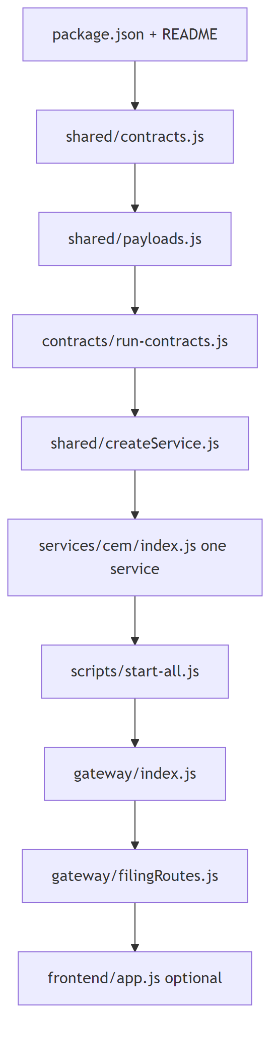
Figure 13: Recommended beginner read order

Gate 4
Check | Status
Important files tabulated | Done
8 deep dives | Done
Generators/patches marked ignorable | Done
Uncertain | Full line-by-line of entire filingEngine.js (~900+ lines) summarized by responsibility, not every helper

04 — End-to-End Flow
Source file: 04-end-to-end-flow.md

04 — End-to-End Flow
Theoretical walkthrough only. No tests were executed for this analysis.

1. Lifecycle sequence (how contracts work HERE)
Important difference from classic Pact: In this repo, contracts are hand-authored in JS, not generated by a consumer unit test framework. The “consumer test” step is replaced by catalog + sample payloads. Verification = HTTP GET against live producers.
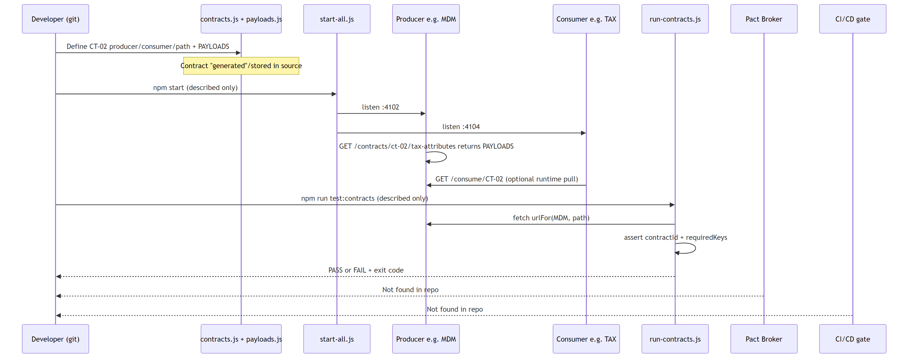
Figure 14: Contract lifecycle sequence

2. Numbered lifecycle table
Step | Actor | Action | File / Class / Method | Output
1 | Developer | Author CT metadata | CONTRACTS in shared/contracts.js | Catalog row (id, producer, consumer, path, direction)
2 | Developer | Author JSON shape | PAYLOADS in shared/payloads.js | Sample body keys
3 | Service factory | Register produce route | createService loop app.get(ct.path, …) | Live endpoint
4 | Ops / QA | Start mesh | scripts/start-all.js → npm start | Processes on 4100–4106
5 | Consumer (runtime) | Optional pull | GET /consume/:contractId in createService.js | { payload, ok, sourceUrl }
6 | Contract runner | Verify all CTs | check(ct) in contracts/run-contracts.js | Console PASS / FAIL
7 | Runner | Aggregate | main() | N/18 contracts passed; exit 1 if fail
8 | Broker publish | — | Not found in repo | —
9 | CI can-i-deploy | — | Not found in repo | —

3. Happy path (contracts stay valid)
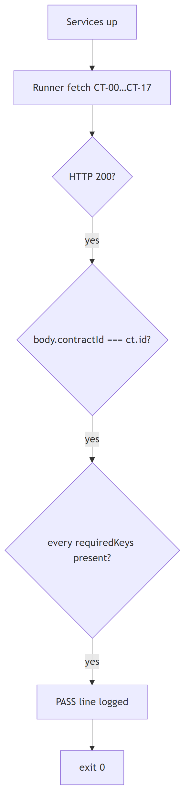
Figure 15: Happy path verification
Assertion in check(ct) | Source
res.ok | HTTP status from producer
body.contractId === ct.id | Response must echo catalog id
key in body for each requiredKeys(ct.id) | Keys from PAYLOADS minus contractId
PAYLOADS[ct.id] exists | Catalog/payloads stay in sync

Expected console shape (expected behaviour, not captured output):
PASS CT-00 CLM→MDM (downstream)
PASS CT-01 MDM→ACC (downstream)
…
18/18 contracts passed

4. Contract broken path (theoretical)
Scenario: Provider MDM changes CT-02 response and removes field taxAttributes (or stops returning contractId: 'CT-02').
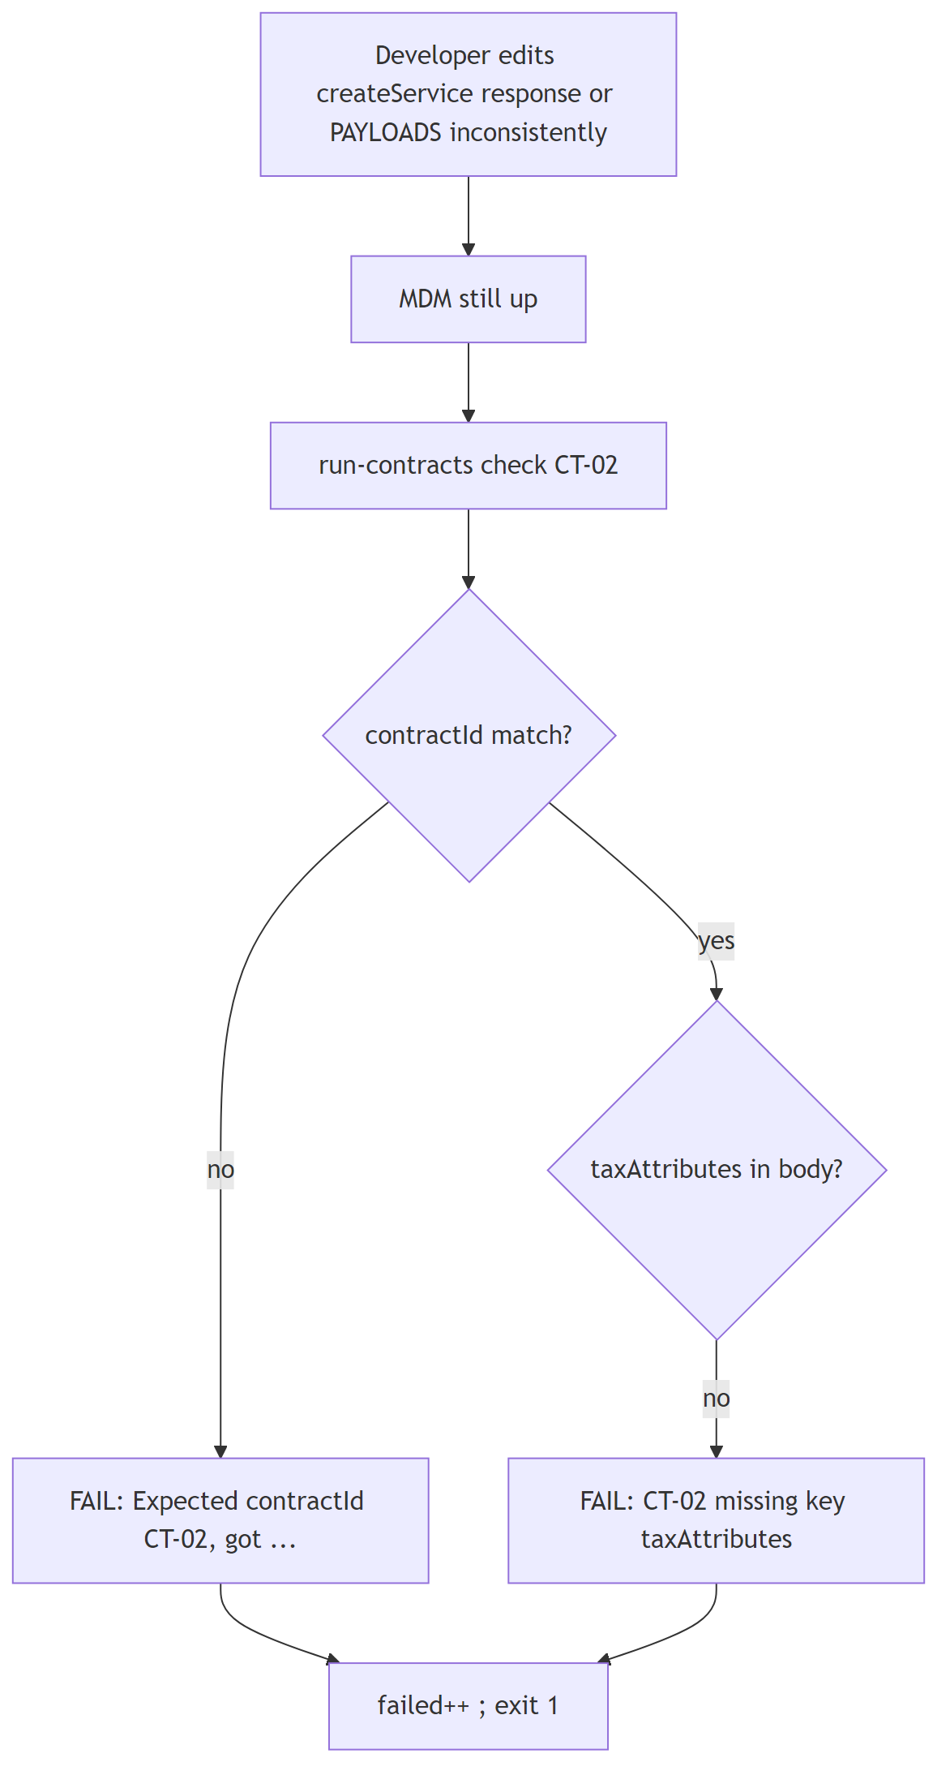
Figure 16: Contract broken path
If change is… | Which check fails | Why (code)
Producer down / wrong port | HTTP ${status} or fetch throw | check first lines
Wrong contractId in JSON | Expected contractId… | body.contractId !== ct.id
Missing field still listed in PAYLOADS | missing key "…" | requiredKeys loop
Delete sample from PAYLOADS but leave CONTRACTS | No sample payload for CT-xx | last assert in check
Change only consumer code | Runner may still PASS | Runner does not execute consumer business logic — only producer shape

Filing demo impact (separate from runner): If Excel/MDM data lacks partners/EIN, validateTim in shared/businessValidation.js adds findings like TIM-BV-02 — UI/API returns 422 on tax calculate (gateway/filingRoutes.js), even if CT runner still passes sample payloads.

5. Sample contract explained — CT-02
Catalog row (shared/contracts.js):
Field | Value | Meaning
id | CT-02 | Contract identifier
producer | MDM | Who serves JSON
consumer | TAX | Who needs it
direction | downstream | Forward along journey
path | /contracts/ct-02/tax-attributes | HTTP path on MDM
title | Entity tax attributes | Human label

Sample payload (shared/payloads.js → PAYLOADS['CT-02']):
Field | Example value | Meaning
contractId | CT-02 | Must match catalog; asserted by runner
engagementId | ENG-2025-1065-001 | Ties data to engagement
entityId | ENT-ALPHA-LP | Partnership entity
taxAttributes | object | Tax setup block
taxAttributes.filingType | 1065 | Form type
taxAttributes.fiscalYearEnd | 12-31 | FYE
taxAttributes.multiState | true | Multi-state flag
taxAttributes.states | ['NY','CA'] | State list
taxAttributes.section754Election | true | 754 election

Extra fields added at produce time (createService.js):
Field | Meaning
producer | Service id
consumer | Target consumer
direction / flow | downstream vs upstream
producedAt | ISO timestamp

Required keys for runner = engagementId, entityId, taxAttributes (via requiredKeys — all keys except contractId).

6. Full contract matrix (evidence)
ID | Producer → Consumer | Direction | Path
CT-00 | CLM → MDM | downstream | /contracts/ct-00/engagement-context
CT-01 | MDM → ACC | downstream | /contracts/ct-01/entities
CT-02 | MDM → TAX | downstream | /contracts/ct-02/tax-attributes
CT-03 | MDM → ALC | downstream | /contracts/ct-03/ownership
CT-04 | MDM → DOC | downstream | /contracts/ct-04/filing-meta
CT-05 | ACC → MDM | reverse | /contracts/ct-05/mapping-gaps
CT-06 | ACC → TAX | downstream | /contracts/ct-06/book-balances
CT-07 | ACC → ALC | downstream | /contracts/ct-07/capital-map
CT-08 | TAX → MDM | reverse | /contracts/ct-08/attribute-gaps
CT-09 | TAX → ACC | reverse | /contracts/ct-09/btt-asks
CT-10 | TAX → ALC | downstream | /contracts/ct-10/taxable-income
CT-11 | TAX → DOC | downstream | /contracts/ct-11/tax-summary
CT-12 | ALC → MDM | reverse | /contracts/ct-12/ownership-issues
CT-13 | ALC → TAX | reverse | /contracts/ct-13/allocation-needs
CT-14 | ALC → DOC | downstream | /contracts/ct-14/partner-allocations
CT-15 | DOC → MDM | reverse | /contracts/ct-15/entity-print-needs
CT-16 | DOC → TAX | reverse | /contracts/ct-16/tax-line-needs
CT-17 | DOC → ALC | reverse | /contracts/ct-17/capital-restatement

Source: shared/contracts.js CONTRACTS array.

7. Filing happy path (business demo, not the CT runner)
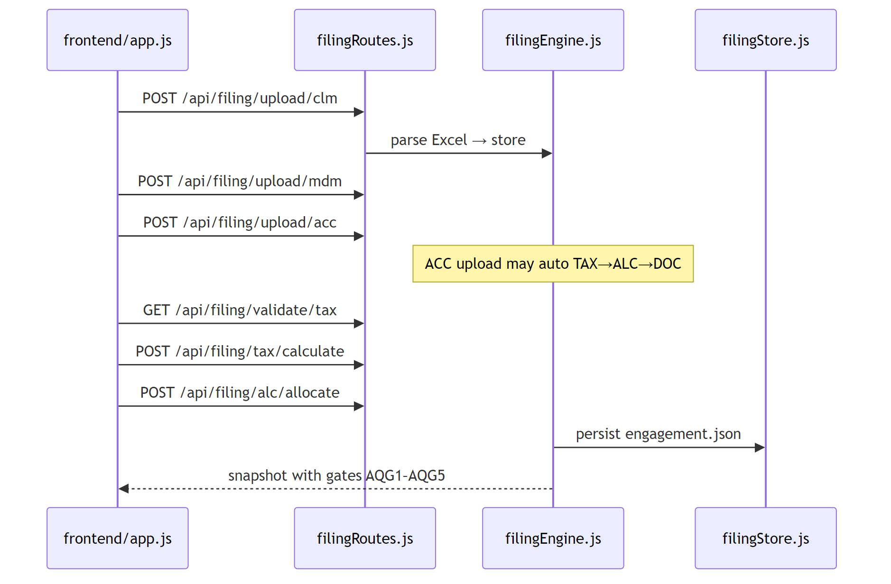
Figure 17: Filing happy path sequence

Gate 5
Check | Status
Flows match actual test names (check, main, CT ids) | Done
Happy + broken paths from code | Done
Sample CT-02 field table | Done
Broker/CI steps | Not found — shown as such
Uncertain | Exact console formatting if Node version differs — based on console.log template strings only

05 — How It Runs (Explained)
Source file: 05-how-it-runs-explained.md

05 — How It Runs (Explained Only — NOT Executed)
Every command row is marked Not executed - explained only. Analysis is from README + package.json + source.

1. Prerequisites
Tool / item | Version found | Required for | Evidence
Node.js | 20 in Docker image; local exact version Not found in README | Run app & scripts | Dockerfile FROM node:20-alpine
npm | Comes with Node; lockfile present | npm install, scripts | package-lock.json
Docker + Compose | Compose file present | Optional container run | docker-compose.yml
Git | Repo has .git | Clone only | folder .git
Pact CLI / Broker | Not found | — | —
Java / Maven / Gradle | Not found | — | —
Browser | Any modern | UI at :4100 | README.md
Optional PUBLIC_BASE_URL | env var | Tunnel/Swagger absolute host | README.md, gateway/index.js

Install step described in README (not run here):
npm install

2. Commands table
Command | What it does internally | What it produces | Where output appears | Status
npm install | Reads package.json / lockfile; installs Express, multer, xlsx, etc. | node_modules/ | Console + folder | Not executed - explained only
npm start | Runs node scripts/start-all.js → spawns 6 services + gateway | 7 Node processes | Console logs per service; ports 4100–4106 | Not executed - explained only
npm run start:clm (etc.) | Starts one service entry | One listener | Console [CLM] … | Not executed - explained only
npm run start:gateway | node gateway/index.js | Gateway only | :4100 | Not executed - explained only
npm run test:contracts | node contracts/run-contracts.js → check each CT | PASS/FAIL lines; exit 0/1 | stdout | Not executed - explained only
npm run generate:excel | scripts/generate-excel-datasets.js | testdata/set-0N/{clm,mdm,acc}.xlsx | filesystem | Not executed - explained only
npm run generate:openapi | Inline node write of buildOpenApi() | docs/openapi.json | filesystem + console | Not executed - explained only
npm run generate:postman | scripts/generate-postman.js | Postman JSON files | postman/ | Not executed - explained only
npm run generate:guide | scripts/generate-guide-docx.js | Word guide | docs/*.docx | Not executed - explained only
npm run docker:up | docker compose up --build | Containers for cem…gateway | Docker + mapped ports | Not executed - explained only
npm run docker:down | docker compose down | Stops containers | Docker | Not executed - explained only

What npm start boots (scripts/start-all.js)
Label | Script path | Port (from SERVICES)
CLM | services/cem/index.js | 4101
MDM | services/mad/index.js | 4102
ACC | services/cam/index.js | 4103
TAX | services/tim/index.js | 4104
ALC | services/rpam/index.js | 4105
DOC | services/forms-print/index.js | 4106
Gateway | gateway/index.js | 4100

What test:contracts does inside check(ct)
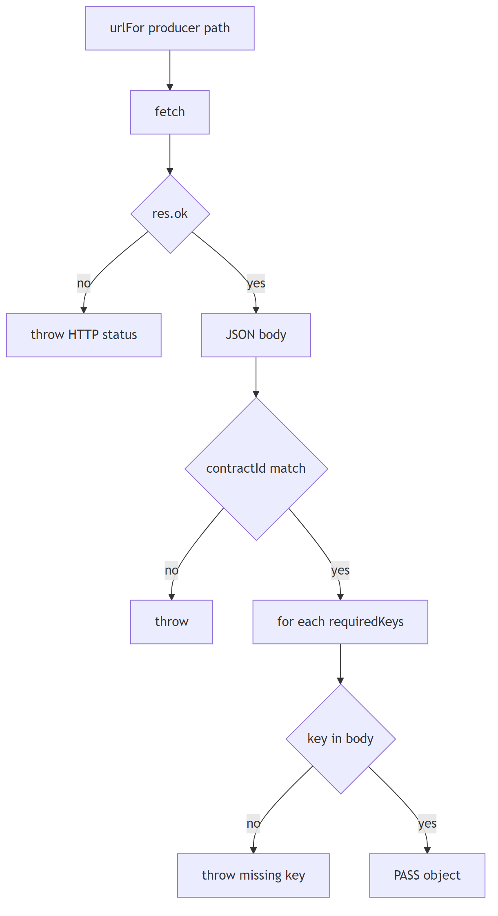
Figure 18: test:contracts check flow

3. Expected PASS vs FAIL (not real output)

PASS — expected behaviour
Signal | Meaning | Code
Line PASS CT-xx PROD→CONS (direction) | That contract’s producer responded with correct id + keys | console.log in main
Final 18/18 contracts passed | All CONTRACTS.length ok | end of main
Process exit code 0 | failed === 0 | no process.exit(1)

FAIL — expected behaviour
Signal | Meaning | Code
FAIL CT-xx … HTTP 404 from … | Producer route missing / service down | thrown Error
FAIL … Expected contractId CT-02, got … | Wrong id in body | assert
FAIL … CT-02 missing key "taxAttributes" | Shape drift | requiredKeys loop
Final k/18 contracts passed with k&lt;18 | Partial success | filter PASS count
Exit code 1 | Any failure | if (failed) process.exit(1)

Filing API FAIL (separate)
Signal | Meaning | Evidence
HTTP 422 on /api/filing/validate/tax | Business validation failed | filingRoutes.js + validateTim
Finding codes TIM-BV-01… | Missing engagement/entity/TB | businessValidation.js

4. Useful URLs (when running — described from README)
URL | Resource
http://127.0.0.1:4100 | TaxMesh UI
http://127.0.0.1:4100/api-docs | Swagger
http://127.0.0.1:4100/openapi.json | OpenAPI JSON
http://127.0.0.1:4100/api/flow | Downstream + upstream catalog
http://127.0.0.1:4100/download/postman.zip | Postman ZIP

5. Troubleshooting
Problem | Likely cause | Fix (from repo config)
test:contracts all FAIL / fetch errors | Services not started | Run npm start first (README order)
One service unhealthy in /api/health | Process crashed / port busy | Check console from start-all.js; free ports 4101–4106
Docker services can’t reach each other | Need compose DNS names | Env URL_CEM… in docker-compose.yml x-env
Upload rejected | Not .xlsx or &gt;5MB | multer filter/limits in filingRoutes.js
Swagger wrong host behind tunnel | Absolute localhost in older setups | Set PUBLIC_BASE_URL or use same-origin / (README.md, gateway)
Postman download 404 | Files not generated | npm run generate:postman (README)
Guide docx 404 | Not generated | npm run generate:guide
Ownership / tax validation errors | Bad Excel data | Use testdata/set-0N; ownership must total 100% (docs/API.md)
Legacy path confusion | CEM vs CLM | Aliases in SERVICE_ALIASES — both work
Looking for Pact broker | Tool not used | Use custom runner only

6. Docker layout (explained)
Compose service | Command | Host port | Maps to workspace
cem | node services/cem/index.js | 4101 | CLM
mad | node services/mad/index.js | 4102 | MDM
cam | node services/cam/index.js | 4103 | ACC
tim | node services/tim/index.js | 4104 | TAX
rpam | node services/rpam/index.js | 4105 | ALC
forms-print | node services/forms-print/index.js | 4106 | DOC
gateway | node gateway/index.js | 4100 | UI + proxy

Evidence: docker-compose.yml.

Gate 6
Check | Status
Commands from README/package.json only | Done
Nothing executed | Confirmed (explain-only)
PASS/FAIL labelled expected behaviour | Done
Uncertain | Whether fetch is available on very old Node without Docker — Docker pins 20; README silent on minimum local Node

06 — Glossary and Q&A
Source file: 06-glossary-and-qna.md

06 — Glossary + Q&A

1. Glossary
Term | Simple meaning | Where in THIS repo
TaxMesh | Name of this Form 1065 microservices demo | README.md, package.json description
Contract | Agreed JSON shape between producer & consumer | shared/contracts.js + shared/payloads.js
CT-00 … CT-17 | The 18 named contracts | CONTRACTS array
Producer | Service that exposes the contract HTTP GET | CONTRACTS[].producer
Consumer | Service that needs that data | CONTRACTS[].consumer
Downstream | Forward along CLM→…→DOC | direction: 'downstream'
Upstream / reverse | Feedback ask to an earlier service | direction: 'reverse'; API name upstream
Payload | Sample JSON body | PAYLOADS
requiredKeys | Keys the runner requires (except contractId) | payloads.js requiredKeys
Provider verification | Checking producer still returns shape | contracts/run-contracts.js check
Pact | Popular contract-testing tool | Not found in repo
Broker | Central contract store | Not found in repo
can-i-deploy | Broker deploy safety check | Not found in repo
CLM | Client Management (engagement) | port 4101, services/cem
MDM | Master Data | port 4102, services/mad
ACC | Accounting | port 4103, services/cam
TAX | Tax Computation | port 4104, services/tim
ALC | Allocations | port 4105, services/rpam
DOC | Forms & Documents | port 4106, services/forms-print
CEM/MAD/CAM/TIM/RPAM/FORMS | Legacy aliases for above | SERVICE_ALIASES
A/B/C/D/E | Letter aliases MDM…DOC | SERVICE_ALIASES
Gateway | Front door :4100 | gateway/index.js
Filing engine | Form 1065 step orchestration | shared/filingEngine.js
AQG1–AQG5 | Quality gates on filing journey | docs/ARCHITECTURE.md, filingStore steps
MeF / e-file | Electronic filing end state | filing status efiled
Form 1065 | US partnership tax return | domain of demo
K-1 / K-3 | Partner schedule forms | DOC / ALC payloads
createService | Factory that builds each MS | shared/createService.js
Flow APIs | /downstream, /upstream, /consume/* | shared/flowApis.js
Swagger / OpenAPI | Interactive API docs | /api-docs, shared/openapi.js
Excel import | Upload-driven demo data | testdata, excelImport.js
Mock/stub (here) | In-memory PAYLOADS returned by producers | createService produce routes
Integration test | Multi-component behaviour | Filing demo (not a separate suite)
E2E | Full UI journey | Manual via frontend/
urlFor | Builds service base URL + path | contracts.js
correlationId | Ties engagement work together | filing / CLM context

2. Interview-style Q&A (15) — answers from THIS project
# | Question | Short answer
1 | What problem does this repo demonstrate? | Keeping API shapes stable across 6 tax microservices (Form 1065) using CT-00…CT-17.
2 | Is this Pact? | No. Custom Node runner in contracts/run-contracts.js.
3 | Where is the contract stored? | In source: shared/contracts.js + shared/payloads.js (no broker).
4 | What does npm run test:contracts do? | HTTP GETs each producer path; asserts contractId and required keys.
5 | Who is producer for CT-02? | MDM; consumer is TAX (shared/contracts.js).
6 | Downstream vs upstream? | Downstream = journey forward; upstream = reverse feedback (apiDirection).
7 | How does a service expose a contract? | createService registers GET ct.path returning PAYLOADS[ct.id].
8 | How does a consumer pull a contract? | GET /consume/:contractId fetches producer via urlFor.
9 | What happens if a required field is removed? | Runner logs FAIL … missing key and exits 1.
10 | What are AQG1–AQG5? | Filing quality gates (CLM→MDM … through MeF), documented in docs/ARCHITECTURE.md.
11 | Why Excel uploads? | Drive realistic Form 1065 demo data into the filing engine (testdata/).
12 | What does the gateway do? | SPA, Swagger, filing APIs, proxy to services (gateway/index.js).
13 | How do you start everything? | npm start → scripts/start-all.js spawns 7 processes.
14 | Is there CI that blocks deploy? | Not found in repo (no workflows / can-i-deploy).
15 | Why legacy folder names like cem? | Historical codes; aliases map CEM→CLM; Docker/start still use old folder paths.

3. “Explain this project in 2 minutes” script
TaxMesh is a Node/Express demo of a US partnership Form 1065 pipeline split into six microservices: CLM, MDM, ACC, TAX, ALC, and DOC, plus a gateway UI on port 4100.
Between those services there are 18 contracts, CT-00 through CT-17 — some downstream (forward data) and some upstream/reverse (feedback asks).
Unlike Pact, contracts here are plain JavaScript objects in shared/contracts.js and shared/payloads.js. Each producer serves its sample JSON on a fixed path; npm run test:contracts fetches those URLs and checks that the `contractId` and required fields are still present.
Separately, you can upload Excel files and walk the filing journey with business validation and quality gates — that’s the business demo layered on top of the contract mesh.
There is no Pact broker and no CI can-i-deploy in this repository; the teaching focus is the mesh + shape checks + Form 1065 story.

4. Learning path
Level | Topic | Where in repo
Beginner | Ports, journey, what CT means | README.md, CASE_STUDY.md, docs-analysis/Beginner Concepts
Beginner | Read one contract end-to-end | CONTRACTS CT-00 + PAYLOADS['CT-00']
Beginner | Run story (when you execute later) | npm start, UI :4100
Intermediate | Service factory + produce/consume | shared/createService.js, shared/flowApis.js
Intermediate | Contract runner assertions | contracts/run-contracts.js
Intermediate | Downstream vs upstream catalog | GET /api/flow code in gateway/index.js
Intermediate | Architecture diagrams | docs/ARCHITECTURE.md, docs-analysis/Architecture
Advanced | Filing engine + gates | shared/filingEngine.js, businessValidation.js
Advanced | OpenAPI generation | shared/openapi.js
Advanced | Docker multi-service env URLs | docker-compose.yml URL_*
Advanced | Compare to real Pact/broker | Contrast with Not found pieces; design what you’d add

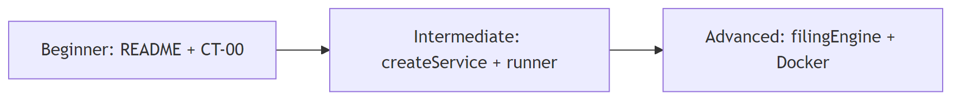
Figure 19: Learning path progression

5. Final summary of uncertainties
Item | Status
Pact / broker / can-i-deploy / CI | Confirmed Not found
Local Node version (non-Docker) | Not pinned in README
Alias service folders vs start-all paths | Both exist; start-all uses legacy names
Whether PAYLOADS nested objects are deeply schema-validated | No — runner only checks top-level keys via requiredKeys
Automated E2E/unit suites | Not found

Gate 7
Check | Status
Glossary of terms used | Done
15 interview Q&As mapped to project | Done
2-minute script | Done
Learning path | Done
Uncertainties listed | Done

Build metadata
Figures embedded: 19 / 19. Fixes applied during diagram render: 2 — fig-08: defined sink node X for Broker/CI edges, fig-16: removed quotes inside node labels (taxAttributes).

