* **Features affecting crop yield:** temperature, humidity, rainfall, Area
* 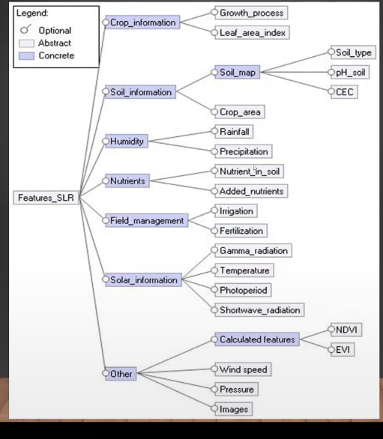
* Cation exchange capacity – major of the soil ability to hold the +ve charged ion
* 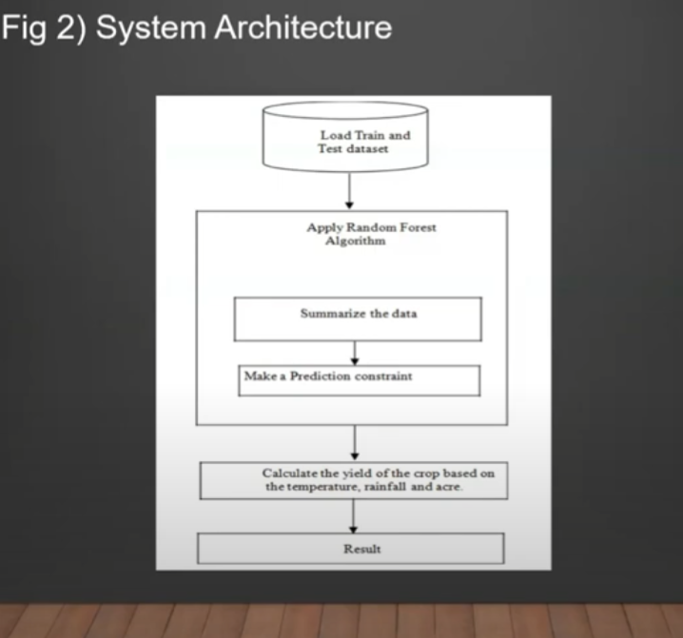

**CROP-RECOMMENDATION DATASET**

* N - ratio of Nitrogen content in soil
* P - ratio of Phosphorous content in soil
* K - ratio of Potassium content in soil
* temperature - temperature in degree Celsius
* humidity - relative humidity in %
* ph - ph value of the soil
* rainfall - rainfall in mm

**features used in the model**

* location
* crop name
* season name
* N
* P
* K
* Area
* Temperature
* Windspeed
* Pressure
* Humidity
* Soil type

**Total features present in the given datasets**

* N - ratio of Nitrogen content in soil
* P - ratio of Phosphorous content in soil
* K - ratio of Potassium content in soil
* temperature - temperature in degree Celsius
* humidity - relative humidity in %
* ph - ph value of the soil
* rainfall - rainfall in mm**(ds1)**
* state wise and district wise rainfall month wise and annually **(ds2)**
* time
* tavg
* tmin
* tmax
* prcp
* snow
* wdir
* wspd
* wpgt
* pres
* tsun **(ds3)**

‘

* State
* State
* Market
* Commodity
* Variety
* Arrival date
* Min_price
* Max_price
* Modal price**(ds4)**

**Geolocation:** Climate, altitude, and geographical location play a significant role in determining what crops are suitable for a particular area. For example, tropical regions are best suited for growing crops such as sugarcane, bananas, and mangoes, while temperate regions are suitable for growing crops like wheat, corn, and soybeans.

**Season:** The timing of planting and harvesting is also an important consideration. Some crops are only suitable for growing during specific seasons or have specific temperature requirements. For example, winter wheat is typically planted in the fall and harvested in the spring, while summer crops like tomatoes, peppers, and corn are typically planted in the spring and harvested in the summer.

**Price:** The market demand and price of different crops can also impact the decision on what to grow. For example, if the price of a particular crop is high, it may be more profitable for a farmer to grow that crop, even if it is not well-suited to their local climate. On the other hand, if the price of a crop is low, it may not be a profitable option, even if it grows well in the area.

**Dataset Links:**

● <https://www.kaggle.com/datasets/rajanand/rainfall-in-india>

● <https://www.kaggle.com/datasets/vanvalkenberg/historicalweatherdataforindiancities>

● <https://www.kaggle.com/datasets/atharvaingle/crop-recommendation-dataset>

● <https://www.kaggle.com/datasets/thammuio/all-agriculture-related-datasets-for-india>

● <https://currentaffairs.adda247.com/major-soil-types-of-india-map/>