## A Project Report on

**ARDUINO RADAR FOR OBJECT DETECTION**

***Submitted By:***

## ROLL NUMBER STUDENT NAME 87185201 ANKIT

**87185202 AVINASH**

## 87185204 BHASKAR BHUSHAN

# BACHELOR OF TECHNOLOGY

IN

ELECTRONICS & COMMUNICATION ENGINEERING

(**SEMESTER-8**)



# STATE INSTITUTE OF ENGINEERING & TECHNOLOGY

# NILOKHERI, KARNAL

### MAY 2021

i



**State institute of engineering & technology**

**Electronics & Communication Engineering**

**CERTIFICATE**

This is to certify that the project report entitled “Arduino Radar for object detection” submitted by **ANKIT-87185201 , AVINASH-87185202, BHASKAR BHUSHAN-87185204**

of B.Tech in ***ECE*** as satisfactorily completed project in the 8th semesterduring the academic year 2020 – 2021.

## Signature of Course Instructor

## NAVDEEP KHATRI

ii

**TABLE OF CONTENTS**

|  |  |  |
| --- | --- | --- |
| S.NO | CONTENTS | PAGE NO |
| 1. | Abstract | v |
| 2. | Introduction | vi-viii |
| 3. | Principle or Methodology | ix-x |
| 4. | Architecture of project | xi |
| 5. | Components required | xii-xiv |
| 6. | Working | xv-xviii |
| 7. | Code | xix-xxiv |
| 8. | Output | xxv-xxvi |
| 9. | Advantages& conclusions | xxvii-xxviii |
| 10. | References | xxix-xxx |

iv

## ABSTRACT

### Radar is an object detection system which uses radio waves to determine the range, altitude, direction, or speed of objects. It can be used to detect aircraft, ships, spacecraft, guided missiles, motor vehicles, weather formations, and terrain. The radar dish or antenna transmits pulses of radio waves or micro waves which bounce off any object in their path. The object returns a tiny part of the wave's energy to a dish or antenna which is usually located at the same site as the transmitter.

The modern uses of radar are highly diverse, including air traffic control, radar astronomy, air-defense systems, antimissile systems ;marine radar start locate landmarks and other ships; aircraft anti-collision systems; ocean surveillance systems, outer space surveillance and rendezvous systems; meteorological precipitation monitoring; altimetry and flight control systems; guided missile target locating systems; and ground-penetrating radar for geological observations. High tech radar systems are associated with digital signal processing and are capable of extracting useful information from very high noise levels.

### The Arduino based project requires a ultrasonic sensor, the sensor released the waves which we want to measure the distance of a object. The microcontrollers of the Arduino board can be programmed using C and C++ languages. When a code is written in Arduino UNO IDE software and connected to the board through a USB cable, Arduino boards have lot of applications in the present day scenario, so we have decided to do a small project on them.

v

# INTRODUCTION

**Defining Arduino:** An Arduino is actually a microcontroller based kit which can be either used directly by purchasing from the vendor or can be made at home using the components, owing to its open source hardware feature. It is basically used in communications and in controlling or operating many devices.

1. Arduino is an open-source electronics platform based on easy-to-use hardware and software. Arduino boards are able to read inputs - light on a sensor, a finger on a button, or a Twitter message - and turn it into an output - activating a motor, turning on an LED, publishing something online. You can tell your board what to do by sending a set of instructions to the microcontroller on the board. To do so you use the Arduino programming language (based on Wiring), and the Arduino Software (IDE), based on Processing.
2. Over the years Arduino has been the brain of thousands of projects, from everyday objects to complex scientific instruments. A worldwide community of makers - students, hobbyists, artists, programmers, and professionals - has gathered around this open-source platform, their contributions have added up to an incredible amount of accessible knowledge that can be of great help to novices and experts alike.
3. Arduino was born at the Ivrea Interaction Design Institute as an easy tool for fast prototyping, aimed at students without a background in electronics and programming. As soon as it reached a wider community, the Arduino board started changing to adapt to new needs and challenges, differentiating its offer from simple 8-bit boards to products for IoT applications, wearable, 3D printing, and embedded environments. All Arduino boards are completely open-source, empowering users to build them independently and eventually adapt them to their particular needs. The software, too, is opensource, and it is growing through the contributions of users worldwide.

vi

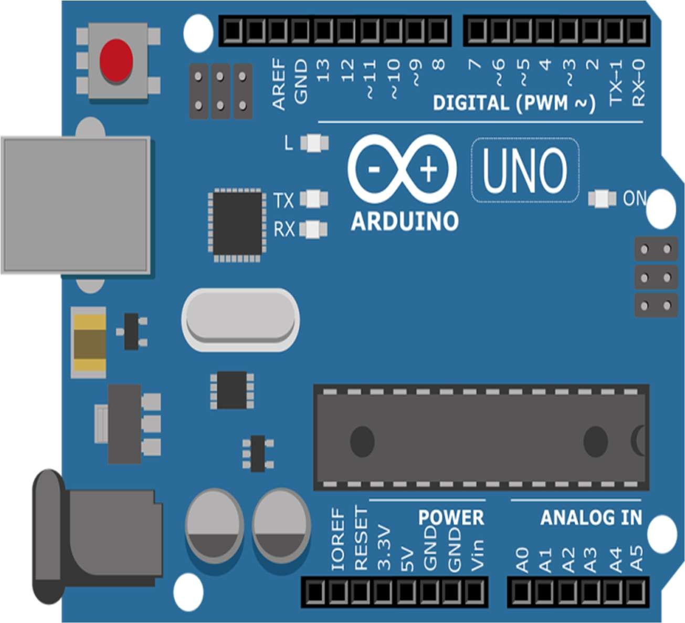

**1.1. How to program an Arduino ?**

The Arduino tool window consists of the toolbar with the buttons like verify, upload, new, open, save, serial monitor. It also consists of a text editor to write the code, a message area which displays the feedback like showing the errors, the text console which displays the output and a series of menus like the File, Edit, Tools menu. Thus the code is uploaded by the bootloader onto the microcontroller.

**ULTRASONIC SENSOR**

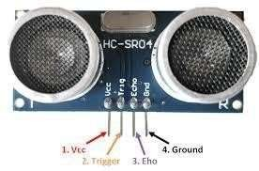

vii

##### 1.1. ULTRASONIC SENSOR

As the name indicates, ultrasonic sensors measure distance by using ultrasonic waves.The sensor head emits an ultrasonic wave and receives the wave reflected back from the target. Ultrasonic Sensors measure the distance to the target by measuring the time between the emission and reception.

An optical sensor has a transmitter and receiver, whereas an ultrasonic sensor uses a single ultrasonic element for both emission and reception. In a reflective model ultrasonic sensor, a single oscillator emits and receives ultrasonic waves alternately. This enables miniaturization of the sensor head.

Distance calculation

The distance can be calculated with the following formula:

Distance L = 1/2 × T × C

Where L is the distance, T is the time between the emission and reception, and C is the sonic speed. (The value is multiplied by 1/2 because T is the time for go-and-return distance.) Features

The following list shows typical characteristics enabled by the detection system. [Transparent object detectable]

Since ultrasonic waves can reflect off a glass or liquid surface and return to the sensor head, even transparent targets can be detected.

[Resistant to mist and dirt]

Detection is not affected by accumulation of dust or dirt. [Complex shaped objects detectable]

Presence detection is stable even for targets such as mesh trays or springs.

viii

**PRINCIPLE OR MEDTHODOLOGY**

A radar system has a transmitter that emits radio waves called a radar signals in predetermined directions. When these come into contact with an object they are usually reflected or scattered in many directions Example:- let us take example for bat

Bat released the eco sound while travelling .if any object came in middle and it reflect back to the bat

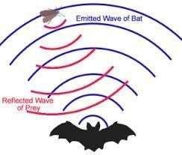

Applications and usages:-

The development of the radar technology took place during the World War II in which it was used for detecting the approaching aircraft and then later for many other purposes which finally led to the development of advanced military radars being used these days. Military radars have a highly specialized design to be highly mobile and easily transportable, by air as well as ground. Military radar should be an early warning, altering along with weapon control functions. It is specially designed to be highly mobile and should be such that it can be deployed within minutes.

ix

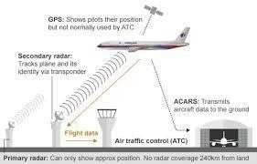

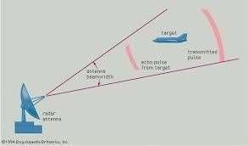Here's a summary of how radar works:

* Magnetron generates high-frequency radio waves.
* Duplexer switches magnetron through to antenna.
* Antenna acts as transmitter, sending narrow beam of radio waves through the air.

Radio waves hit enemy airplane and reflect back.

x

## ARCHITECTURE OF PROJECT:-

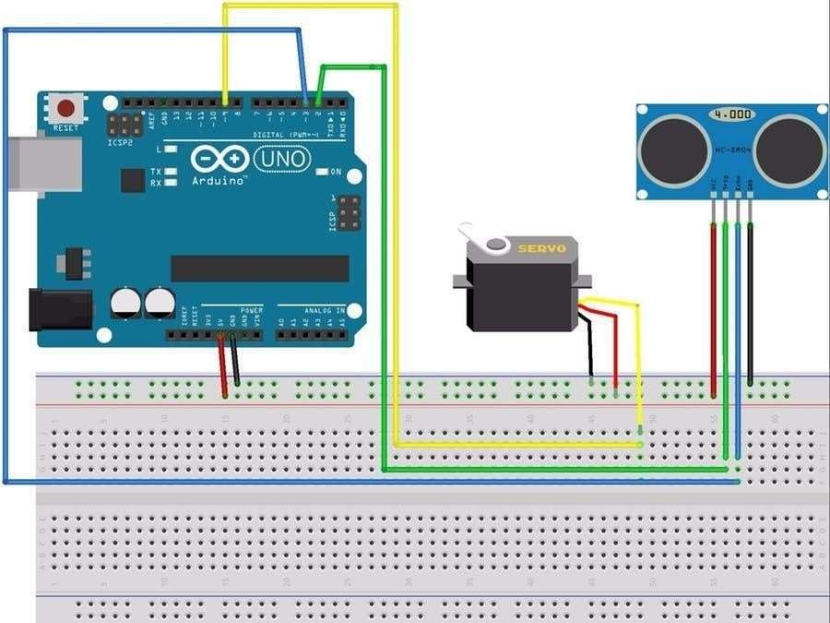

xi

## PROCEDURE

##### Components Required:

In this project we have used the arduino and ultrasonic sensor along with the jumping wires and the relay motors and details list of the hard ware components are

* + Arduino board and arduino cable

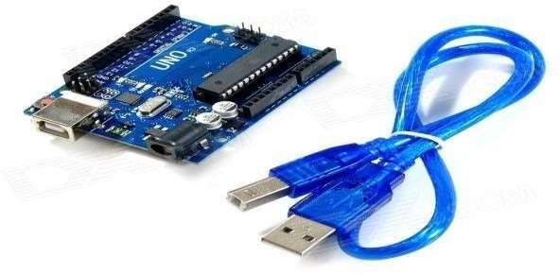

* + Jumper wires

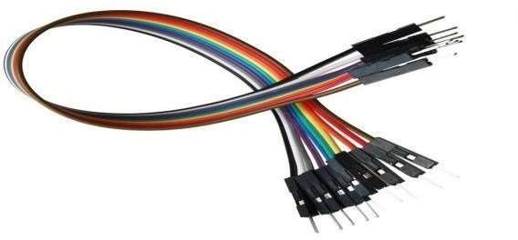

xii

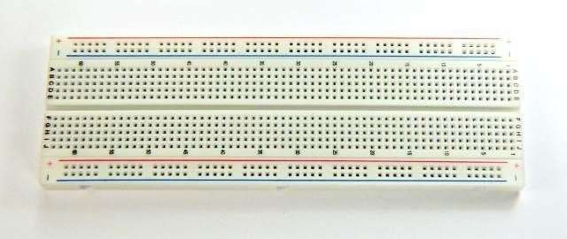

Bread board

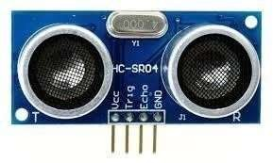

Ultrasonic sensor

xiii

##### Relay motor

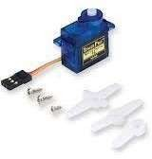

 **Double side plaster**

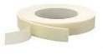

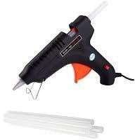 **gum gun**

 **LAPTOP**

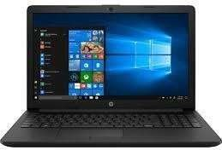

xiv

# WORKING

PRACTICAL IMPLEMENTATION

1. **Making On Arduino Board**

Since, we believe in learning by doing. So, we decided to make our own arduino board instead of using the readymade board. So, the steps required to make an arduino board are as follows:

Boot-loading an Atmega328 using the Arduino board/AVR Programmer by uploading the boot loader to the Microcontroller.

Making the connections on a general purpose PCB, connecting the crystal osicillator, capacitors, connectors for the connections to Arduino board etc.

Providing the power supply, usually 5 volts. Arduino is Ready to use.

After you have done all this, then only the minimum circuitry like crystal oscillator, capacitors, connectors, power supply is required to complete the board. The same circuit can be made on the PCB, either designed or general purpose. Since, Arduino is an Open-Source. Hence, it is easy to make and can have any enhancements as per the requirements.

##### Connecting Servo Motor

A servomotor is a rotary actuator that allows for precise control of angular position, velocity and acceleration.

A normal servo motor has three terminals:

1. VCC
2. GND
3. PULSE

A servo motor works at normally 4.8 to 6 volts. Ground is provided by connecting it to the Ground of the Arduino. The total time for a servo motor pulse is usually 20ms. To move it to one end of say 0 degree angle, a 1ms pulse is used and to move it to other end i.e 180 degrees, a 2ms pulse is applied. Hence, according to this to move the axis of the servo motor to the center, a pulse of time 1.5 ms should be applied. For this, the pulse wire of the servo motor is connected to the Arduino that provides the digital pulses for pulse width modulation of the pulse. Hence, by programming for a particular pulse interval the servo motor can be controlled easily.

xv

##### Connecting Ultrasonic Sensor:-

An Ultrasonic Sensor consists of three wires. One for Vcc, second for Ground and the third for pulse signal. The ultrasonic sensor is mounted on the servo motor and both of them further connected to the Arduino board. The ultrasonic sensor uses the reflection principle for its working. When connected to the Arduino, the Arduino provides the pulse signal to the ultrasonic sensor which then sends the ultrasonic wave in forward direction. Hence, whenever there is any obstacle detected or present in front, it reflects the waves which are received by the ultrasonic sensor.

If detected, the signal is sent to the Arduino and hence to the PC/laptop to the processing software that shows the presence of the obstacle on the rotating RADAR screen with distance and the angle at which it has been detected.5

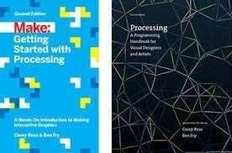

xvi

###### VI. USING PROCESSING SOFTWARE

**VII.**



Processing is an open source programming language and integrated development environment (IDE) built for the electronic arts, new media art, and visual design communities with the purpose of teaching the fundamentals of computer programming in a visual context, and to serve as the foundation for electronic sketchbooks. The project was initiated in 2001 by Casey Reas and Benjamin Fry, both formerly of the Aesthetics and Computation Group at the MIT Media Lab. One of the stated aims of Processing is to act as a tool to get non-programmers started with programming, through the instant gratification of visual feedback. The language builds on the Java language, but uses a simplified syntax and graphics programming models.

###### VIII. PROBLEMS FACED

1. Making Own Arduino Board

The Arduino boards are available readily in the electronics market, but we decided to make our own Arduino board instead of buying one. So, the first problem was where to start from to achieve this goal. Since, all parts on an Arduino board are SMD’s, so we had to find a way to replace the SMD’s with DIP IC’s and also had to make an AVR programmer in order to pursue our further work. Hence, it took us some days to determine and plan our course of action.

After that we had to boot load the AVR chip so as to make it compatible with the Arduino

xvi

IDE software. Hence, we had to find a way to boot load the Arduino using the AVR programmer. It took us a long time to make the AVR programmer by researching on the type of communication and architecture of the AVR as it is not as same as a 8051 microcontroller.

1. Communicating with Arduino through PC

Another major problem related to the Arduino board was the communication with it from PC. Since, there is a requirement of an RS-232 to TTL conversion for the communication, so try some methods:

1. Firstly I used the MAX-232 IC to communicate with the Arduino as with the 8051 but due to large voltage drop and mismatch in the speed, it failed to communicate.
2. Next, I tried to use a dedicated AVR as USB to Serial converter as in the original Arduino board, the difference being DIP AVR used by us instead of the SMD Mega16U2 controller.

But, unfortunately I was unable to communicate through it.

1. At last I had no other choice but to use the FTDI FT-232R chip for USB to Serial conversion. Finally IT WORKED!!!



xvii

##### PROCESSING SOFTWARE:-

ARDUINO SOFTWARE :-



xviii

**ARDUINO CODE**

/*

* LCD VSS pin to ground

* LCD VDD pin to +5V

* 2K2Ohm resistor: ends to LCD VO pin and ground

* LCD RS pin to digital pin 12

* LCD R/W pin to ground

* LCD Enable pin to digital pin 11

* LCD D4 pin to digital pin 5

* LCD D5 pin to digital pin 4

* LCD D6 pin to digital pin 3

* LCD D7 pin to digital pin 2

* LCD A pin to +5V

* LCD K pin to ground

* Buzzer + to 220Ohm Resistor leg and - to ground. The other resistor leg goes to pin 9.

* HC-SCR GND to ground

* HC-SCR Echo to pin 8

* HC-SCR Trig to pin 10

* HC-SCR Vcc to +5V

*/

//Defining pins

#define trigPin 10

#define echoPin 8

#define buzPin 9

#define RS 12

#define Enable 11

#define D4 5

#define D5 4

#define D6 3

#define D7 2

//Defining pitches

#define NOTE_B0 31

#define NOTE_C1 33

#define NOTE_CS1 35

#define NOTE_D1 37

#define NOTE_DS1 39

#define NOTE_E1 41

#define NOTE_F1 44

#define NOTE_FS1 46

#define NOTE_G1 49

#define NOTE_GS1 52

#define NOTE_A1 55

#define NOTE_AS1 58

#define NOTE_B1 62

#define NOTE_C2 65

#define NOTE_CS2 69

#define NOTE_D2 73

#define NOTE_DS2 78

#define NOTE_E2 82

#define NOTE_F2 87

#define NOTE_FS2 93

#define NOTE_G2 98

#define NOTE_GS2 104

#define NOTE_A2 110

#define NOTE_AS2 117

#define NOTE_B2 123

#define NOTE_C3 131

#define NOTE_CS3 139

#define NOTE_D3 147

#define NOTE_DS3 156

#define NOTE_E3 165

#define NOTE_F3 175

#define NOTE_FS3 185

#define NOTE_G3 196

#define NOTE_GS3 208

#define NOTE_A3 220

#define NOTE_AS3 233

#define NOTE_B3 247

#define NOTE_C4 262

#define NOTE_CS4 277

#define NOTE_D4 294

#define NOTE_DS4 311

#define NOTE_E4 330

#define NOTE_F4 349

#define NOTE_FS4 370

#define NOTE_G4 392

#define NOTE_GS4 415

#define NOTE_A4 440

#define NOTE_AS4 466

#define NOTE_B4 494

#define NOTE_C5 523

#define NOTE_CS5 554

#define NOTE_D5 587

#define NOTE_DS5 622

#define NOTE_E5 659

#define NOTE_F5 698

#define NOTE_FS5 740

#define NOTE_G5 784

#define NOTE_GS5 831

#define NOTE_A5 880

#define NOTE_AS5 932

#define NOTE_B5 988

#define NOTE_C6 1047

#define NOTE_CS6 1109

#define NOTE_D6 1175

#define NOTE_DS6 1245

#define NOTE_E6 1319

#define NOTE_F6 1397

#define NOTE_FS6 1480

#define NOTE_G6 1568

#define NOTE_GS6 1661

#define NOTE_A6 1760

#define NOTE_AS6 1865

#define NOTE_B6 1976

#define NOTE_C7 2093

#define NOTE_CS7 2217

#define NOTE_D7 2349

#define NOTE_DS7 2489

#define NOTE_E7 2637

#define NOTE_F7 2794

#define NOTE_FS7 2960

#define NOTE_G7 3136

#define NOTE_GS7 3322

#define NOTE_A7 3520

#define NOTE_AS7 3729

#define NOTE_B7 3951

#define NOTE_C8 4186

#define NOTE_CS8 4435

#define NOTE_D8 4699

#define NOTE_DS8 4978

//Including the LCD and sound library:

#include <LiquidCrystal.h>

// Initialize the LCD library

LiquidCrystal lcd(RS, Enable, D4, D5, D6, D7);

/////Definition of the LCD special characters///

uint8_t cc0[8] = {0x00,0x00,0x00,0x00,0x00,0x01,0x03,0x07};

uint8_t cc1[8] = {0x00,0x00,0x00,0x00,0x00,0x10,0x18,0x1C};

uint8_t cc2[8] = {0x07,0x03,0x01,0x00,0x00,0x00,0x00,0x00};

uint8_t cc3[8] = {0x1C,0x18,0x10,0x00,0x00,0x00,0x00,0x00};

uint8_t cc4[8] = {0x00,0x00,0x00,0x10,0x18,0x0C,0x04,0x06};

uint8_t cc5[8] = {0x06,0x04,0x0C,0x18,0x10,0x00,0x00,0x00};

uint8_t cc6[8] = {0x10,0x08,0x0C,0x06,0x02,0x03,0x03,0x03};

uint8_t cc7[8] = {0x03,0x03,0x03,0x02,0x06,0x0C,0x08,0x10};

////Sound notes setup

int melody0[] = {NOTE_B3, NOTE_B3,NOTE_B3, NOTE_G3, NOTE_B3,0, NOTE_D4, NOTE_D3};

int melody1[] = {NOTE_C6,NOTE_C6,NOTE_C6,NOTE_C6};

int melody2[] = {NOTE_C6,NOTE_C6,NOTE_C6};

int melody3[] = {NOTE_C6,NOTE_C6};

int melody4[] = {NOTE_C6};

//Add melodies here, and at the end of the "music" array.

int* music[6/*number of melodies + 1*/] = {melody0, melody1, melody2, melody3, melody4 /*,add here*/};

////Sound notes durations

int notesMelody0[] = {8,4,4,8,8,8,2,4};

int notesMelody1[] = {8,8,8,8};

int notesMelody2[] = {8,8,8};

int notesMelody3[] = {8,8};

int notesMelody4[] = {4};

//Add durations of the melodies here, and at the end of the "noteDurations" array.

int* noteDurations[6/*number of melodies + 1*/] = {notesMelody0, notesMelody1, notesMelody2 , notesMelody3 , notesMelody4 /*,add here*/};

////Sound sizes

int sizeMelody0 = sizeof(melody0)/sizeof(int);

int sizeMelody1 = sizeof(melody1)/sizeof(int);

int sizeMelody2 = sizeof(melody2)/sizeof(int);

int sizeMelody3 = sizeof(melody3)/sizeof(int);

int sizeMelody4 = sizeof(melody4)/sizeof(int);

//Add sizes here, and at the end of the "sizes" array.

int sizes[] = {sizeMelody0,sizeMelody1,sizeMelody2,sizeMelody3,sizeMelody4 /*,add here*/};

////Tone Function - Plays the tone

int playSong(int track, float durConst){

for (int thisNote = 0; thisNote < sizes[track]; thisNote++) {

int noteDuration = 1000/noteDurations[track][thisNote];

tone(buzPin, music[track][thisNote],noteDuration);

int pauseBetweenNotes = noteDuration * durConst;

delay(pauseBetweenNotes);

noTone(buzPin);

}

}

//Declaring a variable that will count the millis so the blinking is independent of "delays"

unsigned long millisCounter = 0;

int displaying = 0;

int redPin=13;

////////////////////////////////////

//////////////SETUP/////////////////

////////////////////////////////////

void setup(){

pinMode(redPin,OUTPUT);

// Set up the LCD's number of columns and rows:

lcd.begin(16, 2);

// Set up the LCD custom chars (8 maximum)

lcd.createChar(0, cc0);

lcd.createChar(1, cc1);

lcd.createChar(2, cc2);

lcd.createChar(3, cc3);

lcd.createChar(4, cc4);

lcd.createChar(5, cc5);

lcd.createChar(6, cc6);

lcd.createChar(7, cc7);

//Initializes HC-SCR04 pins

pinMode(trigPin, OUTPUT);

pinMode(echoPin, INPUT);

//Plays intro song

playSong(0,1.30);

}

////////////////////////////////////

//////////////LOOP//////////////////

////////////////////////////////////

void loop()

{

unsigned long millisNow = millis();

long duration;

int distance;

digitalWrite(trigPin, LOW);

delayMicroseconds(2);

digitalWrite(trigPin, HIGH);

delayMicroseconds(10);

digitalWrite(trigPin, LOW);

//Measures the distance

duration = pulseIn(echoPin, HIGH);

distance = (duration/2) / 29.1;

if (distance >= 400 || distance <= 0){//Evaluate the distance value.

lcd.setCursor(0, 0);

lcd.print("Out of Range ");

lcd.setCursor(0, 1);

lcd.print(" ");

}

else {

Serial.print(distance);

Serial.println(" cm");

lcd.setCursor(0, 0);

lcd.print("Distance:");

lcd.setCursor(2, 1);

lcd.print(distance);

lcd.print(" cm. ");

//Distance animation

if(distance <= 7)

{

digitalWrite(redPin, LOW);

if(millisNow-millisCounter>50 && displaying == 0){//This part is used for the blinking while at 10 cm less.

//Each of these "lcd.setCursor" and "lcd.write" are responsible for the drawings.

lcd.setCursor(10, 0);//This positionates the cursor on the desired slot

lcd.write(byte(0));//This writes the prefab symbols

lcd.write(byte(1));

lcd.write(byte(4));

lcd.write(" ");

lcd.write(" ");

lcd.write(" ");

lcd.setCursor(10, 1);

lcd.write(byte(2));

lcd.write(byte(3));

lcd.write(byte(5));

lcd.write(" ");

lcd.write(" ");

lcd.write(" ");

playSong(1,1.30);//This plays the "beep"

millisCounter = millisNow;

displaying = 1;

} else {lcd.setCursor(10, 0);lcd.write(" ");lcd.setCursor(10, 1);lcd.write(" ");playSong(1,1.30);displaying=0;millisCounter = millisNow;}

}

if(distance <= 10)

{

if(millisNow-millisCounter>50 && displaying == 0){//This part is used for the blinking while at 10 cm less.

//Each of these "lcd.setCursor" and "lcd.write" are responsible for the drawings.

lcd.setCursor(10, 0);//This positionates the cursor on the desired slot

lcd.write(byte(0));//This writes the prefab symbols

lcd.write(byte(1));

lcd.write(byte(4));

lcd.write(" ");

lcd.write(" ");

lcd.write(" ");

lcd.setCursor(10, 1);

lcd.write(byte(2));

lcd.write(byte(3));

lcd.write(byte(5));

lcd.write(" ");

lcd.write(" ");

lcd.write(" ");

playSong(1,1.30);//This plays the "beep"

millisCounter = millisNow;

displaying = 1;

} else {lcd.setCursor(10, 0);lcd.write(" ");lcd.setCursor(10, 1);lcd.write(" ");playSong(1,1.30);displaying=0;millisCounter = millisNow;}

}

else if(distance <= 25)

{

digitalWrite(redPin, HIGH);

lcd.setCursor(10, 0);

lcd.write(byte(0));

lcd.write(byte(1));

lcd.write(byte(4));

lcd.write(byte(6));

lcd.write(" ");

lcd.write(" ");

lcd.setCursor(10, 1);

lcd.write(byte(2));

lcd.write(byte(3));

lcd.write(byte(5));

lcd.write(byte(7));

lcd.write(" ");

lcd.write(" ");

playSong(2,2.07);

}

else if(distance <= 60){

digitalWrite(redPin, HIGH);

lcd.setCursor(10, 0);

lcd.write(byte(0));

lcd.write(byte(1));

lcd.write(byte(4));

lcd.write(byte(6));

lcd.write(byte(6));

lcd.write(" ");

lcd.setCursor(10, 1);

lcd.write(byte(2));

lcd.write(byte(3));

lcd.write(byte(5));

lcd.write(byte(7));

lcd.write(byte(7));

lcd.write(" ");

playSong(3,3.60);

}

else if(distance <= 400){

digitalWrite(redPin, HIGH);

lcd.setCursor(10, 0);

lcd.write(byte(0));

lcd.write(byte(1));

lcd.write(byte(4));

lcd.write(byte(6));

lcd.write(byte(6));

lcd.write(byte(6));

lcd.setCursor(10, 1);

lcd.write(byte(2));

lcd.write(byte(3));

lcd.write(byte(5));

lcd.write(byte(7));

lcd.write(byte(7));

lcd.write(byte(7));

playSong(4,3.60);

}

}

}

xxiv

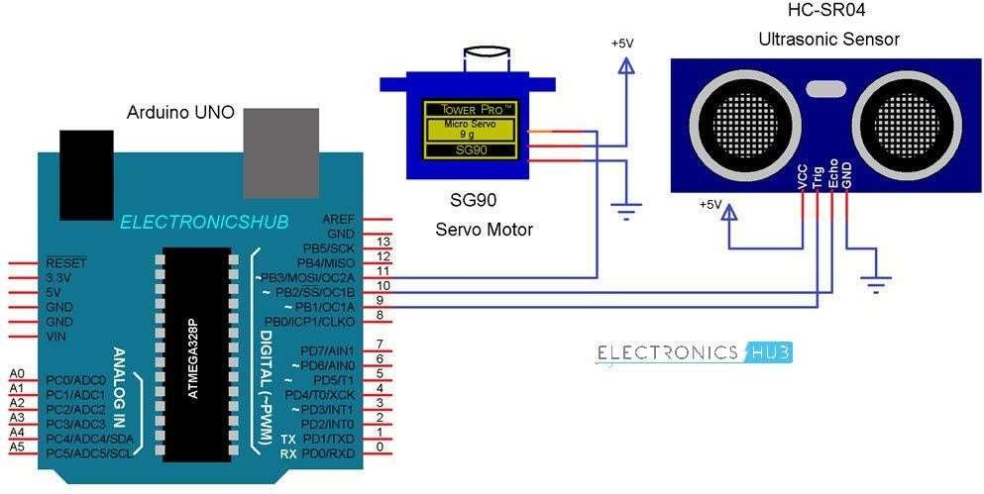

xxvi

#### ADVANTAGES:-

1. **The cost effective** : our project below 1000rs only.
2. **Improvised accuracy**: The resistors with low value in milliohms are used in advanced cars with sensitive power steering and break circuits. Now a days these advancements have become the major cause for the severe accidents . Therefore the components used in such circuits must have accurate and precise value for smooth working of such circuits. Ultimately this refers to the accurate testing of the resistors used. Improvised accuracy is thus the second primary aim of the sensor.
3. **Reduced hardware complexity**: Hardware complexity is one of the reasons for the high cost of the ultrasonic sensor. The use of arduino Uno is to reduce the motherboard present in the conventional ohmmeter in arduino based ultrasonic sensor. The arduino acts as the central board. Since arduino are readily available in market it leads to the reduction in the complexity of the design. The automated range selection is also the objective in order to speedup the testing process. This will also reduce the faults in range selection in manually operated conventional sensor.

xxvii

#### CONCLUSIONS:-

This project aims on the use of Ultrasonic Sensor by connected to the Arduino UNO R3 board and the signal from the sensor further provided to the screen formed on the laptop to measure the presence of any obstacle in front of the sensor as well as determine the range and angle at which the obstacle is detected by the sensor.

xxviii

#### REFERENCES

1. <http://www.arduino.cc/>
2. http://www.arduinoproducts .cc/
3. <http://www.atmel.com/atmega328/>
4. http://en.wikipedia.org/wiki/File:16MHZ_Crystal.jpg
5. http://www.google.co.in/imgres?imgurl=<http://www.electrosome.com/wp-> content/uploads/2012/06/ServoMotor.gif&imgrefurl=<http://www.electrosome.com/tag/se> rvo motor/&h=405&w=458&sz=67&tbnid=rcdlwDVt_x0DdM:&tbnh=100&tbnw=113&zoo m=1

&usg= 6J2h0ZocdoSMrS1qgK1I2qpTQSI=&docid=lEfbDrEzDBfzbM&sa=X&ei=a_

OKU vTbD8O5rgeYv4DoDQ&ved=0CDwQ9QE

1. http//:[www.sproboticworks.com/ic%20pin%20configuration/7805/Pinout.jpg/](http://www.sproboticworks.com/ic%20pin%20configuration/7805/Pinout.jpg/)
2. [http://www.sproboticworks.com/ic%ultrasonicsensor%20pinout.jpg](http://www.sproboticworks.com/ic%25ultrasonicsensor%20pinout.jpg)
3. <http://www.instructables.com/id/>ATMega328-using-Arduino-/
4. <http://www.motherjones.com/files/blog_google_driverless_car.jpg>
5. [http://www.google.co.in/imgres/Radar_antenna.jpg&w=546&h=697&ei=wuuK](http://www.google.co.in/imgres/Radar_antenna.jpg%26w%3D546%26h%3D697%26ei%3DwuuK)
6. <http://www.radomes.org/museum/photos/equip/ANSPS17.jpg> [12] <http://www.wired.com/dangerroom/2011/07/>suicide- bombers-from-100-yards/
7. <http://upload.wikimedia.org/wikipedia/commons/Radaraccumulationseng.png>

xxix

1. <http://arduino.cc/en/Tutorial/BarGraph/>
2. <http://arduino.cc/en/Tutorial/LiquidCrystal/>
3. [http://fritzing.org](http://fritzing.org/)

xxx

xxxi