**ABSTRACT**

Various nations utilize distinctive money, and there is every day variety in these monetary standards comparatives with each other. The individuals who move cash starting with one nation then onto the next (one money to another) must be refreshed with the most recent money trade rates on the lookout. Cash converter small scale venture is assembled remembering this thing. It is just an adding machine-like application created utilizing Ajax, Java servlets web highlights. In this application, there is customary update about cash of each nation by which it shows present money market worth and change rate. Such application can be utilized by any client, yet it is for the most part helpful for business, offers, and account related regions where cash move and money trade happens consistently. In this money converter application, clients are given a choice to choose the sort of transformation, for example from "this" money to "that" cash. This basic component permits clients to enter sum to be changed over (state cash in Dollars),and show the changed over sum (say money in Euro)

**TABLE OF CONTENTS**

* **Introduction**
* **Objective**
* **Theory**
* **Applications**
* **Future Work**
* **Conclusion**

**INTRODUCTION**

A money transformation expense is a charge required by the credit or check card instalment processor or ATM organization to change one cash over to another as a component of a monetary exchange. An unfamiliar exchange expense is a charge required by your credit or check card guarantor or ATM network on a similar exchange. The unfamiliar exchange expense may incorporate the cash change charge, contingent upon whether the card guarantor or ATM network gives that expense to you. (A few cards don't charge unfamiliar exchange expenses.) Dynamic cash change (DCC) is normally more expensive than money transformation through the Visa processor, yet it lets you see the expense of your exchange in U.S. dollars when you cause it instead of when you to get your Visa bill .

**PROPOSED SYSTEM**

This application can be used by any user, but it is mainly useful for business, shares and finance related areas where money transfer and currency exchange take place on a daily basis. The amount of money you’ll get for a given amount of your country’s currency is based on internationally determined live exchange rates. Current international exchange rates are determined by a managed floating exchange rate. The aim of our system is to help people who need to recognize different currencies and able to convert then to another currency using a known exchange rate.

**SYSTEM SPECIFICATION**

**SOFTWARE REQUIREMENT-**

**•JAVA (Eclipse IDE – 64 Bit)**

**HARDWARE REQUIREMENTS-**

**•Processor – Intel Pentium and more**

**•Motherboard- Intel Chipset Motherboard**

**•RAM- 128MB and more**

**•Cache- 512 KB**

**•Hard Disk- 16GB hard disk recommended**

**PROCEDURE FOR CONVERSION**

**(ALGORITHM)**

* getCurrency(): java.util.Currency.getCurrency() method returns ISO 4217 currency code of the passed currency argument.
* getInstance() : java.util.Currency.getInstance() method creates currency instancefor Currency code.
* getDefaultFractionDigits(): java.util.Currency.
* getDefaultFractionDigits() method returns default number of argumented currency fraction digits.
* getDisplayName() : java.util.Currency.
* getDisplayName() method generates the currency name of the argumented currency code.
* getSymbol() : java.util.Currency.getSymbol() method returns Currency symbol for the argumented currency code. In case, no symbol is returned normal currency code will be returned

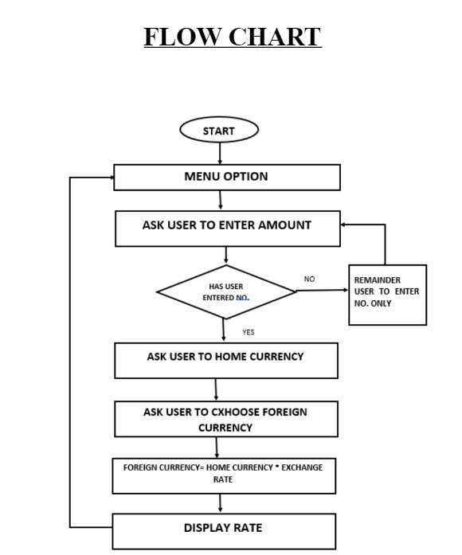

**Code :**

import java.util.*;

import java.text.DecimalFormat;

class Currency_Converter

{

public static void main(String[] args)

{

double rupee,dollar,pound,code,euro,KWD;

DecimalFormat f = new DecimalFormat("##.###");

Scanner sc = new Scanner(System.in);

System.out.println("*** WelCome to Webeduclick Currency Converter Project ***\nEnter the currency code \n1:Rupees\n2:Dollar\n3:Pound\n4:Euro\n5:Kuwaiti dinar");

code=sc.nextInt();

if(code == 1)

{

System.out.println("Enter amount in rupees:");

rupee = sc.nextFloat();

dollar = rupee / 75;

System.out.println("Dollar : "+f.format(dollar));

pound = rupee / 101;

System.out.println("Pound : "+f.format(pound));

euro = rupee / 84;

System.out.println("Euro : "+f.format(euro));

KWD = rupee / 250;

System.out.println("Kuwaiti dinar : "+f.format(KWD));

}

else if (code == 2)

{

System.out.println("Enter amount in dollar:");

dollar = sc.nextFloat();

rupee = dollar * 75;

System.out.println("Rupees : "+f.format(rupee));

pound = dollar * 0.72;

System.out.println("Pound : "+f.format(pound));

euro = dollar * 0.88;

System.out.println("Euro : "+f.format(euro));

KWD = dollar * 0.30;

System.out.println("Kuwaiti dinar : "+f.format(KWD));

}

else if(code == 3)

{

System.out.println("Enter amount in Pound:");

pound = sc.nextFloat();

rupee = pound * 101;

System.out.println("Rupees : "+f.format(rupee));

dollar = pound * 1.35;

System.out.println("Dollar : "+f.format(dollar));

euro = pound * 1.36;

System.out.println("Euro : "+f.format(euro));

KWD = pound * 0.4;

System.out.println("Kuwaiti dinar : "+f.format(KWD));

}

else if(code == 4)

{

System.out.println("Enter amount in Euro:");

euro = sc.nextFloat();

rupee = euro * 84;

System.out.println("Rupees : "+f.format(rupee));

dollar = euro * 1.12;

System.out.println("Dollar : "+f.format(dollar));

pound = euro * 0.73;

System.out.println("Pound : "+f.format(pound));

KWD = euro * 0.34;

System.out.println("Kuwaiti dinar : "+f.format(KWD));

}

else if(code == 5)

{

System.out.println("Enter amount in Kuwaiti dinar:");

KWD = sc.nextFloat();

rupee = KWD * 250;

System.out.println("Rupees : "+f.format(rupee));

dollar = KWD * 3.30;

System.out.println("Dollar : "+f.format(dollar));

pound = KWD * 2.5;

System.out.println("Pound : "+f.format(pound));

euro = KWD * 2.94;

System.out.println("Euro : "+f.format(euro));

}

else

System.out.println("Invalid Code!");

}

}

**Need for Currency Converter**

* The demand for foreign currencies arises whentourists visits another country and need to exchangetheir national currency for the currency of the countrythey are visiting.
* The foreign firms wants to import from other nationsor when the individual wants to invest abroad and soon

**CONCLUSION**

* In this article we have created a currency converter
* This converter can convert between Ruppe, euro and US Dollar
* We created this using Simple switches and methods in java