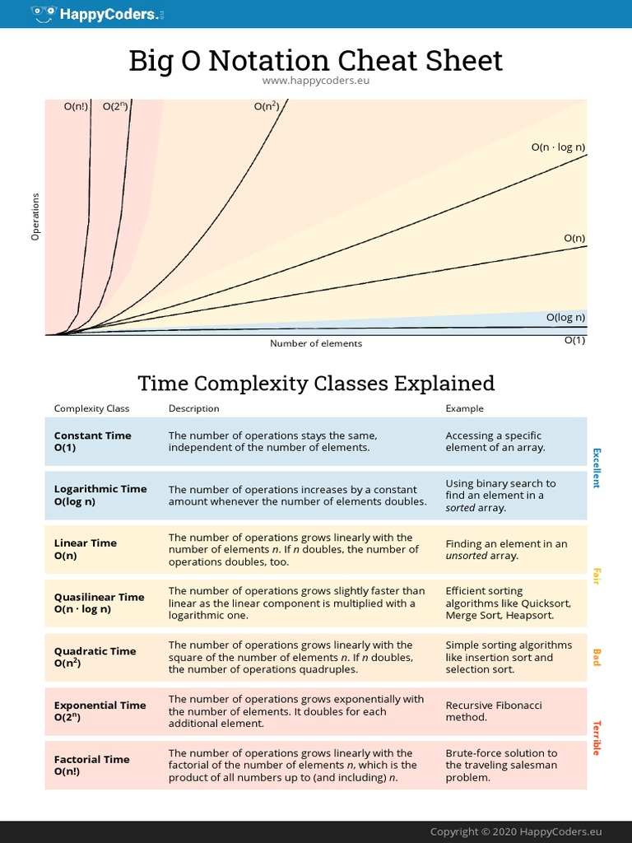
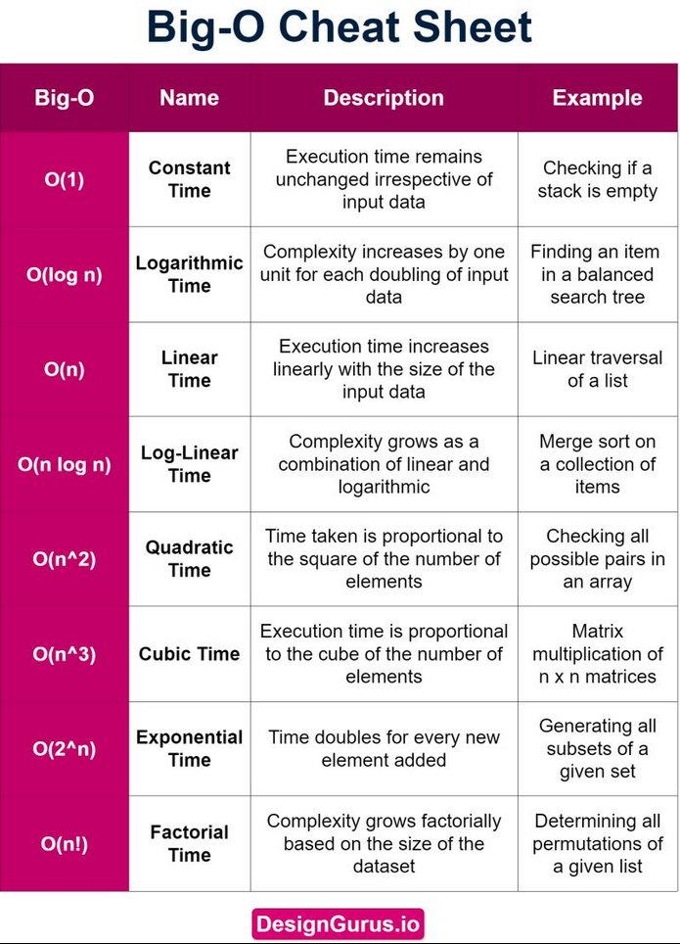
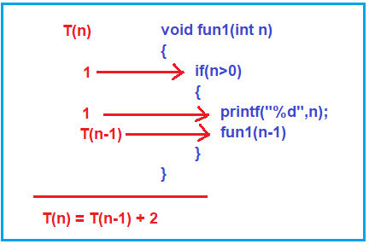
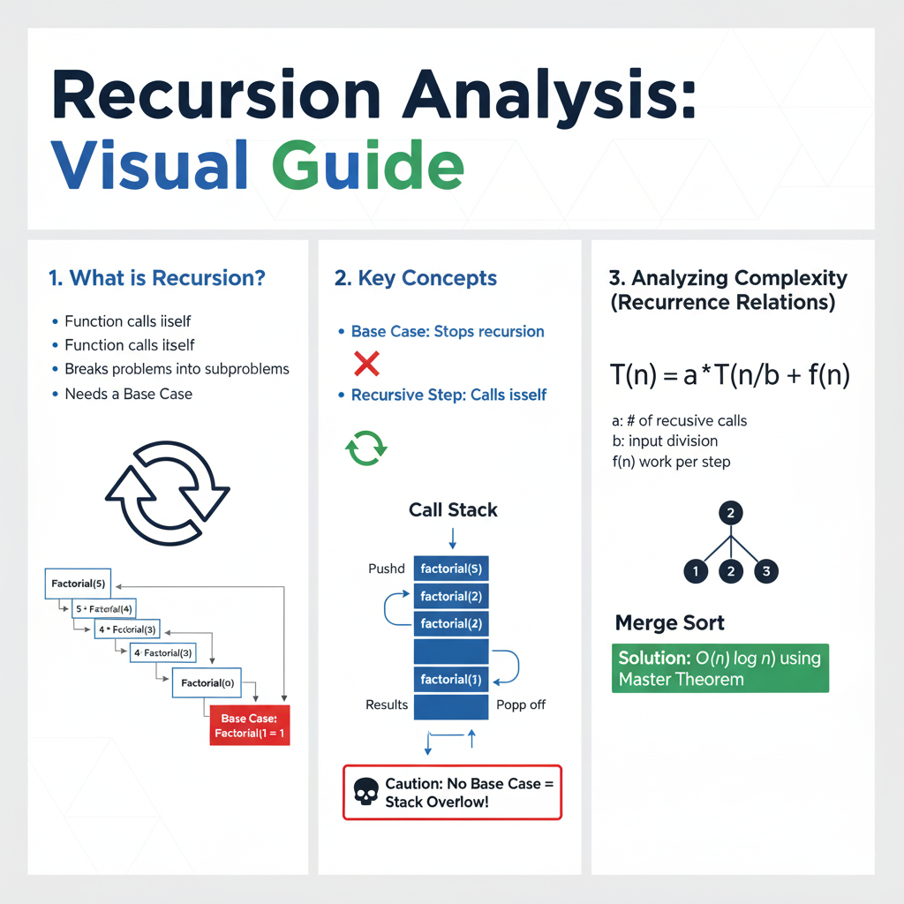

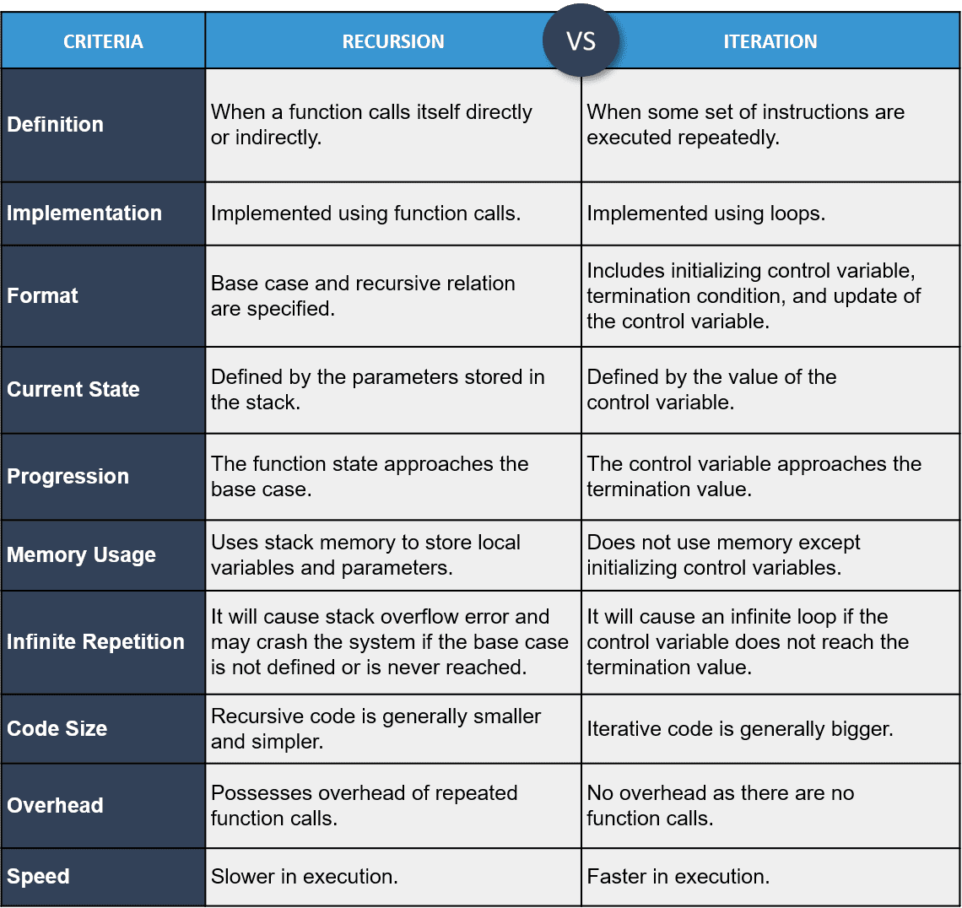
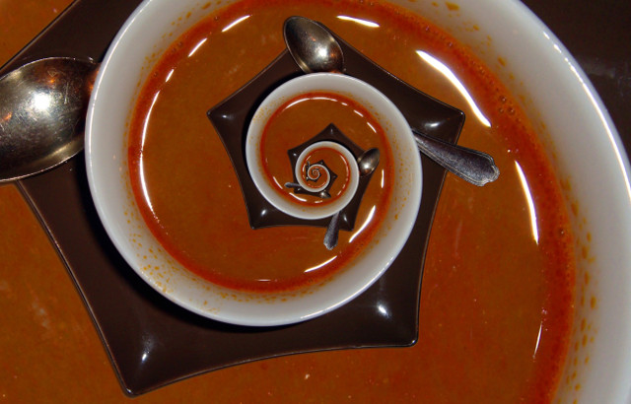
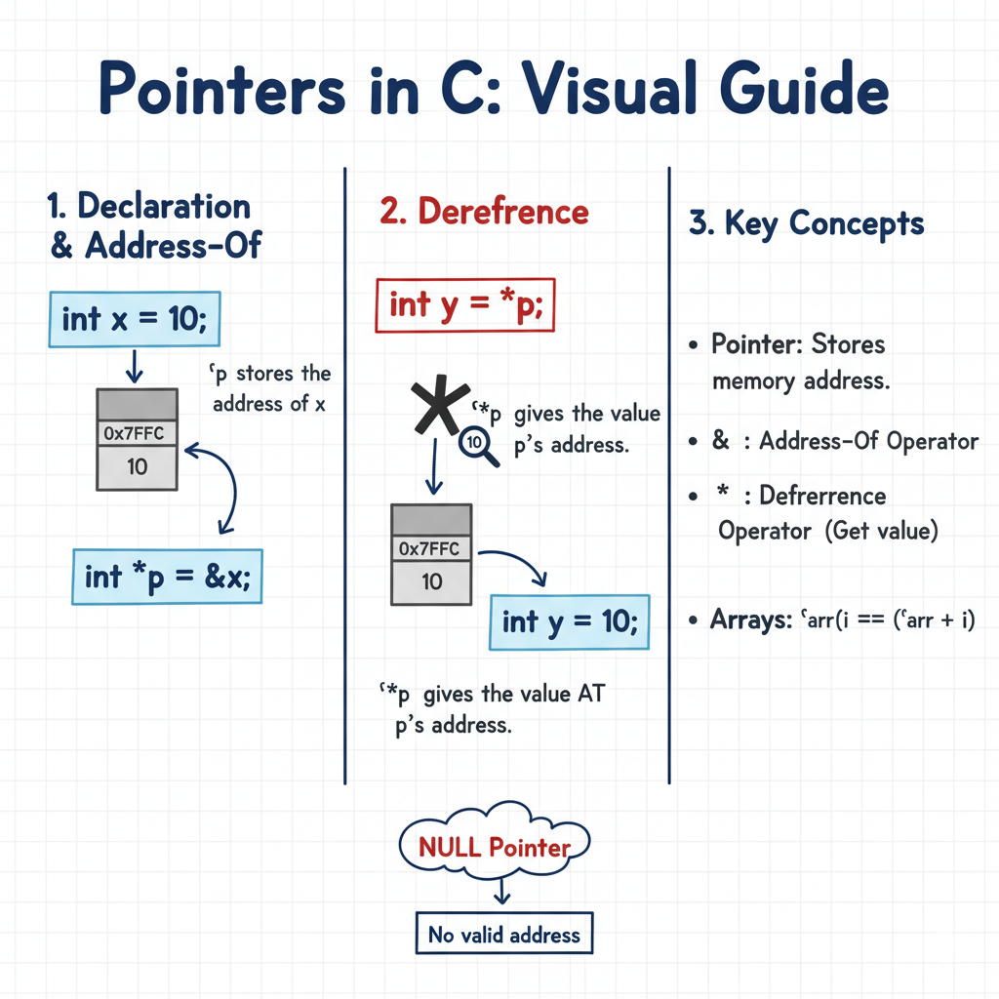

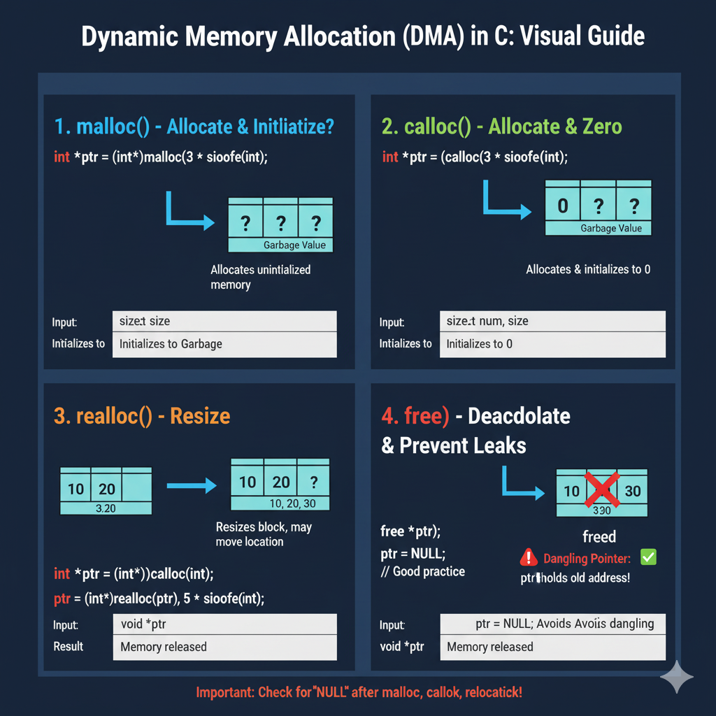

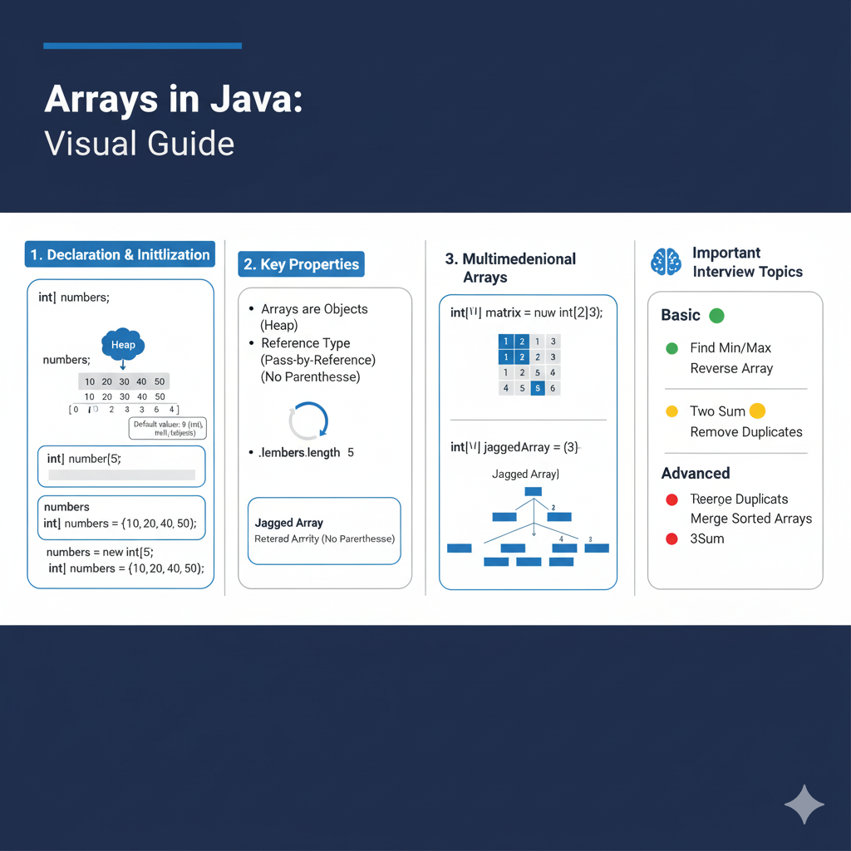

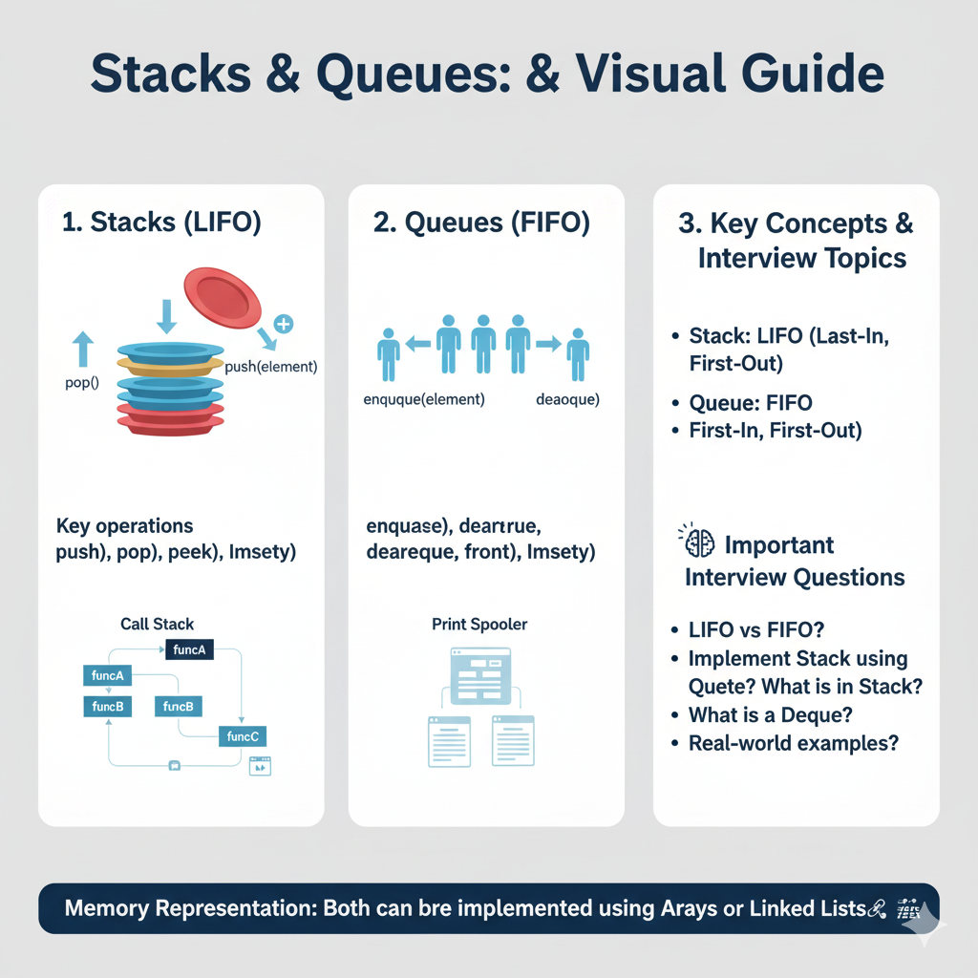
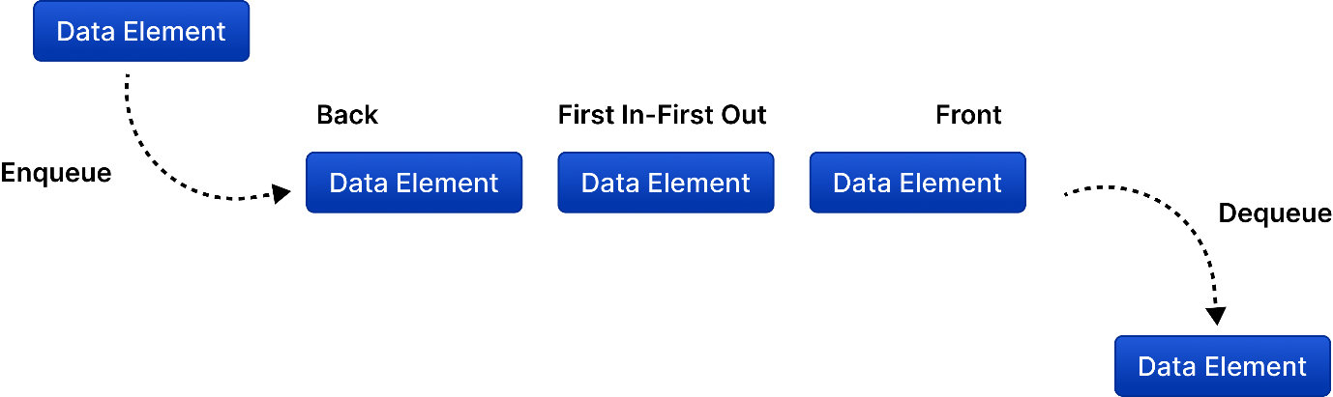

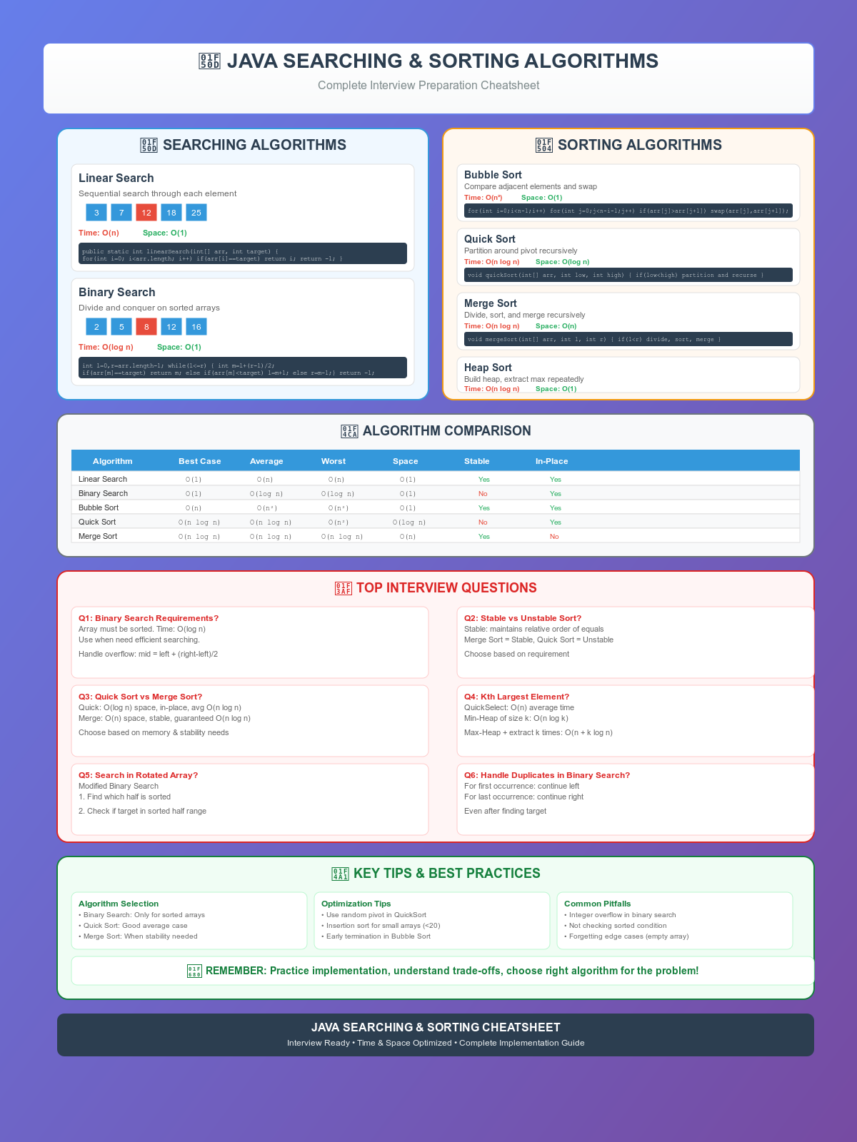
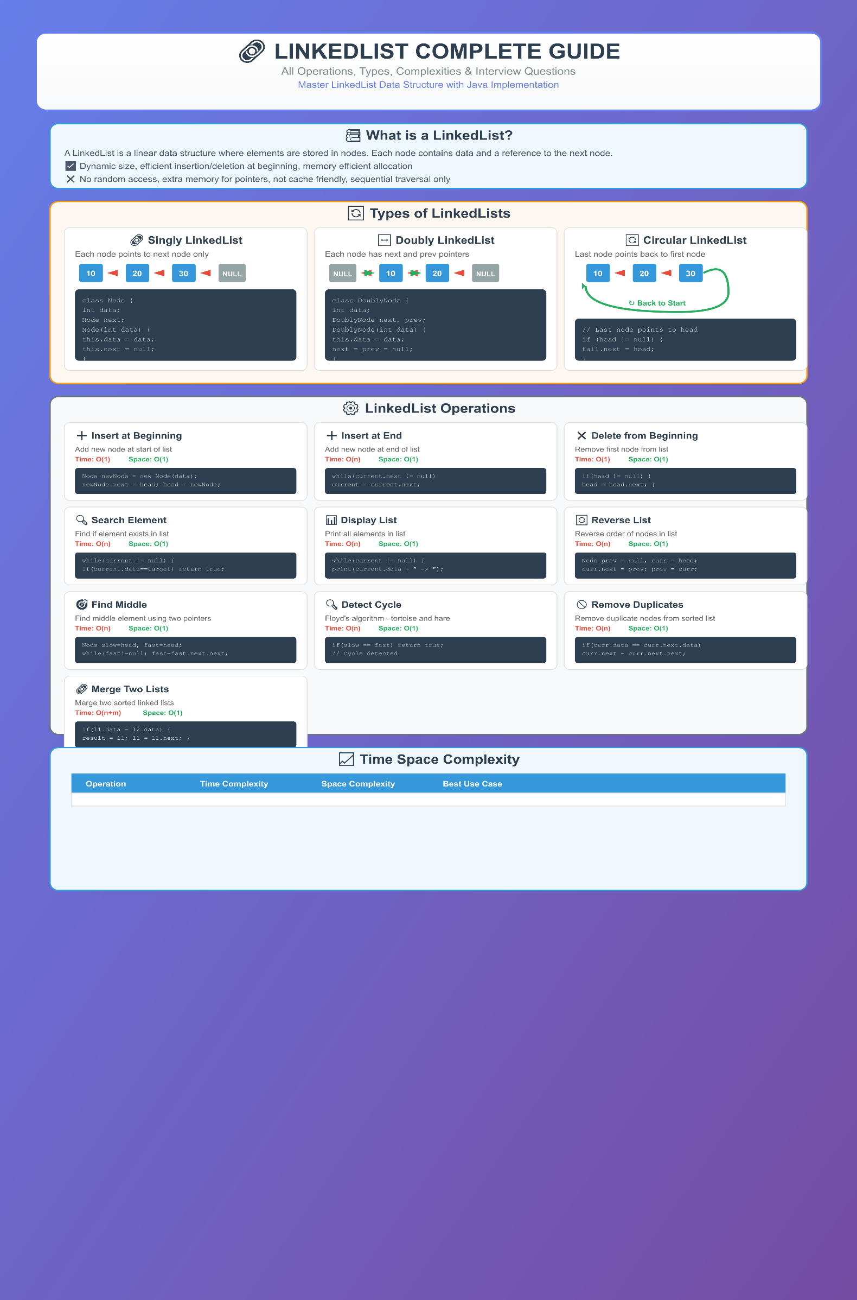

S.No Sheet Name Sheet Link
1 Striver DSA sheet https://takeuforward.org/strivers-a2z-dsa-course/strivers-a2z-dsa-course-sheet-2/
2 Love Babbar 450 Qs DSA sheet https://drive.google.com/file/d/1FMdN_OCfOI0iAeDlqswCiC2DZzD4nPsb/view
3 LeadCoding by Fraz 250 Qs DSA Sheet https://docs.google.com/spreadsheets/u/0/d/1-wKcV99KtO91dXdPkwmXGTdtyxAfk1mbPXQg81R9sFE/htmlview
4 Arsh Goyal 280 Qs DSA Sheet https://docs.google.com/spreadsheets/d/1MGVBJ8HkRbCnU6EQASjJKCqQE8BWng4qgL0n3vCVOxE/htmlview?usp=sharing&pru=AAABgKkdtIE*rPv8dPkWyOpfwjprKvKSeA
5 Apna college 375 Qs DSA sheet https://docs.google.com/spreadsheets/u/0/d/1hXserPuxVoWMG9Hs7y8wVdRCJTcj3xMBAEYUOXQ5Xag/htmlview
6 Siddharth Singh 450 Qs DSA Sheet https://docs.google.com/spreadsheets/u/0/d/11tevcTIBQsIvRKIZLbSzCeN4mCO6wD4O5meyrAIfSXw/htmlview
7 The Code Skool DSA Sheet https://docs.google.com/document/u/0/d/1RxKKXJtErQFJjMfAh1kV-

