**CHAPTER 3 :VISUALIZATION**

## **Lab 1: Creating a Bar Chart**

**Question:** How do you create a **Bar Chart** to display total sales by product category?

**Answer:**

1. Click on the **Bar Chart** in the **Visualizations** pane.
2. Drag **Product Category** to the **X-axis** field.
3. Drag **Total Sales** to the **Values** field.
4. Adjust formatting by clicking the **Format Visual** option.

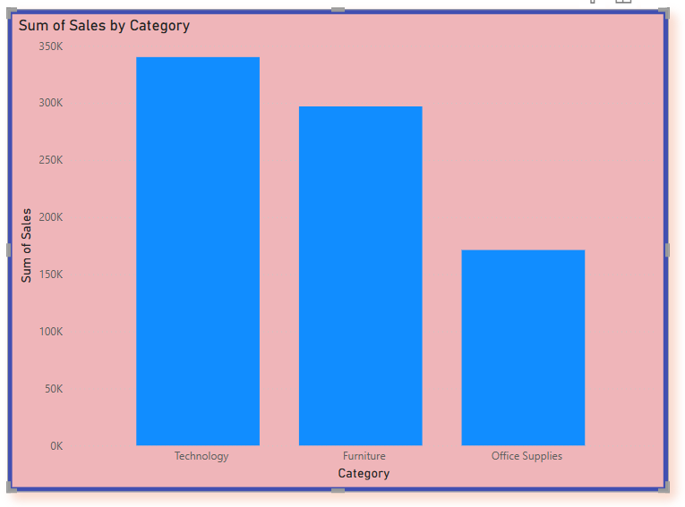

## **Lab 2: Creating a Line Chart**

**Question:** How do you create a **Line Chart** to show sales trends over time?

**Answer:**

1. Click on the **Line Chart** in the **Visualizations** pane.
2. Drag **Date** to the **X-axis** field.
3. Drag **Sales Amount** to the **Values** field.
4. Add a **title and customize colors** in the Format pane.

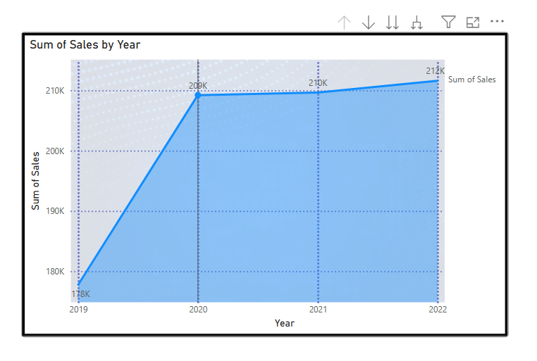

## **Lab 3: Creating a Pie Chart**

**Question:** How do you create a **Pie Chart** to show the percentage of total sales per region?

**Answer:**

1. Click on the **Pie Chart** in the **Visualizations** pane.
2. Drag **Region** to the **Legend** field.
3. Drag **Sales Amount** to the **Values** field.
4. Adjust labels and colors using the **Format Visual** options.

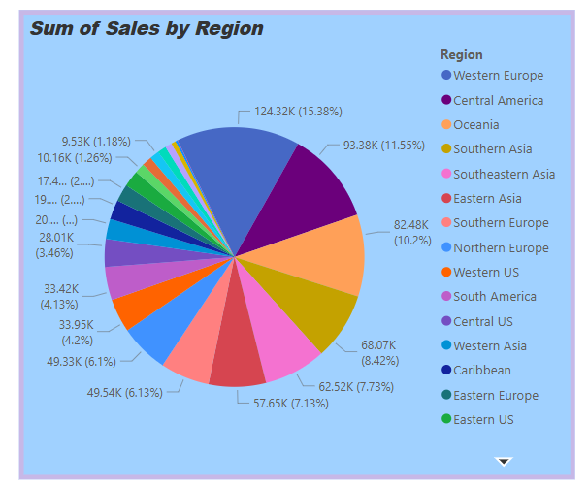

## **Lab 4: Creating a Table and Matrix Visualization**

**Question:** How do you create a **Matrix Table** to display sales data by category and subcategory?

**Answer:**

1. Click on the **Matrix** visual in the **Visualizations** pane.
2. Drag **Category** to the **Rows** field.
3. Drag **Subcategory** to the **Rows** field (under Category).
4. Drag **Sales Amount** to the **Values** field.
5. Expand/Collapse hierarchy for better data analysis.

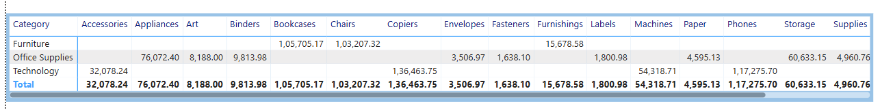

## **Lab 5: Creating a Card Visualization**

**Question:** How do you create a **Card Visual** to display total sales?

**Answer:**

1. Click on the **Card** visual in the **Visualizations** pane.
2. Drag **Total Sales** measure to the **Fields** area.
3. Adjust **font size and color** using the **Format Visual** options.

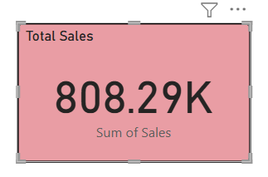

## **Lab 6: Creating a Map Visualization**

**Question:** How do you create a **Map Visual** to display sales by location?

**Answer:**

1. Click on the **Map** visual in the **Visualizations** pane.
2. Drag **City** or **State** to the **Location** field.
3. Drag **Sales Amount** to the **Size** field.
4. Adjust the map style and zoom level in the **Format Visual** options.

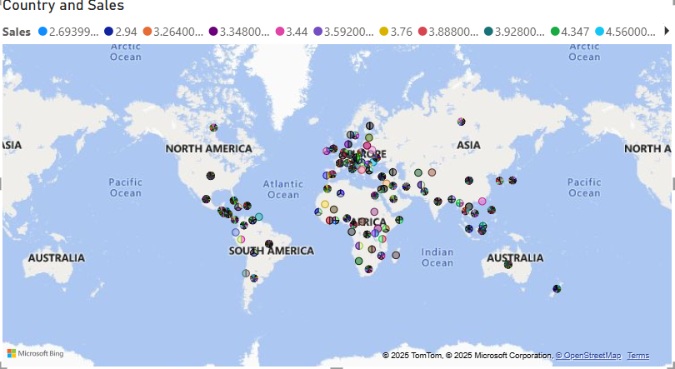

## **Lab 7: Adding Slicers for Filtering Data**

**Question:** How do you add a **Slicer** to filter data by year?

**Answer:**

1. Click on the **Slicer** visual in the **Visualizations** pane.
2. Drag the **Year** column into the **Field** section.
3. Resize and position the slicer for better visibility.
4. Use the slicer to filter data dynamically.

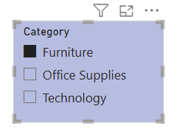

## **Lab 8: Creating a KPI (Key Performance Indicator) Visual**

**Question:** How do you create a **KPI Visual** to track monthly sales performance?

**Answer:**

1. Click on the **KPI Visual** in the **Visualizations** pane.
2. Drag **Total Sales** measure into the **Indicator** field.
3. Drag **Date** into the **Trend Axis** field.
4. (Optional) Add a **Target Sales** measure for comparison.

