**CertiTrack   
Documentation**

**Hack Challenge:**

When employees express the desire to pursue certifications, they frequently encounter difficulties in locating colleagues within the organization who can offer guidance or grant access to resources to support their certification journey.

**Problem Statement:**

Within our organization, employees who aspire to obtain certifications often face challenges in identifying suitable mentors or accessing the necessary resources to assist them on their certification path. This lack of guidance and resources delays their professional development and may result in missed opportunities for both the individuals and the company. How can we facilitate a more seamless and efficient process for employees seeking certification support within the organization?

**Proposed Solution:**

The CertiTrack project aims to simplify the certification process for employees while encouraging a culture of mutual support and learning. This will be achieved through a user-friendly web application designed to serve several key functions:

**1. Certification Tracking:**

The application will enable employees to easily keep tabs on their certifications. They can see which certifications they've completed and which ones they're working towards.

**2. Peer Guidance & Mentor Matching:**

Employees will be able to connect with their colleagues who have already completed specific certifications. This feature encourages knowledge sharing and mentorship within the organization.

To facilitate guidance, the application will help employees find suitable mentors within the company who can assist them on their certification journey.

**3. Q&A Forum:**

An interactive Q&A forum will be available for employees to ask questions and seek answers related to certifications. This creates a collaborative environment for problem-solving.

**4. Learning Resources:**

The application will house a repository of valuable materials and learning paths that employees can access to enhance their certification preparation.

**5. Managerial Oversight:**

Managers and team leads will have the capability to assign and track the certification progress of their team members, streamlining the certification management process.

By implementing these features, the CertiTrack project aims to empower employees to pursue certifications with confidence, while also strengthening the organization's overall knowledge-sharing and professional development ecosystem.

**Business Use cases:**

1. **Who are your customers:**

* **Internal Employees:** Employees seeking certifications and professional development.
* **Managers and Team Leads:** Those managing teams and tracking certification progress.
* **Organizations:** The company itself, benefiting from a more skilled and certified workforce.

1. **Current Competitors:**
   * LinkedIn
   * Stack Overflow
   * Quora
2. **How are you planning to launch this project?**
   * Start with an internal soft launch for early adopters.
   * Create awareness through internal communication channels.
   * Conduct training sessions for employees.
   * Establish a feedback mechanism for improvements.
   * Gradually roll out to all employees.
   * Promote mentorship within the platform.
   * Ensure data security and privacy measures are in place.

**Architecture:**

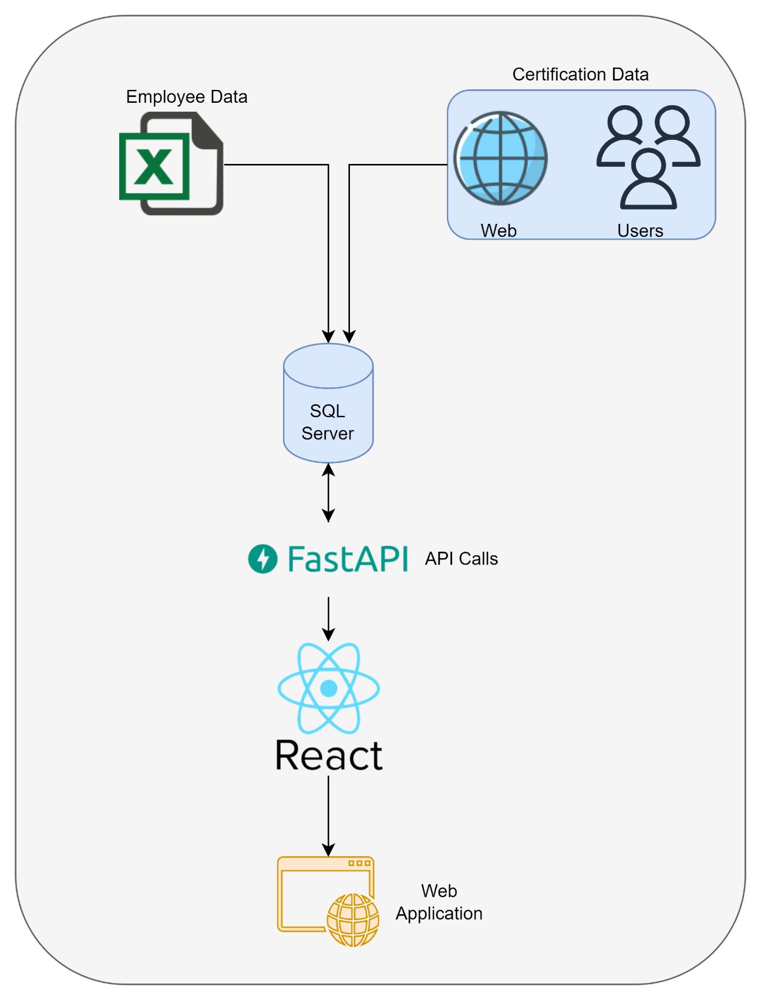

**Technology Stack Used:**

****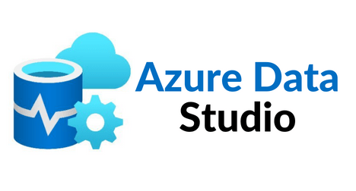

**SQL Agent**​

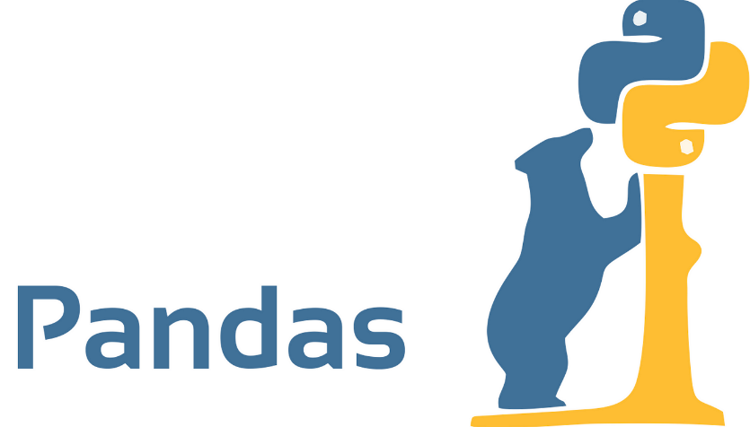



**Roles:**

* Ravi Varma Yalamanchili – Technical Lead and Team Lead
* Avinash Bevara – Architect and Backend Developer
* Ram Giduturi – Frontend Developer
* Karthik Mediboina – Backend & API Developer

**Cross skilling: Upskilling:**

* SQL Server
* Azure Data Studio
* Python
* React
* Git
* FastAPI

**Implementation Details:**

**Module-1: Front end:**

**Packages used**: Axios, React-Router-Dom, React-Datepicker

**Tasks performed**: Login Page, Home Page, Certifications Dashboard, QA page, Add certifications page, My certifications page, Manger dashboard etc.

**Major Achievements**: Learning and implementing front end application using React in short span of time

**Features Promised**: Finding certified people, QA Form, assigning certifications, Tracking and managing certifications, adding certifications, Dashboard for tracking, Learning path.

**Features Achieved:** Finding certified people, QA Form, assigning certifications, Tracking and managing certifications, Adding certifications,

**Module-2: Backend:**

**Packages used:** Pyodbc, FastAPI, json, middleware, pydynatic, uvicorn

**Tasks performed:** Implemented procedures for all the functionalities, Developed APIs, Various functions to connect to database and get results, Dynamic SQLs for sending mails.

**Major Achievements:** Developed APIs and Dynamic SQL procedures for sending mails.

**Optimized solutions:** Dynamic SQLs and procedures.

**Features Promised:** Backend functionalities forfinding certified people, QA Form, assigning certifications, Tracking and managing certifications, adding certifications.

Use PowerBI for Dashboard tracking.

**Features Achieved:** Backend functionalities finding certified people, QA Form, assigning certifications, Tracking and managing certifications, Adding certifications

**Process Flow:**

1. **Login to the CertiTrack Website**:

After logging into the application, user will be directed to the homepage. Depending on the user who logs in, different views will be displayed, namely Manager and Individual

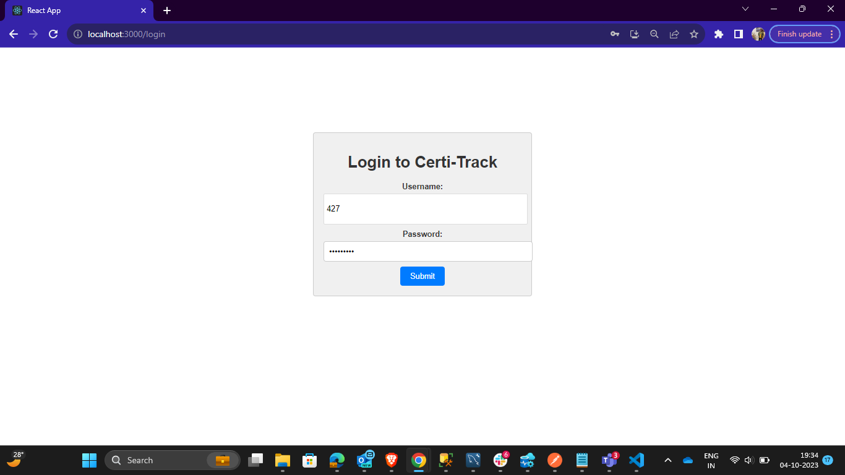

1. **Home Page**:

The homepage contains all available certifications and provides a count of how many people within the organization have completed each certification.

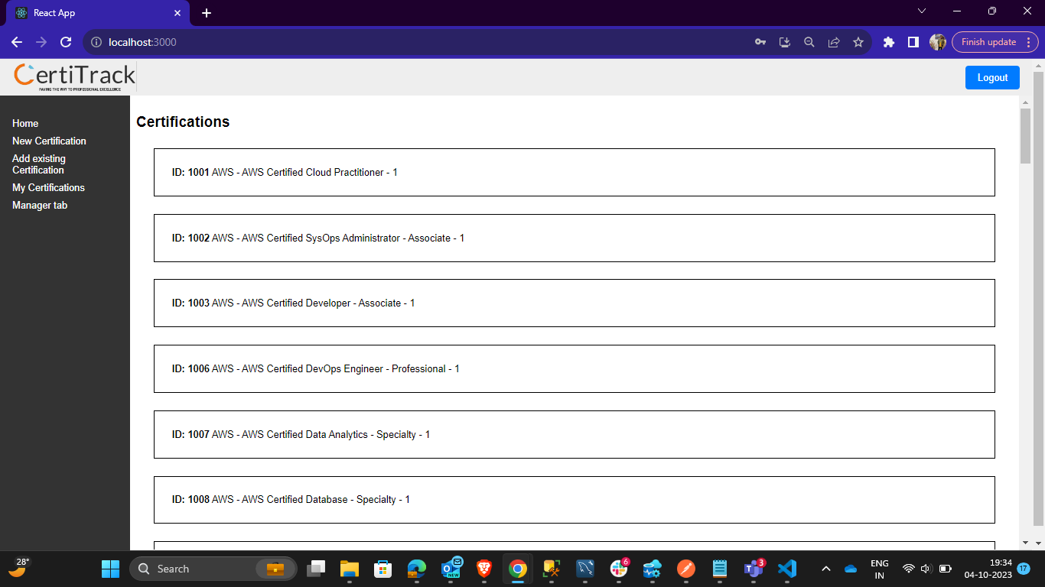

Upon clicking on a specific certification, user will be redirected to a page where he/she can find a list of all the individuals who have completed that particular certification. Additionally, there will be a Q&A page available.

1. **Q&A Page:**

In this section, user will have the capability to access all the asked questions and engage in asking and answering questions or addressing any doubts he/she may have.

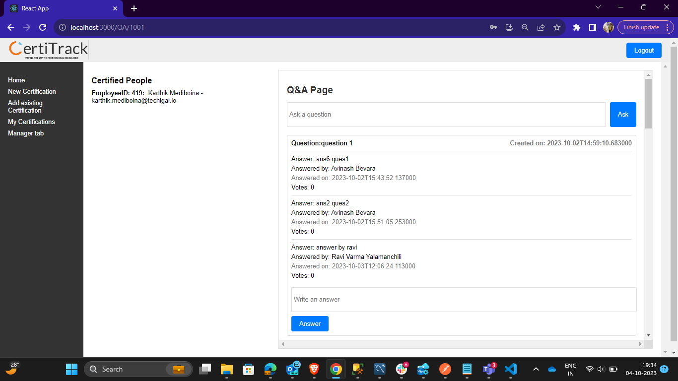

1. **New Certification Page:**

On this page, users have the option to start their certifications they wish to pursue by supplying all the required information. Additionally, managers can use this page to assign certifications to their team members (reportees) and set due dates for completion.

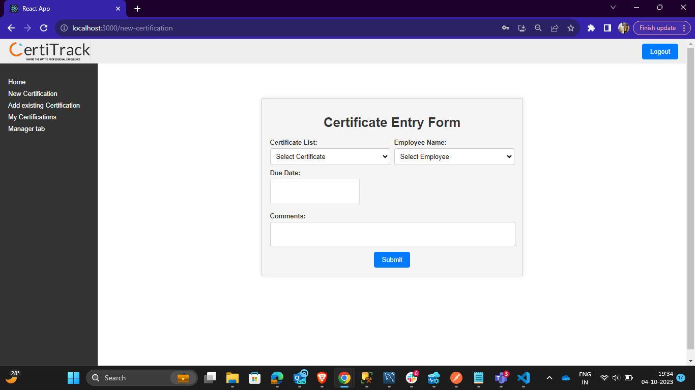

1. **Add Existing Certification:**

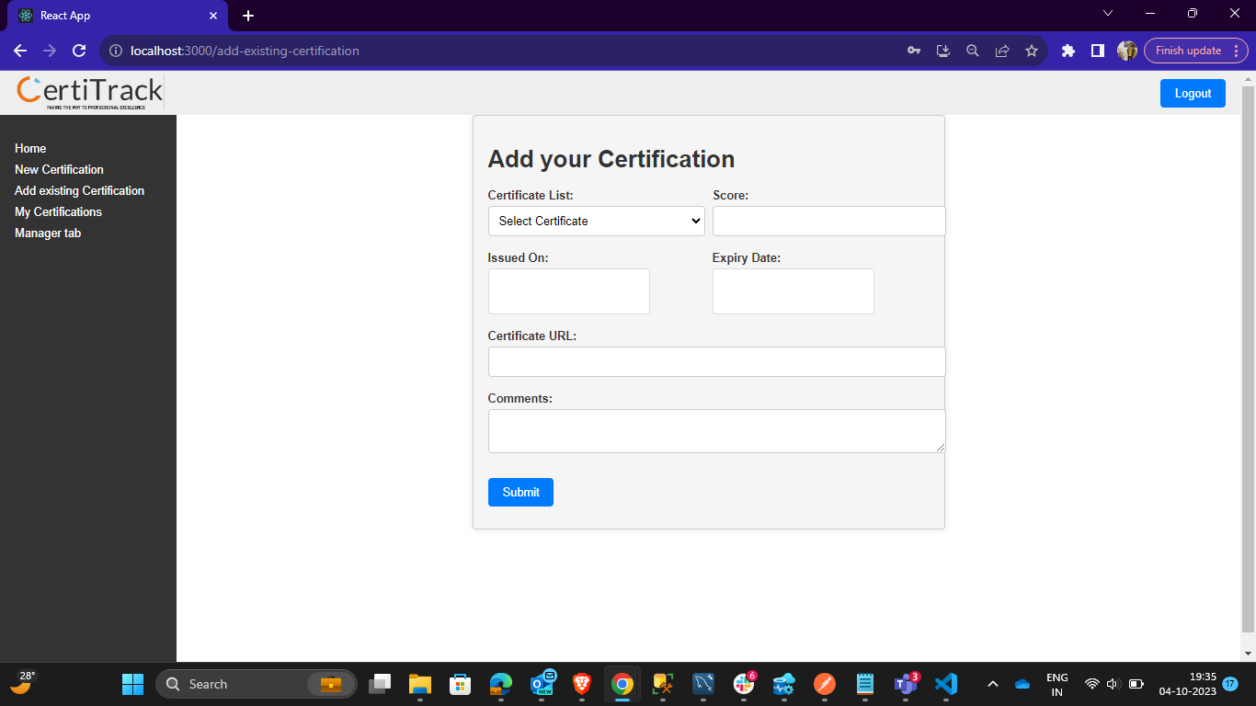On this page, users can add existing certificates, which will then be submitted for approval. These certificates may either be approved and marked as completed, or they may be rejected based upon validating the certificate submitted by the user.

* 1. **Assign Notification: c. Certification Approved Notification**

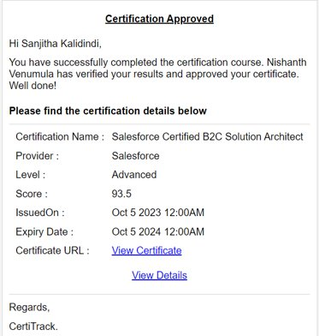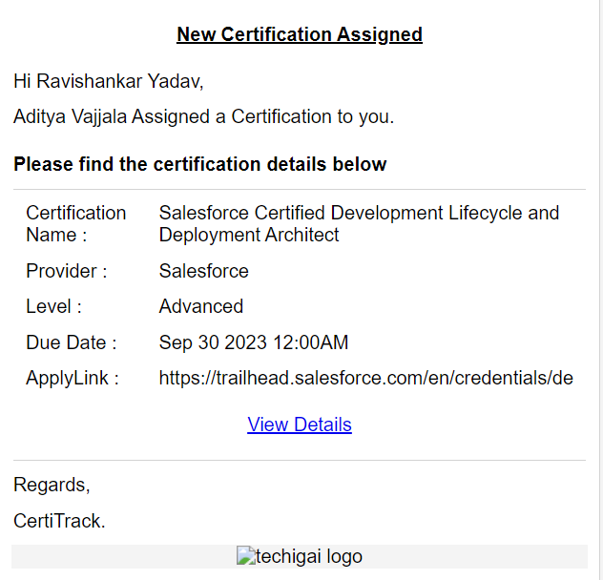

* 1. **Certification Due Notification: d. Certificate Expired Notification**

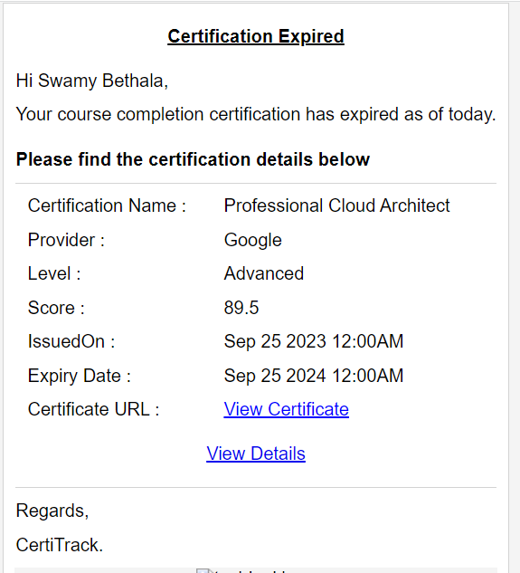 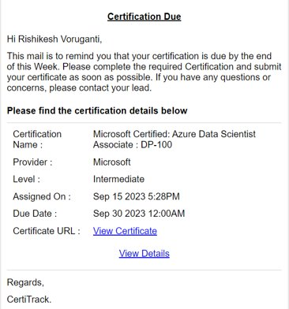

1. **My Certifications Page:**

This Page allows users to access their personal certification details organized in different tabs based on the certification's status. Users will also have the option to edit their in-progress certification information.

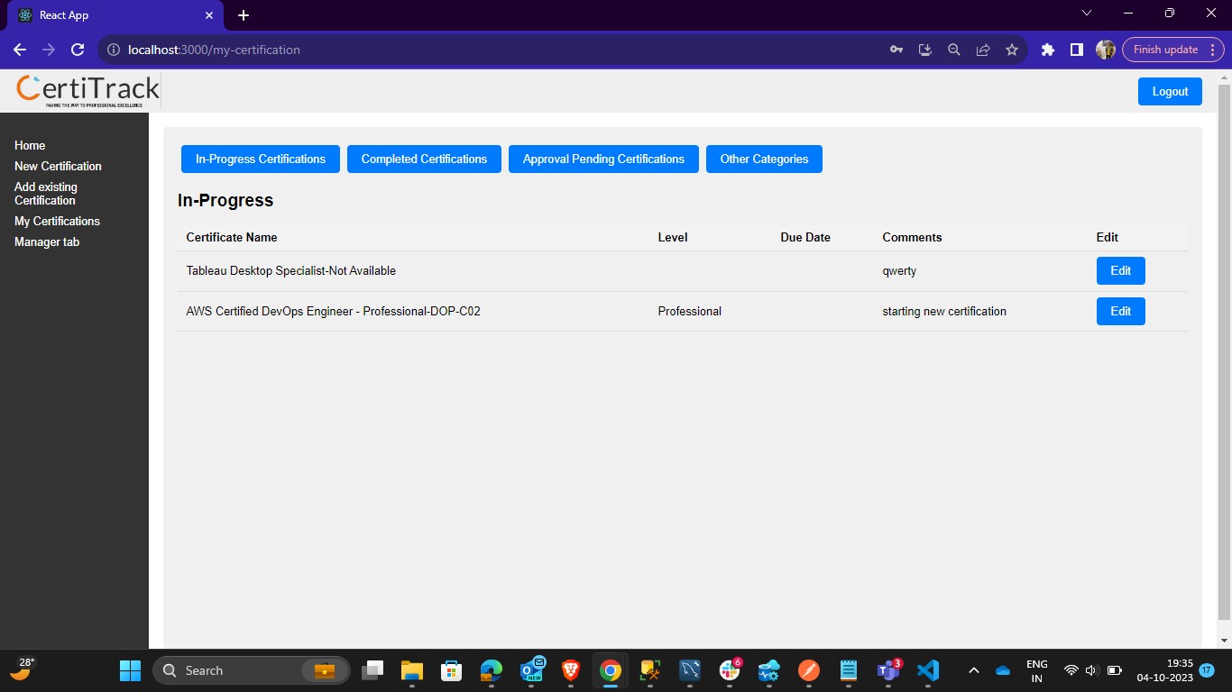

1. **Manger Tab:**

On this manager page, managers can monitor the certification details of their team members (reportees) and have the authority to assign certifications. Managers are also able to take actions such as approving, rejecting, revoking, or resuming certifications when deemed necessary.

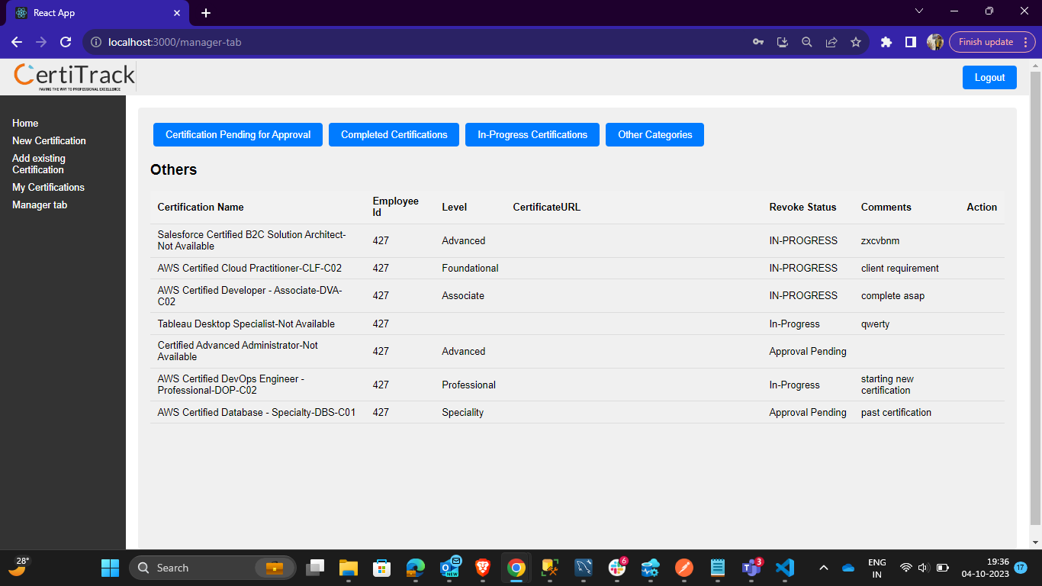

**Gitlab Link:**

<https://git.techigai.io/hackathon-2023/certitrack-innovators/test-project>

**Demo Link:**

Share point project URL

**Future Scope:**

1. **Coupons Notifications using Web Scraping:**

* Implement a feature that uses web scraping techniques to gather information about available discounts, promotions, and coupons related to certification exams and training programs.
* Notify users within the CertiTrack application about these costs saving opportunities, helping them minimize expenses associated with certifications.

1. **Reimbursement of Certification Cost:**
   * Develop a functionality within CertiTrack to facilitate the reimbursement process for certification costs incurred by employees.
   * Streamline the reimbursement request submission, approval, and tracking process, ensuring that eligible employees receive financial support for their certification endeavors.
   * Implement clear policies and guidelines for reimbursement eligibility to manage costs effectively.
2. **Dashboard for various Metrics:**
   * Develop a dashboard to show different type of metrics like no of certifications completed by each employee and his progress.
   * No of certifications per day/month/quarter/year.
3. **Add a New Certificate to Certificate List:**
   * Allow users to add certificate which is not present in the certificate list and add it when it is approved by the Lead/Approver.

These future scope enhancements aim to further enhance the value and utility of the CertiTrack application, making it a comprehensive platform for certification support, cost savings, and seamless integration into the organization's existing ecosystem.

**Conclusion:**

In conclusion, the CertiTrack project is poised to revolutionize how our organization approaches certification management and employee development. By offering a user-friendly web application that tracks certifications, encourages mentorship, and provides valuable resources, we are setting the stage for a more efficient and collaborative environment.

CertiTrack isn't just a tool; it actively encourages positive change. It empowers our internal employees, managers, and the organization as a whole by promoting a culture of knowledge-sharing and growth. As we move forward on this journey, we eagerly anticipate the substantial impact it will have on our employees' career paths and the overall success of our organization. With CertiTrack, we're not merely managing certifications; we're nurturing a thriving learning environment.