**Career Guidance System**

**Current Scenario:**

Taking into consideration the various limitations of manual career counselling such as high fees, biased in terms of personal opinions and availability of them in rural areas, here we are proposing unbiased, easy to use system to guide students.

The proposed system has three users namely,

1. Student
2. Admin
3. Registrar

**Roles:**

1. **Admin:**
   1. To edit the information of all users and can even delete the user from database
2. **Registrar:**
   1. Update or add aptitude test questionnaire
   2. Add colleges and fields
   3. Upload various portion related E-books
   4. Can view ranking of students attempting the test.
3. **Student:**
   1. Give counselling aptitude test
   2. Has statistical dashboard
   3. Can view his previous test result ( historic data is maintained )

**{Some screenshots from our implemented work}**

**Registrar dashboard:**

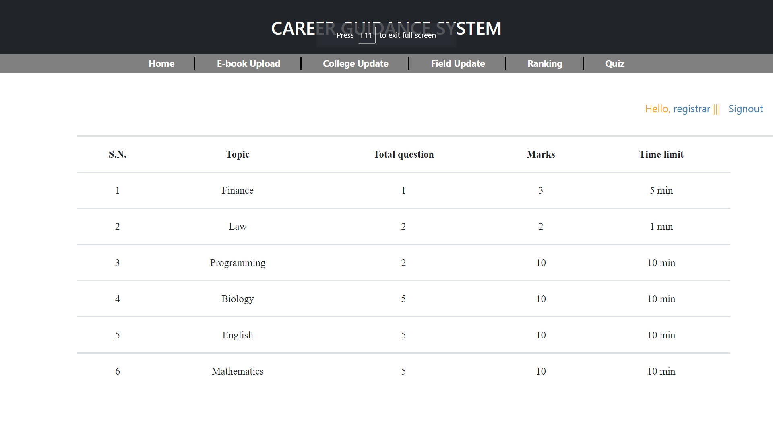

**Registrar adding new aptitude quiz**

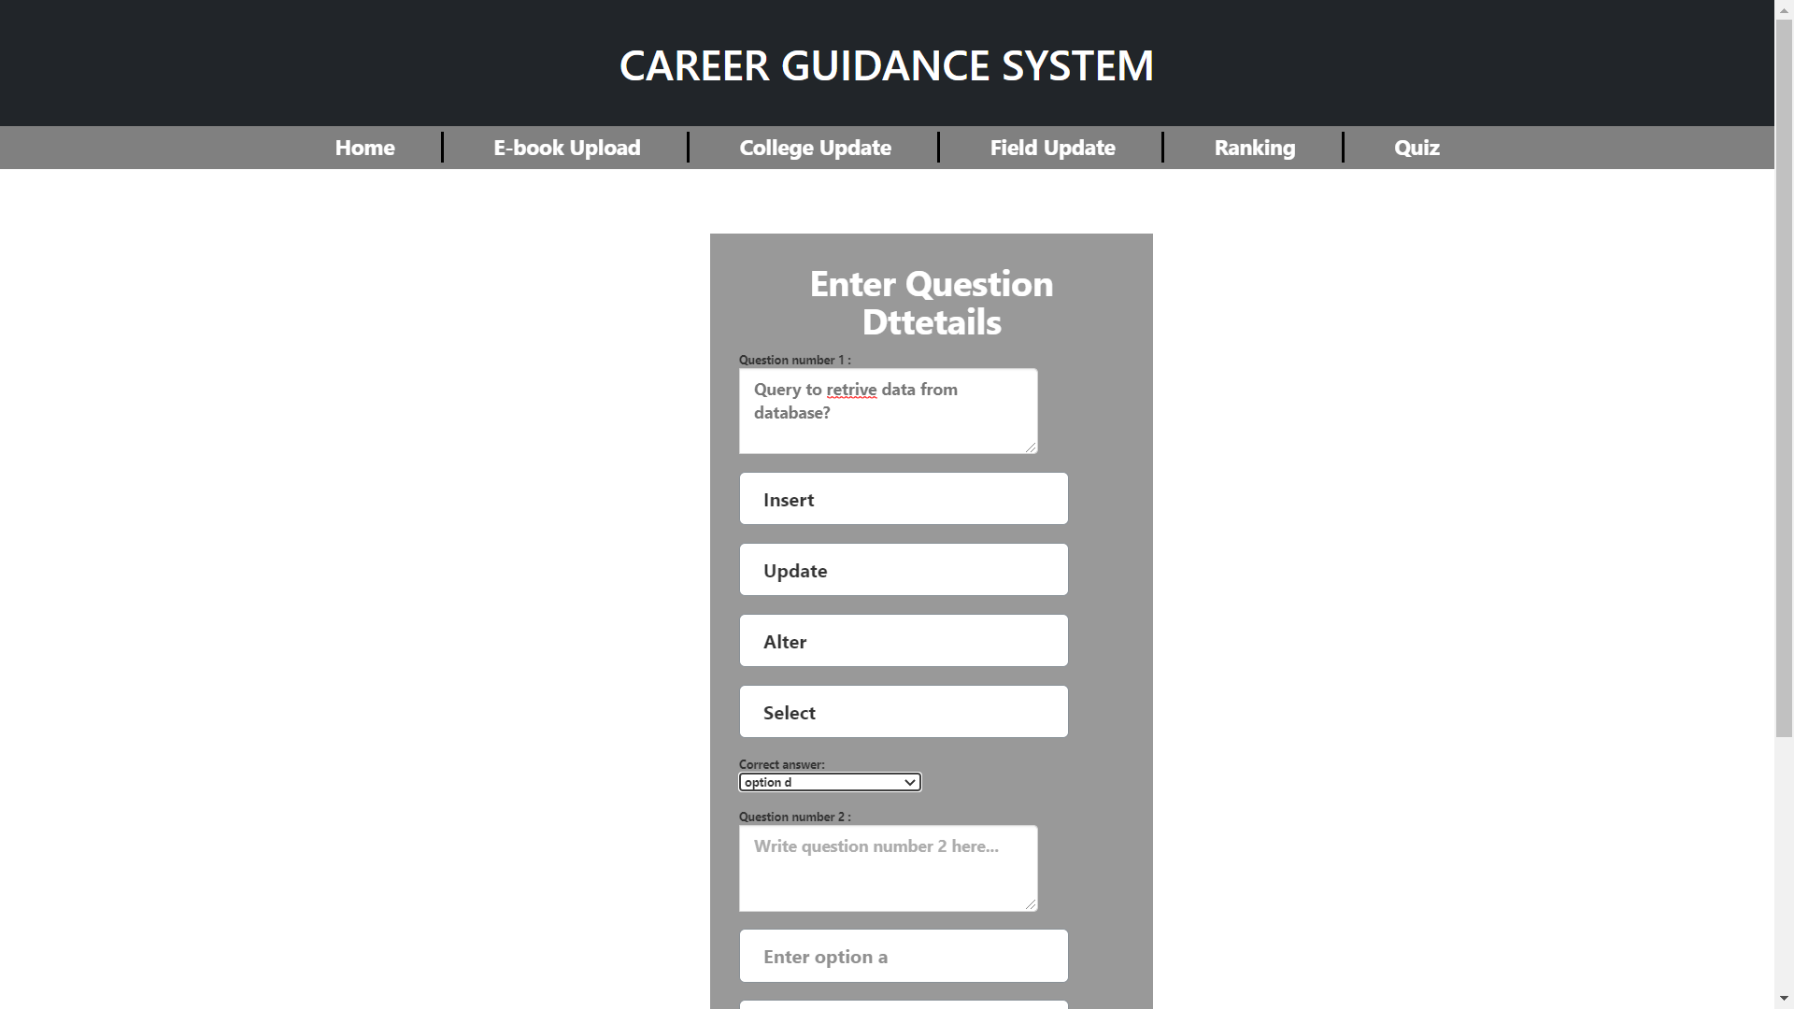

**Student Dashboard:**

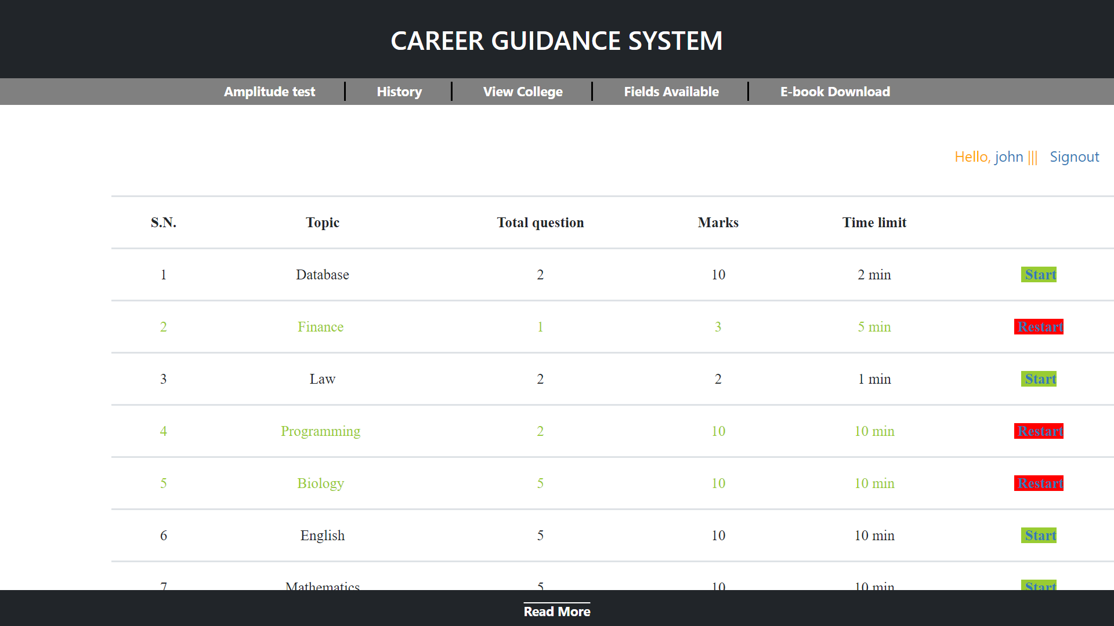

**Will Implement:**

1. To recommend various career paths to students we will use machine learning based recommendation algorithm.
2. For test data, we have shared a google form which collects data regarding the personal interest, academic scores, stream chosen, etc. from users.We are going to use this data as features for our algorithm to recommend students.

**{Attaching response graph of our form}**

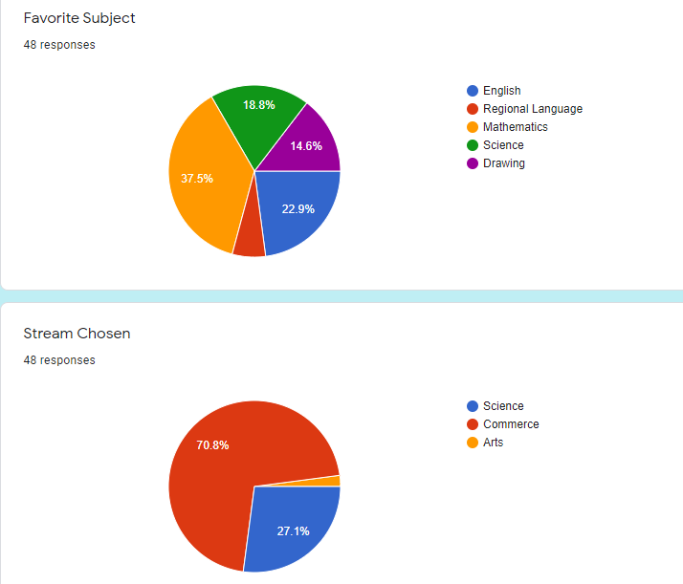

1. Result will be generated considering all provided information from students as well as average scores of aptitude test.
2. Graphical view of scored marks will be shown to students in different sections of aptitude.
3. Based on the results generated the student will be suggested with a list of colleges providing that course.
4. There will also be a chatbot which will answer the FAQ.