Infosys Springboard Virtual Internship 7.0 Completion Report
Team Details : 1

Batch Number :2
Start date :July 20
Name :Pamarthi Avinash
Internship Duration : 8 Weeks

Project Title
BillSphere: Billing and Subscription Management Platform for SaaS Operations

Project Objective
The main objective of this internship project was to design and develop a full-stack billing and subscription management platform for SaaS businesses. The system was designed to handle important business activities such as customer management, plan creation, subscription management, invoice generation, payment processing, and billing lifecycle automation.
The project was intended to provide a practical solution for organizations that rely on subscription-based revenue models. By bringing customer, subscription, invoice, payment, and billing information together in one centralized platform, BillSphere aims to make billing operations more organized, transparent, and efficient.
The project also provided an opportunity to understand how a real-world software system can be designed around business requirements and then developed into a working application.

Project description in detail
BillSphere is a full-stack application developed to manage the major workflows involved in SaaS billing and subscription management. The platform includes features for user authentication, customer management, plan configuration, subscription lifecycle management, invoice generation, payment processing, refund handling, payment retry logic, and audit logging.
The application was developed using a modern web technology stack. The backend was built with Python and FastAPI, while the frontend was developed using React, TypeScript, and Vite. SQLAlchemy and PostgreSQL were used for database management, and Redis was used as part of the backend infrastructure.
The backend provides APIs for authentication, billing operations, payment status updates, refund processing, and administrative functions. The frontend provides a responsive interface through which customers and administrators can interact with the platform.

The major functionalities supported by the platform include:
- Customer registration and authentication
- Creation and management of plans and billing cycles
- Subscription activation, cancellation, trial management, and renewal
- Invoice generation and invoice status tracking
- Payment confirmation and failure handling
- Retry scheduling for failed payments
- Audit logs for improved transparency and traceability
- User-specific access control and secure API handling
The project demonstrates how software can be used to automate billing processes that might otherwise require considerable manual effort. By keeping important billing information organized and improving consistency across different operations, BillSphere can help subscription-based businesses manage their billing workflows more effectively.
The project is particularly relevant to SaaS products, digital service platforms, and other businesses that depend on recurring subscriptions and automated billing.

4. Timeline Overview
Week | Activities Planned | Activities Completed
Week 2 | Backend architecture and database design | Database schema and model structure finalized
Week 3 | User authentication and customer APIs | Authentication and user modules implemented
Week 4 | Plan and subscription modules | Plan creation and subscription workflows completed
Week 5 | Invoices, payments, and billing logic | Invoice generation and payment flow implemented
Week 6 | Retry logic, refund handling, and audit logs | Failed-payment and refund features integrated
Week 7 | Frontend dashboard and UX refinement | React UI completed and optimized
Week 8 | Testing, debugging, documentation, and final presentation | Full validation, fixes, and final documentation completed

5a. Key Milestones
Milestone | Description | Date Achieved
Project Kickoff | Introduction to the project, objectives, AI usage, development approach, team responsibilities, and initial project discussion | 20 July 2026
Prototype/First Draft | Project environment setup, prerequisite learning, GitHub onboarding, initial system design, task allocation, and development of the first working version. | 2 August 2026
Mid-Term Review | Review of project progress, implementation of core functionalities, technical guidance, integration activities, testing, and completion of intermediate milestones. | 16 August 2026
Final Submission | Completion of technical development, final review, documentation, project report, and presentation preparation. | 30 August 2026
Presentation | Final PPT submission, project presentation and demo preparation, mock presentations, final demonstration, and project closure. | Not Yet Completed

5b. Project execution details
The project was carried out in a structured way, beginning with requirement analysis and system architecture. During the initial stage, the main business requirements were studied and the core features needed for a billing and subscription platform were identified. These included customer management, subscription handling, invoice generation, payment workflows, and related billing operations.
After defining the requirements, the backend architecture was designed using FastAPI and SQLAlchemy. The main database models were created for users, customers, plans, subscriptions, invoices, payments, and audit logs. This helped maintain a clear separation between the API layer, business logic, and data models.
The next stage focused on implementing the core application functionality. Authentication was introduced to secure the application, followed by customer and plan management APIs. Subscription functionality was then developed to support activation, lifecycle transitions, and other state changes.
The project then moved to invoice and payment processing. Payment records were connected with invoices and customer subscriptions, while successful and failed payment events were handled through the application logic. A retry mechanism was also incorporated to support failed-payment scenarios and improve billing reliability.
Once the backend functionality was in place, development of the frontend dashboard was carried out using React, TypeScript, and Vite. The dashboard was designed to make information about plans, subscriptions, invoices, payments, and customers easier to access and understand.
The final stage focused on testing, debugging, optimization, and documentation. The application was validated through backend tests and frontend build checks. Issues identified during testing were addressed, and the project was prepared for final submission and presentation.
Overall, the project followed an iterative development process in which each stage built upon the previous one, from requirements and architecture through implementation, testing, and documentation.

6. Snapshots / Screenshots
The following section is intended to contain screenshots demonstrating the work completed during the project. These visuals may include the main dashboard, subscription and billing workflows, payment and invoice modules, and the administrative interface.
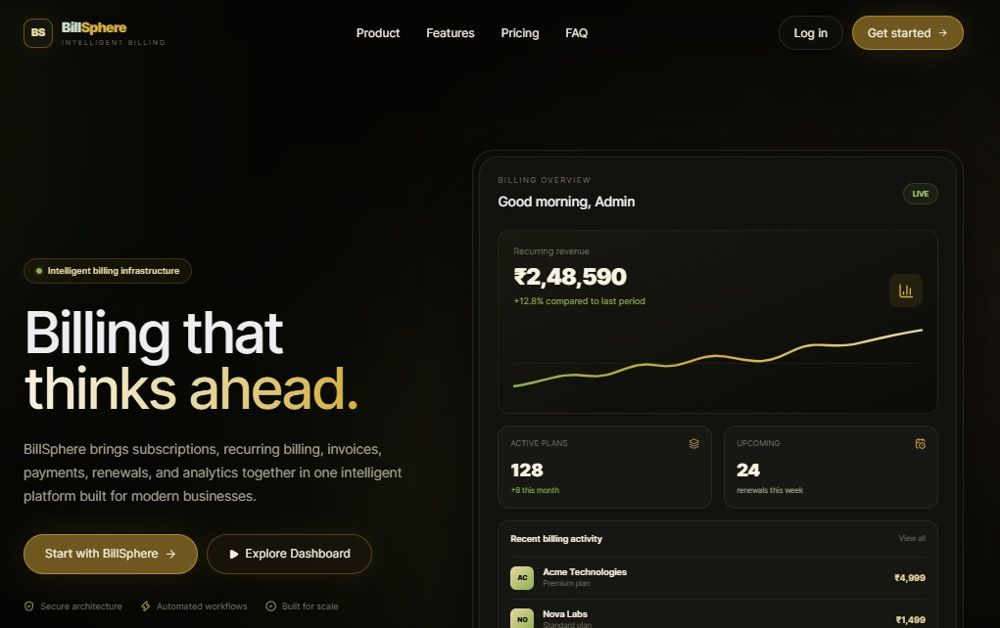
BillSphere Landing Page
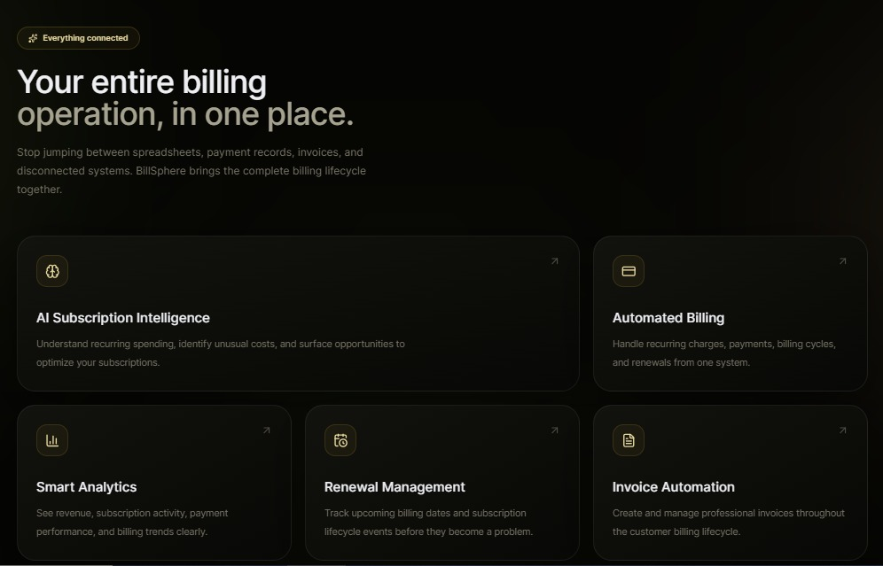.Billsphere Description
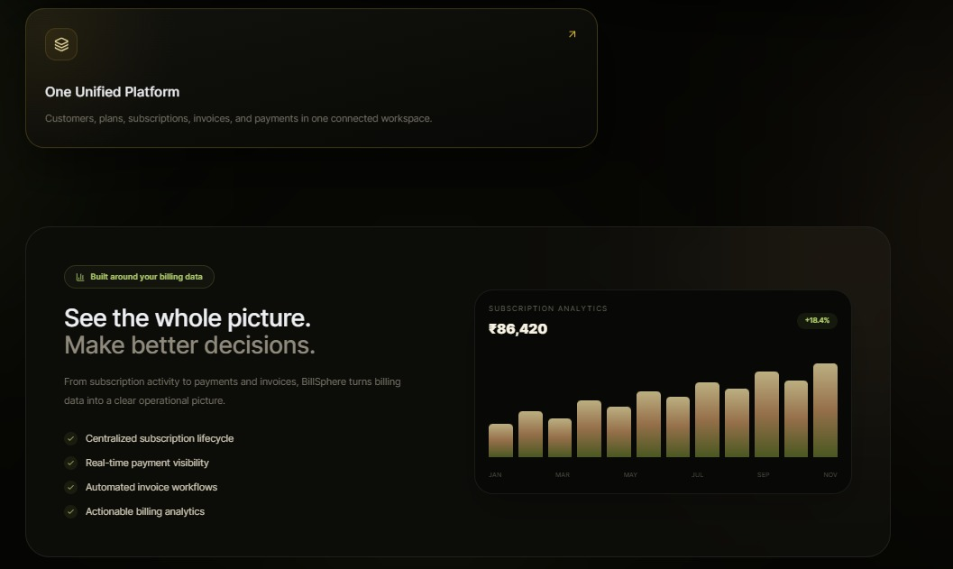
Billsphere Features
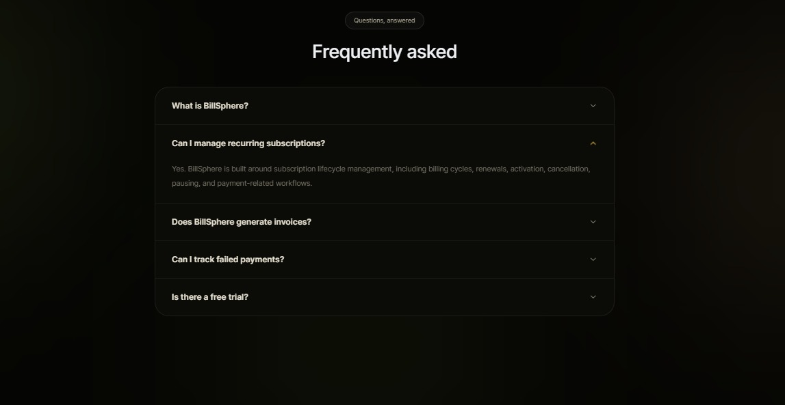
Billsphere FAQ
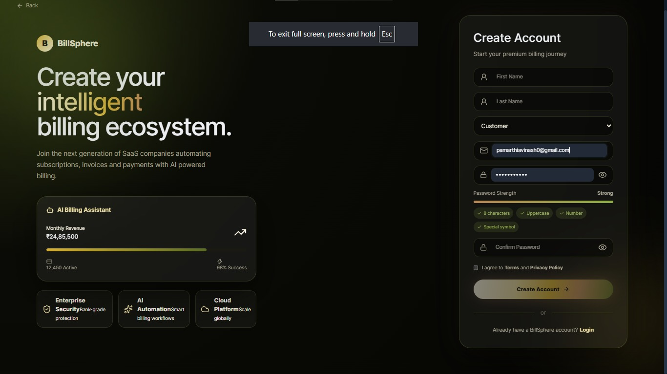
.Billsphere Account Creation
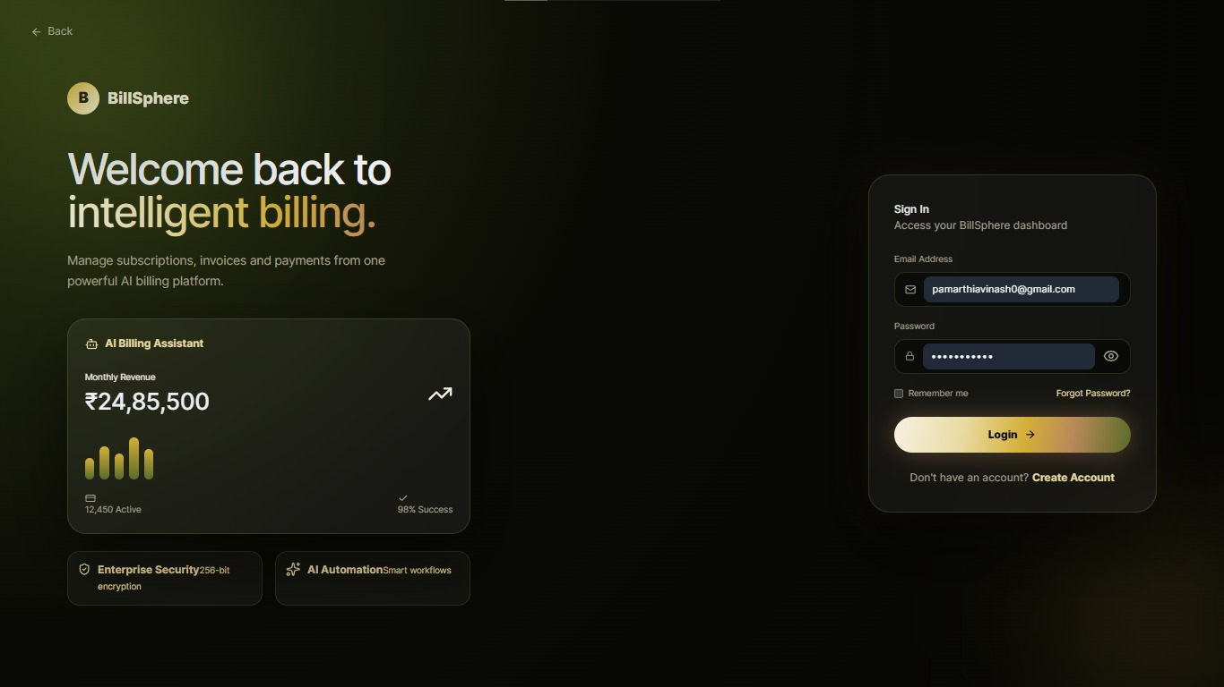
Billsphere Account Creation 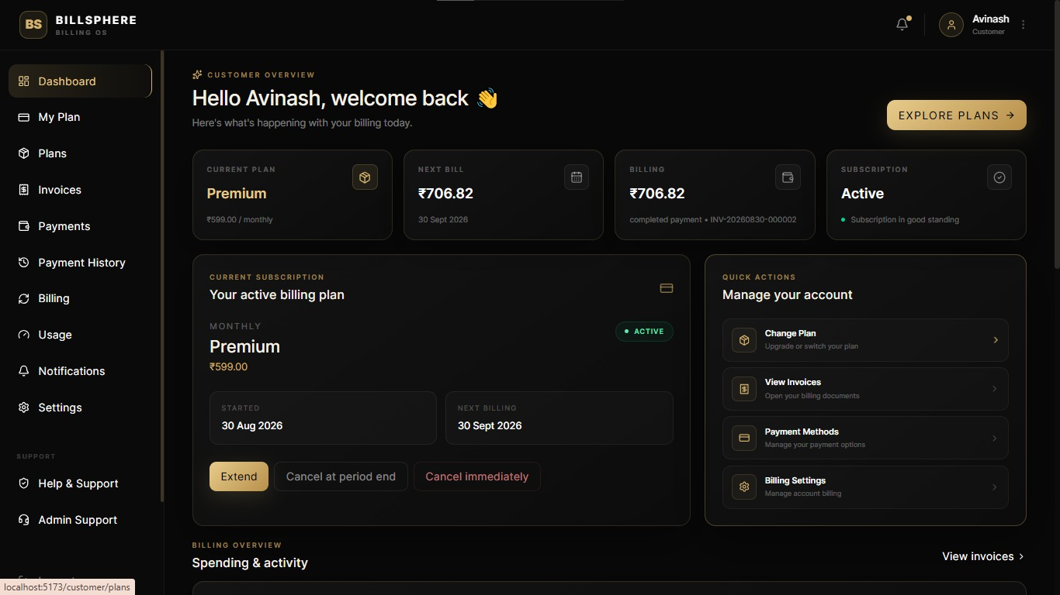
Billsphere User Dashboard

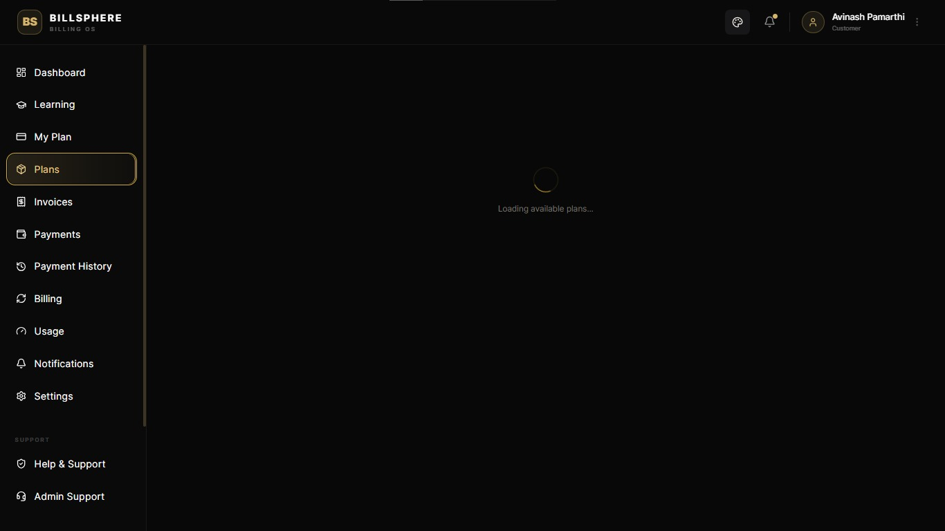
Billsphere Loading Page
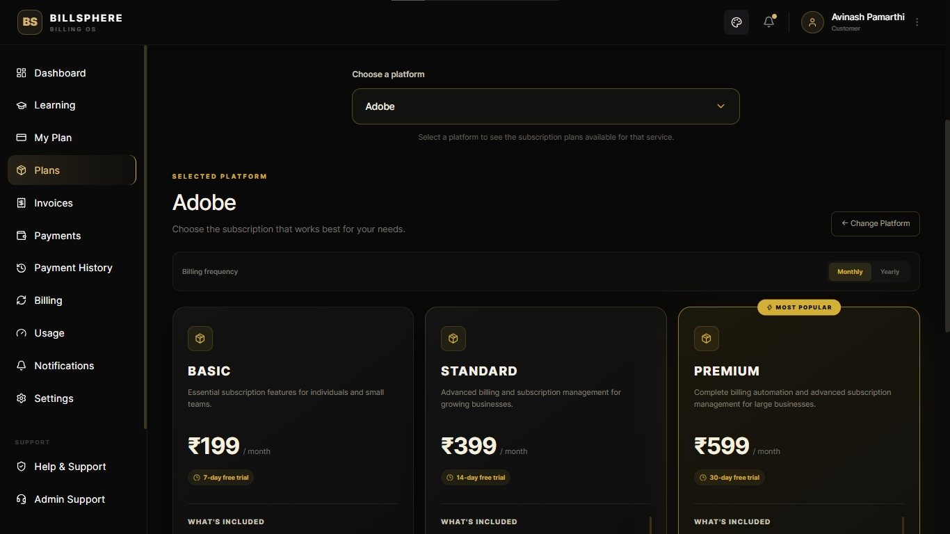
Billsphere Plan Selection Page

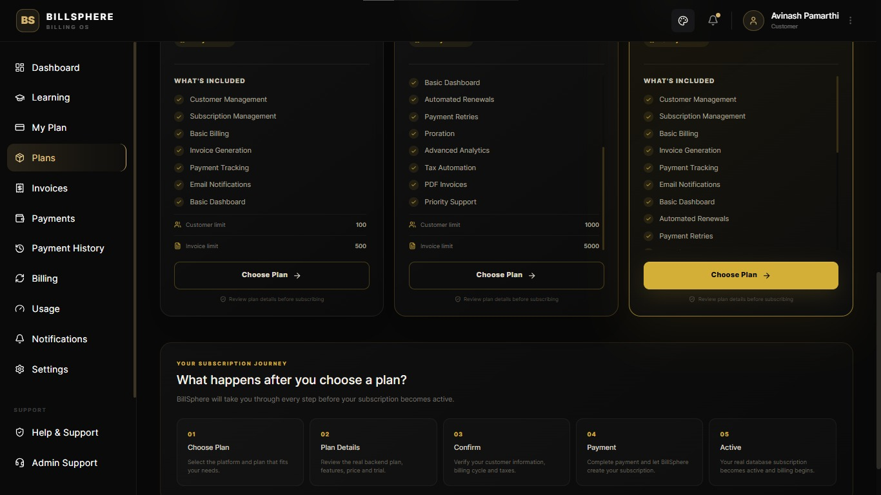
Choosing Plan Details
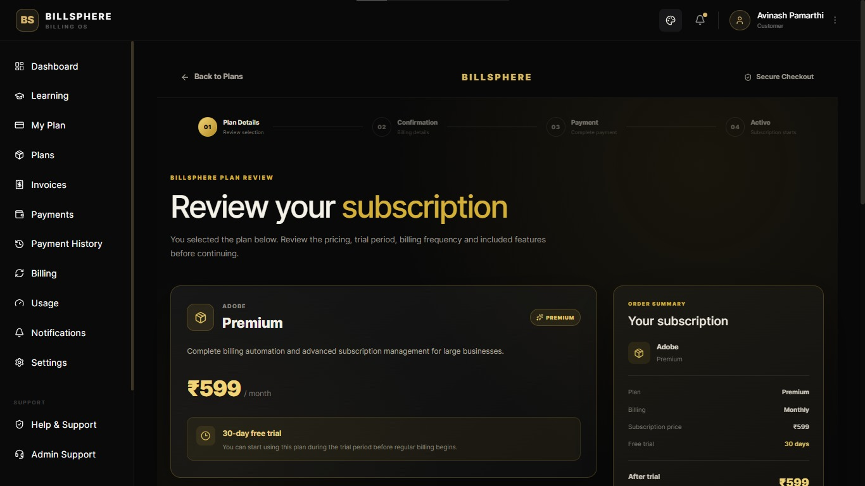
Reviewing Plan and Checking Plan Features

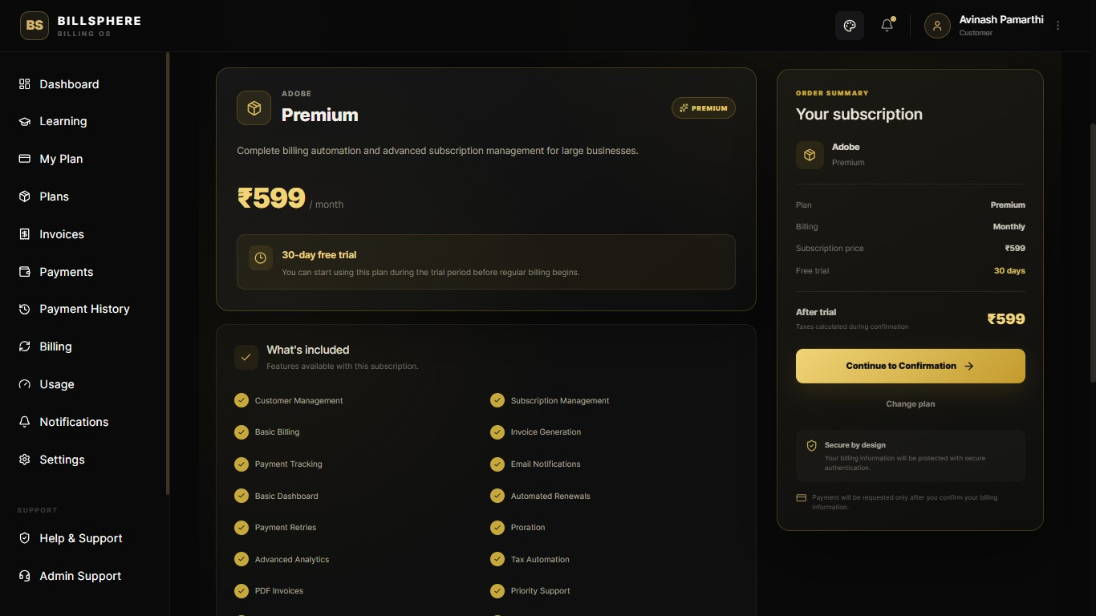
Completing the Confirmation
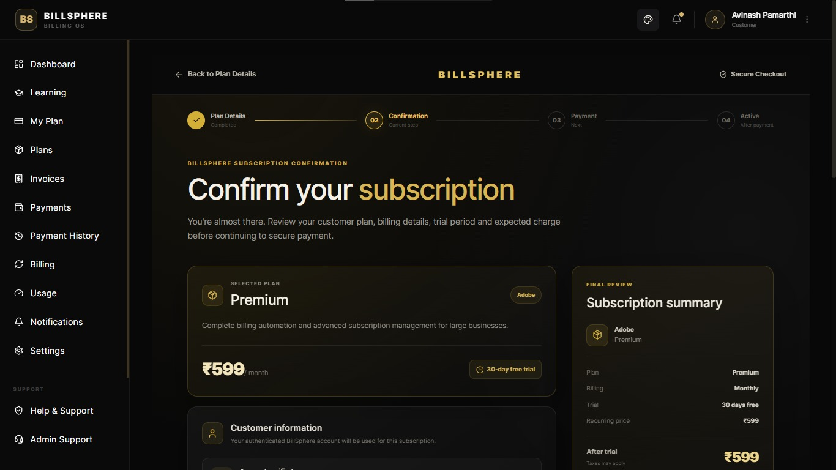
Contiuning to Payment

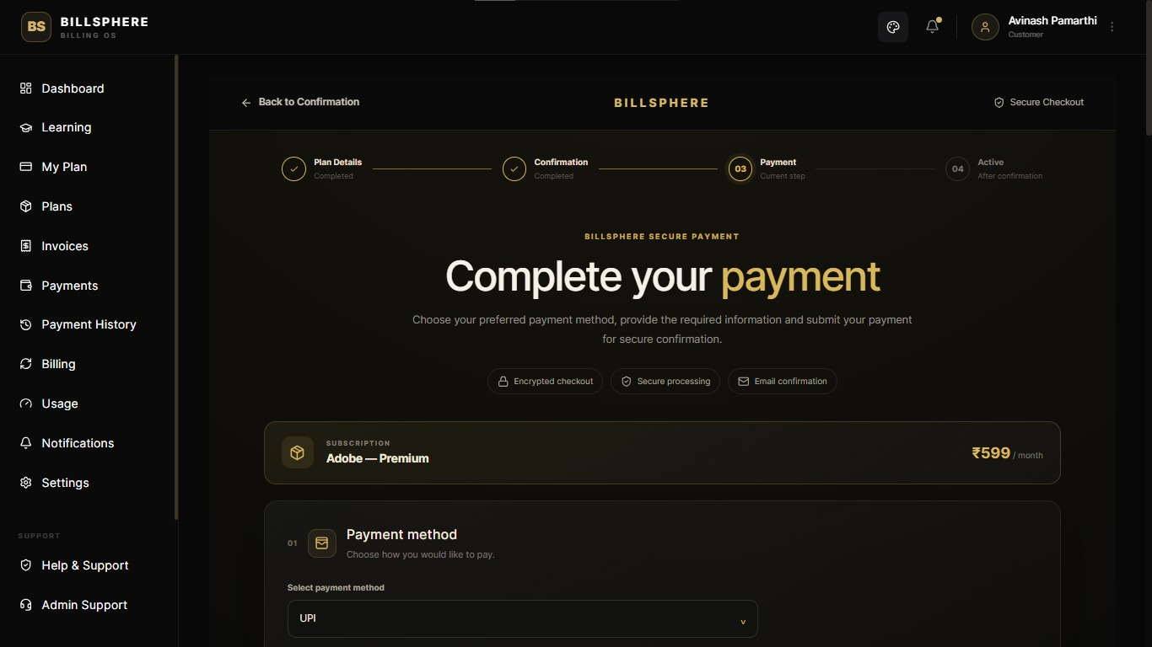
Completing Payment By Adding Neccesary Details
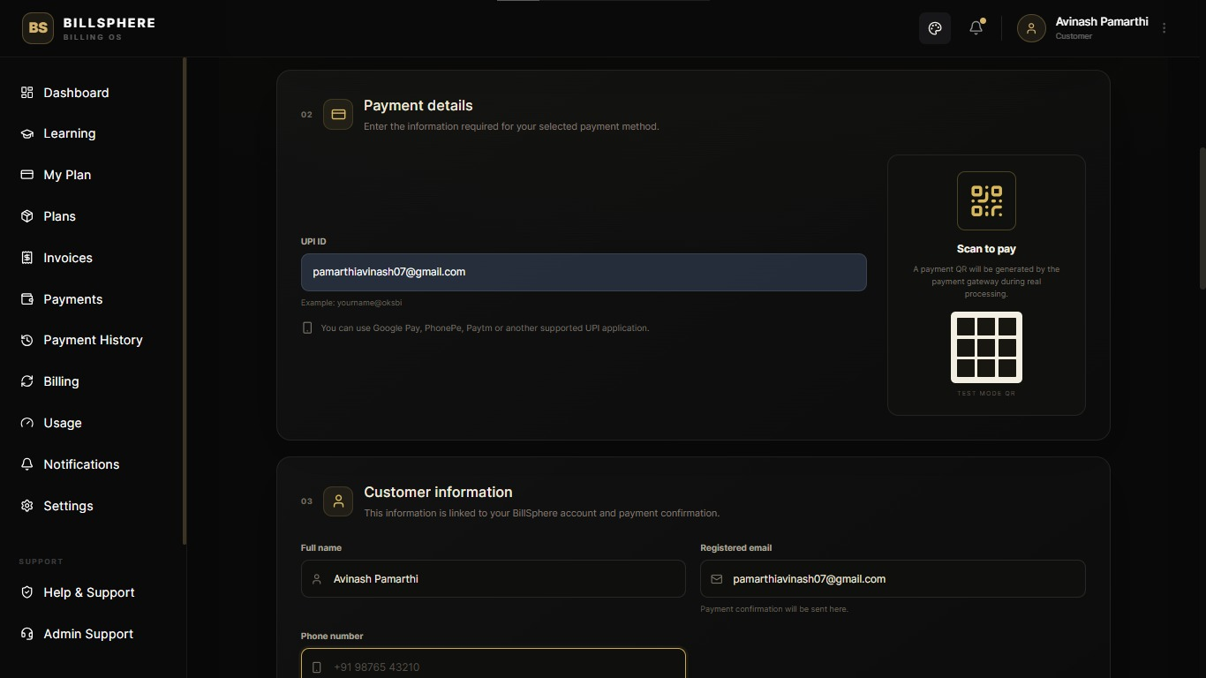
Entering UPI ID and Other Required Details

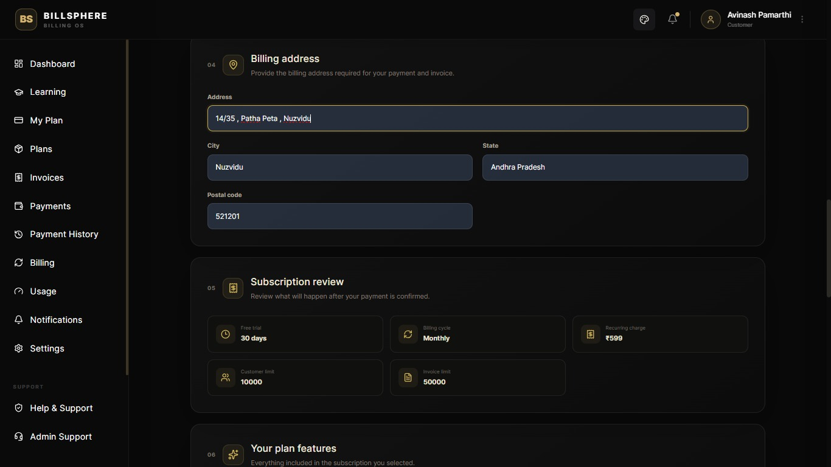
Filling Address , Pincode , User details
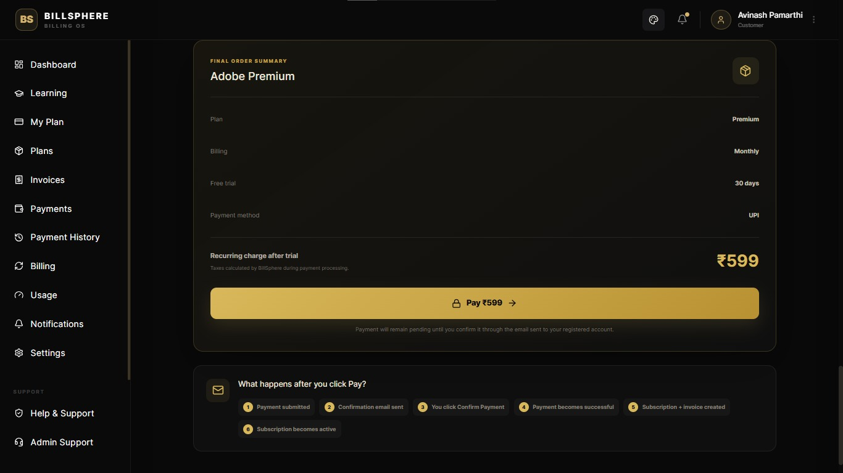
Continuing to Payment

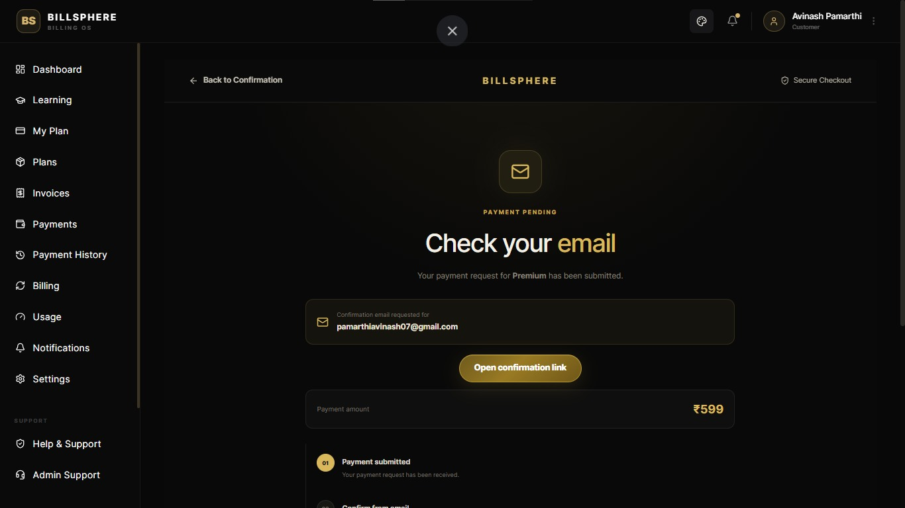
Email Confirmation for Security Purposes
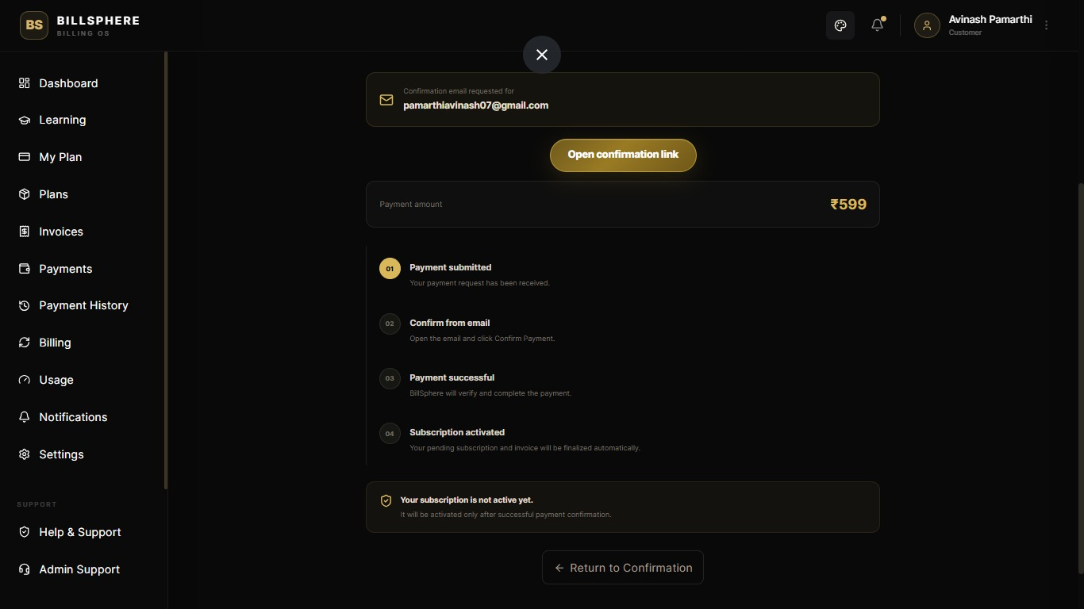
After Confirmation , Redirected to Application
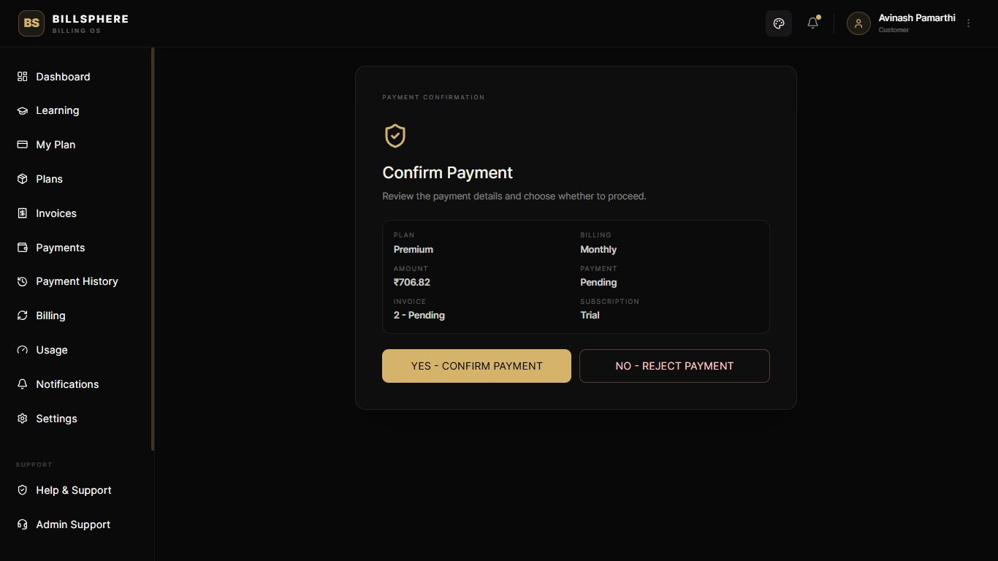
Confirming Payment
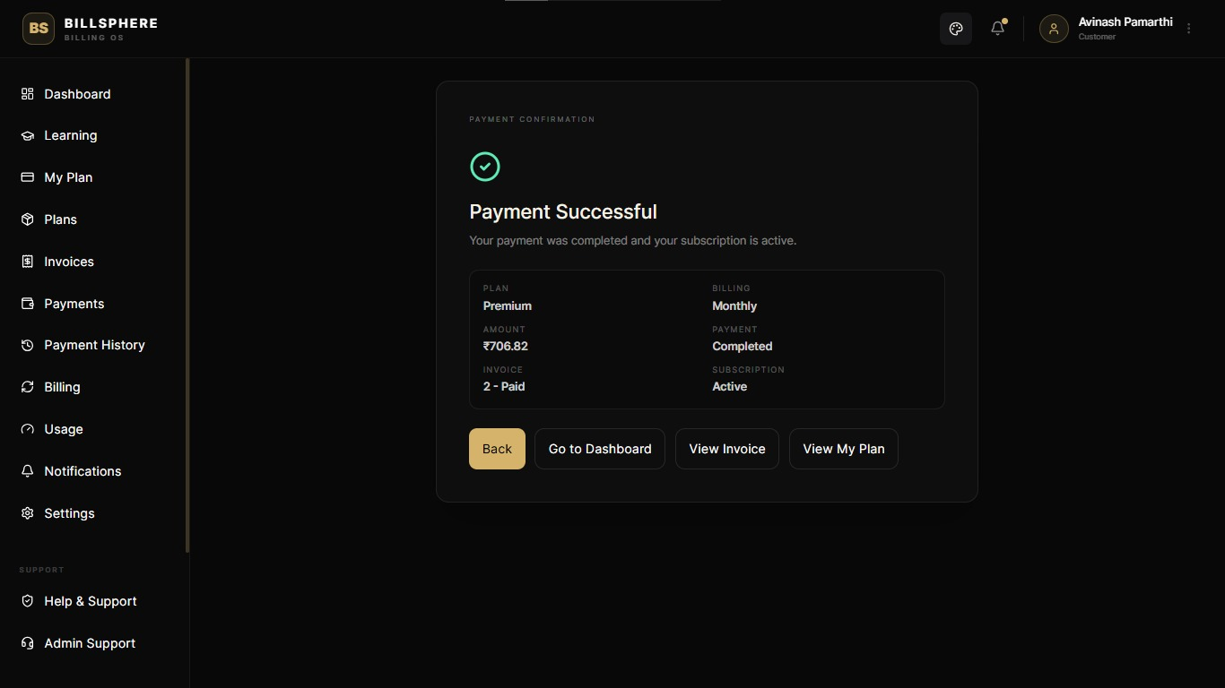
Payment Succesful Page [Demo , NO UPI Transcations Held in Real]

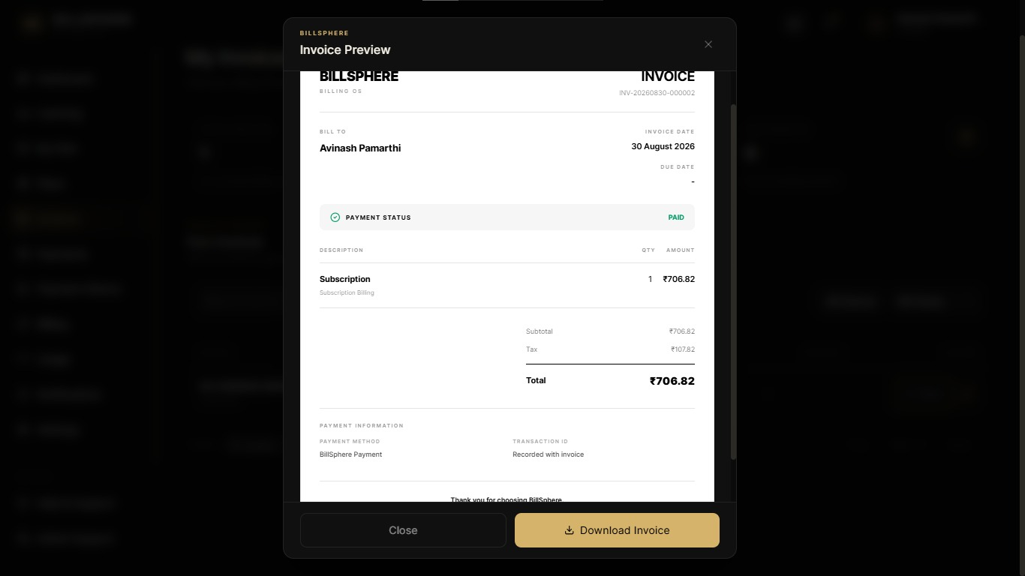
Invoice with Download option as PDF with GST and other Tax Calculation Metrics

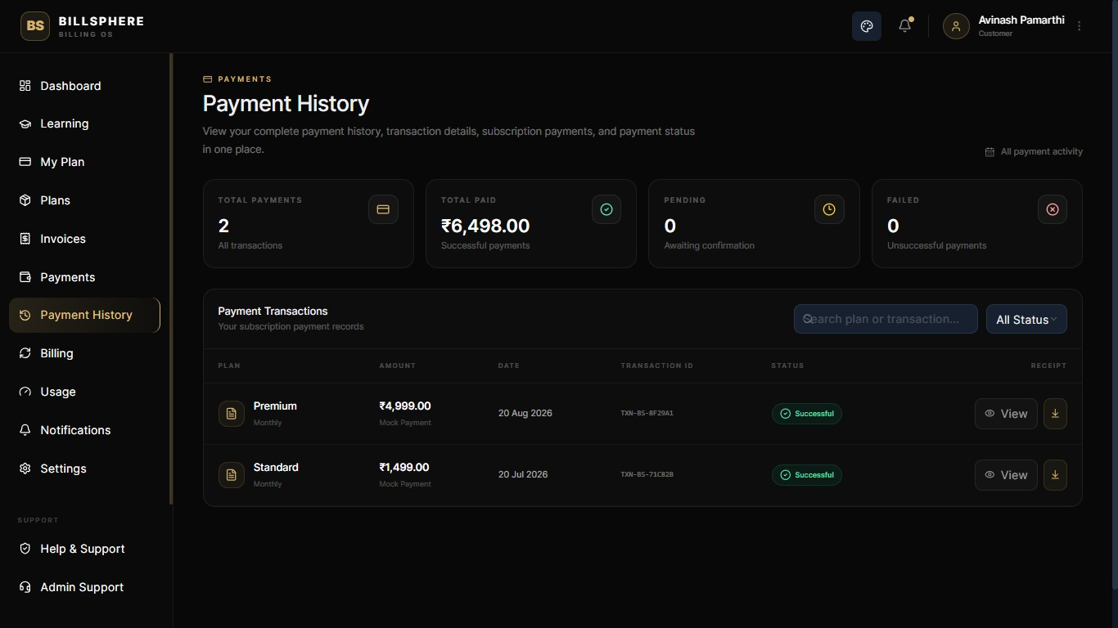
Payments History Page

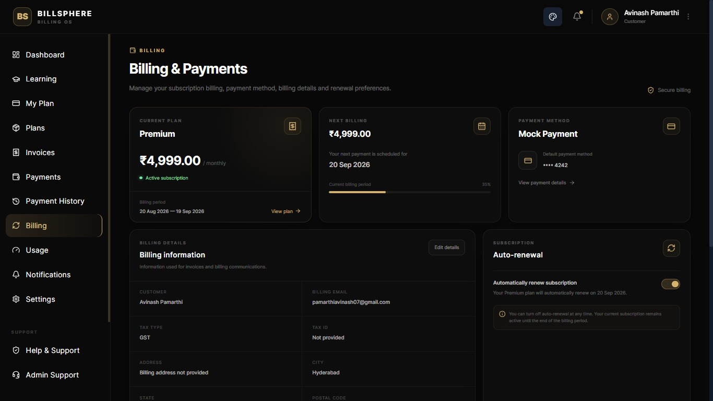
Billing Details Page
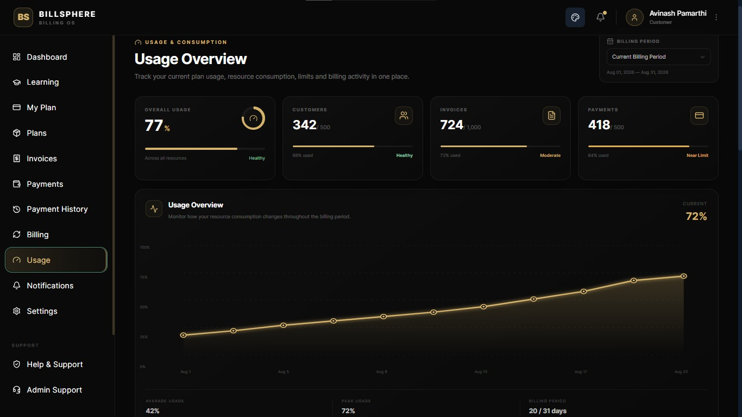
Usage Overview Page

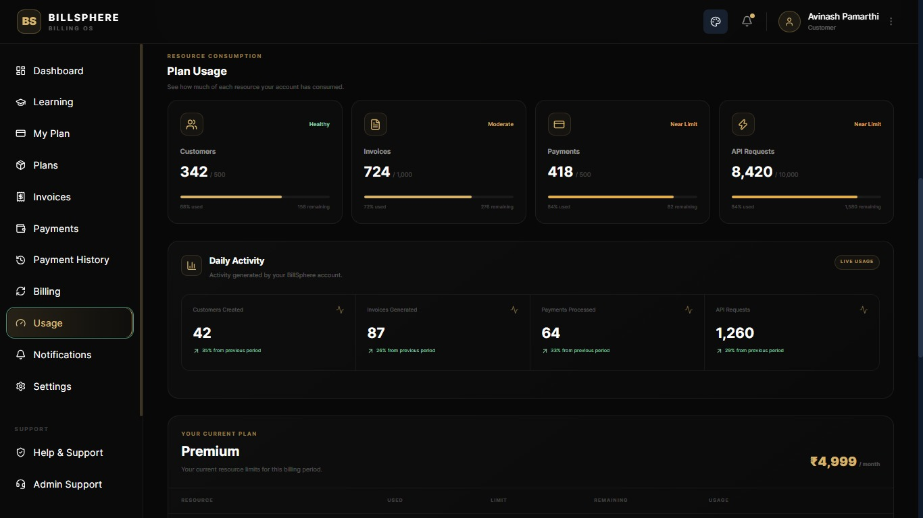
Plans Usage
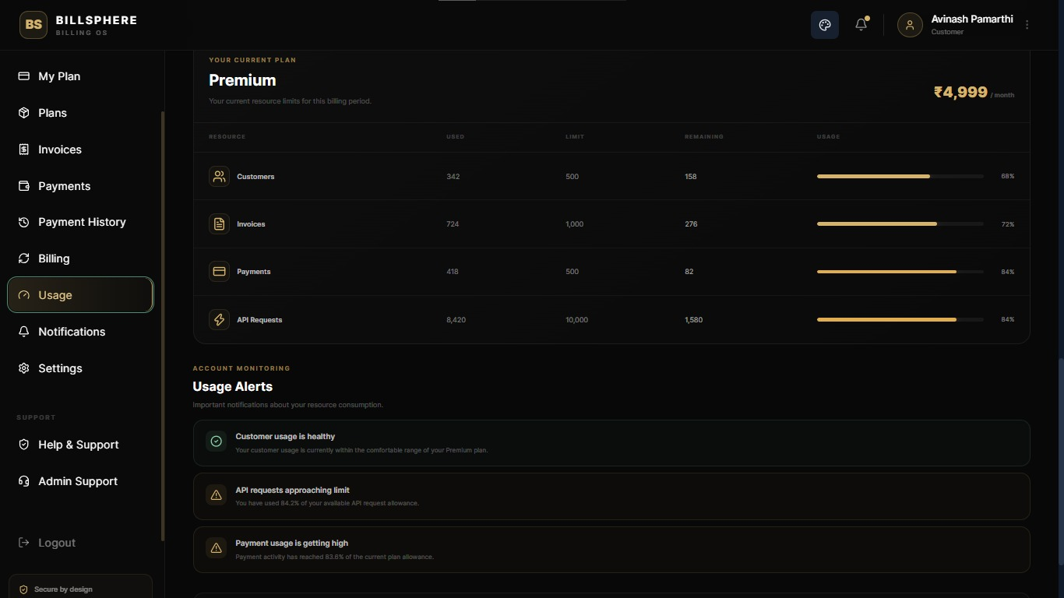
User Plans Details

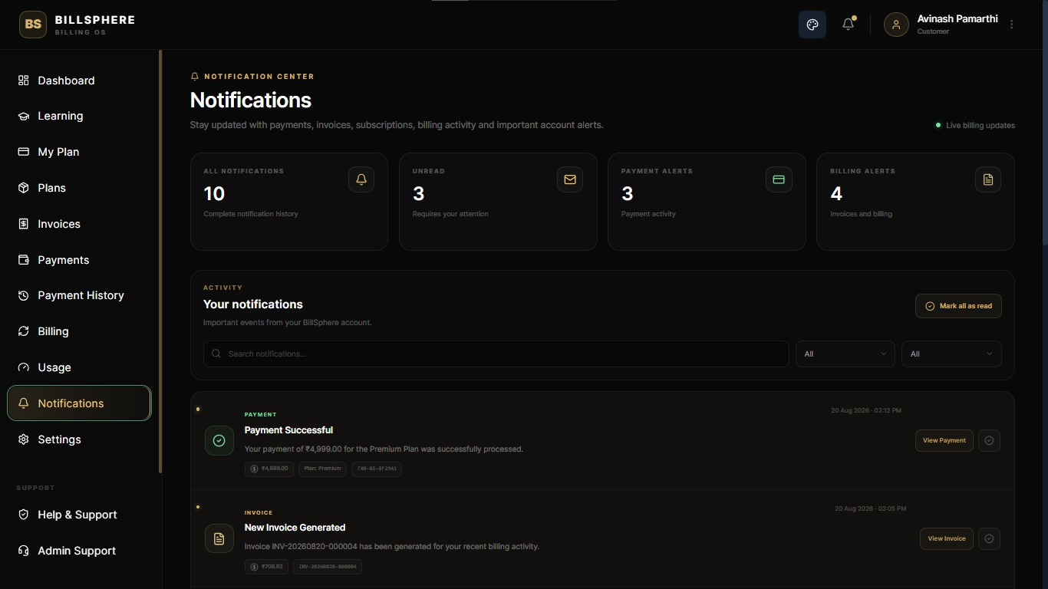
Notifications Page
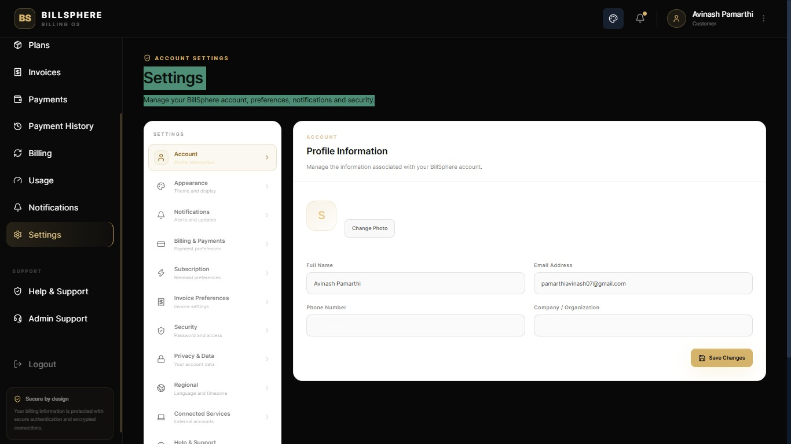
Settings Page

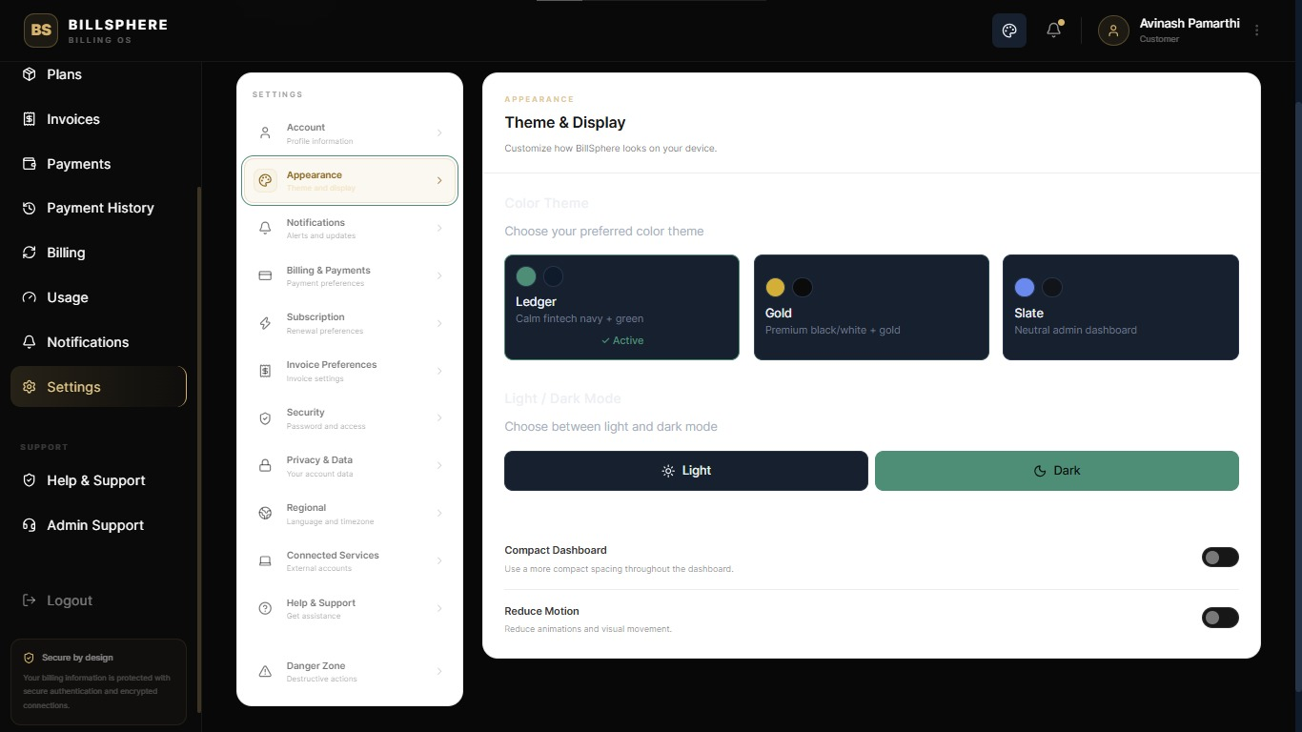
Theme and Display Settings
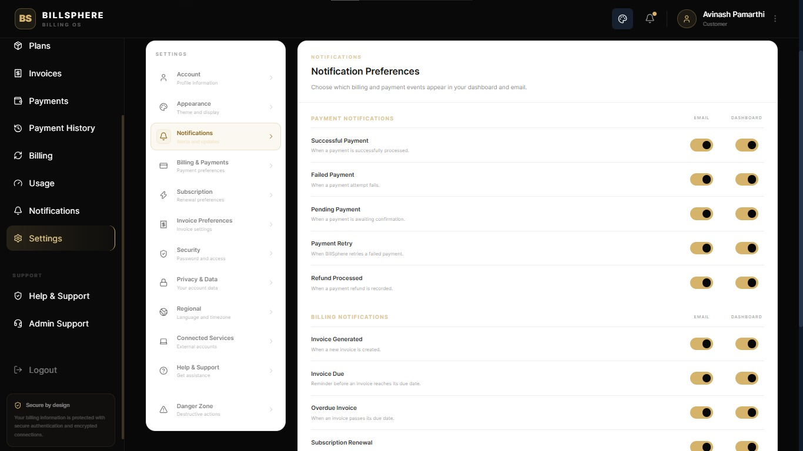
Notification Preferences Customization Page

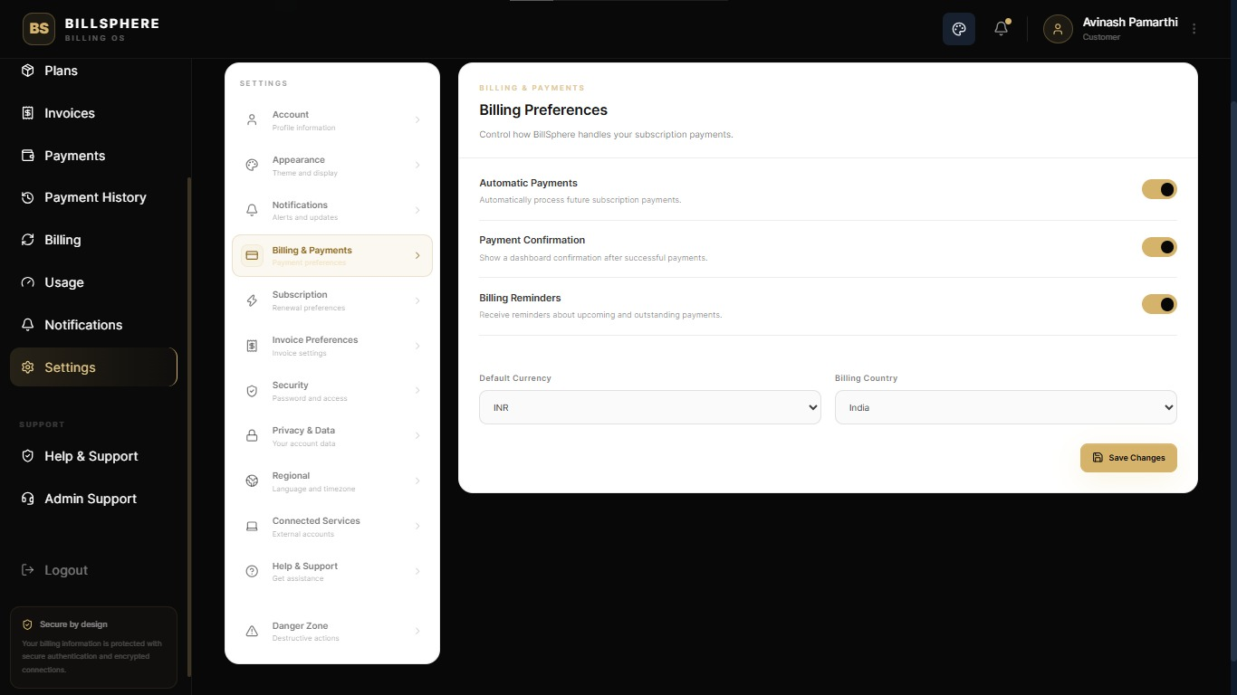
Billing Preferences , Autopay settings
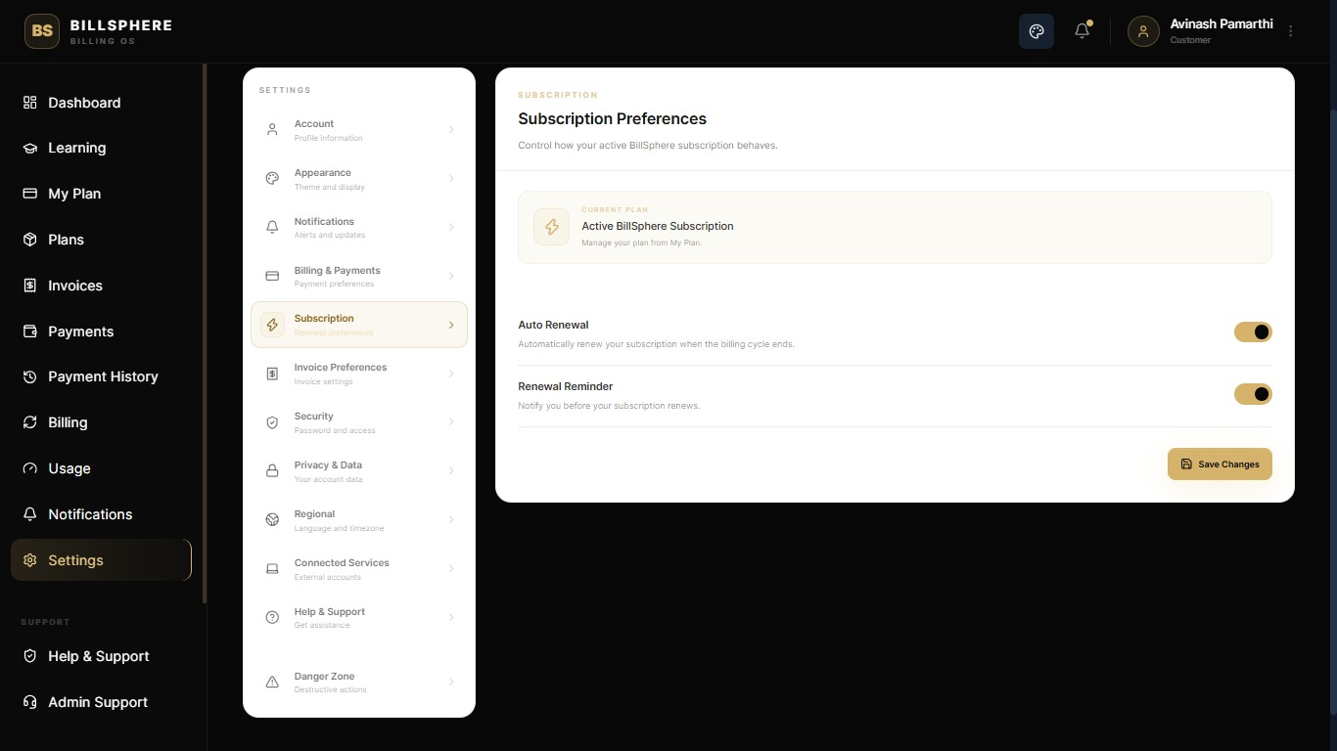
Subscription Preferences

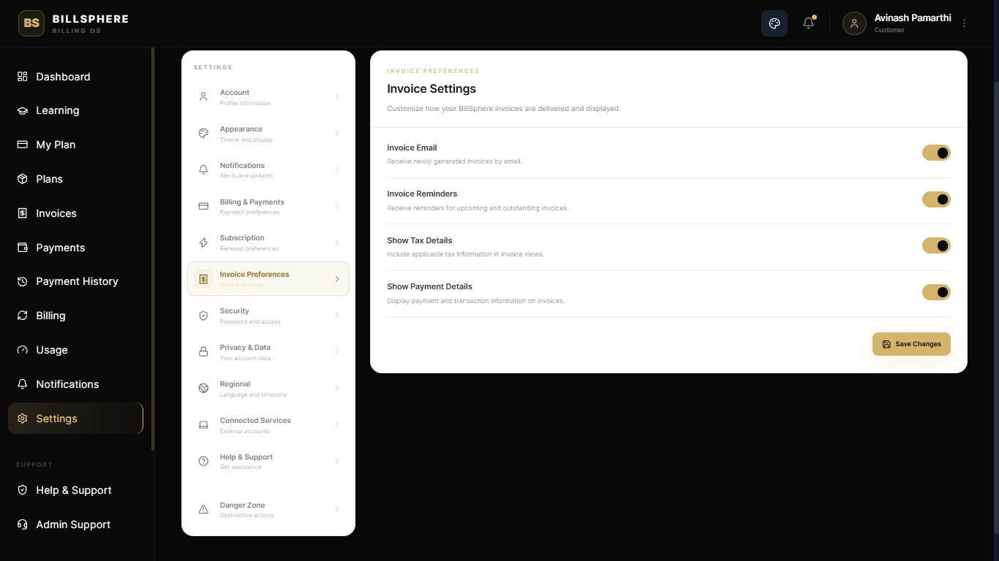
Invoice Settings
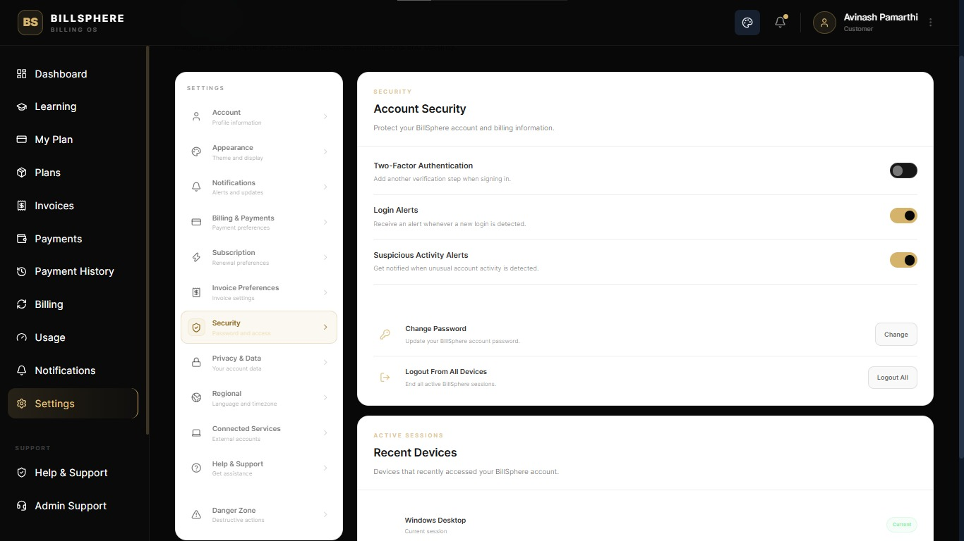
Account Security Page with 2 Factor Authentication Settings

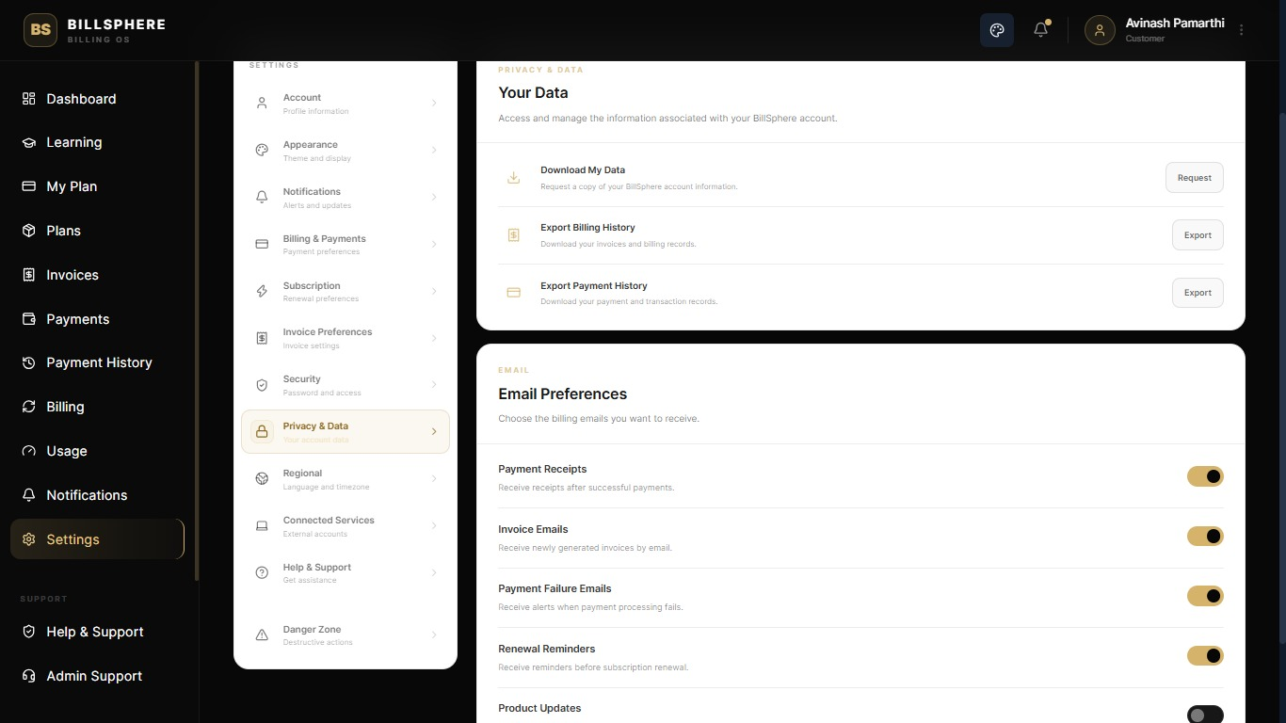
Personal information Details
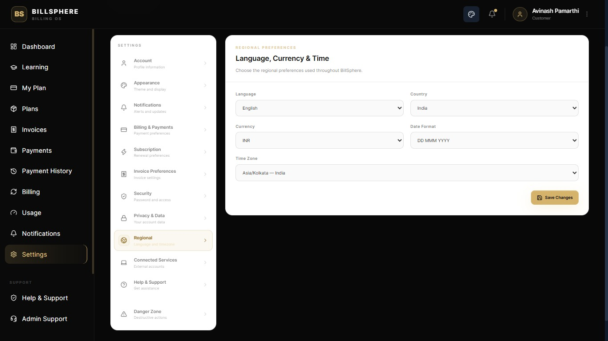
Language and Time Settings

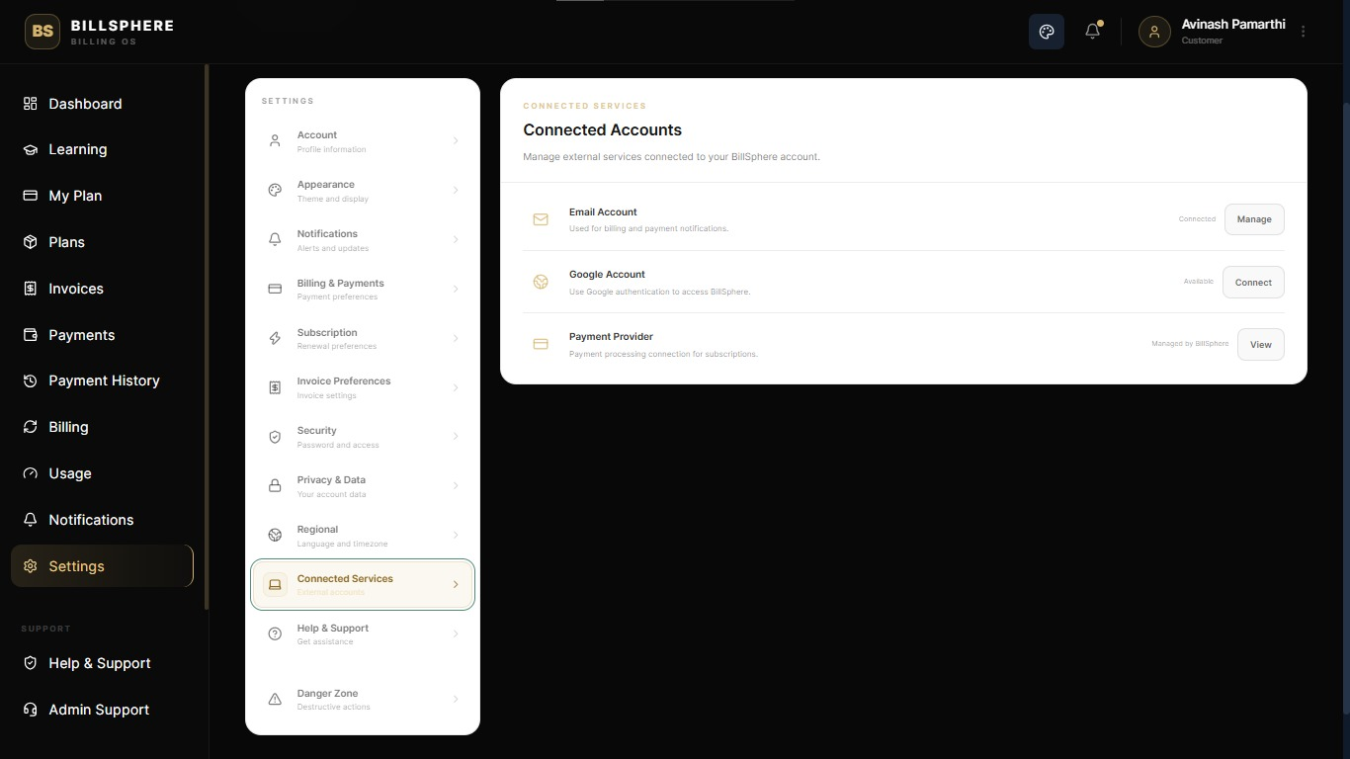
Account Management page
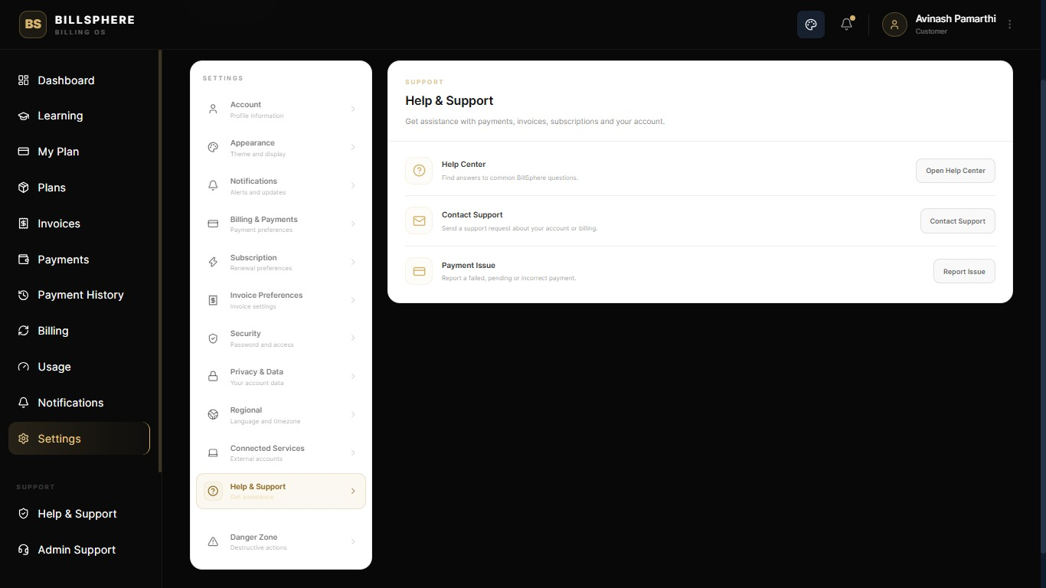
Help and Support Page

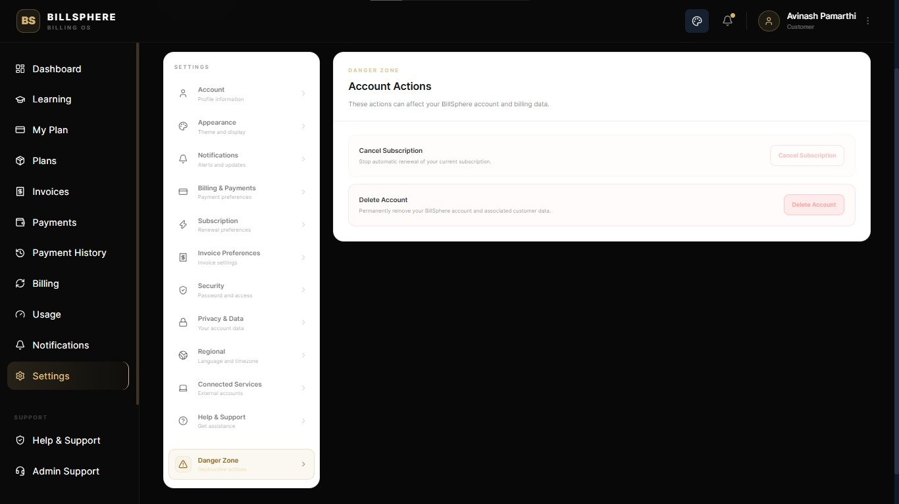
Account Deletion , Logout Session Page
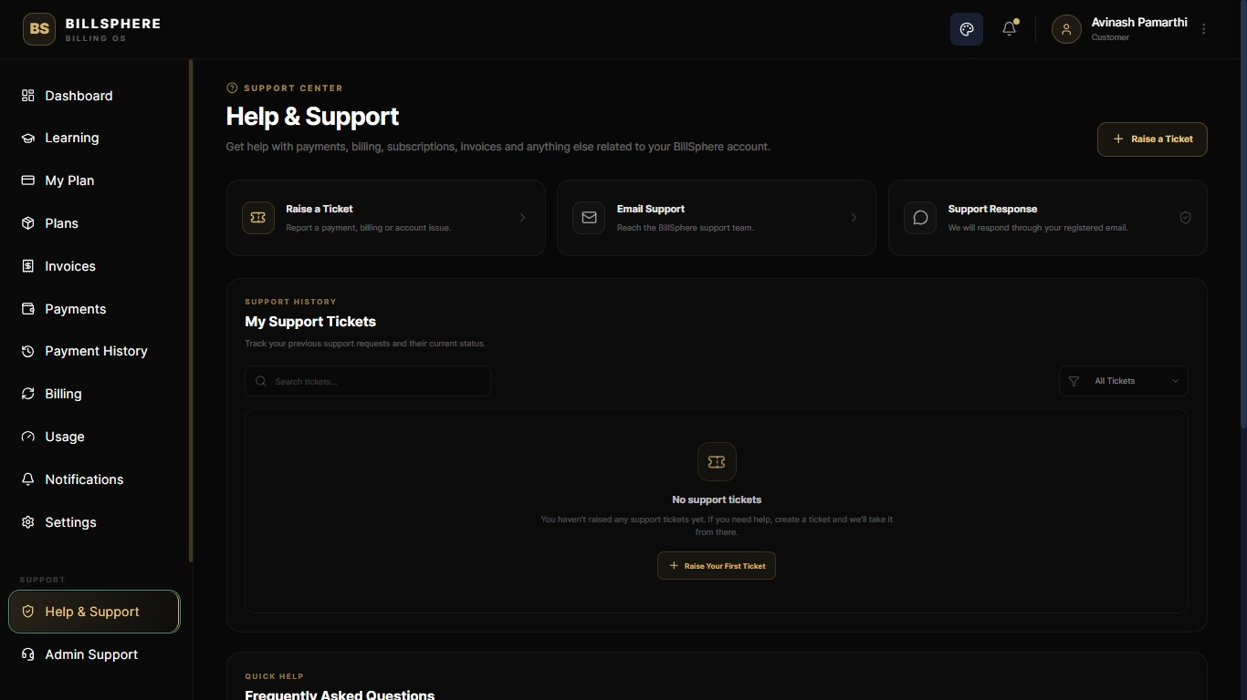
Help and Support for Users to allow Tickets generation to Admins

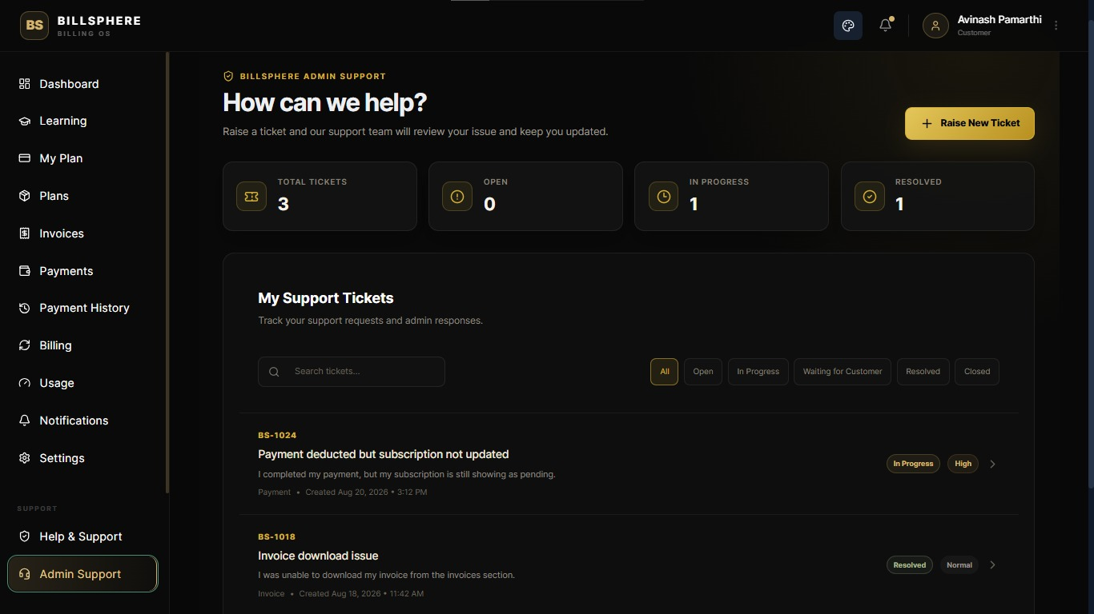
Admins FAQ section and Ticket Management
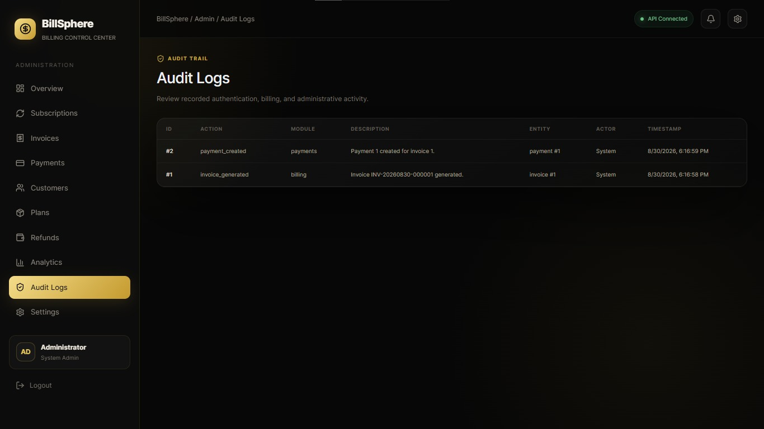
Admin Audit Logs

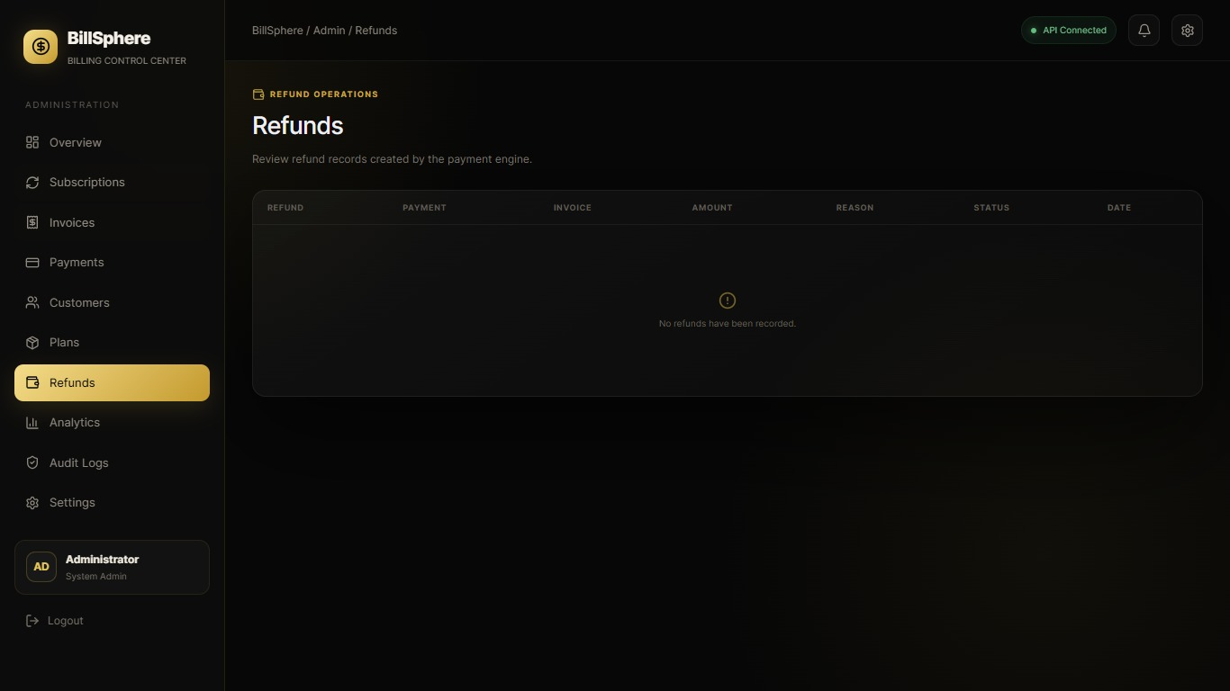
Admins Refunds Page
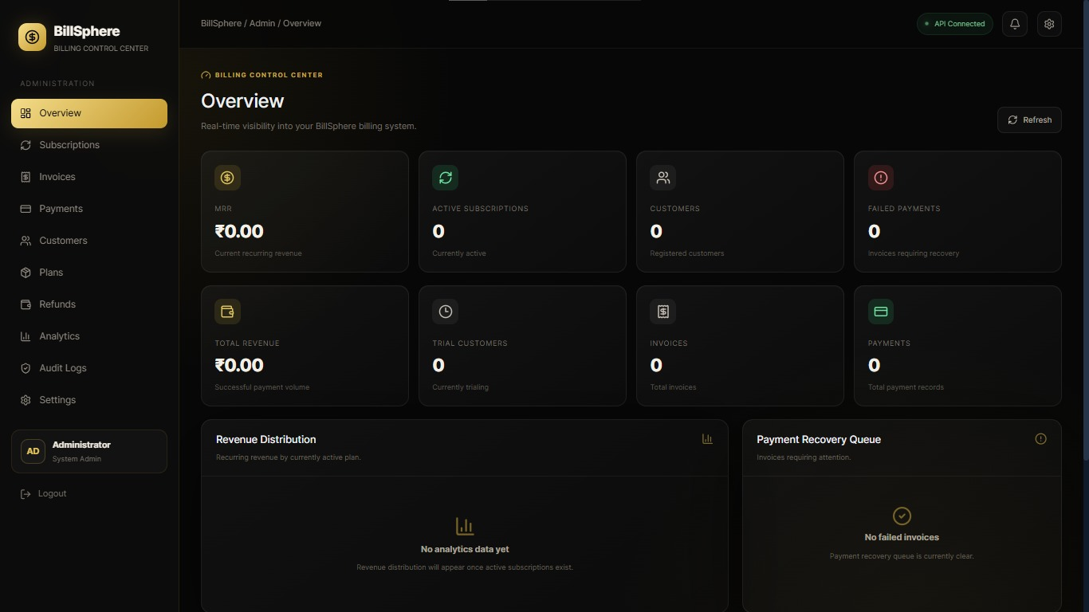
Admins Overview of Dashboard

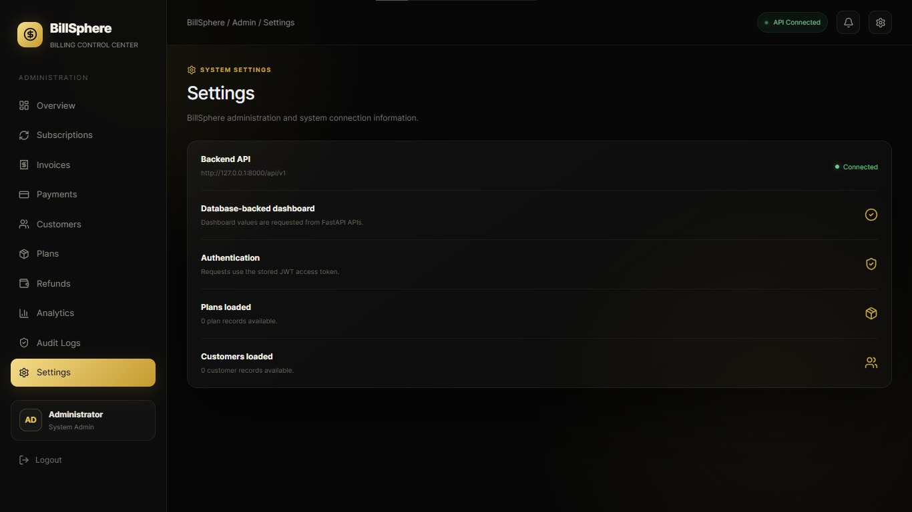
Admins Quick Settings Page

7. Challenges Faced
One of the first major challenges during the internship was understanding the complete billing workflow and translating it into a suitable software architecture. Billing and subscription systems involve several connected processes, so changes in one area can affect other parts of the application. Maintaining consistency across these modules therefore required careful planning.
Another challenge was implementing invoice and payment workflows while keeping the related data consistent. Payment status changes, invoice states, refunds, and audit records needed to work together correctly. Secure authentication and authorization also required attention to ensure that users could access only the functionality appropriate to their roles.
Frontend development presented another set of challenges. The dashboard had to provide access to multiple areas, including plans, subscriptions, invoices, payments, and customer information, while remaining responsive and easy to use.
There were also some challenges related to the development environment, dependency versions, and runtime configuration. These issues were handled through debugging, testing, and repeated validation of the application.
Working through these challenges helped strengthen the understanding of modular development and systematic problem-solving. Instead of addressing issues individually without a clear process, the project encouraged an iterative approach involving development, testing, debugging, and improvement.

8. Learnings & Skills Acquired
The internship provided practical experience across several areas of software development. The major technical and professional skills gained during the project include:
- Full-stack web application development using FastAPI and React
- Database design and schema management using SQLAlchemy and PostgreSQL
- Designing and integrating APIs for real-world business workflows
- Understanding recurring billing and payment lifecycle concepts
- Debugging and problem-solving through systematic testing
- Version control and collaboration using Git
- Basic understanding of deployment and environment configuration
- Technical documentation and project presentation
- Time management and structured task execution
In addition to technical skills, the project provided experience in understanding business requirements and translating them into practical software features. It also helped improve communication, collaboration, and the ability to work through technical problems in a structured manner.
Overall, the internship helped connect academic concepts with practical software development and provided a broader understanding of how software systems can support business operations.

9. Testimonials from team
The project was a valuable learning experience because it provided an opportunity to work on a practical business problem and develop a complete application around it. Working on BillSphere helped connect theoretical concepts learned during academics with actual software development practices.
The project also improved my confidence in working with backend APIs, frontend development, database design, business logic, and testing. Building different modules and bringing them together into a single application provided a better understanding of how individual software components work as part of a larger system.
I am grateful for the opportunity to work on this project through the internship. The experience provided valuable exposure to practical development and helped me better understand the expectations involved in building software for real-world use cases.

10. Conclusion
The BillSphere internship project was a valuable opportunity to apply software engineering concepts to a practical SaaS billing and subscription management problem. The project brought together backend development, frontend development, database management, billing workflows, testing, and documentation within a single application.
Through the development of BillSphere, hands-on experience was gained in areas such as FastAPI, React, PostgreSQL, SQLAlchemy, subscription management, payment workflows, data modeling, and user interface development. The project also provided a better understanding of how business requirements can be translated into functional software features.
The internship strengthened practical software development skills and provided useful experience in planning, implementing, testing, debugging, and documenting a complete application.
Overall, the experience helped bridge the gap between academic learning and real-world software development and provided a strong foundation for future work in software engineering, backend systems, product development, and business technology solutions.

11. Acknowledgements
I would like to express my sincere gratitude to Infosys Springboard for providing this internship opportunity and for creating an environment where I could gain practical experience in software development.
I am also thankful to the mentors, guides, and team members who provided support, guidance, and feedback throughout the project. Their assistance helped me understand the requirements, overcome technical challenges, and complete the project successfully.
Finally, I am grateful for the opportunity to work on BillSphere and for the knowledge and experience gained throughout the internship journey.

