Introduction
Problem Statement: Identify the holes in the point set (2D or 3D).
Input: Point set S
Output: Indices of points of holes H subset of S
Challenges: Problem’s solution’s accuracy dependent on the distribution of given point set in particular area.

Detecting holes within a planar point set poses a significant challenge in various fields, including face recognition, model retrieval, and pattern recognition. While outer boundary detection (shape reconstruction) has garnered substantial attention, inner boundary (hole) detection remains relatively under explored, primarily due to the inherent difficulty in discerning hole presence. Nonetheless, hole detection holds immense practical value, prompting the need for effective methodologies.

In this document, we present a novel approach using Delaunay triangulation for hole detection and subsequent reconstruction. Our methodology offers a unified solution capable of handling both boundary samples (points sampled solely from the object's perimeter) and dot patterns (points sampled from across the entire object). Notably, our method is non-parametric and adept at detecting holes of various shapes.

Theoretical underpinnings, grounded in a sampling model, validate the accuracy of our hole reconstruction algorithm for specific structural configurations. Through qualitative and quantitative comparisons with existing methods, we demonstrate the efficacy of our approach, showcasing its superiority or comparability in performance.

Furthermore, we conduct experiments encompassing diverse point densities and distributions to illustrate the algorithm's robustness against sampling variations. Despite its strengths, we also acknowledge the limitations inherent in our approach, paving the way for future refinements and advancements in hole detection methodologies.
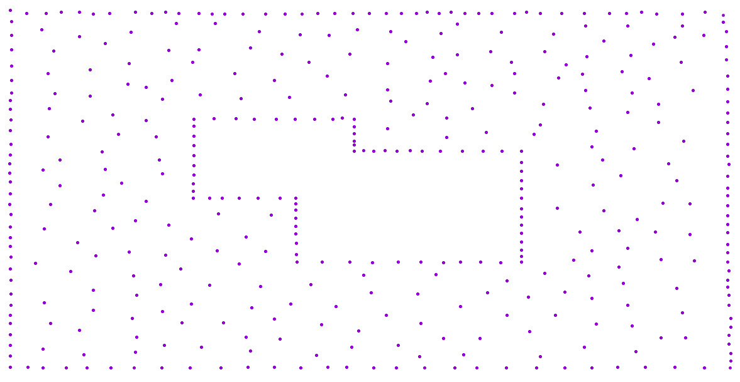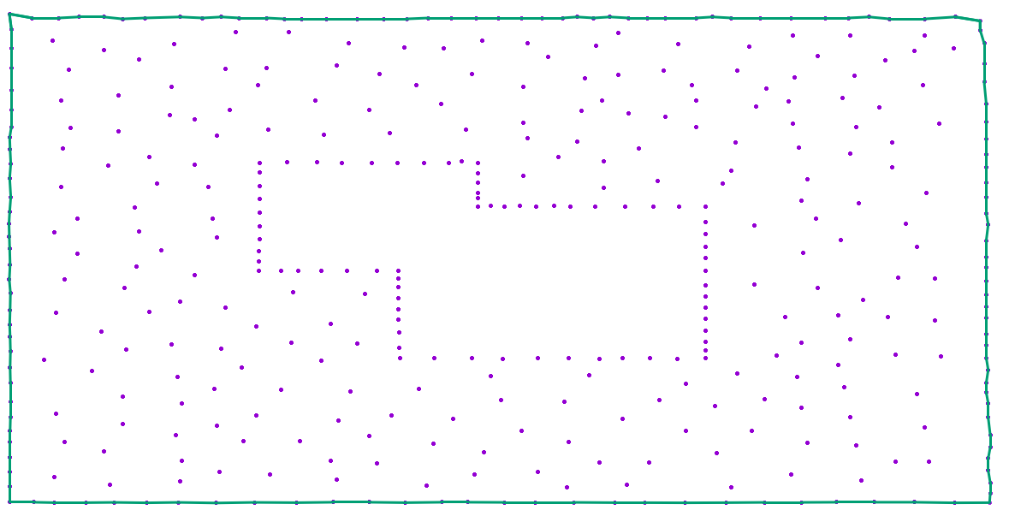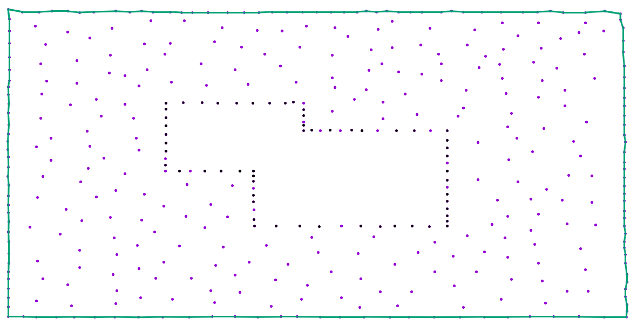
- (b) (c)
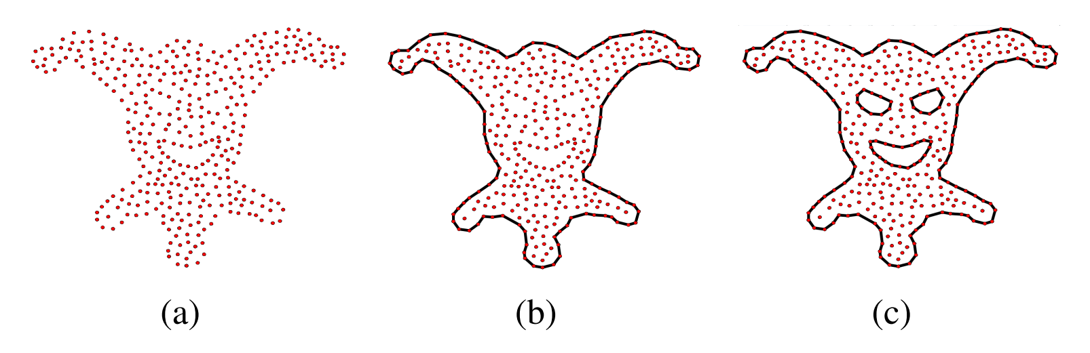
(a) Input point set (b) Shape with reconstructed (c) Shape with reconstructed outer
outer boundary (green) and inner boundaries (black)

Delaunay Triangulation-Based Hole Detection and Reconstruction:

-Empty circle approach
Basic Definitions and Notations:

Let S = {p₁, p₂,..., p_{n}} be the set of n points in a plane, where n is a positive integer greater than 2. An edge between two points p_{i} and p_{j} is denoted as e_{ij} . We also use e_{i} to denote an edge, when the endpoints of the edge are not relevant to explain the context. The length of an edge e_{ij} is denoted as ||e_{ij}||. A triangle formed by three points p_{i}, p_{j} and p_{k} is denoted as △_{ijk}. We also assume that the input point set is without noise (unwanted points), that means the sampling is done exactly from the hole boundaries so that no unwanted points are sampled.

Voronoi diagram: Voronoi diagram of S is a subdivision of the plane to n cells, one for each site in S, with a property that a point q lies in the cell corresponding to a site pi if and only if
distance (q,p_{i}) < distance (q,p_{j}) for each p_{j}$∈$S where i , j, where distance (q,p_{i}) denotes the Euclidean distance between the points q and p_{i}.

Delaunay triangulation (DT): Delaunay triangulation of S is a straight line dual graph of Voronoi diagram of S.
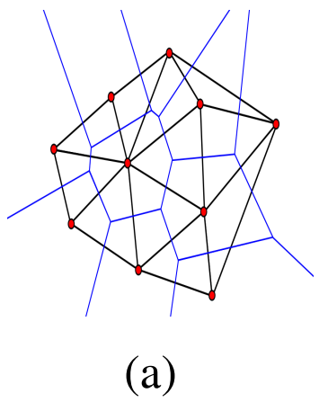
A Delaunay triangulation overlaid on top of a Voronoi diagram for a set of points

Exterior triangle (ET): A triangle of a Delaunay Triangulation is a triangle which has at least one edge which is not shared by (part of) any other triangle. Exterior edge of an ET is the edge which is not shared by (part of) any other triangle in DT. An edge which is not an exterior edge is known as an interior edge.
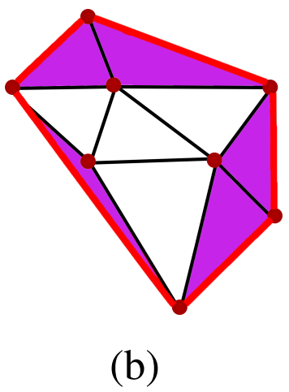
The purple coloured triangles, the red coloured edges and the black coloured edges in Figure are the exterior triangles, exterior edges and interior edges respectively.

Outer boundary reconstructed triangulation (OBRT): DT with exterior edges removed, leaving only the boundary triangles.
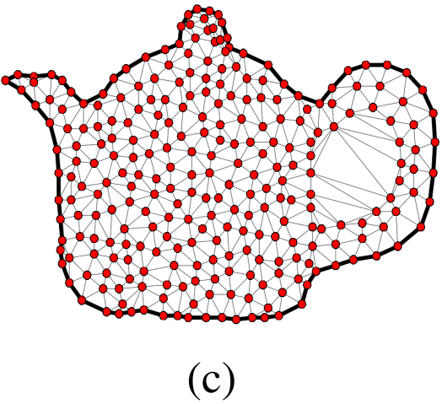
OBRT for a teapot point set, solid black line indicates the reconstructed outer boundary

Let e_{ij} be an edge under consideration which is shared between two triangles △_{ijk} and △_{ijl}.

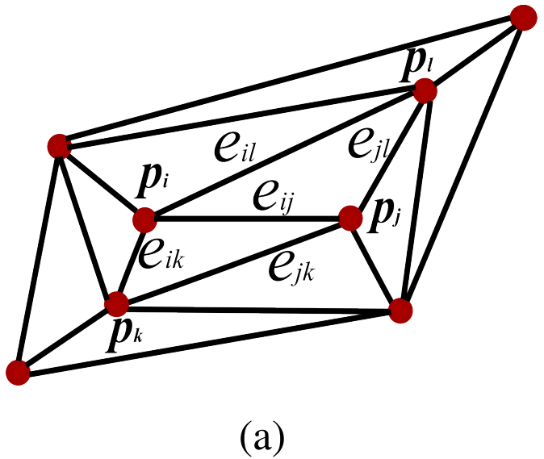
Interior edge e_{ij} shared by △_{ijk} & △_{ijl}

Diametric disk: Diametric disk of an edge e_{ij} is a disk with centre as the midpoint of the edge and with diameter ||e_{ij}||.
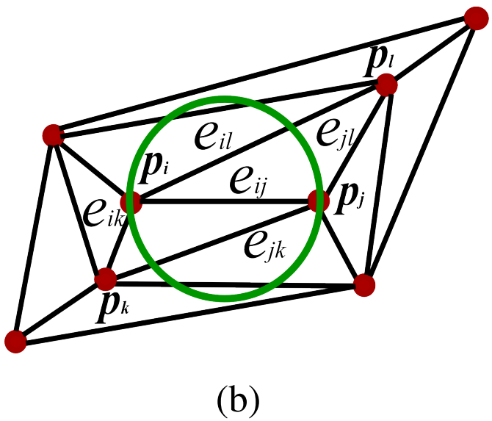
Diametric disk on interior edge e_{ij} with diameter ||e_{ij}||

Chord disk: Chord disk of an edge e_{ik} or e_{jk} or e_{il} or e_{jl} is a disk with the edge as its chord and with diameter ||e_{ij}||.

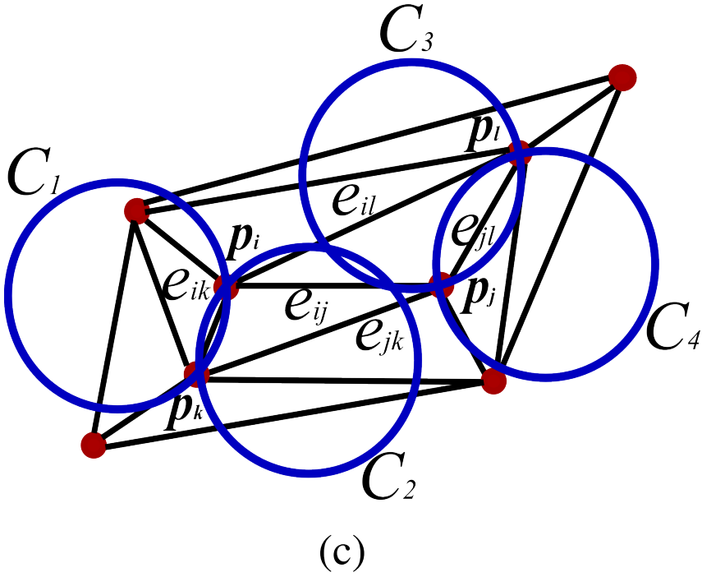
Chord disks C₁ & C₂ on e_{ik}, C₃ & C₄ on e_{jl} with diameter ||e_{ij}||

Midpoint disk: of an edge e_{ik} or e_{jk} or e_{il} or e_{jl} is a disk whose centre is the midpoint of the edge and with diameter ||e_{ij}||.

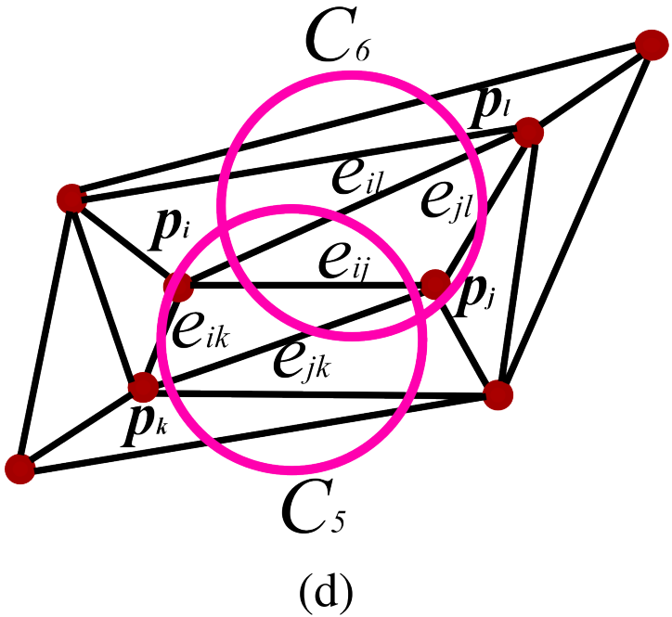
Midpoint disks C5 on e_{jk} & C6 on e_{il} with same diameter ||e_{ij}||

Disk and Regularity Constraints:
Let e_{ij} in △_{ijk} of G be the edge under consideration, where G is outer boundary reconstructed triangulation of the point set.
Our algorithm checks two constraints before removing an edge e_{ij} from G: (i) disk constraint and (ii) regularity constraint. Disk constraint checks whether a disk on an edge e_{ij} contains any point other than p_{i} and p_{j}, or in other words if the disk is non-empty. Non-emptiness of the disk on e_{ij} implies, e_{ij} is longer in the local neighbourhood and so it can be considered for removal.
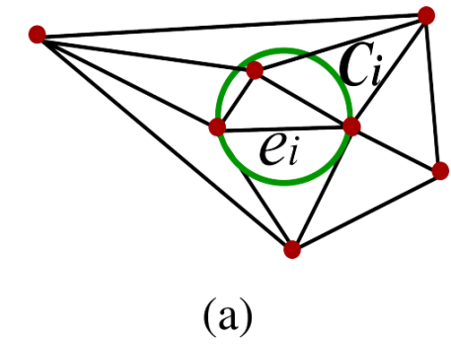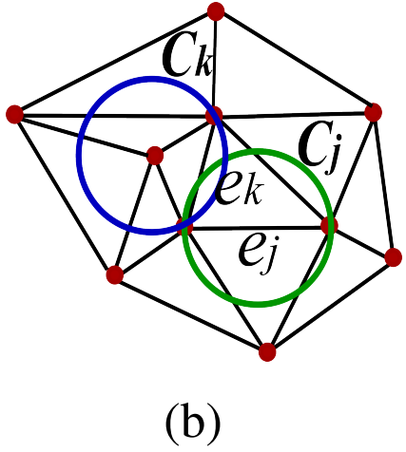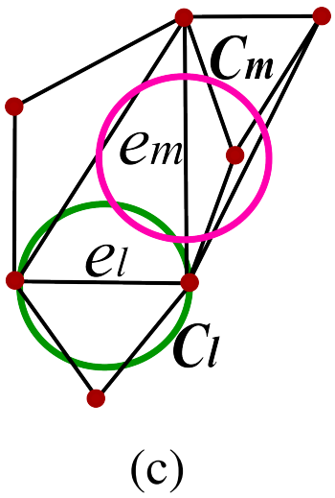
(a) Non-empty diametric disk C_{i} on e_{i} (b) Empty diametric disk C_{j} on e_{j} and non-empty chord disk C_{k} on e_{k} (c) Empty diametric disk C_{l} on e_{l} and non-empty midpoint disk C_{m} on e_{m}

Disk constraint: Disk constraint is satisfied if any of the disks is non-empty. For that:
- Check diametric disk on e_{ij} with diameter || e_{ij} || is non-empty
- If diametric disk is empty:
  - Check any of the chord disks with the same diameter || e_{ij} ||
(on the adjacent edge(s) of e_{ij}) is non-empty
  - If all the chord disks are empty:
    - Check any of the midpoint disk(s) with the same diameter || e_{ij} ||
(on the adjacent edge(s) of e_{ij}) is non-empty

(a) Non-empty diametric disk C_{i} on e_{i} (b) Empty diametric disk C_{j} on e_{j} and non-empty chord disk C_{k} on e_{k} (c) Empty diametric disk C_{l} on e_{l} and non-empty midpoint disk C_{m} on e_{m}

An empty diametric disk C_{j} on e_{j} and a non-empty chord disk C_{k} on e_{k} are shown in Figure (b). Figure 7(c) shows an empty diametric disk C_{l} on e_{l} and a non-empty midpoint disk C_{m} on
e_{m}. When e_{i} is considered for removal (after satisfying disk constraint), the regularity constraint is checked on G − e_{i}, where G − e_{i} is G without e_{i}.
Regularity constraint is based on a simplicial complex viz.cut vertex. A vertex in a simplicial complex is a cut vertex, upon whose removal results in an increased number of components.

Valid highest area triangle: A valid highest area triangle in G is the highest area triangle whose none of the vertices are on the reconstructed outer or inner boundaries. Even if the triangle coloured green in Figure (a) is of highest area in G, it is not a valid highest area triangle. On the other hand, the triangle coloured blue in Figure (b) is a valid one.

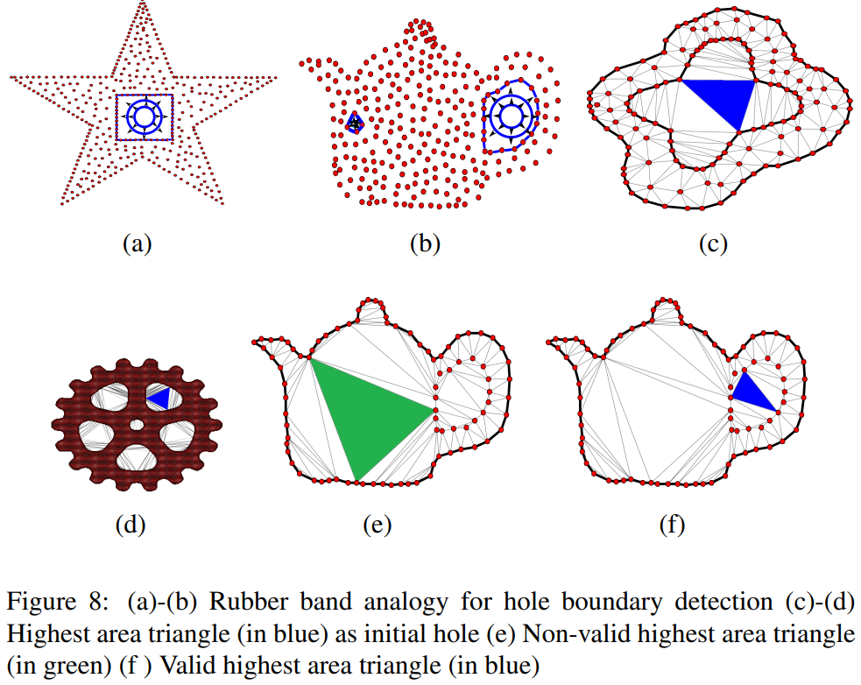
(a)Non-valid highest area triangle (in green) (f) Valid highest area triangle (in blue)

Hole Detection Algorithm
Intuition: As pointed out in Introduction, the major challenge of the hole detection problem is identifying the presence of a hole. We assume that a small rubber band (Figures (a), (b)) is placed in an arbitrary position. We can then grow the rubber band (unlike shrinking the rubber band in the case of convex hull for the outer boundary) to obtain the boundary of the hole. As shown in Figure (b), the rubber band can be placed in more than one arbitrary positions.

Observation: From the observations of holes of different shapes in Figures (c) and (d), the highest area triangle △ (shown in blue colour) can be considered as an initial candidate (rubber band) for hole region for the algorithm due to the following reasons: (i) △ is the sparsest region, i.e. the region which has no points interior to it (ii) When the initial hole region is grown, the adjacent triangles of △ contribute to expand the region (iii) It expands towards the lesser area triangles which are closer towards the boundary of the hole and (iv) All three points on △ are part of the reconstructed hole (analogous to the case of convex hull in Introduction).


(a)-(b) Rubber band analogy for hole boundary detection (c)-(d) Highest area triangle
(in blue) as initial hole (e) Non-valid highest area triangle (in green) (f ) Valid highest area triangle
(in blue)

Outer boundary reconstruction:
From the given point set, DT is constructed and its outer boundary is reconstructed using an outer boundary reconstruction algorithm.

Outer boundary:

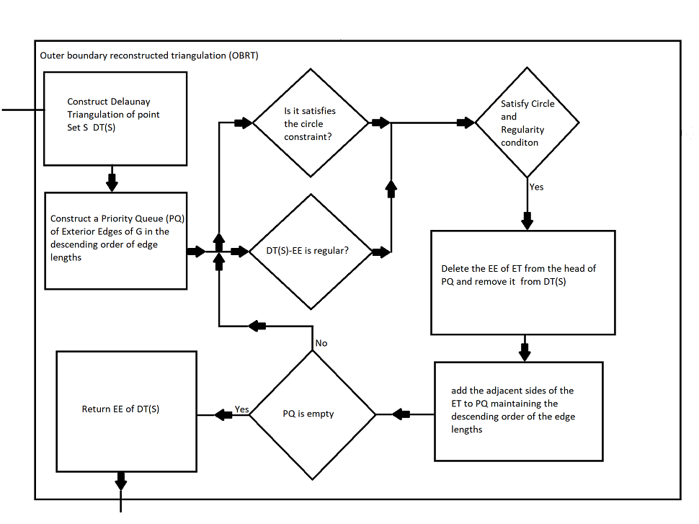

Hole detection:

The algorithm starts by constructing the Delaunay triangulation (DT) from a given set of points. Then, its outer boundary is reconstructed using a outer boundary reconstruction algorithm. Next, it identifies a valid triangle △₁ with the highest area from this boundary, which is considered the initial hole. The three neighbouring triangles of △₁ are then placed into a priority queue (PQ), ordered by their areas in descending order. The algorithm then takes the triangle △₂ from the head of the PQ. If non-empty disk constraints are satisfied on the edge shared between △₁ and △₂, and if the resulting triangulation after removing this edge from G satisfies regularity, then △₂ and the edge are removed from G and added to the hole. The process continues until the PQ becomes empty. This procedure for single hole detection is repeated to obtain multiple holes.

Single Hole detection:
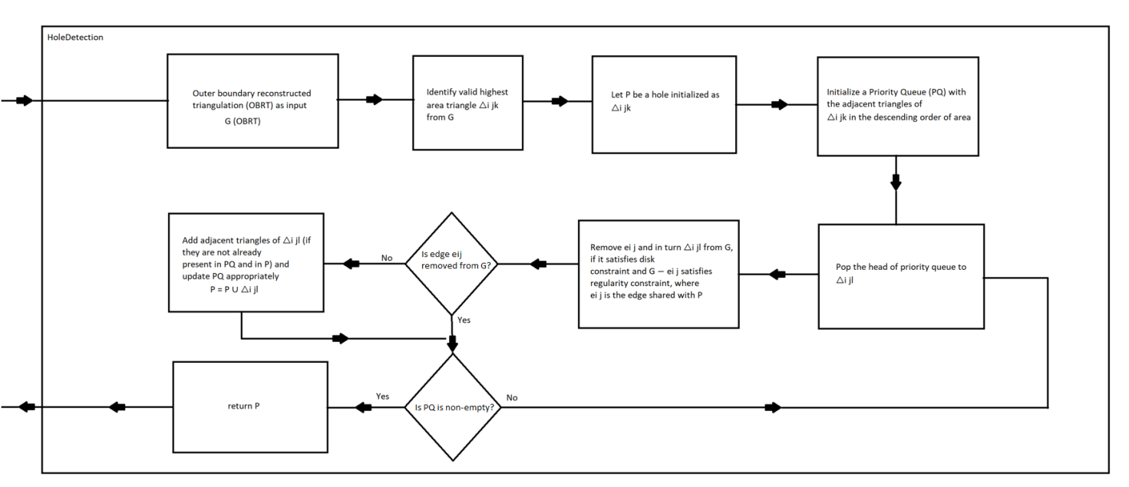

Multiple Holes detection:
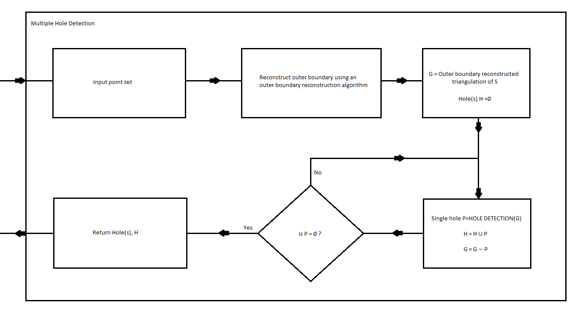

Limitations of algorithm
1. Valid highest area triangle Limitation: The algorithm's effectiveness depends on the valid highest area triangle being located within the hole region. If this condition isn't met, the algorithm's performance suffers, where the valid highest area triangle △₁ is not within the hole region. This issue arises because △₁ doesn't have its circumcenter inside the hole boundary.

2. Handling Sharp Angles: The algorithm struggles to capture holes with acute sharp angles, even with increased point density. This difficulty arises because holes with acute sharp angles fail to meet the body-arm condition. However, if a hole has non-acute sharp angles, the algorithm effectively captures the sharp corners.

3. Handling Noisy Input: In cases where the input point set contains noise, the algorithm's ability to capture the hole boundary is compromised.

4. Random Distribution: When the input point set is randomly distributed, the algorithm's performance deteriorates due to over-digging.

Overall, while the algorithm offers several advantages, such as efficient hole detection in certain scenarios, it also exhibits limitations in handling specific geometric configurations, noise, and random distributions of input points.

How to solve this limitation
Observation: The problem arises due to the non-uniform density of the point set.

Solution: To address this issue, we propose adjusting the distances between points to achieve a more uniform distribution. By reducing the distance between points, we can achieve uniformity through uniform sampling, thus making the point set more evenly distributed. To accomplish this, we first determine the minimum distance of each point to its nearest neighbour. If this minimum distance is consistent across the dataset, indicating uniformity, no further action is needed. However, if the minimum distances vary, suggesting non-uniformity, we employ a clustering approach to identify areas of high density. We then remove each high-density cluster along with its centroid to promote a more even distribution.

Intuition:

1. Sphere of Influence: Each point has a region around it within which it exerts influence over the distribution of points. Adjusting the distances between points ensures that each point's sphere of influence is appropriately sized to achieve uniformity.
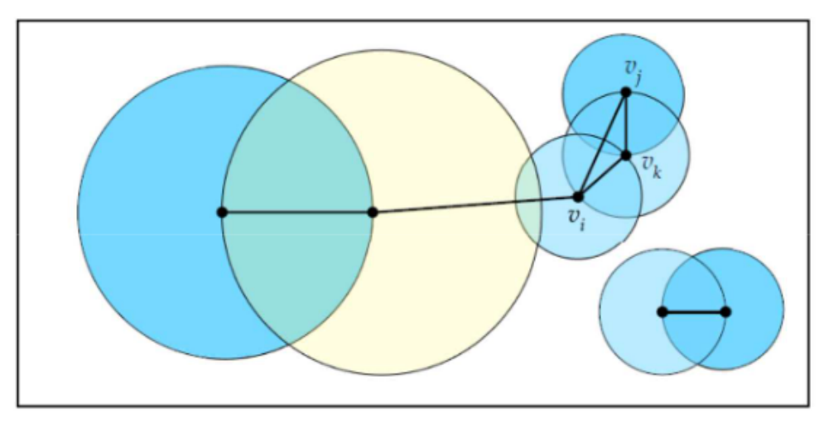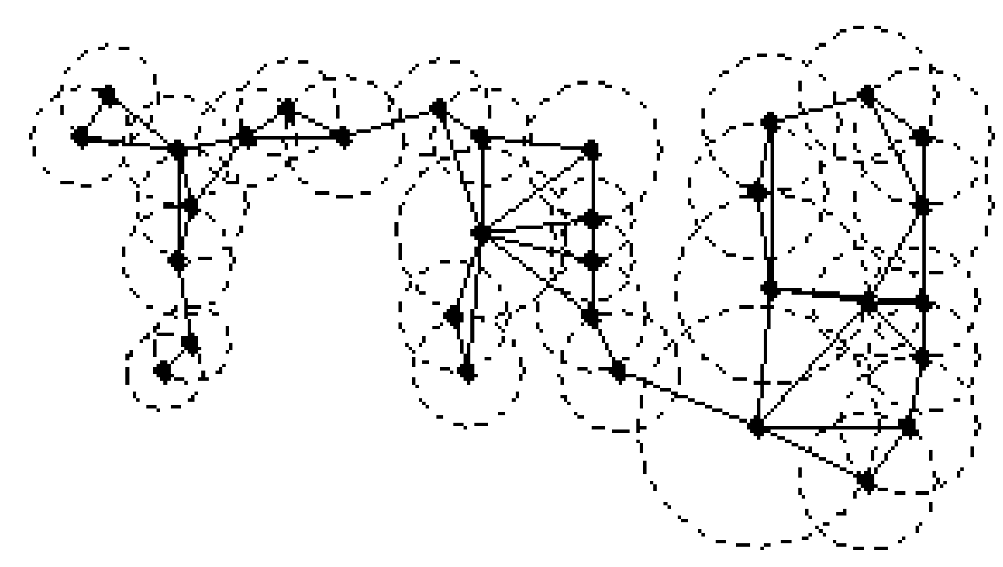
Sphere of Influence graph (edges) of set of points, showing their nearest neighbour circles

2. Nearest Neighbour Graph: Analyzing the nearest neighbour relationships helps identify areas where points are densely packed, enabling targeted adjustments to promote uniformity.

3. Largest Upper Bound (LUB): We calculate the largest upper bound for a set of values between the mean and mode of the second derivative of the minimum distances. This metric provides insights into the degree of non-uniformity and guides the adjustment process to achieve a more balanced distribution of points.

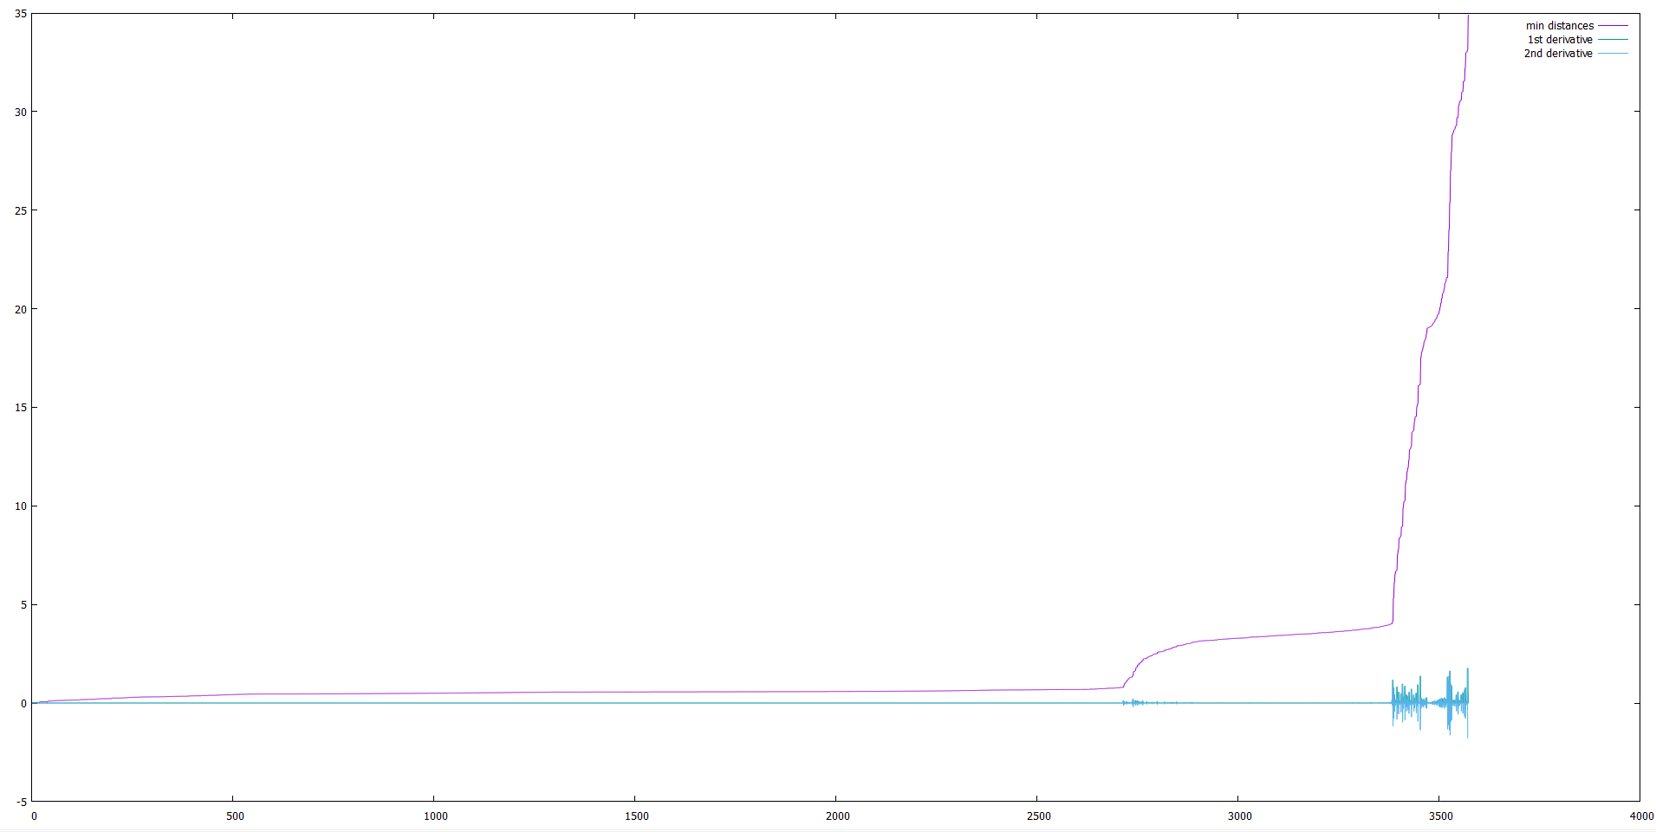
Minimum distance of each point (sphere of influence) in sample point cloud
Variation in min distance is calculated using second order derivative

Algorithm:
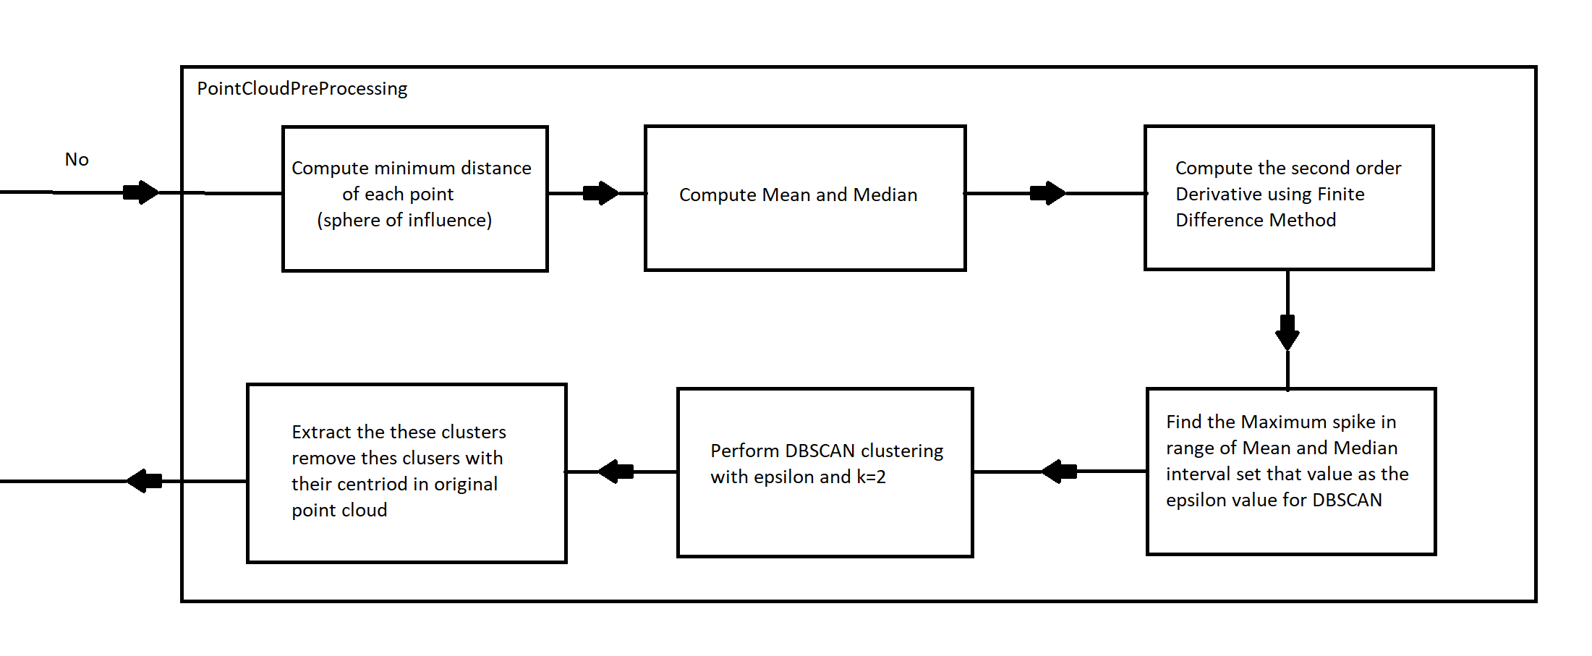

Integration
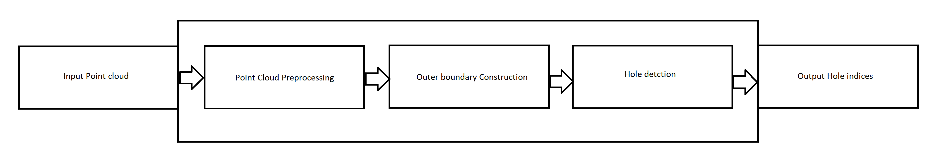

Level 0:

Level 1:

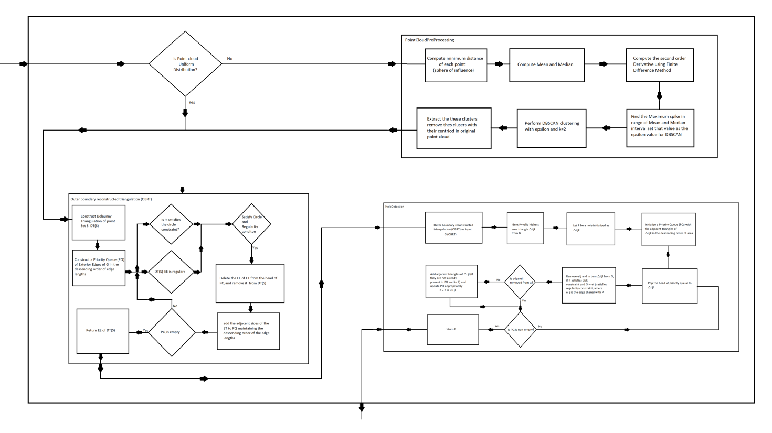

Development
Tools: Visual Studio, Gnuplot
Technologies :C++, CGAL, PCL (point cloud library)

Results: 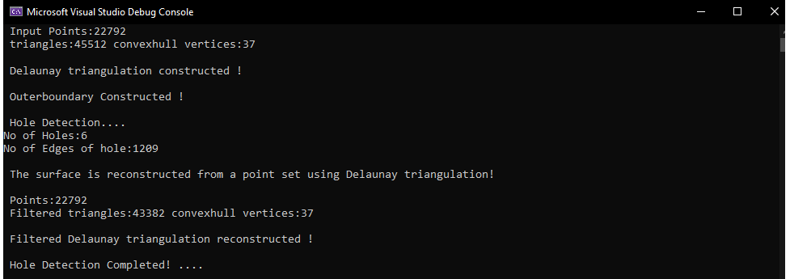

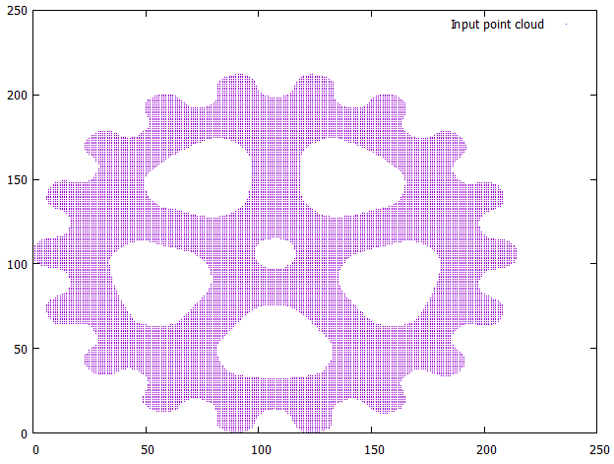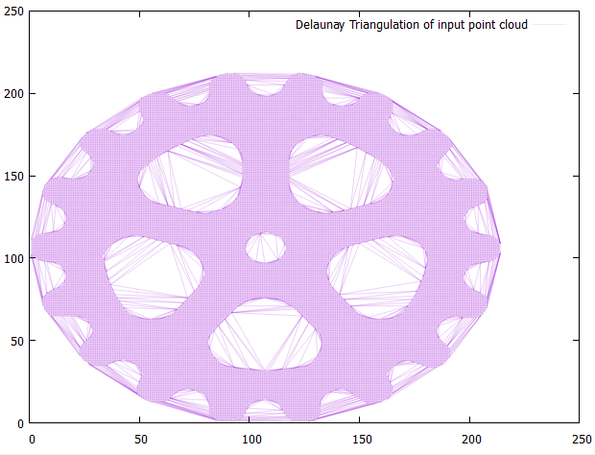

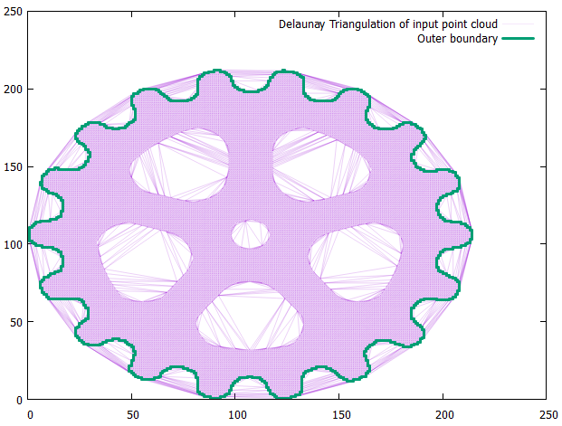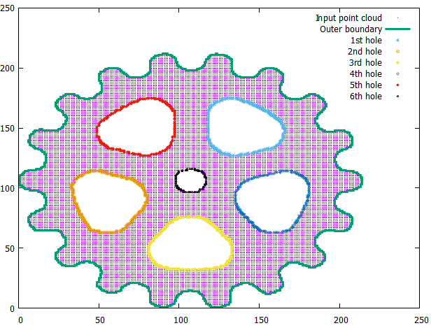

References
- Hole detection in a planar point set: An empty disk approach,Computers & Graphics 66 June 2017/66,Subhasree Methirumangalath, Shyam Sundar Kannan, Amal Dev Parakkat, Ramanathan Muthuganapathy
- Cgal, Computational Geometry Algorithms Library. http://www.cgal.org.
- M. Duckham, L. Kulik, M. F. Worboys, and A. Galton. Efficient generation of simple polygons for characterizing the shape of a set of points in the plane. Pattern Recognition, 41(10):3224–3236, 2008.
- S. Methirumangalath, A. D. Parakkat, and R. Muthuganapathy. A unified approach towards reconstruction of a planar point set. Computers & Graphics, 51:90 – 97, 2015. International Conference Shape Modeling International.
- J. Peethambaran and R. Muthuganapathy. A non-parametric approach to shape reconstruction from planar point sets through Delaunay filtering. Computer-Aided Design, 62:164 – 175, 2015.
- N. Amenta, M. Bern, and M. Kamvysselis. A new Voronoi-based surface reconstruction algorithm. In Proceedings of the 25th Annual Conference on Computer Graphics and Interactive Techniques, SIGGRAPH’98, pages 415–421, New York, NY, USA, 1998. ACM.
- Herbert Edelsbrunner.Shape reconstruction with delaunay complex.In Claudio L. Lucchesi and Arnaldo V. Moura, editors, LATIN,volume 1380 of Lecture Notes in Computer Science, pages 119–132. Springer-Verlag Berlin Heidelberg, 1998.
- The Sphere of Influence Graph: Theory and applications, Godfried T. Toussaint, Computer science New York University Abu Dhabi,UAE

